Marketing Fundamentals Assessment 1



Course: BA Business Management
Module name: Marketing Fundamentals
Module code: LCBB4004
Lecture name: Gasso Wilson Mwaluseke
Title of report: Blogging to communicate
Student Name: Sali Refat
Student ID: 2122704

Table of Contents
Background of the Company 3
Samsung’s Product 4
Samsung’s Prices 6
Place 8
Promotion 10
References 12

Background of the Company
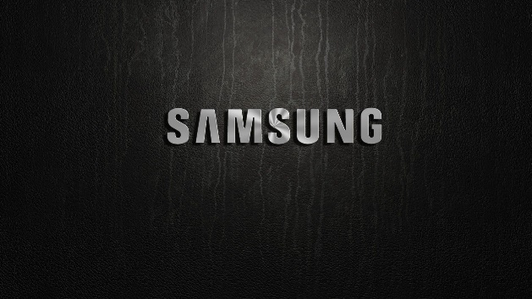
South Korea-based Samsung is one of the world's major electronics manufacturers. Samsung offers a wide variety of electronics for the consumer and business markets, including devices, digital entertainment goods, processors, microchips, and integrated systems (Hughes, 2016). One of the most well-known names in technology, it now accounts for around 25 percent of South Asia's entire trade. In March of 1938, Lee Byung-Chull established the business as a grocery. The company's first effort into the then-nascent electronics manufacturing sector was the release of a black-skinned television in 1969.
Mission and Values
Samsung, an international electronics titan, was founded in South Korea. Samsung develops a variety of electronic products for both the commercial and industrial markets, including gadgets, digital entertainment devices, semiconductors, microchips, and integrated systems. It now accounts for more than a quarter of South Korea's exports and has become one of the world's most recognisable technology brands. About us provides background information on Samsung. Malaysia (Regan and Bharti, 2015). My Samsung device. Seoul is home to the South Korean electronics giant Samsung. Home appliances, digital media players, electronics, computer chips, and embedded circuits for business and industry are some of the various sorts of electronics that Samsung creates. It is now one of the most recognisable names in technology and accounts for more than 25 percent of South Korea's total exports. Company Background: Samsung Malaysia. Okay, I'll confess: I own a Samsung. According to Samsung, moral ideals are essential to the long-term success of any business. Together with a strict code of conduct, these core ideas serve as the basis for all organisational activity (Senker, 2019). LG Electronics published a document titled "5 Samsung Business Guidelines" in 2005 to demonstrate the company's commitment to CSR as an industry leader. The principles serve as the basis for the company's global code of conduct, ensuring that the company adheres to all applicable rules and ethical standards and fulfils its CSR commitments.

Samsung’s Product
Samsung Electronics is a multinational business that produces electronic equipment including computers, mobile phones, storage devices, Optical discs, solid-state drives, televisions, digital theatre displays, and laptops. This company once produced printing and hard discs. The S10 series, which is a member of the Star family, is Samsung's most well-known smartphone lineup.
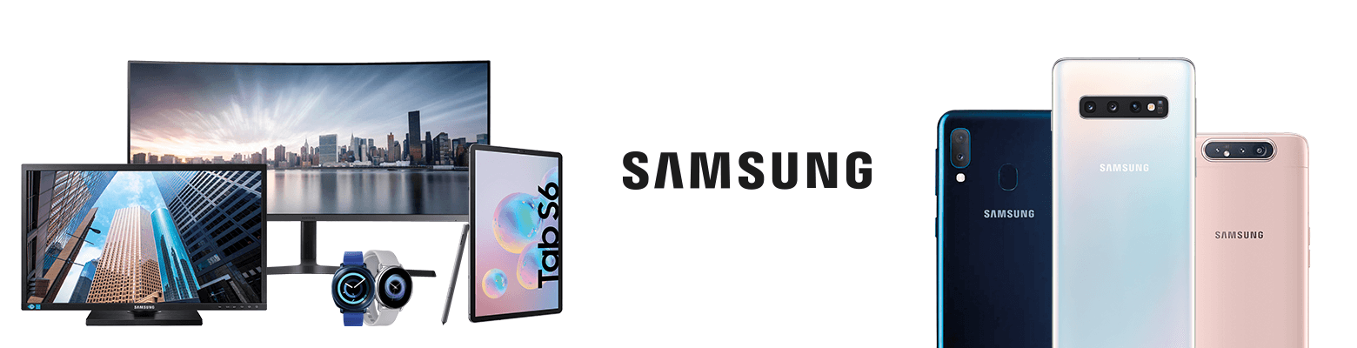
Samsung's new Galaxy S video is its premium smartphone, making it the primary competitor to Apple's iPhone. Let's begin by examining what Samsung is producing or plans to produce in order to corner a market (Asdi, 2020). In addition, Samsung TV Company employs a uniform pricing strategy across all of its business units and target markets. Since the rise of e-commerce and the dominance of corporations like Walmart, Samsung's TV channel mix has taken on a new dimension, which impacts the company's location strategy. Motorola's television marketing and public relations have to adjust to the new realities of media platforms and digital campaigns. Such as,
LED TV
The UA50TU7000KXXM is a 50-inch 4K UHD Smart LED TV offered by Samsung. This television is both affordable and effective, earning it a spot on the list of the best Smart TVs in Malaysia for 2021.
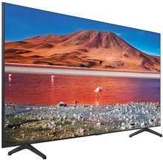
Build Quality
Samsung's 50-inch TU7000 is an amazing television due to its 3-edge design, slim chassis, and decreased framework. It is extremely lightweight, weighing only 11.6 kg with the bike stand.
Performance & Features
Crystal Panel and Samsung's Crystal Processor 4K provide this TV exceptional colour accuracy:
- In addition to HDR processing, colour accuracy and excellent contrast are also provided.
- It has a blur-reducing games boosting mode. A neat cable system that simplifies cable organisation.
- Samsung voice command and Tap-view broadcasting are also supported.
A business is not something physical, but rather the value it provides to the buyer (Yoo, 2010). Consumers of Samsung TVs can especially big in a variety of forms, including but not limited to: initial and well before e - learning from sales staff, product installation and maintenance facilities, personal recommendations, actual products, trusted brand names, user-friendliness, affordable pricing, flexible payment options, and moment in time equity.

Samsung’s Prices
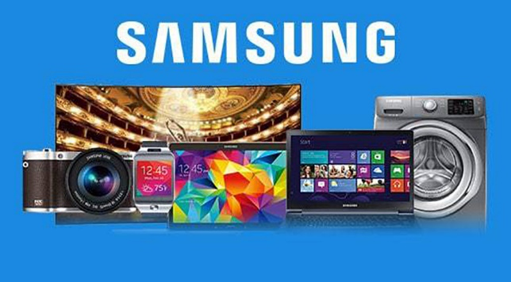
Incredibly nuanced thought and planning must go into pricing anything. The other three Ps of pricing inform pricing strategy. Intangible price can be thought of as the most money a client would pay for such a Samsung set given the current market conditions. Samsung's mobile telephone prices are set so that they barely make a profit. When consumer interest is strong because of a major iteration, the pricing is adjusted to maximise profits (Ahmad, 2014). When the early excitement and buzz die off, Galaxy lowers the prices to appeal to a wider audiences.
Electronic Products
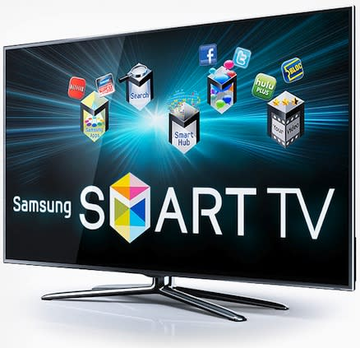
Regarding pricing and quality, we have both bases covered. While the secondary market may be an excellent location to locate savings on TVs such as the Samsung UA43AUE65AKXXL 2022 43-inch Ultra HD 4K Smart LED TV and the Samsung Crystal 7 Series 55AU7600 55-inch Ultra HD 4K Smart LED TV, you may want to preserve your money for the air conditioning system. Using your fan loyalty card is as simple as bringing it into the store or inputting your unique ID at the online checkout (Saputra, 2013). There is a clear relationship between shoe style and the cost of our merchandise. LED television prices range from around £60,000 to approximately £10,000. Frequent visits to our website will keep you abreast of the newest items and most competitive pricing in the market.

Air Condition
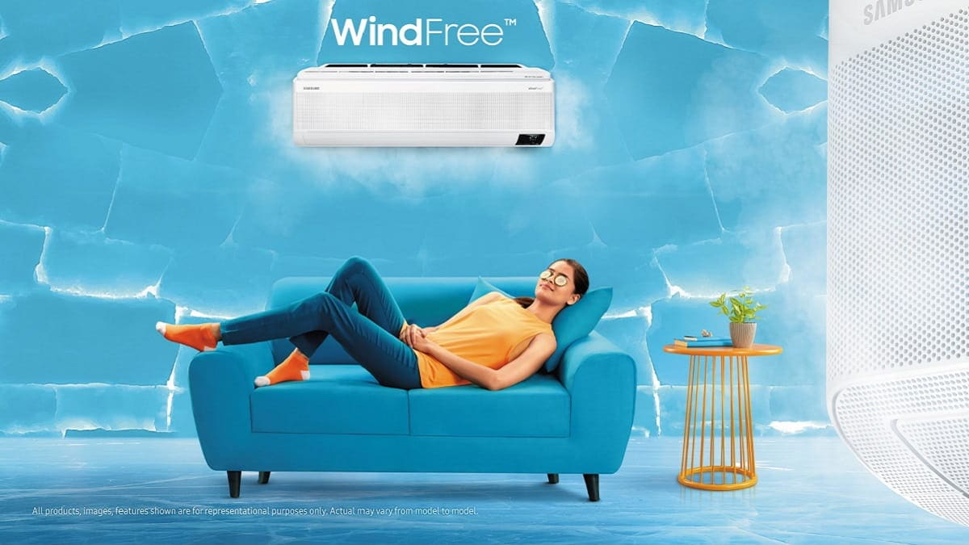
Samsung is the place to look for a new AC. Our ACs are extremely effective since they were created with efficiency in mind from the start. Learn more about it immediately by looking it up online. In comparison to traditional air conditioners, transformer models chill a space to a comfortable temperature in about ten minutes. If you need cooling to happen quickly, the two-way rapid option is a great choice. When compared to conventional air conditioners, the noise level produced by the outdoor unit is minimal when using an inverter model. Rates typically range from a low of 27000€ for non-inverter models to a high of 60000€.
Smartphones
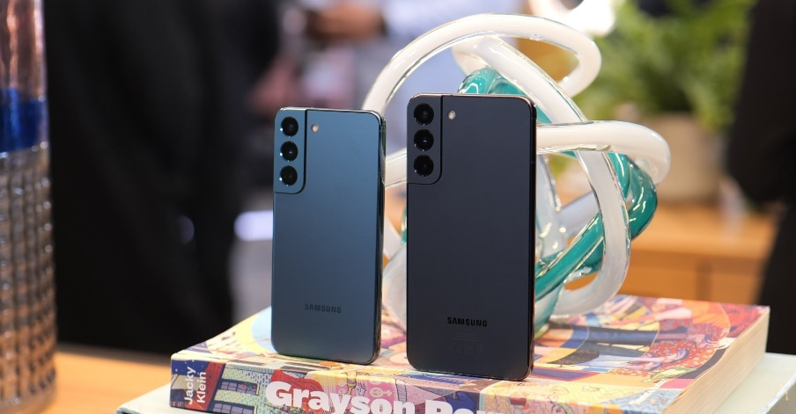
After assessing the cost of the raw materials, our charges are set at a level that represents the value of the consumer product we're giving. Ultimately, we bring to market a variety of products with the promised quality and anticipated price. The best-rated, most affordable Apple phones now available on the market.
- Samsung Galaxy A22 5G.
- Samsung Galaxy A13 5G.
- Samsung Galaxy A03s.
- Samsung Galaxy M53.
- Samsung Galaxy M52 5G.
- Samsung Galaxy M33.
- Samsung Galaxy M23.
- Samsung Galaxy F23.
And it starts from 20000 and over 1 lac.

Place
To deliver their items to consumers, corporations such as Samsung employ a "place" or "as far as" designation. Logistics, informing consumers about the products, lowering the price per unit so that even small businesses can sell products, streamlining the allocation of finished to customers, confirming an item's reliability, and providing after-sale and installation support are a few of the many needs that transfer and advertising strategies fulfil (Raeros, 2011). Offer a diverse selection of items and customization possibilities in-store.
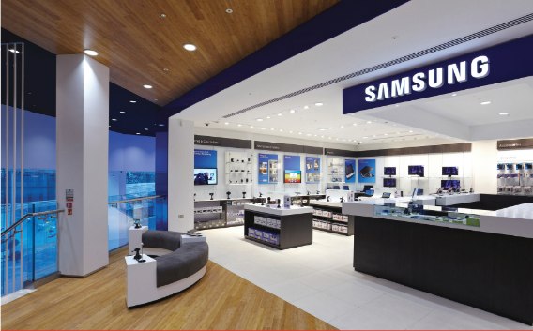
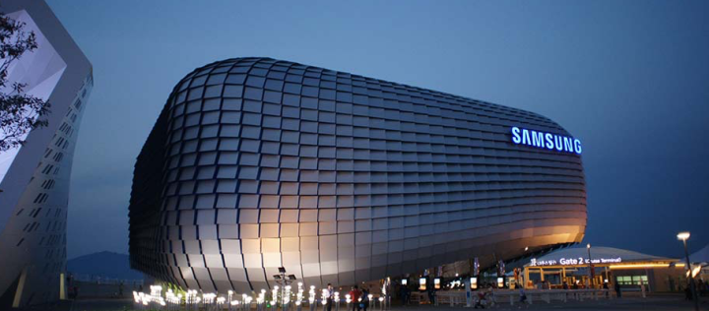Channel Design
When planning the network's layout, we must decide which of three dissemination strategies it will employ: direct, roundabout, or both. Samsung's research of our industry's service offering, current client comfortable location, the length, width, and depth of our manufacturing line, and competitors ability all factored into our decision to implement a particular distribution channels..

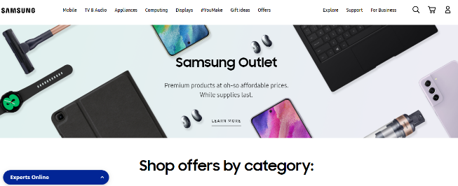
Direct distribution system
External communication refers to the practise of supplying goods directly to customers from the manufacturer or the supplier. Distributing in this way has the potential to boost sales and decrease promotional costs for companies. Samsung's cell phone division operates its own direct channel for distribution. We are selling everything we make through our own retail outlet and through internet channels such as Facebook and our very own website.
Indirect distribution system
What we mean by "indirect distribution" is that, as the manufacturer, we are selling our wares in bulk to middlemen, such as wholesalers and retailers. They maintain it, showcase it, and employ salespeople to put it into hands of consumers (Liu, 2019). The Apple Group employs a wide variety of intermediaries, including retailers, exporters, delivery agencies, and freight forwarders.

Promotion
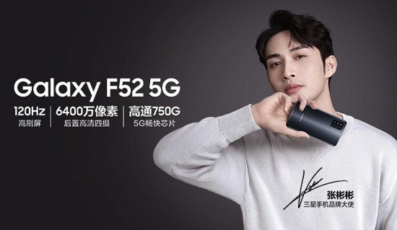
Samsung utilises an Integrated Advertising Strategy (or "Advertising Mix"), which is a combination of various advertising methods. There are five subsets within marketing: advertisements, promotions, direct marketing, public relations, and direct mail (Sammut-Bonnici, 2014). All five channels of information on a product or service can be utilised to influence a buyer's choice: where it is sold, how much it costs, what sets it apart from the competitors, how readily it can be gotten, and how effectively it can be used.
Email Marketing for TV Samsung
Email marketing, which is part of our company's internet marketing strategy, is a powerful instrument for spreading the word about our wares. It combines elements of direct mail and web advertising. If we integrate it with our digital marketing campaigns, we can educate our customers about our newest offerings and sales. Samsung employs e-mail marketing to directly communicate with potential customers (Tsaur, 2016). Samsung uses email marketing to follow up with prospects after gathering their contact details through kiosks, trade promotions, and survey questionnaires.
Search Engine Marketing
Online marketing, also known as SEM, is a form of internet advertising that focuses on increasing website visitors through organic and sponsored search engine results (Borden, 2014). 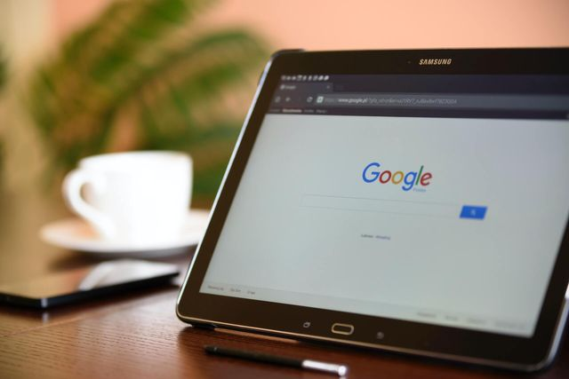
Internet marketing, which presents advertisements to customers based on their research and internet activity, is yet another significant form of marketing that has arisen in the past two decades. Similar to email advertising, this can target folks who are actively studying your product online and are hence likely to purchase it.

References
Ahmad, E.H., 2014. The Influence Of Marketing Mix, Customer Satisfaction, And Trust Towards Repurchase Intention Of Samsung Platform. STATE ISLAMIC UNIVERSITY SYARIF HIDAYATULLAH, FACULTY OF ECONOMIC AND BUSINESS. JAKARTA: State Islamic University Syarif Hidayatullah.
Asdi, A. and Putra, A.H.P.K., 2020. The Effect of Marketing Mix (4P) on Buying Decision: Empirical Study on Brand of Samsung Smartphone Product. Point Of View Research Management, 1(4), pp.121-130.
Borden, N.H., 2014. The concept of the marketing mix. Journal of advertising research, 4(2), pp.2-7.
Hughes, B., 2016. Samsung Galaxy S10.
Liu, J., Zhai, X. and Chen, L., 2019. Optimal pricing strategy under trade-in program in the presence of strategic consumers. Omega, 84, pp.1-17.
Raeros, R.T. and Nugrahani, R.U.,2011. The Effect of Samsung Android-Based Mobile Phone Marketing Mix toward its Brand Awareness (A case study at Telkom Institute of Management in 2011).
Regan, M. and Bharti, P., 2015. Samsung.
Sammut-Bonnici, T. and Channon, D.F., 2014. Pricing strategy.
Saputra, A., 2013. ANALYSIS OF MARKETING MIX 7PS TOWARD THE SAMSUNG SMARTPHONE CONSUMER BUYING DECISION AMONG STUDENTS AT PRESIDENT UNIVERSITY (Doctoral dissertation, President University).
Senker, C., 2019. Big brands.
Tsaur, R.C. and Huang, Y.C., 2016. Reused Smartphones Pricing Analysis-A Duopoly Model Analysis with respect to Apple and Samsung Smartphones. International Journal of Information and Management Sciences, 27(4), pp.405-422.
Yoo, B., Donthu, N. and Lee, S., 2010. An examination of selected marketing mix elements and brand equity. Journal of the academy of marketing science, 28(2), pp.195-211.

