Project Management in Workplace
BMSW5104

The impacts of Coronavirus on specific organisation

Osman Solma
1713188

3/7/ 20
University of Wales Trinity Saint David

Findings:
Project definition…………………………………………………………………………………………………....1
Project management – private schools……………………………………………………………………2
Tools and techniques in private schools………………………………………………………………….3
Independent school curriculum as year project……………………………………………………...4
Project plans and stakeholder communication……………………………………………………….5
Skills gain and ability of project manage………………………………………………………………...6
Conclusion………………………………………………………………………………………………………………7
Recommendation……………………………………………………………………………………………………8
Self-development plan……………………………………………………………………………………………9

Summary:

This is a critical assessment of project management of tools and techniques for managing project in private schools. the assessment is to show how private schools manage to accomplish the year curriculum. The assessment will analysis the tools and the ability to implement the curriculum with an example of private school and how to adapt to the coronavirus.
Further the assessment will be about how the project plans will be communicated with stakeholders to demonstrate the implementation of the project plan. The assessment will provide recommendation for future self-development plan for own performance.

Table of Contents
Findings: 2
Summary: 3
Introduction: 5
Project definition: 6
Project management in private schools: 8
Project management tools and techniques for private schools: 9
Independent schools- Curriculum as yearly project: 10
Project plans and the stakeholders communication in independent schools: 12
Evaluation: 13
Skills and Ability gained of managing a project: 14
Conclusion: 15
Recommendations: 16
Self-development plan for future performance: 17
References: 18

Introduction:
This report will critically assess and provide project management tools used for managing project in government schools, as well as in the independent schools. They are independent organisations to accomplish a project of schools curriculum every academic year.
The report will analyse the tools and ability to plan project in the workplace. Kings Monkton independent school is the organisation chosen for this report assessment, studying the tool and the techniques used to finish the school curriculum at every academic year to achieve good academic result and good business profit. Kings Monkton is profitable organisations to execute the curriculum to deliver the best education results. The assessment will show how independent schools as workplace can adapt the project which is the year 2020 curriculum with covid-19.
Furthermore, the report will show project plans in the private schools and how it can to be communicated with the stakeholders while implementing the project plan, showing the importance and priorities in making effective communication based on stakeholder’s respective positions, applying the appropriate communication means to keep them well-informed .
This report will critically evaluate the ability of managing projects and the skills gained from private school and the execution of curriculum project which affected by Coronavirus pandemic , followed by the future recommendation and make self-development plan to improve the performance based on the critical assessment and analysis of this report done to achieve quality delivered project at the end of every academic year.

Project definition:
The project definition varied from one another, some about an activity within limited time carried by individuals or groups to achieve positive idea or temporary attempts to do or create product at fixed time limit. According to Hartney (2018) that project is temporary timed having specific budged and unique because no project is exact as other, but could be similar because every project has different end time or different scheduled time or different resources and different team or individuals that execute the project.
The project is initiated to solve problems set as goals and achievements and defined by the initiator(s), the one who draws the boundaries and what will be delivered at the end. Every project’s features are different unique temporary and can be unfamiliar. According to McGuinness (2016) that six characters identified, that can make different and they are: unfamiliarity, the start and end time, the unique boundaries, not repeatable on process and of cross function.
The project management father is Henry Gantt1861-1919 and named as schedule diagram for tasks. According to Haughey (2014) that innovation of Gannt chart was a radical idea that helps managers to accomplish a project, and the project management began in the 1950s.
To implement a successful project, is engage with the project cycle. Leadership or manager is intitle to demonstrate the administrative abilities and skills using the appropriate tools and techniques help to deliver activities.

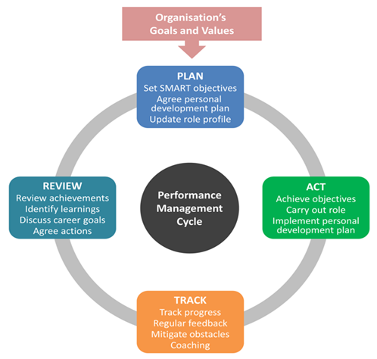
Project cycle.
Figure 1. Image by Stuart Hearn on 28 Aug 2017
Other definition for project is “A project is a series of activities which are connected in order to achieve a goal which must be accomplished within a specific time, and asset budget, and according to specification” (Epstein,2015). Project is featured by start and finished time, unique done in sequential order, having budget, human resource having responsibilities and clear objectives, can be changed and be completed. Clarizen describes project success as follow:
In brief, project management objectives are the successful development of the project’s procedures of initiation, planning, execution, regulation and closure as well as the guidance of the project team’s operations towards achieving all the agreed upon goals within the set scope, time, quality and budget standards!
( Clarizen, 17 March 2018 )
To run a project means introducing new product or services, to improve productivity to make profit.
Project management came in late of 1950’s, to adapt the changes in projects nature. The tools and techniques are created to enable firms to execute effectively and efficiently strategic tasks.
The equilibrium of the project triangle must be kept delivering the quality required based on balanced iron triangle constraint by what is most important to start and take right decision and action, because ignoring one of the three, lead to the project failure.
E.g. of the project constrains.
time

quality cost
Figure 2
the logic is one compromise the other two.

Project management in private schools:
It is the administrative role to get project done, planning, monitoring controlling, moving things towards accomplishment point. It is an application stage, processing using methods knowledges, skills, tools to achieve the goals. Managers in private schools are to consider the three important constraint, time, cost and quality done. According Eby (2017) that project management Iron Triangle is key managing elements for project managing and directing it with the appropriate methods, based on priority but on balanced process, which is most important to measure its success at delivery stage. To finish the projects task, is to apply the appropriate tools, and techniques considering all aspects of cost and time, to avoid project failure that mean manager have to be able to apply the project specific activities, measurable agreed upon ,realistic and well timed.
Kings Monkton school is the example for independent school. It is one of oldest independent Wales schools. The school is run as business profitable delivering the best quality education for 140 years. The school principal is communicating the important the stakeholders like Welsh government, pupils, staff to update them about the situation. Coronavirus update (Norton ,2020). The coronavirus update and reopening of the school on new criteria as plan has changed to online learning not onsite. Taking all essential steps of risk assessment and staff to be trained for new environment.

Project management tools and techniques for private schools:
They are essential tools and techniques used regularly in appropriate way which help execute the project within the time limitation of project. Gantt Chart is developed by Henry L Gantt to show the key element and the timed- lines for each task the order and the progression. The project life cycle demonstrated the plan phase, do and review evaluating closure. Landau (2019) explained that tools can reduce project cost. So private schools are concerned of using appropriate tools enable them to compete in this business field. The stakeholders and initiators are expecting revenue to meet their expectations encourage them to invest in private schools.
E.g. of school Gantt chart. 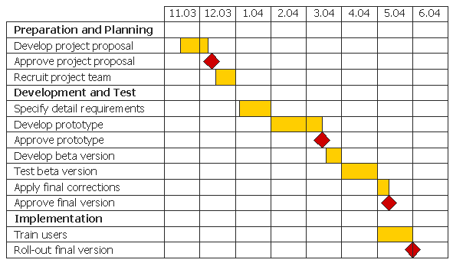
Image of : sites.google.com.
School Gantt Charts are the most important tools to visualise the timetable, the beginning of academic year and the end of it. Every school Gantt chart varies from one another and might not cover the same activities. Managers and staff make their individual Gant charts or network diagram for the different tasks and activities within the school’s general curriculum chart prepared by the school principal. According to Kienapple (2019) that every project has its own Gantt chart that construction one is different from the school Gantt chart.

E.g.: School Project: A visit to national museum:
Time: | Actions:
11 weeks advance. | 1. Research options for a school visit relevant to of curriculum and pupils' learning  2. Budget estimation.
9.Weeks advance. | 3. Proposal for staff justifying the visit and learning outcome according to the curriculum.
8.Weeks advance. | 4.Detailing the visit confirmation, date and means of transport.  5. Assess and research the museum visiting observing location, park, where to eat etc.
7. Weeks advance. | - To assess risk and legal conditions.  Review and update the overall proposal for final approval.
5.Weeks advance. | 7. Discussing and final checking with coordinators and managers showing cost and letters to parents.  8.Confirming the activities in the museum.

Not all what on Gantt chart or projects of internal activities can be accomplished within the time given due to the risks that can cause or change situation, in one of the project scopes. According to Kashyap (2019) there are numerous benefits of Gantt Charts for multiple tasks for groups or people working on the project, that is to have clear overview on the timeline showing the project progression. A Network diagram is the other visualising tool to keep monitoring the project process.

Independent schools- Curriculum as yearly project:
Project cycle of schools are not different from any project, but it is important to know that within the organisation, there are sub projects that based on the task within different departments such as teachers projects plan or the lesson plan for classes, within aim of the curriculum. Welcome (2019) described the classroom projects for kids as a reflection to what is in the present and will be in their future.
Private schools are independent organisation to deliver the education services to execute every year the academic year curriculum for quality and efficient education to make profit that satisfy the initiators and stakeholders. The tools are carefully selected for implementation of curriculum. According to actitime.com (2019) that every project is to adapt tools and techniques that make the project successful. Schools curriculums are the yearly project to be accomplished at the end of academic year in UK and Wales. As an example of project disrupted at the do stage buy coronavirus, independent schools’ timetables, operation cost and the quality that visualised on Gantt chart or network diagram for staff subject execution which visualising the tasks, must be reviewed because of lockdown, so the end of the curriculums are facing uncertainty . E.g. of activity network diagram.

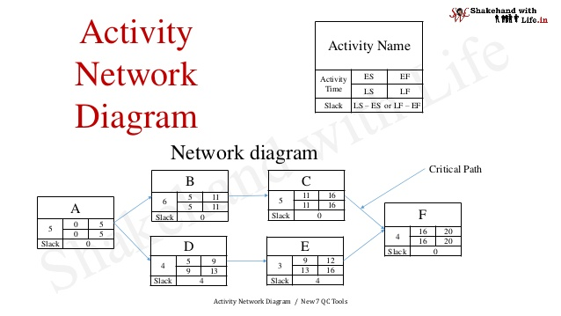
Image by Shakehandwihlife ,2018

The network diagram is to find out where the interdependencies activities stopped, or progress remain according to the programme, and things must be adjusted to the situation, and that means the plan stopped at the do stages. According to Shelton(2017) that both network diagram and Gantt Charts for visualising the project, but the network diagram is to show the linkages , start and end of the project, and Gantt charts show the work breakdown , both used by the managers to implement the project. This year most of projects are threatened by the lockdown because of pandemic and that risks the project, and assessment is the daily process to follow, and identified by unknown unknown risk happened unexpected during project execution. The appropriate tool and technique for this risk is Boston Chart to find out the risk categories. E.g. of Boston Chart:
High Risk and  Low Return | High Risk and  High Return
Low Risk and  High Return | Low Risk and  Low Return
Figure 3
Other important tool and technique at this stage of the lockdown is the risk assessment risk analysis grid to detect what impact the risk has on the project, to prepare for the action to avoid project failure

Project plans and the stakeholders communication in independent schools:
Stakeholders or the audience are those infected. It is the part of the project chart (quad chart) where involvement of project owners and initiators or beneficiaries, client, audience, supporters, suppliers. According to Barker (2019) that communication is the main part of the strategies to engage stakeholders being concerned for their involvement attracting new audience to the project.
Kings Monkton school in this academic year 2019/20 is under pressure to overcome the impact of the coronavirus -19, due to the lockdown. The curriculum as a yearly project with specific timed set for July 20. The plans needed to be monitored and evaluated for future unexpected situation. According to sopact.com (2017) that monitoring, and evaluation are continues process to assess projects to make changes or response to the situation that impacted the project continuation. According to Norton (2020) that there is the need to change and adapt the situation to reopen the site.
Communicating project plans is the role and responsibility of managers, as a project doer after the planning stage or the paradigm on a well-defined set quad chart to clarify project factors. Abudi, Gina (2013) showed the importance of stakeholder’s communication at every level of the project, giving the priority to who to communicate and how often as the communication has different impact on stakeholders. Stakeholders communication is key to project success when communicating with project influential. Bourne (2014) justified that there are three type of communication that managers can conduct to make project successful, by keeping reporting, public relation communication and marketing communication. according to Subramniam (2020) that stakeholder’s analysis is a tool to apply to priorities the communication with the audience who, for what and how to communicate.
Stakeholder analysis:
Priority  H/M/L | Stakeholder (audience) | Stakeholder’s  Perspective | Action

Monitoring and evaluation are essentials specially for private schools because they are under business category and delivering services for contracted stakeholders to meet the standards. According to Wightwick (2019) independent schools are inspected by Estyn regularly checking the standards of education. That is to a sure the delivery of the curriculum.
The project plans in private schools are crucial for all stakeholders to be communicated and updated as they shareholders or the business owners, consumers and beneficiaries who are interested in the performance. There tools and methods to keep stakeholders well informed are differs at every level of task groups. According to Lucidchcartcontent team (2020) that any success of a project is result of successful communication plan and methods to update stakeholders through appropriate means.
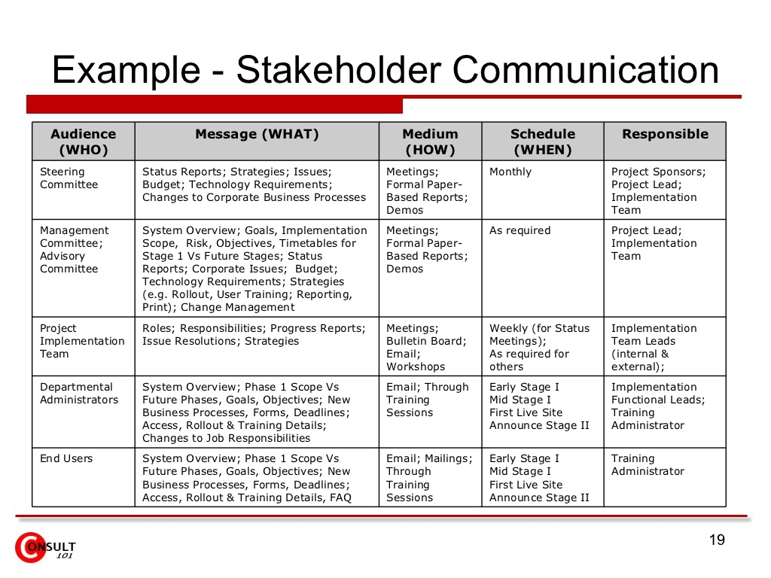 Image by: Anansubramaniam,2009
According to Linton (2019) that stakeholders communications channels is to have strong relationships for development to avoid project fail. Project fail because the fail to do at the do face of the project cycle, and Kings Monkton school deliver face is crucial to continue and attract new students and stakeholders.
Kings Monkton school and other private schools in Wales affected by the lockdown and they will not be able to implement the year calendar on time and other changes to be in-place. According to Wardell (2020) that private schools will face financial and operational risks. As a year project the three factors for success time is the main factor deciding the future of the academic plan.

Evaluation:
Project management and skills gained from Kings Monkton independent school are management experiences which linked two kinds of business background and managing project for specific stakeholders. Managing project is to have the ability to apply the knowledge of how and what to produce with right skills, using tools and techniques to achieve the expectations of audience. Harrin(2015) uttered that to get project plan done , managers need a set of skills required; like planning and leadership, communication skills ,time managing skills, being fair ,practical attitude, flexible, realistic and decisive able to manage and identify risk, critical thinker, assertive , hands dirty and having sense of acceptance and motivator.
Kings Monkton school manager is improve performance by keeping close eye on the internal elements of the project and it is easily identified by the Mckinsey 7s ,1980s tool, the strategies, structure system as hard part of the project and skills, style, staff and shared values, as soft part of the project . E.g. of Mckisey7s
Image by Strategic Management Insight.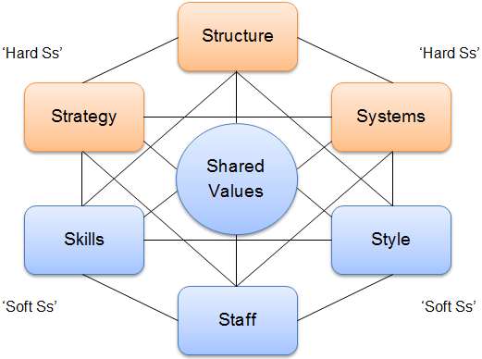
The tool is to outline the linkage between the soft and hard and facilitate changes or bring in new strategies and monitoring the emerged changes. Jurevicius (2013) explained that the 7s model is about the effectiveness because they are interconnected where changes are dynamical. It is important to avoid failure by making use of tools techniques and skills.

Skills and Ability gained of managing a project:
The ability to manage a project is to have the knowledge, skills, and how to use the effective techniques, and tools that enable project managers to act. Aston (2020) explained that abilities of project management skills are three categories, hard which are about competence when applying technical tools and methods, soft which about the managers intelligence abilities how to deal with practices. Skills and abilities gained are:
- Leadership skills managing independent school to accomplish the year curriculum.
- Skills to deal with the network diagram to delete or prioritise or make new preparations for the tasks. Donnelly (2019) explained that developing leadership skills are manager’s success that enable him to run projects.
- Skills to structure, schedule and time management to link things in order follow up.
- Creating plans, structure chart to assure the project success. According to Hughes (2018) that project structure is to a confirm to the expected result for all audience.
- The technique of the work breakdown structure is essential to know where the adjournment of tasks.
- Risk management skills under covid-19 pandemic, how to manage unexpected situation while project process, that principal is able to manage unexpected risk, selecting the right tools and techniques available, like Boston chart to update, sharing plans, able to decide, flexible.
- Effective communication and empathy with stakeholders are key to success to have all informed about situation changed due to the pandemic.
- Adaptability skills as a manager about the changes, actions and flexibility.

Conclusion:
This report showed that project management is about to know what, how and who can manage organisation project, with ability to plan and implement it, using tools and techniques. The organisation chosen for this report is Kings Monkton school curriculum as yearly project to be accomplished at the end of every academic year.
Gantt charts, project cycle, Iron triangle, network diagrams and Boston risk management tool, Quad chart are the enablers for project managers to accomplish their respective projects.
This year 2020 the world is hit by the covid-19 pandemic, and UK lockdown triggered to stop this year curriculum. Kings Monkton is a profitable business and the initiators are risking their capital, if they do not accomplish the project at the time set. The school’s principals are concerned to revise the whole year plan and create methods inserting new tools to achieve curriculum’s goal to deliver the quality of education expected. Kings Monkton school made necessary steps prepared to the reopening due to the new environment.

Recommendations:
- Revisit of their curriculum plans to solve the shortages caused by the coronavirus lockdown.
- Review for financial situation by owners
- Create new methods and tech tools for teaching.
- Teachers and staff to be trained to teach online for other levels and develop new methods for activities that must be done according to he knew situation.
- Active communication with all stakeholders through accessible communication means for update.
- Review of quad chart which can attract the audience.
- Risk management training for risk control staff.

Self-development plan for future performance:
Scheduled | Goals | Actions | Supports and resource | Meet my goals | Date achieved.
2 months | IT | Training | Computer  Teacher  Internet sites | Be able to do programming | 2nd August
3 months | Risk management skills | Course | Relevant books  friends | Be able to manage risks | 2nd September
1 month | Health and safety skills | course | Friends. Books. | Be able to manage school health and safety | 28th July

References:
Abbeywoodedexcelapliedic (n. d) Gantt Charts. Available at: https://sites.google.com/(acceesed: n. d)
Abudi, G. (2013) Managing Communications Effectively and Efficiently. Available at: www.pmi.org/ (Accessed:29 October 2013).
Actitime.com (2019) Useful Project Management Tools and Techniques. Available at: www.actitime.com/ Accessed: December 2019).
Aston (2020) Essential Project Management Skills For 2020. Available at: thedigitalprojectmanager.com/ (Accessed: 21 April 2020).
Ballard (2020) COVID-19: how is the pandemic affecting private schools Available at: https://www.businessleader.co.uk/(Accessed:24 April 2020).
Barker (2019) Demystifying public relations for private schools - PR Academe. Available at: pracademy.co.uk/ (Accessed: 19 November 2019).
Bourne (2014) The 3 types of stakeholder communication. Available at: https://projectmanager.com.au/ (Accessed: 28 May 2014).
Clarzin.com (2018) What Are the Objectives of Project Management? Available at: clarizen.com (Accessed:17 March 2018).
Donnelly (2019) ‘Project management’ why developing leadership skills matters for project management [blog].29 Jan. Available at: blog.workep.com/ (Accessed:29 January 2019).
Eby (2017) The Triple Constraint Theory of Projects. Available at: www.smartsheet.com/(Accessed: 20 September 2017).
Epstein (2015) The seven key characteristics of a project – LinkedIn. Available at: www.linkedin.com/(Accessed:19 April 2015).
Hartney (2018) What is a Project? - Project Engineer. Available at: projectengineer.net › (Accessed: 11 May 2018).
Harrin (2015) ‘15 Top Skills Project Managers Need’, Elizabeth Harrin[blog].8 January. Available at: www.strategyex.co.uk/blog/pmoperspectives (Accessed: 8 January 2015).
Haughey (2014) History of Project Management - Project Smart. Available at: www.projectsmart.co.uk/ (Accessed: 24 December 2010).
Hearn (2017) Explaining the Stages of the Performance Management Cycle. Available at: www.clearreview.com/ Acessed:28 August 2017).
Hughes (2018) ‘project organization 101’, How structure your project Kirs Hughes [blog],8 Oct. Available at: www.projectmanager.com/ blog (Accessed:8 October 2018).
Jurevicius (2013) McKinsey 7s Model. Available at: www.strategicmanagementinsight.com › (Accessed: 20 December 2013).
Kienapple (2019) ‘11 Gantt Chart Examples and Templates For Project’, Bronwyn Kienapple [ blog], 25 Mar. Available at: venngage.com › blog › gantt chart example (Accessed: 25 March 2019).
Landau, P. (2019) ‘5 Project Management Techniques Every PM Should Know’, Peter Landau, [ blog].3 Sep. Available at: www.projectmanager.com/blog/(Accessed: 3 September 2019).
Lucidchart (n. d) ‘How to Create a Project Management Communication Plan’, Lucidchart Content Team. [ blog]. No date. Available at: www.lucidchart.com/blog/project management communication plan/ (Accessed: n. d).
Linton (2019) What Are the Benefits of Stakeholder Communication? Available at: https://smallbusiness.chron.com/ (accessed: 6 March2019).
McGuinness (2016) ‘What are the Characteristics of a Project? – BrightWork’, McGuinness [ blog]. 23 March. Available at: www.brightwork.com/blog/ (Accessed: 23 March 2016).
Norton, P. (2020) Coronavirus Update: Paul Norton[video]. Available at: www.youtube.com/watch?v=IGXH6JCyT_ (Accessed:11 May 2020).
Shakehandwithlife (2018) Activity Network diagram. Available at: www.slideshare.net/ (Accessed:18 February 2018).
Sopact.com (2017) Monitoring and Evaluation Tools, Framework, Plan and Courses. Available at: www.sopact.com/ (Accessed:5 December 2017).
Stakeholder Map (n. d) project-management/project-triangle-quality. [figure]. Available at: https://www.stakeholdermap.com/ (Accessed: n. d).
Shelton (2017) Differences Between a Gantt Chart & a Network Diagram. Available at: bizfluent.com/ (Accessed: 26 September 2017).
Subramaniam (2009) stakeholder communication. Available at: www.slideshare.net/ (Accessed: 27 July 2009).
Welcome (2019) 6 Creative Classroom Project Ideas. Available at: https://www.gettingsmart.com/ (Accessed: 26 May 2019).
Wightwiek (2019) How all of Wales' private schools compare on fees and results. Available at: www.walesonline.co.uk › News › (Accessed:30 April 2019).

