Tourist Attraction or Tourist Detraction: Formula 1
Date Submitted: 05/03/18
Author (Lydia Smith, P141878, University of Wales Trinity Saint David)

Abstract:
Purpose – The purpose of this paper is to access the advantages and disadvantages of hosting the Formula 1 to see if the event is an attraction or detraction, in line with recent departure of Malaysia who can no longer sustainably host the competition.
Approach - A case study approach has been adopted for this research. Articles were collected from the public domain and analysed with information that was gained by the author during MTOUR field trip to Malaysia.
Findings – Hosting the F1 has become an increasingly competitive market. The success of each event depends entirely on the surrounding environment, advantages of hosting are: financial gain and increased tourism. The disadvantages could be; lack of demand leading to financial loss on the event and lack of support from the local community. The decision for Malaysia to take a break from F1 was deemed practical at this point in time, but officials in Malaysia said they would return in the future at a more economically viable time.
Introduction:
It is widely known that hosting large scale sport tourism events gains substantial attention around the world (Kim & Walker, 2012). Sport tourism has been defined as ‘a social, economic and cultural phenomenon arising from unique interactions of activity, people and place’ (Weed and Bull, 2004). Sports tourism has seen significant growth in popularity due to the commercialisation and professionalisation (Houlihan, 2003) of the sector. Large sporting events are generally regarded as leveraging opportunities for economic growth and urban redevelopment (Konstantaki & Wickens, 2010). Some examples of this are, increasing income and job opportunities, minimizing inflation, and enhancing the status of under-represented cities or countries (Bull & Lovell, 2007), all of these are considered prominent outcomes of event hosting.
For that reason, governments around the world compete to host the best and largest sporting events including; The Olympic Games, FIFA World Cup and Formula 1 GP – but none of these events are easy and cheap to stage. This article will look at the advantages and disadvantages of hosting a large scale sporting event, directly relating to the case study Formula 1 & Malaysia.
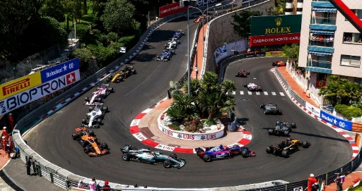
Figure 1. Formula 1 Monaco

Formula 1 Phenomenon:
The FIA, Formula 1 World Championship launched in 1950 following the success of races in Europe (ESPN, 2010). Formula 1 is currently the highest class of single seated auto racing which is governed by the Federation Internationale de Automobile (FIA). The popularity of Formula 1 has grown in strength worldwide with the 2017 season reportedly reaching 1.4 billion viewers, 601 million of which were returning fans (F1, 2018). Formula 1 was the fastest growing sport brand on social media in 2016/17, significantly growing by 54.9%, making it the dream platform for advertisers, and perfect for place promotion opportunities in tourism, (Forbes, 2017).
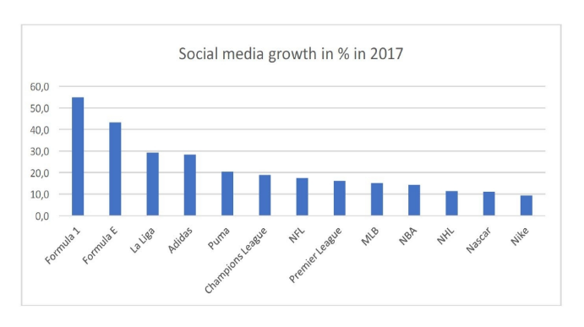
Figure 2. F1 Social Media Growth
In 2017, ‘The Global F1 Fan Survey’ (Burrows, 2017), attributed that an increase in viewer numbers and social media awareness was due to the takeover of F1 by Liberty Media for £3.3 bn. The new chairman of F1 Chase Carey is no stranger to the world of media due to his other role as vice chairman of 20th century Fox. Chase sees a vision for the future of F1 where fan engagement is of upmost importance, he says ‘I see great opportunity to help formula 1 develop and prosper for the benefit of the sport, the fans, teams and investors alike’ (BBC, 2016).
The influence of F1 has been highly recognised by nations around the world, which makes getting on the F1 calendar very competitive. Some nations have lavished from the benefits of hosting, whilst others have fell short, one nation in particular is Malaysia.
Malaysia Dropped:
Sepang circuit opened in 1999, and spent the next 19 years being host to the Malaysian Formula 1 GP. The Malaysian government funded the event for 19 years and in 2017 announced it would no longer be on the F1 calendar because ‘the race no longer justifies the investment’ (BBC, 2017). Malaysia joins a long list of other countries who no longer host due to financial constraints, some of which were Turkey and India. Bernie Ecclestone the Ex-chairman of F1 before Liberty Media, sold the success story of F1 hosting, by boasting the influence of ‘Global awareness’ and ‘economic greatness’. Many nations have fought to get their place on the F1 calendar but come face to face with increased competition from influential destinations. Figure 3. Sepang
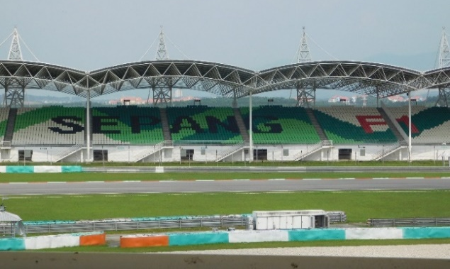

Attraction or Detraction:
There are many reasons why nations would be attracted to hosting the Formula 1, but equally there are many reasons why they would also be deterred. Hosting the F1 is a chance to showcase the home nation to the rest of the world (1.4Bn total reach) and has helped developing countries like Azerbaijan make improvements to their economy and social status. The Azerbaijan, Baku street circuit made its debut in 2016 and after 2 years in F1 had seen a contribution of $277.3 million (PricewaterhouseCoopers, 2018) to the local economy. This is just one example of how hosting the F1 can have great economic benefits.
Financial Sustainability
Formula 1 is at the pinnacle of motorsport, so it’s no surprise that hosting it comes at a substantial cost. The average price of hosting an F1 race now sits around $33 million (Forbes, 2017) with further investment needed from governments for; maintenance of the track, advertisement, staffing and hospitality. The sad reality is that many tracks like Sepang, struggle to make enough money for the event to be ‘financially viable’ (BBC,2016). The British GP at Silverstone is the latest race to come under strain, and may be following in Malaysian footsteps by taking a break from hosting F1 until Liberty Media can find a way to make hosting the event more financially sustainable. The UK Government has negotiations underway to look into moving the event from Silverstone to London where it would be held on a street circuit (BBC, 2017). Although this is only at the concept stage, it is clear that the UK are keen to keep hold of hosting the F1 but are looking for a location which is more financially sustainable.
Countries that struggle to finance the F1 have scrutinised the owners, now Liberty Media, for charging an extortionate amount for the hosting fee which increases every year (Forbes, 2017). Tracks are not known to make any revenue from advertising or digital media platforms, this revenue goes to F1 Group, thus meaning the track has to rely solely on ticket sales to make revenue. The launch of popular tracks around the world can cause less popular tracks which are struggling to see a decline in ticket sales, this was the case for Sepang, when the launch of the Singapore GP led to an influx of spectators choosing Singapore over Sepang - which inevitably led to Malaysia to take a break from hosting.
Figure 4 Marina Bay Circuit, Singapore
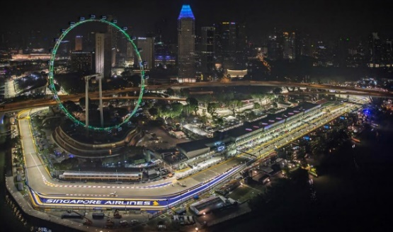

Singapore has seen economic success year after year since their debut in 2008, with their spectacular Night Race at Marina Bay Street circuit, becoming one of the favourites on the F1 calendar (Pricewaterhouse Coopers, 2018).
The nations that have the best economic success from F1 tend to be those who are affluent in current affairs or developing in awareness across the world (ESPN, 2016). The two things that gain a destination/ host nation the most interest however is those who have street races and or it’s a night race. As well as Singapore, Abu Dhabi relishes from success due to its status as a night race and hosts the last race of the season. Yas marina where the event is held experiences a tourism boom because of the spectacular experience they put on for the guests. The USP of hosting an F1 night race or having a street circuit is recognised by fans around the world (Delottie, 2008) with the most popular tracks being, Abu Dhabi, Singapore and Monaco. Monaco GP is so sustainable that F1 has gone as far to say that they need Monaco more than Monaco need F1, in turn they charge them very little in the way of hosting fee’s as an incentive to stay in the sport (F1news, 2016), to keep the fans interested.
Demand
F1 is the most watched annual sport series in the world (Forbes, 2017). Many of the host nations who have economic success tend to have the most spectators. The more spectators attracted to the event the better the benefits i.e. indirect spend. In 2012 USA announced they would return to the F1 calendar with the circuit of America’s in Austin, Texas. The event attracted 117, 429 spectators making it the second highest race day attendance of the year. Hotels in the area took in a total of $32million which is triple the amount on the previous years and even beverage sales were up 23%. (Raconteur, 2015). This increase was attributed to the hosting of the F1, fans in US had been waiting for a USA track to return to the calendar and when it did they attended in the masses. This is good news for Malaysia if they choose to return to F1 hosting in the future, because there could well likely be more demand from old spectators and new to visit a track which has been out of use.
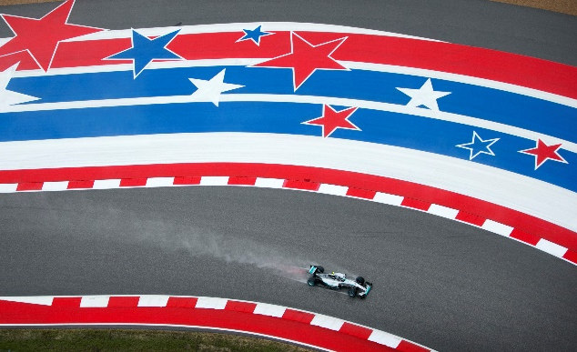
Figure 5. Austin GP

One of the biggest problems Malaysia faces is the lack of audience trackside. F1 gained interest across all media platforms in 2017 with an increase of 7.5% on app users (F1, 2018), so you have to question how you get the spectators away from the screen and into the track. One of the best advertising tools which will attract spectators into F1 is the endorsement of a national driver. An example of this would be Max Verstappen, Max made his debut to F1 in 2015 at just 17 years old and currently holds numerous records including youngest driver to win an F1 race. Race fans around the world are ‘falling in love’ (Pricewaterhouse, Coopers, 2017) with Max Verstappen which reflects the increase in spectators to his home race Spa, in Belgium. In 2017 The Global F1 Fan Survey reported that Verstappen had doubled in popularity since the previous year which again in turn reflects the increase of 13.38% attendance at Spa for 2017 (F1, 2017).
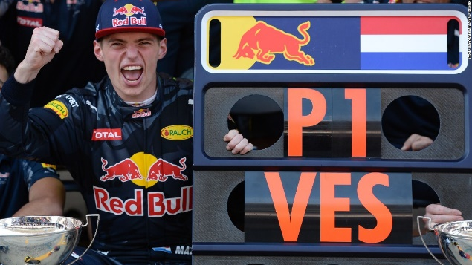
Figure 6. Max Verstappen

The problem for Malaysia is they do not currently have an active Malaysian driver in F1, this limits the advertising reach of F1 in Malaysia due to the lack of celebrity endorsement. Malaysian Prime Minister Datuk Seri Najib Razak announced at a press conference in 2017 that he ‘wanted to see more participation from Malaysia in motorsport and that the fans wanted to see Malaysian drivers participate’ (MalayMail, 2017). There are ways to tackle this, some nations have been known to contribute money towards buying a driver’s spot in F1 in order to gain interest domestically (Autosport, 2017). Initiatives from governments could encourage more people to get into the sport by allocating extra funding and promoting the sport to younger aspiring drivers. If Malaysia could secure a Malaysian national spot in F1 then they could see demand from spectators to re-host the F1 in coming years.
Large sporting events like the F1 play a large role in destination marketing (Singh and Hu, 2008). If the event is big in scale there is more likely to be higher levels of promotion and tourism demand (Henderson, et al, 2010). For the case of Malaysia, the event is promoted by Petronas the leading sponsor for Mercedes F1 team. It could be thought that keeping Sepang on the F1 calendar would be in the best interest of the promoter Petronas as their headquarters is situated one hour away in Kuala Lumpur. However, the decline in oil costs over previous years meant Petronas could no longer invest in the race, but stated they would still support Mercedes AMG team in line with their current marketing strategy (Petronas, 2017).
The lack of demand / spectators visiting the Malaysian GP could be attributed to many different factors, but for the Minister for Tourism and Culture Nazri Abdul, it couldn’t be clearer. He believes the lack of spectators at the Malaysian F1 is because of the race becoming less attractive due to competing nations, the lack of Malaysian talent in the sport and mostly because if people were to travel to Malaysia to view sport they would attend the Moto GP, which is also hosted by Sepang (NewsAsia, 2016). The Moto GP at Sepang has seen an increase of spectator’s year in year out and ‘if that event were to be scrapped it would effect Malaysian tourism badly’ (Nazri, 2016). ‘The 2020 Economic Transformation plan’ for Malaysia states that hosting more international events is necessary to attract tourists and will provide a boost in the tourism industry.
Does More Harm Than Good?
Embracing sustainability in Formula 1 is not an easy task, but in the long term it could generate additional sponsorship revenue from brands who have traditionally shied away from motorsport because of the environmental impact it has (Bratches, 2017). Henderson, et al (2010) stated that Grand Prix racing was a pollutant sport and even though its effects were confined temporarily, due regard should be given to the environmental ramifications (Collins, et al, 2009), so initiatives can be put in place to limit harm.
The argument defending F1 against its environmental impact is the design and development of cleaner more efficient powered engines used in the sport. The UK Government invested £38 million in 2016 across the auto-motive sector to support emission reduction projects including the initiative to deploy F1 technology to make family cars lighter (Valimaki, 2016). Most of the technology used in F1 will eventually be used in production road cars, thus providing the environmental impact of F1 with justification. Some of these energy saving developments include; ‘light weighting’ technology to make cars more energy efficient and ‘thermal energy recovery systems’ which harnesses the energy produced when braking, which can cut fuel consumption by 30% (Valimaki, 2016). It is the job of the F1 Group to ensure that regulations in F1 allow and encourage the development of energy efficient parts to ensure the sustainability of the sport – but the impacts must also be accounted for by the race promoters.
The Bahrain F1 Energy and Environmental Consideration Report of 2006 noted that demands on power (Alnaser, et al, 2006) noise congestion and increased emissions from the event were of main concerns to the public. The environmental issues were raised by some people online, but there were no official public or private debates discussing the topic before or after. Hosting the F1 comes with an extreme responsibility to create environmental initiatives to reduce the carbon footprint of said event and to maintain ethical responsibility. Initiatives such as; the use of solar panels or recycling could be used to reduce the environmental impact of any event. Malaysian Ministers should look into innovative energy technologies if they plan to return to F1 in the future, to not only ensure the sustainability of Sepang as a race track but to set them aside from competing nations whose corporate ethical considerations are lacking.
The environmental impacts of large sporting events are most often more bad than good, to justify these impacts governments will try to outweigh the negative environmental impacts against the potential positive social impacts (Event Impacts, 2018). Social impacts of F1 were identified as, community pride, socio- cultural exchange, urban development and image enhancement (Henderson, et al, 2010). Survey results found that in Malaysia the community tends to actually prefer Grand Prix motorcycle racing over F1 and was deemed to find Sepang race track inaccessible due to transport and urban underdevelopment (Forbes, 2017).
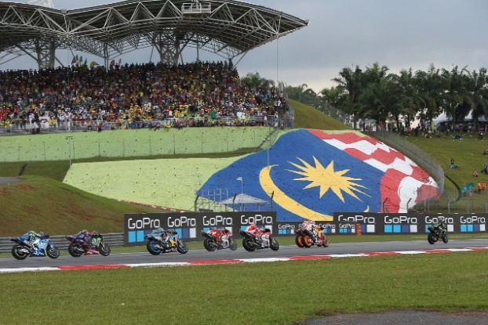
Figure 7. Malaysian Moto GP

This shows a lack of connection between F1 hosts and local community, event organisers promised the development of infrastructure surrounding Sepang circuit including hotels, restaurants and transport but due to economic decline not much in the way of development was actually done (NewsAsia, 2016). The loss of support from the local community and increased economic loss from an event which promised to deliver economically and socially all attribute to why this event has been scrapped by the Malaysian government. The use of sport events in tourism strategies is a relatively recent trend in parts of Asia (Henderson, el, 2010), Malaysian organisers will need to adopt modern, innovative event impact strategies to ensure the event can be sustainable in the future. This is in line with the current Government 2020 plan to establish a dedicated events body for Malaysia to identify, and bid for more major sporting events (MalaysianGovernment, 2009).
The Verdict
It is clear that hosting large scale sporting events has both its attractions and detractions. The Malaysian Government do not by any means want to take a break from F1, but have said they will return in the future if the new owners make the event financially viable and when ‘F1 is exciting again’.
F1 as an event can be economically sustainable to host if the nation hosting has a good economy and an attractive track. This is not the case for Malaysia, their economy is in turmoil which has inevitably led to government funding being dropped. Sepang track has also lost attractiveness since the launch of their competitor’s track Marina Bay Circuit in Singapore, unattractive tracks unavoidably lead to a decrease in ticket sales, making the event not financially viable to the promoters. The economic advantages of hosting the F1 are increased revenue from both direct and indirect spend and an increase in tourism numbers. The economic disadvantage of hosting on the other hand is the risk of staging a large-scale event when the economy isn’t stable, much like Malaysia. Therefore, when considering hosting the F1 nations should contemplate the full cost of staging including that of the $33million hosting fee.
Demand in F1 is another contributing factor when deliberating hosting the F1. As stated new or returning tracks can gain from increased demand from fans who want to engage with that nation again, but in turn can see a decrease in demand if competing tracks have a USP, such as being a night race or having a street circuit. But the biggest contributing factor is talent, fans usually resonate loyalty to a competitor from their home nation, this represents patriotism. This is the case for Lewis Hamilton of Great Britain and Sebastian Vettel of Germany, both are such prominent characters in F1 and have fans in the masses. Both the Malaysian prime minister and tourism minister have expressed demand from the Malaysian people for more Malaysian participation in F1, so in the long-term Malaysia should invest in initiatives to encourage aspiring young drivers into the sport to keep F1 alive. That being said this may be hard due to the competitive threat of Moto GP which is increasingly popular in Malaysia.
Finally, when considering the environmental impact of hosting, sustainability should be embraced to ensure the corporate image of F1 and said nation is protected. No nation should host the F1 if they are not prepared to create initiatives to tackle the environmental impact. Not much in the way of debate has been discussed as far as what the hosts can do to ensure environmental sustainability, but the advantage of Malaysia taking a back step allows them to spend some time focusing on the environmental aspects which the local community had concerns about. Socially large-scale sporting events are known to bring people together with a sense of pride, but Malaysians were dealt a sour hand after promises of urban redevelopment, improved transport networks and increased tourism numbers were broken. Organisers of Sepang F1 will need to reconsider all impacts of the event economically, socially, and environmentally before they apply to re- host.
Overall the advantages and disadvantages of hosting the F1 are relatively balanced. That being said, at this time hosting the F1 in Malaysia where there is an unstable economy and lack of demand for the sport would be unviable. Therefore, the decision by the Malaysian Government and Sepang CEO Razali to take a break from F1 can be deemed practical. Lewis Hamilton reigning world champion in F1 says F1 is losing its toughest race of the season, leaving hope for Malayans that F1 could well return in the future.
Figure 8. Lewis Hamilton Current F1 World Champion


References

Alnaser, W. et al., 2006. Bahrain Formula 1 Racing circuit energy and environmental considerations.
Autosport, 2017. Malaysian GP promoter open to F1 return if racing improves.
BBC, 2016. Liberty Media Who Are They.
BBC, 2017. F1 London Street Circuit plans.
Bracthes, S., 2017. F1 Annual Report 2017.
Bull , C. & Lovell, J., 2007. The impact of hosting major sporting events on local residents.Ed: 12 Journal of sport and tourism.
Burrows, I., 2017. Global F1 Fan Survey. Motorsport Network.
Collins, A., Jones, C. & Munday, M., 2009. Assessing the enviromental impacts of mega sporting events, two options. Tourism Management Volume 30.
Deloitte, 2008. Historic night race shines spotlight on Singapore. London
ESPN, 2010. The History of Formula 1.
ESPN, 2016. F1 Growing in audience.
F1, 2017. Formula 1 Audience Growth.
F1, 2018. Formula 1 Growth in Audience.
Forbes, 2017. Cost of Hosting the F1.
Forbes, 2017. Malaysia Wins by kicking out F1 car races.
Henderson, J., Foo, K., Lim, H. & Yip, S., 2010. Sports Events and Tourism: Singapore Formula 1 GP :International Journal of Event and Festival Management .
Houlihan, B., 2003. Sport and society: A student introduction :Sage London.
Kim, W. & Walker, M., 2012. Measuring social impacts associated with the Super Bowl.
Konstantaki, M. & Wickens, E., 2010. Residents perception of environmental and security issues at the London 2012 Olympic Games. 15 ed: Journal of Sport and Tourism.
MalayMail, 2017. Sepang Circuit will not be a White Elephant, says Najib. Kuala Lumpur: MalayMail.
MalaysianGovernment, 2009. Economic Transformation Plan 2020 - Malaysia.
Nazri, A., 2016. Tourism Minister confirms contract end with F1 at Sepang.
NewAsia, 2017. Minister for Tourism and Culture confirms end of F1 at Sepang.
News, F1., 2016. Does Monaco Pay Hosting Fee's.
Petronas, 2017. Marketing Strategy Initiatives for Petronas. Kuala Lumpur
PricewaterhouseCoopers, 2018. Economic Impact Report F1 Baku 2016/17.
Raconteur, 2015. Power Behind F1s Winning Global Drive.
Singh, N. & Hu, C., 2008. Understanding strategic alignment for destination marketing and the 2004 athens olympic games: Tourism Management Volume 29.
Valimaki, C., 2016. Formula 1 Racing: Innovation with Environmental Impact.
Weed, M. & Bull, C., 2004. Sport Tourism: participants , policy and providers.: Butterworth-Heinnman Oxford .

