Interdisciplinary Arts Reflection

Students will submit a critically reflective project workbook (1,500 word) in which they reflect upon their interdisciplinary practice, performance and contribution to the overall project in context.
This work will reference their experiences and influences, and critically evaluate their
creative process.
Images and drawings can be used in the document as reference to influence and practice.

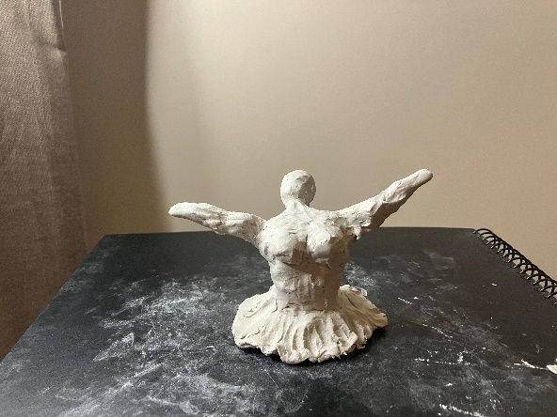 Original sculpture (Partridge, 2022)

Acknowledgements

Blaze Roper – for her understanding and support during my confusion.
Amy Jeffers – for her empathetic and intuitive responses to my emotional reactions throughout the term.
Charlie Seale – for sharing their work and processes with me.
Lowri Wilson – for her passionate defence of me and my values.
Jonathan Pugh – for his kind, compassionate and intelligent approach towards my studies.
Jessica Lerner – for her tuition and the depth of understanding and knowledge which I have gained through our interactions during our time together.
Dan Jones – for being a constant source of intellectual delight and surprise.
Bar Rowlands – for bringing inclusion and a wide knowledge of the arts into my life.

Introduction

“Sensations” is an approximately 20 minute performance piece, utilising ideas of interdisciplinary arts to create a cohesive whole. The work has been heavily influenced by the module tutor Jessica Lerner, who is a performance and fine art practitioner. The piece pulls together various strands, using dance, art and technology to convey the overarching theme of the piece, which is an exploration into my personal experiences of traditionally feminine virtues and values.

In this project workbook, I will outline the background to the piece before breaking the piece down into segments which I will explore in more depth. I will then write my reflective response (see Glossary of Terms) to the piece in the form of various original poems written by myself, before concluding with my thoughts about the piece as a whole. I have included as an Appendix a Glossary of Terms, as there are certain terms which I will use throughout this workbook which have slightly different meanings in the context in which I will use them to the normal definitions.

All artwork and poetry has been created by myself, unless otherwise stated.

Background

The original ideas surrounding the piece were those of the elements. This idea was as a response to working on site in Herberts Quarry and at the iron pour at Coleg Sir Gar, which (to me) represented elements of earth and metal. Charlie Seale then shared his work with me as he had designed his own pack of tarot cards. I was specifically interested in the Queens of the four suits and his representation of these:
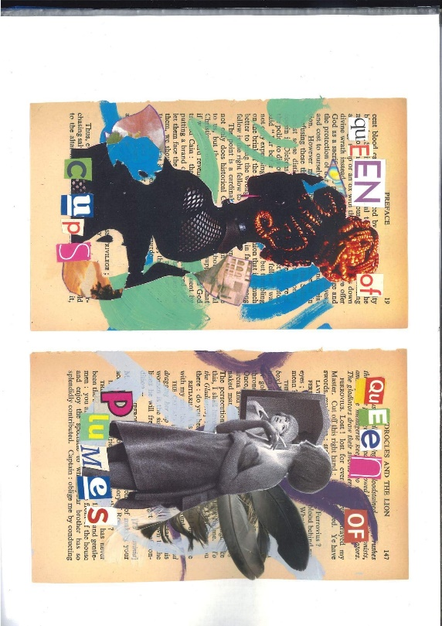

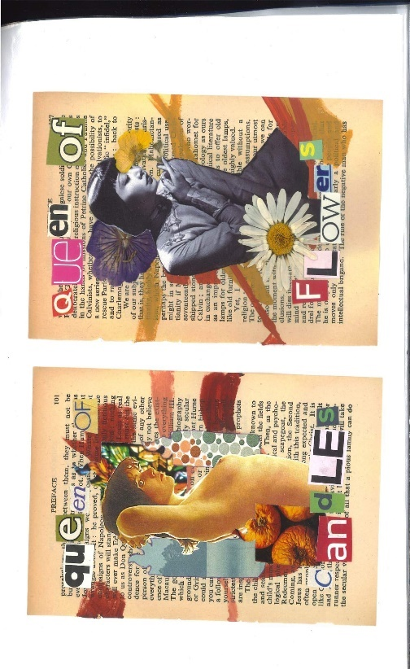

(Reproduced with permission of Charlie Seale (2023), BA (Hons) Fine Art, 3rd year).

I had three other performers interested in collaborating on the piece but, due to prior commitments the week of the performance, all three had to pull out. Therefore, I left the idea of the Queens, but kept the number four as a basis for the piece. I created four videos and original soundtracks for the four sections, and used four pre-existing paintings of mine which represented (to me) different aspects of femininity. I placed these intuitively at various places in the space. These places did not correspond to the logical pairing of the section and the painting. Upon reflection, I used numerology to explore why I had intuitively made these choices.

Over the weekend, as I contemplated the performance space, I decided to use the mirrors as both an extension of, and boarder to, the performance. Using the mirrors in this way also partially broke The Fourth Wall (see Glossary of Terms) by bringing the spectators into the performance space through seeing their reflections. This is an example of one of the pillars of Immersive Theatre (see Glossary of Terms) and led to the spectators becoming co-collaborative spectators (see Glossary of Terms), rather than simply “the audience”.

I had created a playlist of songs which I listened to repeatedly, and whose music or lyrics helped inform my movements during the performance:

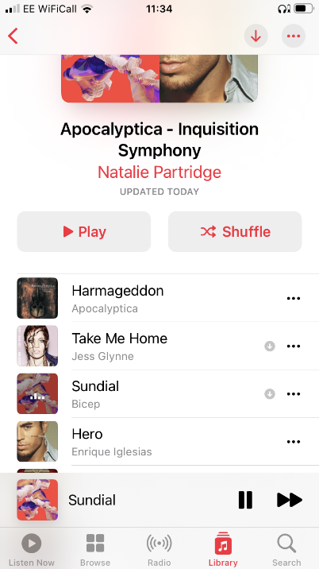 Playlist (Partridge, 2023)

I also brought an aroma diffuser into the space, which emitted a mixture of aromatherapy smells to further engage the senses. Finally, I had a keyboard in order to play the start of Beethoven’s Für Elise, which related to experiences in my childhood of my father teaching me to play.

Please see the MindMap linked below for a visual representation of the background to the piece:

https://mm.tt/map/2690043265?t=ESFH1202CJ

Composition

Prologue:

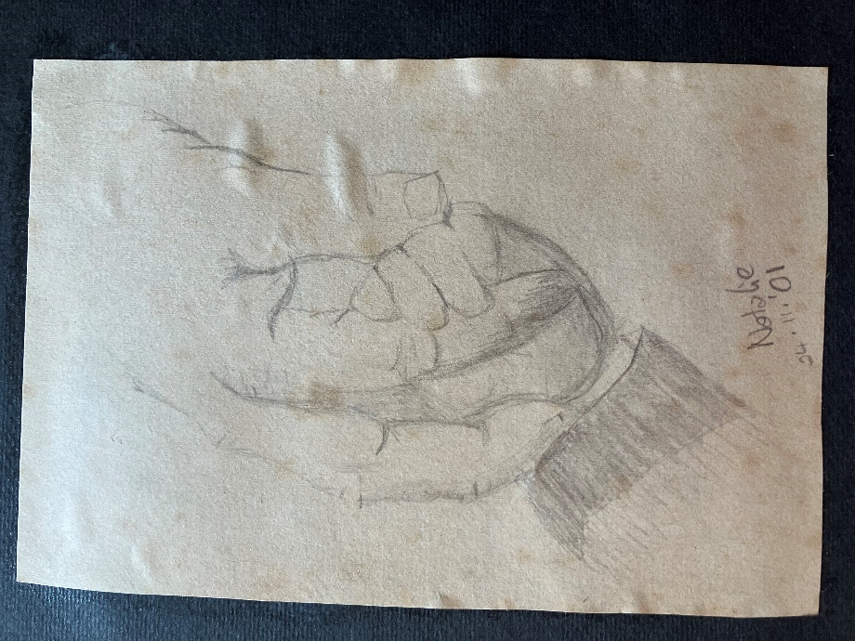 Original drawing for my Dad (Partridge, 2001)

Beethoven’s Für Elise:

“The Romantic period of music was all about contrasting emotions and the human condition, and the rondo structure of this piece showcases a nostalgic and sweet main theme, a sparkly section, and then a stormier section before returning to calm.” (Hoffman Academy Team, date unknown).
Four sections:

Number | Video | Number | Painting | Master | Numerology Meaning
Acts of love through service to the family and home
1 | Housekeeping | 3 | Body Image | 1 + 3 = 4 | “The 4 in Numerology is a no-nonsense number with a heads-down approach to life and work.” (Numerology.com Staff, date unknown)

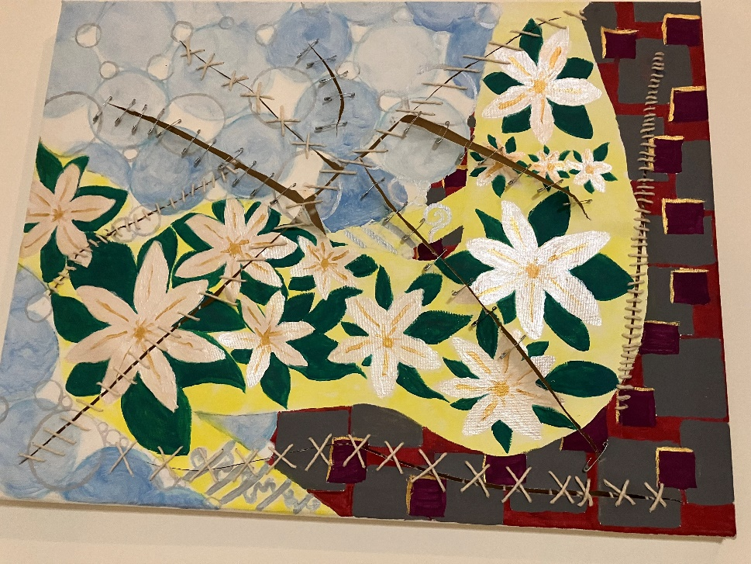 Broken? (Partridge, 2019) – this is the correct picture for section one of the performance, however it was uncovered second (please see MindMap for more information).

Number | Video | Number | Painting | Master | Numerology Meaning
A deep appreciation and affinity for nature
2 | Nature | 1 | Broken? | 2 + 1 = 3 | “Its energy is youthful and positive and it has an incredible zest for life.”  (Numerology.com Staff, date unknown)

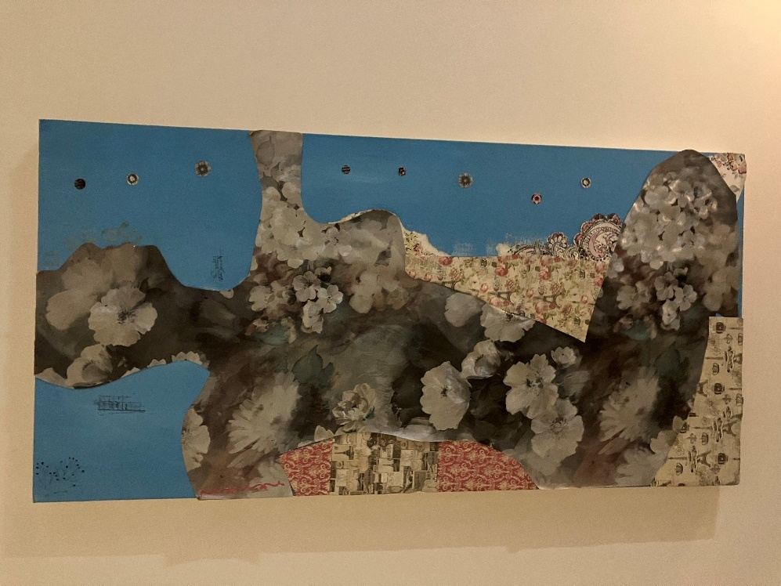 Yoga (2013) - this is the correct picture for section two of the piece, however it was uncovered fourth (please see MindMap for more information).

Number | Video | Number | Painting | Master | Numerology Meaning
A strong need for communication and understanding
3 | A.I. | 4 | Bleeding Heart | 3 + 4 = 7 | “It is an analytical number that enjoys gathering and filtering through information to find answers.” (Numerology.com Staff, date unknown)

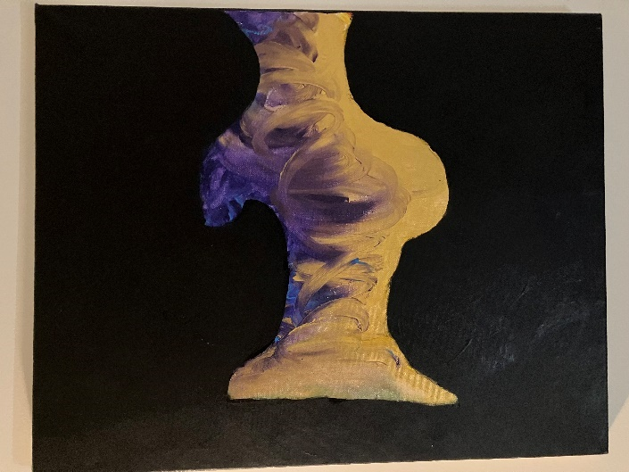 Body Image (2020) – this is the correct picture for section three of the piece, however it was uncovered first (please see MindMap for more information).

Number | Video | Number | Painting | Master | Numerology Meaning
A passionate defence of the people she loves
4 | Sword Dance | 2 | Yoga | 4 + 2 = 6 | “It is a powerful force of compassion and empathy and its warm light is a beacon of hope.” (Numerology.com Staff, date unknown)

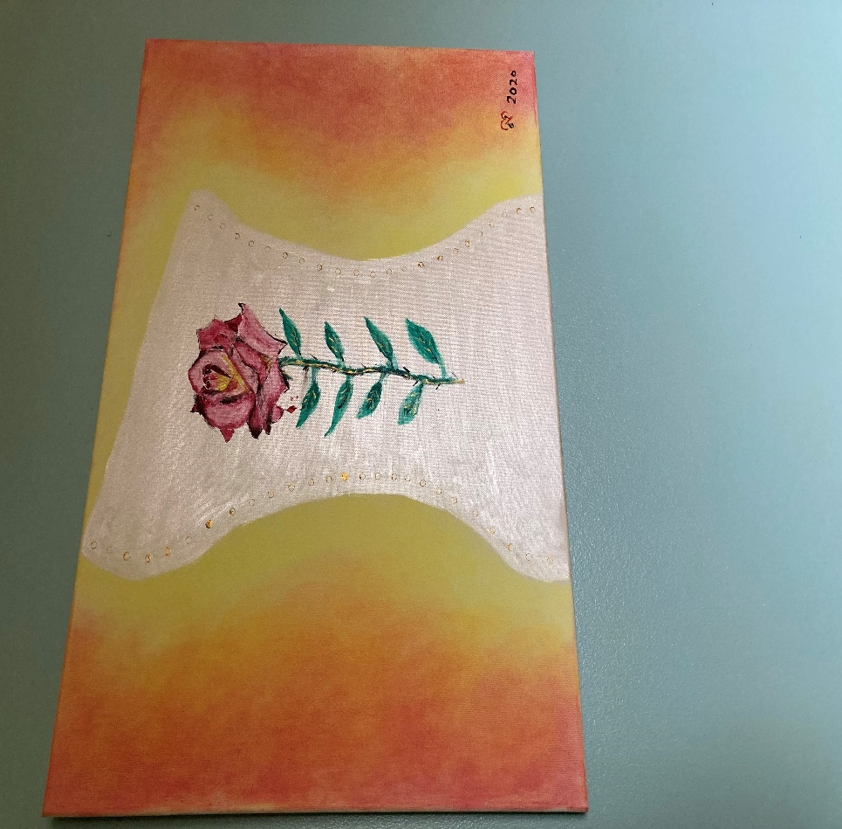 Bleeding Heart (2021) – this is the correct picture for section four of the piece, however it was uncovered third (please see MindMap for more information).

The total was derived by adding the master numbers of the four sections, which were calculated by adding the section number to the actual
number which the painting uncovered represented (i.e. section 1 had section 3’s painting uncovered, therefore 1 + 3 = 4).

TOTAL |  |  |  | 4 + 3 + 7 + 6 = 20  Root:  2 + 0 = 2 | “The Numerology number 2 is known to numerologists as a supremely feminine force, one that represents both grace and power. It is cooperative, always aiming to bring peace and balance back to a relationship or situation. This Numerology number is also very sensitive -- of all the numbers, it has the strongest intuition. It is able to sense currents and feelings instinctively, then use these clues to connect with others empathically.” (Numerology.com Staff, date unknown)

Reflective Response

Prologue:

The Father Figure weeps in his remembrances’
Of simple times past. Welcomed home with joy
Revelling in intriguing utterances -
Before the wild. Uncontrolled nature overtook
Which settles, finally, into peaceful sublimities.
(2023)

Four sections:

Independent Integrity Invites Introversion
Nurturing Natural Neutral Navigation
Fosters Feeling Freely
Posers Posture Proactively.
(2023)

Dear Lord,

Keep me busy
Through this day
With acts of love
In integrity.

Cleanliness and
Culinary creations
Hopefully greeted with
Grateful salutations.

Please help others to see
My labour as a gift
And not as just a given.

Amen
(2023)

Independent Integrity Invites Introversion
Nurturing Natural Neutral Navigation
Fosters Feeling Freely
Posers Posture Proactively.
(2023)

The rhythm of the sky moves many.
It’s turbulent devotion to change –
As crystal clear in its’ role
As Mother Natures’ reactive eye.
(2023)

Independent Integrity Invites Introversion
Nurturing Natural Neutral Navigation
Fosters Feeling Freely
Posers Posture Proactively.
(2023)

Softly, slowly, gently
Guided through.
Taken by the hand
The beauties of this land.
Revealed quietly, calmly,
Consistently disarmingly.
Birds twittering harmlessly –
Endless communication!
As the river laps
At the side of the pool;
The waterfall really trickles down –
When taken drip by drip.
Into a deep, beautiful swirl,
Afterwards subsiding
Into something much more quietly –
Moving along steadily.
Softly, slowly, gently.
(2011)

Independent Integrity Invites Introversion
Nurturing Natural Neutral Navigation
Fosters Feeling Freely
Posers Posture Proactively.
(2023)

So, for the sake of conformity,
Uniformly.
Unquestioningly.
And again (yet!)
To be thrown around –
To the open ground;
Where there is no sound,
Except the pound.
Of breaking hearts.

Gloriously!
Lifted and free –
Fighting and fighting.
Never right, yet never wrong.
Darkness and light dividing her –
Dizziness overtaking – higher temperature!
Defeated. Broken – Defender!
A little strength please; just to lend her.
She’s trying to return!

The Answer?
(2011)

Conclusion

The movements in the performance were based on intuitive improvisation (see Glossary of Terms) and were not set. The monotone energy of the movements throughout the sections relate to the Post-Structural (see Glossary of Terms) ideology inherent in the piece, with the liminal (see Glossary of Terms) video watching phases furthering the immersive experience as the performer becomes a co-collaborative spectator. The unveiling of the paintings was a revealing of my internal world, whilst the mirrors point to moments far further away than my own reflection.

The performance is, I believe, compositionally multi-layered (see Glossary of Terms) which was a choice I made to convey my subjective experiences of being a cis-gendered, heterosexual woman existing in my social world over time (see Glossary of Terms).

(word count: 1572)

References

Hoffman Academy Team (date unknown), All about Fur Elise, https://www.hoffmanacademy.com/blog/all-about-fur-elise/ (accessed 17/04/2023)

Numerology.com Staff (date unknown), Number 4 Meaning in Numerology https://www.numerology.com/articles/about-numerology/single-digit-number-4-meaning/, (accessed 12/04/2023)

Numerology.com Staff (date unknown), Number 3 Meaning in Numerology https://www.numerology.com/articles/about-numerology/single-digit-number-3-meaning/, (accessed 12/04/2023)

Numerology.com Staff (date unknown), Number 7 Meaning in Numerology https://www.numerology.com/articles/about-numerology/single-digit-number-7-meaning/, (accessed 12/04/2023)

Numerology.com Staff (date unknown), Number 6 Meaning in Numerology https://www.numerology.com/articles/about-numerology/single-digit-number-6-meaning/, (accessed 12/04/2023)

Numerology.com Staff (date unknown), Number 2 Meaning in Numerology https://www.numerology.com/articles/about-numerology/single-digit-number-2-meaning/, (accessed 12/04/2023)

Bibliography

Books:

Gribbin, J. (1991), In Search of Schrodinger’s Cat, London, Black Swan Books

Schechner, R. (2020), Performance Studies An Introduction, 4th Ed., Abingdon, Routledge

Websites:

Waltmann, S. (2023), What is Immersive Theatre?, https://www.backstage.com/magazine/article/immersive-theatre-explained-75850/ (accessed 16/04/2023

Playlist:

Apocalyptica (1998), Harmageddon, https://www.google.com/search?client=firefox-b-d&q=harmageddon+apocalyptica Polygram Finland Oy (accessed 31/03/2023)

Bicep (2021), Sundial, https://www.google.com/search?client=firefox-b-d&q=sundial+bicep Ninja Tune (accessed 31/03/2023)

Glynne (2015), Take Me Home, https://www.google.com/search?client=firefox-b-d&q=jess+glynne+take+me+home&si=AMnBZoFs9uB3Z_GHFPC_zPRokU4hDDys_iOzJ85ZD9elR2f5DP30adEZdYmEeLerwNHZhCjn_MwoQr3nS6TM1NHf3G-s6h709wWQlnVdv0hv2OORqqiLmb3YbRbcLVechdo9xSdFqpKW&ictx=1&ved=2ahUKEwjJu8PAm7D-AhWQT8AKHRjECU8QyNoBKAB6BAgMEAA Atlantic Records (accessed 31/03/2023)

Iglesias (2001), Hero, https://www.google.com/search?client=firefox-b-d&q=hero+enrique+iglesias Interscope Records (accessed 31/03/2023)

Appendix

Glossary of Terms

I have created this Glossary of Terms which may be helpful, as it shows how I use certain terms in my writing (although not all terms are used, they have all informed my writing of this project workbook):-

Co-collaboration: The interaction between the performers, each other and the technology used within the piece. Whether this is through relationship in real life, or the impersonal relationship of a recording or technology, all participants interact in a way which creates a co-collaborative performance.

Co-collaborative spectators: In this context, I am using this to mean the interplay between the performer and the audience – both of whom create the meaning of the piece in a subjective and relativistic manner (see: Relativism).

Codified Score: The overarching ideas and values inherent in the piece. If ideas are like rain drops, the Codified Score is akin to an umbrella which shields the piece from too many ideas, so that the performance can highlight a specific theme chosen by the creator.

Contemporary: Of being contemporary to the “present” - as we conceive of this concept (see: Time).

Compositionally Multi-layered: Relating to the themes and ideas used to create the performance, including the performance itself.

Flow: How movements relate to each other and the whole, through a subconscious “knowing” rather than through chosen movements (see: Intuitive Improvisation).

Fragmentation: The breakdown of linear time and the action necessary to convey the meaning of the piece, specifically under the covering of the Codified Score (see above).

Immersive Theatre: Performances which break down the barriers between the “audience” and the performance.

Intuitive Improvisation: An internal intuitive response to a stimulus seemingly outside of oneself.

Liminal: A rest/recovery/breath used as a connective performance device between sections. Portraying a sense of “listening” before moving to the next series of movement.

Monosyllabic Movement: Movement with a consistent energy level throughout, showing an egalitarian approach to performance.

Numerology: An appreciation for the basis of life, as is seen in pure mathematics.

Pastiche: An authentic, relativistic response to something outside of oneself (similar to Intuitive Improvisation, but not the same).

Post-structural: Where nothing is superior or inferior to anything else. Egalitarian in relation to movement/performance.

Reflective Response: An individual and considered response to an “external”, or “internal” event.

Relativism: Literally anything, subject to individual interpretation.

Ritual: A repetition of a movement, to create a certain emotion within and without.

Time: A social construct which is an organising principal. As opposed to the usual idea of time being linear, in this context I presuppose that all events in time are occurring simultaneously.

The Fourth Wall: A theatre term for the invisible division between the audience and the performers.

