Exercises
Ex: 1: Prove that ABCD + ABD =ABD
Soln:
LHS
= ABCD +ABD
= ABD (C+1) [Distributive law
= ABD.1 [Rule: 2: C+1=1]
=ABD [Rule: 6: D.1=D]
= RHS
Hence proved

Ex 2: Prove that A(A+B) =A
Soln
LHS
= A(A+B)
=AA+AB [Distributive law
=A+AB [Rule7: A.A=A
=A (1+B) [Distributive law
=A.1 [Rule: 2: B+1=1]
=A [Rule: 6: A.1=A]
=RHS
Hence proved

Ex 3: Prove that AB+ABC+AB(D+E) =AB
Soln:
LHS
= AB+ABC+AB (D+E)
=AB (1+C+D+E) [Distributive law
=AB.1 [Rule: 2: B+1=1]
=AB [Rule: 6: B.1=B]
=RHS
Hence proved

Ex: 4: Prove that $XY+XYZ+XY\overline{Z}+\overline{X}YZ=Y(X+Z)$
Soln:
LHS
= $XY+XYZ+XY\overline{Z}+\overline{X}YZ$
= $XY(1+Z)+XY\overline{Z}+\overline{X}YZ$ [Distributive law
= $XY.1+XY\overline{Z}+\overline{X}YZ$ [Rule: 2: Z+1=1]
=$XY+XY\overline{Z}+\overline{X}YZ$ [Rule: 6: Y.1=Y]
= $XY(1+\overline{Z})+\overline{X}YZ$ [Distributive law
= $XY.1+\overline{X}YZ$ [Rule: 2: Z+1=1]
= $XY+\overline{X}YZ$ [Rule: 6: Y.1=Y]
= $Y(X+\overline{X}Z)$ [Distributive law
= $Y(X+Z)$ [Rule 11: $X+\overline{X}Z=X+Z$
= RHS
Hence Proved
Ex: 5: Prove that $\overline{\overline{AB}+\overline{A}+AB}=0$
Soln:
LHS
= $\overline{\overline{AB}+\overline{A}+AB}$
= $\overline{\overline{A}+\overline{B}+\overline{A}+AB}$ [Demorgan’s theorem 1]
= $\overline{\overline{A}+\overline{A}+\overline{B}+AB}$ [Commutative law]
= $\overline{\overline{A}+\overline{B}+AB}$ [Rule 3: $\overline{A}$+$\overline{A}$=$\overline{A}$]
= $\overline{\overline{A}+AB+\overline{B}}$ [Commutative law]
= $\overline{\overline{A}+B+\overline{B}}$ [Rule 11: $\overline{A}+AB=\overline{A}+B$
= $\overline{\overline{A}+1}$ [$Rule 4: B+\overline{B}=1$]
= $\overline{1}$ [Rule: 2: $\overline{A}$+1=1]
= $0$ [$\overline{1}=0$]
= RHS
Hence Proved
Ex: 6: Prove that $AB+\overline{AC}+A\overline{B}C\left(AB+C\right)=1$
Soln:
LHS
= $AB+\overline{AC}+A\overline{B}C\left(AB+C\right)$
= $AB+\overline{AC}+AAB\overline{B}C+ A\overline{B}CC$ [Distributive law
= $AB+\overline{AC}+0+ A\overline{B}C$ [Rule 8:$B.\overline{B}=0$ ]
[Rule7: C.C=C ]
= $AB+\overline{A}+\overline{C}+ A\overline{B}C$ [Demorgan’s theorem 1]
= $\overline{A}+B+\overline{C}+ A\overline{B}C$ [Rule 11: $\overline{A}+AB=\overline{A}+B$
= $\overline{A}+A\overline{B}C+B+\overline{C}$ [Commutative law]
= $\overline{A}+\overline{B}C+B+\overline{C}$ [Rule 11: $\overline{A}+AB=\overline{A}+B$; Here B= $\overline{B}C$
= $\overline{A}+B+\overline{B}C+\overline{C}$ [Commutative law]
= $\overline{A}+B+\overline{B}+\overline{C}$ [Rule 11: $\overline{C}+\overline{B}C=\overline{B}+\overline{C}$
= $\overline{A}+1+\overline{C}$ [Rule: 2: $\overline{C}$+1=1]
= $\overline{A}+1$ [Rule: 2: $\overline{A}$+1=1]
= $1$
= RHS
Hence Proved
Ex: 7: Prove that $Z=AB+A\overline{B}\left(\overline{\overline{A}\overline{C}}\right)$
Soln:
Z= $AB+A\overline{B}\left(\overline{\overline{A}\overline{C}}\right)$
Z= $AB+A\overline{B}\left(\overset{̿}{A}+\overset{̿}{C}\right)$ [Demorgan’s theorem 1]
Z= $AB+A\overline{B}\left(A+C\right)$ [Rule 9: $\overset{̿}{A}=A$ ]
Z= $AB+AA\overline{B}+A\overline{B}C$ [Distributive law
Z= $AB+A\overline{B}+A\overline{B}C$ [Rule7: A.A=A ]
Z= $AB+A\overline{B}\left(1+C\right)$ [Distributive law
Z= $AB+A\overline{B}.1$ [Rule: 2: C+1=1]
Z= $A(B+\overline{B})$ [Rule: 6:$\overline{B}$.1=$\overline{B}$]
Z= $A.1$ [$Rule 4: B+\overline{B}=1$
Z= $A$ [Rule: 6:$A$.1=A]
Ex 8 Draw the logic diagram for the following expression $Z=AC+C(A+\overline{A}B)$
Soln
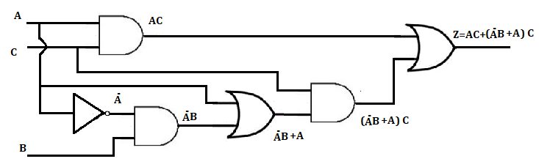

Ex 9: Draw the logic diagram for the following expression $Y=\left(\overline{AB}\right)C+\overline{A}B\overline{C}+\overline{A+C}$
Soln
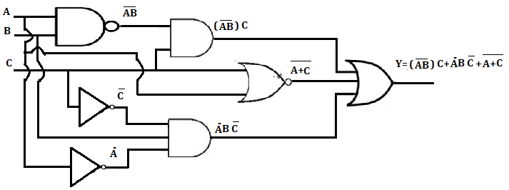
Ex 10: Determine the logical expression for the logic diagram shown below
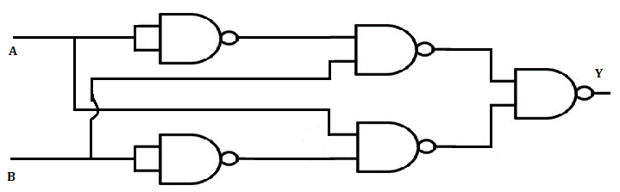
Soln:
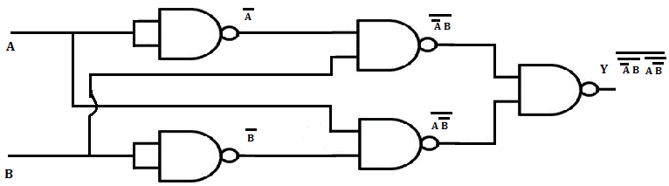

Ex: 11: Simplify the logical circuit shown in figure and implement logic circuit using logic gates.
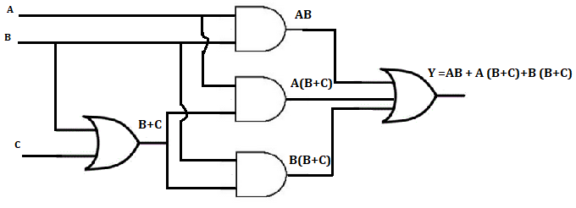

Soln:
Y= AB + A (B+C) + B (B+C)
Y= AB + AB+AC + BB+BC [Distributive law
Y= AB +AC + B+BC [Rule 3: A+A=A]
[Rule 7: B.B=B]
Y= AB +AC + B (1+C) [Distributive law
Y= AB +AC + B.1 [Rule: 2: C+1=1]
Y= AB +AC + B [Rule: 6:$B$.1=B]
Y= AB + B+AC [Commutative law]
Y= B(A + 1)+AC [Distributive law
Y= B+AC [Rule: 2: A+1=1]
Simplified logic diagram
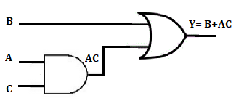
Ex 12: Write a Boolean Expression for the logic diagram shown below and determine the truth table
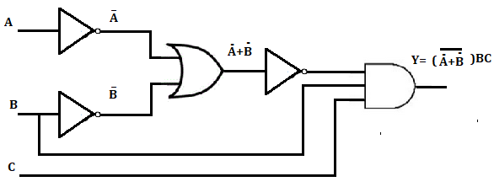
Soln:
Y= $(\overline{\overline{A}+\overline{B}})BC$
Y= $(\overline{\overline{AB}})BC$ [Demorgan’s Theorem 2]
Y= $ABBC$ [Rule 9: $\overset{̿}{A}=A$ ]
Y= $ABC$ [Rule 7: B.B=B]
Truth table
Inputs |  |  | Outputs
A | B | C | Y=ABC
0 | 0 | 0 | 0
0 | 0 | 1 | 0
0 | 1 | 0 | 0
0 | 1 | 1 | 0
1 | 0 | 0 | 0
1 | 0 | 1 | 0
1 | 1 | 0 | 0
1 | 1 | 1 | 1

