

Coercive and Controlling Behaviour: are we policing the impossible?

Cara Price
Student ID: 2031341
BSc (Hons) Professional Policing Practice

Acknowledgements
I would like to thank my dissertation supervisor Laura Shobiye for all her help and guidance throughout this project. I would also like to thank the university staff who have answered countless emails and provided support through the drop-in sessions. Lastly, I would like to thank my friends and colleagues for their ongoing support throughout these first few years of my policing journey, and for their participation in this research project.

Declaration
This work has not previously been accepted in substance for any degree and is not being concurrently submitted in candidature for any degree.
Signed: Cara Price
Date: 7th April 2024

STATEMENT 1
This dissertation is being submitted in partial fulfilment of the requirements for the degree of BA.
Signed: Cara Price
Date: 7th April 2024

STATEMENT 2
This dissertation is the result of my own independent work/investigation, except where otherwise stated.
Other sources are acknowledged by footnotes giving explicit references. A bibliography is appended.
Signed: Cara Price
Date: 7th April 2024

STATEMENT 3
I hereby give consent for my dissertation, if accepted, to be available for photocopying and for interlibrary loan, and for the title and summary to be made available to outside organisations.
Signed: Cara Price
Date: 7th April 2024

STATEMENT 4
I hereby give consent for my dissertation, if accepted, to be available on the university’s IT system to those who have consent to use the system.
Signed: Cara Price
Date: 7th April 2024

Abstract
The fight against domestic abuse continues to be a priority for UK police forces and the government alike. In recent years, new laws have been introduced to criminalise specific behaviours in a bid to further protect victims from their abusers. This dissertation focusses on the offence of coercive and controlling behaviour, which aims to address non-physical abuse that has a psychological impact on the victim.
The policing of such a crime that often plays out behind closed doors and is rarely noticed by those outside of the relationship has proved challenging. The aim of this research is to explore these challenges and identify the difficulties facing the police as they try to investigate this seemingly invisible crime. Secondary research shows that evidential difficulties, poor police attitudes and a failure to recognise the offence all contribute to poor investigations and low charging rates.
The primary research in this study asks police officers of Gwent Police to explain how they would conduct a coercive and controlling investigation and asks for their views on whether a change in the legislation is needed to make it easier for them to prove. Participants were introduced to similar legislation currently being used in Scotland and asked to compare the legislation for ease of understanding and ability to evidence. The results show that the majority of participating officers think that the legislation should be changed, preferring the Scottish legislation and its simpler definition.

Table of Contents
Acknowledgements. . . . . . . . . . . . . . . . . . . . . . . . . . . . . . . . . . . . . . . . . . . . . . . . . . . . . . . . . . . . . . . . . . . 2
Declaration. . . . . . . . . . . . . . . . . . . . . . . . . . . . . . . . . . . . . . . . . . . . . . . . . . . . . . . . . . . . . . . . . . . . . . . . . . 3
Abstract. . . . . . . . . . . . . . . . . . . . . . . . . . . . . . . . . . . . . . . . . . . . . . . . . . . . . . . . . . . . . . . . . . . . . . . . . . . . . 4
Table of contents. . . . . . . . . . . . . . . . . . . . . . . . . . . . . . . . . . . . . . . . . . . . . . . . . . . . . . . . . . . . . . . . . . . . . 5

Chapter one – Introduction. . . . . . . . . . . . . . . . . . . . . . . . . . . . . . . . . . . . . . . . . . . . . . . . . . . . . . . . . . . . 7
  - Background and research questions. . . . . . . . . . . . . . . . . . . . . . . . . . . . . . . . . . . . . . . . . . . . . . . . . . 7
  - Research Objectives. . . . . . . . . . . . . . . . . . . . . . . . . . . . . . . . . . . . . . . . . . . . . . . . . . . . . . . . . . . . . . . 8
  - Research Structure. . . . . . . . . . . . . . . . . . . . . . . . . . . . . . . . . . . . . . . . . . . . . . . . . . . . . . . . . . . . . . . . 8
  - Conclusion. . . . . . . . . . . . . . . . . . . . . . . . . . . . . . . . . . . . . . . . . . . . . . . . . . . . . . . . . . . . . . . . . . . . . . . 9

Chapter two – Literature Review. . . . . . . . . . . . . . . . . . . . . . . . . . . . . . . . . . . . . . . . . . . . . . . . . . . . . . . . 9
2.1 Introduction. . . . . . . . . . . . . . . . . . . . . . . . . . . . . . . . . . . . . . . . . . . . . . . . . . . . . . . . . . . . . . . . . . . . . . 9
2.2 Background. . . . . . . . . . . . . . . . . . . . . . . . . . . . . . . . . . . . . . . . . . . . . . . . . . . . . . . . . . . . . . . . . . . . . . 9
2.3 Evidential difficulties. . . . . . . . . . . . . . . . . . . . . . . . . . . . . . . . . . . . . . . . . . . . . . . . . . . . . . . . . . . . . . 10
2.4 Poor police attitude. . . . . . . . . . . . . . . . . . . . . . . . . . . . . . . . . . . . . . . . . . . . . . . . . . . . . . . . . . . . . . . .12
2.5 Difficulties of recognising CCB. . . . . . . . . . . . . . . . . . . . . . . . . . . . . . . . . . . . . . . . . . . . . . . . . . . . . . . 12
2.6 Resourcing. . . . . . . . . . . . . . . . . . . . . . . . . . . . . . . . . . . . . . . . . . . . . . . . . . . . . . . . . . . . . . . . . . . . . . . 13
2.7 Scottish Legislation. . . . . . . . . . . . . . . . . . . . . . . . . . . . . . . . . . . . . . . . . . . . . . . . . . . . . . . . . . . . . . . . 14
2.8 Conclusion. . . . . . . . . . . . . . . . . . . . . . . . . . . . . . . . . . . . . . . . . . . . . . . . . . . . . . . . . . . . . . . . . . . . . . . 14

Chapter three – Methodology. . . . . . . . . . . . . . . . . . . . . . . . . . . . . . . . . . . . . . . . . . . . . . . . . . . . . . . . . . 15
3.1 Introduction. . . . . . . . . . . . . . . . . . . . . . . . . . . . . . . . . . . . . . . . . . . . . . . . . . . . . . . . . . . . . . . . . . . . . 15
3.2 Research Onion. . . . . . . . . . . . . . . . . . . . . . . . . . . . . . . . . . . . . . . . . . . . . . . . . . . . . . . . . . . . . . . . . . . 16
3.3 Philosophy. . . . . . . . . . . . . . . . . . . . . . . . . . . . . . . . . . . . . . . . . . . . . . . . . . . . . . . . . . . . . . . . . . . . . . . 17
3.4 Approach. . . . . . . . . . . . . . . . . . . . . . . . . . . . . . . . . . . . . . . . . . . . . . . . . . . . . . . . . . . . . . . . . . . . . . . . 17
3.5 Strategy and Choices. . . . . . . . . . . . . . . . . . . . . . . . . . . . . . . . . . . . . . . . . . . . . . . . . . . . . . . . . . . . . . 17
3.6 Time Horizon. . . . . . . . . . . . . . . . . . . . . . . . . . . . . . . . . . . . . . . . . . . . . . . . . . . . . . . . . . . . . . . . . . . . . 18
3.7 Techniques: Data Collection and Analysis. . . . . . . . . . . . . . . . . . . . . . . . . . . . . . . . . . . . . . . . . . . . . 18
3.8 Limitations. . . . . . . . . . . . . . . . . . . . . . . . . . . . . . . . . . . . . . . . . . . . . . . . . . . . . . . . . . . . . . . . . . . . . . . 18
3.9 Ethical Considerations. . . . . . . . . . . . . . . . . . . . . . . . . . . . . . . . . . . . . . . . . . . . . . . . . . . . . . . . . . . . . 19
3.10 Conclusion. . . . . . . . . . . . . . . . . . . . . . . . . . . . . . . . . . . . . . . . . . . . . . . . . . . . . . . . . . . . . . . . . . . . . . 19

Chapter four – Data Analysis and Results. . . . . . . . . . . . . . . . . . . . . . . . . . . . . . . . . . . . . . . . . . . . . . . . . 19
4.1 Introduction. . . . . . . . . . . . . . . . . . . . . . . . . . . . . . . . . . . . . . . . . . . . . . . . . . . . . . . . . . . . . . . . . . . . . 19
4.2 Quantitative Data Results. . . . . . . . . . . . . . . . . . . . . . . . . . . . . . . . . . . . . . . . . . . . . . . . . . . . . . . . . . 20
4.3 Qualitative Data Results. . . . . . . . . . . . . . . . . . . . . . . . . . . . . . . . . . . . . . . . . . . . . . . . . . . . . . . . . . . . 22
4.4 Conclusion. . . . . . . . . . . . . . . . . . . . . . . . . . . . . . . . . . . . . . . . . . . . . . . . . . . . . . . . . . . . . . . . . . . . . . . 23

Chapter five – Main Findings and conclusion. . . . . . . . . . . . . . . . . . . . . . . . . . . . . . . . . . . . . . . . . . . . . . 24
5.1 Introduction. . . . . . . . . . . . . . . . . . . . . . . . . . . . . . . . . . . . . . . . . . . . . . . . . . . . . . . . . . . . . . . . . . . . . 24
5.2 Achievement of the objectives. . . . . . . . . . . . . . . . . . . . . . . . . . . . . . . . . . . . . . . . . . . . . . . . . . . . . . 24
5.3 Main findings. . . . . . . . . . . . . . . . . . . . . . . . . . . . . . . . . . . . . . . . . . . . . . . . . . . . . . . . . . . . . . . . . . . . 25
5.4 Limitations. . . . . . . . . . . . . . . . . . . . . . . . . . . . . . . . . . . . . . . . . . . . . . . . . . . . . . . . . . . . . . . . . . . . . . . 26
5.5 Recommendations. . . . . . . . . . . . . . . . . . . . . . . . . . . . . . . . . . . . . . . . . . . . . . . . . . . . . . . . . . . . . . . . 26
5.5.1 Recommendation one. . . . . . . . . . . . . . . . . . . . . . . . . . . . . . . . . . . . . . . . . . . . . . . . . . . . . . . . . . . . 26
5.5.2 Recommendation two. . . . . . . . . . . . . . . . . . . . . . . . . . . . . . . . . . . . . . . . . . . . . . . . . . . . . . . . . . . . 26
5.5.3 Recommendation three. . . . . . . . . . . . . . . . . . . . . . . . . . . . . . . . . . . . . . . . . . . . . . . . . . . . . . . . . . 27
5.5.4 Recommendation four. . . . . . . . . . . . . . . . . . . . . . . . . . . . . . . . . . . . . . . . . . . . . . . . . . . . . . . . . . . 27
5.6 Conclusion. . . . . . . . . . . . . . . . . . . . . . . . . . . . . . . . . . . . . . . . . . . . . . . . . . . . . . . . . . . . . . . . . . . . . . .27

Bibliography. . . . . . . . . . . . . . . . . . . . . . . . . . . . . . . . . . . . . . . . . . . . . . . . . . . . . . . . . . . . . . . . . . . . . . . . 30
Appendices. . . . . . . . . . . . . . . . . . . . . . . . . . . . . . . . . . . . . . . . . . . . . . . . . . . . . . . . . . . . . . . . . . . . . . . . . 35

Chapter 1: Introduction
  - Background and research questions
The offence of coercive and controlling behaviour (CCB) was introduced in England and Wales in 2015 through the Serious Crime Act 2015 (Home Office, 2021). The nations were among the first to criminalise the behaviour (Nugent, 2019), recognising that domestic abuse reaches beyond physical violence and includes acts of jealously and controlling behaviour that has a lasting psychological impact on the victim (Ash, 2014).

The offence is defined as:
A person (A) commits an offence if—
(a) A repeatedly or continuously engages in behaviour towards another person (B) that is controlling or coercive,
(b) at the time of the behaviour, A and B are personally connected,
(c) the behaviour has a serious effect on B, and
(d) A knows or ought to know that the behaviour will have a serious effect on B.

(Serious Crime Act 2015)

Despite its promise, the legislation has had its issues. CCB investigations are often complicated and time-consuming, with few resulting in a conviction (Gentleman, 2024). This dissertation aims to investigate these issues and answer two main research questions:
- Is a change in CCB legislation necessary to make it easier for police to investigate?
- What is the current process of investigating CCB?

  - Research Objectives

- Identify the challenges facing police officers when investigating CCB.
- Explore Police Officer attitudes towards CCB.
- Identify how CCB is investigated and what can be used as evidence.
- Examine police officer views on the Scottish legislation and whether they believe that CCB legislation in England and Wales should be simplified.

  - Research Structure
This dissertation contains five chapters.
Chapter one has introduced the offence of coercive and controlling behaviour and briefly outlined the main issues. It has presented the research questions and set out the four objectives which will be achieved in the coming chapters. The project will consist of both primary and secondary research through a survey and a literature review.
Chapter two provides a review of the existing literature and achieves objectives one and two. The literature review will present figures which show how low the charging rates are and explore deeper the difficulties that police officers face when investigating the offence. It will introduce the Scottish legislation and provide a gap in the research which this project aims to address.
Chapter three presents the methodology and demonstrates how the primary research will be completed.
Chapter four will analyse the data collected from the primary research using mixed methods. It displays the quantitative results in pie charts and the percentages are displayed in tables beneath. The qualitative data is interpreted by the researcher through thematic analysis and explained within the chapter.
Chapter five presents the main findings and conclusion from the research and provides an answer to the research questions. It also provides limitations and recommendations for further studies.

  - Conclusion
Chapter one has introduced coercive and controlling behaviour legislation and provided a brief explanation for the purpose of this research. The next chapter will discuss in greater detail the background of CCB and the challenges it presents.

Chapter 2: Literature Review
2.1 Introduction
The purpose of this chapter is to review the existing literature on the problems surrounding coercive and controlling behaviour (CCB) investigations. It will present statistics which will demonstrate how few CCB cases have resulted in a charge, including data obtained from Gwent Police. It will explore the evidential difficulties that curtail CCB investigations and examine how police officer ignorance and attitude towards the offence has led to victims feeling unprotected. The review will briefly reference the resourcing issues that impede all policing investigations and also explore the differences in Scottish domestic abuse legislation. The aim of this literature review is to reach objectives one and two of this dissertation, which are: to identify the challenges facing police officers when investigating CCB, and to explore police officer attitudes towards CCB.

2.2 Background
In 2015, CCB legislation was approved in England and Wales to address non-physical domestic violence and protect victims who have suffered psychological and emotional abuse by those closest to them (Home Office and Bradley, 2015). It has been argued by researchers that the snowballing effect of coercive and controlling behaviour is the underlying essence of domestic abuse, as opposed to physical abuse which has long been proscribed by criminal law (McMahon and McGorrery, 2016). This legislation bridges that gap, making it an offence to “repeatedly or continuously engage in behaviour that is controlling or coercive” (Serious Crime Act 2015).
Although this legislation was a major breakthrough in the fight against domestic abuse, there is limited evidence of its success. In the first year of its implementation, there were just 59 CCB convictions, which is disappointing when measured against the 75,000 domestic abuse prosecutions recorded over the 12-month period (Wiener, 2017). A further study by Barlow et al. (2018) which focussed on data from Merseyside Police accumulated between January 2016 and June 2017, found that only 156 of the 18,289 domestic abuse related crime recorded by the force, were listed as CCB. Furthermore, only 16% of those CCB cases were solved. This data indicates a poor level of recording and charging for CCB cases despite the new legislation.
In 2021, a Home Office review of the legislation found that although the number of CCB cases being recorded was rising, the amount of those investigations resulting in a charge had fallen to just 6% in 2018/19 (Home Office, 2021). Gwent Police are no exception to low CCB charge rates. In 2022, 346 cases of CCB were recorded, however only 21 offenders were charged. 194 cases resulted in no further action (NFA) due to the victim declining or withdrawing support, and 106 cases ran into evidential difficulties despite the victim supporting the investigation (Gwent Police, 2023; QlikView, 2023).

2.3 Evidential Difficulties
The Home Office (2021) review recognised that significant improvements are needed in both identifying and evidencing CCB. Research suggests; however, that due to the very nature of the offence, which is often verbal or threatening behaviour over a prolonged period of time, credible and incontestable evidence is difficult and time consuming for the police to collect (Brennan and Myhill, 2022).
According to Walklate, Fitz-Gibbon, and McCulloch (2017), the application of the CCB offence relies on the officers ability to recognise the potential existence of controlling behaviour, probe the victim for details of abusive patterns and then correctly judge that behaviour, to successfully result in a charge. It has been suggested that a large portion of CCB cases resulted in NFA because officers have struggled to capture the sustained experiences of coercive and controlling behaviour when writing the victim’s statement (Johnson and Barlow, 2018).
Understanding what amounts to CCB can be difficult. As Tolmie (2017, p.54) discovers, there is no ‘one size fits all’ logic as every case will present behaviours that are individual to the perpetrator and the victim. Often, the behaviour has been developed by the offender and is intended to ‘exploit fears that are personal to the individual victim’, meaning that subtle hints or gestures will only be understood by those within the relationship. Such behaviours can be difficult to communicate and means that officers will need a complete understanding of the coercive control infrastructure to confidently assess the relationship (Wiener, 2017). There is also the task of being able to accurately convey these behaviours in a written statement.
Another aspect that can be difficult to portray in a statement is a true reflection of the harm suffered by the victim. The legislation states that the behaviour of the perpetrator must have a ‘serious effect’ on the victim, causing them to fear violence on at least two occasions, or causing serious alarm and distress which has an impact on their everyday life (Serious Crime Act 2015). Bishop and Bettinson (2017) explain how CCB is distinct from other offences in that the harm cannot be determined by physical injuries, and therefore evidencing that a particular behaviour has had a serious effect may prove difficult. The interpretation of the serious effect requires a subjective approach and will depend on the victim’s ability to understand and verbalise the impact of the harm they have suffered (Bettinson and Bishop, 2015). Often, this harm cannot be understood until the victim is away from the relationship and has benefitted from professional support (Tolmie, 2017).
The scope of evidential difficulties; however, reaches far beyond poorly constructed statements. In some cases, the lack of victim support, which subsequently means that there is no victim statement at all, can make CCB incredibly difficult to prosecute.
The European Court of Human Rights has stressed the need for due diligence when responding to domestic abuse, highlighting that a legal framework should be established to facilitate criminal prosecutions, regardless of victim withdrawal (Hasselbacher, 2010). The purpose of this is to safeguard victims, meaning that the police can positively deal with perpetrators and seek prosecution based on evidence gathered from other sources.
There are; however, arguments against this. There is growing emphasis on victim-focussed policing and some researchers have found that evidence-led prosecutions disempower victims by taking away their choice, failing to recognise their individual needs (Hitchings, 2005). It must also be considered whether continuing without the victim’s support puts them at an increased risk (CPS, 2022). Hirschel and Hutchison (2003) argue that the preferences of the victim should be considered when deciding whether to arrest, as they are better equipped to predict future violence against them. The authors suggest how victims may oppose arrest for fear of escalation, and question whether ignoring the victim’s wishes actually jeopardises their safety as offenders may seek revenge. This puts the police in a difficult position. While they can advise the victim to leave the relationship and support the investigation, if the victim is likely to return to her abuser, then it may not be of any benefit to her to prosecute (Buzawa and Buzawa, 2013).
In any case, for victimless prosecutions to proceed the investigation must still pass the Full Code Test (College of Policing, 2015). The Full Code Test is applied by prosecutors who must decide whether there is sufficient evidence to provide a realistic prospect of a charge, and whether a conviction is in the public interest (CPS, 2018). There is some question over whether the evidential threshold for CCB is too high. Research shows how some officers are frustrated because despite many months of work, the CPS still choose to take NFA because there is not enough evidence (Elgezouli, 2022). This has caused some officers to pre-empt CPS decision making, and their perception of the high evidential threshold means that often, victims experiences are not deemed serious enough by the police to meet the criteria (Myhill et al. 2022).

2.4 Poor Police Attitude
The Home Office review found that many cases were dropped due to evidential difficulties. Studies show; however, that a lack of evidence is often attributed to a failure by the police to fully investigate CCB. Johnson and Barlow (2018) found that officers frequently failed to take advantage of other obtainable evidence such as independent witness statements, and digital or physical evidence. Moreover, police officers attending reports of assault or criminal damage focussed on gathering evidence for that particular incident, rather than examining whether the incident forms a pattern of abuse (Barlow et al. 2019). This focus on physical evidence has led to an underutilisation of the CCB offence (Brennan et al. 2018).
Myhil et al. (2022) illustrates the prevalence of this incident-based mindset among officers, implying that some officers, despite their awareness of CCB, prefer to focus on the current complaint due to the common conception that CCB is ‘hard to prove’. This attitude has not gone unnoticed by some victims, who felt that the police were only interested in listening to them if they thought they had enough evidence to secure a conviction (Wydall and Zerk, 2020). The study shows how women felt that the police failed to recognise the seriousness of the controlling behaviour and were only invested if the victim presented with a physical injury. This resulted in the victims becoming more fearful due to the police being unable to help them.
Further evidence of police officers not recognising the effect of coercive control is found by Elgezouli (2022). The study shows how officers failed to understand why victims choose to stay with their partners, becoming frustrated when they refuse to co-operate and demonstrating ‘victim-blaming’ attitudes. They do not recognise that victims might be too afraid to leave the relationship and therefore are complacent to the true impact of the controlling behaviour.

2.5 Difficulties of recognising CCB
It has been acknowledged that, due to the gendered nature of domestic abuse, CCB can be difficult to recognise as it falls into the extreme end of the scale of power dynamics within a ‘normal’ relationship (Bishop and Bettinson, 2017). This is further explained by Bishop (2016, para. 5) who states that CCB is hard to distinguish “because it involves micro-regulation of some of the daily activities already commonly associated with women in their ‘traditional’ role as homemakers, mothers, and sexual partners”.
A failure by police to recognise the offence is evident in the findings of Myhill et al. (2022), who observed that some officers used their own gendered opinions about relationships to determine whether CCB was present. The study provides an example of a victim who disclosed feeling pressured into having sex with her partner, and only acquiesces to it to ‘keep the peace’. The officer deemed this to be a normal marital argument, failing to recognise sexual coercion.
Failings by the police to recognise the numerous manifestations of domestic abuse and the associated level of harm has been a topic for researchers for some time (Robinson, Myhill, and Wire, 2017). A reliance on ‘the violence model’ that focusses only on the harm inflicted by violent acts means that many of the characteristics of CCB, such as isolation, degradation, and threatening behaviour go unnoticed (Stark, 2012).
It has also been documented that the use of officer discretion in domestic abuse cases has led to improper investigation and an under-recording of domestic-related crime (Myhill and Johnson, 2015). This study found that low-level domestic assaults were often ‘cuffed’ by officers, who failed to see that the incident was indicative of a course of conduct. This further demonstrates the need for a true understanding of CCB, which the authors say would enable a consistent and effective response to domestic abuse.

2.6 Resourcing
The ongoing lack of police resources is having a major impact, not only on domestic abuse related crime, but all criminal investigations. This is evident in an article by Jayanetti and Townsend (2022, para. 4) who describe policing as ‘overstretched and undermined’, resulting in several forces being inadequate or needing improvement when it comes to investigating crime.
Myhill et al. (2022) discovered how officers investigative processes were impeded by their heavy caseloads, and how cases must be prioritised due to officer shortage. This means that only the most high-risk investigations are progressed. Further staffing issues were acknowledged by Myhill and Johnson (2015) who found that frontline officers often worked beyond their tour of duty to write up the incidents that they had been to. The lack of overtime payment then provides little incentive for them to thoroughly document and investigate cases that they consider to be low risk.
2.7 Scottish Legislation
In 2019, Scotland brought into force a new offence of Domestic Abuse that incorporates the theories of coercive control (Cairns, 2020). The legislation criminalises a course of abusive behaviour towards a partner or ex-partner and defines abusive behaviour as that which a ‘reasonable person would consider to cause physical or psychological harm’ (Domestic Abuse (Scotland) Act 2018).
The Scottish government decided against using the phrase ‘coercive control’ due to the complexities of defining it, instead opting for the broader term of ‘abusive behaviour’ (Burman and Brooks-Hay, 2018). Despite this, the legislation ‘accurately reflects and incorporates’ the concept of coercive control and is considered to be ‘gold-standard’ by experts (Cairns, 2020, p.400).
Bettinson (2020) argues that the Scottish model of coercive control has far less evidential barriers as it does not require the victim to show that they have suffered harm. Instead, the offence focusses on the behaviour and the perceived intent of the perpetrator, referencing his own ‘reasonable’ understanding that his behaviour will harm or frighten the victim, rather than the victim having to prove what the effects of such harm might be (Stark and Hester, 2019, p. 85).

2.8 Conclusion
The research clearly shows that the police are failing to investigate CCB properly with only a tiny percentage of cases resulting in a charge. This is largely due to the difficulties in securing evidence, either because of the problems that officers have capturing the points to prove in their victim statements, or because the victims are too afraid to support the investigation. Some consideration should be given to the decision that officers must face on whether continuing with a victimless prosecution puts the victim at further risk of violence, or indeed if the evidential threshold would be met without the victim’s support.
It has also been noted how the not always violent nature of coercive control means that there is often no physical evidence such as injury or bruising, which one might consider the hallmark of domestic abuse. Some of the research indicates that police officers are put off investigating matters thoroughly for this particular reason. The research also shows how police officers still possess an incident-based approach which means that the pattern of abuse behind repeat victims is being ignored. Furthermore, there is evidence of a ‘victim-blaming’ mindset, where officers fail to recognise how the controlling behaviour is preventing the victim from leaving.
The review has found how many police officers are failing to recognise CCB due to their own opinions about the dynamics of a relationship. Some disclosures made by victims have been deemed as ‘normal’ arguments and the absence of violence means that many CCB traits are missed. The police have used their own judgement to ‘cuff’ minor incidents, again failing to recognise that there may be an underlying course of conduct.
Resourcing is perhaps an obvious barrier to successful investigations; however, its impact on domestic abuse cases is clear to see. Studies find that often, only the riskiest of cases are able to be progressed due to staff shortage and a lack of overtime payment affecting police officer morale means that some lower-level incidents are not being properly investigated.
The literature highlights that the criminalisation of coercive and controlling behaviour has not yet had the success that its advocates had hoped. This is largely down to the difficulties in securing evidence, as well as failures by the police to recognise and investigate the crime thoroughly. This dissertation aims to gather police officer views on the current legislation, identify how CCB is investigated and either confirm or reject the difficulties investigating CCB which were identified in this chapter. It will also examine whether police officers think that simplifying the offence to align with Scotland’s definition will make CCB easier to investigate.

Chapter 3: Methodology
3.1 Introduction
This chapter will explain how the research will be carried out. There are two types of research: primary and secondary. Bouchrika (2023) describes primary research as the collection of new data relating to a specific question, using methods such as interviews, surveys, and observations. Secondary research involves the analysis of primary data from other researchers. Primary research can be further split into quantitative or qualitative research. Quantitative research is the large-scale collection of data which is then statistically analysed. It is objective and focusses on results that cannot be influenced by the researcher (Kandel, 2020). Alternatively, qualitative data is not produced through any statistical measures and usually involves interviewing and observing participants to reflect on their perceptions. This subjective approach allows the researcher to gain an in depth understanding of the topic (Aliyu et al. 2015).
The previous chapter has covered two of the study’s objectives and explored the evidential difficulties that police officers face when investigating coercive and controlling behaviour (CCB). It has also found how many officers still demonstrate an incident-based mindset and as a result, are failing to recognise and properly investigate CCB. This part of the study aims to find out how officers in Gwent Police are currently investigating CCB, further explore evidential difficulties, and find whether they believe that a change in the legislation would ease some of the challenges they face.

3.2 Research Onion
The research onion provides researchers with a framework to help them choose their research and analysis methods (Saunders, Lewis and Thornhill, 2009). The onion demonstrates the stages of the research process with the idea that the researcher works in from the outer layer. The stages of the onion are: philosophy, approach, strategies, choice, and time horizon (Thesismind, 2019).

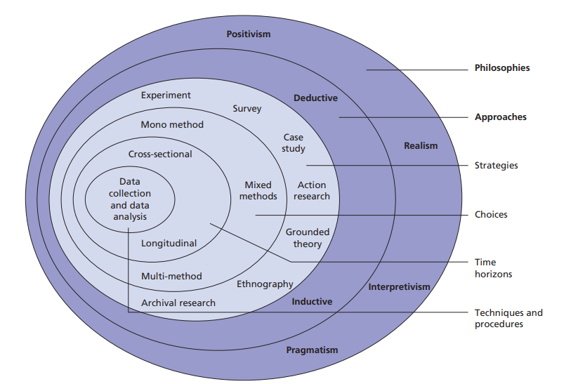

Fig. 1. The Research Onion (Saunders, Lewis, and Thornhill, 2009)

3.3 Philosophy
Research philosophy refers to “a system of beliefs and assumptions about the development of knowledge” (Saunders, Lewis, and Thornhill, 2009, p. 130). Three common philosophies in research are positivism, interpretivism, and pragmatism. Positivists believe that knowledge should be obtained from empirical observations and focus on objective data usually obtained by quantitative methods (Rashid, 2023). Interpretivism is subjective and means that knowledge hangs on the values, experiences, and beliefs of the subjects of the study. This requires the researcher to interpret these results and clarify their meaning (McBride, Misnikov, and Draheim, 2021). Pragmatism falls in the middle, highlighting the practical impacts of knowledge and encouraging a flexible and problem-solving method (Rashid, 2023). This study will use an interpretivist approach as it will focus on collecting the views and opinions of serving police officers. The data will then be analysed and interpreted by the researcher.

3.4 Approach
The research onion shows two approaches to research: deductive and inductive. Deductive research starts with a theory developed from existing knowledge, which is then tested in order to develop, prove, or disprove that theory (Saunders, Lewis and Thornhill, 2009). Inductive research begins with a particular observation and seeks to provide a more generalised theory (Burney and Saleem, 2008). This study will adopt the deductive approach, as it aims to use present theories and add to existing empirical knowledge and evidence.

3.5 Strategy and Choices
The aim of this study is to gather police officer views on current CCB legislation and ascertain whether a simplified definition, such as what is in place in Scotland, would be easier to investigate. The research will also discover how the police conduct CCB investigations and what they consider can be used as evidence.
The researcher will create a survey using Microsoft Forms that will be disseminated to officers within Gwent Police via email and using the Gwent Police intranet page. The survey will use a mixture of open and closed questions that relate to the research objectives. The advantage of digital surveys is that they are inexpensive and can reach a large audience. A disadvantage; however, is that there may be a low response rate (LinkedIn, 2023).
This study will use mixed methods of data collection which will be interpreted by the researcher to establish current views on CCB legislation and investigative practices. Mixed methods combines both quantitative and qualitative research in order to gain a wider understanding of the topic (Schoonenboom and Johnson, 2017).

3.6 Time Horizon
The timeframe in which the research is carried can be split into two categories: longitudinal or cross-sectional. Longitudinal research is continual research over a prolonged period of time, whereas cross-sectional refers to a study that analyses data collected in one instance (Caruana et al. 2015). This will be a cross-sectional study because of its smaller scale and established deadline.

3.7 Techniques: Data Collection and Analysis
This study will be conducted within Gwent Police. The survey link will be emailed to sergeants across several areas and distributed to their teams. The link will also be posted on the Gwent Police intranet page, which is only accessible to Gwent Police employees and allows the researcher to reach officers across the force. The researcher is aiming to obtain 30-50 responses, of which the data will be analysed and displayed in pie charts to establish police views on whether changes to legislation are necessary.

3.8 Limitations
Limitations in research explore factors that may affect the results (Hassan, 2023). One limitation of this study is the ability to reach the target sample size. Gwent Police is a small force, and due to the nature of policing, officers may not have the time to complete the survey within the timeframe.
Another limitation is that there is a lack of existing research that compares Scottish and English CCB legislation, therefore restricting the ability to compare the data collected in this study, which may produce a less meaningful result.
This study will be using data collected from Gwent Police officers only. Gwent Police is one of 43 police forces in England and Wales and therefore the results may not reflect the overall views of police in the UK.

3.9 Ethical Considerations
Domestic Abuse is a sensitive topic and as such considerations were given to the welfare of the study subjects. An ethics form was completed prior to this research and to ensure that all participants are protected, they will be signposted to wellbeing teams within Gwent Police as well as external support services. A list of domestic abuse support services will also be provided. The researcher has also considered her own welfare and will familiarise herself with support services should the need arise.

3.10 Conclusion
This chapter has explained research methodology and explained why the researcher has selected the chosen methods. The next chapter will analyse and present the data collected through these chosen methods.

Chapter 4: Data Analysis and Results
  - Introduction
This dissertation focussing on coercive and controlling (CCB) legislation set out four objectives. Two of these were met in the literature review which examined issues that police face during CCB investigations. The methodology outlined how mixed methods research will be used to achieve objectives three and four, which are:
- Identify how CCB is being investigated and what can be used as evidence.
- Examine police officer views on the Scottish legislation and whether they believe that CCB legislation in England and Wales should be simplified.

This chapter will present the results of the study. 4.1 will display statistical analysis of quantitative data collected in the survey through percentages. 4.2 will provide a thematic analysis of the qualitative data collected in the free text boxes.
In this chapter, the results of seven questions will be analysed. The researcher did not capture demographic or characteristic data as the survey focussed purely on police officer views of the legislation. A blank copy of the survey will be available in appendix one and the results to all questions available in appendix two.
  - Quantitative Data Results
How easy do you think the current legislation used in England and Wales is to understand?
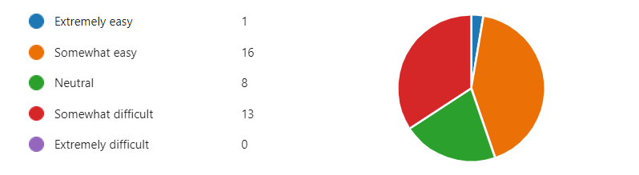
Somewhat difficult | 35% | Extremely easy | 3%
Neutral | 21% | Somewhat easy | 42%

When investigating CCB, how easy do you think it is to achieve the points to prove?
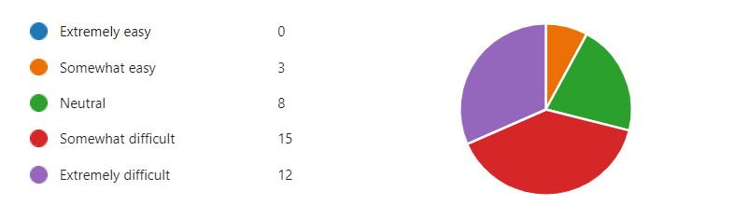

There are four ‘points to prove’ within the CCB offence definition.
Somewhat easy | 8% | Somewhat difficult | 39%
Neutral | 21% | Extremely difficult | 32%

When asked what is considered the most difficult points to prove, points one and four were thought the most difficult. Point three also scored highly with only two respondents selecting point two.
Considering the Scottish Legislation, how much do you agree with the following statements?
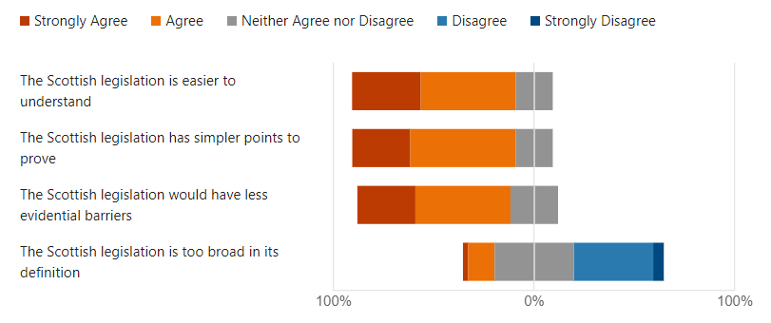

 | Strongly Agree | Agree | Neither agree not disagree | Disagree | Strongly disagree
Easier to understand | 34.2% | 45.4% | 18.4% | 0 | 0
Simpler points to prove | 28.9% | 52.6% | 18.4% | 0 | 0
Less evidential barriers | 28.9% | 47.4% | 23.7% | 0 | 0
Too broad in definition | 2.6% | 13.2% | 39.5% | 39.5% | 5.3%

The Scottish Legislation focusses on offender behaviour as opposed to victim impact. Do you think this would be easier to investigate?
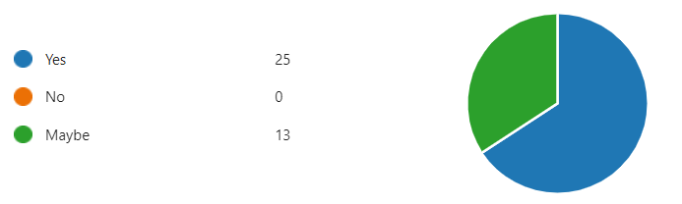
66% of respondents think that focussing on offender behaviour would be easier to investigate and the remaining 34% answered maybe. When asked to explain their answer, 13 respondents thought that that offender behaviour would be easier to identify or prove. Nine participants have said that victim impact is difficult to evidence, with some saying impact is subjective, and others recognising that victims can find it hard to express the impact. Three respondents think that it is important to investigate both offender behaviour and victim impact. One thought that victim impact is easier to evidence as behaviour can be difficult to capture. One officer thinks that the Scotland legislation is easier to understand but is too broad and open to misinterpretation.

Do you think that changes to legislation in England and Wales are necessary to simplify coercive control and bring more offenders to justice?
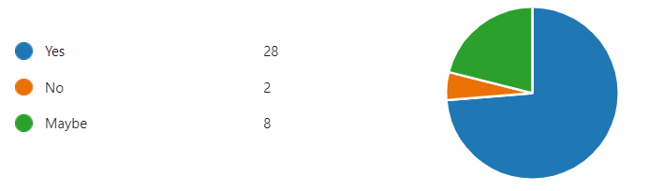
Yes | 74%
No | 5%
Maybe | 21%

4.3 Qualitative Data Results
Please briefly explain how you would conduct a CCB investigation.
22 out of 38 respondents said that they would speak to the victim and obtain a statement. Seven mentioned gaining all available evidence however did not go into detail about this. 11 officers have said that they would consider phone work, such as downloading a suspect’s phone or obtaining screenshots of text messages. 17 respondents mentioned witness statements, with 12 identifying these witnesses as friends and family, and 5 also adding work colleagues as potential witnesses. Four officers would consider gaining medical records, whilst some would also consider looking at bank statements. A continuing theme throughout the responses is the safeguarding of the victim and arresting and interviewing the subject.
Respondents were also asked what they would consider can be used as evidence. The results are displayed in the table below.

Evidence | No. of Mentions
Statements | 24
Digital Enquiries (EG. Phone download) | 24
Finance Records | 17
CCTV | 12
Medical Records | 11
999 Recordings | 3
Tracking Devices | 3

What do you think are the biggest challenges that response officers face when investigating CCB?
The qualitative results find that the most common theme equates to officers not having time to investigate CCB due to daily demand, high workloads, and staffing issues. Some have noted that officers and victims may not recognise or understand the offence, and many have mentioned evidential difficulties such as victim not supporting. When asked how long on average a CCB investigation might take, quantitative results show that 61% said 6-12 months, 26% thought 12-18 months, 11% thought 18 months or more. Only one person thought that a CCB investigation takes up to 3 months.

4.4 Conclusion
This chapter has presented and analysed the data collected in this study. The survey achieved 38 responses in total with all candidates being employed by Gwent Police. The vast majority of this sample agreed that the legislation used in Scotland is easier to understand and would be easier to prove than the current CCB legislation used in England and Wales. This is reminiscent of the views of Bettinson (2020).
The study has also revealed how officers would conduct a CCB investigation, with the most common answers being to speak to the victim and witnesses. Phone, finance, and medical records are also considered to be relevant evidence.
Participants were also asked about the challenges that response officers face dealing with CCB. The overarching factors are time, demand, and low staff, along with lack of understanding, and evidential difficulties. This fully supports the findings of the literature review.
The next chapter will discuss the findings of this study and how the objectives have been achieved.

Chapter 5: Conclusion and recommendations
5.1 Introduction
The previous chapter analysed the results of this mixed methods research project. This chapter will discuss how the dissertation objectives were achieved and present the main findings of the study. The chapter will also include recommendations for future research, along with the final conclusion and answers to the overall research questions:
- Is a change in CCB legislation necessary to make it easier for police to investigate?
- What is the current process of investigating CCB?

5.2 Achievement of the objectives
This project has used both primary and secondary research to examine CCB legislation and achieve its set objectives.
Objectives one and two were achieved in the literature review when the researcher reviewed existing literature and identified evidential difficulties and resourcing issues as the main challenges. The chapter also explored negative police officer attitudes and failure to recognise the presence of CCB.
The literature review identified a gap in research as to how CCB investigations are conducted and also presented the question of whether changes to legislation are needed. Therefore, the primary research aimed to examine the current process of investigating CCB and gather views on Scottish legislation to assess whether CCB legislation in England and Wales should be simplified.
Objectives three and four were achieved using both qualitative and quantitative methods. The results of this were presented in chapter four and the main findings will be discussed next.
5.3 Main findings
This primary research aimed at police officers within Gwent Police sought views and opinions on CCB legislation. There were fairly level views on whether the legislation is easy or difficult to understand; however, the small majority believed that it was easy. Despite this, it is clear that the legislation has its faults. Over 70% of 38 participants think that the points to prove are difficult or extremely difficult to achieve, with proving the offender’s behaviour and his knowledge of it, along with proving the serious effect that the behaviour has on the victim being the most difficult. This result supports the findings of the literature review where it became apparent that officers struggle to capture the specific behaviour and victim impact within their statements.
In order to further investigate the views of Bettinson (2020), officers were asked for their opinion of the Scottish domestic abuse legislation. Bettinson suggested that the Scottish model has less evidential barriers by focussing on offender behaviour rather than victim impact. This study finds that almost all participating officers agree or strongly agree that the Scotland legislation is easier to understand and has simpler points to prove, with 66% of participants agreeing that investigating the offender’s behaviour is an easier approach.
The study found that 74% of participating officers believe that changes to legislation are necessary to bring more offenders to justice. This result suggests that officers are struggling with the current legislation and presents further research opportunities that will be recommended in the final chapter.
The second part of this study asked police officers to explain how they would conduct a CCB investigation and what they consider can be used as evidence. The majority of officers would collect victim and witness statements, with witnesses varying from friends, family, and work colleagues. Other lines of enquiry would be to download the suspects phone and consider the collection of finance or medical records. It became apparent in the results that arresting the suspect and safeguarding the victim were important factors in a CCB investigation. Statements and digital enquiries were the most cited possible evidence, both receiving 24 mentions each.
Officers were also asked what they feel are the biggest challenges when investigating CCB. The findings echo that of the literature review, with lack of time, staffing, lack of recognition for the offence and evidential difficulties being the most mentioned concerns.

5.4 Limitations
The main limitation of this study has been the word count restrictions. There are several avenues that could have been explored; however, due to chapter size limits it was not possible. One of these avenues would have been to explore the views of the CPS to gather a better understanding of their decisions. Another would be to examine the outcomes of Scottish cases of domestic abuse to compare with those in England and Wales. This data would prove or disprove that a simpler legislation is more successful. Research into current police training about CCB was also beyond the scope of this dissertation.
Another limitation to this study has been the predetermined deadlines. The researcher has been managing this project alongside full-time duties as a response police officer and has therefore been restricted for time. The researcher had originally planned to interview police officers to collect the qualitative data; however, the reality of the planning and execution of this research proved extremely difficult with the set deadline and other work commitments.
There are also limitations in sample size as Gwent Police is a small force. 38 people responded to the survey and therefore their views may not reflect those of the wider policing community.

5.5 Recommendations
5.5.1. Recommendation 1: Research Scotland Legislation and its crime outcomes
This study has not been able to include Scottish domestic abuse crime outcomes and therefore research is needed to gather this data and compare it with the outcomes in England and Wales. It should be factored into the research that Scotland did not introduce the legislation until 2018.
A comparison of crime outcomes between the two pieces of legislation would provide answers as to whether the Scottish legislation is more effective at bringing abusers to justice. It would also identify issues with the Scottish legislation and provide further recommendations as to how the legislation throughout the UK can evolve to ensure victims are fully protected.
5.5.2. Recommendation 2: Further qualitative research with police officers
This study was limited by time and sample size. More in depth and protracted research should be carried out by interviewing police officers in order to dig deeper into the views and opinions of those leading these types of investigations. Gwent Police is a small force. It would be beneficial to include all UK forces in any future research as each might have their own processes to investigate domestic abuse with higher success rates.
5.5.3. Recommendation 3: Qualitative research with the Crown Prosecution Service (CPS)
In order to gather a full and comprehensive understanding of charging standards, and to explore the relationship between the police and the CPS, future studies should include qualitative research with lawyers from the CPS to gain a deeper insight and increase knowledge of acceptable evidence.
5.5.4. Recommendation 4: Research Police Training
The current police training of CCB has not been explored in this dissertation. The literature review identified that some police officers are still displaying an incident-based mindset and therefore neglect to recognise patterns of abusive behaviour. The reason for these attitudes has not been examined; however, so research into police training methods would highlight any weaknesses and suggest improvements to police training and practices.

5.6 Conclusion
The primary research in this project used mixed methods to examine police officer views of CCB legislation and identify how CCB is currently being investigated. The qualitative and quantitative results were displayed in chapter four and the main findings have been explained in this final chapter.
The primary research has successfully answered the research questions:
Is a change in CCB legislation necessary to make it easier for police to investigate?
This study has found that although a small majority of participating officers think that the current CCB legislation is easy to understand, the points to prove within the legislation are difficult to achieve. Most officers agree that the Scottish legislation is easier to understand and believe changes are needed in order to improve charge rates and bring more offenders to justice.
What is the current process of investigating CCB?
The findings show that a typical CCB investigation would begin by gathering victim and witness statements, followed by digital enquiries, and gathering other evidence such as finance or medical records. This shows that the participating officers have a good understanding of available evidence and good awareness of potential lines of enquiry.

The existing literature shows that problems with CCB legislation have already been acknowledged and that there is scope for further investigation into these issues.
The most significant findings of this project show that the main barrier to successful CCB investigations is that there is simply not enough evidence to submit to the CPS to authorise a charge. This is hindered by many factors. Firstly, the necessity to hit the points to prove presents officers with the difficult challenge of characterising the behaviour within their victim statements (Johnson and Barlow, 2018), which can be difficult to do when the behaviour is often so subjective and personal to the individual (Tolmie, 2017).
Perpetrators of CCB are known for their manipulative qualities, which sadly means that many victims refuse or withdraw their complaint, sometimes due to their own perception of risk should they continue to support. This limits the police’s ability to discover new lines of enquiry and therefore they have no choice but to close with no further action.
The psychological nature of CCB means that there is often an absence of the visible evidence you would associate with domestic violence and therefore a statement might be the only representation of the abuse. The quality of this statement relies heavily on the officers true understanding of the CCB offence and ability to recognise the impact that the behaviour is having.
The existing research clearly shows police failings in this area. Whilst this project proves that officers have a good idea of how CCB should be investigated and an awareness of possible evidence, responding officers must at first be in the mindset that the incident they are attending may be part of a deeper abusive pattern. Furthermore, the police are constantly battling high workloads, low staffing, and stressful work environments and therefore their motivation to take on lengthy and taxing CCB investigations, knowing there is little chance of a charge will no doubt be impacted.
This project has found that gathering enough evidence to achieve the points to prove is the main reason for cases being dropped. This highlights the complexities of the offence wording which, when compared with the Scottish legislation proved less favourable.
There is limited existing research into the comparison of the two versions; however, this study indicates that the majority of participating police officers think that the offence wording should be revised in favour of a simpler meaning.
The policing of domestic abuse will forever be scrutinised and therefore continual assessment and review of the effectiveness of domestic abuse legislation, how it is being used, and more importantly, how it is being investigated, is vital to ensure that the police are doing all they can to protect victims. This project has highlighted the legislative difficulties and evidential challenges that face those investigating CCB and invites future research to be conducted so that the offence can develop and evolve to reach its full potential in preventing non-physical domestic abuse in order to provide safety and freedom to all of its survivors.

Bibliography
- Aliyu, A.A. et al. (2015) ‘Ontology, epistemology and axiology in quantitative and qualitative research: education of the research philosophical misconception’, Proceedings of The Academic Conference: Mediterranean Publications & Research International on New Direction and Uncommon. Available at: https://www.researchgate.net/publication/318721927_ONTOLOGY_EPISTEMOLOGY_AND_AXIOLOGY_IN_QUANTITATIVE_AND_QUALITATIVE_RESEARCH_ELUCIDATION_OF_THE_RESEARCH_PHILOSOPHICAL_MISCONCEPTION Accessed: 13th December 2023
- Ash, T. (2014) “We have to look beyond violence to the pattern of domination and control”. Available at: https://safelives.org.uk/policy_blog/%e2%80%9cwe-have-look-beyond-violence-pattern-domination-and-control%e2%80%9d Accessed: 30th March 2024
- Barlow, C. et al. (2018) Police Responses to Coercive Control. Available at: https://documents.manchester.ac.uk/display.aspx?DocID=56477 Accessed: 17th October 2023
- Barlow, C. et al. (2019) ‘Putting Coercive Control into Practice: Problems and Possibilities’, The British Journal of Criminology, 60(1), pp. 160-179. https://doi.org/10.1093/bjc/azz041
- Bettinson, V. (2020) ‘A Comparative Evaluation of Offences: Criminalising Abusive Behaviour in England, Wales, Scotland, Ireland and Tasmania’, in McMahon, M; McGorrery, P. (eds) Criminalising Coercive Control. Singapore: Springer
- Bettinson, V; Bishop, C. (2015) ‘Is the creation of a discrete offence of coercive control necessary to combat domestic violence?’, The Northern Ireland Legal Quarterly, 66(2), pp.179-197, https://doi.org/10.53386/nilq.v66i2.149
- Bishop, C. (2016) Why it’s so hard to prosecute cases of coercive and controlling behaviour. Available at: https://theconversation.com/why-its-so-hard-to-prosecute-cases-of-coercive-or-controlling-behaviour-66108 Accessed: 19th October 2023
- Bishop, C; Bettinson, V. (2017) ‘Evidencing domestic violence*, including behaviour that falls under the new offence of controlling or coercive behaviour’, The International Journal of Evidence and Proof, 22(1), pp. 3-29, https://doi-org.ezproxy.uwtsd.ac.uk/10.1177/1365712717725535
- Bouchrika, I. (2023) Primary Research vs Secondary Research: Definitions, Differences, and Examples. Available at: https://research.com/research/primary-research-vs-secondary-research Accessed: 12th December 2023.
- Brennan, I.R. et al. (2018) ‘Service Provider Difficulties in Operationalising Coercive Control’, Violence Against Women, 25(6), pp. 635-653, https://doi-org.ezproxy.uwtsd.ac.uk/10.1177/1077801218797478
- Brennan; I; Myhill, A. (2022) ‘Coercive Control: Patterns in Crimes, Arrests and Outcomes for a New Domestic Abuse Offence’, The British Journal of Criminology, 62(2), pp. 468-483, https://doi.org/10.1093/bjc/azab072
- Burman, M; Brooks-Hay, O. (2018) ‘Aligning policy and law? The creation of a domestic abuse offence incorporating coercive control’, Criminology and Criminal Justice, 18(1), pp. 67-83, https://doi-org.ezproxy.uwtsd.ac.uk/10.1177/1748895817752223
- Burney, S.M.A; Saleem, H. (2008) ‘Inductive and Deductive Research Approach’, [Lecture] University of Karachi. 6th March 2008. DOI:10.13140/RG.2.2.31603.58406
- Buzawa, E.S; Buzawa, A.D. (2013) ‘Evidence-Based Prosecution – Is it worth the cost?’. Criminology and Public Policy, 12(3), pp.491-505. https://doi.org/10.1111/1745-9133.12056
- Cairns, I. (2020) ‘The Moorov doctrine and coercive control: Proving a ‘course of behaviour’ under s. 1 of the Domestic Abuse (Scotland) Act 2018’, The International Journal of Evidence and Proof, 24(4), pp. 396-417, https://doi.org/10.1177/1365712720959857
- Caruana, E.J. et al. (2015) ‘Longitudinal Studies’, Journal of Thoracic Disease, 7(11), pp. 537-540. doi: 10.3978/j.issn.2072-1439.2015.10.63
- College of Policing (2015) Investigative Development. Available at: https://www.college.police.uk/app/major-investigation-and-public-protection/domestic-abuse/investigative-development Accessed: 18th October 2023
- CPS (2018) The Code for Crown Prosecutors. Available at: https://www.cps.gov.uk/publication/code-crown-prosecutors Accessed: 18th October 2023
- CPS (2022) Domestic Abuse. Available at: https://www.cps.gov.uk/legal-guidance/domestic-abuse Accessed: 2nd November 2023.
- Domestic Abuse (Scotland) Act 2018, s1. Available at: https://www.legislation.gov.uk/asp/2018/5/section/1/enacted Accessed: 3rd November 2023
- Elgezouli, S. (2022) Perceptions of Survivors and Police Officers Regarding the Police Response to Coercive Control. Unpublished PHD thesis, Canterbury Christ Church University. Available at: https://repository.canterbury.ac.uk/download/0e6a2d23de06b4576f1beb280b7b6ce6595df972997400079c6968e95fbe4546/2142838/Thesis%20%281%29.pdf Accessed: 19th October 2023
- Gentleman, A. (2024) ‘But he didn’t hit you, did he?’: inside the coercive control courtroom. Available at: https://www.theguardian.com/lifeandstyle/2024/mar/23/but-he-didnt-hit-you-did-he-inside-the-coercive-control-courtroom Accessed: 30th March 2024
- Gwent Police (2023) ‘Crime outcomes 2022’, QlikView Accessed: 20th October 2023
- Hassan, M. (2023) Limitations in Research – Types, Examples and Writing Guide. Available at: https://researchmethod.net/limitations-in-research/#:~:text=Limitations%20in%20research%20refer%20to%20the%20factors%20that,and%20the%20limitations%20of%20the%20data%20analysis%20techniques. Accessed: 16th December 2023
- Hasselbacher, L. (2010) ‘State Obligations Regarding Domestic Violence: The European Court of Human Rights, Due Diligence, And International Legal Minimums of Protection’, Northwestern Journal of International Human Rights, 8(2), https://scholarlycommons.law.northwestern.edu/cgi/viewcontent.cgi?article=1098&context=njihr
- Hirschel, D; Hutchison, I.W. (2003) ‘The Voices of Domestic Violence Victims: Predictors of Victim Preference for Arrest and the Relationship Between Preference for Arrest and Revictimization’, Crime and Delinquency, 49(2), pp. 313-336, https://doi-org.ezproxy.uwtsd.ac.uk/10.1177/0011128702251067
- Hitchings, E. (2005) ‘A Consequence of Blurring the Boundaries - Less Choice for the Victims of Domestic Violence?’, Social Policy and Society, 5(1), pp. 91-101, DOI:10.1017/S1474746405002770
- Home Office (2021) Review of the Controlling or Coercive Behaviour Offence. Available at: https://assets.publishing.service.gov.uk/government/uploads/system/uploads/attachment_data/file/982825/review-of-the-controlling-or-coercive-behaviour-offence.pdf Accessed: 17 October 2023
- Home Office and Bradley, K. (2015) Coercive and Controlling Behaviour now a crime. Available at: https://www.gov.uk/government/news/coercive-or-controlling-behaviour-now-a-crime Accessed: 16 October 2015
- Jayanetti, C; Townsend, M. (2022) ‘Revealed: half of English police forces fail to meet standards in crime investigations’, The Guardian, 26th January. Available at: https://www.theguardian.com/uk-news/2022/nov/26/revealed-half-of-english-police-forces-fail-to-meet-standards-in-investigations Accessed: 19th October 2023
- Johnson, K; Barlow, C. (2018) Researching police responses to coercive control. Available at: https://www.n8prp.org.uk/2018/04/05/researching-police-responses-to-coercive-control/ Accessed: 17th October 2023
- Kandel, B. (2020) ‘Qualitative verses Quantitative Research’, Marsyangdi Journal, Vol. 1. Pp. 1-5.
- McBride, K; Misnikov, Y; Draheim, D. (2021) ‘Discussing the foundations of Interpretivist Digital Government Research’, in Charalabidis, Y; Flak, L.S, yPereira, G.V. (eds) Scientific Foundations of Digital Governance and Transformation. Springer Nature. DOI:10.1007/978-3-030-92945-9_6
- McMahon, M; McGorrery, P. (2016) ‘Criminalising controlling and coercive behaviour: the next step in the prosecution of family violence?’, Alternative Law Journal, 41(2), pp. 98-101. https://doi-org.ezproxy.uwtsd.ac.uk/10.1177/1037969X160410020
- Myhill, A. et al. (2022) ‘A genuine one usually sticks out a mile’: policing coercive control in England and Wales’, An International Journal of Research and Policy, 33(4), pp. 398-413. https://doi.org/10.1080/10439463.2022.2134370
- Myhill, A; Johnson, K. (2015) ‘Police use of discretion in response to domestic violence’, Criminology and Criminal Justice, 16(1), pp.3-20, https://doi-org.ezproxy.uwtsd.ac.uk/10.1177/1748895815590202
- Nugent, C. (2019) ‘Abuse Is a Pattern.’ Why These Nations Took the Lead in Criminalizing Controlling Behavior in Relationships. Available at: https://time.com/5610016/coercive-control-domestic-violence/ Accessed: 30th March 2024
- Rashid, H.A. (2023) Research philosophy: positivism, interpretivism, and pragmatism. Available at: https://limbd.org/research-philosophy-positivism-interpretivism-and-pragmatism/ Accessed: 14th December 2023
- Robinson, A.L; Myhill, A; Wire, J. (2017) ‘Practitioner (mis)understandings of coercive control in England and Wales’, Criminology and Criminal Justice, 18(1), pp. 29-49, https://doi-org.ezproxy.uwtsd.ac.uk/10.1177/1748895817728381
- Saunders, M; Lewis, P; Thornhill, A. (2009) Research Methods for Business Students. 5th edn. Essex: Pearson Education Limited.
- Schoonenboom, J; Johnson, R.B. (2017) ‘How to Construct a Mixed Methods Research Design’, Cologne Journal of Sociology and Social Psychology, 69(2), pp. 107-131. doi: 10.1007/s11577-017-0454-1
- Serious Crime Act 2015, s76. Available at: https://www.legislation.gov.uk/ukpga/2015/9/section/76/enacted Accessed: 16th October 2015
- Stark, E. (2012) ‘Looking Beyond Domestic Violence: Policing Coercive Control’, Journal of Police Crises Negotiations, 12(2), pp. 199-217, https://doi-org.ezproxy.uwtsd.ac.uk/10.1080/15332586.2012.725016
- Stark, E; Hester, M. (2019) ‘Coercive Control: Update and Review’, Violence Against Women, 25(1), pp. 81-104. https://doi.org/10.1177/1077801218816191
- Thesismind (2009) Analysis of Saunders Research Onion. Available at: https://thesismind.com/analysis-of-saunders-research-onion/ Accessed: 12th December 2023
- Tolmie, J.R. (2017) ‘Coercive control: To criminalise or not to criminalise?’, Criminology and Criminal Justice, 18(1), pp. 50 - 66, https://doi.org/10.1177/1748895817746712
- Walklate, S; Fitz-Gibbon, K; McCulloch, J. (2017) ‘Is more law the answer? Seeking justice for victims of intimate partner violence through the reform of legal categories’, Criminology and Criminal Justice, 18(1), pp.115-131, https://doi.org/10.1177/1748895817728561
- Wiener, C. (2017) ‘Seeing what is invisible in plain sight: Policing coercive control’, The Howard Journal of Crime and Justice, 56(4) pp.500-515. https://doi-org.ezproxy.uwtsd.ac.uk/10.1111/hojo.12227
- Wydall, S; Zerk, R. (2020) ‘Listen to me, his behaviour is erratic and I’m really worried for our safety’: Help-seeking in the context of coercive control’, Criminology and Criminal Justice, 21(5), pp. 614-632, https://doi-org.ezproxy.uwtsd.ac.uk/10.1177/1748895819898513

Appendices
Appendix one: Blank survey
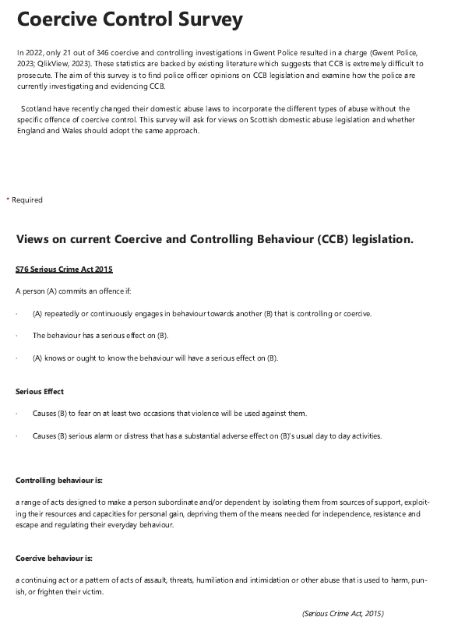

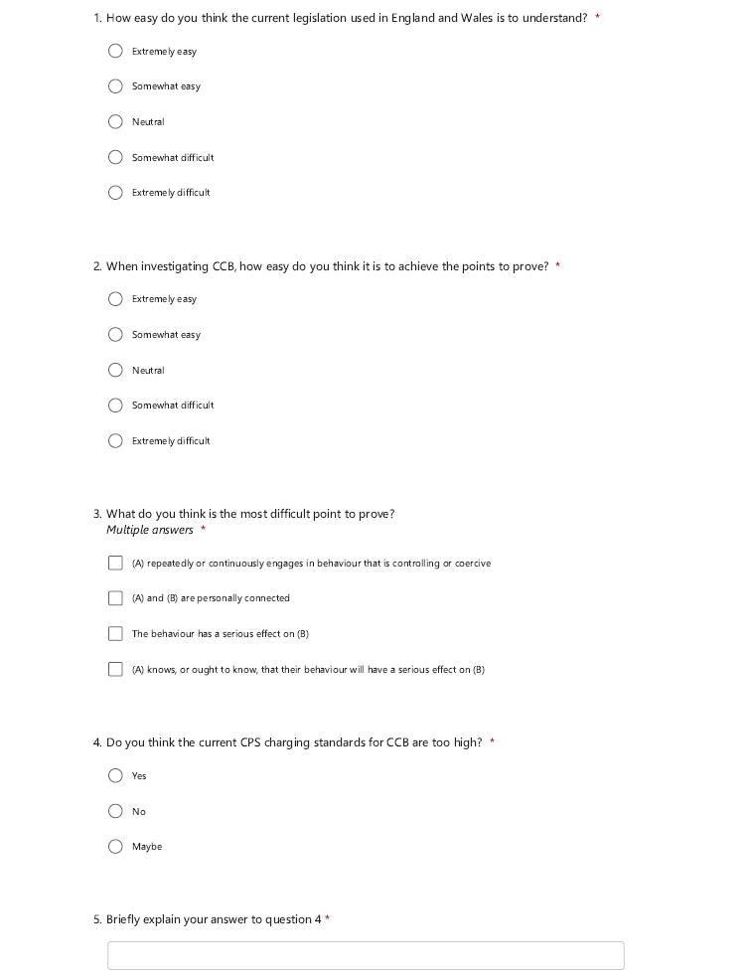

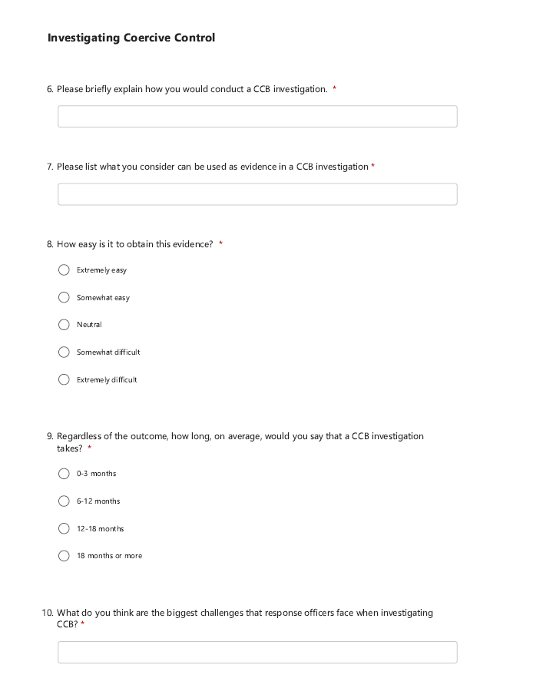

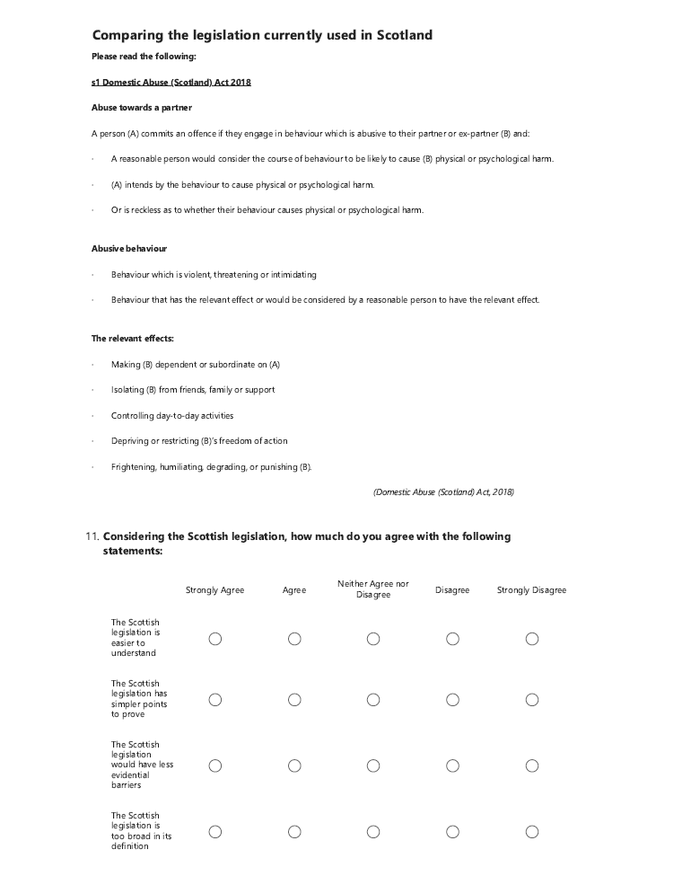

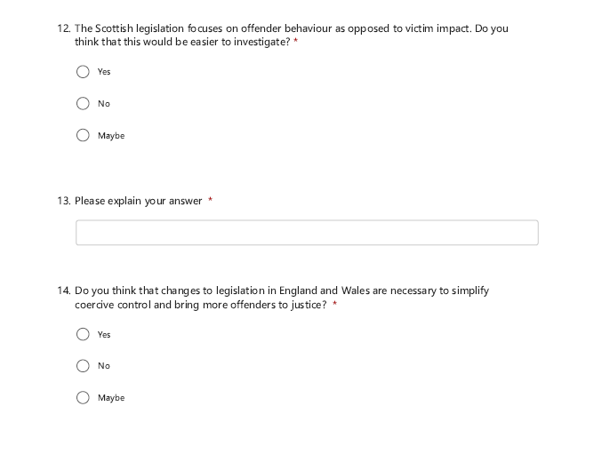
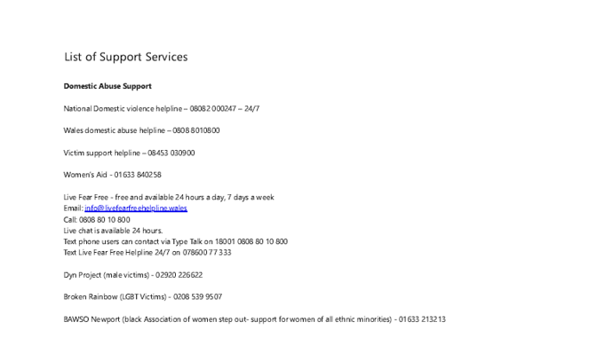



Appendix 2: Survey results
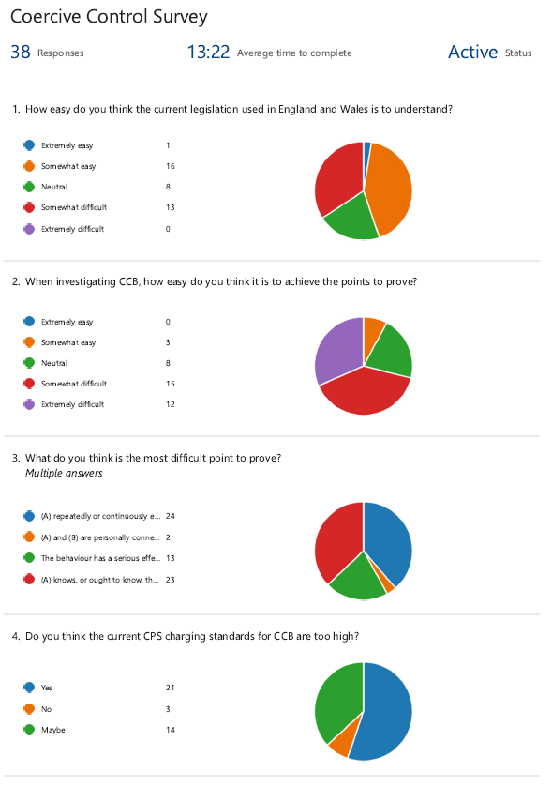

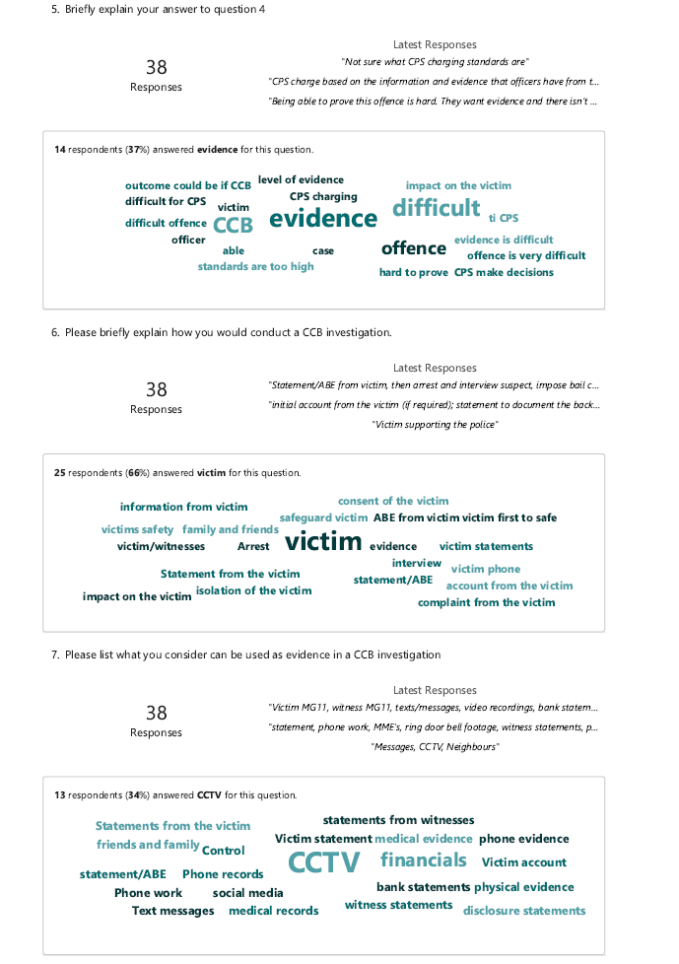

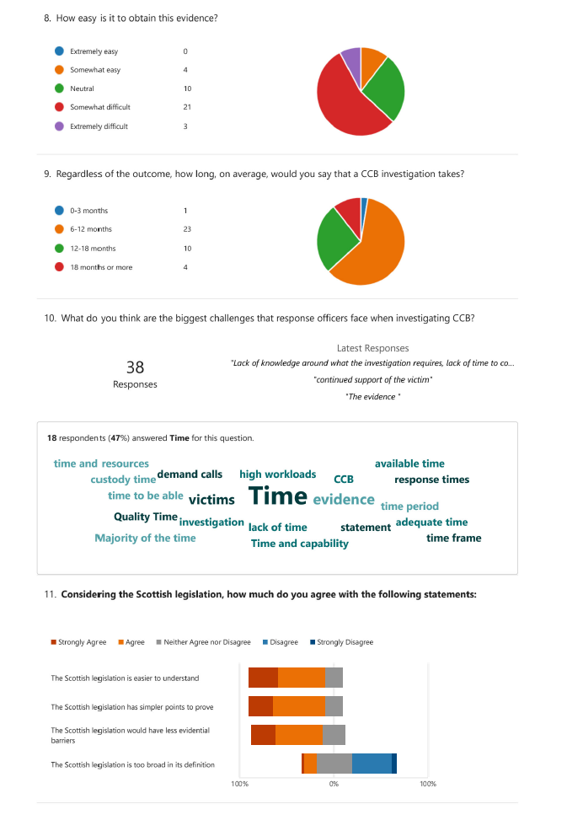
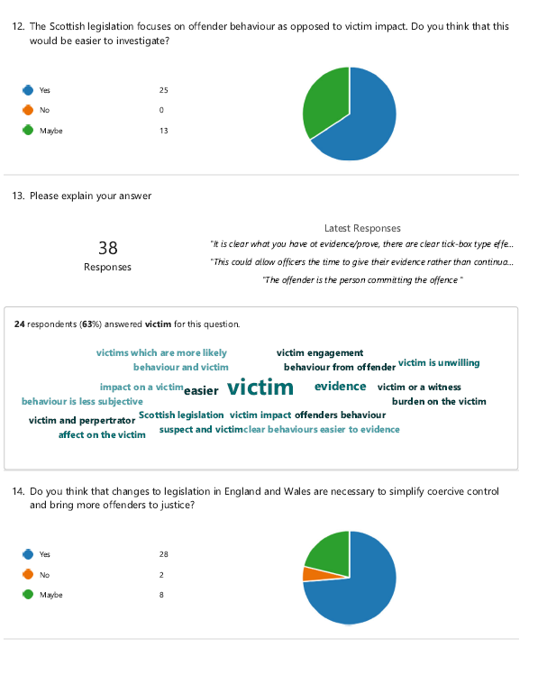

Appendix three: Application for Ethical Approval

Appendix four: Research proposal

ETHICAL ISSUES:

Domestic abuse is an extremely sensitive topic and I have considered the effects that this research will have on those asked to participate. Officers will be asked about their experience in dealing with CCB and I accept that some may find this difficult, particularly if a case has not gone their way. To counter this, I will ensure that a list of support services is available at the beginning and end of the survey.

I have also considered police officer confidentiality. They will be fully informed of how the data will be used and at no point will their details be revealed. I will follow university procedures for data storage and management and comply with GDPR (UWTSD, 2023).

In order to obtain reliable research, I will be asking officers to answer my questions honestly. I have considered the police Codes of Practice (College of Policing, 2014) and how an honest answer has the potential to go against these standards. Depending on the context, their anonymity will be kept unless I feel there is a need to inform a supervisor. This would be in extreme circumstances and only if I felt that a victim was in danger. This is to honour my own integrity as a serving police officer myself.

As I will be asking officers to talk about their investigations, I have considered whether victims could be indirectly identified. To rectify this, I will ask participants not to use names. Any names that are accidently disclosed, either in person or in the questionnaires will be disregarded and not used in any final result.

1. (A) repeatedly or continuously engages in behaviour that is controlling or coercive 2. (A) and (B) are personally connected 3. The behaviour has a serious effect on (B) 4. (A) knows or ought to know that the behaviour has a serious effect on (B)

