BA (Hons) Degree in Inclusive Education

Inclusive Education: Policy and Practice

Part 2
Case Study

1804982
Introduction
This assignment is going to look at inclusive interventions and support provided for a child with Moderate Learning Difficulties placed in a Local Authority mainstream primary school. For the purpose of this assignment and case study, the practitioner is used to identify the one to one Learning Support Assistant employed within the school and the child will be identified as Child J to conform with the school’s policies on confidentiality and the Data Protection Act (1998 updated in 2018 for the digital age). According to the ESTYN Inspection Report 2018 the school has 481 pupils on register aged 3 to 11 which includes 75 part time children in the nursery. Around 21% of the children are eligible for Free School Meals. The school identifies that around 34% of the children have Additional Learning needs and a few have a statement of Special Educational Needs. The majority of pupils are of White British Ethnicity, there are a few children with English as a Second Language and a few whom speak Welsh at home. Very few children are Looked After by the Local Authority.
Child J is a pleasant and generally happy and affectionate child from a professional family. Her Chronological age is 7 years and 7 months. J has an older brother by 6 years and speaks of him fondly. J has friends in class and interacts fairly well with them, though struggles a little in the playground. J loves creative activities such as drawing and making things, music and dance, and outdoor learning for example forest schools. J is very enthusiastic about the subjects she enjoys she seems to really enjoy history and stories. J is usually a well behaved pupil and is well-liked amongst her peers. With a diagnosis of right paresis which means she has a weakness in the right hand side of her body due to a left parietal lobe infarct, J walks independently but with an unusual gait and holds her right arm up due to the increased tone in her limbs. This can make her tire more quickly and she is prone to fall. J’s speech and language is delayed and she has global developmental difficulties. When J first came to the school in reception her vocabulary was limited she had difficulty stringing more than a couple of words together and relied heavily on gestures and pointing to communicate. J has an IEP, please see appendix 1 Throughout the foundation phase with the help of interventions, support and her sheer determination, J has made leaps across the board developmentally and most significantly in her communication skills. J has settled into Key stage 2 relatively well, but has become less enthusiastic, and a little withdrawn. There are some concerns over her social and emotional well-being at this difficult time of transition and as she continues to develop and progress through the school. J does not like speaking in front of the class for example, to give a small presentation of homework or talk about herself and her interests, and does not like everyone’s focus on her. J responds well to working in small groups, seems more comfortable interacting with her peers in smaller numbers and is more likely to participate in small group discussions. Some planned provision is highlighted in the pyramid. Please see Appendix 2
After some deliberation regarding which interventions and strategies would be beneficial to J and her current needs, J’s support team decided that Talkabout would be a an appropriate intervention to help support J. The intervention had been used previously in the school with year 4 pupils and had proven to be quite successful.
The question that this case study asks is: How are children’s social and emotional development supported through transitions in a local primary school?

Methodology
J’s support team consisting of the practitioner, the class teacher the ALNCo, and the pastoral care practitioner discussed interventions and strategies to decide which they felt would be most suited to her needs. The children in J’s class are starting to get more aware of themselves, each other and their differences. This is part of the reason why the Talkabout intervention was suggested.
Talkabout is a program designed for teachers and or therapists to help with social and emotional difficulties. The first book is aimed at helping to raise self-awareness and self-esteem in children. The intervention has eight topics and uses a hierarchical approach to teaching skills. This means teaching the more basic self-awareness skills first and the more complex skills last. This is me, is the first topic with the aim to improve basic self-esteem and awareness through thinking about likes and dislikes in order to encourage them to start talking about their feelings. The intervention is designed to run for a year but can be run as a twenty week program.
The practitioner suggested running the program as a whole class incentive. The children were assessed using the process incorporated within the program please see appendix 3 and placed into groups according to those baseline results. The teacher planned for the sessions to be run in the PSD time slots. One group of eight children to be taken by the practitioner while the other three groups are supervised by the teacher carrying out other PSD activities, and then work in a carousel fashion until all groups have had their turn. Specific Parental permission to participate was not required as the intervention was run as a PSD lesson for the whole class. The practitioner and the teacher decided in the first instance to run as a double session to allow the children sufficient time so they didn’t feel rush and still allow time for all four groups to have their turn. It was decided to run as a twenty week program. The sessions were held once a week and the children’s progress was monitored and evaluated using the forms in the program. The children were then reassessed at the end of the twenty weeks and regrouped where necessary. It was decided to continue with the program for the rest of the year.

Findings
According to Hryniewicz, L. (2013) “Self-esteem is the way in which we view ourselves and our abilities and how we compare ourselves to others. It influences the way we respond to any aspect of life. The messages that other people give us about ourselves can have a big effect on how we view ourselves and our abilities.” The sessions were popular with the children even those most reluctant at the start, engaged more and started to participate more as the weeks went on.
The Teacher noticed improved general behaviour in the class and that the children seemed more willing to give things a go.
After a few sessions of the intervention J started to open up a little and once she could explain it seemed that J had been feeling a little self-conscious. It took quite a while for J to be able to find the words to express her feelings and understand what they meant. The practitioner wanted to encourage her but was careful not to put words into her mouth. As her speech is impaired, she does not want to speak out the front in class in case her words come out wrong and her friends don’t understand her. She also felt because of the way she stands and holds her arm that people are looking at her funny. Working through the topics one at a time moving on to My strengths and qualities, and What makes me feel good helped J to start building a more positive image of her-self. Talking with the other children who have similar feelings but for different reasons helped J to realise that although everyone is different, everyone is a little worried about something especially when there is a lot of changes. The practitioner found the intervention to be very positive and helpful for the children’s emotional well-being, and a very useful tool to gather a holistic view of the children beyond their academic and physical skills, to be able to provide a more appropriate individualised support where it is needed. When the children got to topic 8 How great am I, they summarised what they had learned by considering what makes them special and great.
This program has follow up programmes tackling different aspects of emotional development as the children grow. The second book concentrates on Social Skills and the third is Developing Friendships. This means that this intervention can be used as a continuous provision for J. According to Crossley, G. (2011) “Many children with MLD suffer with lower levels of self-esteem and motivation Often, as they progress through school, the gap between their abilities and those of their peers grows wider.”

Conclusion

References:
Crossley,G (2011) Professional Inclusion: Special Needs in Supporting Teaching and Learning (2ed) Oxon:Routledge Publishing. p.153

Hryniewicz, L. (2013) Teaching assistants: The Complete Handbook. 3rd edn Norwich: Adamson Publishing Ltd

XXXX Primary School ESTYN Inspection Report June 2018. Available at:
http://www.estyn.gov.wales/sites/default/files/documents/xxxxx
Accessed 3rd March 2019
Xxxx = Name of school omitted for confidentiality purposes.

Local School Information. Available at
http://mylocalschool.wales.gov.uk/Schools/SchoolSearch?lang=en
Accessed 3rd March 2019

Appendices
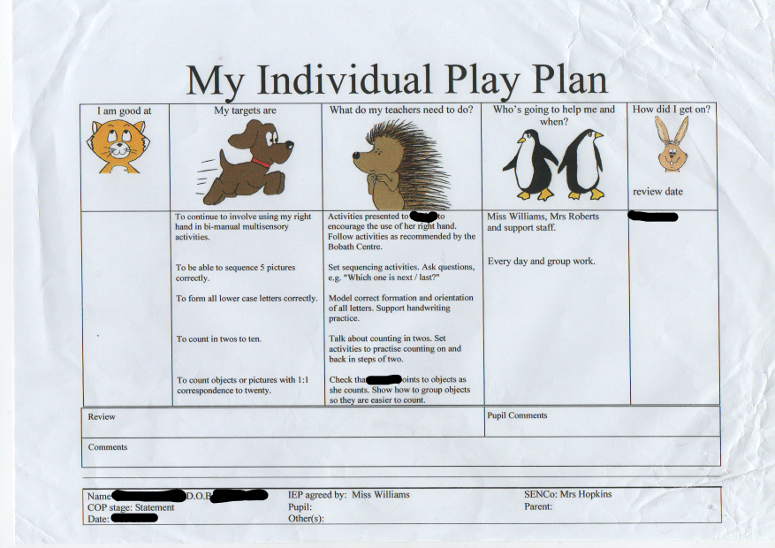
Appendix 1
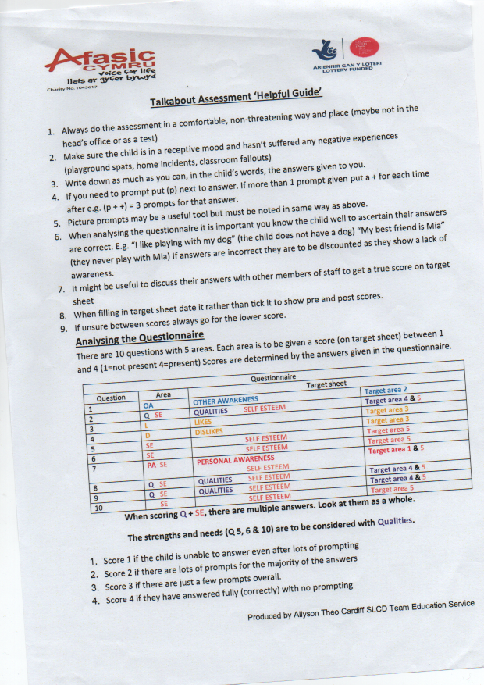

Appendix 2
Pupil Provision Guide 2018 – 2019
Year 3 (AL) – November 2018
- 4 sub levels below / 1 full level or more below
- below 74 SS

Individualised Provision
 | PSD | Language / Literacy | Mathematics / Numeracy
 | N Russ Specialist Support | Speech and Language referral, Language Link, WellComm, Small group Rapid Phonics  Daily reading , HFW, Reading Eggs - 73 | Small Group support (Orange Group)  Numicon
 |  | Speech & Language Referral, Small group Rapid Phonics, HFW, Daily reading, Reading Eggs
J | Self awareness | Small group Rapid Phonics, Daily reading, Reading Eggs, HFW | Small Group support  Numicon
- 3 sub levels behind EARLY INTERVENTION
- 75 – 84 SS

PSD | N Russ
Language/Literacy | Rapid Phonics
 | Reading 3 times a week
Mathematics/Numeracy | Small Group Support – Differentiated and targeted work | ,
- 1 sub level below - Class Group Support
- 85 – 94 SS

PSD | N Russ Specialist Support
Language /  Literacy | Speech & Language (HW)
 | High Frequency words
 | Reading Eggs
Mathematics / Numeracy | Differentiated maths (small group support)

Universal Provision
All Pupils | Pie Corbett, Differentiation, Individual Reading, Shared Reading, Guided Reading, Mental Maths, Abacus
MAT:
- 1 level above - 115 SS

Language /  Literacy | Differentiation
Mathematics / Numeracy | Differentiated maths  Small group support
Statement

School Action +

