NAME: SIMISOLA KALEJAIYE

STUDENT NUMBER: 2014232

LECTURER: DIYA GANGULY.

MODULE: EFFECTIVE TEAMWORK AND COMMUNICATION

DATE: 30 APR 2021.

Introduction
This report will be talking about communication, models of communication and communication skills. It will also be discussing case studies referring to what model most appropriately suits every case study problems in the mode of communication used. This report will also be stating problems experienced at workplaces and how / what model of communication can solve the problem.
What is communication?
Communication means the way and manner of which we make contact with others and being understood. (skillsforcare2016). When it comes to conversation, there are two types: verbal and nonverbal. Verbal communication is essential the things people tend to say while stuff we don't tell make up nonverbal communication. but is mostly expressed by body languages. Body languages in terms of facial gesture like nodding your head, smiling, making eye contacts etc.
Verbal communication skills: verbal communication skills are basically words we say. For example; when we give orders to people or pass a message to someone. Doing this one is expressing themselves through words.
Non – verbal communication skills: non verbal skills are not communicated through words but they are done by using body languages and gestures. For example making faces, or using your hands or part of the body to pass messages or communicate. (Lumen n.d).
In general health care there are 7 keys to communication (EducationExecutive 2017) which are:
Clear: Be clear about your purpose or message while writing or speaking to others. What are you trying to achieve by communicating with this person? If you're unsure, the audience would be unsure as well.
To be transparent, keep the number of ideas in and sentence to a minimum. Make sure that your reader will comprehend what you're doing. People shouldn't have to "read between the lines" or make assumptions to figure out what you're trying to mean on their own.
The required details and actions must be clearly stated such that the reader has the information they need to take action.
Concise: When you communicate concisely, you stick to the point and keep it short. Your audience isn't interested in reading six sentences when you could get your point across in three.
Concrete: When your message is concrete, your audience understands exactly what you're doing. There are plenty of information (but not too many), vivid statistics, and laser-like concentration. Your message is clear and concise.
Correct: When the communication is on point, it is tailored to your target audience. And error-free communication is the same as right communication.
Coherent: It's rational when the communication is coherent. The tone and flow of the text are both simple, and all of the points are relevant and applicable to the main topic.
Complete: The audience has everything they need to be educated and, if necessary, take action in a complete letter.
Courteous: Courteous contact is accessible, polite, and truthful. There are no secret insults or passive-aggressive sounds in this conversation. You consider the reader's point of view and are sympathetic to their needs.

Communication involves listening which makes communication effective. One of the factors of effective communication is listening; listening if divided into three ways which are:
Active listening; this is when your paying attention to the speaker and not being committed to the conversation, when you also avoid interruptions is also a good sign of listening.
Empathetic listening: this is to be able to understand how someone else/ speaker is feeling and putting yourself in their shoes. To do this you would need full concentration and focus to show empathy towards the speaker i.e from their body language, facial expressions and so on.
Some models of communication include:
The Shannon and beaver model of communication. (1948)
The Schramm model of communication. (1954)
The Berlo model of communication. (1960)
Shannon and weaver model of communication:
Shannon was an American mathematician, and Weaver was a physicist, and they came up with the Shannon and Beaver model of communication. The model was developed when both authors collaborated on a Mathematical Theory of Communication article for the Bell System technical journal. This model was created with the aim of improving the sender-to-receiver contact. They also discover "Noise"-related factors that influence the communication process. Initially, the model was created in order to enhance technical communication. (communicationtheory Shannon and Weaver).
The model deals with various concepts like Information source, transmitter, Noise, channel, message, receiver, channel, information destination, encode and decode.
Sender : The originator of message or the information source selects desire message.

Encoder: The transmitter which converts the message into signals.

Note: The sender's messages are converted into waves or binary data, which can be compressed and transmitted over cables or satellites. For instance, in a telephone, voice is translated into wave signals and transmitted through cables.
Decoder: The signal's receiving point, which transforms signals into messages. A reversal of the encode operation.

Note: The receiver transforms the binary data or waves into a message that is comfortable for the receiver to understand. Otherwise, the recipient would not receive the same letter, which would compromise the sender-receiver relationship.

Receiver: The destination of the message from sender.

Note: The receiver provides input to the sender based on the decoded packet. The information flow between the sender and recipient would be disrupted if the message is distracted by noise.

Noise: The messages are sent via a pipe from the encoder to the decoder. Physical noise, such as horn sounds, thunder, and crowd noise, may disturb or impact messages during this step, or encoded signals may distract in the channel during the transmission process, causing the communication flow to be disrupted or the receiver to receive the incorrect message. 

For instance, the Pedro and Maria case study where Maria called her husband for him to buy her chicken on his way home which he agreed to buy it but he heard her say meet me in the kitchen when you come back. This took place due to the transmission of the call where noise could have been the problem mainly because he works in a building site which is mostly noisy, this affected their communication and made him receive the wrong information.
This could have been avoided if he called her back to reconfirm what he heard her or left the noisy environment to speak to her.

Scharamm model of communication: Communication, according to the Schramm model, is a mechanism that There will be a message, as well as a means through which the message can be transmitted, between a sender (transmitter) and a recipient. This paradigm comes to an end that senders should send information in a way that the receiver can understand, and that language should not be an obstacle. (OSGOOD).
Encoder: Who encodes the message or sends it? (message originates).
Decoder: the person who receives the message.
Interpreter: individual attempting to comprehend (observe, analyse) or translate.
Note: There is an understanding going on from the beginning to the end of the message. Only the message is obtained based on this understanding.
This model appears to communicate in a realistic way by shattering the sender-receiver paradigm. It's not your typical model. It can occur between two individuals or within ourselves; Each person serves as both a sender and a receiver requiring understanding. It is taking place at the same time. Encoding, translate, and decoding, for example.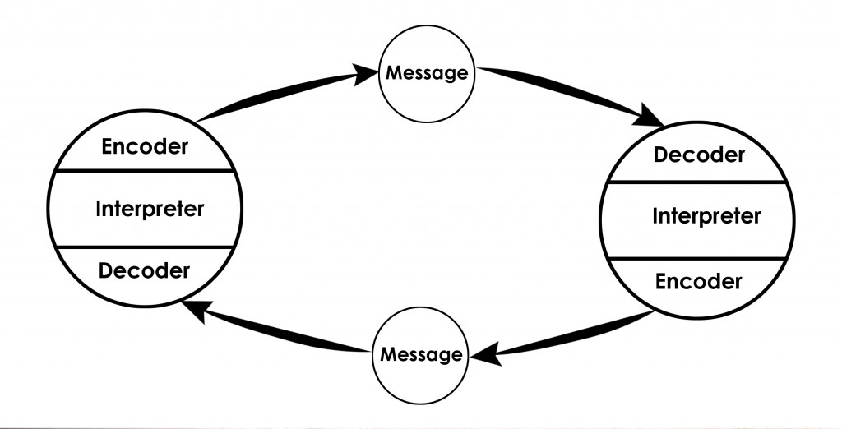

This refers to the professor and the village case study where the professor was living in a village around less civilised people, where his house was on fire and he screamed out to the villagers for help but he was ignored because he was speaking in a completely different language from what the villagers spoke which made his house destroyed because he couldn’t get help as nobody understood what he was saying.

The Berlo model of communication: The sender and receiver must be on the same wavelength, according to the Berlo model of communication in order for them to communicate and be understood by each other. Before the sender sends the message and before the recipient receives it, it focuses on encoding and decoding and it consists of four main components: sender, message, channel, and receiver. (BERLO).
Sender (source): Many factors influence this, including communication skills, mindset, experience, social structure, and community.
Message: this component is affected by many components like contents, element, treatment, structure and code.
Channel: Hearing, seeing, touching, smelling, and tasting all have an impact on this aspect.
Receiver: Communication skills, attitudes, experience, the social system, and culture all have an impact on this aspect.
This model refers to the Barry case study with his employees in the restaurant where he had employed diverse people which English is not their primary language so in this case they are not on the same level of communication. In this case according to the Berlo’s model Barry and his employees are not going to be able to communicate because they have to be good listeners to communicate with the sender of the information. 

One of the major problems at my work place is the communication between worker because a lot of people tend to misunderstand peoples information given to them. For example when you tell someone to do something a certain way and the person does it a different all because you have said it shouldn’t be done a certain type of way and then you get blamed for it because you corrected the way it was done by them initially.
Ways in which communication can be improved are:
- Considering employee communication app: The easiest way to meet all of the staff, including frontline and non-desk personnel, is to use a contact app. It enables you to communicate every type of information in an easily accessible and appealing manner that is customised to your company's brand. You can target and personalise your messages, as well as gather feedback on the efficacy of your communication, with this easy but comprehensive tool.
- Build a communication- friendly culture: You should provide your team with not only the right communication tools, but also a comfortable space where expressing emotions, exchanging thoughts, and broaching tough topics is encouraged.
- Ask for feedback: Top-down or one-way communication should never be the standard. Allow your workers to voice their opinions at all times. When it comes to reviews, make it possible to answer anonymously. Employees are also reluctant to give their bosses critical or negative reviews.
- Keep the flow going: Internal correspondence must be managed strategically, which necessitates a steady flow of information and discussion. For example, instead of annual reviews, as a manager, schedule monthly one-on-ones to stay current on your team members' workload and job satisfaction. Inquire about their well-being and what they want from you. Know that "less is enough," on the other hand. Do not bury your employees under a mountain of data. What you want to say to them, or what you want to ask them, should always be important to them.
- Introduce communication training: It's easier for your workers to form bonds, have difficult conversations, and solve issues as a group when you use the right techniques. One way to help the employees connect more efficiently and, as a result, collaborate and perform better is to hire a communication trainer.

This could aslo be improved by following the Schramm theory which tells you to be communicate with people in a way that is understood by both parties and not just a one way communication. This would help both the sender and the receiver to communicate fluently and not having to be misineterpreted so we have a good sender and receiver in this model.
In conclusion, for good communication to take place in most cases there must be a good level of understanding between the sender and receiver, the way we also communicate with people is also a very major factor from the tone to the attitude and manner at which we talk or approach people. Noise is also a major factor in communication because there can be so many hinderances in sending messages to people like sending emails to people and they don’t receive it, that is noise stopping the message from getting to the receiver. I would like to practice the Schramm model more at my workplace this would be more effective as it is more realistic.

References

Skills for Care (2016). Communication Skills in Social Care. [online] . Available at: https://www.skillsforcare.org.uk/Documents/Learning-and-development/Core-skills/Communication-skills-in-social-care.pdf. (accessed on 09.04.2021)
moodle.uwtsd.ac.uk. (n.d.). UWTSD Moodle 2020/21:Log in. [online] Available at: https://moodle.uwtsd.ac.uk/course/view.php?id=7030 [Accessed 09.Apr. 2021].
Communication Theory (2014). Shannon and Weaver Model of Communication. [online] Communication Theory. Available at: https://www.communicationtheory.org/shannon-and-weaver-model-of-communication/. (accessed on 10.04.2021).
www.google.com. (n.d.). schramm model of communication - Google Search. [online] Available at: https://www.google.com/search?q=schramm+model+of+communication&oq=schr&aqs=chrome.2.69i57j0i67l2j46i67j0i67j0i433j46i433j0i433j0i67i433j0i67.3908j0j7&sourceid=chrome&ie=UTF-8 [Accessed 30.04. 2021].
Communication Theory. (2014b). BERLO’S SMCR MODEL OF COMMUNICATION. [online] Available at: https://www.communicationtheory.org/berlos-smcr-model-of-communication/. (Accessed on 11.04.2021).

Education Executive. (2017). The seven Cs of Communication – Edexec.co.uk. [online] Available at: https://edexec.co.uk/the-seven-cs-of-communication/. (accessed on 29.04.2021).
Verschuren, R. (n.d.). How To Improve Communication in the Workplace: 5 Tips | Speakap. [online] www.speakap.com. Available at: https://www.speakap.com/en/blog/how-to-improve-communication-in-the-workplace. (accessed on 29.04.2021).
Lumenlearning.com. (2019). Communication Challenge: Listening | Introduction to Communication. [online] Available at: https://courses.lumenlearning.com/introductiontocommunication/chapter/challenge-listening/. (accessed on 30.04.2021).

