EFFECTIVE TEAM WORKING AND COMMUNICATION
BMSW4002

RUGEYRO ARENAS ID:1916149
DARLIN ROSIS ID:1914225
YSMAEL RAMIREZ ID:1912612
KAMAL SALEC ID:1909112
NATALIA CASTANO ID:1916149

SYED JAFFERY

UNIVERSITY OF WALES: TRINITY SAINT DAVID.
PRIFYSGOL CYMRU: Y DRINDOD DEWI SANT.

28-AUG-2020
TABLE OF CONTENTS
BENEFITS OF TEAM WORKING 1

STAGES OF TEAM WORKING 2

TEAM ROLES (BELBIN) / LEADERSHIP ROLES (HERSEY & BLANCHARD) 3
Belbin Theory 3
Belbin’s Nine Team Roles 3
Leadership Roles Hersey & Blanchard 4

MANAGING CONFLICT (THOMAS & KILMANN) 5

SUCCESSFUL TEAM DEVELOPMENT 7
STRONG TEAM 7

BIBLIOGRAPHY 8

APENDIX 9

RUGEYRO ARENAS
1916149

BENEFITS OF TEAM WORKING

- A definition of effective team is therefore: A group of persons who dominate different skills to work in a team to achieve a common goal. (Carysforth, 2003)

- “Coming together is a beginning. Keeping together is progress. Working together is success.”
- Henry Ford (pioneer of the assembly-line production method)

Teamwork is a fundamental part of workplace achievement. Like a football team working together to score a goal, every team member has a special role to play in a finishing tasks on the job. This mean that when everyone works together to achieve goals, everyone wins.

Teamwork mean work and built relationships with other members using different important skills and habits such as:
- Sense of responsibility
- Communication (as Sender and Receiver)
- Sharing ideas
- Giving suggestions
- Working cooperatively
- Accept and respect different opinions

Working in a team mean that there is no “I”, there is a different option such as We, Our and many more. Being an admirable team member is learning how to understand what you have to offer to your colleagues (Personal Strengths) but is understand at the same time what you might need from others.

Teamwork can be difficult. Dealing with many personalities and compromise in not easier.

Skills for each member of a team:
- Effective Communicator
- Flexible
- Cooperative
- Reliable
- Active Listener
- Respectful
- Problem Solver

DARLIN ROSIS
1914225

STAGES OF TEAM WORKING
Bruce Tuckman: he was born in 1938, he was professor in philosophical, psychological, and comparative studies in Ohio State University. In 1965 he published an article calling ‘Development sequences in group, this theory is about the four phases of group development: forming, storming, norming, performing. In 1970 he added the fifth stage named adjourning.

- Forming:
- High dependence on the leader for guidance and direction.
- Individual responsibilities are unclear.
- The leader must be prepared to answer a lot of questions about the team purpose.
- Member test the tolerance of system and leader.

- Storming:
- A lack to make a group decision.
- Clarity of the team purpose increase.
- Compromise may be required to enable progress.

- Norming:
- Roles and responsibilities are clear and accepted.
- The team discusses and develops its processes and working style.
- Big decisions are made by group agreement.
- Commitment and unity are strong.

- Performing:
- The team has high degree of autonomy.
- Team members looking after each other’s.
- Team requiring delegated task and projects from the leader.
- The shared vision of the team.

- Adjourning:
- The team achieved their projects.
- There is good relationship in the team.
- They think in the improvement of the team.
- The team celebrate their successes.

YSMAEL RAMIREZ
1912612

TEAM ROLES (BELBIN) / LEADERSHIP ROLES (HERSEY & BLANCHARD)

Belbin Theory
Belbin's theory was developed in 1981. This theory is based on the behaviour of people when they work as a team. Belbin was able to discover nine types of teamwork behaviour, he classified them into three different groups.
- Thought Oriented Roles: where three team roles Plant, Specialist and Monitor are included.
- Action Oriented Roles: Shaper, Implementer and Completer / Finisher.
- People Oriented Roles: teamwork, Coordinator and Resource Investigator. (Cambridge, 2016)

All this means that for your team to be successful, the nine aspects must be covered, but in the same way this does not mean that in a team it must have nine members, because one person can fill several roles.

Belbin’s Nine Team Roles
Thinking
- Plant
Strengths: Imaginative, free-thinking, problem solving.
Weaknesses: too preoccupated to communicate effective.

- Specialist
Strengths: provide specific knowledge and skills.
Weaknesses: contribute on a narrow front and can dwell on the technicalities.

- Monitor Evaluator
Strengths: judges accurately and sees all options.
Weaknesses: may be too much critical.

Action
- Shaper
Strengths: dynamic and challenging.
Weaknesses: easy to provoke and can easily offend the feelings of others.

- Finisher
Strengths: conscientious, anxious and Searches out errors.
Weaknesses: worries too much and doesn't like to delegate.

- Implementer
Strengths: Practical, efficient and organises work that needs to be done.
Weaknesses: can be a bit inflexible.

People
- Coordinator
Strengths: Identifies talent, mature and confident.
Weaknesses: others can see it as powerful and manipulative.

- Team worker
Strengths: Perceptive, diplomatic and co-operative.
Weaknesses: tends to avoid confrontation and can be indecisive in crunch situations.

- Resource investigator
Strengths: Outgoing, enthusiastic, develops contacts and explores opportunities.
Weaknesses: Might be over-optimistic. (Belbin, 2020)

Leadership Roles Hersey & Blanchard

This theory explains that are four leadership styles; telling, selling, delegating, and participating.
Those styles have to be combined with the four levels of maturity; they need to be combinate correctly to have successful results. The leader has to choose with style he is going to use according to the task and the team that they have.

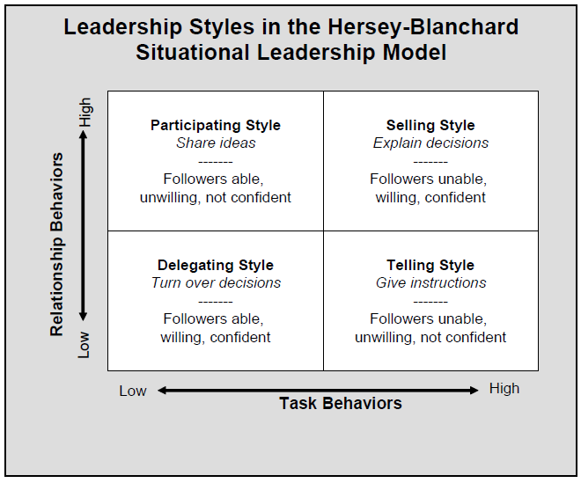 (HANIZADJALI, 2014)

KAMAL SALEC
1909112

MANAGING CONFLICT (THOMAS & KILMANN)

In a group sometimes the members do not agree on some things among themselves, which sometimes leads to conflicts due to their character, accumulated stress, ego ... Therefore, action must be taken before the situation becomes more unpleasant. This could be handled in a number of ways. In this case we will choose the acceptable Thomas-kilmann model. Which is an excellent way to handle these situations.

In the 1970s Kenneth Thomas and Ralph Kilmann developed a conflict model, describing conflict as the condition in which people's concerns are incompatible. If two things that concern two people are opposed, then there is conflict.

The word conflict has a natural negative association of fighting, yelling, and arguing. This makes conflict seem like something to be avoided at all costs. However, the conflict has a very positive side of debating, questioning and challenging the status quo. If conflict is seen as a simple incompatibility of concerns, then it is a rational question to choose an approach in each situation. We can then control the conflict through our choice of approach.

The Thomas Kilmann model identifies two dimensions when choosing a course of action in a conflict situation, these are assertiveness and cooperation. Assertiveness is the degree to which you try to satisfy your own needs, while cooperativeness is the degree to which you try to satisfy the other person's concerns. From there arise five modes of conflict management.

1.Avoiding: Sidestepping the conflict.

2.Accommodating: Traying to satisfy the other persons concerns at expense of your own.

3.Compromising: Trying to find an acceptable settlement that only partially satisfies both people concern.

4.Competing: Trying to satisfy your concern at the expense of others.

5.Collaborating: Trying to find a win-win solution which completely satisfies both people concern.
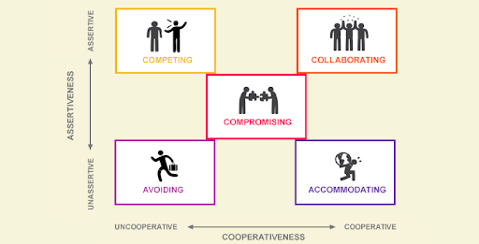

No method will make sense to solve a problem if the people on the team do not listen to each other, do not recognize, respond or resolve differences.

NATALIA CASTANO
1916149

SUCCESSFUL TEAM DEVELOPMENT

- Focus on roles: Everyone in team know already what their strength are and what they give to team to make it stronger and to develop their skills.

- Each Role is important: Every member of the team has skills that makes them unique and important to the team.

- Communication: Keep everyone updated, ask for opinion and give feedback. It is very important to keep communication clear and transparent and to make sure everyone knows every step and decisions that are taken and also to give feedback when is needed.

- Set realist goals: Have common objectives and have deadlines. Have long and short terms goals is very important to complete daily tasks, knowing every task is important to meet their objectives.

- Celebrate successful and failures: Appreciate every effort and support each other in tough times. If someone in the team is doing a great job highlight it so they know every effort is appreciate and they feel value, this will contribute to a greater performance. On the other hand, if the team fails the best way is to come together and turn the situation into a new experience.

- Know each other: Interact with the team to understand their motivations and concerns.
- It does not mean to become best friends it is just important to socialize to get to know your team members in other environment to understand them and to help them when they need extra help. (Johnson, 2016)

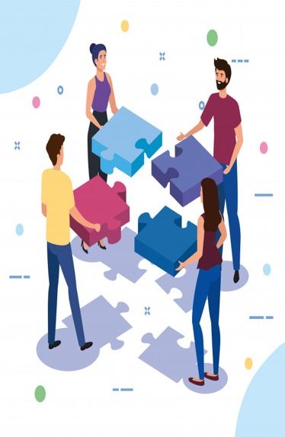

BIBLIOGRAPHY
Anon., n.d. [Online].
Belbin, 2020. The Nine Belbin Team Roles. [Online]
Available at: https://www.belbin.com/about/belbin-team-roles/
[Accessed 28 july 2020].

Cambridge, U. o., 2016. Belbin's team roles. [Online]
Available at: https://www.ifm.eng.cam.ac.uk/research/dmg/tools-and-techniques/belbins-team-roles/
[Accessed 01 August 2020].

Carysforth, C., 2003. OCR Certificate in Administration Level 2. 1st Edition ed. s.l.:Heinemann.
Gaille, B., 2018. 13 Situational Leadership Advantages and Disadvantages. [Online]
Available at: https://brandongaille.com/13-situational-leadership-advantages-and-disadvantages/
[Accessed 10 July 2020].

HANIZADJALI, 2014. Hersey and Blanchard Situational Leadership Model. [Online]
Available at: https://pmioman14.wordpress.com/2014/06/06/w1_hani_tuckman-assessment/
[Accessed 28 july 2020].

Johnson, C., 2016. Entrepreneur Europe. [Online]
Available at: http://entm.ag/20AyIhC
[Accessed 10 08 2020].

KENTON, W., 2020. Hersey-Blanchard Model,BUSINESS LEADERS,. [Online]
Available at: https://www.investopedia.com/terms/h/hersey-and-blanchard-model.asp
[Accessed 10 July 2020].

Luenendonk, M., 2019. Situational Leadership® Guide: Definition, Qualities, Pros & Cons, Examples,. [Online]
Available at: https://www.cleverism.com/situational-leadership-guide/
[Accessed 10 July 2020].

Nguyen, M., 2017. Learn Belbin Team Roles through Reflection. [Online]
Available at: https://dotnetsharing.wordpress.com/2017/09/19/learn-belbin-team-roles-through-reflection/
[Accessed 03 July 2020].

Noordin Yahaya1, Mohammad Aslan B Mohammad Taib1, Jasmi Ismail1, Zainudin Shariff1, Azizi Yahaya2*, Yusof Boon2 and Sharin Hashim2 , 2011. Relationship between leadership personality types and source of power and leadership styles among managers. [Online]
Available at: https://www.researchgate.net/figure/Leadership-styles-in-the-Hersey-Blanchard-situational-leadership-model_fig1_267372486
[Accessed 10 July 2020].

APENDIX



