Module Name: Entrepreneurship

Assignment 1 Title: Individual Business Model Canvas with entrepreneurial reflection using appropriate academic models

Module Code: BMIH5001

Student Name: Ionut Paul Poltz

Student ID: 2022 1194 41

Lecturer’s name: Ben Chong

Part 1
Introduction
The pursuit of sustainable innovation in the hospitality industry is discussed in this essay’s strategic formulation of a BMC for an EcoHaven Hospitality conceptual venture. Through justifications and detailed explanations, contemporary examples and sources demonstrate decision-making trends that leverage knowledge to shape existing business concepts into new businesses. In particular, a great deal of attention is drawn to the deconstruction of the value proposition in which its uniqueness and competitive edge among current market offerings are emphasised. Through the detailed dissection of each BMC section from customer segments to key resources, this essay shows some complexity about “EcoHaven Hospitality” and its potential impact on changing luxury hospitality through strong environmental consciousness.
Discussion
EcoHaven Hospitality’s primary target audience includes ecological tourists who desire to transcend themselves when travelling into the beauty and simplicity of nature. There are many travellers who care about sustainability while choosing accommodations that suit their environmental principles (Barringer and Ireland, 2018). These insightful individuals are those who spend money on high-end events. It gives them the feeling of intimacy with nature and comforts as well. Further, there is an opportunity for derivative segments that are sustainability-oriented companies seeking to promote team unity through eco-friendly corporate retreats and team building events (Williams, 2021). The emphasis on ecological tourists who love nature also corresponds well with the trend towards sustainable forms of travel. Through the development of this niche market, “EcoHaven Hospitality” can create a competitive edge and seize on one of today’s most important trends in travel going green.
In “EcoHaven Hospitality”, we offer a blend of luxury and environmental consciousness that has yet to be matched. Our glamping sites act as sanctuaries for guests in which they can cultivate intimate connections with nature and enjoy unprecedented luxuries. We stand out by offering immersive lifestyles that blend luxury lodging with ecologically good approaches, making us a forward-looking voice in the hospitality industry (Burns, 2022). The value proposition of EcoHaven Hospitality relates to the fact that it is aimed at meeting changing demands and preferences of modern tourists who prefer nature travel with sustainability (Nelson, 2013). Through this combination of both luxury and ecological awareness, we can also catch the attention of travellers who appreciate realities in nature.
The digital media, eco travel community groups and partnerships with the lifestyle brands such as food display caterers form part of our strategy for marketing EcoHaven Hospitality. The digital media and partnerships allow us at EcoHaven Hospitality to reach out therefore promoting our intent in sustainability demonstrated through dedicated websites as well social media sites (Rickman and Roddick, 2013). Connecting with eco-travel communities and collaborating with travel agencies will enable us to increase the brand’s visibility, reach potential guests who share our values.
In ‘EcoHaven Hospitality, one of the most important things is to build relationships with our guests that will last. Our focus is from the personalized services that will make each customer feel appreciated and satisfied. Through our active encouragement of feedback and by engaging them in an online environment, we build a sense of community that is based among the customers (Blackwell, 2011). The customer loyalty programs, specials and regular newsletters guarantee the guests to remain loyal for future visits. Customer relationship investments, such as customer retention and positive word-of mouth marketing are crucial for repeat business. Through special service and open channels of communication, “EcoHaven Hospitality” can build a base of returning customers who are more satisfied with the services as compared to their counterparts (Hisrich et al., 2018).
The sources of revenue for EcoHaven Hospitality include room fees, specially oriented activity packages and strategic partnerships. Leveraging special experiences and partnering with local enterprises for genuine regional operations, we create alternative revenue sources that attract diverse guests (Mariotti and Glackin, 2012). Research on corporate collaborations for eco-friendly retreat alternatives can offer other income streams. Rae (2008), states that revenue stream diversification minimizes dependency on a single revenue source and balances against financial risk. “EcoHaven Hospitality” can boost its revenue by providing custom activity packages and establishing strategic partnerships in order to provide value-added services for guests.
The success of “EcoHaven Hospitality” relies on the presence of pristine natural locations, partner suppliers that are responsible and a team committed to eco-tourism (Rono, 2023). There is a significant role of effective partnerships and community involvement in sustainable tourism activities. Site selection, operational excellence and environmental sustainability are dependent on building relationships with local communities (Timmons and Spinelli, 2008). Working with the local native community and responsible supplier partners guarantees that business is done ethically, as well as makes guest experiences more real. Through focusing on sustainable resource management and community engagement, “EcoHaven Hospitality” can turn social and environmental impacts into business success.
At “EcoHaven Hospitality,” our operational focus identifies the maintenance and operations of our glamping sites which entails site development, green infrastructure management, as well as nature immersion activities (Zimmerer and Scarborough, 2011). Marketing and community relation activities are also essential for guaranteeing the continuity of guests into the Haven and an active eco-friendly community. Investing in site development and green infrastructure management is critical to maintaining sustainability in “EcoHaven Hospitality.” The provision of quality nature immersive experiences, as well as effective marketing strategies that highlight community engagement for guests who practice eco-travel lifestyle can be used as an example of this program.
The principle of collaboration is the basis for ‘EcoHaven Hospitality’. We can also be in a position to refine our services, enhance the output credible location improvements alongside sustainable goals measurement that helps us better realize mutual benefits for all parties by as well working with environment groups and local authorities plus communities. It is essential to engage local leaders and people closer for successful site landing. By collaborating with environmental groups and local communities, sustainability efforts of ‘EcoHaven Hospitality’ are strengthened even more while contributing to a stronger sense of realness in the experience for guests (Mair and Smith, 2022). We can manage to address both positive social and environmental consequences when achieving business prosperity by incorporating the stakeholders.
The cost structure for “EcoHaven hospitality” involves initial capital spending on land purchase, development and the design of green infrastructure. According to De et al. (2020), operational expenses include the use of human resource, marketing activities and sustainability-oriented operations. Long-term success and resilience of the hospitality industry will largely depend on its investments in renewable energy sources as well eco-friendly facilities. Supporting sustainable infrastructure and sustainability initiatives reflects the worthiness of environment-friendly travel (Streimikiene et al., 2021). Through shifting focus on sustainability in our cost structure, “EcoHaven Hospitality,” we can improve brand reputation, attract green guests and ensure long-term financial viability.
We provide in “EcoHaven Hospitality” a unique blend of luxury and eco-awareness, my glamping sites become nature connection sanctuaries where one can immerse oneself into deep healing comforts.
We distinguish “EcoHaven Hospitality” by creating unique, immersive experiences that blend sustainable practices and luxury accommodations (Manfreda et al., 2023). Our unique glamping offers are not just confined to our customized units but make it a point for every guest experience through organized activities such as nature walks and mediative star gazes.
Care and Precision into all elements of our offer are what make us unique. Our commitment to sustainability does not detract from the luxury that we offer; it only makes our services better. Every single detail, from eco-friendly amenities to sustainable energy sources is all about providing extravagance without betraying our green philosophy.
In order to achieve this, we focus on dealing with local vendors who are concerned about engaging in practices that promote sustainability (Cunha et al., 2020). Utilizing local materials and resources, we minimize our carbon footprint onto the planet, support the local economy for business sustenance as well as remain in tune with principles of sustainability (Hariram et al., 2023). Our partnership with local artisans for unique, region-centric amenities expands our care towards the community.
In contrast to the competitors focusing solely on eco-friendliness, “EcoHaven Hospitality” is distinguished by its comprehensive approach (Khachatryan et al., 2023). It is not only about being green; it is creating the perfect integration of extravagance and sustainability. Although others provide environmentally friendly lodgements, we do more; the entire aspect of our guests’ stay is based on environmental awareness.
Looking at the local competitors, we have found a market gap, there is no offer that easily combines luxury and sustainability. “EcoHaven Hospitality” fills this gap by offering an experience that meets the needs of discriminating travellers who demand both comfort and a deep sense of communion with nature (Wong et al., 2021).
Conclusion
In contrast to the rest of its rivals in this paradigm, “EcoHaven Hospitality” is different with a combination of luxury and environmental concerns. The difference between our immersive experiences which incorporate sustainable elements with luxurious hold and those manual providers of the same kind is quite clear. Additionally, we distinguish ourselves with a strong preference for domestic goods and long-term partnerships with sustainable vendors who help to reduce the carbon footprint while supporting regional needs. In contrast to competitors who specialize only in eco-friendliness, we provide a holistic approach where every element of our guests’ stay represents our commitment to sustainability and guarantees an unforgettable experience. However, by carefully evaluating the local competitors we have found an occupied vacancy on the market allowing “EcoHaven Hospitality” to become a leader in luxury with an environmental touch.
Part 2
Introduction
In this essay, I will utilize the Gibbs reflective cycle to analyse my personal entrepreneurial/managerial test results obtained from in-class questionnaires. Through structured reflection, I will critically evaluate my entrepreneurial and management motivations and characteristics, employing relevant academic models and frameworks to provide insights and recommendations for further development.
Discussions
The entrepreneurial/managerial test result reception encouraged me to conduct a detailed analysis of my total scores and score metrics. The Overall Get2 Score value of 57% presented a moderate entrepreneurial aptitude, with Need for Achievement and Creative Tendency at 58%, indicating the balanced drive for goal attainment integrated with innovative thinking. Interestingly, the low score of 0% for Need for Autonomy and higher scores of 67% on Calculated Risk Taking as well as a score of 75 % in Locus Control increased some interesting questions about my entrepreneurial mindset.
My first reaction was a combination of delight and surprise. Although the acceptable overall score and measurements of Need for Achievement (autonomy) as well as Creative Tendency were sufficient, problems with higher risk-taking and external locus of control emerged. This led to a greater reflection on my entrepreneurial and management drive.
A critical reflection revealed an equal mix of entrepreneurial characteristics. The Strong Need for Achievement and Creative Tendency represent ambition and innovation. Nevertheless, the 0% for Need for Autonomy raised questions as to comfort level with independence and high scores on Calculated Risk-Taking and Locus of Control indicated tendency towards risk tolerance and external beliefs.
Using the academic theories, models and frameworks, it helps to continue to assess my entrepreneurial and managerial propensity (Rickman, and Roddick, 2013). These theories indicate that individuals having high achievement tendencies are likely to succeed in entrepreneurial projects and those with strong autonomy might find themselves preferring independent choices. These concepts match my findings to some extent, showing the right balance between acquisition orientation and risk propensity.
Looking at my scores, I can see both numerous strengths and weaknesses of entrepreneurial as well as managerial profile. Though I have traits such as creativity, risk propensity and internal locus of control the areas that need improvement are independence in decision-making processes.
In order to leverage my entrepreneurial and managerial skills, I will continually look for opportunities to make decision making independent of situations that call upon personal projects or businesses. In addition, it is necessary to develop the ability to assess risks as such; use calculated risks in accordance with the established objectives and values (Nelson, 2013). As I capitalize on my strongholds and work towards improving weaker ones, then it will be easier for me to become an all-inclusive entrepreneur with the direction of success in future business.
Conclusion
My entrepreneurial/managerial test results revealed a balanced mix of strengths and areas for improvement. While possessing traits such as creativity and risk-taking, I need to focus on enhancing autonomy in decision-making processes. Moving forward, I aim to cultivate independence and refine my risk assessment skills to excel in future entrepreneurial endeavours.

References
Barringer, B. R. and Ireland, R.D., 2018. Entrepreneurship: Successfully Launching New Ventures, 4 th Ed., Prentice Hall: New Jersey
Blackwell, E., 2011. How to Prepare a Business Plan: Planning for Successful Start-up and Expansion, (5th Ed) Sunday Times Business Enterprise Series, Kogan Page
Burns, P., 2022 Entrepreneurship and Small Business, 5 th Ed., Palgrave Macmillan: Basingstoke
Cunha, C., Kastenholz, E. and Carneiro, M.J., 2020. Entrepreneurs in rural tourism: Do lifestyle motivations contribute to management practices that enhance sustainable entrepreneurial ecosystems?. Journal of hospitality and tourism management, 44, pp.215-226.
De, D., Chowdhury, S., Dey, P.K. and Ghosh, S.K., 2020. Impact of lean and sustainability oriented innovation on sustainability performance of small and medium sized enterprises: a data envelopment analysis-based framework. International Journal of Production Economics, 219, pp.416-430.
Hariram, N.P., Mekha, K.B., Suganthan, V. and Sudhakar, K., 2023. Sustainalism: An integrated socio-economic-environmental model to address sustainable development and sustainability. Sustainability, 15(13), p.10682.
Hisrich, R.D., Peters, M.P. and Shepherd, D.A. (2008) Entrepreneurship, 7th Ed.,McGraw Hill: NY
Khachatryan, A., Sakhbieva, A., Kirpicheva, M., Dolgova, M. and Chernov, S., 2023. Consumer Demand for Environmental Friendliness as a New Round of Modern Marketing Development. Polish Journal of Environmental Studies, 32(5).
Mair, J. and Smith, A., 2022. Events and sustainability: why making events more sustainable is not enough. In Events and sustainability (pp. 1-17). Routledge.
Manfreda, A., Melissen, F., Presbury, R., Richardson, S. and King, J., 2023. A model of luxury lodge experience quality. Journal of Hospitality and Tourism Management, 54, pp.486-499.
Mariotti, S. and Glackin, C., 2012. Entrepreneurship: Starting and Operating a Small Business (3rd Ed), London: Prentice-Hall.
Nelson, O., 2013. Enterprise development in SMEs and entrepreneurial firms dynamic processes. IGI Global.
Rae, D., 2008. Entrepreneurship: from opportunity to action, 2nd Ed., Basingstoke: Palgrave Macmillan
Rickman, C., and Roddick, D., 2013. The Small Business Start-Up Workbook: A step-by-step guide to starting the business you’ve dreamed of. London, How To Books
Rono, M., 2023. The role of local business in ecotourism in Central Finland.
Streimikiene, D., Svagzdiene, B., Jasinskas, E. and Simanavicius, A., 2021. Sustainable tourism development and competitiveness: The systematic literature review. Sustainable development, 29(1), pp.259-271.
Timmons, J. and Spinelli, S., 2008. New Venture Creation: Entrepreneurship for the 21st Century, McGraw Hill: Boston
Williams, S., 2021. FT Guide to Business Start Up 2021-2023. Pearson UK.
Wong, J.Y., Hsiung, M.L., Lee, S.J. and ChouHuang, C.Y., 2021. The relationship between endurance involvement and travel behavior in camping and the moderating effect of place attachment. Sustainability, 13(9), p.5016.
Zimmerer, T.W. and Scarborough, N.M., 2011. Essentials of Entrepreneurship, 6th Ed., Prentice Hall: New Jersey.

Appendices
Appendix 1: Business Model Canvas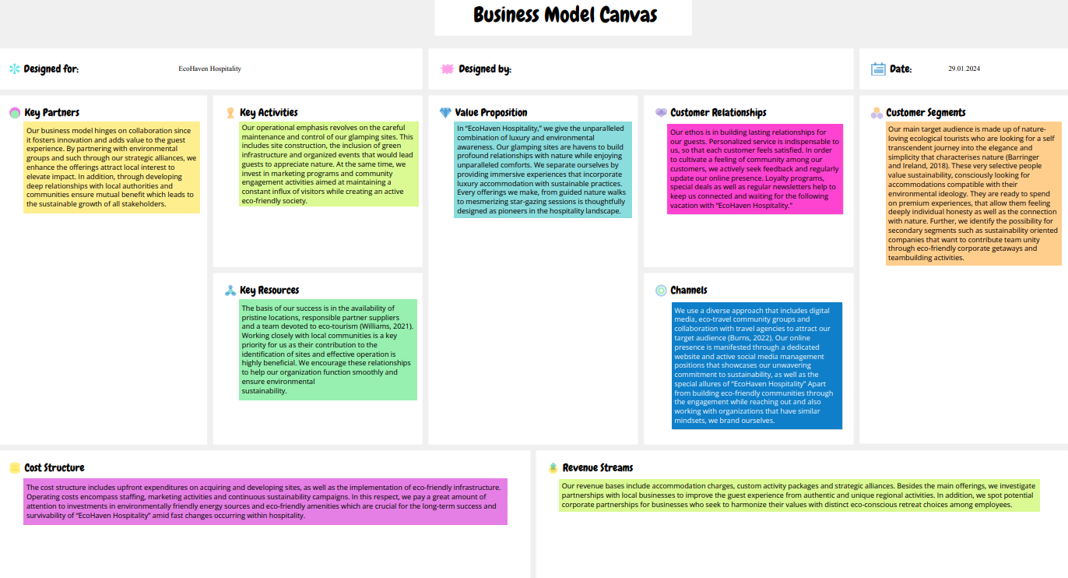

Appendix 2: Test result


