Chapter three – Methodology

3.1 Introduction

The literature review chapter of the dissertation completed objective one by analysing the current literature that is available surrounding neurodiversity and neurodiversity within the police force. This chapter of the dissertation seeks to achieve objective two which is:

- Objective 2: To identify the research method most suitable to gather data surrounding police officer’s views on Neurodiversity in the workplace.

Research is the activity of data collection, with the purpose of identifying social trends (Mogalakwe, 2006), and is an important part in academic or professional duty which is defined as a structured investigation for discovering knowledge (Bahodirovich, 2025). Objective two of this dissertation seeks to collect primary data from serving police officers, primary data is an approach which collects first hand data from an individual (Taherdoost, 2021), whilst secondary data is scoped from studies which are published in articles such as journals and books (Mazhar, 2021).
Quantitative and qualitative research are designs which are applied whilst collecting data. Quantitative research focuses on numerical data and is structured by establishing patterns and trends (Dehalwar, 2023). Quantitative research aims to test hypotheses and is beneficial for obtaining large data and statistics in a timely manner, it is often the preferred method for participants due to the uncomplicated and straightforward method.
Qualitative data refers to data which is often gathered through interviews (Pilcher, 2023), or questionnaires utilizing open ended questions. Qualitative data is more in depth and focuses on understanding the ‘How’ and ‘Why’ of the research rather than the statistics.

3.2 The Research Onion
The Research Onion is a framework developed by Saunders et al, 2016, to help formulate an effective and transparent methodology (Abdelhakim, 2021). The framework will structure the research undertaken for this dissertation.
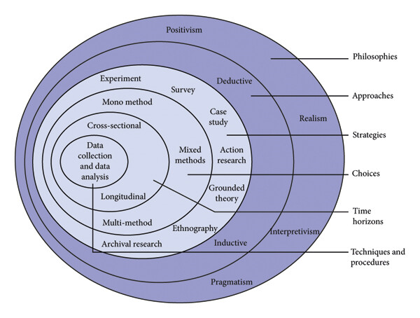
Figure 1. Research onion model (Saunders et al., 2016)

The Research Onion resembles an onions layer, when peeled back, they resemble a different aspect of the model. The core of the Research Onion is the data collection and data analysis which meets the main objective of this dissertation.

3.3 Research approach
As displayed in 3.1, Figure 1 - The Research Onion model, demonstrates the sections required to fulfil the objectives of research. The mono-method approach of the onion resembles the use of qualitative and quantitative data and the choices that one can utilise for research. The strategies undertaken for this dissertation, seek the collection of primary data which are outlined in detail in 3.3 – The Research strategy. Nearing the outer layer of the Research Onion is the choices, the choices are split into two categories – Deductive and Inductive.
The deductive approach starts with a theory, the implications of the theory are then tested with the data (Usman, 2021) received from the study. The inductive approach is the opposite of the deductive approach. As stated by Usman 2021, it starts with a collection of observations, then looks for patterns in the data in attempt to create a hypothesis to explain the patterns.

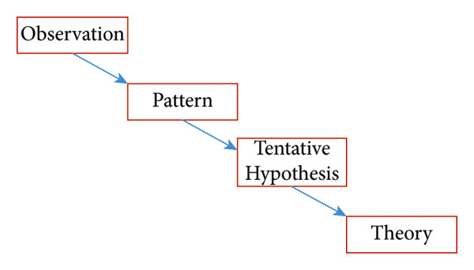

Figure 2. The Inductive approach (Source Usman 2021)
The Inductive approach will be applied for this dissertation. The initial observations of the study present the lack of discussion surrounding neurodiversity within South Wales Police. The study seeks to identify any patterns, evidence the hypothesis and obtain a theory in the findings of the surveys.

3.4 Research strategy
The research strategy for this project is to obtain quantitative research methods from primary sources. The research method that will be used will be a questionnaire with simple check box answers, this is due to time restraints as police officers have limited spare time during their tour of duty. The project aims to collect a quantity of data from serving police officers, the data will be obtained by seeking permission from officers with South Wales Police who are willing to participate.

3.5 Time scale
The Research Onion framework presents two-time horizons – Cross sectional and longitudinal. The cross-sectional time horizon captures a momentary picture of a specific group at one time (Mphale, 2024), this best suit the projects time scale as it seeks to obtain this information in a particular time.

3.6 Data collection
The collection of data represents the key findings of any research project (Bryman, 2016), the collection of data for this project will be in the form of quantitative questionnaires. The interviews will be structured through Microsoft forms, in the format of a questionnaire with tick boxes. The questions will be structured to suit the projects intentions, the participants will be able to select one or multiple boxes to complete the questionnaire. Data collection in the Research Onion framework seeks to identify techniques and procedures.

3.7 Limitations
The limitations to this dissertation are minor, aside from time constrictions due to officers’ high workloads, the sample population for the project may not be large enough to obtain valid reflection to the data. The questionnaire has been set out in a simplistic manner which is straightforward to navigate, therefore, making it more appealing for individuals to participate. The collection of data in the form of a quantitative study is best suited to this project, as it is timely and simple for officers to complete.

3.8 Ethical issues
Prior to the commence of data collection for this project, an ethics form has been completed to ensure that the project was commenced in an ethical manner. The project was approved by the course supervisor. Prior to the questionnaire aspect of this project, participants are informed that they may withdraw their consent at any time and that their identity would remain anonymous throughout.

3.9 Conclusion
This chapter of the project has concluded the methodology, it has outlined the methods that will be utilised for the questionnaire process. It has highlighted objective two and has explained the process of the objective. The next chapter of the dissertation seeks to analyse the data that collected as part of this project and examine whether Neurodiversity has a positive or negative effect on policing.
Word count – 981

