Dylan Hocking (2312757)
2312757@student.uwtsd.ac.uk
OS install and setup
Introduction to Computer Systems (ACCA4021)

Table of Contents
1.0. Setting up a Virtual Machine 2
1.1. Creating the Virtual Machine 2
1.2. Split Memory into two Partitions 4
2.0. Downloading Software 8
2.1. Connect to Network 8
2.2. Downloading Chrome and OpenOffice 9
3.0. Drivers 13
3.1. Explanation of Drivers 13
3.2. Driver Setup 13
3.3. Network and Sound Card Drivers 16
References 16

1.0. Setting up a Virtual Machine

1.1. Creating the Virtual Machine
When first creating the virtual machine, a setup page appeared so the author then followed the steps to create the machine. The first step was to name the virtual machine, the author named the machine windows7. Also, the page asks for a file destination for the virtual machine to be saved in and the file destination for an ISO that will be used, the author used a windows 7 ISO image.
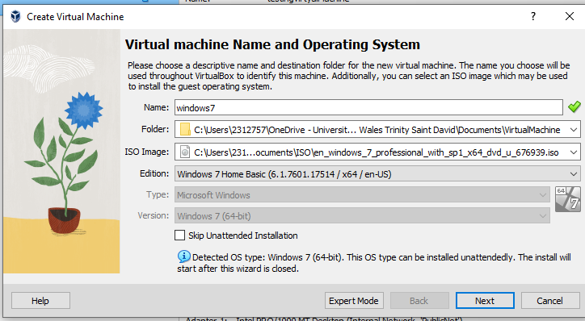
Then, the setup page asks for a username and password, so the author used “Admin” as the username and used “admin@123” as the password.
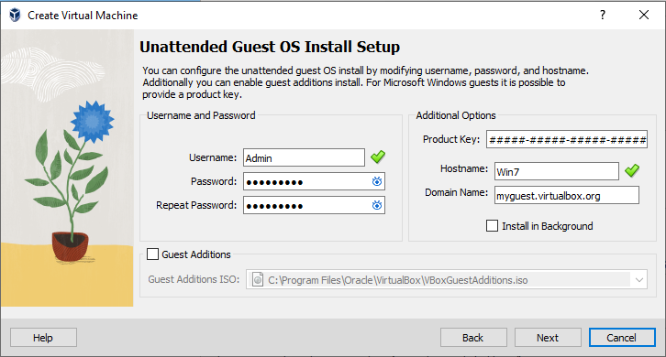
The next step was to set up the amount of RAM and the number of cores the virtual machine has. The author then used 4096MB of RAM, as the amount is fine the virtual machine will not need so much RAM because the author would not need to do high RAM taxing tasks [1]. They also chose to use two cores as the computer they were using had 24 cores and to check to see if the extra core would help the virtual machine.
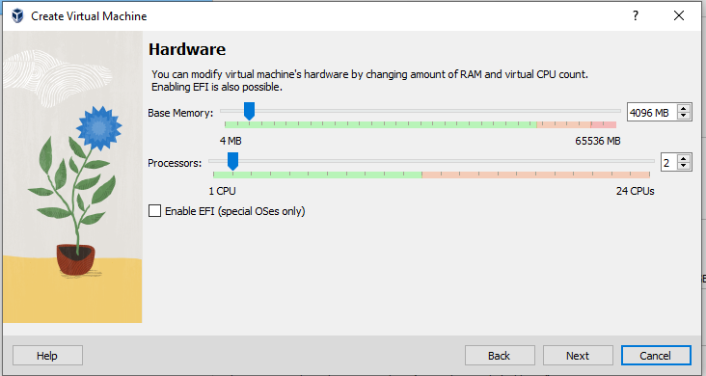
The author then needed to set a size for the hard disk of the virtual machine, they set it to 32GB because it would give the machine plenty of space to download software and split the hard disk as well.
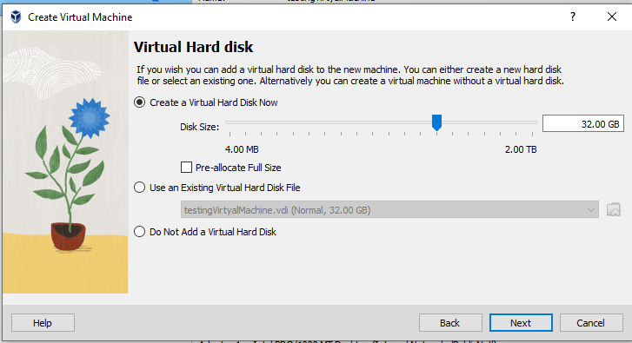
A summary of the virtual machine and all the changes the author has made are shown below.
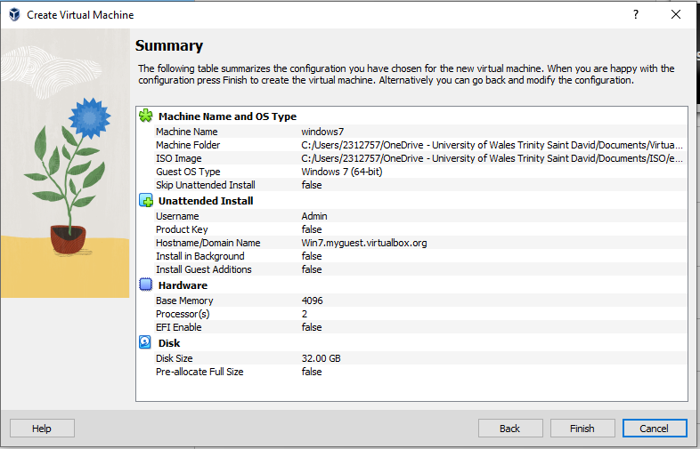
The virtual machine has been created and shows information about the machine.
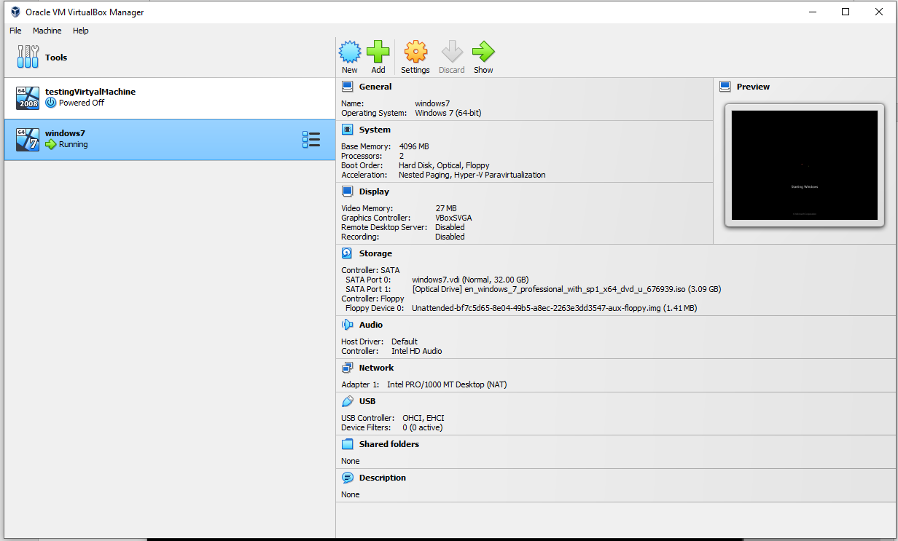

1.2. Split Memory into two Partitions
The author powered on the virtual machine and installed the widows 7 operating system using the ISO image provided at setup.
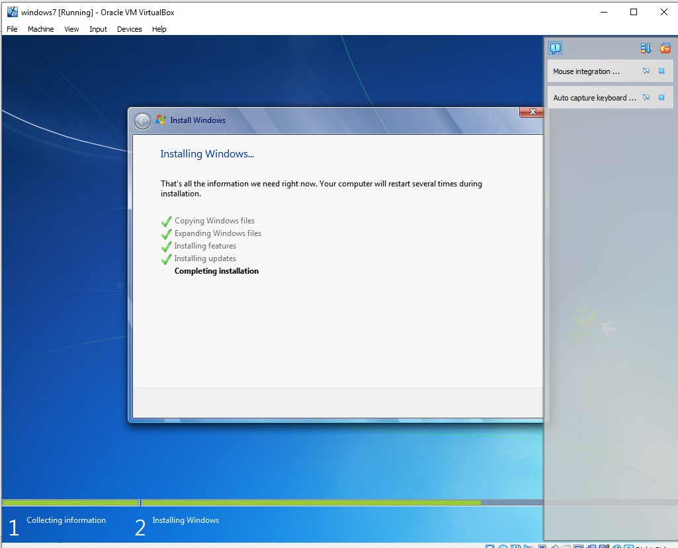
The next thing the author was tasked to do was to split the hard disk into two partitions. The author accessed the computer management window when the virtual machine finished starting up.
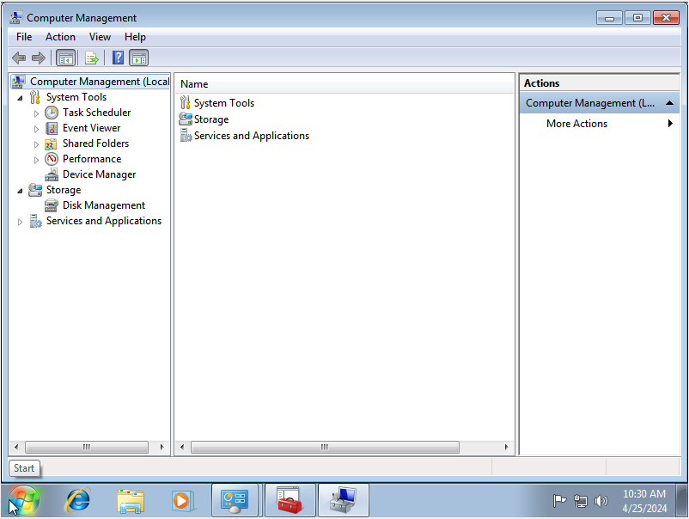
Then the author accessed the ‘Storage, Disk Management’.
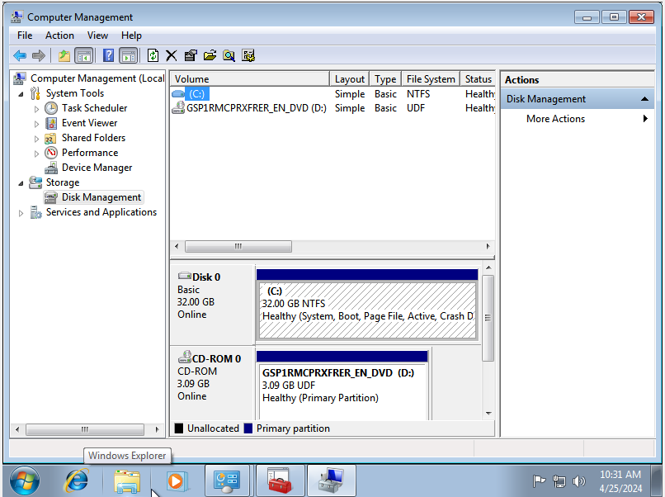
Next the author right clicked on the ‘(C:)’ and clicked ‘shrink volume’ because to split the hard disk in two partitions, first the author needed to half the size of the C drive to create a second drive then secondly the author shrunk the C drive by 16000MB, this is about half the capacity of the hard disk.
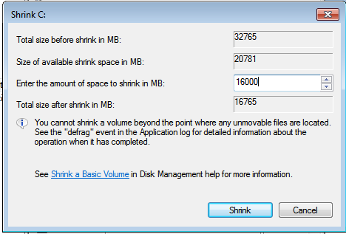
The C drive has been split in half and there is now unallocated space on the hard disk for the second partition.
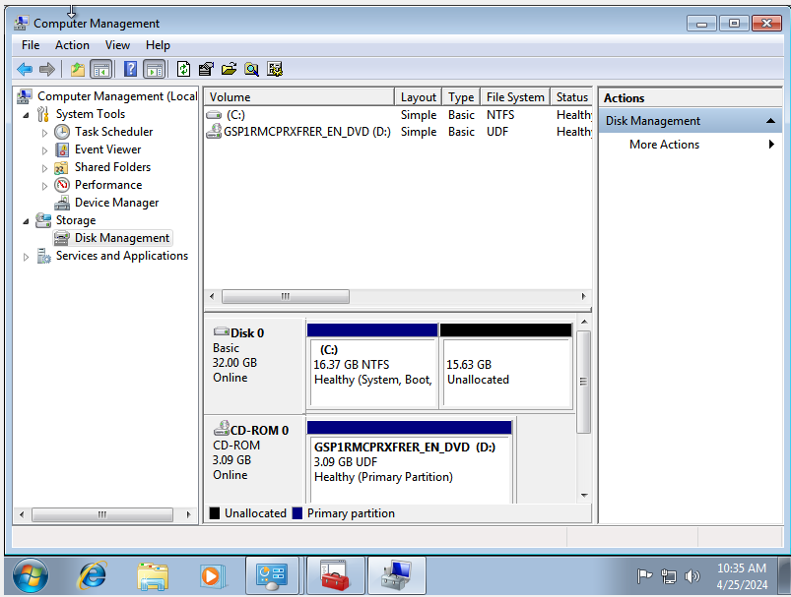
The author then created a new drive and assigned the drive letter ‘Z’.
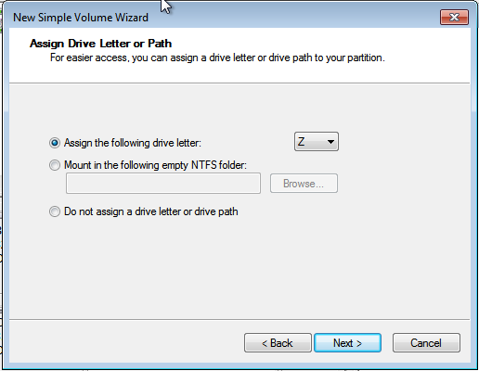
The next page asked the author to give the new drive a label, the author used ‘Drive Z’ as the label.
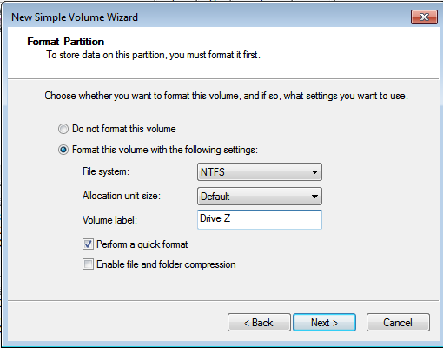
The Drive Z has been created and has been allocated to the rest of the hard disk, so the drive has 15.63GB.
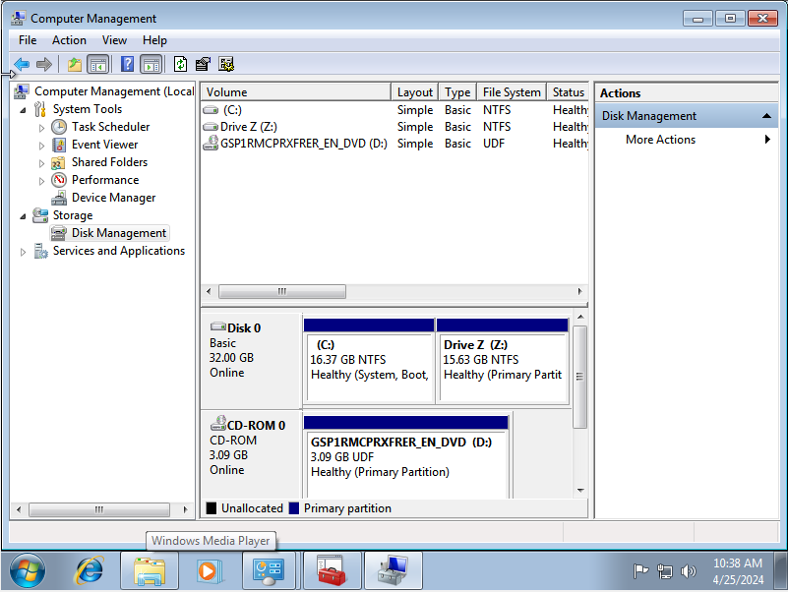
The author showing the two partitions of the hard disk working.
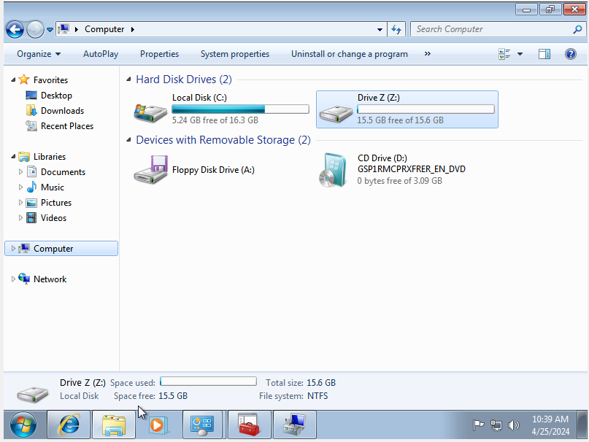

2.0. Downloading Software

2.1. Connect to Network
Before downloading software, the author must connect the virtual machine to the network so the author can use the internet. The author went on to the settings of the virtual machine and changed the network to bridged adapter.
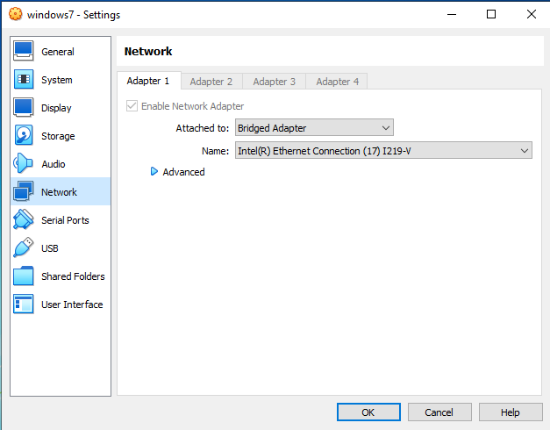
The author tested the connection, but the internet did not work so the author went back to the settings and switched the network back to NAT. This worked as the author could now use the internet.
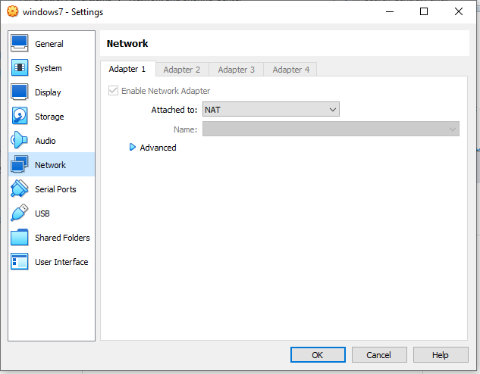

2.2. Downloading Chrome and OpenOffice
To download Chrome the author went on to Microsoft’s Internet Explorer and searched for Chrome then downloaded it.
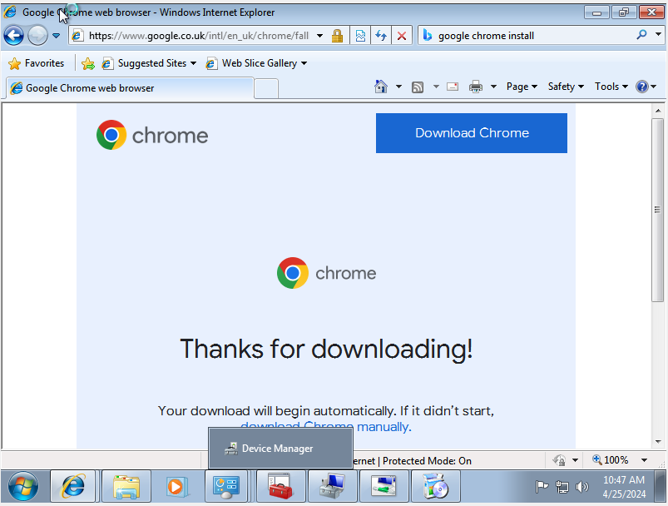
After downloading the software, the author loaded Chrome up and searched for OpenOffice.
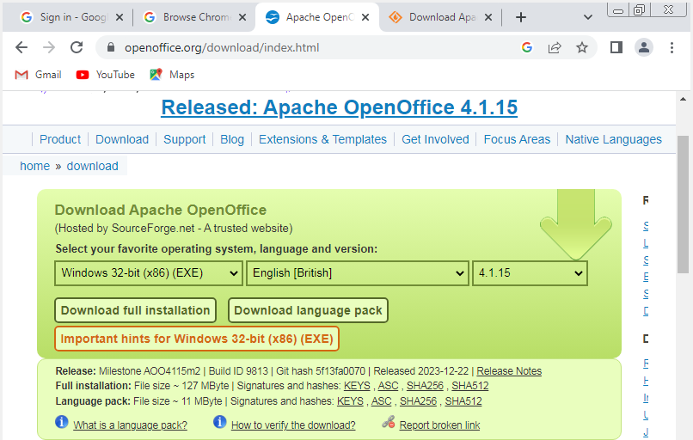
The author then clicked to start to download OpenOffice.
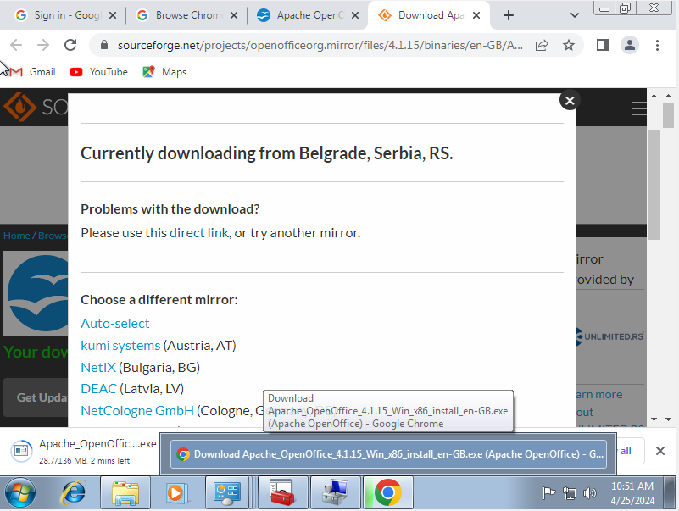
This shows that the download of OpenOffice was completed correctly.
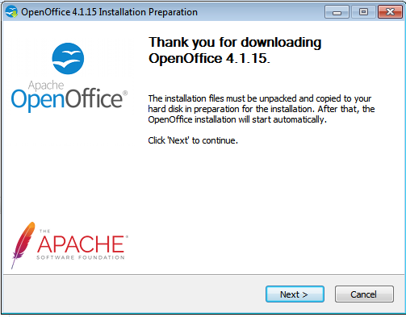
The installation page then started making a shortcut of OpenOffice on the desktop.
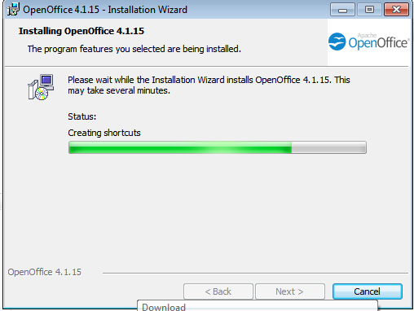
This shows that Google Chrome and OpenOffice have both been downloaded and have shortcuts icons on the desktop.
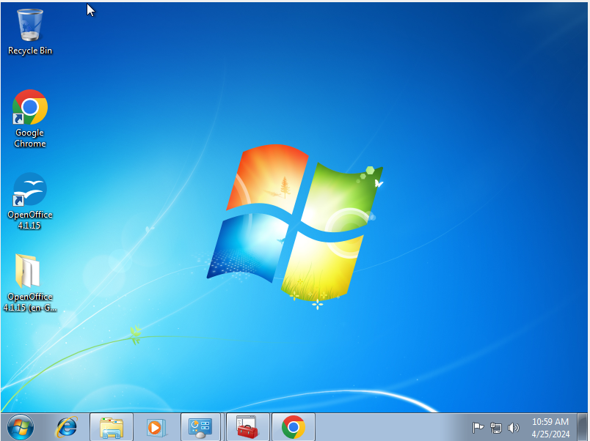
This shows the author opening and testing OpenOffice to see if the program can run effectively.
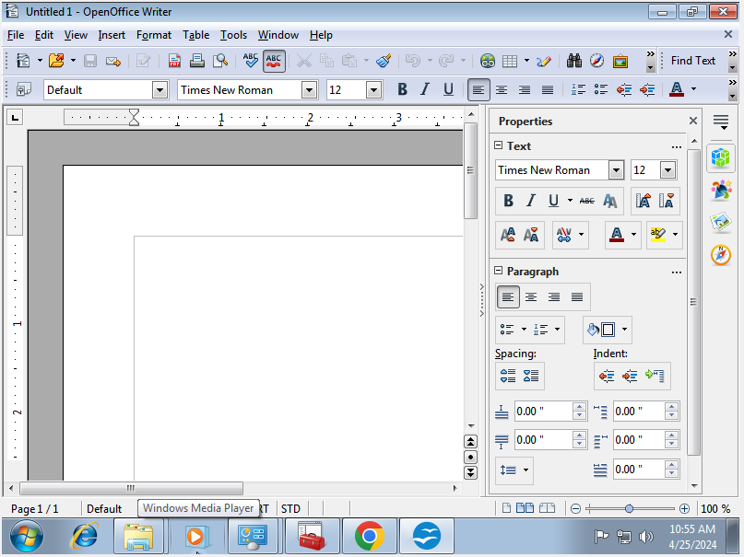

3.0. Drivers

3.1. Explanation of Drivers
Drivers are a software element that allows an operating system to communicate with a hardware device or the other way around [2]. The hardware device will also send the status to the operating system after activity of the drivers [3]. The drivers will supply information to the CPU on how to communicate with a specific piece of hardware [4].

3.2. Driver Setup
First, to setup the drivers the author needed to access the control panel and then click on ‘System’.
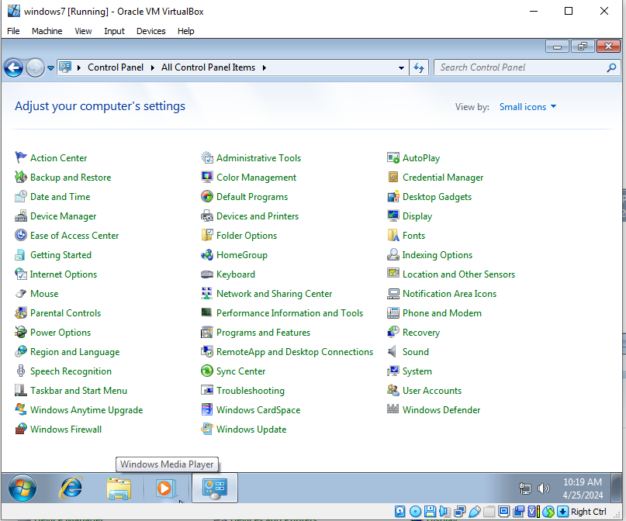
This then opened information about the virtual machine. To access the drivers the author clicked on ‘Device Manager’.
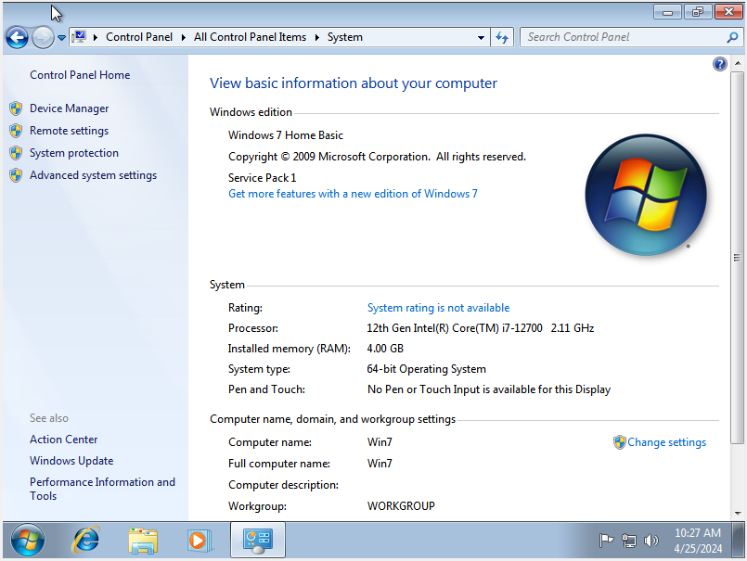
Once the author clicked on ‘Device Manager’ this page opened. The device manager shows all the devices connected to the computer and if clicked on one of the devices it will show all the drivers for that device.
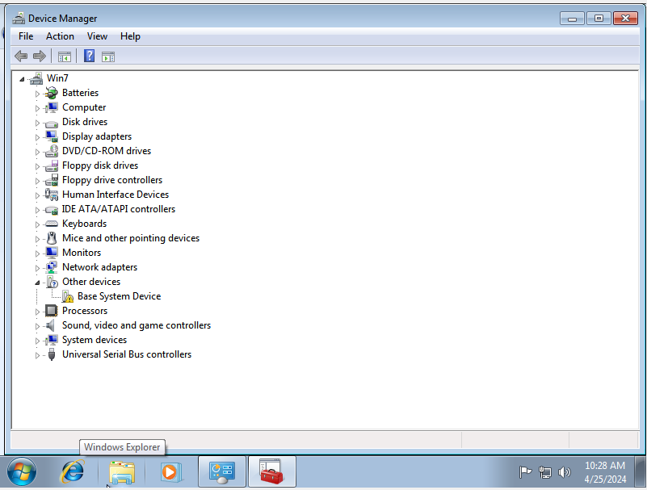
The drivers for the network card are shown here.
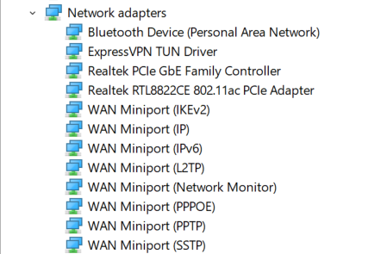
The drivers for the sound card are shown here.
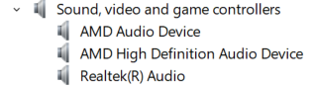

3.3. Network and Sound Card Drivers
The sound card driver will allow different sound-based devices like a microphone or speaker to communicate with the operation system. The network card driver will convert general networking instructions to particular instructions for the operating system it is running on [5].

References

[1] | “How much RAM memory do I need for my laptop?,” [Online]. Available: https://www.lenovo.com/gb/en/glossary/how-much-memory-ram-do-i-need-on-my-laptop/?orgRef=https%253A%252F%252Fwww.google.co.uk%252F. [Accessed 12 May 2024].
[2] | A. Viviano, A. Buck and M. Hopkins, “What is a driver?,” 16 December 2023. [Online]. Available: https://learn.microsoft.com/en-us/windows-hardware/drivers/gettingstarted/what-is-a-driver-. [Accessed 12 May 2024].
[3] | “Device Driver and It’s Purpose,” 28 September 2022. [Online]. Available: https://www.geeksforgeeks.org/device-driver-and-its-purpose/. [Accessed 12 May 2024].
[4] | “What is a device driver?,” [Online]. Available: https://www.lenovo.com/gb/en/glossary/device-drivers/?orgRef=https%253A%252F%252Fwww.google.co.uk%252F. [Accessed 12 May 2024].
[5] | “What is a network device driver?,” [Online]. Available: https://www.lenovo.com/us/en/glossary/network-device-driver/?orgRef=https%253A%252F%252Fwww.google.co.uk%252F. [Accessed 12 May 2024].

