Student Name: Elza Soares
Student Number: 1815430
Programme: BA International Hotel Management
Modulo: Personal Resourcing and Development
Module code: M5X01921
Lecturer: Abdi Rahman

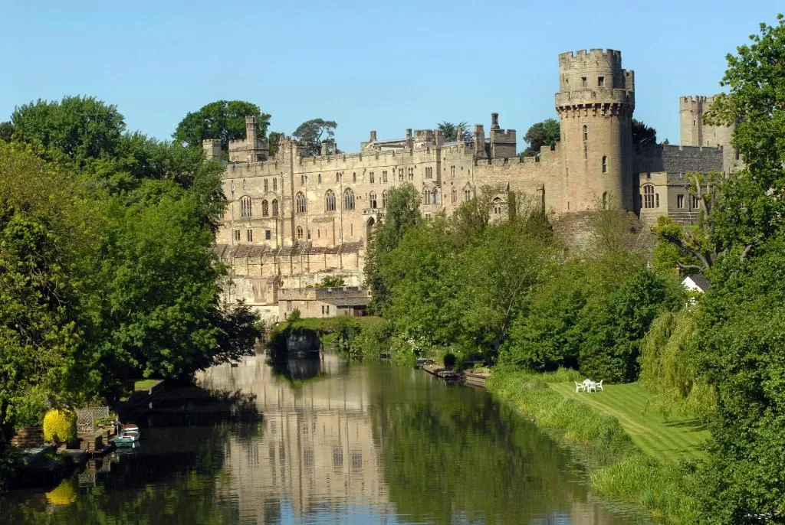

Introduction-------------------------------------------------------------------------------------1
Hotel-----------------------------------------------------------------------------------------------2
Pestel---------------------------------------------------------------------------------------------------------------3
Importance of an Effective Recruitment and Selection process------------------------------------4
Principal Factor that affect Culture, Equality and Diversity of an organization----------------5
Methods of Performance Management Utilised by Organization---------------------------------6
Outline plan which offers recommendation-------------------------------------------------------------7
Conclusion---------------------------------------------------------------------------------------------------------8
References---------------------------------------------------------------------------------------------------------9

Introduction:
The purpose of this work was to show, through research and
literature review, the feasibility of implementing a Hotel based in the West Midlands.
The importance of the study lies in the fact that this will be an opportunity to put practice all the learning acquired during classes.
I will do my own research and discover the important points of this work
(www.business-to-you.com)
Hospitality is the most important element in the tourism sector in general. Employers in the hospitality industry emphasize a caring and customer-oriented nature, generating a fascinating mystique. Destination determines the nature of the sector at that location. Professional-level training is critical to skill needs. (Yadav, 2008)

Warwick Castel Knights’ Village Hotel
Located: In the grounds of Warwick Castle, in the centre of Warwick. The property is situated in woodland and the River Avon.
his Medieval castle was developed from a wooden fort, this Castel was built by William the conqueror in 1068, the castle is located in Warwickshire by the river Avon Warmly furnished permanent tents with an old-world vibe provide free Wi-Fi, power outlets and shared bathrooms; some have 4-poster beds. Wood cabins add tea and coffeemakers, cable TV and balconies, plus towels and en suite wet rooms. Regal suites in the castle's 14th-century tower feature Watch as history is brought vividly to life!
At Warwick Castle, we have over 1100 years of history to discover within the castle grounds. spectacular LIVE shows take place every day showcasing a piece of Warwick Castle's incredible history.
All of live shows (excluding The Castle Dungeon) last about 30 minutes.
(Booking.com) 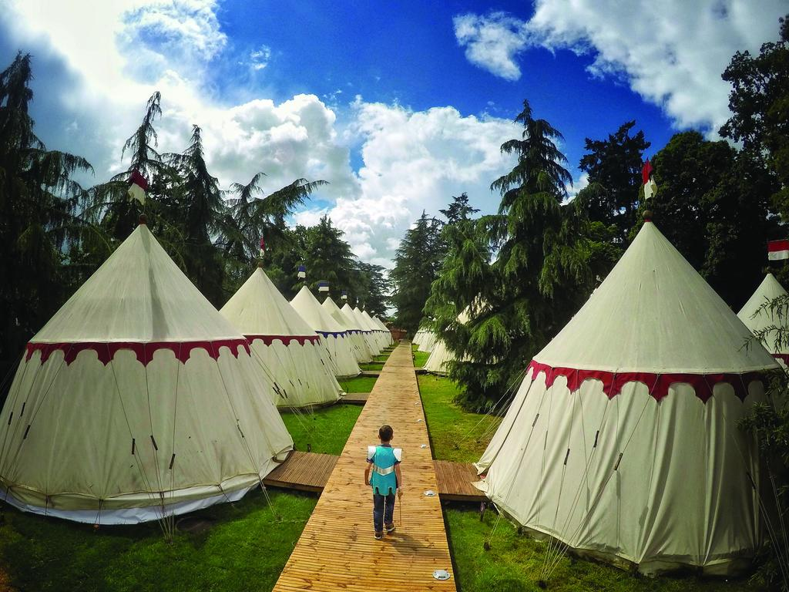



PESTEL is the easiest way to analyse the potential factors of a company in the short and long term (John Dudovskiy) is why we can also analyse its economy.
It is important to know the local politics to better determine the strategies and all the rights of the work.
The policy of a location is crucial to any business and its stability is fundamental to the success of the local business, because it can directly or indirectly influence customers
Actual example, coronavirus at this time will greatly reduce the economy of all countries. (Umar Farooq December 12, 2019)
The current example is the coronavirus, constant terrorist attacks are likely to be inventions in the future; of course, any drop-in air travel would decrease the demand for hotel rooms.
Economic
A big change affects the hotel industry a lot. Inflammations, inflammations and other economic consequences greatly affect people's ability to buy luxury hotels, and that way, economical hotels will win. (Marketing tutor.net)
Social
The current new generation has a strong tendency to travel the media and the media has fuelled young people to have this freedom to be able to travel alone
this type of hotel for young people is likely to increase in the future.
(Umar Farooq December 12, 2019)
There are no more hotels for different social classes, so you end the discrimination with the money you pay and take advantage of the opportunities that the establishment offers
There are many pages on social networks offering discounts for people to have longer stays and not have empty hotels. We are living in a society of constant change, tastes and fashion are the most concrete example of this. Social networking sites are becoming more and more popular with young people who no longer know how to live without Facebook for example.
What is normal in the younger generation is the use of a mobile phone, a laptop for everything they need, shopping for clothes, travel, food, while for the older people they prefer the traditional method, these changes affect companies in many ways, forcing them to be updated in a certain way. also in a virtual way.

Technologies
Almost all hotels are equipped with CCTV cameras, thus providing more security for their guests, there are some that in addition to the cameras have internal security.
Booking by message, online in this way increases the booking fee even though it is in another country the facility is the same so that it is in the same country, thus preventing stress and with that you can discover all the information and through these applications you can ask or inform the hotel if I have a special need without leaving your comfort.
Technology is very important and fundamental for almost everything.
Environmental
Currently, recycling is very important for pollution. You need to make smart choices. On the hotel's website, you can get information to ask guests to contribute so that they feel useful and have a good image of the establishment.
Have bins visible to hotel guests and staff. The choice of local purchases also helps with development and environmental impact. (Hydrofinity)
Legal
With the evolution, it was necessary for hotels to have more rigid laws and in order to protect everyone, the client, the space itself, exterior interior up to the laws of tourism and even places of each country.
The security of workers, customers, health and identification is also becoming stricter before allowing guests to settle in their facilities, due to the crime rate and the increasing terrorism in the world. (HOSPITALITY, 1 JUNE 2018)

Importance of an Effective Recruitment and Selection process
The recruitment of all companies has the specific department to elaborate this task in need of more staff, although there are others that prefer to work with an external company in charge of this service.
In this process it is very important to know what type of candidate you are looking for, your qualifications whether or not you have experience for the desired position and the availability and flexibility if applicable. (Mondy & Noe, 2008)
In this hotel they have several strategies for recruiting staff, directly with the hotel, with online platforms and have their own program that work with schools in the hotel industry, what makes them unique and different in this midland zone.
Example Recruitment process for the Warwick Castel Knights’ Village Hotel
The magic memorial, a recruitment agency with extensive experience in attractions, is recruiting a photographer for the Warwick Castel Hotel, and is a dynamic and innovative company that offers the opportunity to grow with the company.
The role:
Assist and photograph our customers to capture their memories throughout their experience.
Deliver A-MAZING customer service.
Promote and sell a wide range of photography products ensuring that our guests are taking away their favourite souvenirs of the day.
Am I qualified?
YES - no experience is necessary, full training will be provided.
All we ask is that you are hard-working, dependable, self-motivated and have flexible availability.
Bags of enthusiasm, customer service and selling skills, awesome communication skills and basic PC skills are a glorious advantage.
What do I need to do?

In addition to your base salary we offer an unlimited commission whenever you sell a product.
we also have The magic Box which offers discounted promotions in various stores, restaurants, cinemas and much more.
FREE consultation and guidance to support your success at work and at home, with additional access for your family too!
This hotel has the particularity of entertaining the whole family.
Here are some shows you can see at the castle, in addition to the large garden and the river with various activities
The falconer's mission * Wars of the Roses LIVE! *Dragonkiller The Falconer's Quest *Wars of the Roses LIVE! *Dragon Slayer
The Dungeon. (Booking.com)

Example Recruitment process for the Marriott Hotel
Employment Food & Beverage & Cooking
Schedule full time (In fact)
Start your journey with us
A good opportunity to start a new career with Marriott Hotel's.
The Zest Bar and Restaurant is about fresh seasonal ingredients, traditional combinations of flavours and time-honoured cooking methods. A bet on unique flavours and palettes that people like to eat. We believe in simple and adequate tasty food, well done.

What You Do?
Work with talented chefs to deliver exceptional customer experiences
Become the face of Cast Iron Grill
Manage your Restaurant keeping it clean and food safe.
What You Have?
Energy and enthusiasm are the key
A good attitude and balance with a sense of fun.
natural friendliness to offer a great customer service experience.
Confidence to let your personality shine.
What’s in It for You?
Amazing in-house training courses & online food service school
Tasty meals on duty free of charge
Explore the world with friends & family discounts (50% off F&B and discounted accommodation rates)
In this hotel for recruitment can be directly or through a job agency and online tools, this hotel does not have activities for family or for children it is more geared towards golf which makes it aborted for parents who are on tour and who want to be with the family.

Regarding Marriott hotels vs the Warwick Castel
The Marriott does not invest much in staff, management is constantly changing, there are many managers, lack professionalism and do not invest in training employees
The Castel works directly with local schools in its recruitment, has several activities to entertain its guests and of all ages

Principal Factor that affect Culture, Equality and Diversity of an organization
multicultural countries, such as the United States or Great Britain, the issue of diversity is not new these countries have invested a lot in tourism and the fact that they speak English which is a universal language and their multiculturalism has developed a lot to the point where it is fashionable to go the UK or USA
Diversity includes age, ethnicity and culture, gender, race, religion, sexual orientation and abilities (Schwind, Das & Wagar, 2007. (2007).
It was and still is a hard work to remove the many barriers that keep communities away. Equality is very important within society because we can have the same opportunities and just.
you must know how to respect and accept the other regardless of your religion, sexual orientation, race, disability. (by D Lančarič - ‎2015)
Organizational performance management is the process of ensuring that
It is very important for the company to use its resources correctly; it is a fundamental objective for the development of it and all its employees.
there are three basic phases for the development of its employees: training, corrective action and termination. The first phase is more focused on the training, incentive and orientation process for employees.
good performance management is fundamental because it involves measuring, reporting and managing the progress of workers for a company up to the organization, the main objective is to improve performance. (Bernard Marr)
Outline plan which offers recommendation
The appearance and appearance of a building affects the location very much.
Landscaping is the best option to protect a neighbourhood or place, it helps in its accessibility, it goes against nature and worries a lot about the handicapped.
Appearance and easy access is very important for any business, it is now fashionable to use open spaces in order to take advantage of natural light as much as possible.
Conclusion
Tourism is one of the main activities that contribute to the
socio-economic and cultural development of a country, besides being sectors that present more favourable conditions for development
sustainably. The present work has as objective, during the
case study in a hotel, identify and analyse how sources consumers its policy, the economy, technology, respect for nature, the way in which its employees are selected.
This work was in line with the material given in class and in the research, I did and with my personal experience and placement work during the course
Today, the hotel sector is one of the main generators of income and jobs in the world.
In a hotel, the need for education and training cannot be ignored. for the best, customer satisfaction is necessary to provide adequate and systematic training to all employees. Computers are an efficient and low-cost way to provide training to employees, but for that, it is necessary to install appropriate equipment, according to the training program designed, in order to make the entire system accessible.
(Baum, Tom (2009)
( Mohsin, Asad (2006)
(Aziz, Stiti F.A. and Ahmad, Shamsuddin (2011),

References:
(Aziz, Stiti F.A. and Ahmad, Shamsuddin (2011)
(Bernard Marr)
(Baum, Tom (2009)
(Booking.com)
(www.business-to-you.com)
Castelli (2001)
(by D Lančarič - ‎2015)
(Google.com)
(Hydrofinity)
(HOSPITALITY, 1 JUNE 2018)
(John Dudovskiy)
(Marketing tutor.net)
(Mondy & Noe, 2008)
( Mohsin, Asad (2006)
(Schwind, Das, & Wagar, 2007. (2007).
(Yadav, 2008).
(Umar Farooq December 12, 2019)

.

