Andreea Popa

By Cosmin Daniel Popa Student Number 1919080
Strategic Management and Sustainability
UNIVERSITY OF WALES TRINITY SAINT DAVID

Table of Contents
Introduction 2
Business Strategies of VW 3
Resources and Capabilities of VW 5
Sustainability and the environment of VW 7
Recommendations to the company to enhance its further sustainability practices 9
Conclusion 11
Reference List 12

Introduction

CEO of the VW group, Herbert Diess declared that Volkswagen was considered one of the primary automakers consigning to the Paris climate agreement back in the year 2018. On the other side, by the year 2050, the organization aims to be balance sheet CO₂ neutral. Therefore, the report mainly focused on the sustainability actions of the organization. Likewise, it also made recommendations to VW about further enhancing its concentration on sustainability practices. Such as, the company must be required to invest its time and efforts in training employees on the significance of sustaining the surroundings as well as share what the company is doing to assists conserve resources of the environment. Adding to it, many things such as powering down equipment at the end of the day as well as giving energy-saving settings on all desktops in the working environment are considered as some of the key instances of sustainability policies and procedures that can support the cause.

Business Strategies of VW

A business strategy considers all the decision-making procedures as well as actions undertaken by a company with the main aim of accomplishing note-worthy growth and development across the world. In addition to this, knowing the business strategy or approach gives a greater chance for the manager of the company about accomplishing the larger vision of the company and becoming a market leader in the domain (Naciti et al., 2022). Specifically, a business approach refers to the backbone of every business in the marketplace, and any risks, threats, or shortcomings could declare that the business objectives of an organization get lost midway. In the context of this, the world of mobility will alter dynamically by the year 2030 as electric drive and abundant-networked transportation with self-directed drive will conclude how VW moves around in expectations. Therefore, with the group approach comprised of 'NEW AUTO', the company can fulfil the needs and preferences of the consumers and establish its image as a significant leader in the marketplace. Moreover, VW hastens its repositioning from vehicle manufacturer to tech organization. Apart from that, the well-established image of brands and the automobile will prolong to play an essential role in personage mobility in the future. Adding to it, the core product of VW refers to the car and the fundamental business models of the company are fundamentally altered. Furthermore, the sources of revenue of the organization will also revolutionize gradually between now and the year 2030. Thus, VW usually concentrates on boosting its brand image over the globe as most of its business actions are based on technological automation through many digital platforms in the USA, China, Europe, and so on. These technology platforms generally include the area of Mechatronics, Battery & Charging, Software, and Mobility solutions.
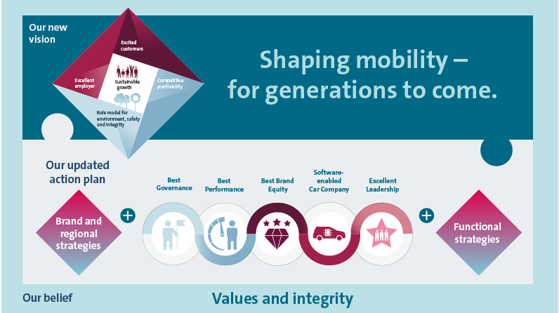
(Source: Villamil et al., 2022)

They enable the company to leverage scale as compared to rivals in the marketplace and synergies over the brands. However, there are varied standards of a business strategy named corporate-level strategy, business unit-level strategy, functional-level strategy, and so on. The business strategy serves as a vital component of the company. The reason is that it develops a clear vision concerning the organization and it must encourage employees to progress their efforts and efficiency towards the accomplishment of the vision. Adding to it, an approach enables employees with a shared purpose of working together. On the other side, a business strategy of the organization also gives a greater edge to the decision-makers about keenly identifying opportunities and trends for future development of the company over the globe. However, it is considered a dynamic procedure as it needs time-to-time modification (Kücükgül et al., 2022). A business strategy safeguards both the company and its people from complacency. Thus, it comprises one of the crucial elements for VW, and the manager of the company is required to keenly concentrate on it.

Resources and Capabilities of VW

Large Production Infrastructure- VW has made its well-known presence and a very huge production infrastructure across the world (Naciti et al., 2022). Thus, in the year 2017, the company produced around 11 million units of vehicles. The comprehensive production network of the organization includes around 140 positions across the globe. Out of these, the greatest range of manufacture positions of VW is there in Europe. Moreover, VW constantly made its efforts and concentrates on improving its production concepts as well as line-up them with further improvements of technologies. In the context of this, the competitive designs of VW’s international production network serve as one of its greatest powers.
Brand image and global presence- VW developed its noteworthy brand presence and upheld a very good brand image over the globe. Thus, it assists the organization to catch note-worthy growth and profitability as of its relative rivals in the marketplace. According to the research, the diesel scandal might have flawed the reputation of VW to a greater extent. But on the other side, the organization has made a note-worthy return and that serves as one of the greatest strengths of VW (Villamil et al., 2022). It operates its business actions and offering in many corners of the globe. In the context of this, two of the greatest markets of VW where it made its offering refer to Europe and the Asia Pacific. Sales of the company in these 2 counties have remained the highest.

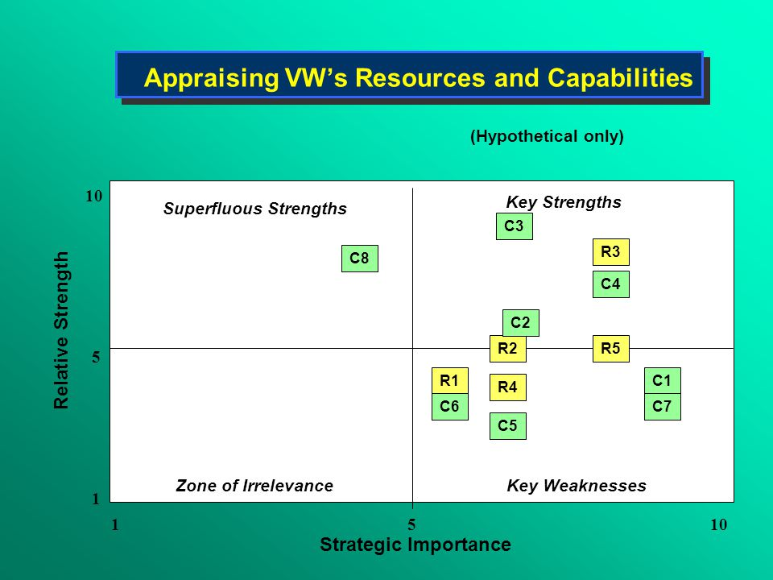
(Source: Kücükgül et al., 2022)
Research and Development Capabilities- VW develops strong research as well as development capabilities. In addition to this, the company also spends a great sum on development and research activities (Kücükgül et al., 2022). But on the other hand, investment in Research and Development is significantly enhancing the value of its sustainability over the community. In the year 2017, the R&D of VW amounted to around 13.13 billion Euros.
Large and Extensive Supply Chain- Another greatest potential of VW's brand is considered its greatest and most widespread supply chain across the world. Adding to it, the company also made its noteworthy presence and a special set of connections of FAST suppliers in the marketplace as of its relative competitors. FAST is referring to an inventiveness by the company that usually aims to make its supply network potential poof (Naciti et al., 2022). In the context of this, one of the core objectives of VW is to effectively implement its development and globalization actions by engaging suppliers more intensely as well as extremely at an untimely stage. The range of FAST suppliers in the marketplace increased from around 60 in the year 2016 to around 71 in the year 2017.
Large product Portfolio- It also serves as the greatest capability of VW in the marketplace as of its rivals. The company has a large product portfolio around the globe which is made up of around 12 varieties many of which it has the greatest scheming stake. They must refer to Audi, Lamborghini, Volkswagen commercial vehicles, Porsche, Man and Ducati, and so on (Kücükgül et al., 2022). Through this capability, the company can achieves the needs and preferences of a diverse consumer group in the marketplace ranging from upper-end and first-class consumers to the mid-earning (middle-class) customers.

Sustainability and the environment of VW

Sustainability is defined as a trending topic globally. In addition, it persistently enhances its importance for businesses all over the globe. Thus, many organizations nowadays must have a basic sustainability strategy. For VW, sustainability serves as pursuing ecological, environmental, economic, technological, and social goals simultaneously as well as with equal energy. Thus, one of the key objectives of VW behind their sustainability actions are referred as to develop lasting values, conserve resources, and the surrounding, offer better working circumstances to the employees, and so on. Through its sustainability concept, VW wants to make sure that both advantages and threats are associated with the company's ecological, governance, and social actions (Villamil et al., 2022). Adding to it, they recognized as early as possible at each section of its value creation procedures. Thus, in keeping with this objective, the manager of VW determined that the CSR activities of the organization will have a lasting as well as a positive influence on its significance and reputation in the marketplace. Sustainability gives a greater chance for the company to fulfill its current needs and meet future needs. Therefore, sustainability possesses a positive impact on several aspects of the organization if the company keenly complies with its business actions with sustainability measures, consumers in the marketplace are more probable to support a sustainable business. Apart from that, developing sustainability actions is a complex matter for the company, but getting started is easy. The human impact of sustainability is defined as it helps the organization to not burden its workforce and allows them to maximize their efforts and efficiency towards accomplishing noteworthy goals and growth of the company across the world.

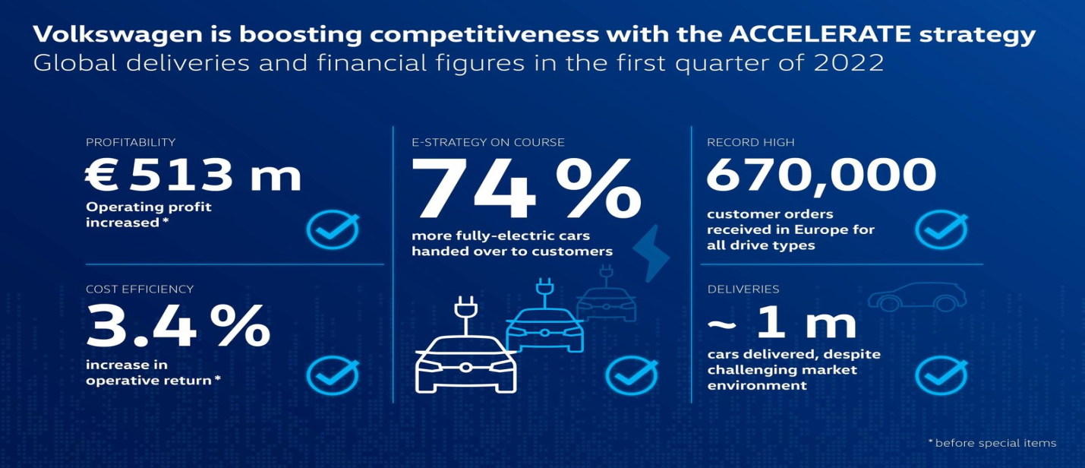
(Source: Mio et al., 2022)

The climate crisis serves as the greatest threat to the growth and development of VW. In the context of this, the CEO of the VW group, Herbert Diess declared that Volkswagen was considered one of the primary automakers consigning to the Paris climate agreement back in the year 2018. On the other side, by the year 2050, the organization aims to be balance sheet CO₂ neutral. This clearly describes the sustainability efforts of VW towards making to defend the environment in most of the sections such as in production, distribution, its products, as well as together with partners. Moreover, a significant contribution of the company towards effective climate protection is referring to its shift to e-mobility. Likewise, according to several researchers, battery-powered electric cars are more probable to bring the best climate footprint of all drive kinds within the community (Du and Yalcinkaya, 2022). Apart from that, one of this research was equally presented by 3 renowned research institutes in the year 2020 named the Mercator Research Institute on International Commons and MCC (Climate Change), the Potsdam for environmental influence Research (PIK), and the PSI (Paul Scherrer Institute). However, the climate lead of e-cars in the community has persistently enhanced in recent years. The reasons are longer battery life, a greater share of renewable energy in Europe, advances in battery production, and so on.

Recommendations to the company to enhance its further sustainability practices

Be intentional about sustainability- One of the basic recommendations recommended to VW is refer as the company required to be intentional about its sustainability actions. It must be incorporated into the company's approaches as well as reflected in its business objectives. This defined that it requires making sustainability a priority in each aspect of the company's actions. On the other side, with several business initiatives, the manager of VW must be required to make a specific plan of action and assign accountability to employees towards sustainability (Bianchi et al., 2022). Managers of the organization also ensure that results can be derived on a determining basis. This will allow both VW and its people to bring momentum to their sustainability efforts.
Partner with employees- Another recommendation to VW to progress its further sustainability practices is referred as to partner with workforces in their working surroundings. The company must be required to invest its time and efforts in training employees in the significance of sustaining the surroundings as well as share what the company is doing to assist conserve resources of the environment. In addition to this, the manager of VW also solicits further opinions from the workforce for resource conservation (Engert et al., 2016). This will give a greater chance for the organization to successfully engage its people in its sustainable practices.
Develop sustainability work policies- Another major recommendation to VW is refer as to bring several sustainability work policies into its workplace. It allows the company to reinforce the efforts of employees toward sustainability actions (Stead and Stead, 2014). Many things such as powering down equipment at the end of the day as well as giving energy-saving settings on all desktops in the working environment are considered some of the key instances of sustainability policies and procedures that can support the cause. However, the challenge to keep business activities sustainable by VW can be overwhelming. But, if the organization can contribute its efforts towards conserving this great planet, it will become easier for both it and its people.
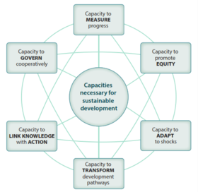
(Source: Baumgartner, 2014)

Supply Chains- According to the research, both the people and consumers in the marketplace are more probable to purchase and work with sustainable organizations that are eco-friendly. Thus, VW needs to maintain a list of sustainable or environment-friendly vendors as well as give them priority to only allow it to successfully bring sustainable business practices to the community (Moutinho and Vargas, 2018). It must negotiate contracts with this probability made clear.
Develop a recycling program- The manager of VW must recommend developing an in-house policy for recyclable goods such as electronics, paper products, supplies, computers and monitors, electronics, and so on. The reason is that, with the implementation of a waste management vendor, VW was able to create a successful process for this (Stead and Stead, 2014). In the context of this, this is considered as one of the core recommendations to the company as it made greater assistance to it to improve its further sustainable business practices.
Purchase only energy-efficient products- VW needs to look for energy-efficient commodities and use ecologically friendly settings on workplace equipment (Moutinho and Vargas, 2018). Likewise, the organization chooses IT acquisition products, electronics, computers, etc. about derive the highest level of efficiency in the marketplace as of rivals.

Conclusion

In conclusion, the report usually emphasizes the business strategies of VW as it concludes with the group approach comprised of 'NEW AUTO', company can fulfill the needs and preferences of the consumers and establish its image as a significant leader in the marketplace. Moreover, VW hastens its repositioning from vehicle manufacturer to tech organization. On the other side, it also examines the resources and capabilities of the company as according to the research, the diesel scandal might have a flawed reputation for VW to a greater extent. But on the other side, the organization has made a note-worthy return and that serves as one of the greatest strengths of VW. Apart from that, the company has a large product portfolio around the globe which is made up of around 12 varieties many of which it has the greatest scheming stake. They must refer to Audi, Lamborghini, Volkswagen commercial vehicles, Porsche, Man and Ducati, and so on. Adding to it, the manager of VW determined that the CSR activities of the organization will have a lasting as well as a positive influence on its significance and reputation in the marketplace. Thus, the report also scrutinizes sustainability and the environment of VW.

Reference List
Baumgartner, R.J., 2014. Managing corporate sustainability and CSR: A conceptual framework combining values, strategies and instruments contributing to sustainable development. Corporate Social Responsibility and Environmental Management, 21(5), pp.258-271.
Bianchi, G., Testa, F., Tessitore, S. and Iraldo, F., 2022. How to embed environmental sustainability: The role of dynamic capabilities and managerial approaches in a life cycle management perspective. Business Strategy and the Environment, 31(1), pp.312-325.
Du, S., Bstieler, L. and Yalcinkaya, G., 2022. Sustainability-focused innovation in the business-to-business context: Antecedents and managerial implications. Journal of Business Research, 138, pp.117-129.
Engert, S., Rauter, R. and Baumgartner, R.J., 2016. Exploring the integration of corporate sustainability into strategic management: A literature review. Journal of cleaner production, 112, pp.2833-2850.
Kücükgül, E., Cerin, P. and Liu, Y., 2022. Enhancing the value of corporate sustainability: An approach for aligning multiple SDGs guides on reporting. Journal of Cleaner Production, 333, p.130005.
Mio, C., Costantini, A. and Panfilo, S., 2022. Performance measurement tools for sustainable business: A systematic literature review on the sustainability balanced scorecard use. Corporate social responsibility and environmental management, 29(2), pp.367-384.
Moutinho, L. and Vargas-Sanchez, A. eds., 2018. Strategic management in tourism, cabi tourism texts. Cabi.
Naciti, V., Cesaroni, F. and Pulejo, L., 2022. Corporate governance and sustainability: A review of the existing literature. Journal of Management and Governance, 26(1), pp.55-74.
Stead, J.G. and Stead, W.E., 2014. Sustainable strategic management. Routledge.
Villamil, C., Schulte, J. and Hallstedt, S., 2022. Sustainability risk and portfolio management—A strategic scenario method for sustainable product development. Business Strategy and the Environment, 31(3), pp.1042-1057.

