University of Wales, Trinity Saint David
Information Engineering (ACCB4013)
Database Design (The Book Store)
Anton Hall 1809131
Contents
1. Introduction 1
2. Entity Relationship Diagram (ERD) 1
3. Forms, Reports and User Guide 3
4. Structured Query Language (SQL) 12
5. Conclusion 12
References 13

1. Introduction
The aim of this report is to describe the development and design of a database for a book store. The database will be developed in Microsoft Access and must allow the user to place book orders with suppliers, place customer orders for books, view customer information, view stock information and ongoing orders must be visible. The database will also be menu driven for ease of access to certain information and reports will need to be generated directly from these menus.

2. Entity Relationship Diagram (ERD)
Before beginning to build the database directly in MS Access it is imperative to plan how the different elements of the database will relate to one another. Entity Relationship Diagrams (ERD) represent the design of all the information that will be required within a database system and how this information will relate to one another. These diagrams can used in conjunction with the person developing the database and the end user to form an agreement on expectations of the end database. [1]
The first component that is created in an ERD are the entities; these represent the different types of information that is required to be stored and accessed by an organisation. For Dylan’s Books Store, five entities have been created that will meet the requirements of the users:
- Customers – A table containing all current customer information.
- Orders – A table containing all current ongoing order information.
- Books – A table containing all current books and information about the books.
- Stock – A table containing current stock numbers for books.
- Suppliers – A table containing all current supplier information.
Once the entities have been created, the information that will be held in each of them will need to be considered and how each of them will relate to each other. When deciding on the information that will be held in each table, certain fields that will be contained within more than one table will need to be created, so that we can create a relationship between those tables. These fields are referred to as Primary and Foreign keys. Primary keys are used to uniquely identify records within a table, normally referred to as an ID field, and there can only be one primary key within an entity. The foreign key is a field in a table that is the primary key of another table, you can have more than one foreign key in a table. Both primary and foreign keys can be used to create a relatable database.
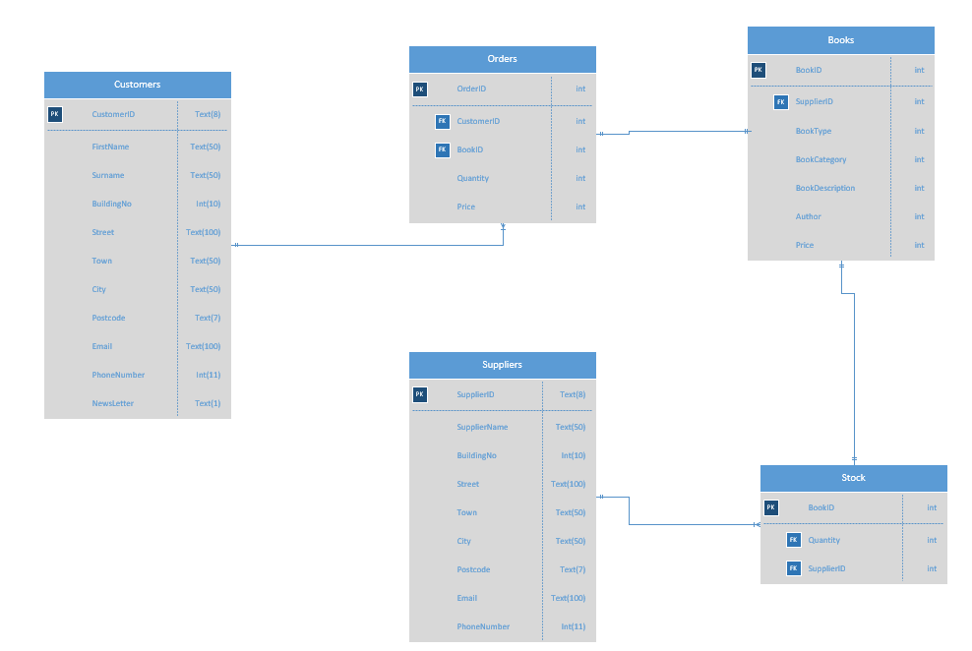
Figure 1: Entity Relationship Diagram
Figure 1 above shows the entity relationship diagram that has been developed for Dylan’s Book Store. It has a total of five entities that have been previously mentioned and each contains the required information for the end user to be able to achieve what they need to from the database. The first entity is the Customers table; this will link to the Orders table through the Customer ID with a one to many relationship. The Order table will then link to the Books table with a one to one relationship using the Book ID. The Book table is linked to the Stock table through the Book ID field on a one to one relationship. Then the Suppliers table is linked to the Stock table based on the Supplier ID field using a one to many relationship.

3. Forms, Reports and User Guide

This section of the report will illustrate the forms and reports that have been developed to meet the requirements of the end user. The database is menu driven so all elements can be accessed from a form and can be viewed in a report. There is a total of six forms in the database and six reports that can be accessed directly from the forms. Below is a screenshot from all forms and reports. This section will also include a brief user guide on how to use the database to access, add or remove certain information.

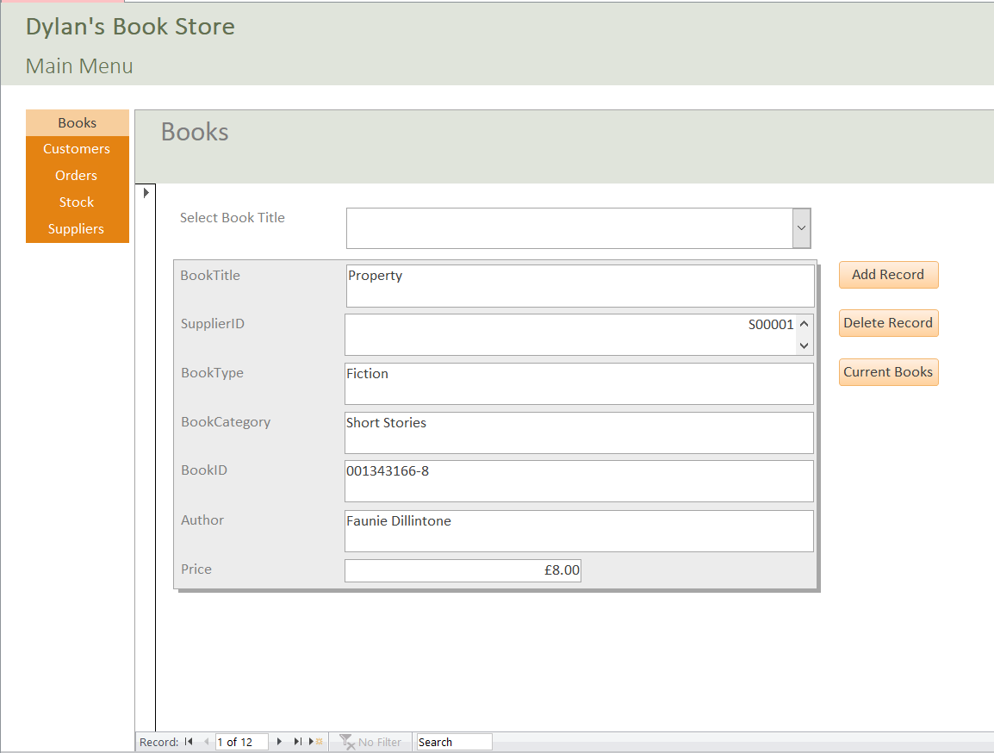
Figure 2: Form 1/ 2 Main Menu & Books
Figure 2 shows the main menu form, and this is where a user will begin each time they open the database. The main menu form is a parent form which contains multiple child forms, making it easier for the user to access all the relevant forms in one place. From the main menu any of the five forms that represent each of the entities within the database can be accessed, simply by selecting one of their names on the left-hand side. This will then take the user to the relevant form but will keep them within the main menu form. The first form within the main menu is the Book form, from here the drop down list at the top of the form can be used to see all the book titles which are held by Dylan’s Book Store. If one of these titles is then selected from the drop down list, the remainder of the form will populate with the information relating to the selected title. To add a record, a user is required to click the ‘add record’ button and fill in the relevant information on the from. To delete a record, first select the record to be deleted using the drop down and then click the ‘delete record’ button. To view a report containing all the current books on the Dylan’s Book Shop database, click the ‘current books’ button and a report will open as shown by Figure 3 below.
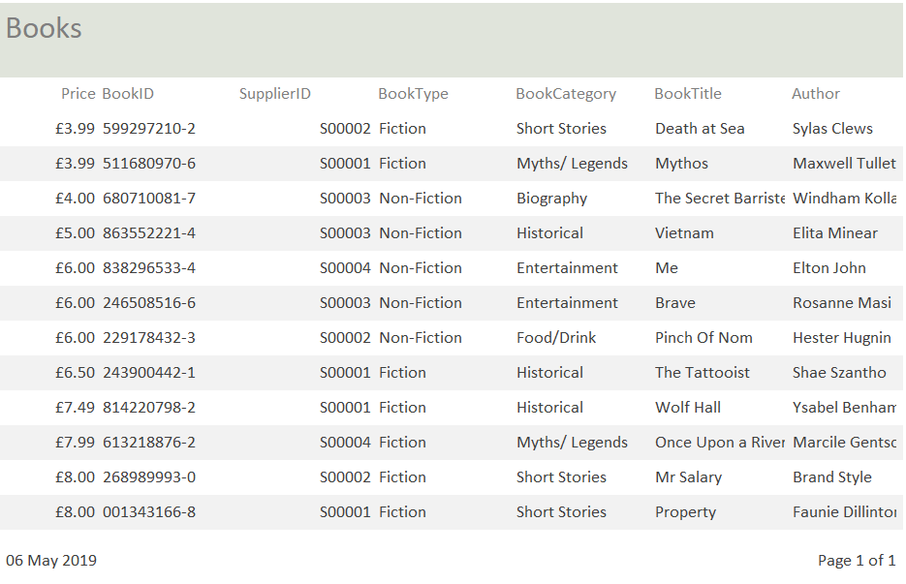
Figure 3: Report 1 Books

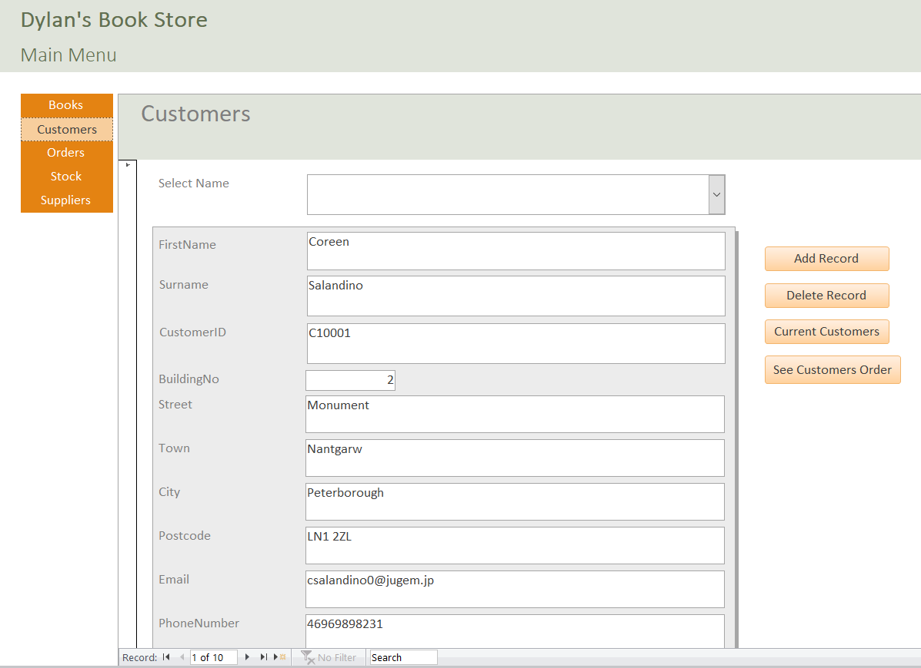
Figure 4: Form 2 Customers
Figure 4 above shows the customers form that can be accessed from the main menu. To view a customer’s information, the user can select a customer name from the drop down at the top of the page, the information held for the selected customer will then be displayed on the form. To add a record, click the ‘add record’ button a fill in the relevant forms. To delete a record, a user should select the record to be deleted from the drop down and click ‘delete’. To view a report of all current customers, click the ‘current customers’ button and a report will open to display all current customers held in the database as shown in Figure 5 below. To see a customer’s current orders, select the customer of interest from the drop down and click the see ‘customers order’ button. This will run a query on the database to see if the current selected customer has any ongoing orders and will display a report of the results, which can be viewed in Figure 6 below.
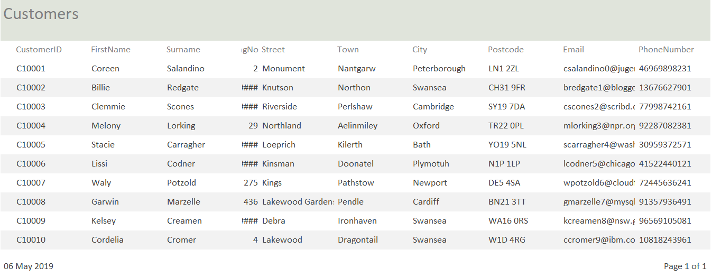
Figure 5: Report 2 Customers

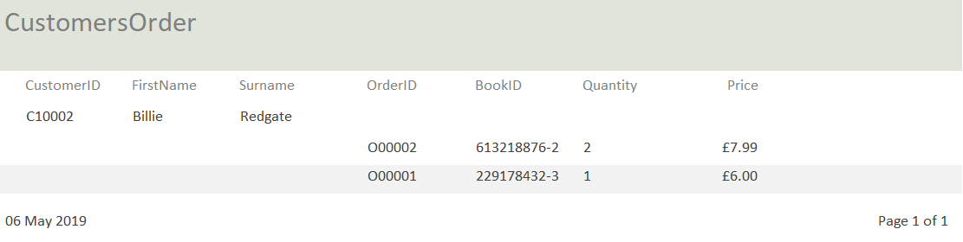
Figure 6: Report 3 Customers Order
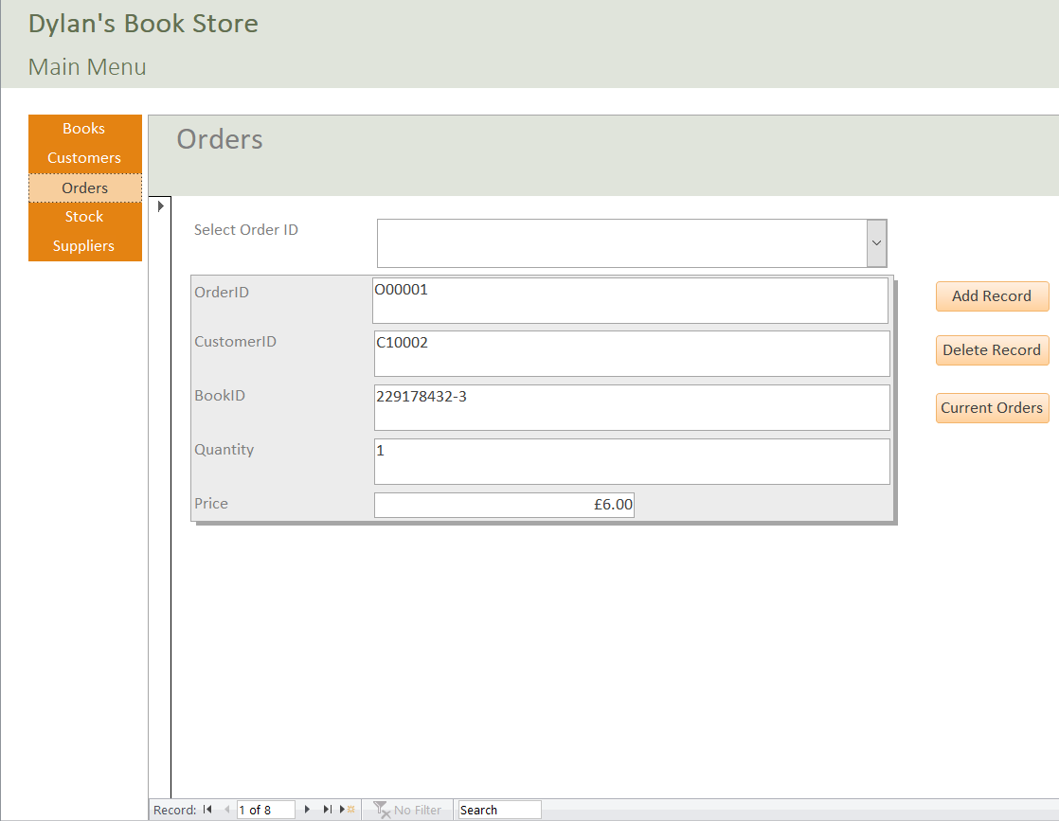
Figure 7: Form 3 Orders
Figure 7 above is a screenshot of the Orders form; from here any information regarding current orders can be seen and there is also the option to add or remove them. To view a record, a user can select an order ID from the drop down at the top of the page. To add a record, click the ‘add record’ button and complete the relevant fields. To delete a record, select the record to be deleted from the drop down and click ‘delete record’. To see a report of all the current orders click the ‘current orders’ button and a report will be created as shown in Figure 8 below.
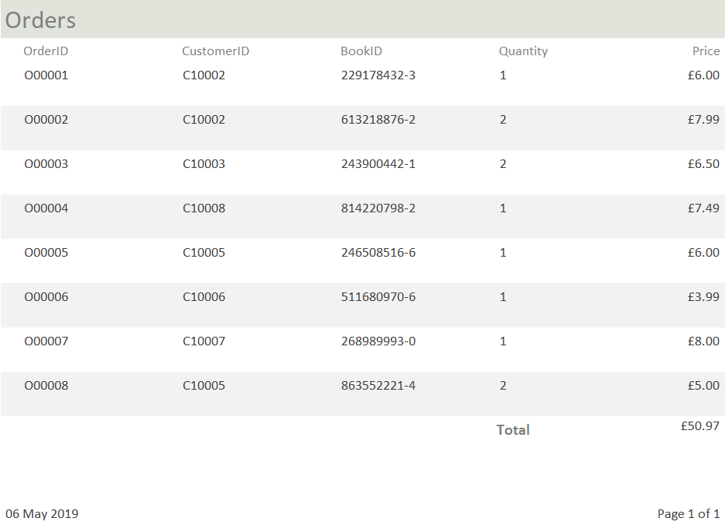
Figure 8: Report 4 Current Orders
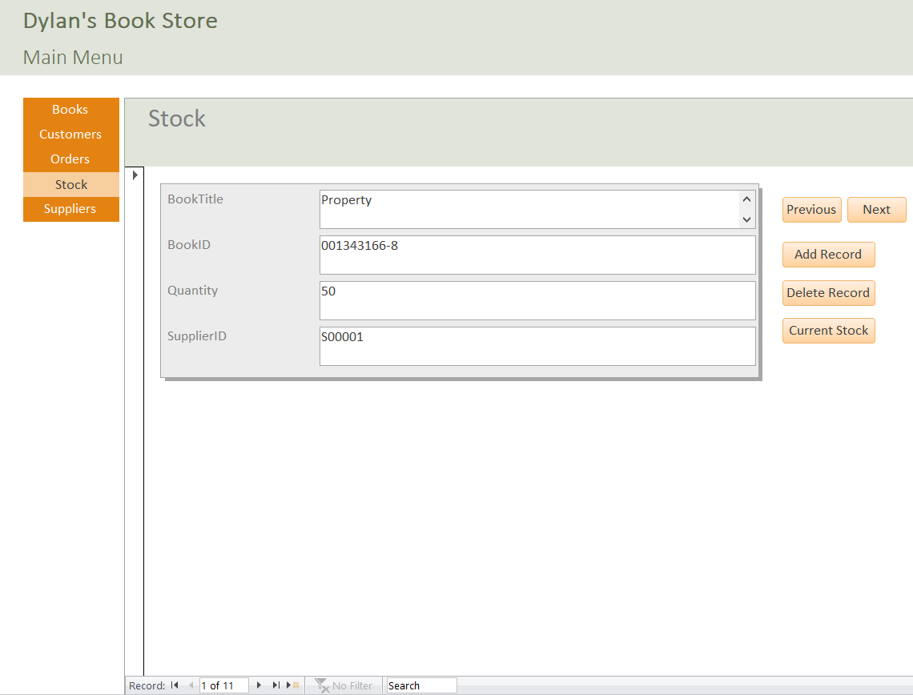
Figure 9: Form 4 Stock
Figure 9 shows the Stock form; this is where all current stock of books held in the database can be viewed. To see information on a particular book, a user should use the ‘next’ and ‘previous’ buttons to navigate through the entries in the table. To add a record, click the ‘add record’ button and fill in the relevant fields. To delete a record, navigate to the record to be deleted and click the ‘delete record’ button. To view a report of the current stock, click the ‘current stock’ button and a report as demonstrated in Figure 10 below will be generated.
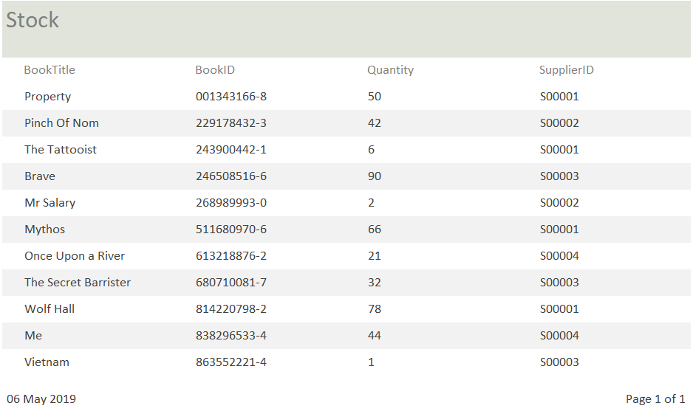
Figure 10: Report 5 Current Stock

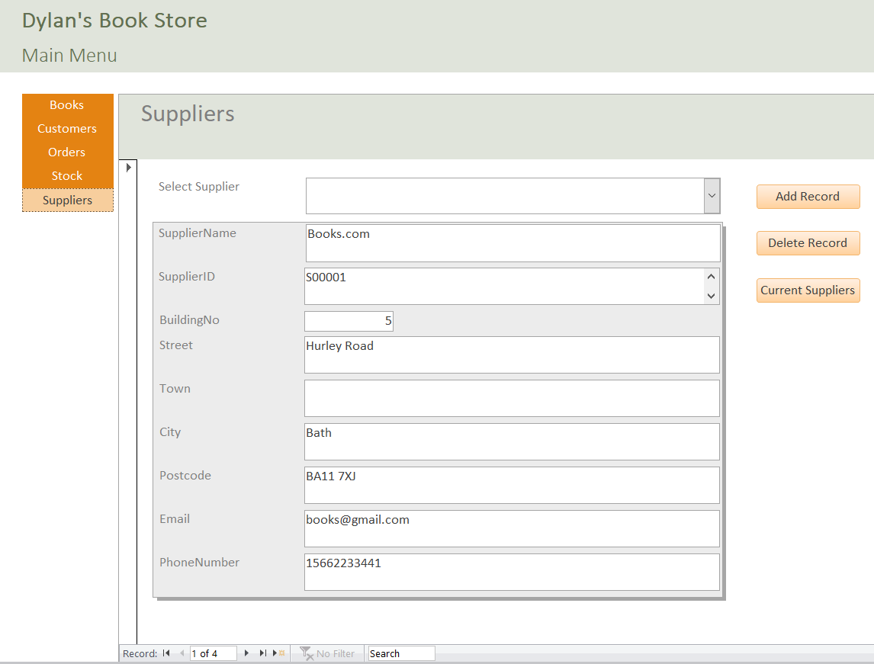
Figure 11: Form 5 Suppliers
Figure 11 above shows the Suppliers form. This form shows information regarding any current supplier of books held within the database. To view such detail, a user should select the supplier name from the drop down list and information relating to that supplier will be presented. As previously, to add a record, click the ‘add record button’ and fill in the relevant fields. To delete a record, select the record to be deleted in the drop-down list and click the ‘delete record’ button. To view a report of current suppliers, click the ‘current supplier’s’ button and a report similar to that shown in Figure 12 below will be generated.

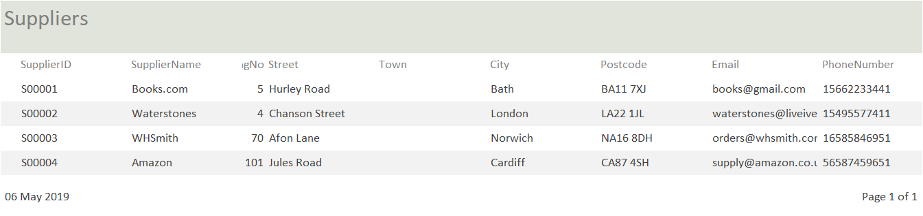
Figure 12: Report 6 Current Suppliers
The screenshots in the above section demonstrate that the database has been set up to be as user friendly as possible. The user is initially presented with the main menu form as soon as they open the database and from here they can navigate to any form they so wish. Each form is formatted in a very similar way so that it is easy to navigate and carry out any of the required functions within the database.

4. Structured Query Language (SQL)
W3Schools describe SQL as “the standard language for storing, manipulating and retrieving data in databases.” [2] It stands for Structured Query Language and it is widely used across multiple types of relational databases as it is seen as the industry standard. SQL can be used to create table structures within databases and create relationships between entities. It can also perform simple tasks such as; insert, update and delete, as well as more complex queries. SQL can be grouped into three main categories depending on the type of command being executed:
Data Definition Language (DDL) – used to create and modify entities.
Data Control Language (DCL) – used to implement security on a database.
Data Manipulation Language (DML) – used to store modify and delete information. [3]
Figure 13 and 14 below show some of the SQL commands that have been used in the development of Dylan’s Book Store database. Figure 13 demonstrates the command that was used to create the Stock table, as well as creating the relevant fields within the table and creating the relationship to the Suppliers table. Once this table was created, SQL was then used to insert data into the Stock table which can be seen below in Figure 13.
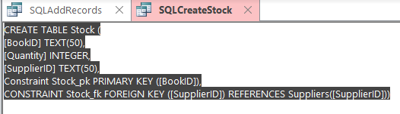
Figure 13: SQL create table
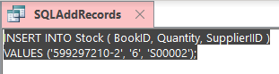
Figure 14: SQL insert data

5. Conclusion
The above report has illustrated the design and development of a database that meets the requirements of the end user. It shows the early stages of design with the use of an entity relationship diagram as well as the development within MS Access. The report contains screen shots of each form and report that has been created to help the user access the information they require. A brief user guide has also been created for the database showing how to use each element that has been developed in order to view, create and delete information. Evidence of SQL that was used to create a table within the database and insert data into that table has also been included within this report.

References

[1] “Entity Relationship Diagram (ERD) - What is an ER Diagram?” [Online]. Available: https://www.smartdraw.com/entity-relationship-diagram/. [Accessed: 06-May-2019].
[2] “SQL Tutorial.” [Online]. Available: https://www.w3schools.com/sql/. [Accessed: 06-May-2019].
[3] S. Chauhan, “Basics of SQL Commands.” [Online]. Available: https://www.dotnettricks.com/learn/sqlserver/basics-of-sql-commands. [Accessed: 06-May-2019].

