Introduction
The goal of this assignment was to create a website that contained various JavaScript elements that allowed for user interaction. As the exact topic and content of this website was left as a personal choice, I decided to showcase the various custom designed cards I have made to be used in the trading card game ‘Yu-Gi-Oh’.

Components

HTML Form
After several attempts to create a search function through a form proved unsuccessful, I decided to go with a simpler option and create a quiz.
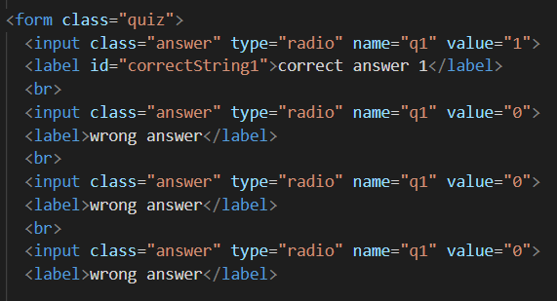
Firstly, I needed to decide what input types I was going to use and the “radio” type was the most appropriate for this, allowing for a singular option to be checked out of a list, with others such as the “checkbox” type being usable but only for certain types of questions.
The next step was to create some placeholder text to allow me to test whether the JavaScript that I will be using is working or not, this was done quite easily as shown in the accompanying image.

Now that I had an easily repeatable framework for making questions in html, I moved onto the JavaScript and the first step here was to get it to find the answer score.
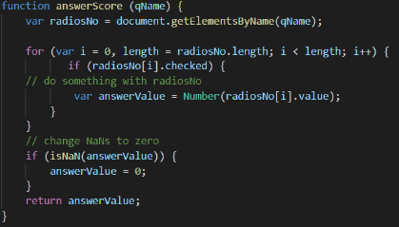
By giving the input tags a ‘name’, I could use the JavaScript to search for my questions by setting the JS to look for ‘q’ followed by a number allowing to easily designate an answer to a question, and to make sure that it considered empty inputs I had the code convert them into zeros.
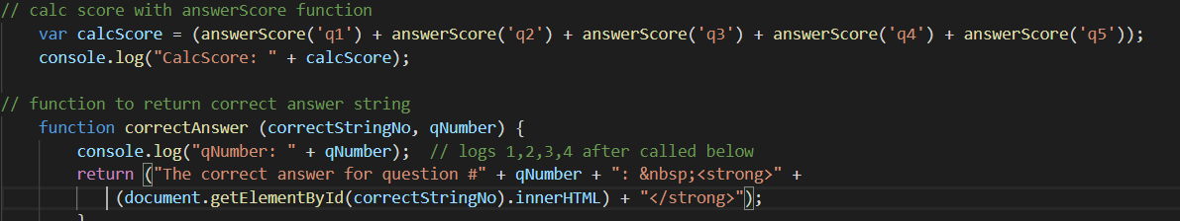
Moving on, next in the code I set up a variable to calculate the score of my quiz which was a fairly simple though lengthy issue to deal with. There is likely a way to do it more efficiently but this works. After calculating the score, I have it display to the console in order to confirm whether it is working or if it is broken.
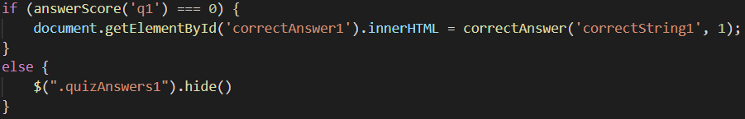
Following that, I created a function to display the correct answer to a question when the incorrect answer is given. This is then accompanied by some code that allows for the correction to be removed when the answer is changed to the correct one.
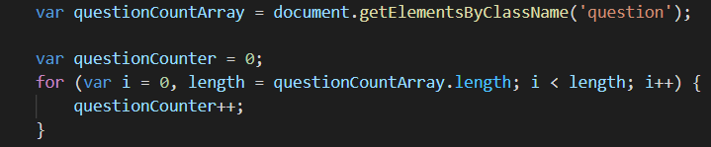
In order to calculate the final score, I needed a way to count the total number of questions. This was easily solved by designating them with a class and then building an array out of them by searching for that class name. This allows for the adding of more questions later on as rather than a specified size the array is built by how many results it finds and that determines how big the question counter variable is.
Finally, is the code for showing the final score which builds itself using the various past variables and if the score is perfect, it has a special message pop up.
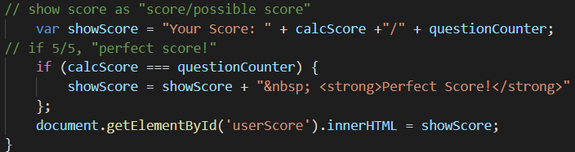
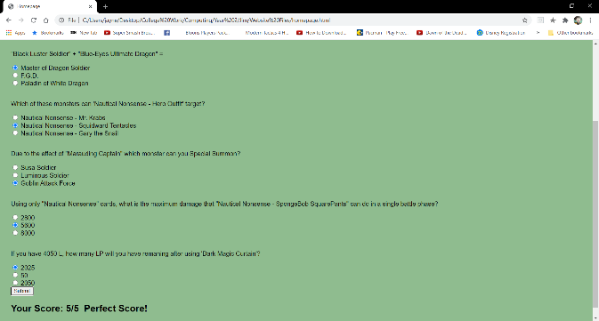
Screenshots
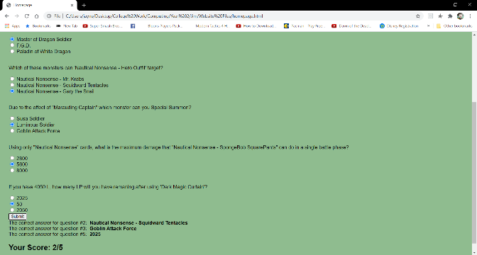

Full code
function submitQuiz() {
console.log('submitted');

// get each answer score
function answerScore (qName) {
var radiosNo = document.getElementsByName(qName);

for (var i = 0, length = radiosNo.length; i < length; i++) {
if (radiosNo[i].checked) {
// do something with radiosNo
var answerValue = Number(radiosNo[i].value);
}
}
// change NaNs to zero
if (isNaN(answerValue)) {
answerValue = 0;
}
return answerValue;
}

// calc score with answerScore function
var calcScore = (answerScore('q1') + answerScore('q2') + answerScore('q3') + answerScore('q4') + answerScore('q5'));
console.log("CalcScore: " + calcScore);

// function to return correct answer string
function correctAnswer (correctStringNo, qNumber) {
console.log("qNumber: " + qNumber); // logs 1,2,3,4 after called below
return ("The correct answer for question #" + qNumber + ": &nbsp;<strong>" +
(document.getElementById(correctStringNo).innerHTML) + "</strong>");
}

// print correct answers only if wrong (calls correctAnswer function)
if (answerScore('q1') === 0) {
document.getElementById('correctAnswer1').innerHTML = correctAnswer('correctString1', 1);
}
else {
$(".quizAnswers1").hide()
}
if (answerScore('q2') === 0) {
document.getElementById('correctAnswer2').innerHTML = correctAnswer('correctString2', 2);
}
else {
$(".quizAnswers2").hide()
}
if (answerScore('q3') === 0) {
document.getElementById('correctAnswer3').innerHTML = correctAnswer('correctString3', 3);
}
else {
$(".quizAnswers3").hide()
}
if (answerScore('q4') === 0) {
document.getElementById('correctAnswer4').innerHTML = correctAnswer('correctString4', 4);
}
else {
$(".quizAnswers4").hide()
}
if (answerScore('q5') === 0) {
document.getElementById('correctAnswer5').innerHTML = correctAnswer('correctString5', 5);
}
else {
$(".quizAnswers5").hide()
}

// calculate "possible score" integer
var questionCountArray = document.getElementsByClassName('question');

var questionCounter = 0;
for (var i = 0, length = questionCountArray.length; i < length; i++) {
questionCounter++;
}

// show score as "score/possible score"
var showScore = "Your Score: " + calcScore +"/" + questionCounter;
// if 5/5, "perfect score!"
if (calcScore === questionCounter) {
showScore = showScore + "&nbsp; <strong>Perfect Score!</strong>"
};
document.getElementById('userScore').innerHTML = showScore;
}

jQuery
Deciding on what function to use from jQuery was hard, but I decided on using both of the hide and show functions, these will allow the list of cards to switch between a list view and a portfolio/mosaic look. I chose this as it something that almost every similar type of website uses such as product lists on a shopping website.
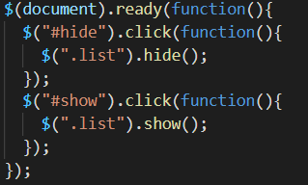
To begin with, I needed to figure out what the code for this function even was and how to twist it for my own use. Following the tutorial on w3schools.com ^{[1]} I created a simple function to hide and show a few of my chosen images.
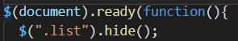
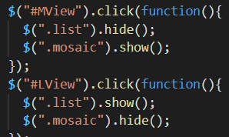
Next came the challenge of making it switch between the different views, first of all I had to make one of the options hidden upon opening the page and then follow that up with an addition to the above code.
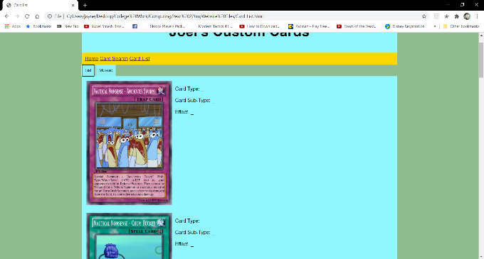
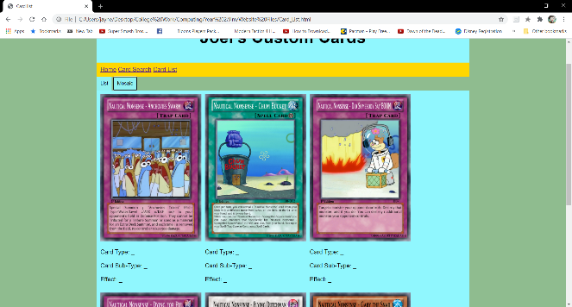
Screenshots of the component

Full code
$(document).ready(function(){
$(".list").hide(); // Hides the list from view upon opening the page
$("#MView").click(function(){ // Switches to Mosaic view by hiding the list and revealing the mosaic
$(".list").hide();
$(".mosaic").show();
});
$("#LView").click(function(){ // Switches to List view by hiding the mosaic and revealing the list
$(".list").show();
$(".mosaic").hide();
});
});

Free Choice

Misc.

Conclusion

References

[1] | w3schools, “jQuery Effects - Hide and Show,” [Online]. Available: https://www.w3schools.com/jquery/jquery_hide_show.asp. [Accessed 6 January 2021].

Bibliography

