University of Wales Trinity Saint David

School of Engineering



Analytical Assessment of Engine Internal Components

Contemporary Powertrain Design (ACHA6006)
BEng Motorsport Engineering

Franklin Spencer Tim Attwood
2004876
March 2025
Word Count: 2548

Table of Contents
Table of Figures and Tables 3
Tables 3
Figures 3
1 Introduction 5
2 Fatigue 6
3 Midpoint of Connecting Rod 7
4 Point A of Gudgeon Pin 10
5 Connecting Rod Bolts 14
5.1 Factory Engine Speed Range (6000 RPM) 15
5.1.1 No Stress Concentration Factor 15
5.1.2 Accounting for Stress Concentration Factor 15
5.2 Extended Engine Speed Range (9000 RPM) 17
5.3 Connecting Rod Bolt Redesign for Increased Engine Speed 18
5.3.1 Reduced Diameter Bolt Shank (RS) 18
5.3.2 Rolled Threads (RT) 20
6 Crankshaft Designs 22
6.1 Flat-Plane Crankshaft 22
6.2 Cross-Plane Crankshaft 23
6.3 Flat plane vs Cross Plane Crankshafts 24
6.3.1 Toque Inertia Force 24
6.3.2 Gas Torque 25
6.3.3 Crank Torque 26
7 Conclusion 28
8 References 29
9 Appendices 31
9.1 Provided Information for Ford 1.6 Sigma Engine 31
9.1.1 General Specifications 31
9.1.2 Connecting Rod Specifications 31
9.1.3 Gudgeon Pin Specifications 31
9.1.4 Connecting Rod Bolt Specifications 32
9.1.5 Stress Concentration Data 32
9.2 MATLAB Live Script 33

Table of Figures and Tables

Tables
Table 3-1 - Midpoint of connecting rod stress table 8
Table 4-1 - Point A of gudgeon pin stress table 12
Table 5-1 - Connecting rod bolt stress table 15
Table 5-2 - Connecting rod bolt stress accounting for stress concentrations table 16
Table 5-3 - Connecting rod bolt stress Kt 9000 rpm addition table 17
Table 5-4 – Connecting rod bolt reduced shank stress table 19
Table 5-5 - Connecting rod bolt reduced shank and rolled thread stress table 21

Figures
Figure 2-1 - S-N curve example (Homan, 2018) 6
Figure 3-1 - Net force verses crank angle graph for all RPM sites 7
Figure 3-2 - Mid-point of connecting rod goodman diagram for max stress range (4000 RPM) 8
Figure 4-1 - Gudgeon pin diagram showing point A 10
Figure 4-2 - Bending, shear and resultant stress verses crank angle graph for 6000 rpm 11
Figure 4-3 - Point A of gudgeon pin goodman diagram for max stress range (4000 RPM) 13
Figure 5-1 - Generic Crankshaft Assembly illustration (Pro-Race Engineering, 2025) 14
Figure 5-2 - Connecting Rod CAD File Thread Specification 14
Figure 5-3 - Stress concentration factor a U-notch diagram 15
Figure 5-4 - Connecting rod bolt goodman diagram accounting for stress concentrations (6000 RPM) 16
Figure 5-5 - Connecting rod bolt Kt goodman diagram (9000 RPM) 17
Figure 5-6 - Reduced shank bolt illustration (Fastenerdata, 2025) 18
Figure 5-7 - Connecting rod bolt reduced shank goodman diagram (9000 RPM) 19
Figure 5-8 - Thread rolling tooling diagram (Brooks Forging, 2025) 20
Figure 5-9 - Cut verses rolled thread material grain cross section (Brooks Forging, 2025) 20
Figure 5-10 - Connecting rod bolt reduced shank and rolled thread goodman diagram (9000 RPM) 21
Figure 6-1 - Flat plane crankshaft torque inertia force verses crank angle at 6000 RPM graph 22
Figure 6-2 - Cross plane crankshaft torque inertia force verses crank angle at 6000 RPM graph 23
Figure 6-3 - Flat and cross plane crankshaft torque inertia force verses crank angle at 6000 RPM graph 24
Figure 6-4 - Flat and cross plane gas torque verses crank angle at 6000 RPM graph 25
Figure 6-5 - Flat and cross plane torque verses crank angle at 1000 RPM graph 26
Figure 6-6 - Flat and cross plane torque verses crank angle at 6000 RPM graph 26

Introduction
This technical report presents an analysis of the forces and stresses experienced by the bottom end components of the Ford 1.6 Sigma engine during its operating cycle and focusing on fatigue safety factor (FSF). The components analysed are the midpoint of the connecting rod, point A of the gudgeon pin and the rod bolts. Additionally, the report explores the potential impact of extending the RPM range to 9000RPM on the rod bolts and proposes a redesign of the connecting rod bolt geometry to achieve optimal safety factors. Calculations were conducted using a MATLAB live script (appendix 9.2). Lastly, the report calculates instantaneous torques for both flat and cross plane crankshaft configurations, highlighting the differences and suitability for various applications.

Fatigue
The main aspect to be analysed for the upcoming engine components is the fatigue safety factor. According to Haider (2022) fatigue is progressive structural damage caused by cyclic or fluctuating loads. These loads initiates crack formation, crank growth, and propagation, ultimately leading to material failure. Fatigue life of a material is based on the number of loading cycles it can withstand before failure. This is further supported by Xin stating:
Fatigue is a slow cycle-number-dependent irreversible process of plastic deformation when a material is under cyclic loading. It is a progressive and localized type of structural damage. Fatigue is caused by stress levels less than the ultimate tensile strength or even below the yield strength.
(Xin, 2011, page 136)
A common method for modelling fatigue behaviour in a material is to use the S-N curve method also known as a fatigue curve or Wöhler curve. When looking at a S-N curve Homan (2018) says after 10⁶ cycles the component is classed to have an infinite life expectancy regarding fatigue.
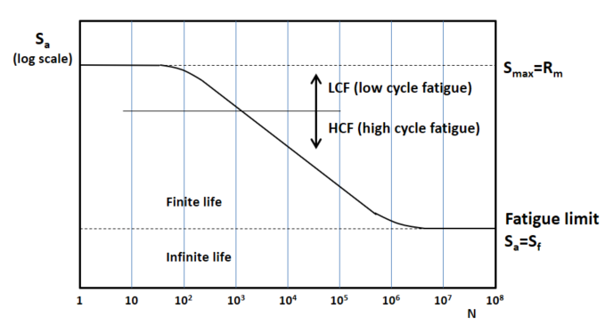
Figure 2-1 - S-N curve example (Homan, 2018)
For the FSF ratio of a component anything below 1 is demeaned to fail due to fatigue.

Midpoint of Connecting Rod
Two main stresses are experienced by the connecting rod; the gas force created by the combustion event and the inertia force due to the reciprocating mass accelerating. The total force seen by rod is referred to as Net Force where negative values are compressive. During this section stress concentration factors (SCF) are not taken into effect due to the lack of dimensions for the H-beam rod.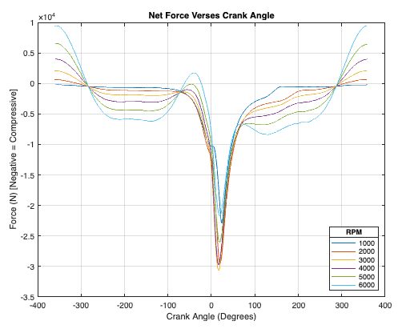
Figure 3-1 - Net force verses crank angle graph for all RPM sites
Expected Trend:
- Compressive force to be the largest at point of combustion (0° to 30° ATDC).
- Tensile force to be the most coming up to TDC after the exhaust stroke (300° to 360° ATDC).
Analysis:
- Effect the inertia force has on the compressive force during the end of the inlet stroke (-280° to -180°)
- Inertia force is higher than the gas force created by the compression stroke (-100° to 0° BTDC) particularly visible at 6000rpm.
- The dwell point of the piston can be seen with a constant stress (straight line) for 5°/6° at TDC on the exhaust stroke (-360° to -355°).
Table 3-1 - Midpoint of connecting rod stress table
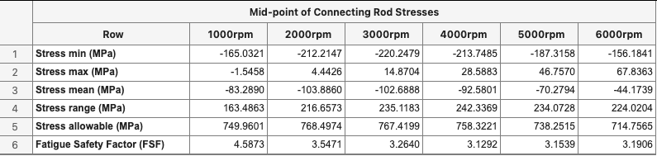
The above table was produced using the live script, the provided pressure data and the connecting rod specifications (appendix 9.1.2). Looking at the FSF the lowest value is 3.1292 in the 4000-rpm site, this shows it is at 4000 rpm where the rod experiences the largest stress alternations. This data is plotted in a goodman diagram as shown below.

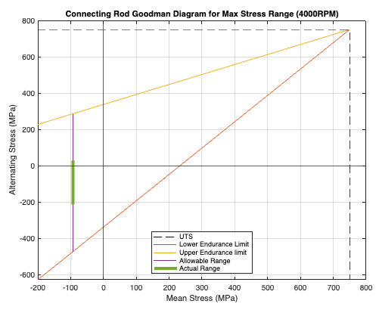
Figure 3-2 - Mid-point of connecting rod goodman diagram for max stress range (4000 RPM)
- Safety Margin - The actual stress range is safely within the allowable range, providing a decent safety margin.
- Mean Stress - The mean stress values are compressive (negative), indicating that the connecting rod is predominantly under compression during its operation. This is expected for the conditions of a connecting rod.
- Alternating Stress - The alternating stress is moderate, which is expected since connecting rods experience cyclic loads due to the reciprocating motion of the piston.

Point A of Gudgeon Pin
The gudgeon pin at point A (shown below) experiences bending and shear forces both of which are caused by the piston inertia and the gas force. Combining the bending and shear forces gives the resultant force.
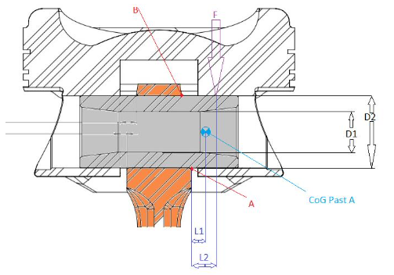
Figure 4-1 - Gudgeon pin diagram showing point A
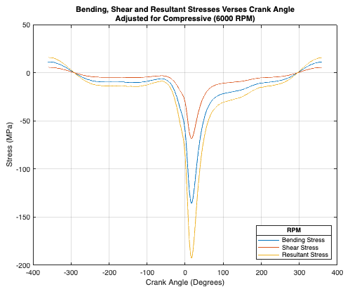
Figure 4-2 - Bending, shear and resultant stress verses crank angle graph for 6000 rpm
Expected Trend:
- Bending forces to be more than the shear forces due to the distance L2 = 7mm resulting in a small moment.
- All forces to mainly be compressive (negative) as the piston and pin would be forced together in the same direction for most of the 4-stroke cycle (compression, power and exhaust).
- On the inlet stroke forces would be tensile (positive) as the pin would pull the piston down the bore.
Analysis:
- Between -291° and 296° all forces are compressive meaning for 81% of the cycle the pin is in compression.
- Faily flat section between -230° and -115° where all forces are constant despite the compression stroke starting at -180°.
- The points at which the forces change from compressive to tensile and vice versa (0 MPa) is the point of maximum piston velocity.

Table 4-1 - Point A of gudgeon pin stress table
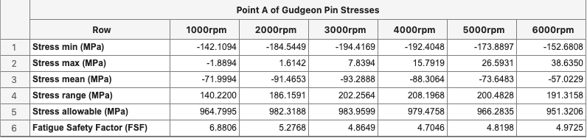
Using the live script and gudgeon pin specifications (appendix 9.1.3) the above table is created. Looking at the FSF the lowest value is 4.7046 in the 4000-rpm site, the same range as the connecting rod which is expected.

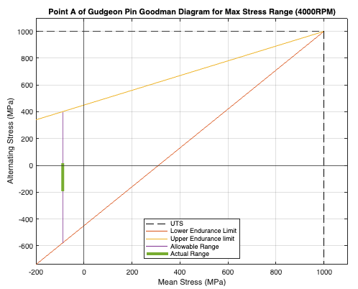
Figure 4-3 - Point A of gudgeon pin goodman diagram for max stress range (4000 RPM)

- Safety Margin – Much like the connecting rod the actual stress range is safely within the allowable range and the distance from the UTS line shows the connecting rod is not at risk of immediate tensile failure.
- Mean Stress – Similar to the connecting rod, the gudgeon pin’s experience is almost entirely compressive (negative mean stress), which matches the expected behaviour for a gudgeon pin under reciprocating loads.
- Alternating Stress - The alternating stress are like the connecting rod however since the allowable range is 27% larger than the connecting rod, these stresses are less of a concern.

Connecting Rod Bolts
Each con rod assembly has two bolts securing the rod cap to the rod body, this secures the big end of the connecting rod to the crankpin journal accompanied with a journal bearing which is supplied with high pressure oil.

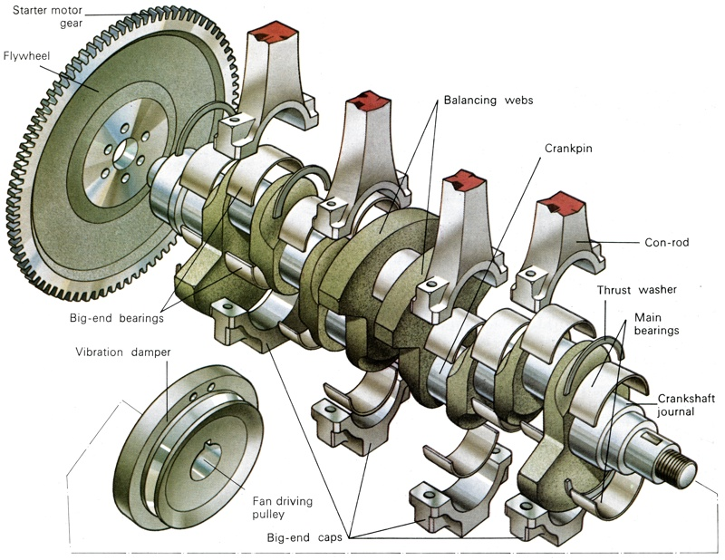
Figure 5-1 - Generic Crankshaft Assembly illustration (Pro-Race Engineering, 2025)

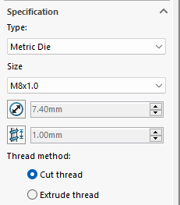
By sourcing uprated bolts for the factory con rod via Parts Plug UK (2025) and Speeding Performance Parts (2025) both can supply M8 ARP high strength bolts with a thread pitch of 1mm. This bolt thread (M8x1.00) matches up with the provided CAD files as can be seen in thread specification. The bolt thread is critical for calculating the stress concentration factor.

Figure 5-2 - Connecting Rod CAD File Thread Specification

Factory Engine Speed Range (6000 RPM)

No Stress Concentration Factor
Using the connecting rod bolt specifications (appendix 9.1.4) the below table is created using the live script. As the rod bolts only see reciprocating inertia forces acting away from the crankshaft it is expected to see the lowest FSF at the highest rpm site of 6000 rpm, this results in a FSF ratio of 9.5487.
Table 5-1 - Connecting rod bolt stress table
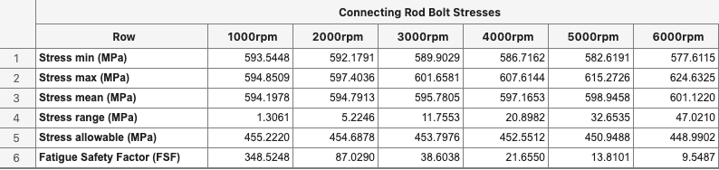

Accounting for Stress Concentration Factor
To account for the SCF which is caused by the threads of the bolts the below condition is selected from Roark’s formulas. This is for two U-shaped notches which is similar to the threads of the rod bolt threaded into the connecting rod. This will give an approximate SCF because the threads are not U-shaped but rather V-shaped limiting the accuracy of the calculations.
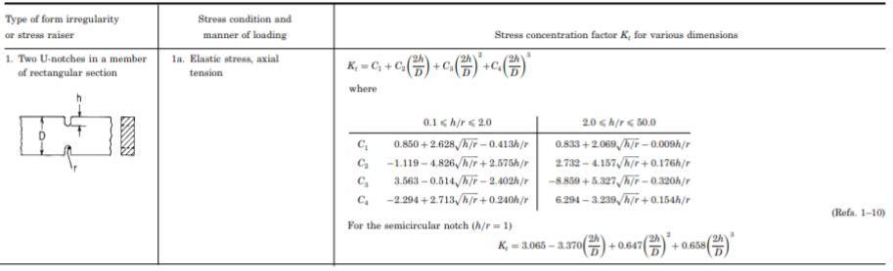
Figure 5-3 - Stress concentration factor a U-notch diagram

The rod bolt stress table is updated taking SCF (Kt) into account using an M8x1.00 bolt and refencing the thread lookup table (appendix 9.1.5). The new FSF is now 2.2198 which is a 76% decrease after account for SCF.
Table 5-2 - Connecting rod bolt stress accounting for stress concentrations table
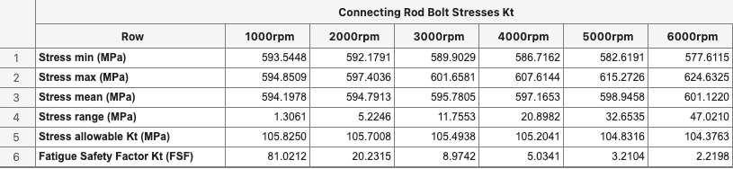

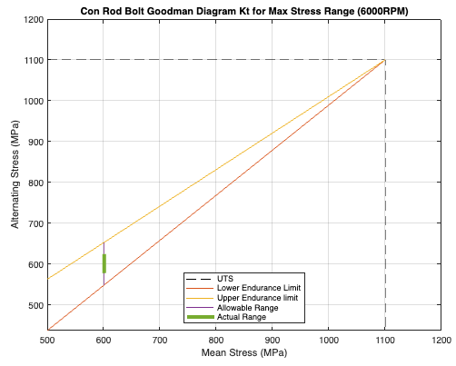
Figure 5-4 - Connecting rod bolt goodman diagram accounting for stress concentrations (6000 RPM)
The actual operating range is very close to the upper endurance limit, which is concerning. Given the high mean stress (> 600 MPa), fatigue failure is a critical concern. The proximity to the UTS line also implies potential risk if loads increase.

Extended Engine Speed Range (9000 RPM)
Since the rod bolts only see inertia forces extending the rpm to 9000 is calculated easily by working out the piston acceleration at 9000 rpm and then performing the same calculations as before. The updated table now has an additional collum for 9000 rpm with a FSF of 0.9690 which, being below 1 would certainly fail.
Table 5-3 - Connecting rod bolt stress Kt 9000 rpm addition table
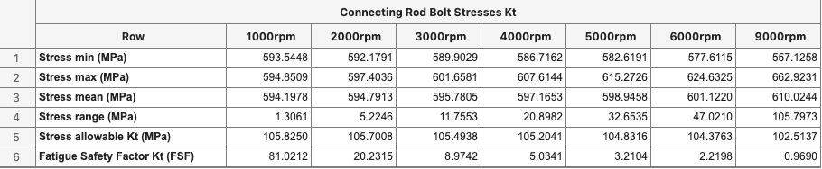

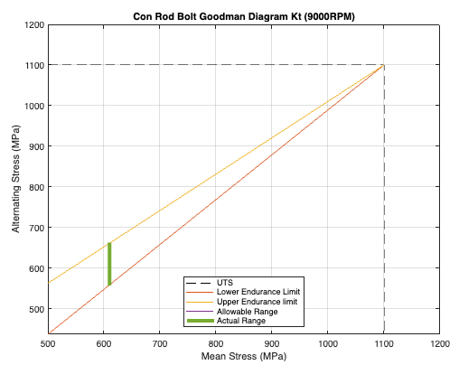
Figure 5-5 - Connecting rod bolt Kt goodman diagram (9000 RPM)
It is obvious looking at the above goodman diagram the bolt would instantly fail with the actual stress range exciding the endurance limits of the material.

Connecting Rod Bolt Redesign for Increased Engine Speed

Reduced Diameter Bolt Shank (RS)
By reducing the diameter of the bolt shank the cross-sectional-area (CSA) is reduced resulting in a reduced stiffness. The redesigned bolt has a shank diameter of 6mm for 24mm down the length of the shank, this allows for a 1mm section directly under the bolt head which can be filleted. The new bolt stiffness is calculated using the following equation:
$$\frac{1}{K_{bolt}}=\frac{1}{K_{1}}+\frac{1}{K_{2}}+\frac{1}{K_{3}}$$
Factory bolt has a K value of 32.69x104 N/mm and the new bolt a K value of 22.69x10⁴ N/mm decreasing the stiffness by 30%.
Since this changes the CSA, it is assumed that when calculating the axial force, the average CSA is used.

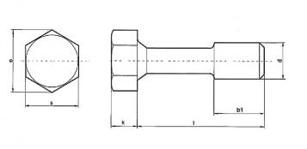
Figure 5-6 - Reduced shank bolt illustration (Fastenerdata, 2025)

Table 5-4 – Connecting rod bolt reduced shank stress table
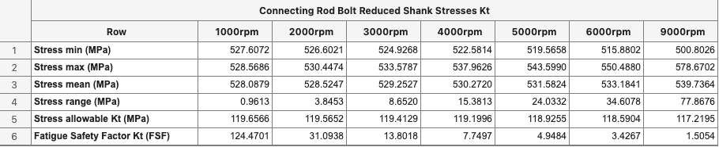
The new FSF is now 1.5054 an increase of over 55%, at this point the bolt may not fail which can easily be seen in the below goodman diagram, but it is still 47% away from the original value of 2.2198 in the 6000-rpm range.
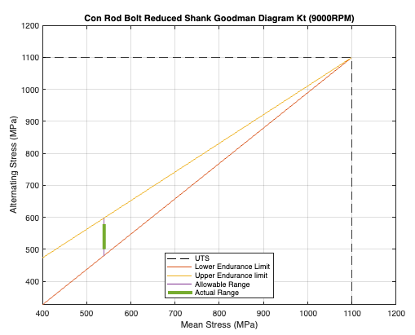
Figure 5-7 - Connecting rod bolt reduced shank goodman diagram (9000 RPM)

Rolled Threads (RT)
Another method that can be applied is to roll the bolt threads instead of cutting them. According to Codipro (2025) cold-rolled threads have a 30% increase in fatigue strength and Graphskill (2025) says they has seen increases in the tensile strength (UTS) by 30% and can improve fatigue strength by 50-75%. Although the effect on the UTS would differ between thread sizes for this study a 30% increase in UTS is used to attempt to increase the FSF to the point of the original ratio.
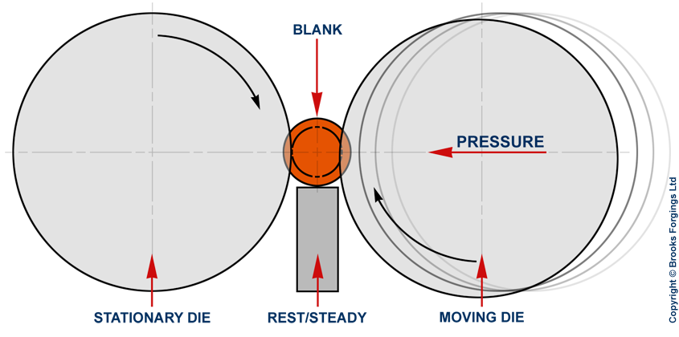
Figure 5-8 - Thread rolling tooling diagram (Brooks Forging, 2025)
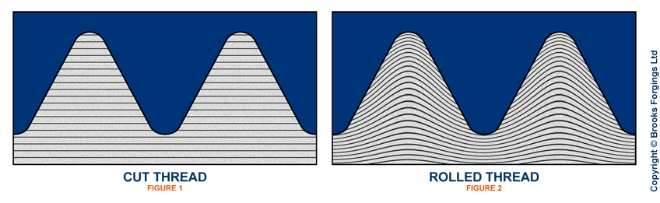
Figure 5-9 - Cut verses rolled thread material grain cross section (Brooks Forging, 2025)

Taking a 30% increase in UTS the new UTS for the bolt material is now 1430MPa and calculating the new FSF values gives a ratio of 1.9665 when combining the reduced shank bolt design with the rolled threads.
Table 5-5 - Connecting rod bolt reduced shank and rolled thread stress table
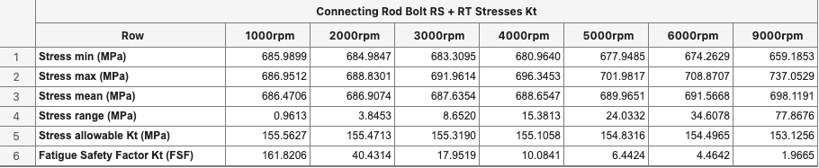
This new FSF ratio is still not at the same point of the original bolt at 6000 rpm of 2.2198 but it is only 12% off and looking at the goodman diagram it does not show signs of fatigue failure. It must be noted that there are serval limitations to the calculations and that although the FSF suggests the bolt will not fail due to fatigue there are other factors which could alter the outcome.
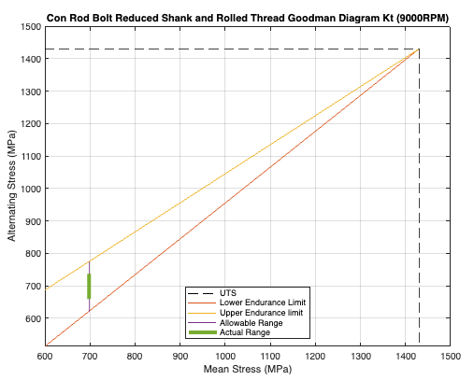
Figure 5-10 - Connecting rod bolt reduced shank and rolled thread goodman diagram (9000 RPM)

Crankshaft Designs
For an inline 4-cylinder configuration there are two common crankshaft designs, a flat-plane crankshaft and cross-plane crankshaft.

Flat-Plane Crankshaft
A flat-plane crankshaft is most common with the crankpins for cylinder 1 and 4 inline on the same plane and cylinder 2 and 3 in the same plane but 180° around from cylinder 1 and 4 crankpins. With a firing order of 1-3-4-2 the firing intervals are every 180° equally spaced.

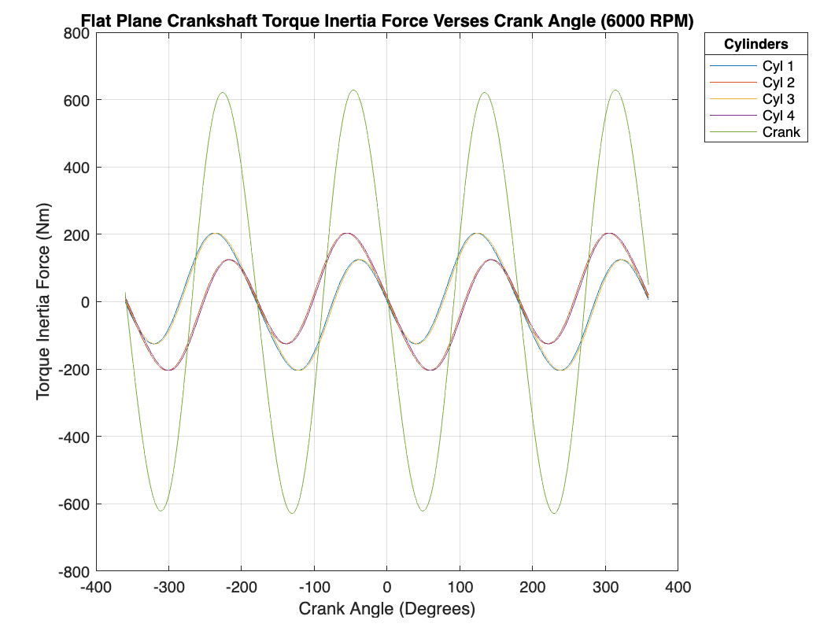
Figure 6-1 - Flat plane crankshaft torque inertia force verses crank angle at 6000 RPM graph
Looking at the crank inertia torque it is evident the individual cylinder torques occur overlapping another in the same amplitude resulting in increased inertia torque as the pistons reciprocate in pairs (cylinders 1 & 4 and 2 & 3).

Cross-Plane Crankshaft
With a cross-plane crankshaft each crankpin is offset by 90°. The effect of this is a firing order of 1-3-2-4 with unequal firing intervals:
1 = 180°
3 = 270°
2 = 180°
4 = 90°

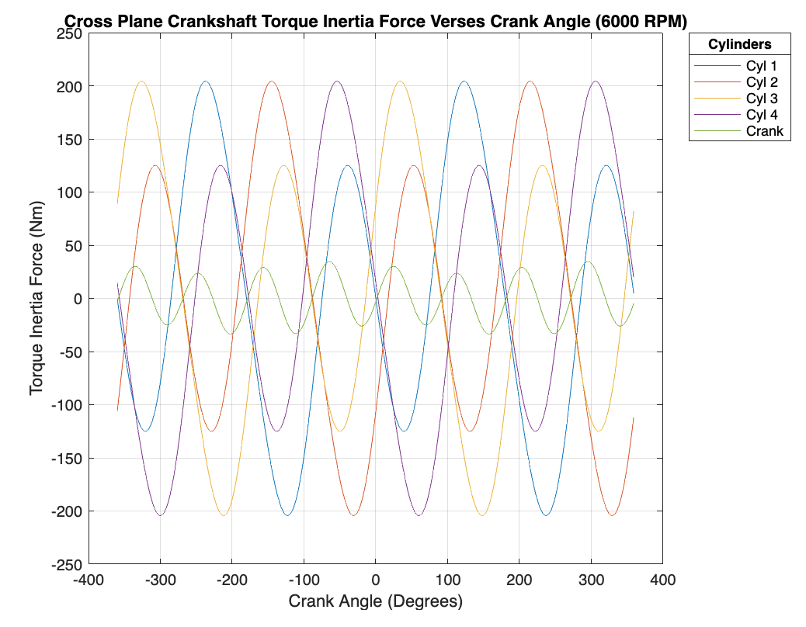
Figure 6-2 - Cross plane crankshaft torque inertia force verses crank angle at 6000 RPM graph
On a cross-plane crank since the pistons don’t reciprocate in pairs it would be expected for the inertia torques of each cylinder to cancel out the other. This is event looking at the crank inertia torque.

Flat plane vs Cross Plane Crankshafts

Toque Inertia Force
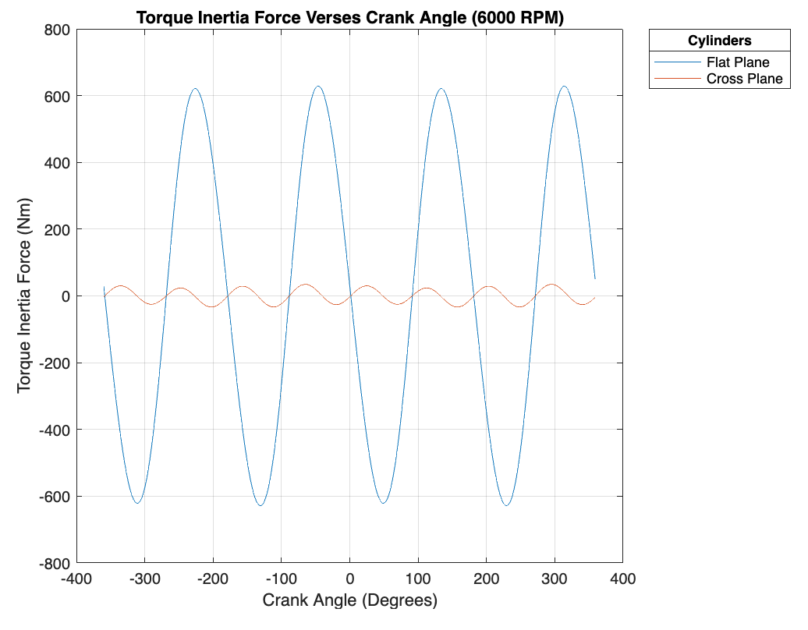
Figure 6-3 - Flat and cross plane crankshaft torque inertia force verses crank angle at 6000 RPM graph
Overlaying the crank torque inertia from both crank designs it is clear the cross-plane crank is superior with 600Nm less inertia torque compared to the flat-plane crank.

Gas Torque
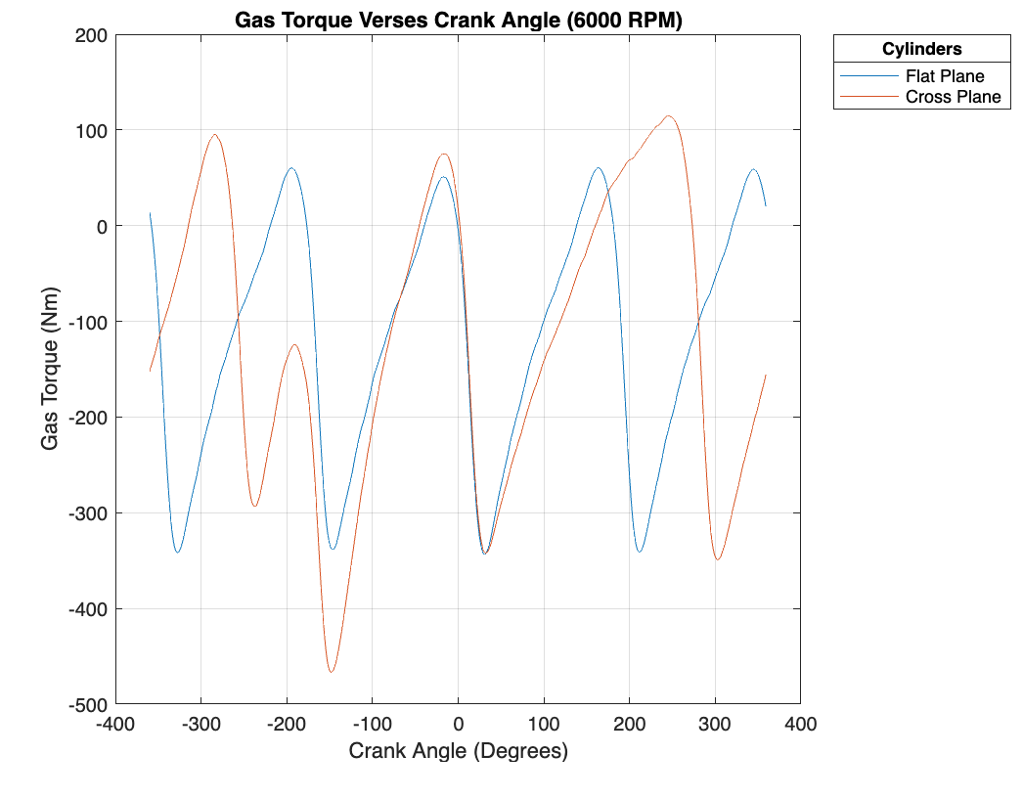
Figure 6-4 - Flat and cross plane gas torque verses crank angle at 6000 RPM graph
When looking at the gas toque of both cranks the firing internals are evident however this does not account for the inertia torque.

Crank Torque
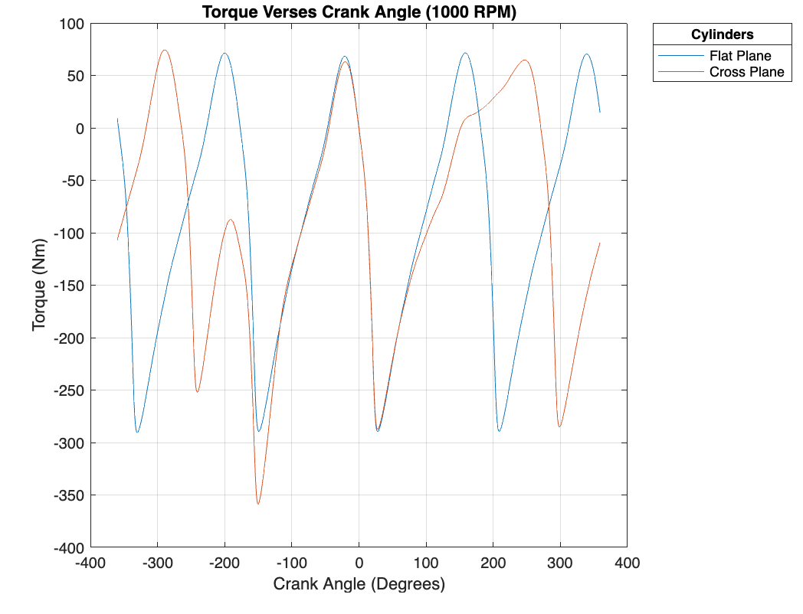
Figure 6-5 - Flat and cross plane torque verses crank angle at 1000 RPM graph
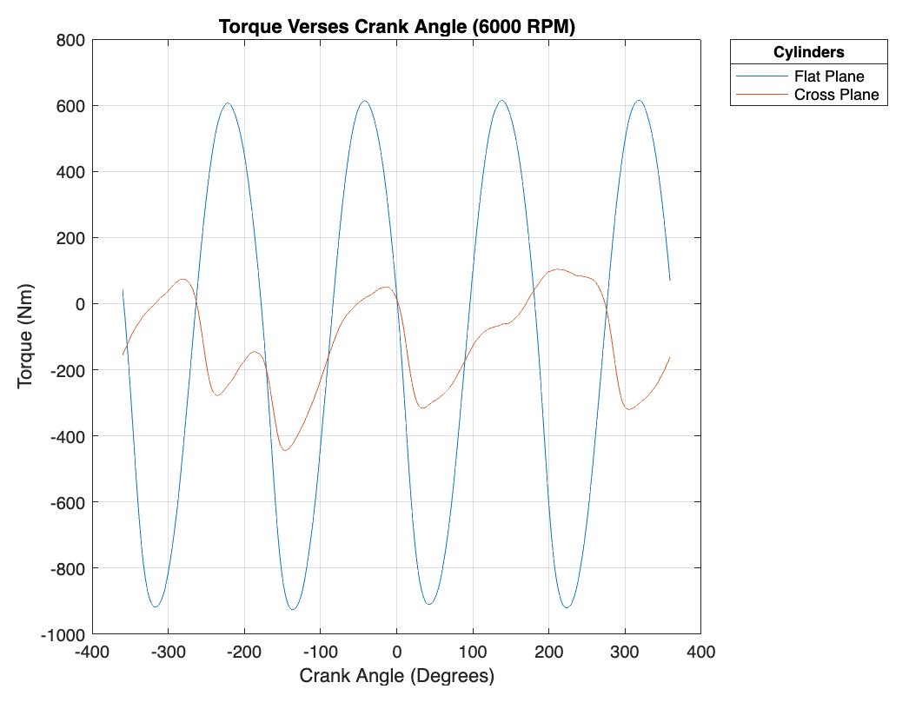
Figure 6-6 - Flat and cross plane torque verses crank angle at 6000 RPM graph
When accounting for the inertia torque this is when the advantage of a cross-plane crankshaft is most evident especially at increase engine speed. Looking at the 1000 rpm graph the cross-plane crank has 70Nm more than the flat-plane at the highest peak but when looking at the 6000 rpm graph the flat-plane crank produces just over 480Nm more than the cross-plane crank. This would only worsen with higher engine speeds meaning a cross-plane crankshaft design would be suited for a high revving engine.

Conclusion
In conclusion, from the calculations performed in the MATLAB live script it is event that the connecting rod, gudgeon pin and rod bolts used in the Ford sigma engine are unlikely to fail due to fatigue if the engine is run under normal operating conditions. This was evident as all components achieved a FSF ratio of over 2 even when accounting for stress concentrations factors. When increasing the engine speed to 9000 rpm it was clear the rod bolt would fail and even after applying two different bolt design techniques to improve the bolt strength (reduced shank diameter and rolled threads) the FSF ratio was still 12% short that of the original bolt at 6000 rpm however it was discussed that the new bolt would unlikely fail due to fatigue. Crankshaft designs were considered concluding that a high revving engine would benefit from a cross-plane crankshaft.

References
All-Pro Threaded Products (2025) Advantages of Rolled Threads
Available at: https://www.aptp.com/technical/advantages-of-rolled-threads/
(Accessed: 09/03/2025)

Bolt Science (2025) Bolt Fatigue and a Bolt's Thread Root
Available at: https://www.boltscience.com/pages/Bolt-Fatigue-and-the-Thread-Root.htm#:~:text=There%20are%20two%20main%20reasons,used%20in%20the%20rolling%20process.
(Accessed:09/03/2025)

Brooks Forging (2025) Thread Rolling
Available at: https://brooksforgings.co.uk/processes/thread-rolling
(Accessed: 16/03/2025)

Codipro (2025) Rolled thread or cut thread? Differences and advantages
Available at: https://codipro.net/en/rolled-thread-or-cut-thread-differences-advantages/#:~:text=The%20characteristics%20of%20a%20rolled,%2D%3E%20up%20to%2030%25%20higher
(Accessed: 15/03/2025)

Fastenerdata (2025) Metric Coarse Reduced Shank Bolt DIN 931 Grade-8.8 DIN7964D
Available at: https://www.fastenerdata.co.uk/fasteners/bolts/hexagon/metric-coarse/metric-coarse-reduced-shank-bolt-din-931-grade-88-din7964d.html
(Accessed: 14/03/2025)

Ford UK (2010) Component Sales – 1.6 GTDI EcoBoost
Available at: https://www.ford.co.uk/content/dam/guxeu/uk/documents/home/experience-ford/about-ford/ford-component-sales/specification-details-data-sheets/16-ecoboost-np.pdf
(Accessed: 06/03/2025)

Graphskill Ltd (2025) GRAPHSKILL USE THREAD ROLLING - WHY?
Available at: https://u-bolts-r-us.co.uk/blog/15_graphskill-use-thread-rolling-why.html
(Accessed: 15/03/2023)

Haider, A. & S. (2022) Renewable Polymers and Polymer-Metal Oxide Composites
Cambridge: Elsevier

Homan, J. (2018) Description of a S-N Curve
Available at: https://www.fatec-engineering.com/2018/02/20/description-of-a-s-n-curve/
(Accessed: 08/03/2025)

Parts Plug UK (2025) ARP Ford Zetec 1.6/2.0 MK1 RS 45mm UHL M8 1mm pitch rod bolt kit 151-6003
Available at: https://www.partspluguk.co.uk/product/arp-ford-zetec-1-6-2-0-mk1-rs-45mm-uhl-m8-1mm-pitch-rod-bolt-kit-151-6003/
(Accessed: 08/03/2025)

Pro-Race Engineering (2025) Crankshaft and Flywheel Balancing For Inline Engines
Available at: https://prorace-engineering.co.uk/product/crankshaft-and-flywheel-balancing-for-inline-engines/
(Accessed: 08/03/2025)

Speeding Performance Parts (2025) ARP Ford Zetec 1.6/1.8/2.0L rod bolt kit (M8x1)
Available at: https://www.speedingparts.co.uk/p/brands/arp/connecting-rod-bolts/arp-ford-zetec-161820l-rod-bolt-kitm8x1.html
(Accessed: 08/03/2025)

Xin, Q. (2011) Diesel Engine System Design
1st Edition
Cambridge: Woodhead Publishing

Appendices

Provided Information for Ford 1.6 Sigma Engine

General Specifications
Bore Diameter = 79mm
Crank Radius (throw)= 40.7mm Connecting Rod Length = 134mm
Piston Mass = 258g
Con-Rod Mass (whole with bolts) = 372g Ring Masses = 9g
Clips Mass = 5g
Pin Mass = 80g

Connecting Rod Specifications
Calculated mid-point of con rod length
CSA at mid length = 139.65mm2
UTS of material = 750 MPa
Endurance Limit of Rod material = 45% of UTS

Gudgeon Pin Specifications
L1 = 7.75mm
L2 = 7mm
Exposed Mass = 23.28g
D1 = 12.3mm
D2 = 21mm
UTS of material = 1000 MPa
Endurance Limit of Pin material = 45% of UTS

Connecting Rod Bolt Specifications
Cap mass = 105g
Bolts x2 mass = 35g
Head Diameter = 12.9mm
Cap interface cross sectional area = 210 mm^2
Modulus of Elasticity of cap = 170,000 N/mm^2
Length of connecting rod cap section interacting with bolt = 25mm Cross sectional area of bolt = 42.43 mm^2
Modulus of Elasticity of bolt = 210,000 N/mm^2
Length to 2nd engaged thread (effective working length) = 27.26mm Total length of threaded section = 32mm
UTS of Bolt material = 1100 MPa
Yield Strength of material = 90% of UTS Endurance Limit of Bolt material = 45% of UTS The bolt is of continuous thread design.

Stress Concentration Data
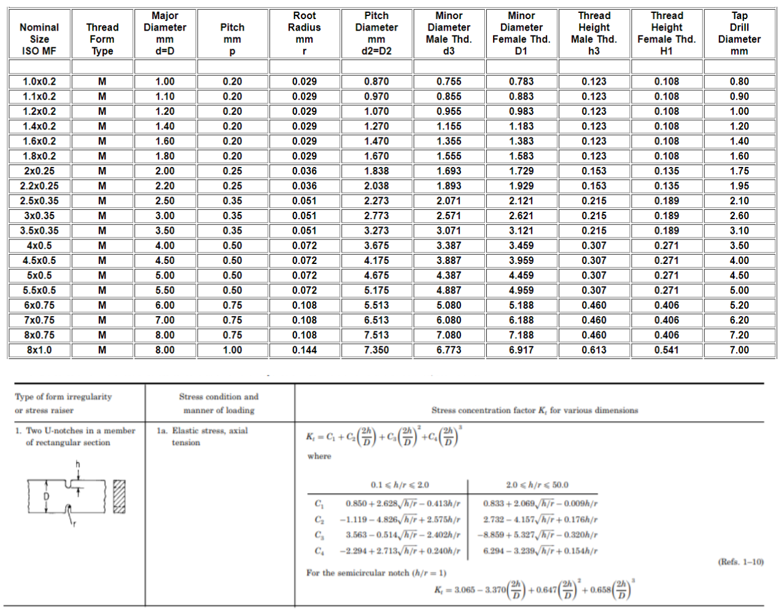

MATLAB Live Script
clc, clear, close all % Empty command window, clear workspace and close any open figures

mean_pressure = readmatrix("1600 sigma Pressure Data.xlsx","Range","B5:G724"); % Read in the mean cylinder pressure data
crank_angle = readmatrix("1600 sigma Pressure Data.xlsx","Range","A5:A724"); % Read in crank angle data
rpm = readmatrix("1600 sigma Pressure Data.xlsx","Range","B2:G2"); % Read in all the rpm sites

bore = 0.079; % Set the bore (m)
stroke = 0.0814; % Set the stroke (m)
rod_length = 0.134; % Set the connecting rod length (m)
comp_ratio = 10.1; % Set the compression ratio from the Ford component sales sheet (researched)
clearance_volume = (((pi.*(bore^2))./4).*stroke)./comp_ratio; % Calculated clearance volume
crank_radius = stroke./2; % Crank Radius (m)

rod_angle = (asind((crank_radius.*(sind(crank_angle)))./rod_length)); % Rod angle

s = (crank_radius+rod_length) - ((crank_radius.*cosd(crank_angle)) + (rod_length.* cosd(rod_angle))); % Piston position relative to TDC (m)

calculated_volume = (clearance_volume) + (((pi.*(bore^2))./4).*s); % Calculated cylinder volume (m3)

figure; % Creates a window
plot(crank_angle,(s.*1000)); % Plotting crank angle and chamber volume piston position relative to TDC
title('Piston Position Relative to TDC Verses Crank Angle'); % Adds a title to the graph
xlabel('Crank Angle (Degrees)'); % Labels the x axis
ylabel('Distance from TDC to Piston (mm)'); % Labels the y axis
grid on; % Adds major grid lines

figure; % Creates a window
plot(crank_angle,(calculated_volume.*1000000)); % Plotting crank angle and chamber volume
title('Chamber Volume Verses Crank Angle'); % Adds a title to the graph
xlabel('Crank Angle (Degrees)'); % Labels the x axis
ylabel('Chamber Volume (cc)'); % Labels the y axis
grid on; % Adds major grid lines
w = rpm.*((2.*pi)./60); % RPM in Rad/s

piston_v = zeros(720,6); % Pre-allocate zeros to variable

for i = 1:6
piston_v(:,i) = (crank_radius.*w(:,i).*sind(crank_angle)) + ((((crank_radius.^2).*w(:,i))./(2.*rod_length).*(sind(2.*crank_angle)))); % Calculate piston velocity in m/s for all rpm sites
end

figure; % Creates a window
plot(crank_angle,piston_v); % Plotting crank angle and piston velocity
title('Piston Velocity Verses Crank Angle'); % Adds a title to the graph
xlabel('Crank Angle (Degrees)'); % Labels the x axis
ylabel('Piston Velocity (m/s)'); % Labels the y axis
grid on; % Adds major grid lines
legend('1000','2000','3000','4000','5000','6000') % Adds a legend to the graph with labels for each line
title(legend,'RPM'); % Adds a legend title

piston_acc = zeros(720,6); % Pre-allocate zeros to variable

for i = 1:6
piston_acc(:,i) = (crank_radius.*(w(:,i).^2).*cosd(crank_angle)) + (((crank_radius.^2)./rod_length).*(w(:,i).^2).*cosd(2.*crank_angle)); % Calculate piston acceleration in m/s^2 for all rpm sites
end

figure; % Creates a window
plot(crank_angle,piston_acc); % Plotting crank angle and piston acceleration
title('Piston Acceleration Verses Crank Angle'); % Adds a title to the graph
xlabel('Crank Angle (Degrees)'); % Labels the x axis
ylabel('Piston Accleration (m/s^2 )'); % Labels the y axis
grid on; % Adds major grid lines
legend('1000','2000','3000','4000','5000','6000',Location='northeastoutside') % Adds a legend to the graph with labels for each line
title(legend,'RPM'); % Adds a legend title
figure; % Creates a window
surf(rpm,crank_angle,piston_acc); % 3D plot of crank angle and piston acceleration for all rpm sites
title('Piston Acceleration Verses Crank Angle and RPM'); % Adds a title to the graph
xlabel('RPM'); % Labels the x axis
ylabel('Crank Angle (Degrees)'); % Labels the y axis
zlabel('Piston Accleration (m/s^2 )') % Labels the z axis
grid on; % Adds major grid lines
piston_mass = 0.258; % Kg
ring_mass = 0.009; % Kg
pin_mass = 0.08; % Kg
clips_mass = 0.005; % Kg
rod_mass = 0.372; % Kg

rod_rec_mass = rod_mass./3; % 1/3 con rod mass (Kg)
rod_rot_mass = (rod_mass./3).*2;
piston_parts_mass = piston_mass + ring_mass + pin_mass + clips_mass; % Mass of just the piston parts (Kg)
rec_mass = piston_parts_mass + rod_rec_mass; % Mass of the reciprocating components (Kg)

F_inertia_rec = rec_mass.*piston_acc; % Calculate force due to inertia

figure; % Creates a window
plot(crank_angle,F_inertia_rec); % Plotting crank angle and piston acceleration
title('Piston Force Due to Inertia Verses Crank Angle'); % Adds a title to the graph
xlabel('Crank Angle (Degrees)'); % Labels the x axis
ylabel('Force Due to Inertia (N)'); % Labels the y axis
grid on; % Adds major grid lines
legend('1000','2000','3000','4000','5000','6000',Location='northeastoutside') % Adds a legend to the graph with labels for each line
title(legend,'RPM'); % Adds a legend title

figure; % Creates a window
surf(rpm,crank_angle,F_inertia_rec); % 3D plot of crank angle and reciprocating inertia force for all rpm sites
title('Piston Force Due to Inertia Verses Crank Angle and RPM'); % Adds a title to the graph
xlabel('RPM'); % Labels the x axis
ylabel('Crank Angle (Degrees)'); % Labels the y axis
zlabel('Force Due to Inertia (N)') % Labels the z axis
grid on; % Adds major grid lines

figure; % Creates a window
plot(crank_angle,mean_pressure); % Plotting crank angle and cylinder pressure
title('Cylinder Pressure Verses Crank Angle'); % Adds a title to the graph
xlabel('Crank Angle (Degrees)'); % Labels the x axis
ylabel('Cylinder Pressure (Bar)'); % Labels the y axis
grid on; % Adds major grid lines
legend('1000','2000','3000','4000','5000','6000') % Adds a legend to the graph with labels for each line
title(legend,'RPM'); % Adds a legend title

F_gas = (mean_pressure.*1e5).*((pi.*(bore.^2)./4)); % Calculate the gas force
F_net = F_inertia_rec - F_gas; % Calculate the net force acting on the reciprocating components

figure; % Creates a window
plot(crank_angle,F_net); % Plotting crank angle and net force
title('Net Force Verses Crank Angle'); % Adds a title to the graph
xlabel('Crank Angle (Degrees)'); % Labels the x axis
ylabel('Force (N) [Negative = Compressive]'); % Labels the y axis
grid on; % Adds major grid lines
legend('1000','2000','3000','4000','5000','6000',Location='southeast') % Adds a legend to the graph with labels for each line
title(legend,'RPM'); % Adds a legend title

u = 0.1; % Coefficient of friction for oil in shear

F_rod = F_net./(cosd(rod_angle)); % Calculate the con rod force
F_piston_side = F_net.*(tand(rod_angle)); % Calculate the piston lateral force
F_friction = u.*F_piston_side; % Calculate the piston frictional force

end_limit_rod = 0.45; % Set the endurance limit for the rod material

UTS_rod = 750; % Set the ultimate tensile strength for the rod material (MPa)

CSA = 139.65; % Cross-sectional area at mid point of con rod (mm^2)
%CSA = 0.00013965; % Cross-sectional area at mid point of con rod (m^2)

stress_min_rod = (min(F_rod))./CSA; % Calculate minimum stress at con rod mid point (MPa)

stress_max_rod = (max(F_rod))./CSA; % Calculate maximum stress at con rod mid point (MPa)

stress_mean_rod = (stress_min_rod + stress_max_rod)./2; % Calculate mean stress at con rod mid point (MPa)

stress_range_rod = (stress_max_rod - stress_min_rod); % Calculate stress range at con rod mid point (MPa)

stress_allow_rod = (2.*(UTS_rod.*end_limit_rod).*(1-(stress_mean_rod./UTS_rod))); % Calculate the allowable stress at con rod mid point (MPa)
fsf_rod = stress_allow_rod./stress_range_rod; % Calculate fatigue safety factor at con rod mid point (MPa)
varTypes = ["double","double","double","double","double","double"]; % Sets the variable type for each column
varNames = ["1000rpm","2000rpm","3000rpm","4000rpm","5000rpm","6000rpm"]; % Sets the rpm sites as the names for each column

Stress_rod = table('Size',[0 6],'VariableTypes',varTypes,'VariableNames',varNames); % Creates a table for the mass fraction burned

Stress_rod{"Stress min (MPa)",:} = stress_min_rod;
Stress_rod{"Stress max (MPa)",:} = stress_max_rod;
Stress_rod{"Stress mean (MPa)",:} = stress_mean_rod;
Stress_rod{"Stress range (MPa)",:} = stress_range_rod;
Stress_rod{"Stress allowable (MPa)",:} = stress_allow_rod;
Stress_rod{"Fatigue Safety Factor (FSF)",:} = fsf_rod;
Stress_rod = table(Stress_rod,'VariableNames',{'Mid-point of Connecting Rod Stresses'})
figure;
x_axis_min = round(stress_mean_rod(:,4)-100,-2);
xy_axis_max = max(round(UTS_rod+50,-2));

LowerEL = [(interp1([0,UTS_rod],[-(end_limit_rod.*UTS_rod),UTS_rod],(x_axis_min),'linear','extrap')),UTS_rod];
UpperEL = [(interp1([0,UTS_rod],[(end_limit_rod.*UTS_rod),UTS_rod],(x_axis_min),'linear','extrap')),UTS_rod];
Allowable_inter = [(interp1([0,UTS_rod],[-(end_limit_rod.*UTS_rod),UTS_rod],(stress_mean_rod(:,4)),'linear','extrap')),(interp1([0,UTS_rod],[(end_limit_rod.*UTS_rod),UTS_rod],(stress_mean_rod(:,4)),'linear','extrap'))];

plot([x_axis_min,UTS_rod,UTS_rod],[UTS_rod,UTS_rod,LowerEL(1,1)],'--','Color','black') %% UTS

hold on
axis([x_axis_min,xy_axis_max,LowerEL(1,1),xy_axis_max])
plot([x_axis_min,UTS_rod],LowerEL)
plot([x_axis_min,UTS_rod],UpperEL)
plot([stress_mean_rod(:,4),stress_mean_rod(:,4)],Allowable_inter)
plot([stress_mean_rod(:,4),stress_mean_rod(:,4)],[stress_min_rod(:,4),stress_max_rod(:,4)],'LineWidth',4)
h = yline(0);
v = xline(0);
title('Connecting Rod Goodman Diagram for Max Stress Range (4000RPM)'); % Adds a title to the graph
xlabel('Mean Stress (MPa)'); % Labels the x axis
ylabel('Alternating Stress (MPa)'); % Labels the y axis
grid on; % Adds major grid lines
legend('UTS','Lower Endurance Limit','Upper Endurance limit','Allowable Range','Actual Range',Location='south')

L1 = 0.00775;
L2 = 0.007;
D1 = 0.0123;
D2 = 0.021;
pin_exp_mass = 0.02328;
UTS_pin = 1000;
end_limit_pin = 0.45;

piston_parts_mass_pin = piston_parts_mass - pin_mass;

I = (pi./64).*((D2^4)-(D1^4));
CSA_pin = ((pi./4).*((D2^2)-(D1^2))); %((pi./4).*(((D2.*1e3)^2)-((D1.*1e3)^2))); %mm^2

F_inertia_pin = pin_exp_mass.*piston_acc;
M_inertia_pin = F_inertia_pin.*L1;
F_inertia_piston = piston_parts_mass_pin.*piston_acc;
F_net_pin = F_inertia_piston - F_gas;
M_net_force = ((F_net_pin./2).*L2);

M = M_net_force + M_inertia_pin;

bending_stress = ((M.*(D2./2))./I).*1e-6;
max(bending_stress)
min(bending_stress)
shear_stress = (((F_net_pin./2) + F_inertia_pin)./(CSA_pin)).*1e-6;
max(shear_stress)
min(shear_stress)
resultant_stress = sqrt(((bending_stress).^2) + ((2.*shear_stress).^2));
max(resultant_stress)
min(resultant_stress)

figure;
plot(crank_angle,bending_stress(:,6),crank_angle,shear_stress(:,6),crank_angle,resultant_stress(:,6));
title('Bending, Shear and Resultant Stresses Verses Crank Angle (6000 RPM)'); % Adds a title to the graph
xlabel('Crank Angle (Degrees)'); % Labels the x axis
ylabel('Stress (MPa)'); % Labels the y axis
grid on; % Adds major grid lines
legend('Bending Stress','Shear Stress','Resultant Stress') % Adds a legend to the graph with labels for each line
title(legend,'RPM'); % Adds a legend title

index = bending_stress<0;
index2 = shear_stress<0;
idx = (index+index2)==2;
resultant_stress(idx) = resultant_stress(idx) *-1;

figure;
plot(crank_angle,bending_stress(:,4),crank_angle,shear_stress(:,4),crank_angle,resultant_stress(:,4));
title({'Bending, Shear and Resultant Stresses Verses Crank Angle','Adjusted for Compressive (6000 RPM)'}); % Adds a title to the graph
xlabel('Crank Angle (Degrees)'); % Labels the x axis
ylabel('Stress (MPa)'); % Labels the y axis
grid on; % Adds major grid lines
legend('Bending Stress','Shear Stress','Resultant Stress',Location='southeast') % Adds a legend to the graph with labels for each line
title(legend,'RPM'); % Adds a legend title

stress_max_pin = max(resultant_stress);
stress_min_pin = min(resultant_stress);
stress_mean_pin = (stress_min_pin + stress_max_pin)./2;
stress_range_pin = (stress_max_pin - stress_min_pin);
stress_allow_pin = (2.*(UTS_pin.*end_limit_pin).*(1-(stress_mean_pin./UTS_pin)));
fsf_pin = stress_allow_pin./stress_range_pin;

Stress_pin = table('Size',[0 6],'VariableTypes',varTypes,'VariableNames',varNames); % Creates a table for the pin stresses
Stress_pin{"Stress min (MPa)",:} = stress_min_pin;
Stress_pin{"Stress max (MPa)",:} = stress_max_pin;
Stress_pin{"Stress mean (MPa)",:} = stress_mean_pin;
Stress_pin{"Stress range (MPa)",:} = stress_range_pin;
Stress_pin{"Stress allowable (MPa)",:} = stress_allow_pin;
Stress_pin{"Fatigue Safety Factor (FSF)",:} = fsf_pin;
Stress_pin = table(Stress_pin,'VariableNames',{'Point A of Gudgeon Pin Stresses'})
figure;
x_axis_min = round(stress_mean_pin(:,4)-100,-2);
xy_axis_max = max(round(UTS_pin+50,-2));

LowerEL = [(interp1([0,UTS_pin],[-(end_limit_pin.*UTS_pin),UTS_pin],(x_axis_min),'linear','extrap')),UTS_pin];
UpperEL = [(interp1([0,UTS_pin],[(end_limit_pin.*UTS_pin),UTS_pin],(x_axis_min),'linear','extrap')),UTS_pin];
Allowable_inter = [(interp1([0,UTS_pin],[-(end_limit_pin.*UTS_pin),UTS_pin],(stress_mean_pin(:,4)),'linear','extrap')),(interp1([0,UTS_pin],[(end_limit_pin.*UTS_pin),UTS_pin],(stress_mean_pin(:,4)),'linear','extrap'))];

plot([x_axis_min,UTS_pin,UTS_pin],[UTS_pin,UTS_pin,LowerEL(1,1)],'--','Color','black') %% UTS

hold on
axis([x_axis_min,xy_axis_max,LowerEL(1,1),xy_axis_max])
plot([x_axis_min,UTS_pin],LowerEL)
plot([x_axis_min,UTS_pin],UpperEL)
plot([stress_mean_pin(:,4),stress_mean_pin(:,4)],Allowable_inter)
plot([stress_mean_pin(:,4),stress_mean_pin(:,4)],[stress_min_pin(:,4),stress_max_pin(:,4)],'LineWidth',4)
h = yline(0);
v = xline(0);
title('Point A of Gudgeon Pin Goodman Diagram for Max Stress Range (4000RPM)'); % Adds a title to the graph
xlabel('Mean Stress (MPa)'); % Labels the x axis
ylabel('Alternating Stress (MPa)'); % Labels the y axis
grid on; % Adds major grid lines
legend('UTS','Lower Endurance Limit','Upper Endurance limit','Allowable Range','Actual Range',Location='south')

UTS_bolt = 1430; % OG 1100
yield_bolt = 0.9;
end_limit_bolt = 0.45;
CSA_bolt = 42.43;
CSA_cap = 210;
E_bolt = 210000;
E_cap = 170000;
length_bolt = 27.26;
length_cap = 25;

bolts_mass = 0.035;
cap_mass = 0.105;

f_whip = (rod_rot_mass.*crank_radius.*(w.^2).*(cosd(crank_angle)));
f_inertia_cap = (rec_mass.*piston_acc);
f_total_cap = f_whip + f_inertia_cap;

w(1,7) = 9000.*((2.*pi)./60);

f_inertia_per_bolt = (((rec_mass.*(crank_radius.*(w.^2).*cosd(crank_angle)+((crank_radius.^2)./rod_length).*(w.^2).*cosd(2.*crank_angle))) + (rod_rot_mass.*(crank_radius.*(w.^2).*cosd(2.*crank_angle))))./2);

k_cap_stiff = (E_cap.*(CSA_cap./length_cap));

k1 = (E_bolt.*(CSA_bolt./1));

k2 = (E_bolt.*(28.2743./24)); % 6mm shank

k3 = (E_bolt.*(CSA_bolt./2.26));

k_total = 1./((1./k1)+(1./k2)+(1./k3));

k_bolt_stiff = k_total%(E_bolt.*(CSA_bolt./length_bolt));

f_extra_bolt = ((f_inertia_per_bolt.*k_bolt_stiff)./(k_bolt_stiff+k_cap_stiff));

stress_axial = 0.6.*(yield_bolt.*UTS_bolt);

F_axial = stress_axial.*37.711433%CSA_bolt; % reduced shank avg CSA 37.711433

f_bolt_new = f_extra_bolt + F_axial;

test = min(f_bolt_new)

stress_max_bolt = (max(f_bolt_new)./CSA_bolt);
stress_min_bolt = (min(f_bolt_new)./CSA_bolt);
stress_mean_bolt = (stress_min_bolt + stress_max_bolt)./2;
stress_range_bolt = (stress_max_bolt - stress_min_bolt);
stress_allow_bolt = (2.*(UTS_bolt.*end_limit_bolt).*(1-(stress_mean_bolt./UTS_bolt)));
fsf_bolt = stress_allow_bolt./stress_range_bolt;

varTypes = ["double","double","double","double","double","double","double"]; % Sets the variable type for each column
varNames = ["1000rpm","2000rpm","3000rpm","4000rpm","5000rpm","6000rpm","9000rpm"]; % Sets the rpm sites as the names for each column

Stress_bolt = table('Size',[0 7],'VariableTypes',varTypes,'VariableNames',varNames); % Creates a table for the pin stresses
Stress_bolt{"Stress min (MPa)",:} = stress_min_bolt;
Stress_bolt{"Stress max (MPa)",:} = stress_max_bolt;
Stress_bolt{"Stress mean (MPa)",:} = stress_mean_bolt;
Stress_bolt{"Stress range (MPa)",:} = stress_range_bolt;
Stress_bolt{"Stress allowable (MPa)",:} = stress_allow_bolt;
Stress_bolt{"Fatigue Safety Factor (FSF)",:} = fsf_bolt;
Stress_bolt = table(Stress_bolt,'VariableNames',{'Connecting Rod Bolt Stresses'})
figure;
x_axis_min = round(stress_mean_bolt(:,6)-100,-2);
xy_axis_max = max(round(UTS_bolt+50,-2));

LowerEL = [(interp1([0,UTS_bolt],[-(end_limit_bolt.*UTS_bolt),UTS_bolt],(x_axis_min),'linear','extrap')),UTS_bolt];
UpperEL = [(interp1([0,UTS_bolt],[(end_limit_bolt.*UTS_bolt),UTS_bolt],(x_axis_min),'linear','extrap')),UTS_bolt];
Allowable_inter = [(interp1([0,UTS_bolt],[-(end_limit_bolt.*UTS_bolt),UTS_bolt],(stress_mean_bolt(:,6)),'linear','extrap')),(interp1([0,UTS_bolt],[(end_limit_bolt.*UTS_bolt),UTS_bolt],(stress_mean_bolt(:,6)),'linear','extrap'))];

plot([x_axis_min,UTS_bolt,UTS_bolt],[UTS_bolt,UTS_bolt,LowerEL(1,1)],'--','Color','black') %% UTS

hold on
axis([x_axis_min,xy_axis_max,LowerEL(1,1),xy_axis_max])
plot([x_axis_min,UTS_bolt],LowerEL)
plot([x_axis_min,UTS_bolt],UpperEL)
plot([stress_mean_bolt(:,6),stress_mean_bolt(:,6)],Allowable_inter)
plot([stress_mean_bolt(:,6),stress_mean_bolt(:,6)],[stress_min_bolt(:,6),stress_max_bolt(:,6)],'LineWidth',4)
h = yline(0);
v = xline(0);
title('Con Rod Bolt Goodman Diagram for Max Stress Range (6000RPM)'); % Adds a title to the graph
xlabel('Mean Stress (MPa)'); % Labels the x axis
ylabel('Alternating Stress (MPa)'); % Labels the y axis
grid on; % Adds major grid lines
legend('UTS','Lower Endurance Limit','Upper Endurance limit','Allowable Range','Actual Range',Location='south')

figure;
x_axis_min = round(stress_mean_bolt(:,7)-100,-2);
xy_axis_max = max(round(UTS_bolt+50,-2));

LowerEL = [(interp1([0,UTS_bolt],[-(end_limit_bolt.*UTS_bolt),UTS_bolt],(x_axis_min),'linear','extrap')),UTS_bolt];
UpperEL = [(interp1([0,UTS_bolt],[(end_limit_bolt.*UTS_bolt),UTS_bolt],(x_axis_min),'linear','extrap')),UTS_bolt];
Allowable_inter = [(interp1([0,UTS_bolt],[-(end_limit_bolt.*UTS_bolt),UTS_bolt],(stress_mean_bolt(:,7)),'linear','extrap')),(interp1([0,UTS_bolt],[(end_limit_bolt.*UTS_bolt),UTS_bolt],(stress_mean_bolt(:,7)),'linear','extrap'))];

plot([x_axis_min,UTS_bolt,UTS_bolt],[UTS_bolt,UTS_bolt,LowerEL(1,1)],'--','Color','black') %% UTS

hold on
axis([x_axis_min,xy_axis_max,LowerEL(1,1),xy_axis_max])
plot([x_axis_min,UTS_bolt],LowerEL)
plot([x_axis_min,UTS_bolt],UpperEL)
plot([stress_mean_bolt(:,7),stress_mean_bolt(:,7)],Allowable_inter)
plot([stress_mean_bolt(:,7),stress_mean_bolt(:,7)],[stress_min_bolt(:,7),stress_max_bolt(:,7)],'LineWidth',4)
h = yline(0);
v = xline(0);
title('Con Rod Bolt Goodman Diagram (9000RPM)'); % Adds a title to the graph
xlabel('Mean Stress (MPa)'); % Labels the x axis
ylabel('Alternating Stress (MPa)'); % Labels the y axis
grid on; % Adds major grid lines
legend('UTS','Lower Endurance Limit','Upper Endurance limit','Allowable Range','Actual Range',Location='south')
%for m8x1.0 bolt
D = 8;
h = 0.613;
r = 0.144;
h_r = h./r;

c1 = 0.833 + (2.069.*sqrt(h_r)) - (0.009.*h_r);
c2 = 2.732 - (4.157.*sqrt(h_r)) + (0.176.*h_r);
c3 = -8.859 + (5.327.*sqrt(h_r)) - (0.320.*h_r);
c4 = 6.294 - (3.239.*sqrt(h_r)) + (0.154.*h_r);

Kt = c1 + (c2.*((2.*h)./D)) + (c3.*(((2.*h)./D).^2)) + (c4.*(((2.*h)./D).^3));

stress_allow_bolt_Kt = (2.*((UTS_bolt.*end_limit_bolt)./Kt).*(1-(stress_mean_bolt./UTS_bolt)));
fsf_bolt_Kt = stress_allow_bolt_Kt./stress_range_bolt;

Stress_bolt_Kt = table('Size',[0 7],'VariableTypes',varTypes,'VariableNames',varNames); % Creates a table for the pin stresses
Stress_bolt_Kt{"Stress min (MPa)",:} = stress_min_bolt;
Stress_bolt_Kt{"Stress max (MPa)",:} = stress_max_bolt;
Stress_bolt_Kt{"Stress mean (MPa)",:} = stress_mean_bolt;
Stress_bolt_Kt{"Stress range (MPa)",:} = stress_range_bolt;
Stress_bolt_Kt{"Stress allowable Kt (MPa)",:} = stress_allow_bolt_Kt;
Stress_bolt_Kt{"Fatigue Safety Factor Kt (FSF)",:} = fsf_bolt_Kt;
Stress_bolt_Kt = table(Stress_bolt_Kt,'VariableNames',{'Connecting Rod Bolt RS + RT Stresses Kt'})
figure;
x_axis_min = round(stress_mean_bolt(:,6)-100,-2);
xy_axis_max = max(round(UTS_bolt+50,-2));

LowerEL = [(interp1([0,UTS_bolt],[-((end_limit_bolt.*UTS_bolt)./Kt),UTS_bolt],(x_axis_min),'linear','extrap')),UTS_bolt];
UpperEL = [(interp1([0,UTS_bolt],[((end_limit_bolt.*UTS_bolt)./Kt),UTS_bolt],(x_axis_min),'linear','extrap')),UTS_bolt];
Allowable_inter = [(interp1([0,UTS_bolt],[-((end_limit_bolt.*UTS_bolt)./Kt),UTS_bolt],(stress_mean_bolt(:,6)),'linear','extrap')),(interp1([0,UTS_bolt],[((end_limit_bolt.*UTS_bolt)./Kt),UTS_bolt],(stress_mean_bolt(:,6)),'linear','extrap'))];

plot([x_axis_min,UTS_bolt,UTS_bolt],[UTS_bolt,UTS_bolt,LowerEL(1,1)],'--','Color','black') %% UTS

hold on
axis([x_axis_min,xy_axis_max,LowerEL(1,1),xy_axis_max])
plot([x_axis_min,UTS_bolt],LowerEL)
plot([x_axis_min,UTS_bolt],UpperEL)
plot([stress_mean_bolt(:,6),stress_mean_bolt(:,6)],Allowable_inter)
plot([stress_mean_bolt(:,6),stress_mean_bolt(:,6)],[stress_min_bolt(:,6),stress_max_bolt(:,6)],'LineWidth',4)
h = yline(0);
v = xline(0);
title('Con Rod Bolt Goodman Diagram Kt for Max Stress Range (6000RPM)'); % Adds a title to the graph
xlabel('Mean Stress (MPa)'); % Labels the x axis
ylabel('Alternating Stress (MPa)'); % Labels the y axis
grid on; % Adds major grid lines
legend('UTS','Lower Endurance Limit','Upper Endurance limit','Allowable Range','Actual Range',Location='south')

figure;
x_axis_min = round(stress_mean_bolt(:,7)-100,-2);
xy_axis_max = max(round(UTS_bolt+50,-2));

LowerEL = [(interp1([0,UTS_bolt],[-((end_limit_bolt.*UTS_bolt)./Kt),UTS_bolt],(x_axis_min),'linear','extrap')),UTS_bolt];
UpperEL = [(interp1([0,UTS_bolt],[((end_limit_bolt.*UTS_bolt)./Kt),UTS_bolt],(x_axis_min),'linear','extrap')),UTS_bolt];
Allowable_inter = [(interp1([0,UTS_bolt],[-((end_limit_bolt.*UTS_bolt)./Kt),UTS_bolt],(stress_mean_bolt(:,7)),'linear','extrap')),(interp1([0,UTS_bolt],[((end_limit_bolt.*UTS_bolt)./Kt),UTS_bolt],(stress_mean_bolt(:,7)),'linear','extrap'))];

plot([x_axis_min,UTS_bolt,UTS_bolt],[UTS_bolt,UTS_bolt,LowerEL(1,1)],'--','Color','black') %% UTS

hold on
axis([x_axis_min,xy_axis_max,LowerEL(1,1),xy_axis_max])
plot([x_axis_min,UTS_bolt],LowerEL)
plot([x_axis_min,UTS_bolt],UpperEL)
plot([stress_mean_bolt(:,7),stress_mean_bolt(:,7)],Allowable_inter)
plot([stress_mean_bolt(:,7),stress_mean_bolt(:,7)],[stress_min_bolt(:,7),stress_max_bolt(:,7)],'LineWidth',4)
h = yline(0);
v = xline(0);
title('Con Rod Bolt Reduced Shank and Rolled Thread Goodman Diagram Kt (9000RPM)'); % Adds a title to the graph
xlabel('Mean Stress (MPa)'); % Labels the x axis
ylabel('Alternating Stress (MPa)'); % Labels the y axis
grid on; % Adds major grid lines
legend('UTS','Lower Endurance Limit','Upper Endurance limit','Allowable Range','Actual Range',Location='south')

torque_inertia_flat_cyl_1 = zeros(720,6);
torque_inertia_flat_cyl_2 = zeros(720,6);
torque_inertia_flat_cyl_3 = zeros(720,6);
torque_inertia_flat_cyl_4 = zeros(720,6);
torque_inertia_flat_crank = zeros(720,6);

for i = 1:6
torque_inertia_flat_cyl_1(:,i) = (F_inertia_rec(:,i).*(tand((rod_angle))).*(crank_radius.*(cosd(crank_angle)))) - (F_inertia_rec(:,i).*(crank_radius.*(sind(crank_angle))));
torque_inertia_flat_cyl_3(1:181,i) = torque_inertia_flat_cyl_1(540:720,i);
torque_inertia_flat_cyl_3(182:720,i) = torque_inertia_flat_cyl_1(1:539,i);
torque_inertia_flat_cyl_4(1:181,i) = torque_inertia_flat_cyl_3(540:720,i);
torque_inertia_flat_cyl_4(182:720,i) = torque_inertia_flat_cyl_3(1:539,i);
torque_inertia_flat_cyl_2(1:181,i) = torque_inertia_flat_cyl_4(540:720,i);
torque_inertia_flat_cyl_2(182:720,i) = torque_inertia_flat_cyl_4(1:539,i);
torque_inertia_flat_crank(:,i) = torque_inertia_flat_cyl_1(:,i) + torque_inertia_flat_cyl_3(:,i) + torque_inertia_flat_cyl_4(:,i) + torque_inertia_flat_cyl_2(:,i);
end

figure; % Creates a window
plot(crank_angle,torque_inertia_flat_cyl_1(:,1),crank_angle,torque_inertia_flat_cyl_2(:,1),crank_angle,torque_inertia_flat_cyl_3(:,1),crank_angle,torque_inertia_flat_cyl_4(:,1),crank_angle,torque_inertia_flat_crank(:,1))
title('Flat Plane Crankshaft Torque Inertia Force Verses Crank Angle (1000 RPM)'); % Adds a title to the graph
xlabel('Crank Angle (Degrees)'); % Labels the x axis
ylabel('Torque Inertia Force (Nm)'); % Labels the y axis
grid on; % Adds major grid lines
legend('Cyl 1','Cyl 2','Cyl 3','Cyl 4','Crank',location = 'northeastoutside') % Adds a legend to the graph with labels for each line
title(legend,'Cylinders'); % Adds a legend title

figure; % Creates a window
plot(crank_angle,torque_inertia_flat_cyl_1(:,6),crank_angle,torque_inertia_flat_cyl_3(:,6),crank_angle,torque_inertia_flat_cyl_4(:,6),crank_angle,torque_inertia_flat_cyl_2(:,6),crank_angle,torque_inertia_flat_crank(:,6))
title('Flat Plane Crankshaft Torque Inertia Force Verses Crank Angle (6000 RPM)'); % Adds a title to the graph
xlabel('Crank Angle (Degrees)'); % Labels the x axis
ylabel('Torque Inertia Force (Nm)'); % Labels the y axis
grid on; % Adds major grid lines
legend('Cyl 1','Cyl 2','Cyl 3','Cyl 4','Crank',location = 'northeastoutside') % Adds a legend to the graph with labels for each line
title(legend,'Cylinders'); % Adds a legend title

torque_inertia_cross_cyl_1 = zeros(720,6);
torque_inertia_cross_cyl_2 = zeros(720,6);
torque_inertia_cross_cyl_3 = zeros(720,6);
torque_inertia_cross_cyl_4 = zeros(720,6);
torque_inertia_cross_crank = zeros(720,6);

for i = 1:6
torque_inertia_cross_cyl_1(:,i) = torque_inertia_flat_cyl_1(:,i);
torque_inertia_cross_cyl_3(1:271,i) = torque_inertia_cross_cyl_1(450:720,i);
torque_inertia_cross_cyl_3(272:720,i) = torque_inertia_cross_cyl_1(1:449,i);
torque_inertia_cross_cyl_2(1:181,i) = torque_inertia_cross_cyl_3(540:720,i);
torque_inertia_cross_cyl_2(182:720,i) = torque_inertia_cross_cyl_3(1:539,i);
torque_inertia_cross_cyl_4(1:91,i) = torque_inertia_cross_cyl_2(630:720,i);
torque_inertia_cross_cyl_4(92:720,i) = torque_inertia_cross_cyl_2(1:629,i);
torque_inertia_cross_crank(:,i) = torque_inertia_cross_cyl_1(:,i) + torque_inertia_cross_cyl_2(:,i) + torque_inertia_cross_cyl_3(:,i) + torque_inertia_cross_cyl_4(:,i);
end

figure; % Creates a window
plot(crank_angle,torque_inertia_cross_cyl_1(:,1),crank_angle,torque_inertia_cross_cyl_2(:,1),crank_angle,torque_inertia_cross_cyl_3(:,1),crank_angle,torque_inertia_cross_cyl_4(:,1),crank_angle,torque_inertia_cross_crank(:,1))
title('Cross Plane Crankshaft Torque Inertia Force Verses Crank Angle (1000 RPM)'); % Adds a title to the graph
xlabel('Crank Angle (Degrees)'); % Labels the x axis
ylabel('Torque Inertia Force (Nm)'); % Labels the y axis
grid on; % Adds major grid lines
legend('Cyl 1','Cyl 2','Cyl 3','Cyl 4','Crank',location = 'northeastoutside') % Adds a legend to the graph with labels for each line
title(legend,'Cylinders'); % Adds a legend title

figure; % Creates a window
plot(crank_angle,torque_inertia_cross_cyl_1(:,6),crank_angle,torque_inertia_cross_cyl_2(:,6),crank_angle,torque_inertia_cross_cyl_3(:,6),crank_angle,torque_inertia_cross_cyl_4(:,6),crank_angle,torque_inertia_cross_crank(:,6))
title('Cross Plane Crankshaft Torque Inertia Force Verses Crank Angle (6000 RPM)'); % Adds a title to the graph
xlabel('Crank Angle (Degrees)'); % Labels the x axis
ylabel('Torque Inertia Force (Nm)'); % Labels the y axis
grid on; % Adds major grid lines
legend('Cyl 1','Cyl 2','Cyl 3','Cyl 4','Crank',location = 'northeastoutside') % Adds a legend to the graph with labels for each line
title(legend,'Cylinders'); % Adds a legend title

figure; % Creates a window
plot(crank_angle,torque_inertia_flat_crank(:,6),crank_angle,torque_inertia_cross_crank(:,6))
title('Torque Inertia Force Verses Crank Angle (6000 RPM)'); % Adds a title to the graph
xlabel('Crank Angle (Degrees)'); % Labels the x axis
ylabel('Torque Inertia Force (Nm)'); % Labels the y axis
grid on; % Adds major grid lines
legend('Flat Plane','Cross Plane',location = 'northeastoutside') % Adds a legend to the graph with labels for each line
title(legend,'Cylinders'); % Adds a legend title

torque_gas_flat_cyl_1 = zeros(720,6);
torque_gas_flat_cyl_2 = zeros(720,6);
torque_gas_flat_cyl_3 = zeros(720,6);
torque_gas_flat_cyl_4 = zeros(720,6);
torque_gas_flat_crank = zeros(720,6);
torque_flat_crank = zeros(720,6);

for i = 1:6
torque_gas_flat_cyl_1(:,i) = (F_gas(:,i).*(tand((rod_angle))).*(crank_radius.*(cosd(crank_angle)))) - (F_gas(:,i).*(crank_radius.*(sind(crank_angle))));
torque_gas_flat_cyl_3(1:181,i) = torque_gas_flat_cyl_1(540:720,i);
torque_gas_flat_cyl_3(182:720,i) = torque_gas_flat_cyl_1(1:539,i);
torque_gas_flat_cyl_4(1:181,i) = torque_gas_flat_cyl_3(540:720,i);
torque_gas_flat_cyl_4(182:720,i) = torque_gas_flat_cyl_3(1:539,i);
torque_gas_flat_cyl_2(1:181,i) = torque_gas_flat_cyl_4(540:720,i);
torque_gas_flat_cyl_2(182:720,i) = torque_gas_flat_cyl_4(1:539,i);
torque_gas_flat_crank(:,i) = torque_gas_flat_cyl_1(:,i) + torque_gas_flat_cyl_3(:,i) + torque_gas_flat_cyl_4(:,i) + torque_gas_flat_cyl_2(:,i);
torque_flat_crank(:,i) = torque_gas_flat_crank(:,i) + torque_inertia_flat_crank(:,i);
end

torque_gas_cross_cyl_1 = zeros(720,6);
torque_gas_cross_cyl_2 = zeros(720,6);
torque_gas_cross_cyl_3 = zeros(720,6);
torque_gas_cross_cyl_4 = zeros(720,6);
torque_gas_cross_crank = zeros(720,6);
torque_cross_crank = zeros(720,6);

for i = 1:6
torque_gas_cross_cyl_1(:,i) = torque_gas_flat_cyl_1(:,i);
torque_gas_cross_cyl_3(1:271,i) = torque_gas_cross_cyl_1(450:720,i);
torque_gas_cross_cyl_3(272:720,i) = torque_gas_cross_cyl_1(1:449,i);
torque_gas_cross_cyl_2(1:181,i) = torque_gas_cross_cyl_3(540:720,i);
torque_gas_cross_cyl_2(182:720,i) = torque_gas_cross_cyl_3(1:539,i);
torque_gas_cross_cyl_4(1:91,i) = torque_gas_cross_cyl_2(630:720,i);
torque_gas_cross_cyl_4(92:720,i) = torque_gas_cross_cyl_2(1:629,i);
torque_gas_cross_crank(:,i) = torque_gas_cross_cyl_1(:,i) + torque_gas_cross_cyl_3(:,i) + torque_gas_cross_cyl_4(:,i) + torque_gas_cross_cyl_2(:,i);
torque_cross_crank(:,i) = torque_gas_cross_crank(:,i) + torque_inertia_cross_crank(:,i);
end

figure; % Creates a window
plot(crank_angle,torque_gas_flat_crank(:,6),crank_angle,torque_gas_cross_crank(:,6))
title('Gas Torque Verses Crank Angle (6000 RPM)'); % Adds a title to the graph
xlabel('Crank Angle (Degrees)'); % Labels the x axis
ylabel('Gas Torque (Nm)'); % Labels the y axis
grid on; % Adds major grid lines
legend('Flat Plane','Cross Plane',location = 'northeastoutside') % Adds a legend to the graph with labels for each line
title(legend,'Cylinders'); % Adds a legend title
figure; % Creates a window
plot(crank_angle,torque_flat_crank(:,1),crank_angle,torque_cross_crank(:,1))
title('Torque Verses Crank Angle (1000 RPM)'); % Adds a title to the graph
xlabel('Crank Angle (Degrees)'); % Labels the x axis
ylabel('Torque (Nm)'); % Labels the y axis
grid on; % Adds major grid lines
legend('Flat Plane','Cross Plane',location = 'northeastoutside') % Adds a legend to the graph with labels for each line
title(legend,'Cylinders'); % Adds a legend title

figure; % Creates a window
plot(crank_angle,torque_flat_crank(:,6),crank_angle,torque_cross_crank(:,6))
title('Torque Verses Crank Angle (6000 RPM)'); % Adds a title to the graph
xlabel('Crank Angle (Degrees)'); % Labels the x axis
ylabel('Torque (Nm)'); % Labels the y axis
grid on; % Adds major grid lines
legend('Flat Plane','Cross Plane',location = 'northeastoutside') % Adds a legend to the graph with labels for each line
title(legend,'Cylinders'); % Adds a legend title

