

Skills for Professional Practice Assignment
Level 4 - ACBA4027

Report on an ethical dilemma in a construction project

Written by: Lisa Jane Simpson
Student ID: 2514119
Table of Contents
Introduction 1
The Ethical Problem 1
Background 1
Ethical Issue 1
Impacts 2
Options & Consequences 2
Rules and Responsibilities 3
Decision 5
Conclusion 5

Introduction
This is a report detailing the ethical dilemma posed by an issue arising on a construction project and evaluates the impacts of different courses of action. As project manager on a government funded new build hospital project with strict timescales; it has been brought to light that the concrete mix doesn’t meet the specified standard. The ethical consideration of structural instability is to be weighed against the financial & socio-economic impact of delays.
It discusses the different approaches available from an ethical standpoint and evaluates how that will impact the outcome.
Ethics is important within the construction industry, which has received bad publicity over recent years and unethical behaviour impacts upon the public perception and company standings. Professional Codes of conduct have been adopted by many professional bodies within the construction industry striving to improve the industries reputation. (Watts, et al., 2021)

The Ethical Problem
Background
The hospital build is midway; an engineer has identified the concrete mix supplier has provided concrete which doesn’t quite achieve the strength specification. There are extensive delay penalties and tight completion deadlines for this high-profile project in the public eye. It’s been determined that rectifying the affected areas will take several weeks & the costs delays will be in the millions. The supplier has been informed and has offered a price reduction on future orders for ignoring the issue.
Ethical Issue
The ethical dilemma revolves around the duty to your client to complete the hospital build on time, to your company known for their ability to deliver on time and the potential safety issues associated with any structural instabilities. To further compound the situation the discount offered by the supplier to look the other way could be perceived as a form of bribery. Aware that the hospital is a much-needed amenity by the local community and public perception is at the forefront of the project doesn’t steer away from the fact that leaving a hospital with structural concerns doesn’t feel right.
The idea that something feels right or wrong has come down though many schools of thought, through the history of ethics. This is encompassed by the idea of virtue but can be attributed to the concept of the ‘moral sense’.
The moral sense was an idea documented by Francis Hutcheson who stood against John Locke’s theory that there was no inherent moral character in humans. Arguing that humans had an inherent ability to approve or disapprove of human behaviour’s and consequently determine right from wrong without calculation of their own interests. (Humphreys, 2014)

Impacts
Whatever decision is made it will have impacts on multiple groups, hospitals house patients who would be susceptible to poor environmental controls. Concrete with strength issues could not only affect the structural integrity of the building but the poor performance through the building life cycle. Issues relating to permeability can be associated with low strength concrete leading to moisture and harmful chemical penetration. All of which are far from ideal for hospital patients. Steering again to what is the right thing to do? As history has shown all too often financial considerations hold pole position.
‘The time is always right to do what is right’ (Martin Luther King, 1968)
The weight of public opinion and pressures to safeguard future work can frequently lead to the avoidance of delays to the detriment of safety and standards.

Options & Consequences
Choices can vary from ignoring i.e. doing nothing and hoping for the best which would feel wrong and that in of itself is the definition of an ethical consideration.
Option A- Do nothing
Option B- Replace concrete already laid to the required specification.
Option C- Apply a compromised solution, review loading and replace in areas where structural degradation is a likely outcome.
For each option there are possible outcomes good & bad. (see impact summary table below)
Option C impacts would be the same impacts to a lesser or greater extend of both options. There would be financial & time impacts of a focussed replacement however the risks to safety would be partially mitigated.
Table 1. Impacts on Stakeholder of Options.
Options | Stakeholders | Benefits | Disadvantages/Harm
Option A- Do nothing | Workers | No rework. | Safety/ Integrity concerns.
Option A- Do nothing | Supplier | No reputation impact. | Potential future legal/safety/financial/reputational repercussions.
Option A- Do nothing | Management | Timely completion, financial reward. | Potential future legal/safety/financial/reputational repercussions.
Option A- Do nothing | Client | Completion targets achieved public scrutiny avoided in the short term. | Potential future safety/financial/reputational concerns. Future operational cost to rectify defects.
Option A- Do nothing | End- users | Hospital facilities available sooner. | Potential sub-standard building with integrity issues.
Option A- Do nothing | Public | Hospital facilities available sooner. | Potential sub-standard building with integrity issues.
Option B- Replace substandard concrete | Workers | Integrity, pride in maintaining standards. | Additional workload.
Option B- Replace substandard concrete | Supplier | Avoid future legal implications of structural failure. | Financial cost/reputational cost.
Option B- Replace substandard concrete | Management | Integrity, putting safety first, avoiding potentials future legal implications of structural failure. Demonstrating professionalism. | Financial cost of delays, potential impact on future projects with client. Potential supplier relationship breakdown.
Option B- Replace substandard concrete | Client | Future integrity of building, avoiding future costly remediations. | Public perception and cost of delays.
Option B- Replace substandard concrete | End- users | Safe structurally sound hospital. | Delay in access to hospital facilities.
Option B- Replace substandard concrete | Public | Safe structurally sound hospital. | Delay in access to hospital facilities.

When coming to an ethical decision there are multiple theories on ethics that could be considered, understanding the evolution of ethics is far from an easy task.
The great ancient Greek philosophers Socrates, Plato and Aristotle were first to develop the branch of Philosophy on ethical theory describing their theories on morality & virtue. Consequentialism is a concept of basing ethical morality on the outcome or consequence not the intention. An example of this is Jeremy Bentham’s theory of utilitarianism i.e. causing the least amount of harm to the least amount of people. Alongside the theories of ethics, frameworks for teaching ethics were developed of which Deontology is the opposite of consequentialism that it is the intention to do good not the outcome that determines the goodness. (Watts, et al., 2021)

Rules and Responsibilities
Moving on from these frameworks came the modern ‘professional ethic’ as demonstrated by the rules & codes of conduct set out by various professional bodies. By following these rules in theory, ethical decisions should be made. The crux lies in the differing, sometimes opposing rules set out by different professional bodies within the construction industry.
As stated in the 2022 updated RIC Rules of Conduct there are 5 rules, by following these rules and taking your responsibilities as a professional seriously the ethical decision should become immediately apparent. To assist in the practical application of the rules, RIC has provided a decision-making tree (see below)
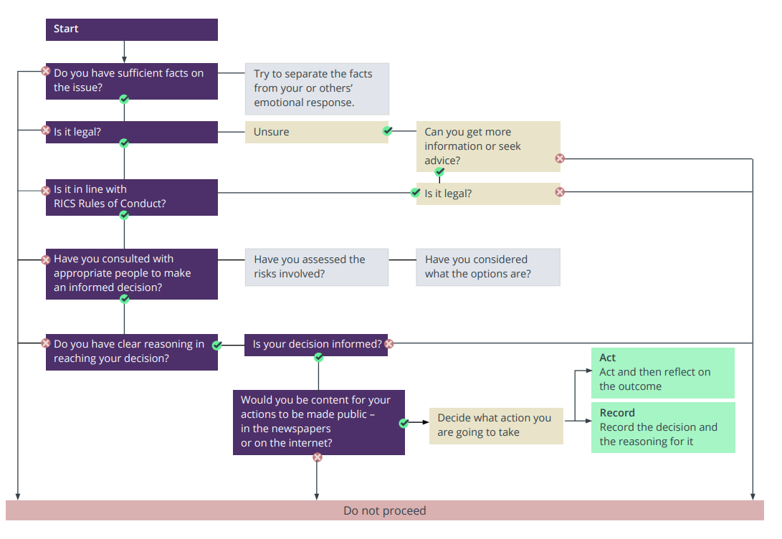
Figure 1. RICS Ethics decision tree (RICS, 2021)
Specifically Rule 1 applies to this situation it states that ‘Members and firms must be honest, act with integrity and comply with their professional obligations.’ (RICS, 2021)
Rule 5 is equally applicable stating that ‘Members and firms must act in the public interest, take responsibility for their actions and act to prevent harm and maintain public confidence in the profession.’ (RICS, 2021)
The following sub clauses are directly relevant to this scenario:
  - Members and firms do not mislead others by their actions or omissions, or by being complicit in the actions or omissions of others.
  - Members and firms do not allow themselves to be influenced improperly by others (as a result of, for example, giving or receiving work referrals, gifts, hospitality or payments) or by their own self-interest.
3.10 Members and firms, when advising clients about projects, encourage solutions that are sustainable in that they minimise harm and deliver balanced economic, social and environmental benefits.
5.1 Members and firms question practices and decisions that they suspect are not right, and raise concerns with colleagues, senior management, clients, RICS or any other appropriate person, body or organisation where they believe in good faith that it is necessary to do so. Firms provide processes to allow and support individuals within the firm to raise concerns with senior management. (RICS, 2021)

Decision
Following the rules of conduct the decision would be to go with option B, replace the compromised concrete to the required strength specification, ensuring the safety and structural integrity of the hospital.
Rule 1.1 dictates honesty so as not to mislead by actions or omissions. Rectifying a known defect or replacing a sub-standard material would ensure this rule is adhered to. Conversely basing any decision on the offer of a financial incentive in exchange for not raising the issue of a sub-standard materials would be in breach of rule 1.2. Following the spirit of rule 5 option B is the only real option; leaving any structural weakness in a hospital would be in direct contradiction of the public interest and idea of acting to prevent harm. Collapse or chemical substance penetration could be catastrophic to patients, hospital loadings are significant with heavy medical equipment such as MRI scanners and stipulating a load restriction would be impractical.
This decision could be considered ethical as it causes the least amount of harm, considers the safety of all and is the right thing to do. It would be deemed professional by way of following the documented rules not only in spirit but to the letter.

Conclusion
In summary the ethical decision following the RICS Rules of conduct would be to inform the client (Local government) that a concrete mix below the required strength specification has been identified. The supplier has been informed, and the decision has been made to rectify the affected areas. Provide the client with accurate delay timescales for concrete replacement, advise of the potential safety impacts and long-term operational costs of rectifying further down the line. Demonstrate the decision has been made by following the professional rules of conduct. Negotiate an extension on final completion deadlines and associated penalties on the ground that the public interest and end user safety has been at the forefront of the decision.
Ethical decisions are important in construction to improve public perception and minimise the unethical practices, bribery, corruption and disregard for safety that have been evident in the over recent years.

References
Humphreys, J., 2014. The moral sense of Down man Francis Hutcheson, https://www.irishtimes.com/culture/the-moral-sense-of-down-man-francis-hutcheson-1.1889280: The Irish Times.
Martin Luther King, J., 1968. A Proper Sense of Priorities. Washington, D.C.: s.n.
RICS, 2021. Ethics decision-tree , Accessed 01 December 2025: www.rics.org.
RICS, 2021. Rules of conduct, Accessed 23 October 2025: www.rics.org.
Watts, G., Challender, J., Higham, A. & McDermott, P., 2021. Professional Ethics in Construction and Surveying. Oxon: Routledge.

