

Certificate of Higher Education in Skills for the Workplace

Task 2
Professional career development report

Student name: Tihomira Kaneva
Student ID: 2118131

Module name: Professional Career Development
Module code: (BMSW4005_LON)
Lecturer name: Bianca Sanfilippo
Submission date: 21/12/2022

Table of Contents
- Personal reflection on the role play: Recruitment and Selection, Applying Kolb’s (1984) learning cycle – 3
- Skills and knowledge which contribute toward working effectively – 5
- My personal strengths and areas for further development – 7
- SWOT ANALYSIS - 8
- My employment goals and my personal career action plan/development plan –8
- My short - medium – long term targets for the development of my own professional career plan –10
- Conclusion -11
- References -12
- Appendix A - The questions asked as interviewer in the role play (A1) -13
- Appendix B - Application Form completed as applicant for the role play -14

I want to be became a teacher and teach children from 3 to 10 years of age. In this report I will write about the skills that a teacher should possess. I will write about for the skills that I have and skills that I want to develop in the process of my studies.
In my role of interviewer, I pretended to be a manager for factory and I did well in these areas. But when I heard about this role I was a l little bit shocked. Firstly because I had to do it in front of many people and secondly because I had no experiences an interviewer. I have always been on the other side and now for the first time I had to take an interview. I would say that it was very interesting for me and maybe a little fun. I took this role as training for my future as a manager because one I will be a manager and I need to have some experience. This role showed me what it`s like to be an interviewer and what questions to ask to find the best candidate for a given position.
In my role of applicant, I pretended to be a candidate for a job as a preschool teacher this is because it is my choice for my better future. In my future I want to became teacher. I want to work with children because this is my dream. I want as a teacher to teach children to be kinder to other and to themselves. Helping other and believing in themselves. I want to be the person who will teach them to read and write. I want to be the person who will help them develop as a person. I have qualities that will help me develop in this field such as patience, good speaking skills, listening skills, giving advice.
During this interview I was nervous because I had never interviewed for a teaching job before. So far I`ve always been interviewed for a cleaning job and I always knew what they were going to ask me. With this role play I`m more prepared for that future interview in real life. Now I know how to behave, what to say and how to say it. This role play was for me like a little respect for my future teacher interviews. An exercise that given me some experience and made me believe in myself.
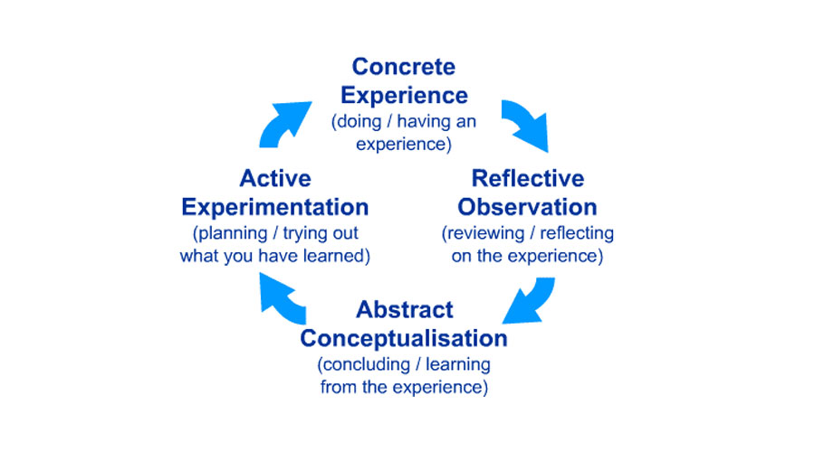
Reflection is on essential instrument to support and enhance career professional development. To reflect on this experience, I apply Kolb`s (1984) learning cycle.

Kolb`s model has four different steps of the reflection process:
- The experience – concrete experience – to reflect it we must have experienced.
- Reflective observation – reflection on the event. When we are experiencing something in our life we gain experience. The best teacher is life. The life can teach us thing that we cannot learn in school. Gaining life experience helps us in our development as a person because we learn from our mistakes. A person who does not make mistakes does not gain life experience because people who do not make mistakes have no desire to develop.
- Abstract conceptualisation – in this stage using theories, logic and ideas to understand problems. The learner relies on theories and ideas to solve problems.
- Active experimentation – new learning from the event into future practice. This model can be applied in my reflection on the role play.
During the role play me and my partner were a bit worried because it`s our first time to participate in such a role play. We had prepared well because we rehearsed in many times. I would say that we did well because we believed in our selves.
- The experience – the event is the role play, which was part of the assessment for the module Career Professional Development. The role was done on MS Teams in week 9, 11 December 2022. In this game I was first in the role of an interviewer and asked questions to my partner who was in the role of a person applying for a job for manager in factory and answers my questions.
- Reflective observation – this role play was important to me because I had the opportunity to face ma fear of failure. This role play made me believe in myself more and be more confident in myself. It was an opportunity to discover what my weakness were and what is my strengths were, opportunity to develop my skills. My strengths is I`m a diligent and punctual person. I always arrive early and complete my work on time and areas for development of being more confident in myself and not being afraid of failure.
- Abstract conceptualisation – it can be stated that my areas of development are communication skills in particular oral communication and non-verbal communication. Before I didn`t know how and what to say because I was very worried and how to behave during an interview. Now I`m more confident in myself and believe that I will handle my future interviews because I know more about communication skills, such as body language.
- Active experimentation – in my next interview I will apply what I learnt from this role play. For example I will motivate myself, I will be more smiling and I will be calm and more restrained. I will speak in a calmer tone and more confidently.

As I want to become a teacher, I need to focus on the skills required to work effectively in this role. The job role and responsibilities of a teacher, according to uk.indeed.com include creating lesson, plans, leading classes and setting and marking examinations.
Related to this responsibility, it is necessary to have excellent communication skill, including ability to show good teamwork and good listening skills to understand the needs of the pupils. One of responsibility is good organisation skills. Teachers are required to have experience of organising, planning and teaching well – structured lessons tailored to the needs of the pupils as well as monitoring each students learning needs, adapting teaching to respond to the strengths and needs of each pupil. Another responsibility is caring and compassionate skills. Teacher is required ability to assess and report students when required. Another responsibility is able to plan and deliver engaging, differentiated lessons and willingness to comply with the schools policies and implement them effectively.
Problem – solving skills is important skills because is ability to manage learning to develop thinking skills. Problems are a part of our lives. Every problem has a solution. One just has to find it.
Literacy skills including english language verbal and written. Good math skills, good teamwork are also skills that a teacher must possess.
Related to my career plan, these are other skills that I need to become a teacher:
- Passion
- Leadership
- Adaptability
- Creativity
- Time management
- Discipline

Teachers play a very important role in society since they assist in the education, support and coaching of students. Knowledge required to work effectively in my job role a teacher is must have content mastery in basic math, literally, social studies and science. As a teacher, I will have the function of helping students learn by importing knowledge and creating a situation where students can will learn effectively. The knowledge which contribute toward working effective for my job like teacher are:
- Teaching – to give someone knowledge.
- Communication skills – share ideas and feeling.
- Problem – solving.
- Creativity – ideas to create something.
- English – the use of English skills.
- Planning.
- Teamwork – work together in group with other people.
- Organisational skills – ability to use time, resource.
- Child care – care one or multiple children at a time

LAWS

- Teachers duty of care to pupils. Their legal responsibilities derive from three sources: the common law duty of care; the statutory duty of care; the duty arising from the contract to employment.
- Physical contact with pupils – In July 2013 the DfE issued revised non-statutory guidance to all schools: use of reasonable force – Advice for head teachers, staff and governing bodies.
- Teachers power to use reasonable force to restrain – In England, the following guidance can be found on the Government website gov.uk/dfe
- Teachers responsibilities – teachers should be familiar with the procedures in their school. By virtue of section 92 of the Education and Inspections Act 2006, there is a legal right for teachers to detain pupils after the end of a school.
- Searching pupils – sections 550ZA and 550ZB of the Education Act 1996 empower teacher to search a pupil or a pupil’s possessions.
- Protection from discriminations – pupils – The Equality Act 2010 prohibits discrimination against pupils on grounds of disability, race, religion or belief, sex, sexual orientation and gender reassignment status. There are referred to as “protected characteristics”.
- Protection from discriminations – teachers – all teachers have protection from discrimination at work – age, disability, maternity, pregnancy, race, religion, sex, sexual orientation, status under the Equality Act 2010. Take are knows as “protected characteristics”.
- Legal and professional advice from the union – members is difficulty or needing advice should contact their workplace representative or for advice and assistance call 0345 811 8111.

My personal strengths and areas for further development as a teacher. I`m an excellent and energetic collaborator. I`m a creative person who has good organizational skills and good communication skills. I have teamwork and planning experience. I have a methodical and analytical approach to my work duties and can easily handle a variety of tasks at the sometime.

SWOT Analysis

SWOT ANALYSIS

STRENGHTS  Planning  Timetable  Organizational | WEAKNESSES  Shyness  Lack of experience
OPPORTUNITIES  Good future  Family  Study for teacher  Better job | THREATS  Disease transmission  Stress

Personal career action plan/development plan

My professional career pathway is:
My professional career pathway is to be a teacher and teaching.

What are my current strengths?
Organizational
Timetable

What are my achievements and areas of success since the beginning of the module/programme?
More knowledge
More confidence
A better chance for better future

In what areas do I need to develop?
Pedagogy
To believe more in myself and be more confident

Why is it important to improve in these areas?
To develop as a good teacher

Who will help me? What resources will I need?
Family. I need the support.

What are the constraints/ barriers to achieving these key areas and how I will manage these– e.g. time, resources.
To face my fears.

What further action do I need to take now?
Actions to be taken – things to do, people to see.
To work and communication to people with experience.

Time scale – by when
September 2024

My short - medium – long term targets for the development of my own professional career plan (using SMART targets)

Short-term plan (3 - 6 months)
Specific | Past all modules.
Measurable | I will study hard.
Agreed | My son already goes to school so I will have more time to study.
Realistic | Good future.
Time-Bound | February 2023
Medium-term plan (1-2 years)
Specific | Bachelor’s degree.
Measurable | Applying for Bachelor`s degree.
Agreed | Study hard.
Realistic | Good future for me and my family.
Time-Bound | September 2025.
Long-term plan (2-5 years)
Specific | Starting a job as a teacher.
Measurable | Applying for job as a teacher
Agreed | I will work hard.
Realistic | Career development as a teacher
Time-Bound | September 2026

Conclusion
In this report I wrote about the skills a teacher should have to be a good teacher. Skills that a teacher should pass on his students. In this report I wrote about my skills that I have and about the skills that I want to improve. Also I did a SWOT analysis.

References:
Main P.( 2017 ). Kolb`s Learning Cycle. Available at: https://www.structural-learning.com/post/kolbs-learning-cycle ( Accessed: 07 December 2022 )

ISC MADICAL (2022) THE BENEFITS OF EXPERIENTIAL LEARNING AND KOLB`S LEARNING CYCLE FOR KOLB`S LEARNING CYCLE FOR TRAINING. Available at :

https://images.app.goo.gl/y5xdY73j4AfoCH6C9 ( Accessed:07 December 2022)
Lecture Notes (2019-2020) Education the law and you. Available at: https://www.google.com/url?sa=i&source=web&cd=&ved=0CAQQw7AJahcKEwjAq4LNvL_7AhUAAAAAHQAAAAAQAg&url=https%3A%2F%2Fneu.org.uk%2Fmedia%2F596%2Fview&psig=AOvVaw0P0iq-M5veunIeMKLg_uLW&ust=1669126926306590
(Accessed: 07 December 2022)

Appendix A: The questions asked as interviewer in the role play (A1)
- Why do you want to be a teacher?
- Why do you want to work for our school?
- How would you get your classroom?
- How do you evaluate your student?
- Why should we hire you to teach here?
The question/s asked as interviewee in the role play (A1)
- I love children and working with them is my dream. Thanks to my teachers I have developed as a person with dreams and a future. They game me the necessary tools that I use all my life. The some tools I can give to children and help to them to develop like a persons with dreams and good future.
- Your focus on academics, character, community and nature fit perfectly with my own philosophy. In this school I will have the chance to work with experienced teachers and I will be able to learn from them.
- I want my classroom to be welcoming. I want the children to feel good and calm. There will be have many posters to help them with their learning and it will be very colourful.
- Formal and informal methods, test, in-class activities, desk work and group activities.
- My skills are highly developed. Skills that mead the policy of this school.

Appendix B: Application Form completed as applicant for the role play (A1).

Job application form

Application for [job title] - Teacher

Your details

Name: Tihomira Kaneva

Education and training
Please give details:

CERTHE Skills for the Workplace (February 20022 – February 2023)
Bachelor Degree BEd ( February 2023 – February 2026)

Qualifications
Please give details:

CERTHE Skills for the Workplace (February 20022 – February 2023)
Bachelor Degree BEd ( February 2023 – February 2026)

Employment history

Your current or most recent employer

Name of employer: NIC group

Job title: Cleaner

Length of time with employer: 4 years

Reason for leaving: Stared studying at the university

Duties:

Cleaning toilets, ovens. Empty bins. Mop. Cleaning windows, offices, dust cleaning.

Previous employers

Please tell us about other jobs you have done and about the skills you used or learned in those jobs.
Before I started studying to be a teacher I worked as a cleaner for 10 years. For my job as a cleaner I used different skills like to be thorough and pay attention to detail. Patience and the ability to remain calm in stressful situations. Knowledge of public safety and security, the ability to organise my time and workload.

Supporting statement
Please tell us why you applied for this job and why you think you are the best person for the job.

I hold the status of a qualified teacher. I follow school policy. I`m responsible. I always take part in whole school activities.

Right to work in the UK
Do you need a work permit to work in the UK? Yes / No

References
Please give the names and contact details of 2 people who we can ask to give you a reference. We may ask them before an employment offer is made. We will not ask your current employer until we get your permission.

- Nick Hall – 075 334 455
- Emma Stow – 074 234 567

Declaration
I confirm that to the best of my knowledge the information I have provided on this form is correct and I accept that providing deliberately false information could result in my dismissal.

Name: Tihomira Kaneva

Signature: T.K.

Date: 20/12/2022

