ACCC5004 Web Development

A report on ”PHP and Student Management website”

 | 

Submitted by:
1805315 Giuseppe Ventimiglia
Under the guidance of: Suneth Fernando
Academic Year 2019/2020

Contents
1 Research 3
1.1 Introduction 3
1.2 Analysis 5
2 Student management website 6
2.1 Requirements 6
2.2 Tools 6
2.3 Users 6
3 Testing 7
4 Evaluation 11
5 References 12
6 Appendix 13
Test case 1 screenshots 13
Test case 2 screenshots 13
Test case 3 screenshots 15
Test case 4 screenshots 18
Test case #5 screenshots 20
Test case 6 screenshots 21
Brief user Guide 22
Website screenshots 23
Database Design 42

1 Research

1.1 Introduction

PHP is a server-side programming language initially developed 1994 and largely used nowadays by website developers because of its simplicity and availability. The analysis conducted by the W3Techs, a web technology survey organisation, makes clear how PHP is the most used server-side programming as shown in the table below.  (Laaziri et al., 2019) |  | 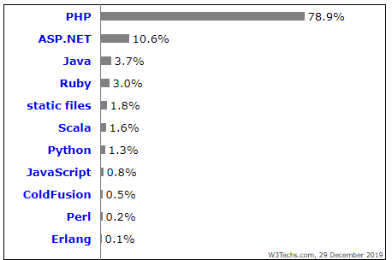
Figure 1 PHP Chart
PHP can also be used to create dynamic contents and usually developers have to write the code using their skills and logic. To facilitate this process, in the past decades different PHP frameworks have been created. A framework is a collection of source codes organized in a specific architecture to support the development of dynamic applications and website and some of the greatest benefits are:
- They provide reusable, flexible and maintainable code
- Enable the user to grow with time with its framework being scalable
- Give a high level of security
- Performs the MVC (Model-View-Controller) that makes certain the separation of logic and presentation
- Boost innovative internet development practices like object-oriented programming
(Prokofyeva and Boltunova, 2017)

In the table below there are listed some of the most used PHP framework :
 | Laravel allows for fantastic code writing facilitating operations like registrations, routing, cashing and working with sessions. |  |  | CakePHP is a framework that has ready codes to develop program quickly, it is also an object-oriented framework with many functionalities.
 | CodeIgniter is one of the fastest frameworks considered to be dying out because of the rarity of new versions. Not particularly designed for large projects. |  |  | Yii 2 is a full stack framework with high performance that allows to develop programs quickly.
 | Symphony is a large full stack framework that can be used to create any project especially with modern requirements. It is indeed used mainly for expensive projects. |  |  | Zend framework is an object-oriented framework that has a lot of functionality and can also be used for academic writing
 | Phalcon framework is quite different from the other framework because its coding style is based on C and C++, but it provides advanced development feature to create flawless web app. |  |  | FuelPHP is a highly modular and extendable framework for developing applications. It also addresses major security issues and has its own authentication framework.

1.2 Analysis
In the following table we will analyse each one of them using different criteria:
- Popularity: number of stars given on GitHub, the largest online developers platform
- Cost: to measure its commercial cost
- Difficulty : Level of knowledge required to start using the framework
- Speed : performance of the framework
- Installation: PHP version required
- Flexibility : ability to extend functionalities adding modules, plugins and creating own extensions
- License: type of software permissive license that can allow programmers to put the code in proprietary software
- Other: to indicate other advantages
(“PHP Frameworks Usability in Web Application Development” 2019)
Framework | Popularity | Cost | Difficulty | Speed | Installation | Flexibility | License | Other
Laravel | 56.9K+ | Open source | Easy | Medium | 5.5.9 or higher | - Modules  - Plugin | MIT | Installation simple and fast  Simple and convenient migration system  Outstanding training material  Multi-functional “ecosystem”
CakePHP | 8.1k+ | Open source | Easy | High | 5.5.9 or higher | - Modules  - Plugin | MIT | Codebase tested by Mozilla Secure Open Source  Zero configuration  Built-in validation
CodeIgniter | 17.8k+ | Open source | Easy | High | 5.6 or higher | - Modules  - Plugin | MIT | Built-in security tools
Phalcon | 1.2k+ | Open Source | Easy | High | 7.2 or higher | Allows flexibility | New BSD | Unique coding structure in C  Low Memory consumption
FuelPHP | 1.4k+ | Open Source |  | Super high | 5.4 or higher | Allows flexibility | MIT | Extensive security features, preferred for end-to-end solutions
Yii Framework | 13.3k+ | Open source | Easy | High | 5.4 or higher | - Modules  - Plugin  - Extension | MIT | Easy to Upgrade  Huge framework  Basic and advanced program frame
Symfony | 22.5k+ | Open source | skilled |  | 5.4 or higher | - Modules  - Plugin  - Extension | MIT | Simple installation  Contains largest number of bundles among all frameworks
Zend | 5.7K+ | Open source | Skilled | Medium-slow | 5.6 or higher | - Modules  - Plugin | New BSD | Store passwords using bcrypt  Encryption with AES-256  SEO Friendly
Samra and Hagelbäck, 2015)
Each framework has different advantages and disadvantages that depending the requirements of a project makes each one of them more or less suitable to use.

2 Student management website

The student management website that has been developed for the “University of Ventimiglia” is a web application that allows through a combination of server-side scripts, and client-side scripts to handle the storage, retrieve information and to present information to the users that can interact with the website. No particular framework has been used to realize it.
2.1 Requirements  The requirements for the website are :  - Data stored in normalised table  - A successful connection between the website and the database  - User privileges (without login) to browse al courses and modules  - Suitable security measures like login and data validation  - User should be able to look for specific information like total number of students, grades of students  - Administrative user to perform CRUD operations | 2.2 Tools  The tools that have been used to realize this web app are listed in the table below:
  Tool | Use
  Sql | Structure query language; a specific language used for managing data held in a DBMS
  PhpMyAdmin | Open source administrator tool for Mysql
  Html | Hypertext Markup language; a standard markup language for documents designed to be displayed in a web browser
  Visual Studio Code | Integrated development environment from Microsoft.
  Xaamp | Open source package to set up a development server
  Javascript | A high-level, just in time complied programming language.
  PHP | Server side

2.3 Users
The application has been intended for three type of users with different privileges:
User Type | Description | Privileges
User | Any client that access the website | - Browse pages (including courses)  - Request more specific information through the contact form  - Enrol to a course through the registration form
Student | Student enrolled to a course | - All User’s privileges  - Login on personal student account through the login form  - Check exam’s grades and login information
Lecturer | University staff | - All user’s privileges  - Login on lecturer account through the login form and check modules taught
Admin | Administrator of the website | - All user’s privileges  - Create, read, update edit records for students, lectures, courses and modules

For the realization of the website some assumptions have been made:
- Students use their personal email to login in the system
- The system has only one Admin
- Lecturer manages the grades for the student
- No year of study and resits have been taken in consideration

3 Testing
To test the functionality of the website, the next following cases have been performed:
Test case # 1 LOGIN  PURPOSE: Testing the functionality of the login operation. |  | Screenshots
INPUT: | Inserting not-existing credentials like username : “username@test.com” and password: “testthispasword” | Figure 1
OUTPUT: | A Javascript alert message states that wrong credentials have been used to login and by pressing ok, the user gets redirected to the login page. | Figure 3
DISCREPANCIES: | No discrepancies, the function performed as intended.
FUNCTIONALITY: | The function works on the output of different conditions:  - Condition 1, highlighted in blue, checks if the username and password fields are empty or not  - Condition 2, highlighted in yellow, selects from the table “Login” the id, password and access_level that correspond to the username  - Condition 3, highlighted in green, checks if the previous condition had a positive result returning a row  - Condition 4, highlighted in orange, checks if the password provided matches the one saved in the table, generating a session ID.  - Condition 5, highlighted in red, a block of nested conditions checks the access_level addressing the user to the right homepage. | Figure 2

Test case #2 ENROLMENT VALIDATION  PURPOSE: Testing validation rules applied to the user’s registration form |  | Screenshots
INPUT: | Email, date of birth and phone number fields have been populated with wrong formatted data | Figure 4
OUTPUT: | The system recognizes only wrong email and date of birth showing a n alert message for each error. | Figure 5 Figure 6 Figure 7
DISCREPANCIES: | Phone number not checked as intended
FUNCTIONALITY: | When the “submit” button is clicked, three Javascript functions start to validate email, date of birth and phone number | Figure 8  Figure 9 Figure 10 Figure 11

Test case #3 Enrolment  PURPOSE: Testing the functionality of the enrolment form |  | Screenshots
INPUT: | Inserting correct sample data to register a user | Figure 12
OUTPUT: | As expected: a new row with user’s details is created in student Management Page for the admin to approve | Figure 14
DISCREPANCIES: | N/A
FUNCTIONALITY: | Once the registration form is submitted, a Sql insert statement modifies the student table adding a new record that contains a variable (“enrolled”) set to default to “no”  It is the admin that can enrol or delete the user’s request.  If it is accepted:  - A query updates the variable “enrolled” to “yes”  - Another query inserts the student ID and course ID into the student_enrolment table  - Another query inserts the username, password and respective access_level in the login table | Figure 13  Figure 15  Figure 16  Figure 17  Figure 18

Test case #4 Crud Operation
Testing the create, read, update and delete operations.

Notes: The admin can perform crud operations on different tables (e.g. tables “course”, “module”, “student”, “lecturer” ) but to simplify the testing process, tests are performed only on the table “course”.

4.1 |  | PURPOSE: Testing create operation |  | Screenshots
 | INPUT: |  | Inserting data in the Course Management form, creating a new record by pressing save. | Figure 19
 | OUTPUT: |  | As expected: the new course is displayed in the dynamic table created in the page, allowing the user to read the data. | Figure 20
 | DISCREPANCIES: |  | N/A
 | FUNCTIONALITY: |  | Once the submit button is pressed, the variables are obtained and inserted in the table | Figure 21
4.2 |  | PURPOSE: Testing update operation |  | Screenshots
 | INPUT: |  | Click on Edit Button | Figure 22
 | OUTPUT: |  | As expected: Records are displayed in the form to be edited, the save button is replaced by the updated button and once clicked, records are stored in the database and showed in the table. | Figure 23  Figure 24
 | DISCREPANCIES: |  | N/A
 | FUNCTIONALITY: |  | All records are constantly printed in a table where for each row, two buttons are created to allow the edit and the delete.  The form is used to both create or update records; a variable called edit_state displays the appropriate submit button that in this case contains an update statement. | Figure 25  Figure 26  Figure 27
4.3 |  | PURPOSE: Testing delete operation |  | Screenshots
 | INPUT: |  | Click on Delete Button | Figure 28
 | OUTPUT: |  | As expected: Record deleted from database
 | DISCREPANCIES: |  | N/A
 | FUNCTIONALITY: |  | Once the delete button is pressed, a delete statement will eliminate the record with the same ID. | Figure 29

Test case #5 Search Operation  PURPOSE: Testing the search operation function created for the admin |  | Screenshots
INPUT: | Inserting a query containing special characters (e.g. : 23max!) | Figure 31
OUTPUT: | As expected: Javascript message displaying that no results were found | Figure 32
DISCREPANCIES: | N/A
FUNCTIONALITY: | The function can be used to search a student by its name, surname or ID.  It prints all details allowing the admin to edit or delete the record.  Once the search button is clicked, a select statement selects all records in the student table that matches even partially the given input | Figure 30

Test case #6 Security  PURPOSE: Testing security by creating sessions for each user |  | Screenshots
INPUT: | Trying to access the admin welcome page knowing the url: localhost/website/admin/ahome.php | Figure 33
OUTPUT: | As expected, access is denied and the user is redirected to the login page | Figure 34
DISCREPANCIES: | N/A
FUNCTIONALITY: | The creation and the management process of session do not allow users to access privileged accounts with no permissions. | Figure 35

4 Evaluation
The web application has been developed meeting the expected requirements of the case study, however there are some improvements that can be performed to enhance its productivity and security as shown in the table below:

 | Name | Description
#1 | Cookies | Cookies are small files stored on the user computer that holds specific data about a user and a website. This allows the web server to deliver a personalised experience to the user from visit to visit.
#2 | Accessibility | Accessibility is the practise of making the website usable to as many people as possible. It includes options like changing text font, size and background of the webpage to make reading better, enable text-to-speech , magnify the screen etc
#3 | Cascading referential Integrity constraint | Cascading referential integrity constraint are foreign keys that tell Sql server to perform certain actions when a primary key field in a primary key-foreign key is updated or deleted.  In this website the update and delete options between relationships are set to cascade, meaning that if a primary key is deleted, all foreign keys will be unnecessarily deleted too. (For example, deleting a course will delete also all grades and lecturer records related to the Course ID.  The introduction of “on restrict” or “null” options while defining the foreign keys constraints are a necessary improvement.
#4 | Enrolment/login | Students use their own email to login in their account, but providing new institutional personalized email increases the security.
#5 | Password | Password have not been encrypted to facilitate the testing process, but the introduction of encryption functions like “md5”, “sha1”, “base64_encode” will increase the security of the web app.

5 References

- Figure 1 Php chart
W3techs.com. (2020). Usage Statistics and Market Share of Server-side Programming Languages for Websites, January 2020. [online] Available at: https://w3techs.com/technologies/overview/programming_language [Accessed 10 Jan. 2020].
- Prokofyeva, N. and Boltunova, V. (2017). Analysis and Practical Application of PHP Frameworks in Development of Web Information Systems. Procedia Computer Science, 104, pp.51–56.
- “PHP Frameworks Usability in Web Application Development.” 2019. International Journal of Recent Technology and Engineering 8 (3S): 109–16. https://doi.org/10.35940/ijrte.c1020.1083s19.
- Laaziri, M., Benmoussa, K., Khoulji, S., Mohamed Larbi, K. and Yamami, A.E. (2019). A comparative study of laravel and symfony PHP frameworks. International Journal of Electrical and Computer Engineering (IJECE), 9(1), p.704.
- Benmoussa, K., Laaziri, M., Khoulji, S., Larbi, K.M. and Yamami, A.E. (2019). A new model for the selection of web development frameworks: application to PHP frameworks. International Journal of Electrical and Computer Engineering (IJECE), 9(1), p.695.
- Samra, J. and Hagelbäck, J. (2015). Thesis Project Comparing Performance of Plain PHP and Four of Its Popular Frameworks. [online] Available at: http://www.diva-portal.org/smash/get/diva2:846121/FULLTEXT01.pdf [Accessed 30 Dec. 2019].

6 Appendix

Test case 1 screenshots
Figure 1 Login form  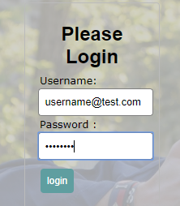  Figure 2 Output wrong login   |  |  |  | Figure 3 Login code statements  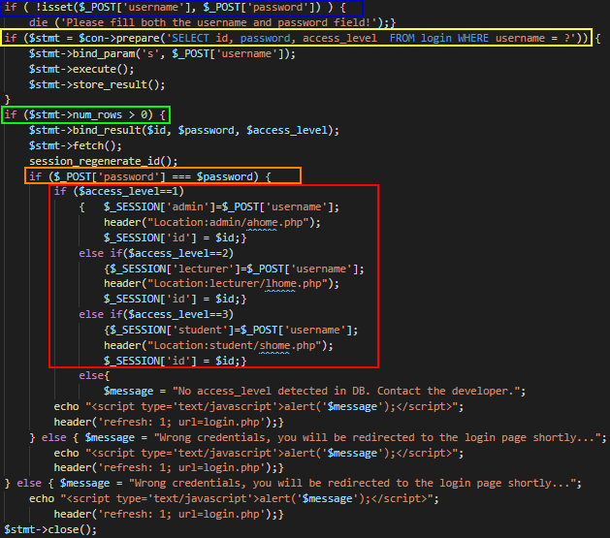

Test case 2 screenshots
Figure 4 Student Enrolment form  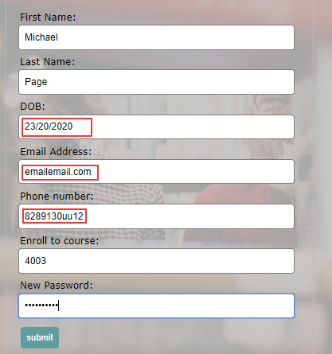 | Figure 5 Email validation message    Figure 6 Date validation message  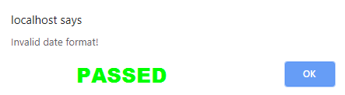  Figure 7 Phone validation not working as expected
Figure 8 Submit button functions  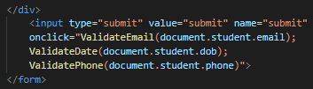  Figure 9 Email validation script  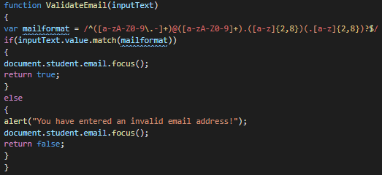 | Figure 10 Date validation script  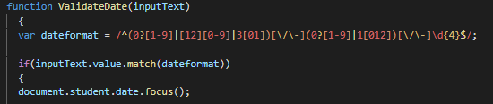  Figure 11 Phone validation script  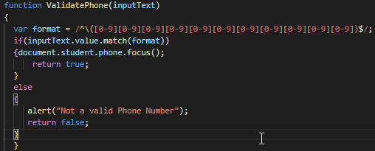

Test case 3 screenshots

Figure 12 Registration form  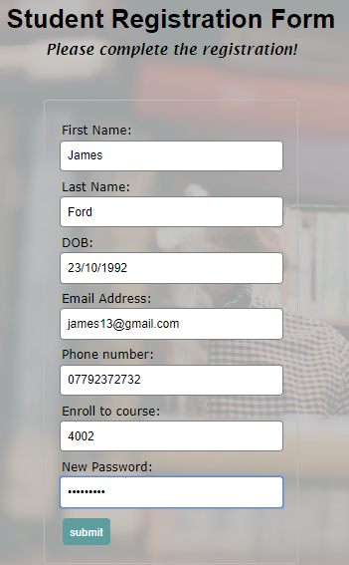 | Figure 13 Registration Insert statement  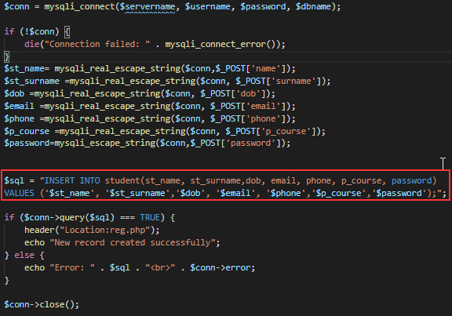
Figure 14 Admin page output
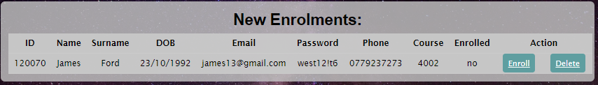
Figure 15 Statements enrol functions
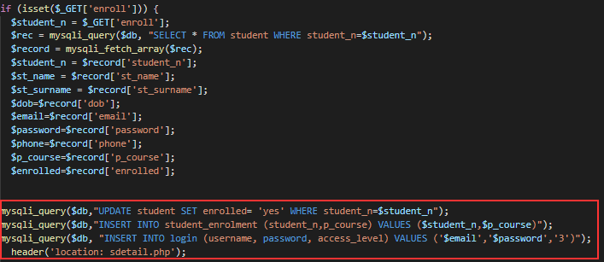
Figure 16 New record in the Student table

Figure 17 New record in the Student_enrolment table

Figure 18 New record in the Login table

Test case 4 screenshots
Figure 19 Adding a new course  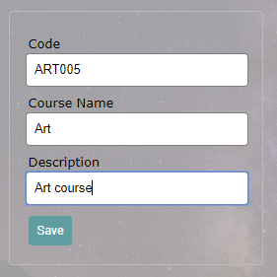 | Figure 20 Output new created course  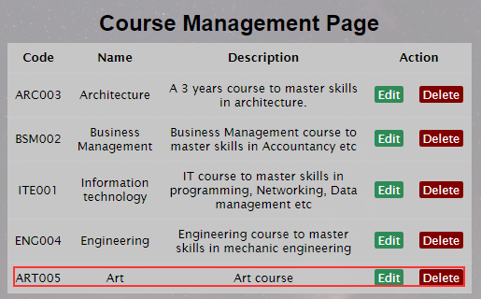 |  | Figure 21 Editing data  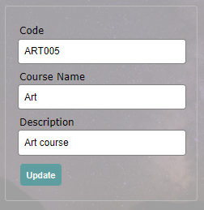
Figure 22 Insert Statement  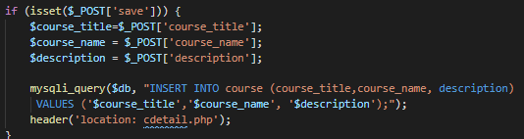 |  | Figure 23 Edit operation  Figure 24 Updated record displayed in table

Figure 25 Echoing records in the table  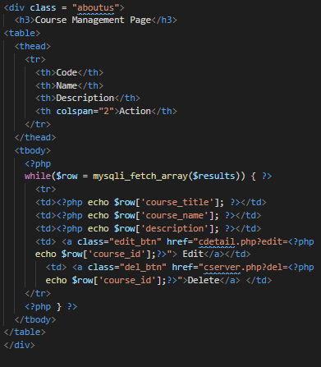 | Figure 26 Boolean variable Edit_state  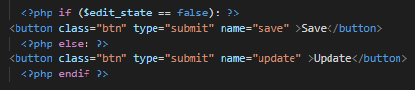  Figure 27 Update statement  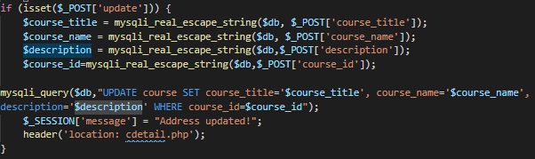
Figure 28 Delete button |  | Figure 29 Delete statement  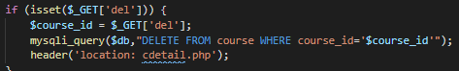

Test case #5 screenshots

Figure 30 Search function  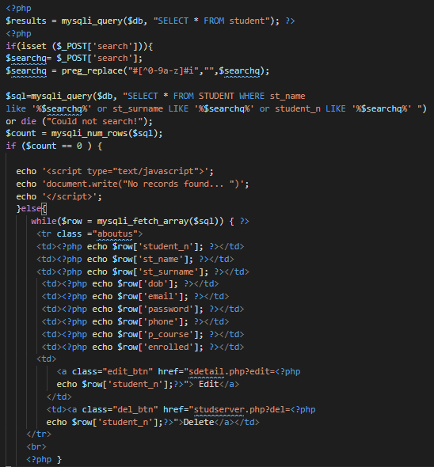 | Figure 31 Search query  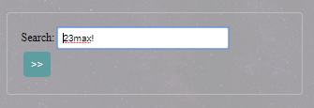  Figure 32 Search output  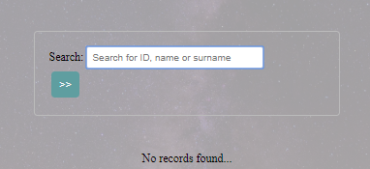

Test case 6 screenshots
Figure 33 Accessing admin page without login  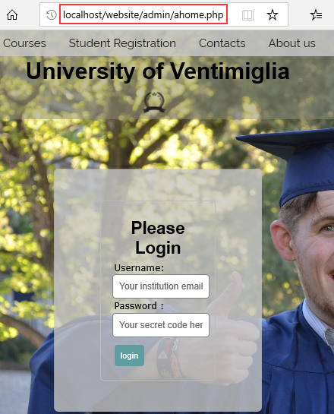 | Figure 34 Access Denied output  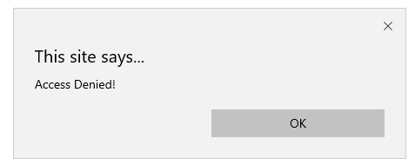  Figure 35 Session creation  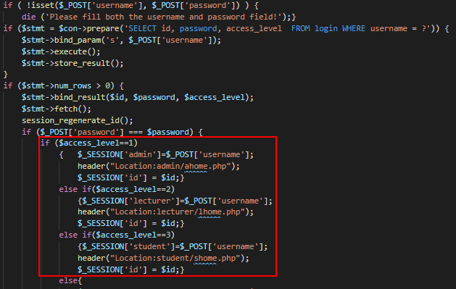

Brief user Guide
The user once connects to the website is brought to the index page where a quick introduction about the University is given. (Figure 36)
From the Home page other sections of the website are accessible :
- Course page: to see al course available at the university (Figure 37)
- Student registration page: where a user can register to a course filling up the form (Figure 38)
- Contacts page: to contact the university for any query through the contact form (Figure 39)
- About us page: to read information related to the university (Figure 40)
- Login Page: to allow registered users to login into their account (Figure 41)
To facilitate the testing process username and password of different user level accounts are provided (more login details available here Figure 55)
Admin: | 
Lecturer:
Student:

Once logged in in the admin account the user is welcomed with the homepage, giving access to other pages like: (Figure 42)
- Module page to perform Crud operations on modules records (Figure 43)
- Course page to perform crud operations on course records (Figure 44)
- Student page to search and perform crud operation on student records (Figure 45)
- Lecturer page to perform crud operation on lecturer records (Figure 46)
- Profile page to show the username and password of the account (Figure 47)
By clicking on Logout, the session on the admin account will be closed and the user is brought to the login page.
The lecturer account has a similar structure to the admin account. The user is greeted on the welcome page and allows the user to: (Figure 48)
- Check his profile information (Figure 49)
- Check the modules taught (Figure 50)
- Assign grades to the student performing crud operation (Figure 51)
When also logging in in the student account, the home page is displayed giving the permission to the student to (Figure 52)
- Check the profile information (Figure 53)
- Check grades (Figure 54)

Website screenshots

Figure 36 Homepage

Figure 37 Course Page


Figure 38 Student registration Page
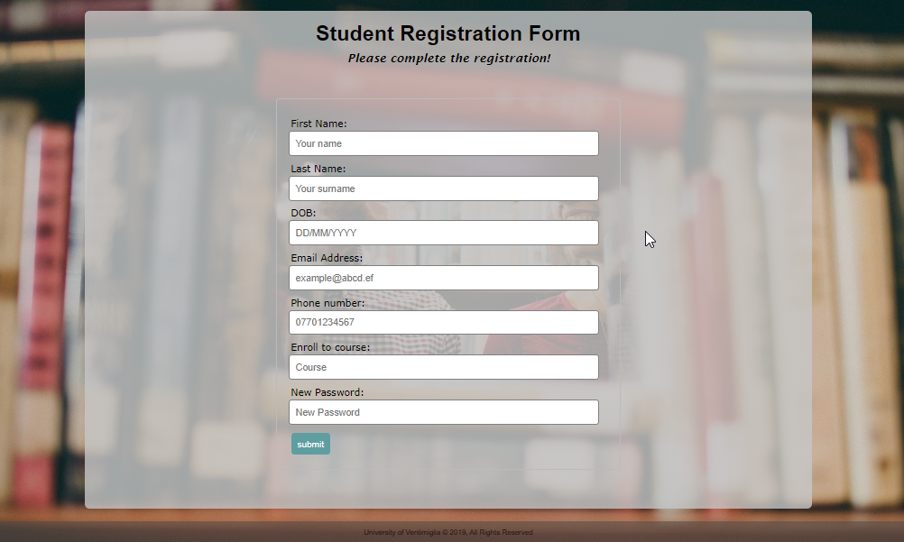

Figure 39 Contact form
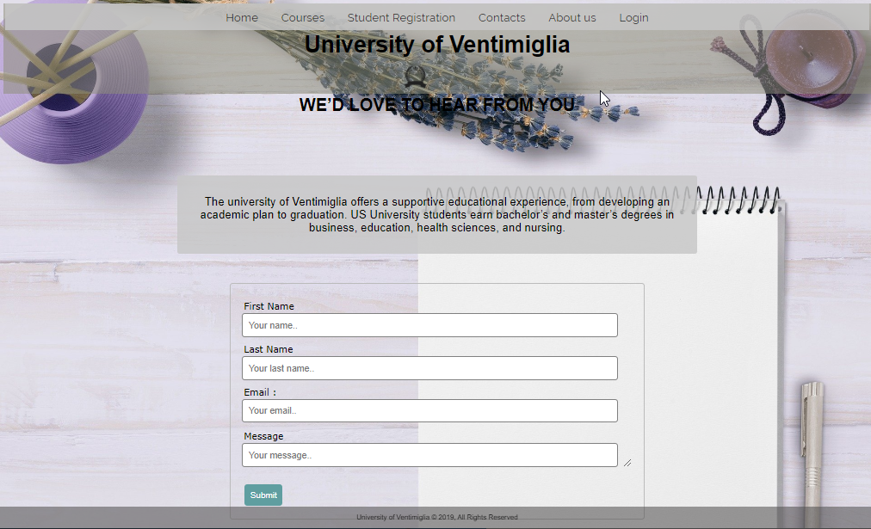

Figure 40 About us page
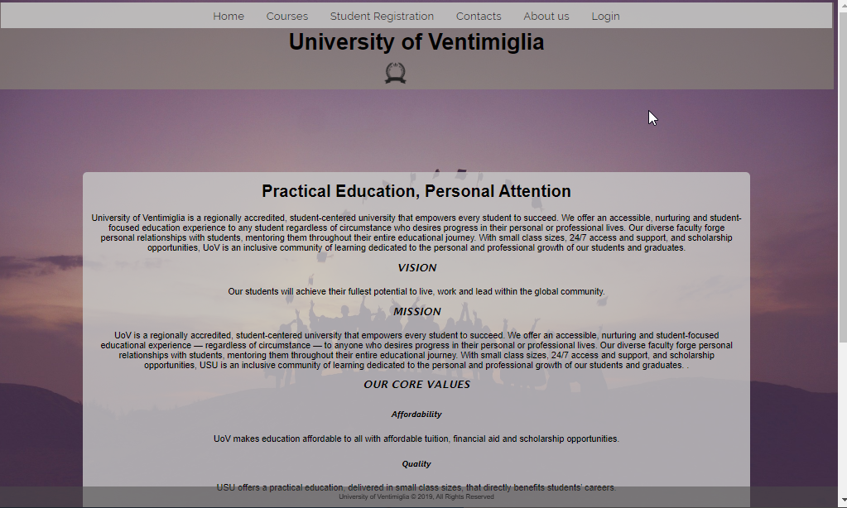

Figure 41 Login page
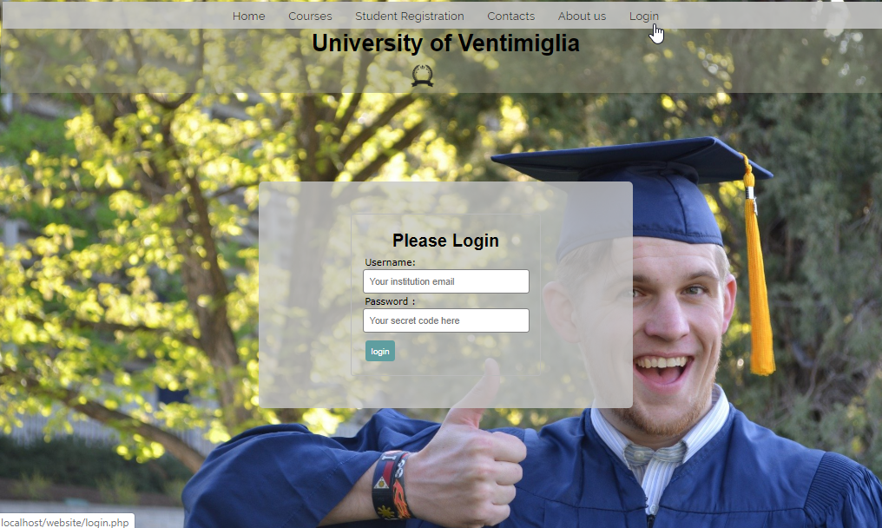

Figure 42 Admin Homepage
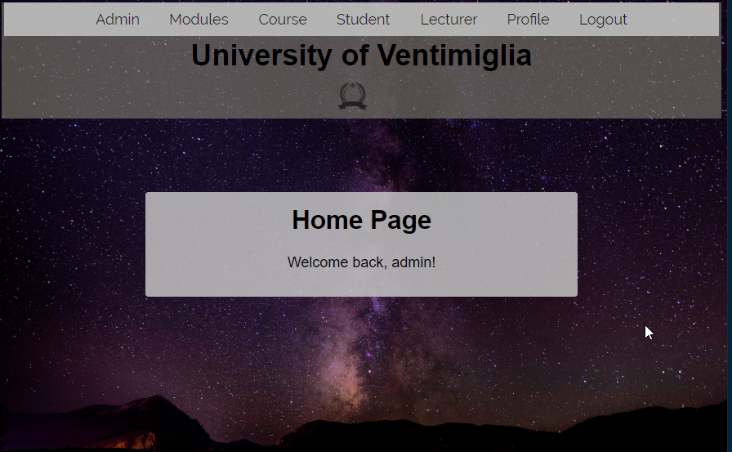

Figure 43 Admin module management page
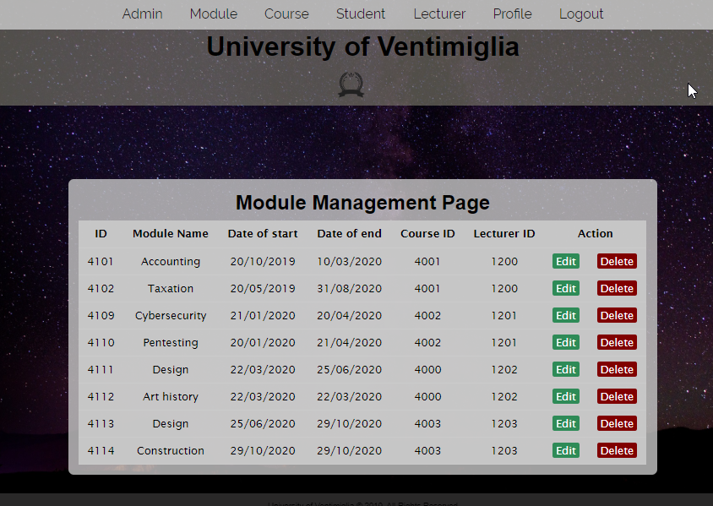
Figure 44 Admin course management page
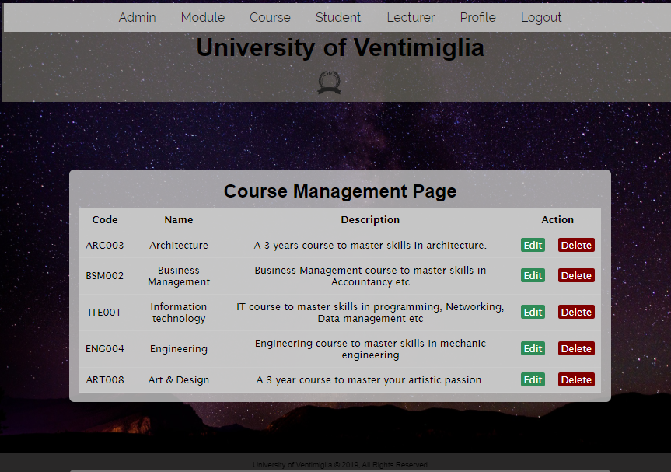

Figure 45Admin student management page
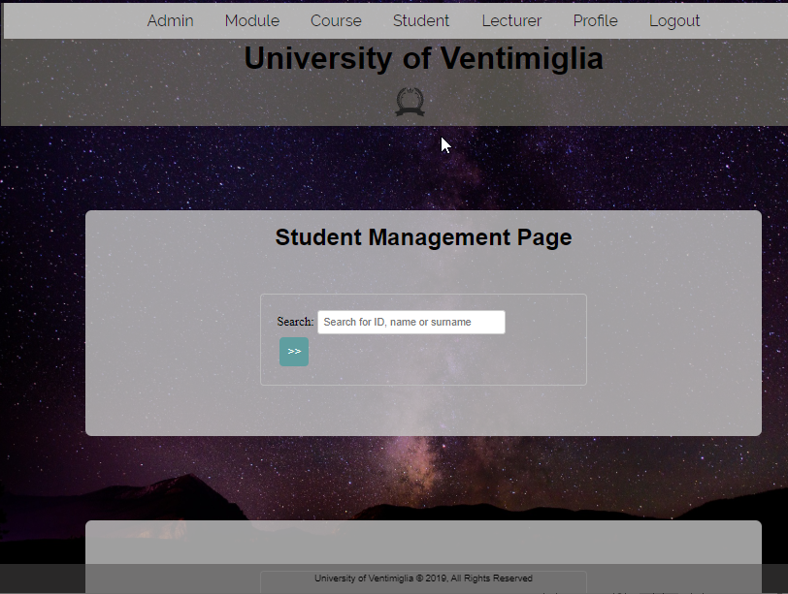
Figure 46 Admin lecturer management page
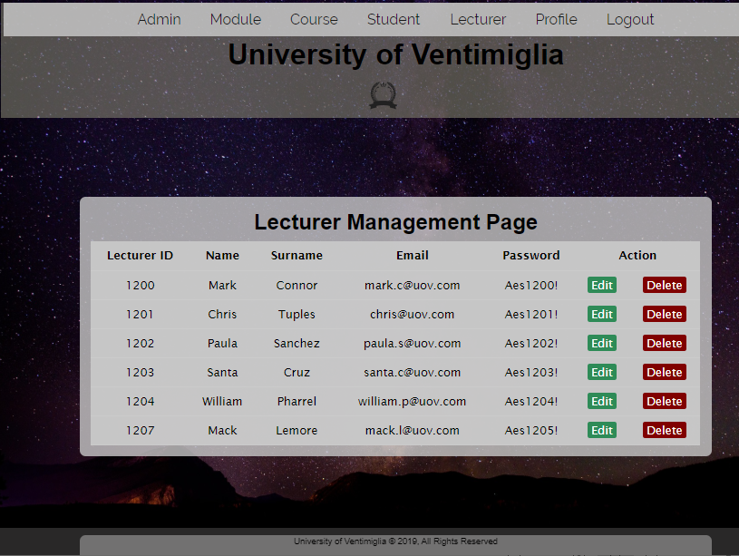
Figure 47Admin profile page
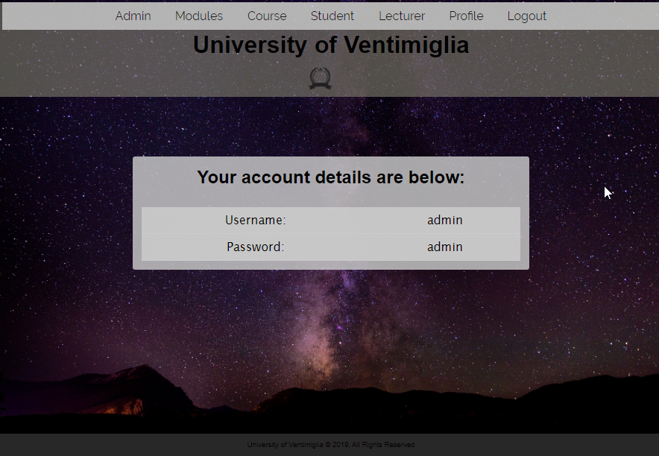

Figure 48 Lecturer homepage

Figure 49 Lecturer profile page
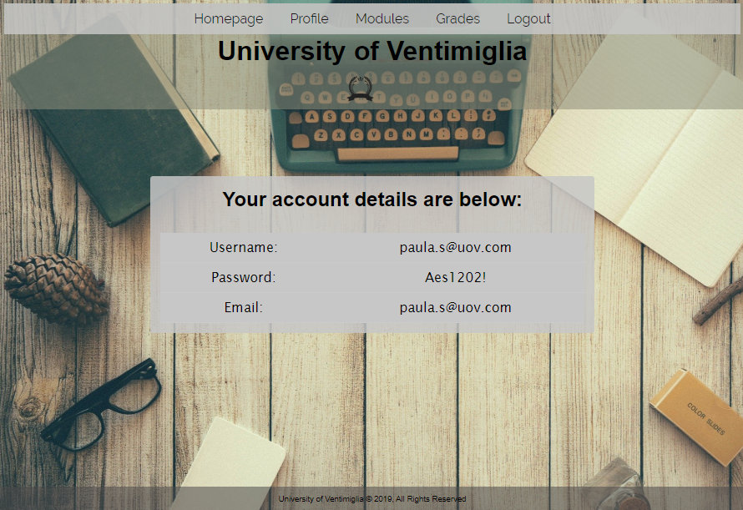
Figure 50 Modules page
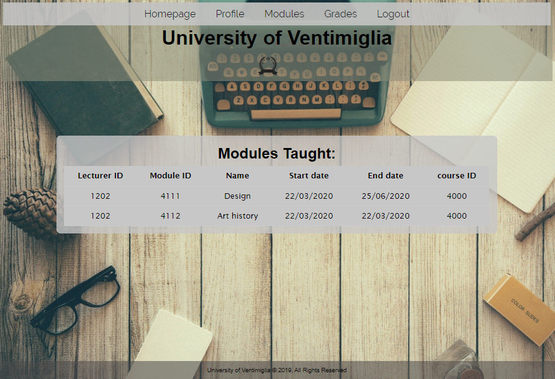

Figure 51 Lecturer module management page
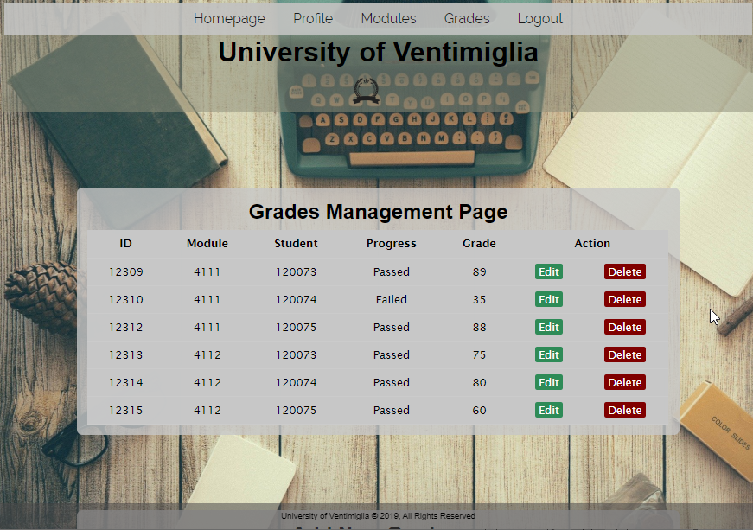

Figure 52 Student homepage
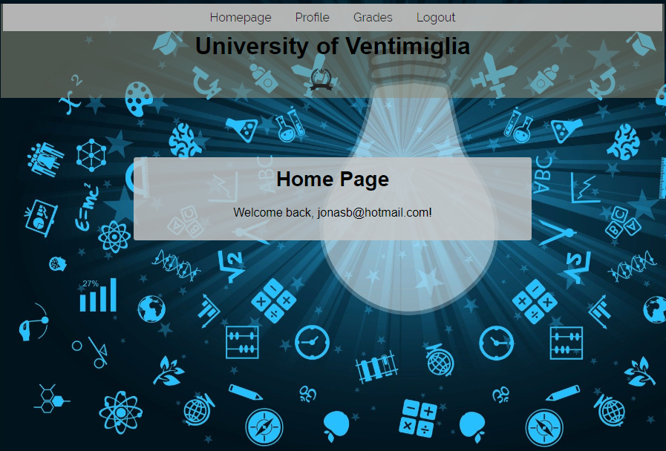

Figure 53 Student profile page
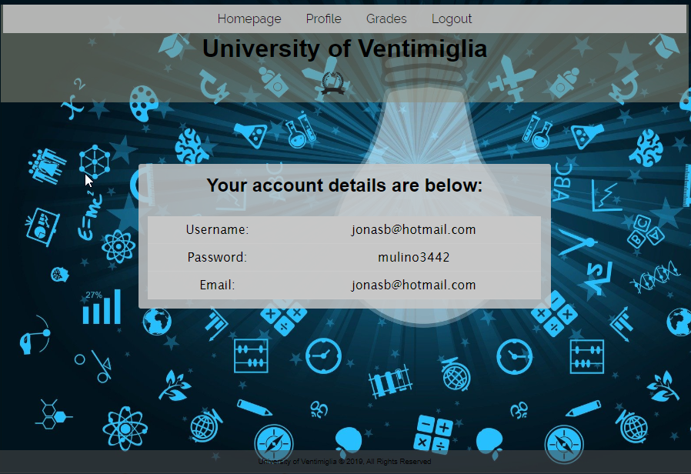

Figure 54 student grades page
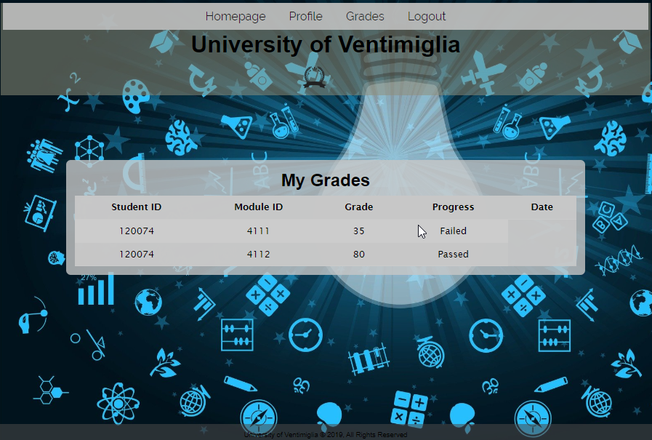

Database Design

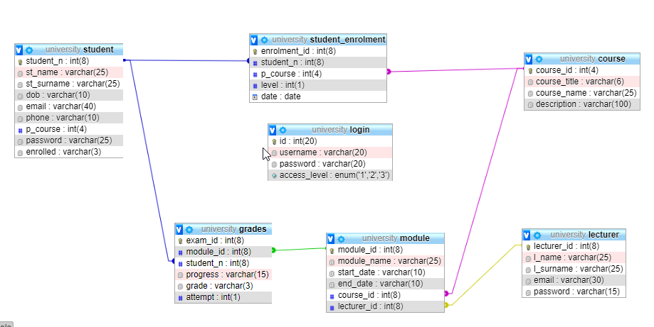

Login information.
To note that access_level 1 indicates an admin account, 2 = lecturer account and 3= student account.
Figure 55 Login


