

DIGITAL SKILLS AND RESEARCH METHODS
ASSESSMENT GROUP 12

Student Name: | ANAMARIA FERMESANU
Student Number: | 1907760
Module No: | BMSW4003_LON
Module Title: | DIGITAL SKILLS AND RESEARCH METHODS
Lecturer: | SUNETH FERNANDO

THE IMPACT OF VIRTUAL LEARNING ENVIROMENT ON THE UNIVERSITY MOODLE

CONTENTS:

1.INTRODUCTION
2. BACKGROUND
3. AIMS AND OBJECTIVES
4. METHOD
5. RESULTS
6. DISCUSSION
7. CONCLUSION
8. REFERENCES
- 1

1.INTRODUCTION:

For education, learning and assessment web resources have become almost indispensable. New technologies provide a wide variety of applications, with traditional teaching methods becoming more and more viable. Web-based apps are often more flexible, open, and diverse, so that those learning can use only a few clicks to access required tools from home. The growth of IT and communication technologies has resulted in classical learning being complex. Thus, we are moving toward a revolution in education; the teacher's present position that of information mediator, loses much of its significance. This learning process is tailored so that students can select the content and resources they want. In contrast to web-based learning, online learning has become difficult to handle. It can indeed be said that books of modern times are these kinds of resources. The website is a new, efficient tool that facilitates the process of instruction and learning and beyond. A broad variety of scientific knowledge is available on the Web for students in databases, online libraries, etc. Teachers and students will share thoughts, perspectives, emails, chat rooms and platforms for social networking. In art or science museums, they can arrange virtual tours of areas that are difficult for students of enter. Virtual learning environments (VLEs) dominate education today and are used to provide educational materials and to promote communication development in just one class.

2. BACKGROUND
In the following report the value of immersive learning environment systems in todays e-learning landscape is highlighted.
Virtual Learning Environment is a web-based online network intended to enhance student learning experience. Teachers and students can chat electronically in this app. You can use it anywhere and every time. Students should share with parents their jobs, degrees, etc. Teachers will create a forum to address their problems, ask questions about their jobs, tasks, deadlines and much more. The students are usually provided with class knowledge, learning materials and jobs on the Internet. Students will take advantage of it in class to collect instructor feedback and even access assignments to their computer. Teachers can use video or online conferencing to interact with students. VLE has gained great advantage in this new environment, particularly for foreign students who can now apply their jobs on such a forum when returning to their homelands. VLE can be used as a remote learning constituent that can also be found in the content learning context. In this thought-proof education market, educational providers have become important to provide students with the newest technologies in order to draw their interests. VLE is the perfect way to help ensure daily participation of students. This boosts the quality of content distribution through interactive media to students.
Types of Virtual Learning Environment:
Blackboard
Moodle
Fronter
Moodle it stands for M-modular O-object O-oriented D-dynamic L-learning E-environment. It is also known as VLE, an online course management programme. It is a software kit developed for pedagogy. It is intended to create an open-source and publicly accessible shared constructability framework for learning and teaching. You will install it on Debian, Mac, Windows and PHP server. It is great with many values and instruments including SCORM, LAMS, ELGG, Free ID, etc.
Benefits: Not much technical experience is mandatory in order to deploy. This is a free open source programme that can be downloaded and used by anyone without any real cost. This can be personalised in shape, look and feel according to the users specifications. Users may be interested in further software development. Moodle is mostly used because it operates well in social events such as group work, debates etc. Navigation is simpler, because you don't have to press too much. Additional resources including the glossary, questionnaire, lessons and diary are available. It tracks the activities of the student and tells the students which field is attractive.
In recent years, educational standards have increased as the need for highly qualified professionals is growing (Alavi & Leidner, 2001). Education has been an ongoing cycle during one's life, and often transforms educational services to fulfil demand and preserve education continuity. The learning that originally took place in a face-to-face environment is now an experience powered by computers and emerging technology.
In 1886, the first president of the University of Chicago, William Rainer Harper, wrote: "A student who has learned a variety of lessons in correspondence will learn more about the topic dealt with in those lessons and will understand more than a student who has taken the same course in the classroom"
Since the 1970s, the Open University of the United Kingdom has introduced the idea of online distance learning by offering mixed face-to-face learning opportunities and training programmes, including audio and video-based course materials. With the rise of the internet, net-based communication technology has grown quickly in universities around the world
That being said, the demand for virtual learning has grown so high today that we barely consider a student / tutor who does not use or know how to use the virtual learning tools available. Some work has been conducted on simulated learning environments and reveals a subjective understanding of VLEs for both students and academic staffing.
Since 2011 there have been a 26% rise in American students learning entirely through online grades at universities in the UK, 41% in Canada and 125% and 135% in Australia and South Africa.
This statistic displays the share of individuals in Great Britain who use online learning materials and online courses in 2019, by age and gender. Those aged 16 to 24 were the most likely to use online learning materials, while men were slightly more likely than women to use this method. Those in the 16 to 24 age bracket were the most likely to have used an online course.
https://www.statista.com/statistics/882117/online-learning-in-the-uk-by-demographic

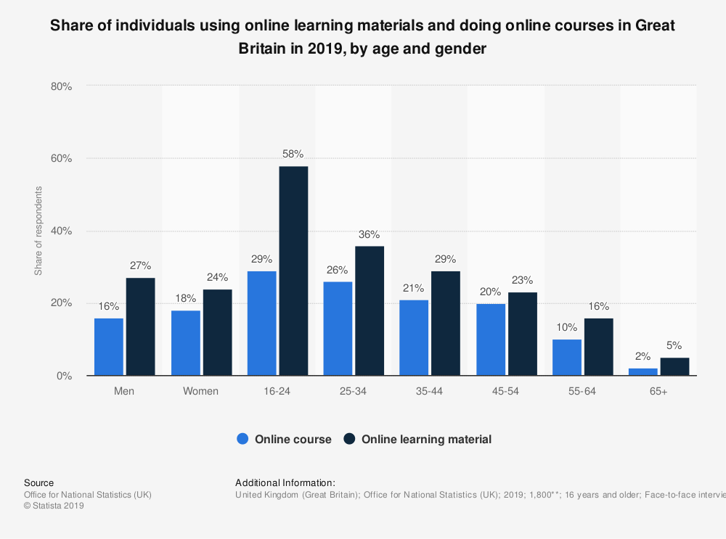
Today’s the COVID-19 pandemic has changed education forever. The COVID-19 contributed to worldwide closure colleges. More than 1.2 billion children worldwide are out of school. Consequently, education has improved significantly with a distinctive growth in e-learning, with learning being performed on interactive platforms and online. With this abrupt change away from the classroom in many parts of the world, some are asking if the growth of online learning would continue to increase post-pandemic, and whether such a move will have an impact on the global education sector.
“I believe that the integration of information technology in education will be further accelerated and that online education will eventually become an integral component of school education,“ says Wang Tao, Vice President of Tencent Cloud and Vice President of Tencent Education.
3. AIMS AND OBJECTIVES OF THIS RESEARCH

The goal of this project is to analyse the influence of the Virtual Learning Environment on Higher Learning Education. The interest lies in the ways in which the Virtual Learning Environment satisfies the needs of students and lecturers as well as the means of facilitating collaboration and sharing of resources in Higher Learning Education.
The general goals of the virtual learning environment are:
- Offer a good learning atmosphere for students to take classes without the time and place limitations of standard teaching.
- Offer internationally large access across this learning environment to various courses available.
- Create a learning atmosphere in which students can study the content themselves
- Facilitate students to enrol in classes offered in the learning environments of special needs and limitations.

4. METHOD
The following analysis has been done using a number of sources. Secondary research was conducted to collect quantitative and qualitative data in relation to Virtual Learning Environment using books, journals and on-line articles.
Primary research was conducted to understand the effectiveness of Virtual Learning Environment in University of Wales Trinity Saint David, in specific The Moodle.
A questionnaire was created and distributed between colleagues and teachers.
MOODLE ON UNIVERSITY OF WALES TRINITY SAINT DAVID
QUESTIONNAIRE


Thank you for taking the time to answer these questions. The following questions are about how well known and successful is Moodle on University of Wales Trinity Saint David.

- ARE YOU A FEMALE OR A MALE?
- Male
- Female
- WHAT IS YOUR AGE? (select one)
- 18-24
- 25-35
- 36-45
- 46-55
- HAVE YOU USED ANY VIRTUAL LEARNING ENVIRONMENT BEFORE?
- Yes
- No
- HAVE YOU USED MOODLE BEFORE?
- Yes
- No
- I FIND MOODLE USEFUL FOR STUDY/ TEACHING.
- Strongly disagree
- Disagree
- Agree
- Strongly agree
- USING MOODLE ALLOW TO COMPLETE MY ASSIGNMENTS BETTER.
- Strongly disagree
- Disagree
- Agree
- Strongly agree
- THE UNIVERSITY HAS SUPPORTED THE USE OF MOODLE SYSTEM
- Strongly disagree
- Disagree
- Agree
- Strongly agree
- HOW SATISFIED OR DISSATISFIED YOU ARE WITH THE MOODLE?
- Very dissatisfied
- Dissatisfied
- Satisfied
- Very satisfied
- HOW SATISFIED OR DISSATISFIED YOU ARE WITH THE CONTENT OF MOODLE ON UNIVERSITY OF WALES TRINITY SAINT DAVID?
- Very dissatisfied
- Dissatisfied
- Satisfied
- Very satisfied
- HOW SATISFIED OR DISSATISFIED YOU ARE WITH THE ONLINE HELP FROM THE MOODLE?
- Very dissatisfied
- Dissatisfied
- Satisfied
- Very satisfied
- RATE YOUR EXPERIENCE ON THE MOODLE? (1=very unlikely, 5=extremely likely)
1 | 2 | 3 | 4 | 5

- RATE THE USEFULNESS OF MOODLE FOR YOU? (1=not useful at all, 5=very useful)
1 | 2 | 3 | 4 | 5

- CONSIDERING YOUR EXPERIENCE WITH THE MOODLE HOW LIKELY WOULD YOU BE TO RECOMAND IT TO FRIENDS OR COLLEGUES? (1=very unlikely, 5=extremely likely)
1 | 2 | 3 | 4 | 5

5.RESULTS
A 13 items questionnaire was designed to collect information from students/ teachers opinions and experiences regarding the usage of MOODLE on University of Wales Trinity Saint David. On this questionnaire participate a total of 20 people.
In the first section of the questionnaire, demographic data on gender and age were gathered.

As you can see 65% of the answers were provided by male while 35% by female, 50% of the participants are with the age between 25-35 years.
On the questions regarding the usage on Virtual Learning Environment and Moodle 100% of the participants answer that they know and used it.

75% of the participants agree that the Moodle is useful for study, 65% agree that the Moodle allowed them to complete the assignments and 60% agree that the University of Wales Trinity Saint David has supported the use of Moodle system.

50% of the students are satisfied with the Moodle, 60% are satisfied with the content of the Moodle and 55% are satisfied with the online help from the Moodle while only 5% is dissatisfied.

55% of the participants rate that their experience with the Moodle was likely, 60% find the Moodle useful and 50% will recommend the Moodle to friends and colleagues.
- DISCUSSION

In the last few years, the concept of traditional education has changed dramatically. Physically in a classroom is no longer the only alternative for learning — not at least with the emergence of the internet and modern technologies. Nowadays, whenever you want you have access to good schooling, as long as you have access to a computer. The revolution in online education is now entering a new age.
Based on my own experience I find Moodle easy to use. It helped me through my study and my assessments, all the different services like dashboard, email and library are easy to access. For me it is a great tool for learn but it is not something that I want to use 100%. I prefer the traditional method of learning and teaching, I like reading books, smell them in physical library, going in classes and meeting my colleagues and teachers, taking notes on the paper. Maybe I am a little bit old style, maybe I am little bit tired of all these technologies, especially now during these pandemic times but for me the virtual learning environment can’t never beat the traditional learning. Yes, virtual learning environment it is something that I apreciate and I am more than happy to recommend it to friends and colleagues but only if its combined with the traditional ways of learning.
The real future of the education for me is the blended learning environment or hybrid learning. This is a model that combines both formal (traditional classroom) and non-formal (online courses) methodologies. I am happy that the University of Wales Trinity Saint David gave me this opportunity of learning using this hybrid learning through this course.

- CONCLUSION

Online education has dramatically increased over the last decade, particularly for adult learners who want to get a degree or qualification during their full-time jobs. In a system, virtual learning environments (VLEs) or learning management systems like Moodle, Blackboard and other systems have many of the necessary instruments for e-learning. Since the early 2000s, they have been more and more widely used by nearly all universities.
Moodle is an ideal way to easily access resources from classes such as presentations, notes, homeworks, assessments and other types. The materials are often arranged by date in certain classes so that you can easily find what you are looking for.
Some people think of "virtual" as an artificial world that substitutes real life. Nevertheless, virtual learning environments will not replace any classrooms or current education activities. They improve them. It adds importance as it extends the field of physical learning. They provide opportunities to improve teachers and students' imaginations.
- REFERENCES

Alavi & Leidner, MIS Quarterly, 2001, Management Information Systems Research Center, University of Minnesota
Martin Weller Virtual Learning Environments: Using, Choosing and Developing your VLE, 2007, Kindle edition
Leonard A. Annetta, Elizabeth Folta, Marta Klesath, V-Learning: Distance Education in the 21st Century Through 3D Virtual Learning Environments, 2010
www. future learn.com
www. global.oup.com Learn about Virtual Learning Environment
www.moodle.org/about/.

