Assessment 1 Community Engagement
Student Name: Szabina Molnar
Module Name: Community Engagement
Module Teacher: Dr Molly Jack
Submission Date: 29.08.2022
Word Count: 2073

Table of Contents
Introduction 3
Discussion 3
Conclusion 9
Reference List 9

Task 1: Essay on Community Engagement

Introduction
By Reynolds and Sariola (2018), Community Engagement today has turned out to be a bigger concept where it is visualized that companies do struggle to engage with them since it is a necessity now. Community engagement does mean the way of engaging with the stakeholders that makes the decision-making process to be informed. The stakeholders from their perspective do claim to create new ideas and also contribute to the success of the organizations. In the essay, the different challenges that are faced by the companies in the community engagement building concept have been elaborated on the struggles faced by the companies. For community engagement, it is claimed that there are different goals such as effectively delivering service, leading the community partnered to research, looking at the education and industrial department welfare, and also making innovative provisions (Pratt, 2019). The essay, therefore, points to the importance of community engagement and its facets in the global concept showing the evidence of competitiveness gained through it.

Discussion
Community engagement is defined as the process where collaboration is evidenced with and through the groups of people affiliated by the geographic proximity with special interest for addressing the issues that do affect the wellbeing (Reynolds and Sariola, 2018).
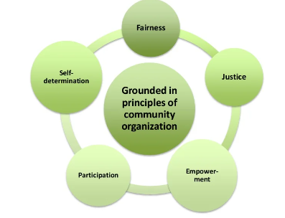
Figure 1: Community Engagement
(Source:
Traditionally decades back, it was evidenced that for community engagement, the means adopted have been discussed in a formal way that appeared to be limited. However, in recent times, it has been found that the means of communication have enhanced. It is idealized that now different means like social media are being utilized to create effective engagement. Today, companies are researching different contexts of creating awareness and effectiveness of engagement so that the well-being and welfare of society could be focused on. According to Camilleri (2022), it is identified that strategies are being developed for creating efficacy such as Stakeholder's Power Interest. Through the Power Interest Matrix, it is being noted that the companies or the management could plan how to engage and with whom to be engaged first or later. In the Stakeholder Interest, the four Matrix are Keep Satisfied, engage closely, monitor them, and keep them informed. It is visualized that with the Stakeholder theory, the management of a company could easily make decisions.
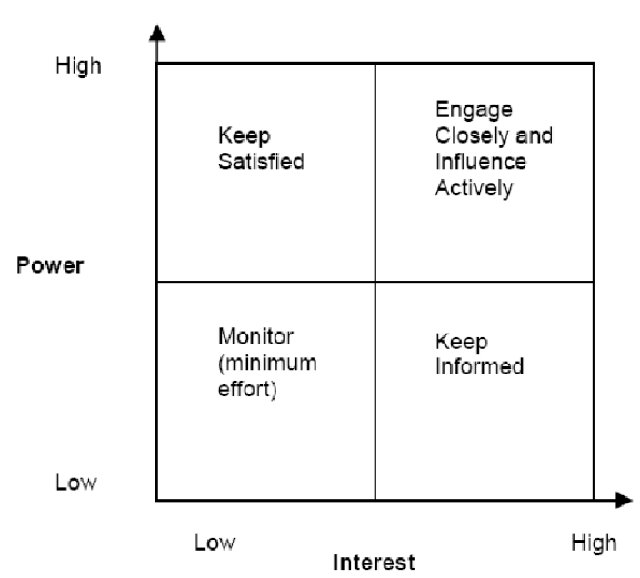
Figure 2: Stakeholders theory
(Source: Jones et al., 2018)
Through the integration of social media, it is stated that stakeholder engagement has been high and effective. It is being visualized that with digital help, the strategy is being enhanced. The process followed is Advocacy, Confidence, Advocacy at scale, and also have authentic effectiveness. In the opinion of Rajhans (2018), it is realized that stakeholders’ interests need to be considered at the earliest so that engagement can be intact and sound. The constructive purpose of the theory is that stakeholders are being managed and efficiently tracked so that ineffectiveness is observed which can cause a challenge to the organizational performance. For example, in the case of Tesco Plc as one of the leading retail companies in the UK, it is being observed that customers, employees, and suppliers are kept in the focus of being managed and monitored closely because of which there can be an external and internal challenge (Awadari and Kanwal, 2019). On the other hand, the Government and Investors along with the employees are kept informed of what is being addressed and how things are being carried forward. Tesco Plc thus with the inclusion of the Stakeholder theory does oversee that all the members are informed and managed to gain the organizational effectiveness that the organization has already obtained.
Undoubtedly as opined by Caputo et al. (2018), digital systems are found to be evolving and changing the traditional system of stakeholder engagement. In this approach, human interaction is regarded to be vitally significant and strategically has been critical in successfully building stakeholder engagement. With it, it is affirmed that relationship management is taken forward through the provision of the analytical, contemporary mechanisms and data-driven insights which influences the stakeholders' activities. Thus, the Chief Communication Officer has been taken as a strategic measure where the CCO is considered to be vital and needed in the innovative system. It is considered an approach to "sophisticated platforms to map and understand the interests of stakeholders (usually through data) and systematize the process of meaningfully engaging with them, not merely as segments but as individuals ()".
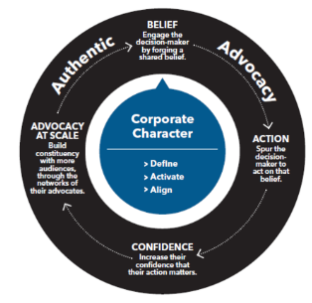
Figure 3: The CCO model for digital stakeholder strategy
(Source:
It is being evidenced that a successful digital engagement system will create the possibility of delivering a personalized and tailored experience for the individuals through the use of the preferred device thus driving alignment and integration between the actions of the individuals and the enterprise's broader goals (Del Vecchio et al., 2021). First of all, for developing an engagement with the stakeholders, the profile page is created that helps in letting all the information out in public. For example, NHS Trust has been aware of such an issue and therefore has built a LinkedIn profile (Samy et al., 2020). Through the link "https://www.linkedin.com/company/nhsengland", anyone can have access to what has been going on and how everyone is informed technically through the means of social media platforms.

Figure 4: NHS LinkedIn profile
(Source: Samy et al., 2020)
Google Alerts for example is considered one of the techniques through which stakeholder conversation could be managed. For managing the users, Google Technology is used. Information on around 1.6 million patients a year will be generated through it (BBC, 2022). By sharing relevant content, the stakeholders are informed and also communicated where a healthy relationship is built. It is idealized thereby that with the social media platforms, the stakeholder’s management has been considered to be strategic and tactical as well for handling different issues at the time and meeting the objectives on time.
However, with the digital means of engagement, some challenges do come to the fore causing obstructions in the engagement.
The communication error: Not all the individuals employed within an organization do seem to be digitally active and know the tactics used for communication. It is being evaluated that communication pattern also changes when digital means are adopted as it becomes faster with the use of collaboration tools. The communicator should know how to use the collaboration tools so that effective results could be obtained. Microsoft Teams or the use of Zoom have been lately with the outbreak of the pandemic popular therefore there can be challenges associated with it.
Lack of understanding among the communities: The community like the employees or the customers may not be well aware of the message to be retrieved from the information passed through the digital channel. Digital channels need effective education on the performance of the tools and also digital literacy is developed. Community engagement can be built through an effective digital portfolio that can enable the activities to be governed and managed closely. It is evaluated that companies do sometimes lack in educating the employees on how to tackle the issues and also effectively train the people on organizing the information as soon as possible.
The community needs to be first accommodated with the different needs and then inform them of what has been addressed and what is going to be addressed. This will help the community also to slowly grab what has been going on and what will go on. It is analyzed that communities need to be first understood and then any changes can be planned. Thus, with the effectiveness, it is being witnessed that companies and stakeholders do work closely and hand in hand makes the operations deem to be successful and effective.
Creativity skills are needed: In the development of digital stakeholder management, creativity is most importantly needed. Employees are not given the empowerment to think creatively in many aspects and that has been the main problem in the context. Stakeholder engagement is problematic.
Therefore, the skills and talents are shaped in a way that stakeholder engagement can be managed effectively. The stakeholders individually do matter a lot in the organizational contribution which needs to be under the close watch of the management so that plans can be plotted accordingly enhancing the organizational performance and taking it to the next level.
For example, with Facebook as one of the active and most viewed social media platforms, awareness can be developed. Through Facebook, many customers like the youths or different segments can be reached out which will help in knowing what product line is produced and vice versa know of the needs of the users as well (Prebanić and Vukomanović, 2021). On the other hand, with the use of WhatsApp for example official messages could be also delivered since business accounts are now being registered. It acts as one of the catastrophic strategies where community members are being either aware or are involved in the plans. Thus, with an effective plan and system, stakeholders can be well identified. In the contemporary era, some challenges can be faced since stakeholders may have different needs but again with the use of the Stakeholder Analysis theory, digitally the stakeholders can be mapped easily, and accordingly the plan can be carried forward. It is being analyzed that with the use of the stakeholder's identification, the engagement procedure does tend to be effective and also strategic. The business world does demand many aspects however the digital connection could help a lot in achieving diverse objectives on time and create new revenue streams and operational efficiency for the business overcoming the challenges.

Conclusion
In the essay, the fact has been brought to the fore that community engagement is one of the crucial issues that is considered now by the community members. It is essentially pointed out in the essay that community members can be engaged with strategies like the use of Stakeholder theory, the COO model, or using any kind of digital source. The models are used in a way so that effective engagement could be managed along with collaborations that will look at the welfare of society. In the essay, the fact has been discovered that community engagement is believed to be an integral part of the corporate world in contemporary times which has been evolving and bringing a transformation. The transformation can be brought about the needs of the society and positively think of their welfare. Collaboration is essential that can culminate in better performance for current and for future as well. The essay has also taken organizational help to understand how stakeholder engagement can be enhanced and included in the strategy

Reference List
Awadari, A.C. and Kanwal, S., 2019. Employee participation in organizational change: A case of Tesco PLC. International Journal of Financial, Accounting, and Management, 1(2), pp.91-99.
bbc.com 2022. NHS using Google technology to treat patients [Online]. Available at: https://www.bbc.com/news/health-38055509 (Accessed: 14 August 2022).
Camilleri, M.A., 2022. Strategic attributions of corporate social responsibility and environmental management: The business case for doing well by doing good! Sustainable Development, 30(3), pp.409-422.
Caputo, F., Evangelista, F. and Russo, G., 2018. The role of information sharing and communication strategies for improving stakeholder engagement. In Business models for strategic innovation (pp. 25-43). Routledge.
Del Vecchio, P., Passiante, G., Barberio, G. and Innella, C., 2021. Digital innovation ecosystems for the circular economy: The case of ICESP, the Italian circular economy stakeholder platform. International Journal of Innovation and Technology Management, 18(01), p.2050053.
Jones, T.M., Harrison, J.S. and Felps, W., 2018. How applying instrumental stakeholder theory can provide a sustainable competitive advantage? Academy of Management Review, 43(3), pp.371-391.
Pratt, B., 2019. Social justice and the ethical goals of community engagement in global health research. Journal of Bioethical Inquiry, 16(4), pp.571-586.
Prebanić, K.R. and Vukomanović, M., 2021. Realizing the need for the digital transformation of stakeholder management: A systematic review in the construction industry. Sustainability, 13(22), p.12690.
Rajhans, K., 2018. Effective communication management: A key to stakeholder relationship management in project-based organizations. IUP Journal of Soft Skills, 12(4), pp.47-66.
Reynolds, L. and Sariola, S., 2018. The ethics and politics of community engagement in global health research. Critical Public Health, 28(3), pp.257-268.
Samy, M., Abdelmalak, R., Ahmed, A. and Kelada, M., 2020. Social media as a source of medical information during COVID-19. Medical education online, 25(1), p.1791467.

