Zornitsa Nikolaeva Karakitukova
1922160



Module Title: Introducing the Modern Workplace
Assignment Title: Structure and Culture
Lecturer: Gregory Cowan
Contents
Introduction 3
Organisational Overview 3
Relationship between structure, culture, people, and organisational performance 3
Nature of Managerial Work 5
Role of Leadership 6
Variables for Effective Management and Leadership In Burberry 7
Behavioural Approach to Management 8
Conclusion 9
References 10

Introduction
Organisation refers to a group of people who get organized for to achieve an objective. A business organisation has the objective to earn profit and gain competitive advantage in the industry. There are certain factors required considering within an organisation. The purpose of this essay is to illustrate some organisational models, theories and concepts in respect to Burberry. This is one of the most prominent UK brands for luxury fashion products. By studying the firm, it will become easier to coherently analyse organisational, managerial and leadership functions.

Organisational Overview
In the year 1856, Burberry started its organisational operations. It is running as one of the leading brands in fashion industry. 10,000 employees are currently appointed here. Their continuous use of knowledge and skill has generated a 2.16% annual growth. The HRM, marketing, accounting and other organisational perspectives are being operated successfully.

Relationship between structure, culture, people, and organisational performance
Organisational structure: It refers to the framework followed by an organisation to distribute organisational responsibilities and functional attributes among employees. The purpose of organisational structure is to achieve business goal using employee’s activities and responsibilities (Williams, 2016). Matrix, divisional, network, hierarchal, etc. are the modern organisational structures. Burberry follows divisional organisational structure design to achieve business outcomes.
Organisational culture: Each organisation has a particular motto, vision, mission and belief to achieve its business purpose. The belief system and attitude of an organisation towards its stakeholder is called organisational culture (Alvesson, 2016). This determines how people will behave within the firm. Hofstede’s cultural dimension stated power, gender, uncertainty avoidance, long term and short term orientation, and individualism cultures in a firm. On the other hand, clan culture, adhocracy, market-based, and hierarchy culture exist in corporate industry (Alvesson, 2016). According to Hofstede, Burberry follows collectivism organisational culture. Hierarchal culture dominates in this firm.
People within a firm: Any person who gains interest from the organisation is included in this section. Customers, employees, employers, suppliers, producers, etc. are people of Burberry. Their contribution is the most effective one within the organisation.
Organisational performance: There are several units to measure organisational performance. Per quarter income statement, growth report, and employee turnover provides a managerial approach to observe organisational performance. Burberry is in the industry for around 170 years. They have cultivated a consistent growth.
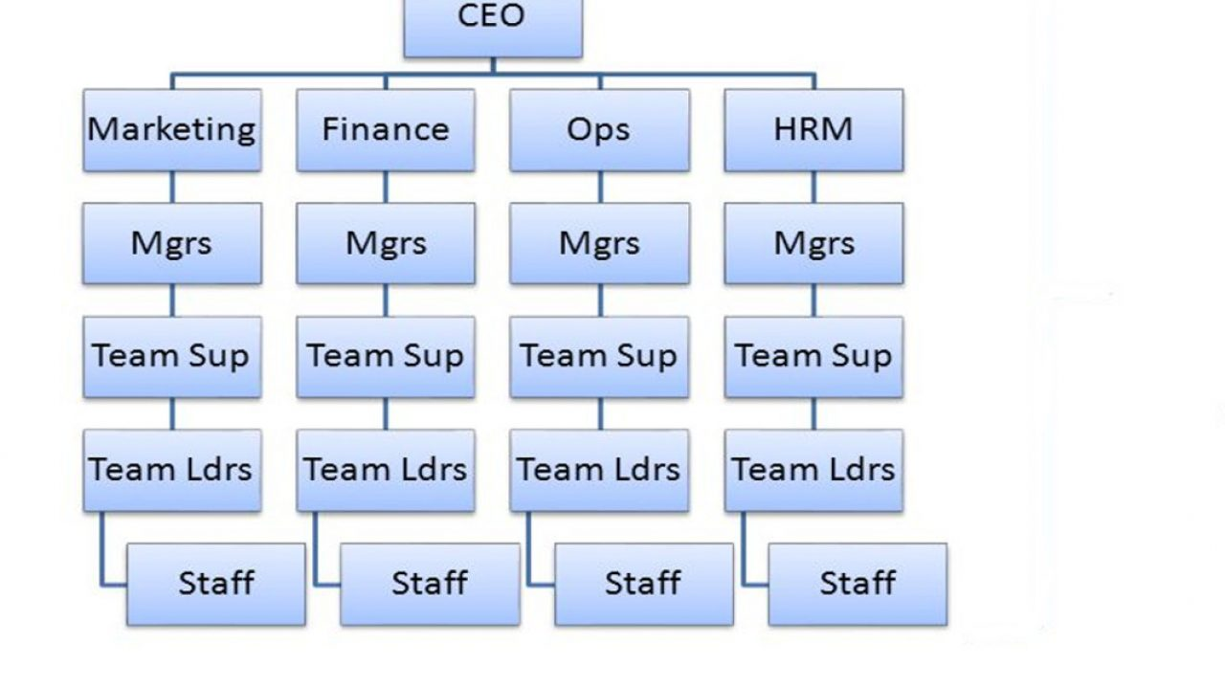
Fig: Hierarchal structure (Griffin, 2017)
Relationships: Burberry’s divisional organisational design is decorated regionally. Each strategic business unit has its own HR, marketing and accounting departments. These create a division as a whole. For example, the London branch has its marketing and HR department to operate business functions. Leeds branch has separate departments to provide HR and marketing support. This relates directly to the collectivism culture. Collectivism culture suggests to create togetherness within the organisation. By developing a structure, the firm approaches to achieve business goal. Hierarchal culture refers to a dominating approach where upper level employees hold more power and use their subordinates to organise activities (Tabory, 2019). Both organisational structure and culture are related to people working in Burberry. The firm gives maximum concentration to their employees and suppliers. Without getting high quality raw materials, it is difficult to produce high quality products. Customer’s loyalty is also maintained by using its collectivism culture. For example, a customer of Burberry will be satisfied only when the seller can provide according to customer’s requirement (Tabory, 2019). The product’s high quality is ensured through a proper supply of high quality production team. People at every stage in the firm cooperates with each other. Collectivism is practiced through it. Meanwhile, when every part of the organisation performs properly, the firm starts developing its overall growth and development aspects.
The whole discussion can be summarised with a critical perspective. Emerging or growing organisational performance is resulted from continuous work of employees in the firm. Employees behave according to the firm’s organisational culture. They are managed using organisational structure design. Burberry complies everything properly to achieve business objectives (Schein and Schein, 2017). Here, the structure of an organisation must match with the structure. A divisional organisational structure must have subordinates. In flat organisation structure, it is difficult to follow clan culture. These are the areas which are needed to be given importance for elevating organisational performance.

Nature of Managerial Work
Management is defined as the organisational activity to create plan, designing the workflow, execute, and control resources. The nature of managerial work in functionally and processes at Burberry differs.
Firstly, managerial work is the backbone of organisations efficiency. Therefore, its quantity is very large. Each person working in the firm is somehow included in management activities. A human resource manager of Burberry has to allocate employees in the most efficient way. The upper management has to take care of internal workflow. This is how the quantity of managerial activities is large to continue.
Secondly, decision-making illustrates managerial work in the most effective approach. The nature of managerial work is to make decisions that will help improving the business growth and overall profitability (Macintosh, 2002). For example, Burberry’s managers took home delivery as their first priority in the recent pandemic attack. To continue the organisational growth, rather than appointing workers in offices and branches, Burberry concentrated on hiring delivery personnel. This increased the organisations’ growth and overall activities.
Thirdly, managerial work involves a lot of controlling features. There has to be some minimum and maximum limit to achieve the proper flow. Management decides whether to control it or not. For example, financial resources of Burberry is handled with care. Upper limit is the maximum cost that managerial accounting can allow to produce and organise selling.
In short, managerial work makes it more convenient for Burberry in gaining an improved business framework. Workforce efficiency and organisational effectiveness are increased through this too. Each function and process of managerial work is required for maximizing profit and productivity of Burberry. Planning, executing, directing, controlling and continuous improvement are those key functional areas.

Role of Leadership
Leadership in business organisation is an immensely important factor. Leadership is defined as the responsibility to lead a team appropriately. This section of the report is for communicating the role of leadership. At Burberry, each division and department is led by team leaders. Their roles are diversified according to the specific department and divisions. The following ones are the major roles communicated in leadership at Burberry.
The first role is visioning. A leader knows the ultimate goal and objective for the firm. The leader has to decide the vision according to the firm’s calibre and available resources. Furthermore, vision helps in making strategic planning for the firm. For example, the HR leader of London Burberry branch sets a sells target in the beginning of a quarter. This vision promotes an effective working culture among the others.
The second role of leadership is motivating. A team is consisted of different teammates. They have different types of skills and knowledge. Without motivating them properly, the team will not be able to perform adequately. Burberry’s team-based culture is promoted among these regional sections. Team motivation does not always require being verbal. Non-verbal communication is also promoted within the organisation. For example, sometime the leader works more than teammates. It motivates the others to put their best to improve overall team performance.
The third role of leadership is to guide employees effectively. The guidance is generated from the leaders’ hard and soft skills. Being able to accomplish result is the key for a leader of Burberry to develop employee’s effectiveness. This is the reason to include guidance is an opportunity to flourish leadership culture for teams.

To conclude this section of the essay, a leader must play his roles in Burberry. This increases the chance to get organisation’s performance boost. Leadership role is constrained by theories such as transformational, transactional, and situational (Griffin, 2017). Burberry promotes transformational and situational leadership styles. Transformational leadership role allows the leader to get attached to the team and shape the performance. Situational leadership role is only for mitigating challenges with the help of situational contexts (Grensing-Pophal, 2010). Transactional leadership role is practiced in a variety of firms. Team leader has to identify the scope to initiate changes according to the result. These are the key aspects of leadership role played in Burberry.

Variables for Effective Management and Leadership In Burberry
An organisation’s management and leadership effectiveness aspects depend mainly on its resources. Time, financial resource and human resources are the key ingredients for getting the most effective leadership and management process.
Time constraint is the first variable to justify the management effectiveness. A manager has to work everything according to the given deadline. Allocation of time in an efficient way gives benefit in many ways. Both manager and leader can contribute more for Burberry. Leaders can make proper vision and channelize the whole team operation according to requirements.
Financial resource is the second variable that requires allocating for purchasing and producing in a cost-efficient way. Money is the fuel of management and leadership. A manager knows exact ways for spending and earning money. Leaders have to optimise money too (Giuliani and Kurson, 2002). A leaders’ part is more dependable on creating particular frame to access outcomes.
The third variable is human resource. Skills and knowledge of human resource of an organisation is always a contributing factor for effective management and leadership (Beardwell and Thompson, 2017). For example, a leader cannot gain the maximum sale without having a sales team of best employees. He or she must allocate works according to their expertise. Managers have to create workflow according to this perspective too.
In short, the way and method of allocating resources is the actual condition to derive effective management and leadership at Burberry.

Behavioural Approach to Management
Employees are the life of an organisation. Their satisfaction and well-being within the firm bear high potential benefit. A major way to calculate organisational performance is measuring employee turnover. Satisfied employees do not leave job without facing severe situations. Behavioural approach to management defines a process of management that increases employee satisfaction by developing healthy employee relations. Employers have to pay proper concentration and focus in this case (Dessler, 2018). Burberry’s management approach follows behavioural pattern. This area will define and evaluate a sequential area to determine this approach.
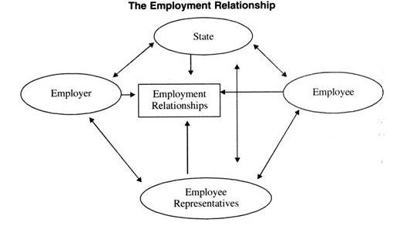
Fig: The Employment Relationship (Riahi-Belkaoui, 2002)
Behavioural management approach signifies internal employee relations. Employers hire employees to increase productivity and profitability. Therefore, the employee has to put the best effort within this organisation. Behavioural management gives the opportunity of Burberry’s employees to organise a certain sequence of working process (Riahi-Belkaoui, 2002). A work-friendly environment is the prerequisite for practicing the management. Each employee is different psychologically and according to the dedication in the job. Employers have to identify diversity and proper meaning of maximizing benefit from employees (Dessler, 2018). Therefore, their behaviour has to be nurtured properly. Positive organisational behaviour increases internal business opportunity. Employees get to know each other positively. Workplace condition improves. The opposite happens when there is a negative organisational behaviour practice.
In order to evaluate this managerial approach, both positive and negative factors are required taking in consideration. If employee behaviour and employers’ behaviour is practiced positively, Burberry gets an improved workplace situation. Internal employee-employee and employee-employer behaviour will be increased. Furthermore, this is going to create emergence in the growth. Employee turnover will decrease and return to a normal figure. On the other hand, employers must know about workforce planning and execution processes (Beardwell and Thompson, 2017). The management can access its best performance only when employers identify sources of development. Otherwise, employees will not be satisfied and leave the job place. This will increase employee turnover (Giuliani and Kurson, 2002). Employee management through behavioural approach is effective through this condition.

Conclusion
The essay can be concluded stating Burberry’s overall use of organisational processes. The firm has implemented a variety of models, theories and frameworks. The result is satisfactory till date. However, the firm’s recent decision-making in managerial sector has been questioned. It will need to identify scopes in market. Managers and leaders can use their excellent way to organise managerial and leadership activities following this opportunity. Thereby, Burberry still needs some areas to put under consideration for increasing managerial work and leadership effectiveness.

References
Alvesson, M. (2016). Organizational culture. Los Angeles: Sage.
Beardwell, J. and Thompson, A. (2017). Human resource management : a contemporary approach. Harlow Etc.: Pearson.
Dessler, G. (2018). Human resource management. New York: Pearson.
Giuliani, R.W. and Kurson, K. (2002). Leadership. New York: Hyperion.
Grensing-Pophal, L. (2010). Employee management for small business. Bellingham, Wash.: Self-Counsel Press.
Griffin, R.W. (2017). Management. Boston, Ma: Cengage Learning.
Macintosh, N.B. (2002). Management accounting and control systems : an organizational and behavioral approach. Chichester: J. Wiley.
Riahi-Belkaoui, A. (2002). Behavioral management accounting. Westport, Ct: Quorum Books.
Schein, E.H. and Schein, P. (2017). Organizational culture and leadership. Hoboken, New Jersey Wiley.
Tabory, M. (2019). MULTINATIONAL FORCE AND OBSERVERS IN THE SINAI : organization, structure, and function. S.L.: Routledge.
Williams, C. (2016). Effective management. Boston: Cengage Learning.
‌

