Student name: Sona Jandi Sila
Student ID: 2216032
Module : Introduction to Health and Social Care
Code : LCHS4003
Lecturer : Patronella Ganza
Reference

https://www.historic-uk.com/HistoryUK/HistoryofBritain/Birth-of-the-NHS/
https://wellcomecollection.org/articles/WyjHUicAACvGnmJI
https://www.england.nhs.uk/nhsbirthday/about-the-nhs-birthday/nhs-history/
https://www.nuffieldtrust.org.uk/health-and-social-care-explained/the-history-of-the-nhs
https://en.wikipedia.org/wiki/Beveridge_Report

nformation for introduction from:
https://www.historic-uk.com/HistoryUK/HistoryofBritain/Birth-of-the-NHS/
https://www.nuffieldtrust.org.uk/health-and-social-care-explained/the-history-of-the-nhs
https://www.england.nhs.uk/nhsbirthday/about-the-nhs-birthday/nhs-history/
Information of the historical context of nhs:
https://wellcomecollection.org/articles/WyjHUicAACvGnmJIormation for introduction from:
https://www.historic-uk.com/HistoryUK/HistoryofBritain/Birth-of-the-NHS/
https://www.nuffieldtrust.org.uk/health-and-social-care-explained/the-history-of-the-nhs
https://www.england.nhs.uk/nhsbirthday/about-the-nhs-birthday/nhs-history/
Information of the historical context of nhs:
https://wellcomecollection.org/articles/WyjHUicAACvGnmJI

FIVE GIANTS OF NHS
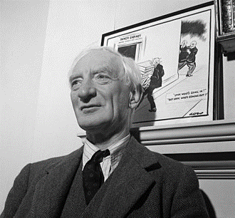
The Beveridge Report, officially known as Social Insurance and Allied Services (Cmd. 6404),[1] is a government document that was released in November 1942 and had a significant impact on the development of the welfare state in the UK.[2] It was written by the Liberal economist William Beveridge, with assistance from his wife, the mathematician Janet Beveridge[3], and was intended to address the "five giants on the road of reconstruction," which he identified as "Want... Disease, Ignorance, Squalor, and Idleness."
Introduction of nhs
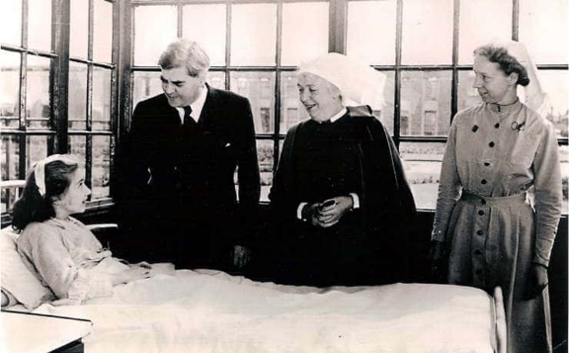
The National Health Service (NHS) began on 5 July 1948. Most of the money for the NHS comes from ordinary taxes, with National Insurance that contributes. The purpose of the NHS was to offer a complete care that was paid for by taxes, accessible to everyone, and free in times of need. Years of effort finished in the creation of the NHS in 1948, caused on by several people.
the historical context of nhs


Clement Attlee led the Labour Party to an unexpected flooding victory over Churchill's Conservatives in 1945, shortly after the end of the European War. He then set about carrying out Beveridge's idea of a welfare state. The creation of a universal, cost-free health service was a key element of this. Its establishment was led by significant socialist and miner's son Aneurin Bevan.
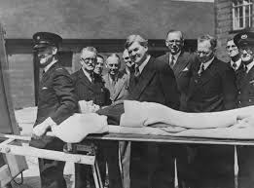

The development of the nhs 
1983- Start of the UK liver transplant programme
1983- Professor Sir Magdi Yacoub performed the first combined heart and lung transplant in the UK at Harefield Hospital in Middlesex.
1986- Beginning at Middlesex's Harefield Hospital is a programme for artificial hearts.
1986- Prof. John Dark performed the first lung-only transplant in Europe at the Freeman Hospital in Newcastle.
Challenges number 1 Shortage staff NHS

The first challenge the NHS may face is shortage of staff. For example, The current issue is the covid-19, which has resulted to more patients going to hospitals with the virus than at its April its highest. While also creating services for patients with long covid, the NHS is being asked to put out the biggest and largest vaccination campaign in its history. Also Another example, the lack of staff and the doctor at the hospital which is not normal, Most of the time we go to the hospital in the hospital in the pedantry area with our Children to be seen and we just spent the whole day there because they don’t have enough Doctors to attend, this situation is still happening every day in hospital, and it also happening to me at Newham Hospital, I got there morning, went to the reception, went To see a nurse and stayed there for 6 hours hope but they want the maximum waiting Time is 4 hours, this lack of staff or doctor so far still exists in hospitals and the NHS They have to better or working this point. This happened because the NHS is having trouble keeping employees due to problems with promotion, in addition to problems with pay and working
conditions. In turn, this makes it more difficult for the health service to hit its aggressive employing goals. The statistics show In NHS England's long-awaited staff plan, the health service is already working with 154,000 fewer full-time employees than it needs.

Challenges number 2 Aging population NHS

The second the NHS may face is by the UK’s aging population. An elderly person, in general, is a person over the age of 65 can be considered older. In the UK, there are currently 3.2 million people over the age of 80, and by 2050, that number will grow to almost 8 million. 25% of the population will be over 65 by this time. The impact of an ageing population is the NHS must treat an increasing number of chronic age-related illnesses like heart disease, Type 2 diabetes, arthritis, and Alzheimer's as more people reach their eighties. Many elderly people need more help with daily tasks because they have difficult social needs. One in six people over the age of 80 will have dementia by the end of 2021. Daily support with tasks like washing, dressing, and cooking can be expensive and frequently requires a patient to help financially. Because older people are more likely to live in countryside or by the sea while younger people are more likely to live in cities, some regions of the UK are more affected than others. The NHS spends about £624 million on first-year treatment cost result of poor housing, which primarily results in too many cold hazards and falls. As a much smaller working-age population supports rising spending on health, social care, and benefits, an increase in the elderly population will put way more stress on public finances, especially if it is not matched by better health.

Reference:
https://www.bmj.com/content/371/bmj.m4973
https://www.themedicportal.com/application-guide/the-nhs/challenges-facing-the-nhs/?v= 79cba1185463
https://www.bma.org.uk/advice-and-support/nhs-delivery-and-workforce/pressures/nhs-backlog-data-analysis#:~:text=In%20part%2C%20these%20long%20waiting,for%20them%20in%20social%20care.

