Arts for Wellbeing Activity Programme

This essay will critically consider issues that Young People are suffering with in this modern age and will focus on designing a programme with various activities that are designed to address the issues directly. This essay will also look at what current government policy exists around the issues mentioned in the essay, and describe the authors plans and approaches to leading, monitoring and evaluating the activities aims and outcomes.
In order to identify the needs and interests of young people and devise what type of activities young people may wish to participate in, the author of this essay has utilized knowledge of issues affecting young people, gained through consultation and focus group discussions, both through personal and professional relationships with young people. Some of the young people mentioned subjects such as addiction, poverty, lack of things to do and places to go, loneliness, isolation, anxiety and depression.
When young people were asked what their hobbies and interests were, most of them answered, spending time online chatting to friends and playing games. One young person even said “why bother going outside when I can easily play and talk to my friends from home”, (Anonymous Young Person, 2018a) and another saying “I don’t have internet and don’t like going outside…I don’t feel safe unless I’m at home” (Anonymous Young Person, 2018b), but the one young person who resonated the most with the author stated: “I don’t like going outside. I can’t be asked to meet with anyone” (Anonymous Young Person, 2018c).
It is apparent that a large amount of people in todays society are dependant on the access and availability to the internet and its immediate response time and is often favoured over genuine physical face-to-face interactions (Ilardi, 2010). Additionally, social media sites are often associated, if not blamed for the decrease in well-being. This is reinforced in a newspaper article by Levin (2017), where the former Facebook executive Chamath Palihapitiya, admitted that the site was designed to be addictive by providing users with a short-term, dopamine-driven feedback loop. Furthermore, the former Facebook executive stated that social media is programming the minds of their users to their benefit (Palihapitiya cited in Stanford Graduate School of Business, 2017).
Although not directly stated by young people as an interest of theirs, their mental health is of great interest and paramount importance for young people to be able to develop holistically (Learning and Skill Improvement Service, 2012) and cope with life and its stresses. Due to the author of this essay having a personal as well as professional understanding of the effects of loneliness, anxiety and depression, especially prolonged exposure to the feelings associated with these conditions, the author has decided to incorporate all of the issues into one programme of activities, comprised of two main activities, which will link together for effectiveness. The programme of activities is designed to combat depression, anxiety and loneliness directly and will include: Creative Art and Horticultural activities, involving group discussions on the subject of Mental Wellbeing and Mental Illnesses. These activities are designed as a mean of therapy and intervention, and will be conducted alongside Meditational activities, such as mindfulness meditation.
Depression is noted as the leading cause of suicide and self-harm among young people and adults and has been dubbed as an epidemic in recent years (Rottenberg Ph.D., 2014). Due to this the author has based the activities on Ilardi’s (2010) 6-ways to combat depression programme. Ilardi (2010) suggests that the human mind does not necessarily need medication to defeat depression, but rather one can influence the body’s natural defences through the application of six changes to our modern-day lifestyles, such as physical activity, balancing Omega-3 and Omega-6 in our diets, increasing exposure to natural sunlight, getting healthy sleep, conducting anti-ruminative activities and being socially connected.
The author plans to incorporate most of Ilardi’s (2010) steps into creative art therapy and horticultural activities to achieve an anti-depressive effect for young people involved. Being engaged in physical activity naturally releases Dopamine and Serotonin and helps the brain turn off its stress responses, helping young people to feel less stressed through natural actions. Through undertaking both activities in direct natural sunlight, vitamin-D levels will be increased, decreasing mental health issues and enhancing the young person’s wellbeing, this is due to sunlight being responsible for the internal body clock which is essential for healthy sleep, as well as Vitamin-D having an anti-inflammatory effect on the brain (Ilardi, 2010). Conducting anti-ruminative activities, such as mindfulness, helps one to focus on the here-and-now rather than being stuck on the same negative train of thought and will help in engaging in social activities and being socially connected. By building relationships and bonding with others the human mind can develop and maintain a higher standard of health due to social bonding being responsible for the release of natural hormones that reduce stress and anxiety (Ilardi, 2010).
Art Therapy is known to have its benefits in the realms of wellbeing and has been used for generations, whether as a form of escapism, allowing an individual to gain distance from their feelings and thoughts such as stresses, anger, frustration, responsibilities and anxieties or as a form of expression when words simply are not enough. Art is a creative-, relaxing-, calming-, expressive-, communicational-, innovative-, and social activity that connects people together, through physical social interactions, especially in group work tasks and community-based projects.
The author notes that art therapy can also be used as a very effective analysis tool, this is backed by the authors personal experiences as well as medical doctors such as M.D., J.D. Marlynn Wei (2018). However, the author believes that, although the researcher may gain knowledge and insight into young people’s thoughts, feelings and needs through the application of art therapy, art therapy is more about the participant gaining deeper insight and analysis of their own psyche. Through combining the young persons self-analysis with critical reflection, a higher level of empowerment can be achieved making long-term change more tangible and achievable to the individual. As for the methods the author desires to use, in regard to art therapy, the author suggests all possible methods of artistic creation to be used, young people may want to express themselves through drawing, painting or sculpting, either through using conventional, traditional tools such as paintbrush, pen, pencil, painters/sculpting knifes or even using non-conventional tools such as hands, feet, cutlery, hairbrush or comb, among a multitude of other tools. Art is truly interpretive, unique, expressive and fun, even if an individual is not a trained art professional. The author agrees with Bob Ross, who once said:
I cannot think of anything more rewarding than being able to express yourself to others through painting. Exercising the imagination, experimenting with talents, being creative…these things, to me, are truly the window to your soul
(Ross, 2016)

According to the Mental Health Foundation (2017), the focus of mindfulness-based activities is to assist young people in making the most out of their potentials and cope with life’s stresses, through the use of meditation methods such as breathing and yoga. Mindfulness has always been important in religions such as Buddhism, but its concept has recently grown in popularity, sparking the increase of mindfulness encouraging Apps for mobile devices. The author plans to use mindfulness techniques throughout the activity to assist reflection and encourage young people to feel safe and calm as well as build confidence within themselves. Being stuck on a thought, also known as ruminating, is a serious cause of depression, especially when young people are stuck for a prolonged period. This programme of activities was designed to provide Young people with a space to relax, feel safe and find inner peace in order to comply with the United Nations Convention on the Rights of the Child (United Nations International Children’s Emergency Funds, 1990), especially Articles 6, 19, 24, 27 and 31.
According to the United Nations Convention on the Rights of the Child (United Nations International Children’s Emergency Funds, 1990), Article 6 focuses on promoting every child’s right to life and healthy development; Article 19 focuses on protecting all children from all forms of physical or mental harm either from actions of others or actions of their own, such as self-harm; Article 24 focuses on the child’s right to attain the highest standard of health and wellbeing, as well as have access to help provisions and organisations if treatment or rehabilitation is needed; Article 27 focuses on children’s right to a healthy standard of living, emphasising the child’s physical, mental, spiritual, moral and social development; Article 31 focuses on ensuring that young people have a space to feel safe, calm and relaxed, as well as the right to participate in recreational activities, stimulating both cultural and artistic aspects of life.

To strengthen the outcomes of the activity programme as well as further link to current government policy, the author plans to combine creative painting with horticultural activities to enhance the outcomes for young people and follow the Five ways to wellbeing Framework (Government Office for Science, 2008). The activity will encourage young people to create their own plant-pot design and plant seeds or bulbs and care for the resulting plant. Horticultural activities have been known to be therapeutic and links greatly with the Five Ways to Well-being (Government Office for Science, 2008), in that Young people can connect with others around them through social creative art and gardening involvement, be active by physically engaging in outdoor gardening activities, take notice of the beauty of art, plant life and the social connections they have, Keep learning new skills and either rediscover or develop interests, and give back to their communities.
As for the authors plan for the Monitorisation of the activities, the author intends on focusing on observation and self-participation to encourage young people’s participation and identify needs and concerns and monitor progression through art collection and reflection. The author notes that a key challenge in using observation as a monitorisation method, in regard to depression and anxiety, is that these conditions are very easily masked and hence sufferers often go unnoticed or untreated. For this purpose, the evaluation aspect of the activity sessions will be concluded with critical reflections using a target-evaluation model and art themed comment boxes (Appendix 2), as well as verbal discussions and reflective journal writing and drawing, or self-reflections for those who wish to maintain anonymity. As a safeguarding measure the author will report any concerns, regarding young people’s mental health and stability, to the Child and Adolescent Mental Health Service if young people are deemed to be at risk of harming others or themselves.
There are multiple key challenges in using art and crafts as an activity, especially when working with young people suffering with depression, anxiety and isolation. The most notable of which include: getting young people to join in the activity and the widely believed concept that people believe that they cannot draw or be creative. Convincing young people to join in an activity that they may benefit from can be a difficult task, even without having conflicting mental health issues, this can be linked to young people often feel judged by their peers and authority figures, intimidated by new concepts and ideas or even anxious due to their self-confidence. The belief that they cannot draw or be creative is not exclusive to young people, as adults of all ages also share the same belief. Communications expert Graham Shaw (cited in Tedx Talks video, 2015), points out that all humans can draw, all that is required is an open mind and the willingness to give things a try.
The importance of mental-, emotional- and physical wellbeing has been recognised by many professionals and government officials across the globe. Some of the key legislations and policies linkable to the programme of activities include:
The National Suicide Prevention Strategy (Welsh Government Social Research, 2015), designed to reduce the suicide and self-harm rates in Wales as well as Promote and co-ordinate support plans and programmes designed for the prevention of suicidal behaviours and self-harm; The National Occupational Standards (Learning and Skill Improvement Service, 2012), which promotes the safeguarding of young peoples needs and interests, such as health and wellbeing, and additionally is often used for basic policy development; Every Child Matters (HM Treasury, 2003), designed to set policies to reduce the number of young people afflicted with ill health and wellbeing, and additionally notes that enjoying good physical and mental health and living a healthy, safe lifestyle and achieving one’s full potential in life is of paramount importance for all young people; United Nation Convention on the Rights of the Child (United Nations International Children’s Emergency Funds, 1990), with dedicated articles focusing on protecting and promoting young people’s mental-, emotional- and physical health and wellbeing; Youth Work Strategy for Wales (Welsh Government, 2014), which states that all young people deserve access to a wide array of activities that they can benefit from, as well as provide them with a place to be safe, have fun and relax and escape their everyday stresses; Youth Work Principles and Purposes (Youth Work Wales Review Group, 2018) promoting young people’s needs, interests, health and wellbeing by providing enjoyable, informal and non-formal activities and learning opportunities; The Wellbeing of Future Generations Act (Welsh Government, 2015) is a legislation designed to ensure that Welsh citizens have a safer, healthier and more prosperous life, both now and in the future by attending to job- and health inequalities, such as the national growth of poverty and the declining Mental-, Emotional- and Physical Health of the nation’s people.
In conclusion this essay has critically considered issues that Young People are suffering with in today’s society and focused on designing a programme of activities which young people would benefit from, that are specifically designed to address the issues. Additionally, this essay has also looked at and linked in current government policy that centres on the issues mentioned in the essay, and described the authors plans and approaches to leading, monitoring and evaluating the activities aims, objectives and outcomes.

Reference List:

Anonymous Young Person (2018a) Conversation with Young Person, 30th October

Anonymous Young Person (2018b) Conversation with Young Person, 30th October

Anonymous Young Person (2018c) Conversation with Young Person, 30th October

Government Office for Science (2008) Five ways to wellbeing. Available at: https://issuu.com/neweconomicsfoundation/docs/five_ways_to_well-being?viewMode=presentation (Accessed: 5th January 2019).

HM Treasury (2003) Every Child Matters. [Cm 5860] Available at: https://assets.publishing.service.gov.uk/government/uploads/system/uploads/attachment_data/file/272064/5860.pdf (Accessed: 5th January 2019).

Ilardi, Ph.D. S. S. (2010) The Depression Cure: The 6-Step Program to Beat Depression without Drugs. London:Vermillion

Learning and Skills Improvement Service (2012). National Occupational Standards for Youth Work. Coventry: LSIS.

Levin, S. (2017) Facebook admits it poses mental health risk – but says using site more can help. [the Guardian online] Available at: https://www.theguardian.com/technology/2017/dec/15/facebook-mental-health-psychology-social-media (Accessed: 3rd January 2019).

Mental Health Foundation (2017) How to look after your mental health using mindfulness. [Pdf] Available at: https://www.mentalhealth.org.uk/sites/default/files/How%20to...mindfulness.pdf (Accessed: 25th August 2018).

Ross, B. (2016) The Joy of Painting. Season 29. [Video] Available at: https://www.youtube.com/user/BobRossInc/videos (Accessed: 19th December 2018).

Rottenberg, Ph.D. J. (2014) Why We Can't Stop the Depression Epidemic: Our reactions to Robin Williams's suicide explain a larger national failure. Available at: https://www.psychologytoday.com/gb/blog/charting-the-depths/201409/why-we-cant-stop-the-depression-epidemic (Accessed: 10th January 2019).

Stanford Graduate School of Business (2017) Chamath Palihapitiya, Founder and CEO Social Capital, on Money as an Instrument of Change. [Video] Available at: https://www.youtube.com/watch?v=PMotykw0SIk (Accessed: 28th December 2018).

Tedx Talks (2015) Why people believe they can’t draw - and how to prove they can. [Video] Available at: https://www.youtube.com/watch?v=7TXEZ4tP06c (Accessed: 3rd January 2019).

United Nations International Children’s Emergency Funds (1990) United Nations Convention on the Rights of the Child. Available at: http://www.unicef.org.uk/wp-content/uploads/2010/05/UNCRC_united_nations_convention_on_the_rights_of_the_child.pdf (Accessed: 25th October 2018).

Wei, M.D., J.D. M (2018) Mindfulness Art Therapy Can Reduce Depression and Anxiety: New research suggests doing art mindfully can reduce stress. Available at: https://www.psychologytoday.com/gb/blog/urban-survival/201803/mindfulness-art-therapy-can-reduce-depression-and-anxiety (Accessed: 10th January 2019).

Welsh Government (2014) The National Youth Work Strategy for Wales 2014-2018. Available at: https://dera.ioe.ac.uk/19353/1/140221-national-youth-work-strategy-en.pdf (Accessed: 13th January 2019).

Welsh Government (2015) Well-being of Future Generations Act: The essentials. Available at: https://gov.wales/docs/dsjlg/publications/150623-guide-to-the-fg-act-en.pdf (Accessed: 7th January 2019).

Welsh Government Social Research (2015) Talk to me 2: suicide and self harm prevention strategy for Wales 2015-2020. Available at: https://gov.wales/docs/dhss/publications/150716strategyen.pdf (Accessed: 9th January 2019).

Youth Work Wales Review Group (2018) Youth Work in Wales: Principles and Purposes. Available at: http://www.cwvys.org.uk/wp-content/uploads/2018/11/YOUTH-WORK-IN-WALES-PRINCIPLES-AND-PURPOSES.pdf (Accessed: 13th January 2019).

Appendices 1. Session Plan:

SESSION PLAN
Session Title: |  | Arts for Healthy Wellbeing
Date: |  | Participants: | Young People aged 11-25
Rationale:

The program of activities will include art based creative activity and horticultural activity conducted alongside mindfulness inspiring activities. The program focuses on promoting young people’s emotional-, mental-, and physical wellbeing and lowering levels of stress and anxiety, and combat depression directly both as a prevention and intervention method

Aims:

The program seeks to promote young people’s health and wellbeing, especially in the realms of depression and anxiety. The activities are designed to be a form of intervention and prevention to the decline of mental health and rise of the depression epidemic.

Objectives:

By involving young people in fun and engaging, physical and social activities, where young people can express themselves through conversation and creative art, form new bonds and relationships, and escape their day to day life stresses, worries and responsibilities through mindfulness meditational activity.

Outcomes:

By partaking in creative art and horticultural activities young people can be freed from external and internal stresses and develop a new sense of confidence, build new relationships and self-reflect to gain a deeper understanding of their mental health needs and how to achieve them, enabling them to be fuller members of society.
Resources:

Preparation work will be conducted by the Youth Worker, such as: finding an appropriate work environment and setting up workspace with the required tools.

Equipment will be provided by the Youth Worker, these include: Oil Paints, Acrylic Paints, Water Paints, Varnishes, Glue, various kinds of Paper (tissue-paper, newspaper, colored-paper), Canvas, Brushes, Pens, Pencils, Sculpting knives, Art Pallets, Plant-pots, Various Seeds and Bulbs, Topping Soil, Cardboard, Scissors, Plasticine, Clay, Gardening Tools (trowel, garden shears, dibber).
ACTIVITY |  |  |  | TIMINGS
1 | Creative expressive art, using any method preferred by the participant |  |  | Approx. 1 hour | Twice Weekly
2 | Creative Plant-pot Designing combined with Horticultural activities. |  |  | Approx. 1 hour 30 minutes | Once a Fortnight

Appendices 2. Session Evaluation Method: Target Model

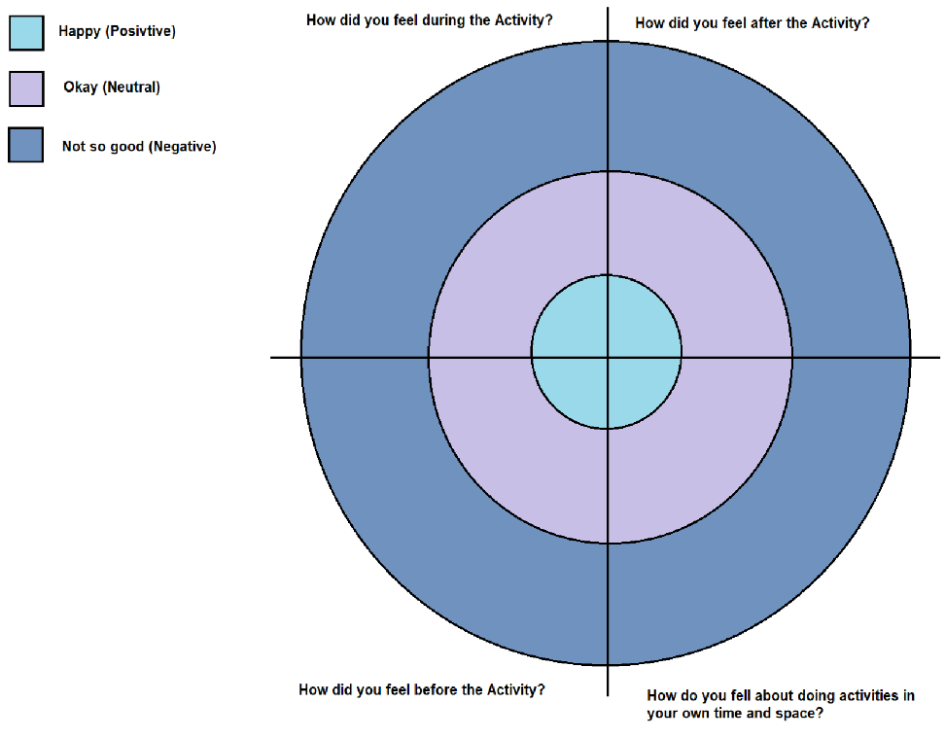

Appendices 2. Session Evaluation Method: Emoji Comments
Draw a Picture or Emoji that matches your experience

How did you feel before the activity? | What did You enjoy about the session?
What would you like to do differently? | How did you feel during the activity?
How did you feel after the activity? | What was bad about the session?

