Research Methodology

Introduction:

This chapter of the dissertation aims to achieve goal three of the study, which is to determine the best research methodology needed to perform the research project, establishing how well educational programmes work to prevent youths reoffending by using the research onion model as a guide and explaining each decision.

Research is a creative and methodical activity done to improve the body of knowledge. It entails the gathering, structuring, and analysis of data to improve one’s comprehension of a subject or problem (Western Sydney University, 2022), additionally, Runco and Beghetto (2017) highlights that there are normally two types of research methods: primary and secondary. Primary research is any study that has required the gathering of unique data for a specific research endeavour (Gratton et al, 2010, p.33). When conducting primary research, the researcher collects data directly from sources opposed to secondary research which summarises or synthesises information and material that has already been compiled and published by others (Question Pro, 2022). Due to a gap in the body of academic work, primary research will be required to help address the research question, "Examine the effectiveness of educational programmes in reducing reoffending among children." To ensure the reader has a clear understanding of the research process, this chapter will describe the anticipated methodology of the project.

Research strategy:

The Research Onion:
The research onion created by Saunders et al (2007) is one of the most popular research techniques used to gather primary data for academic writing. The research tool creates a series of stages (Layers) which when followed helps to organise and develop the research project, (Williams, 2016). For this reason, the Research Onion will be the chosen technique for this dissertation.

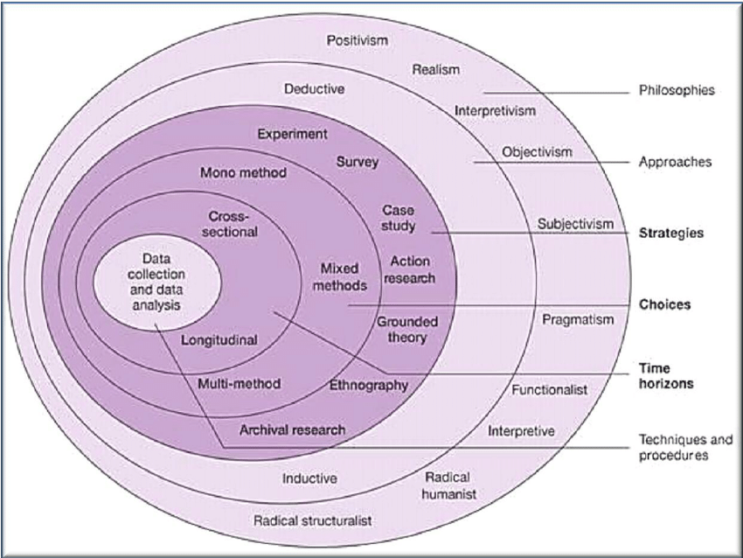
(Saunders et al, Research Onion) (Thesis mind, 2017).

Research philosophy:
The researcher's potential approach is discussed in the first layer of research philosophy, which provides structure direction and potential constraints (Alharahsheh, and Pius, 2022). The method of choice for this research project will be interpretivism, which asks the researcher to give their own interpretations of various study components and is based on a naturalistic approach to gathering data through methods like interviews and observations.

Research approach:
The second layer of the model, "Research Approach,” is a strategy and set of processes that progress from a general hypothesis to specific techniques for gathering, analysing, and interpreting data (Pettey et al. 2017, p.56). Therefore, it depends on the type of research topic being addressed (Mishra and Alok. 2011, p.15). The research approach is mainly split into two categories, deductive reasoning is a theory-testing approach used in applied research and relies mostly on quantitative research as its foundation, in contrast to inductive reasoning, which is theory-building, using basic research and is more suited to qualitative data collection, which can be displayed, allowing an interpretation of the data from a conclusion (Saunders et al. 2016). Due to the nature of the research question an inductive approach would be best suited to the project.

Research strategy and choice:
Initially the planned research strategy for this research project was to be a mixed method approach consisting of survey questionnaires and professional interviews. However, due to time constraints, and the small scale of the study, the research strategy will now be a mono method approach with an importance on collecting data in the form of qualitative interviews.

Unbiased information can be obtained, and a variety of perspectives are allowed by conducting four interviews with individuals who work in four different professions and different organisations, but all have a connection to the youth justice system. This will benefit the research project when analysing its findings. Interviewing individuals from a variety of backgrounds and experiences will better inform and enable the research project to gain insight into a variety of different perspectives, from social work, police, probation, and youth offending team. Whereas a survey questionnaire would have been predominantly closed questions and multiple-choice, which would not provide an in-depth view into answering the research question. Personal experience and understanding the above occupations, being highly stressed and demanding the author felt that most survey questionnaires would not have been completed.

Time Horizon:
The ‘Time Horizon is the final layer of the research onion; it defines the amount of time needed to complete the study. The research onion specifies two types of time horizons: cross sectional and longitudinal (Saunders et al. 2016). Cross sectional time horizon has already been established, whereby date must be gathered. This is used when analysing a specific research topic within a specific time frame. The term "longitudinal time horizon" refers to gathering of data over a protracted period of time (Mishra and Alok. 2011, p.20). Due to the research project being a small-scale study ‘cross-sectional’ is the most appropriate time horizon to be used.

Data collection:
Due to the participant’s individual circumstances and time constraints, they will each be sent a pre-written question sheet, that will consist of several closed questions to aid gaining quantitative figures which will be displayed in the graph from. Included are open questions, allowing the interviewee to be expressive in their answers, and qualitative figures displayed in the pie chart.
By distributing the question sheets head of time, the author gives the interviewee time to think through the questions and the responses they will give. This also gives the interviewee insight into the precise nature and theme of the interview, allowing them the chance to raise any ethical concerns with the author, and allow them to withdraw from the process altogether, giving the author time to find a replacement.

Data recording and analysis:
The four interviews will be audio recorded using a voice recording mobile phone application and will then be downloaded and transcribed using Microsoft Word and attached to the appendix. To find anomalies or recurring themes in the numerous accounts of the interviews, the qualitative and quantitative parts of the interviews will be entered into the relevant software and displayed in the form of graphs and pie charts.

Limitations and problems:
Originally the author chose to conduct the interviews over Microsoft Teams, due to the participants occupations being very unpredictable and demanding, also as Covid-19 is still prominent during the time frame of the research project, with many having limited contact with other and some working from home. However, this may result in technical issues with poor internet connections and computer failure, also the participants may decide to skip a simple teams meeting. These issues were explained to the participants of the study, who all agreed to having face-to-face interviews, under the condition of having lateral flow test prior to the interview, to help allay any fears of infection.

conclusion:
This chapter of the research has successfully demonstrated the most appropriate form of research methodology by using one of the most popular research techniques, the research onion model. Each part of the model was broken down into its individual layers and the author explained his decision-making process.

Bibliography:
Alharahsheh, H,H. and Pius, A. (2022) ‘A key review of paradigms’, Global academic journal of humanities and science, 2(3), pp. 39-43. DOI: 10.36348/gajhss.2020.v02i03.001.
Gratton, C. et al. (2010) Research Methods for sport studies. London: Routledge.
Mishra, S.B and Alok, S. (2011) Handbook of Research Methdology. New Delhi: Educreation Publishing.
Pettey, G.R. et al. (2017) Communication Research Methodology. London: Routledge.
Question Pro (2022) Secondary research. Available at: http://www. Secondary Research- Definition, Methods and Examples. | QuestionPro (Accessed: 21 August 2022).
Runco, M.A. and Beghetto, RA. (2017) ‘Primary and secondary creativity’, Current Opinion in Behavioral Sciences, 27(2), pp.7-10. DOI https://doi.org/10.1016/j.cobeha.2018.08.011.
Saunders, M. et al. (2007). Research Methods for Business Students. 6th ed. London: Pearson.
Saunders, M. Lewis, P. and Thornhill, A. (2016). Research Methods for Business Students. 7th ed. Essex: Pearson Education Limited.
Thesis mind (2017) analysis of Saunders Research Onion. Available at: http://www. Analysis of Saunders Research Onion - Thesismind (Accessed: 8 August 2022).
Western Sydney University (2022). Definition of research. Available at: http://www.Definition of Research | Western Sydney University (Accessed: 20 August 2022).
Williams, M. (2016) Key concepts in the philosophy of social research. London: Sage.

