Understanding the learner, the school and the local community work together to deliver one of the four purposes of the new curriculum: a video presentation that critically examines this process

Dolen fideo / Video link: https://uowtsd-my.sharepoint.com/:v:/g/personal/1603308_student_uwtsd_ac_uk/EQBA4EJRJbdPmJD6N57BUPsBj5RIgYfnaVPcW3oxuzXgRQ?e=JiezqC

Rhestr gyfeirnodi / Reference list:

Department for Education and Skills (DfES). (2014) Rewriting the future: Raising ambition and attainment in Welsh Schools. Cardiff: Welsh Government.

Donaldson, G. (2015) Successful Futures: Independent Review of Curriculum and Assessment Arrangements in Wales. Cardiff: Welsh Government.

Estyn. (2014) ‘A report on School X’ https://www.estyn.gov.wales/sites/www.estyn.gov.wales/files/documents/Inspection%20report%20St%20Thomas%20Community%20Primary%20School%202014%20%28English%20only%29.pdf.pdf.pdf.pdf.pdf.pdf.pdf.pdf.pdf.pdf.pdf.pdf.pdf.pdf.pdf.pdf.pdf.pdf.pdf.pdf.pdf.pdf.pdf.pdf.pdf.pdf.pdf.pdf.pdf [Accessed: 5th April 2020].

Estyn. (2016) ‘Pupil voice benefits pupils and helps schools to improve’ https://www.estyn.gov.wales/news/‘pupil-voice’-benefits-pupils-and-helps-schools-improve [Accessed: 7th April 2020].

Estyn. (2018) ‘Involving parents: Communication between schools and parents of school-aged children’ https://www.estyn.gov.wales/sites/www.estyn.gov.wales/files/documents/Involving%20parents%20-%20en.pdf [Accessed: 7th April 2020].

Harris, A., Andrew-Power, K., and Goodall, J. (2009) Do Parents Know They Matter? Raising Achievement through Parental Engagement. London: Continuum International Publishing Group.

National Assembly for Wales. (2018) ‘Mind over matter: A report on the step change needed in emotional and mental health support for children and young people in Wales’ https://www.assembly.wales/laid%20documents/cr-ld11522/cr-ld11522-e.pdf [Accessed: 10th April 2020].

School X. (2019) ‘School Development Plan’.

School X. (2020) ‘Four purposes – CLIC image’.

UNICEF. (1989) ‘The United Nations Convention on the Rights of the Child’ https://downloads.unicef.org.uk/wp-content/uploads/2016/08/unicef-convention-rights-child-uncrc.pdf?_ga=2.71380243.1083979653.1586969754-278641546.1586969754 [Accessed: 7th April 2020].

Welsh Government (WG). (2014) ‘Guidance for using the Pupil Deprivation Grant’ https://gov.wales/sites/default/files/publications/2018-11/what-really-works.pdf [Accessed: 7th April 2020].

Welsh Government (WG). (2018) ‘Schools in Wales as learning organisations’ https://hwb.gov.wales/storage/f87e720f-8568-4a60-9383-55e20b9a1bb7/schools-in-wales-as-learning-organisations.pdf [Accessed: 8th April 2020].

Welsh Government (WG). (2019) ‘Our National Mission: A Transformational Curriculum’ https://gov.wales/sites/default/files/consultations/2019-01/consultation-document-transformational-curriculum.pdf [Accessed: 10th April 2020].

Welsh Government (WG). (2020) ‘Curriculum for Wales guidance’ https://hwb.gov.wales/storage/b44ad45b-ff78-430a-9423-36feb86aaf7e/curriculum-for-wales-guidance.pdf [Accessed: 10th April 2020].

Appendices
Appendix 1 – Extract from School X School Development Plan 2019-2022.
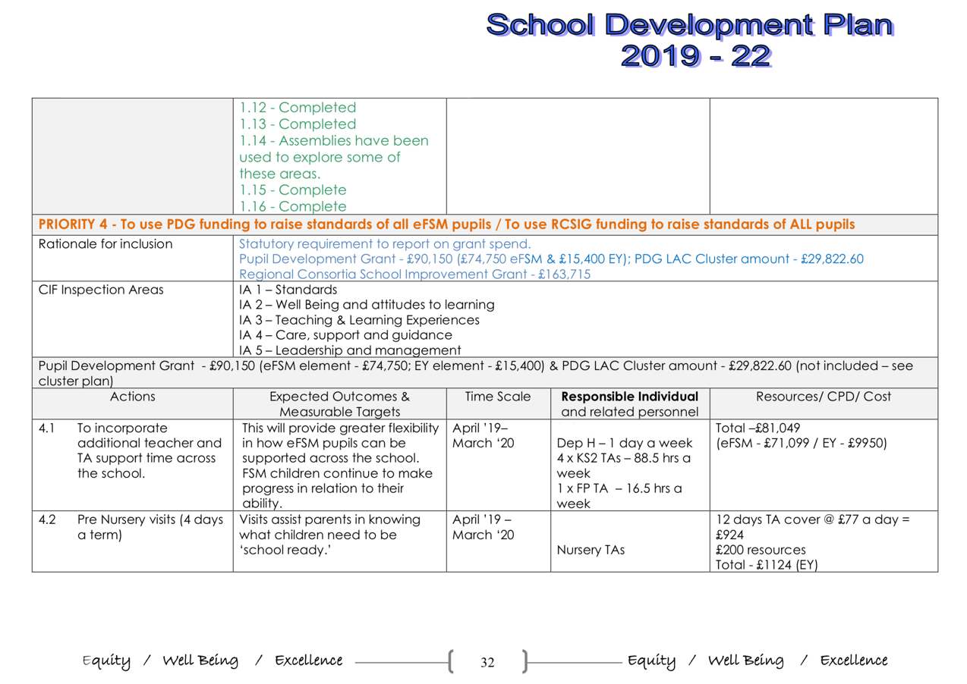

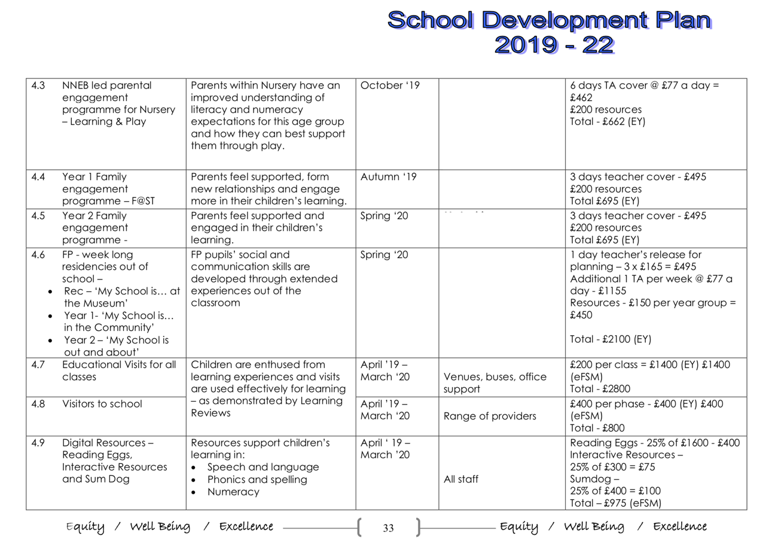

Appendix 2 – Extract from School X School Development Plan 2019-2022.


