Contents
How the application of teamwork theories (Tuckman and Belbin) can improve teamwork 3
in the organisation detailed in the case above. 3
Improving Teamwork in Janet Williams' Fashion Store 3
Tuckman's Stages of Group Development 3
Belbin's Team Roles 4
Conclusion 6
Using models taught on the course to illustrate your points the importance of two-way 7
communication at the organisation in the case study. 7
Two-Way Communication 7
Why effective communication (verbal and non-verbal) is important for the continued success of the organisation, specific to this case study. 8
Shannon and Weaver's Model of Communication 9
The Communication Cycle 10
Conclusion 11
References 12

How the application of teamwork theories (Tuckman and Belbin) can improve teamwork

in the organisation detailed in the case above.

Improving Teamwork in Janet Williams' Fashion Store
The core bases for the smooth-run of any institution whatsoever are good communication as well as teamwork, and this statement is true to the one currently experiencing a fast-paced growth, the Janet Williams' fashion store. In here, we will discuss two theories of teams which are Tuckman's stages of group development and Belbin's team roles and how their application can help in the organizations performance and facilitate effective communication channels.

Tuckman's Stages of Group Development
Tuckman's model outlines four stages of group development: forming a team, storming it, then moving on to norming, and finally performing (AEC772/WC433: Leading Teams #2: Stages of Group development, no date). Each stage affords the construction of its own challenges and doors to individual teams work improvement.
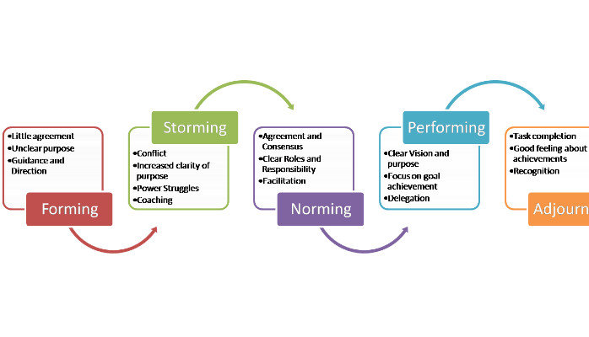

Forming: In the first part of the intro stage, people gather around the campfires and introduce themselves to each other (Jones, 2019). As to its employees, nothing makes the Janet's more diverse than it being the home earner and experiences of different ages. Throughout this phase, form a bonding team between workers and give them the sense of purpose. Janet must create opportunities for team jobs and she should work on team spirit by promoting an open communication to build trust and team spirit among her employees.
Storming: As the team starts to paddle the canoe, some conflicts and objections may arise. This phase of the training in a dynamic setting is for employees where they need to interact as a team, each having different tasks and roles. Although conflict may sometimes help to uncover creativity and innovation, if it is skillfully handled. Janet must make sure that she inserts a positive conflict resolution understanding and for the people to be free to express their views and concerns (Tuckman and Jensen, 1977).
Norming: In the first stage, team members begin developing a "social contract" for their working connection. Janet can create opportunities for cooperation by expecting her team to cooperate, to communicate well, and to perform tasks as a whole (Patterson, 2022). Regular individual and joint events, in-person as well as online, can do the job of putting everybody on the same wavelength, and even working towards one common aim.

Performing: Although there are problems to be solved during the establishment of effective communication channels, the team will eventually overcome them through which they will be able to reach peak potential management. It is recommended that Janet gives her employees their space and tasks assignment by which they can also desire to develop professionally. Whereas acknowledging and rewarding for work done can pave the way for team work towards the goal (Bonebright, 2010).

Belbin's Team Roles

Belbin identified nine team roles which all has their positive and negative parts. Janet can establish this norm for the team because she can value individuals who perform different roles in the team. It is also important that she ensures effective task management and smooth communication within the team (Adamis et al., 2023).
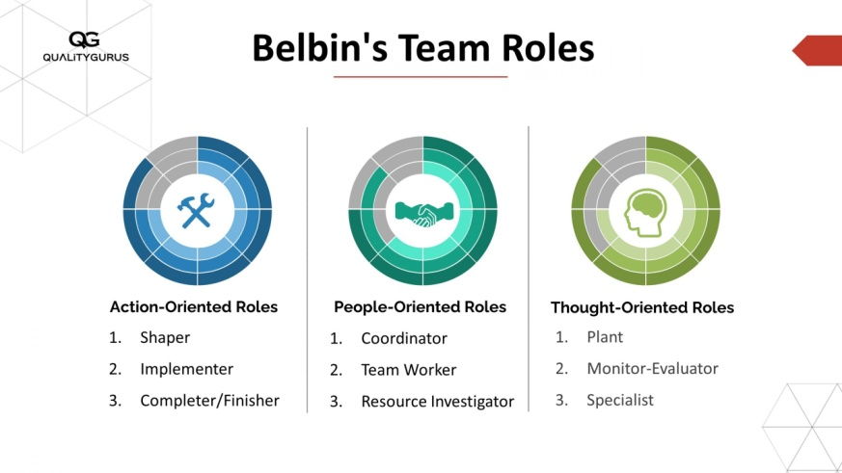

Plant: The thought process of plants are creative and inventive as they not only develop new concepts, but also come up with innovative solutions. A machining that Janet will need to make is to allocate the best employees, who have great creative abilities, in coming up with the marketing strategies and product development ideas.
Resource Investigator: The Resource Investigators are polite and necessarily outgoing, cheerful and talented in networking. They derive information in a very covert manner. Janet will delegate the latter task to those who are already in charge of digital marketing and promotions by telling them to find new avenues and leveraging of the cooperative network.
Coordinator: Coordinators are born leaders and it is in their nature to buttress teamwork by assigning tasks to others and performing well as a group. Janet should develop managers or even may delegate these duties to them equally with other members in order to reach the common goals.
Team Worker: Colleagues are communicative and positive-minded, achieving consensus in matters of negotiation and ensuring that the team is always in peace. Jane should really push everybody into the environment like this, which you will create not only a friendly but also helpful work team where everyone has or wants only good things for another person.
Implementer: Implementers discipline and responsible; so, they will carry out the plan thoughtfully, and thus the plan will be executed successfully. Janet assigns this role to people in stock and online order fulfillment areas of the business, stressing the role of timely service in description of that work.
Completer: Completer-Finishers are conscientiousness individuals who desire the best result and will endeavor to make sure all tasks are thoroughly done. Janet should develop an effective performance reward plan in order to appreciate those that are good at this area of responsibility, for example in the client service and quality maintenance roles.

Specialist: Experts are often equipped with drafted knowledge and skills that are paramount in the collective. It is vital for Janet to learn from other people and to encourage the employees to do the same as the firm's rules and regulations change in digital marketing and e-commerce.
If she gets to know thoroughly the positive traits and difficulties common to each role in the group setting, Janet can select capable members and distribute work afterwards for the purpose of avoiding the productivity loss and issues of the team (Maiztegi, Bejerano and Artetxe, 2022).

Conclusion
To sum up, productive teamwork is the critical factor for Janet Williams’ garment shop to maintain a good run and enhance the scope of its business as well. Tuckman's model of team development describes four major stages – forming, storming, norming, and performing. These stages can be applied by Janet to create a team culture which is both supporting and cohesive; communication flows freely, conflicts are solved productively, and everybody contributes towards shared goals. Aiming to establish long-term relationships, maintain collaboration, and use of the different strengths of the employees, Janet will rather make her business market stand out among the rest.

Using models taught on the course to illustrate your points the importance of two-way

communication at the organisation in the case study.

Two-way communication is now being used within organizational communication to process decision-making and to prevent incidents in the workplace (Kent and Lane, 2021). When the case of Janet Williams'apparel shop is in discussion, then communication is of utmost importance for its unparalleled success in the market even if there is a shift in the services offered like online shopping which involves a rapid growth stage. In this report is the main attention paid to the role of two-way communication and the basic of effective communications and illustrates near the case study how verbal and non-verbal communication are important while using models like Communication Cycle and Shannon and Weaver's model.

Two-Way Communication

The concept 'Two-way communication' consists of the senders and receivers that are involved in the process through active interaction (Kwame and Petrucka, 2021). In Janet's store, implementing two-way communication channels is essential for several reasons.
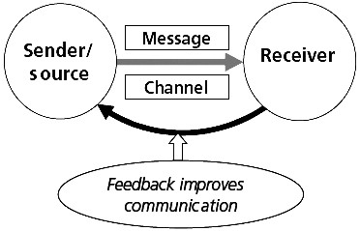
Fostering Employee Engagement and Satisfaction: Our team includes people of all ages and levels, and building a platform where opinions, negative attitude and ideas of each employee are heard encourages employees to take an active role in the job and personal development (Yuan et al., 2017). It is particularly necessary in the case of the retail industry when frontline staff cross the face to face tariff with a client and their opinion might be of great help for the knowledge of the customers’ wishes and demands.
Problem-Solving and Conflict Resolution: In the moving and complex space of novelty values, conflicts and problems are to be reckoned with. However, some HR personnel use strict disciplinary measures resulting in employees’ feeling alienated and devalued which can in turn worsen the situation. On the brighter side, streaming two-way communication channels allow employees to feel empowered to address problems together which results in early resolutions and prevents the small issues from becoming bigger problems (Salterio, Hoang and Luo, 2021). Actually it is of great importance since in this type of setting the skillfulness of managing informal groups like the one of workers is needed.
Promoting Innovation and Creativity: Jane's intentions to cross over the cyber-shopping field is a sign of adaptability and new ideas. Through the interaction of Janet as a conductor, she can draw on the rich pool of knowledge and diverse outlooks of her employees. Their collective consciousness, if creative and innovative, will be ensured to propel the business to greater heights.

Why effective communication (verbal and non-verbal) is important for the continued success of the organisation, specific to this case study.

Effective Communication
Good communication, a combination of spoken and non-verbal messages, is the needed basis of influencing Janet's fashion store's success (Musheke and Phiri, 2021). Specifically, in this case study, effective communication is crucial for the following reasons
Ensuring Consistency and Clarity: Due to the varying of hours that the employees are working as well as some who is working remotely, effective and clear communications is primary, so that everyone is on the same page in regard to the store objectives, procedures and policies (Baumann, 2017). This is very critical for avoiding any lapse of quality in the services and to maintain customer satisfaction by bridging the gap between online and physical platforms.
Building Trust and Rapport: Maintaining effective communication, either verbal or nonverbal, crops the circle of trust and rapport among the team members. Under those conditions in a retail environment where the members’ cooperation is a core ingredient of production, trust creates teamwork enabling the efficient operations, which consequently results in high productivity and job satisfaction (Sharkiya, 2023).
Enhancing Customer Experience: Since an online platform makes for the rapid growth of Janet's store, communication hence becomes a supplementary channel ensuring that the shoppers are provided with the right information just at the right time. The main role of a sales rep is to explain product characteristics correctly and help the customers make an informed shopping decision: this works online and in a store.

Shannon and Weaver's Model of Communication

Developed by Claude Shannon and Warren Weaver in 1949, this model breaks down the process of communication into several key components: sender, message, channel, receiver, noise, and feedback (Ritchie, 1986).

Sender: In the context of Janet Williams' fashion store, Janet herself, as the owner, can be seen as the primary sender of messages within the organization. This includes instructions, updates on business strategies, and other relevant information.

Message: The message is the information or idea being communicated. This could be anything from new store policies to updates on sales targets or promotions.
Channel: Channels are the means through which messages are transmitted. In Janet's store, channels could include face-to-face meetings, emails, Microsoft Teams for virtual meetings, or even notices posted in the staff room.
Receiver: The receiver is the individual or group intended to receive the message. In this case, it could be any member of Janet's staff, ranging from sales representatives to managers or delivery drivers.
Noise: Noise refers to any interference that disrupts the transmission or reception of the message. This could be literal noise in the environment, such as loud music in the store, or psychological noise, such as distractions or misunderstandings.
Feedback: Feedback is the response or reaction to the message sent. It allows for clarification and confirmation that the message was understood as intended. Feedback can be formal, such as during performance reviews, or informal, such as a quick acknowledgment during a meeting.

By understanding and applying Shannon and Weaver's model, Janet can ensure that communication within her organization is clear, effective, and free from disruptions. She can identify potential sources of noise and implement strategies to minimize their impact, while also encouraging feedback to ensure messages are understood and acted upon appropriately.

The Communication Cycle

The Communication Cycle is a four-step model that figuratively portrays the stages of the communication process between a source and a destination (Van Ruler, 2018). It consists of six key elements:

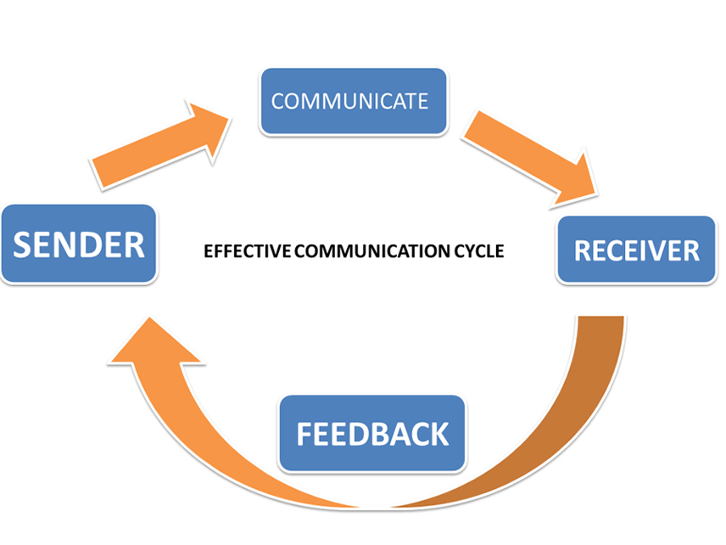
Sender: The actor of communication can be the individual himself or some company or organisation or structured system that transmits a message to the receiver of the communication. In Janet's fashion store, Janet was the one who would convey the messages such as availability of deals, sales, updates on costumers service and any other priority that the costumers could have.
Message: The sender's idea, action or feeling that is being communicated. From introducing new rules to giving the order processing rules for the online business, this list includes kind of anything.

Encoding: The process of converting the message all the way down to the format which can be effectively received. This includes using good expressions, the tone, and the medium in order to be sure the message is comprehensible and clear to the reader.
Transmission: The physical or the virtual tool; the tool through which the message is transmitted to the receiver. During Janet's tenure, employees may get exposed by words of mouth in face-to-face conversations, e-mails or notices posted in the staff room.
Decoding: Through which the message recipient forms their own interpretation and understanding of it. Translating here requires comprehension of words and tone by breaking down their meaning from the global context.
Feedback: The response or animation shown by the strange person to exhibits that they recognize the message. Feedback plays the crucial role of marking the end of the communication cycle and of providing a confirmation that the intended message is received and understood correctly.

Through the employment of the Communication Cycle model, Janet will have an opportunity to ensure that communication within her organization is smooth, fruitful, and encourages joint efforts. She can narrow down on message encoding to meet the tastes and preferences of workers using her diverse workforce and involve the right channels available and also welcoming their feedback on what misunderstandings if any might be there and how to address them.

Conclusion

The conclusion is that two-way communication and communication are fully integrated components, which are crucial for an organization’s success, in a dynamic and fast-developing business like Janet Williams’ fashion boutique. Through adopting models such as Communication Cycle, Shannon and Weaver's Model and drawing the ideas of Tuckman's stages of group development, Janet can built the communication channels that induce the engagement of workers, solve problems, innovate, ensure consistency through the use of strong communication channels and build trust. The foresight of the store manager will allow them to overcome challenges, leverage the chances they might come by, and experience sustainable growth.

References

Adamis, D. et al. (2023) 'Belbin’s Team role balance and team effectiveness in community mental health teams in an area of Northwest Ireland: Implications for leadership,' Merits, 3(3), pp. 604–614. https://doi.org/10.3390/merits3030036.
AEC772/WC433: Leading Teams #2: Stages of Group development (no date). https://edis.ifas.ufl.edu/publication/WC433#:~:text=The%20five%20stages%20of%20group,1983%3B%20Wheelan%2C%202009).
Baumann, N. (2017) 'The importance of effective communication: Some food for thought,' The Journal of Applied Laboratory Medicine, 1(4), pp. 460–461. https://doi.org/10.1373/jalm.2016.021865.
Bonebright, D.A. (2010) '40 years of storming: a historical review of Tuckman’s model of small group development,' Human Resource Development International, 13(1), pp. 111–120. https://doi.org/10.1080/13678861003589099.
Jones, Dr.A. (2019) The Tuckman’s Model Implementation, Effect, and Analysis & The New Development of Jones LSI Model on a small group. https://papers.ssrn.com/sol3/papers.cfm?abstract_id=3525281.
Kent, M.L. and Lane, A.B. (2021) 'Two-way communication, symmetry, negative spaces, and dialogue,' Public Relations Review, 47(2), p. 102014. https://doi.org/10.1016/j.pubrev.2021.102014.
Kwame, A. and Petrucka, P. (2021) 'A literature-based study of patient-centered care and communication in nurse-patient interactions: barriers, facilitators, and the way forward,' BMC Nursing, 20(1). https://doi.org/10.1186/s12912-021-00684-2.
Maiztegi, A.A., Bejerano, E.E. and Artetxe, M. (2022) 'Team formation on the basis of Belbin’s roles to enhance students’ performance in project based learning,' Education for Chemical Engineers, 38, pp. 22–37. https://doi.org/10.1016/j.ece.2021.09.001.
Musheke, M.M. and Phiri, J. (2021) 'The effects of effective communication on organizational performance based on the systems Theory,' Open Journal of Business and Management, 09(02), pp. 659–671. https://doi.org/10.4236/ojbm.2021.92034.
Patterson, D. (2022) 4.5. In-depth look: Tuckman’s Model – Five stages of team development. https://ecampusontario.pressbooks.pub/hrstrategicprojectmanagementtheory/chapter/4-5-in-depth-look-tuckmans-model-five-stages-of-team-development/.
Ritchie, D.G. (1986) 'SHANNON AND WEAVER,' Communication Research, 13(2), pp. 278–298. https://doi.org/10.1177/009365086013002007.
Salterio, S.E., Hoang, K. and Luo, Y. (2021) 'Communication is a two-way street: Analyzing practices undertaken to systematically transfer audit research knowledge to policymakers,' Accounting, Organizations and Society, 94, p. 101265. https://doi.org/10.1016/j.aos.2021.101265.
Sharkiya, S.H. (2023) 'Quality communication can improve patient-centred health outcomes among older patients: a rapid review,' BMC Health Services Research, 23(1). https://doi.org/10.1186/s12913-023-09869-8.
Tuckman, B.W. and Jensen, M. (1977) 'Stages of Small-Group Development revisited,' Group & Organization Studies, 2(4), pp. 419–427. https://doi.org/10.1177/105960117700200404.
Van Ruler, B. (2018) 'Communication theory: an underrated pillar on which strategic communication rests,' International Journal of Strategic Communication, 12(4), pp. 367–381. https://doi.org/10.1080/1553118x.2018.1452240.
Yuan, S. et al. (2017) 'Two-way communication between scientists and the public: a view from science communication trainers in North America,' International Journal of Science Education, 7(4), pp. 341–355. https://doi.org/10.1080/21548455.2017.1350789.

