

MODULE CODE: LCMB7020

MBA DISSERTATION

Strategic Analysis for the Development of a Waterplane Network in Greece

ATHANASIOS KARKATZOULIS
STUDENT NUMBER: 2011249
2011249@student.uwtsd.ac.uk

SUPERVISOR: DR ANASTASIS PETROU

MBA IN GENERAL MANAGEMENT
LONDON, OCTOBER 2021

ABSTRACT

Acknowledgements

Table of Contents

List of Figures

List of Tables

Chapter 1. Introduction

The need of people to transport either themselves or goods has been known since the prehistoric times. Back then, the prehistoric man was moving in search of food, or out of curiosity to get to know their environment, or even to protect themself from various natural dangers. Over the years they created means of transport for both themselves and their goods, starting with the use of animals on land and from the primitive raft to lakes and rivers which led to the sea. Thus, from the wheel, the oar, the sail, and the steam they invented modern turbines of advanced means of transport.
The sector of transportation is a key sector both in Greece and in the rest of the world. It is not an end in itself, but is used as a "tool" to promote other industries such as tourism, trade, logistics, etc. Therefore, transportation is directly affected by the decline or growth of some of these sections of the economy. It is worth noting that it represents 5% of the total GDP in Greece.
Greece as a predominantly island country, but also due to its strategic location favors the development of this sector, either for trade or tourism. It is known that the merchant naval fleet of Greece is one of the largest in the world including more than 2,000 ships. According to the CIA World Factbook of 2005, Greece is in 9th place in the world based on its coastline which is 15,147 kilometers and consists of over 2,500 islands of which 165 are inhabited. Therefore, the development of a comprehensive transport network in Greece based on the sea is rather advantageous both for the country and for the companies that intend to invest in it.
In order to evaluate the transportation market and invest in, the strategic analysis is a necessary step. It all starts with the definition of ‘strategy’. Conceptually, it is a joint word that stems from the ancient Greek words ‘stratos’ (= army) and ‘ago’ which means "I lead". Based on literature, the dominant people in ancient times were those with the strongest army. But times are changing and even though initially the army played a leading role, in the Middle Ages the church became powerful. Today this role is shaped by the companies. Strategy is therefore directly linked to survival and dominance.
In the present work, which will function as a strategic management plan and will implement quantitative and qualitative methods, we will investigate how feasible and interesting it is to develop a grid of waterplanes in Greece.
This work raises the issue of the use of waterplanes to improve national transport planning. The waterplane is a rather unusual and unknown means of transportation for most people, but it has advantages that makes it definitely useful and easy to use in several countries around the world. In addition, this work will analyse whether, and in what way, the waterplane can be part of the solution to the complex and multidimensional transport problem in this area (or other similar).
As it is known, the European subsidies to the shipping companies, which cover the ferry connections between the islands and the mainland, are decreasing more and more every year. As a result, most of the border islands, as well as many other areas, have a serious problem of transport connectivity with the rest of the country, as shipowners are forced to reduce the number of connections of their ships every year. Thus, the government and the European Union must either subsidize the itineraries of these ships, so that they are not unprofitable as businesses, or look for alternatives, which will provide a solution to the problem of interconnection of the islands. This problem can be solved with the use of waterplanes. Already in Europe, due to the economic crisis, several countries, such as France, England, Poland, Norway, Croatia, Malta, etc., have begun to realize the possibilities of the waterplane and started to use them to a greater extent.
The waterplane can replace other commercial flights at short distances, if there are water surfaces, so that it is possible to refresh and alienate. As will be discussed further below, the seaplane already operates as the main means of transportation in Canada, which boasts of many lakes, and in the Maldives, which boasts of many islands. The most important advantage of the waterplane is that it does not require expensive facilities such as airports with special runways. Instead, small water surfaces are required which are ready in nature at zero cost. Finally, we can add to the disadvantages of waterplanes that they are smaller than corresponding planes, due to the floats, and that they are more affected by the weather conditions (Canamar Leyva, Alan Leonel, 2012)
The investigation of the use of waterplanes can be divided into two sub-issues. The first concerns the use of the waterplane as a means of transport for the country's tourists, i.e., when it operates in the touristic areas, and primarily transports visitors to various nearby destinations to and from their place of residence.
The second issue concerns the possible lack of existing transport structures, mainly in the islandic part of a country, where the waterplane can be used as a means of transport for permanent residents to nearby larger areas (healthcare, public services etc.).
Waterplanes may function as a useful tool that will fill the market gap for the connection of remote areas, mainly islands. It can also provide a quick and economical solution for transportation from mainland Greece to other areas where transportation is long and expensive. It is an original medium that can enhance this in turn one of the two most ‘heavy industries’ in Greece, namely tourism. However, for the above to be achieved, there must be a clear legal framework so that the respective companies can operate, as well as the corresponding territory so that the interested investors can understand.

Thesis Outline

Chapter 2. Literature Review & Background
The waterplane is an original and rather strange means of transport, despite its history. It is a means that has been designed to function as a solution to the complex transport issue of archipelagos, including the Hellenic region. Its special features and the need of non-expensive and sophisticated landing and take-off infrastructure, since the seas and lakes are already ready by nature, makes it a rather advantageous transportation solution.

Waterplane – Definition & types
The waterplane is a special category of aircraft that can land, float and take off from water surfaces such as the sea, rivers and lakes (Tsoklis, 2007). The buoyancy of the waterplane is done either through the lateral floats, or by a special adaptation of the fuselage on a vessel. In the past, waterplanes that combined fuselages and floats were called air shuttles, but today, in addition to the term waterplane, we also find the term ‘amphibious aircraft’ (ref). The two main types of waterplanes currently operating are the floatplane and the flying boat.

History of waterplanes
The idea of the waterplane creation was born, primarily due to the lack of proper ground infrastructure and the availability of huge motorboats. The first seaplane flight was executed in 1910 by the French engineer Henry Fabre naming this instrument ‘Le canard’ (The Duck) (ref). Since then, waterplane research has focused in the technical upgrades and designs for this instrument’s wide implementation. Aircraft designers Gabriel and Charles Voisin experimented quite a bit by adapting the floats from Fabre's design to an improved design, the Canard Voisin. The Canard Voisin plane (Figure i) became the first seaplane used in military exercises by the aircraft carrier La Foudre in March 1912 (ref). In the USA, the first prototype was designed by Glenn Curtis who worked with Alexander Graham Bell at the Air Transport Association (AEA). The first British waterplane flight from Sydney Sippe also took place in 1912 (ref). In the late 1930s, forty-two Short S-23 Empire seaplanes (Figure ii) were built in Rochester, England, to operate during the last days of the British ‘empire’ (Canamar Leyva, 2012).
During the I and II World Wars the lack of abundance of ground airports, and the potential to monitor key military points made waterplanes an indispensable tool. After the Great Wars, the prospects of the waterplane as a means of commercial transport began to fade, as this dream was wiped out by the army for its own use (ref). Nevertheless, some airlines continued to promise long-haul seaplanes and the aerospace industry was always heavily involved in water aircrafts R&D (ref).
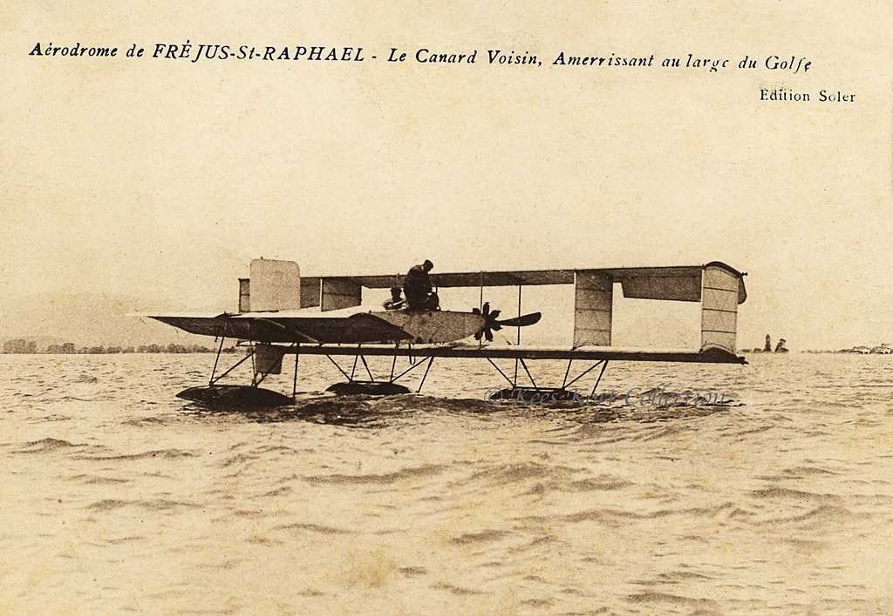
Figure i: The Canard Voisin waterplane in Fréjus Saint-Raphaël, France (1911-1912) (Kees Kort collection, 2016).
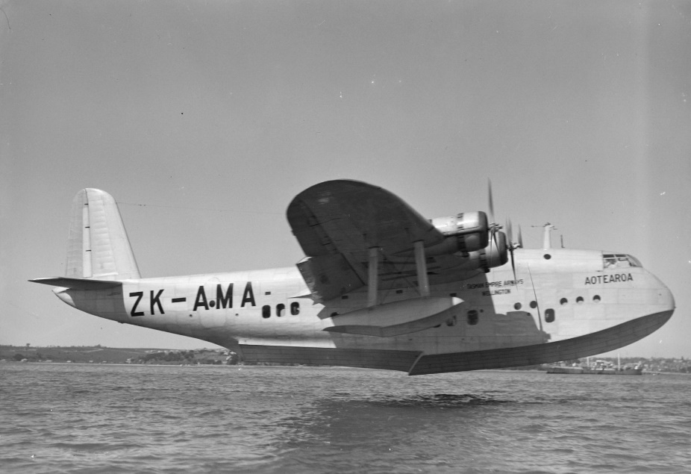
Figure i: The Short S-23 Empire waterplane Bristol, UK (1935). (V&A archives, 2020).

Historical data for Greece
As far as the Hellenic region is concerned, the waterplane as a means of transport made its first appearance in the 1930s. and was a very important means of transportation within the country (Fig.iii-iv). A few years later, however, World War II not only halted their development, but also contributed to the disappearance of the transport service provided by waterplanes until then (ref). Despite several occasional efforts by various operators for their return, waterplanes have stopped flying for over 70 years and there hasn’t been any significant step until the beginning of this century.
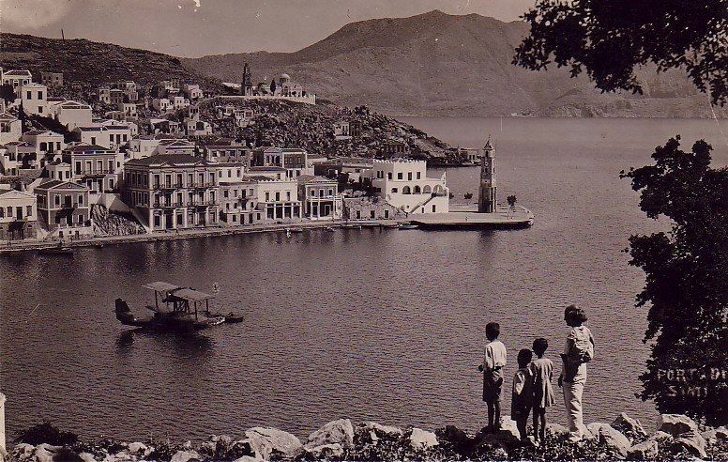
Figure iii: Children watching a waterplane in the port of Symi, Greece (1930) (Pinterest, 2021).
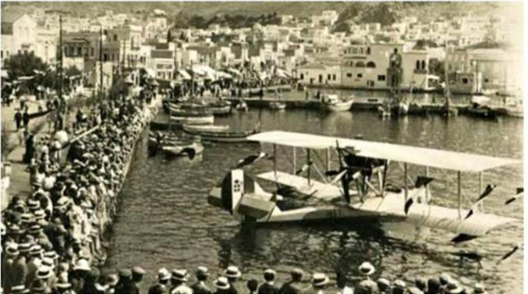
Figure iii: People gathering to see a waterplane in the port of Kalymnos, Greece (1930) (Kyrannis archive, 2020).
In 2004, Air Sea Lines airlines, based in Corfu, resumed waterplane flights, having secured operating permits and building ten waterdromes in the Ionian islands (ref).
In April 2013, arrangements for the establishment, operation and exploitation of airports on water surfaces were included in the updated Investment Law (4146/2013 Articles 32-57). The path towards private investment in Greek waterdromes opens shortly afterwards, in April 2014, after the completion of the public bid for the construction of a waterway within the port of Skyros (island in the North Aegean). Eight months later, in December 2014, the first waterdrome in Greece was completed in the port area of Corfu, the birthplace of the Greek waterdromes (ref). Since then, many maritime areas of islands have been under consideration for licensing, marking a new era for the waterplanes of Greece (Vidalis, 2015). It has to be noted that one of the main problems towards such an investment is the bureaucracy and obstructions on behalf of the government services. In any case, in 2020 the waterdromes bill has been passed with the aim of creating a dense waterplane transport network in Greece, for recreational and commercial purposes (ref).

Greek legislative framework
As mentioned before, the regulations around the licensing of waterdromes and the operation of waterplanes in Greece has been rather cloudy until 2018. According to the law 4568/2018, the purpose of which is to define the licensing framework for the establishment, operation and exploitation of watercourses, the landscape of the market began to unravel. In more detail, this law describes (ref):
- the procedural steps for the approval of the licencing application.
- The technical & environmental report to be submitted.
- The obligations of the waterway operator.
- The prohibitions and restrictions in force with regards to the other means of transport.
- The inspections provision and procedures for the control of waterdromes.
- The specific rules applicable for takeoff and landing in water fields.
In order for the successful implementation and design of waterdromes and waterplane journeys, supplementary joint agreements should have been issued by the ministries involved, to shorten the procedures. Unfortunately, this was not adopted until 2020, when a new supplementary regulation was introduced (ref). According to the Ministry of Infrastructure and Transport, the promotion of this legislation on watercourses regulates the procedures relating to their establishment and operation by simplifying the individual procedures.

Blue ocean Strategy Concept
Part of the creation of new markets is the concept of 'blue ocean strategy'. According to a report by Chan and Mauborgne (2005), the Blue Ocean Strategy aims to create new opportunities where competition is virtually non-existent. They refer to the existing market, or part of it, as an ocean full of sharks who fight to win a competitive advantage and have turned the ocean bloody red. Therefore, the one who will stand out is anyone who can spot a ‘blue’ piece of ocean, where there are no competitors yet. In financial terms, an entrepreneur should focus in investing in a market sector or even create a new one, which is not yet saturated. In Greece, one opportunity for a new market with zero competition for the time being is that of waterplanes.

The contribution of waterplane in the Greek tourist industry and the local community
Tourism is an important socio-economic phenomenon especially nowadays where its development is directly linked to the development of transport, resulting in the ongoing increased and improved investment strategies in transport infrastructure (ref). The element of a safe, fast and affordable travel to a destination are important parameters for attracting tourists. In particular air transport plays an important role in holiday planning due its speed and comfort that offers (Quanta et. al., 2016).
Greece is heavily dependent in tourism; both domestic and international. AEP However, for islandic population and tourists, living or visiting isolated destinations, it may take two or even three routes until they reach their final destination. Access to these destinations is usually via regional airports with limited possibilities and flight frequency, or by a waterway, where weather conditions can be difficult and the boat trips can be long and time-consuming (ref). In fact, the majority of Greek islands are not equipped with a terrestrial airport (Ballis et al, 2018). Therefore, the waterplane would function as a great alternative to the existing means which especially in regions where either connection by boat is long or rare, and where airports are non-existent.
Waterplanes are considered a relatively safe means of transport, as it covers short distances at low altitudes, and are preferred by people with high living standards for its convenience, privacy and continued availability (ref). In addition, several social groups such as the elderly and people with chronic health problems usually opt for a destination based on their accessibility and proximity to medical care units (ref). The waterplanes can eliminate these concerns, since they can deviate from the specific routes and cutoff travel time, which is not possible by the conventional means of especially in remote destinations. Waterplanes will also play a key role in the health sector with patient airlifts and the growing health tourism (ref).
Thus the disadvantage of limited accessibility of several Greek island/ coastal destinations can be transformed into an advantage with the implementation of waterplanes. More age groups of tourists and others will have access to these islands, and this will work for the benefit of local communities.
In addition to their positive contribution towards touristic development, the possibility of having an alternative means of transport has a positive impact on the daily lives of the islandic population as well. Waterplane passenger transportation meets the needs of such areas by connecting the entire coastline and islands throughout the year and thus improving their quality of life.
Moreover, waterplanes are also considered more environmentally friendly than ships or airplanes (ref). The only requirements, apart from the natural water ‘runway’, are the construction of a floating bridge or pier, which provides passenger access. The choice of a site for the construction of a waterdrome depends on the ecological surrounding system. So, it is necessary to identify the positive and / or negative effects that may occur temporarily or permanently and affect the environment. The impact of waterways on the air quality of nearby residential areas depends on the number of waterplanes arriving at the port. In detail, the main sources of emissions in the waterplane port area are:
• The gases produced by the combustion of fuel in seaplane engines.
• The gases released into the atmosphere during refueling.
• Emissions from motor vehicles used to transport passengers, workers and visitors to the port.
The urgent need to introduce the waterplanes in Greece also stems from the fact that the introduction of waterplanes indirectly encourages the revitalization of local areas, especially the islands. A supportive policy planning framework from national to local level can help unleash the potential contribution and value of waterways to the economic, social and environmental well-being of regions, communities and individuals, together with the protection of these valuable assets. It is vital, therefore, to support a policy that recognizes the multifunctional nature of waterways and their contribution to the broader financial, environmental and social objectives, such as public health, sustainable development and enhancing resilience.

Existing Greek market
There is an significant level of interest in the waterplane market for the entrance of investors, as it was expected that by the summer of 2021 the first 30 waterways in various parts of the country will be ready for delivery and operation (ref). Unfortunately, this prediction was not confirmed, due to the CoViD-19 pandemic and the anticipation has been carried over for the summer of 2022. The Canadian ‘HarbourAir’, the TransMalvidian of Blackrock and 2 Greek businessmen (Airwaves, Hellenic Seaplanes), are the first to be prepared, to make the waterplane trips in Greece a reality (M. Protonotariou, 2019, www.mononews .gr). The waterplanes will start flying from Corfu, an ideal starting point due to the great tourist mobility to and from the island. Currently, 8 waterways are being prepared in the Ionian Sea to accommodate these trips. In the summer of 2022, the following waterways are expected to operate (www.naftemporiki.gr/story/1525633/gkazi-gia-tis-adeies-ton-udatodromion).:
• Aegean Sea: 8 waterways in Kalymnos, Leros, Lipsi, Syros, Paros, Naxos, Milos and Amorgos.
• Ionian Sea: 5 + 3 in Kefalonia, Ithaca, Lefkada, Zakynthos and Meganisi and Corfu, Paxos and Patras.
• Evia region: Kymi, Karystos, Edipsos, Chalkida.
• Sporades: Skopelos, Alonissos, Skyros, Skiathos, Volos.
• Future waterdromes to operate: Loutraki, Patmos, Tinos, Elefsina, Amfilochia, Sitia, Kalamata, Kamena Vourla.
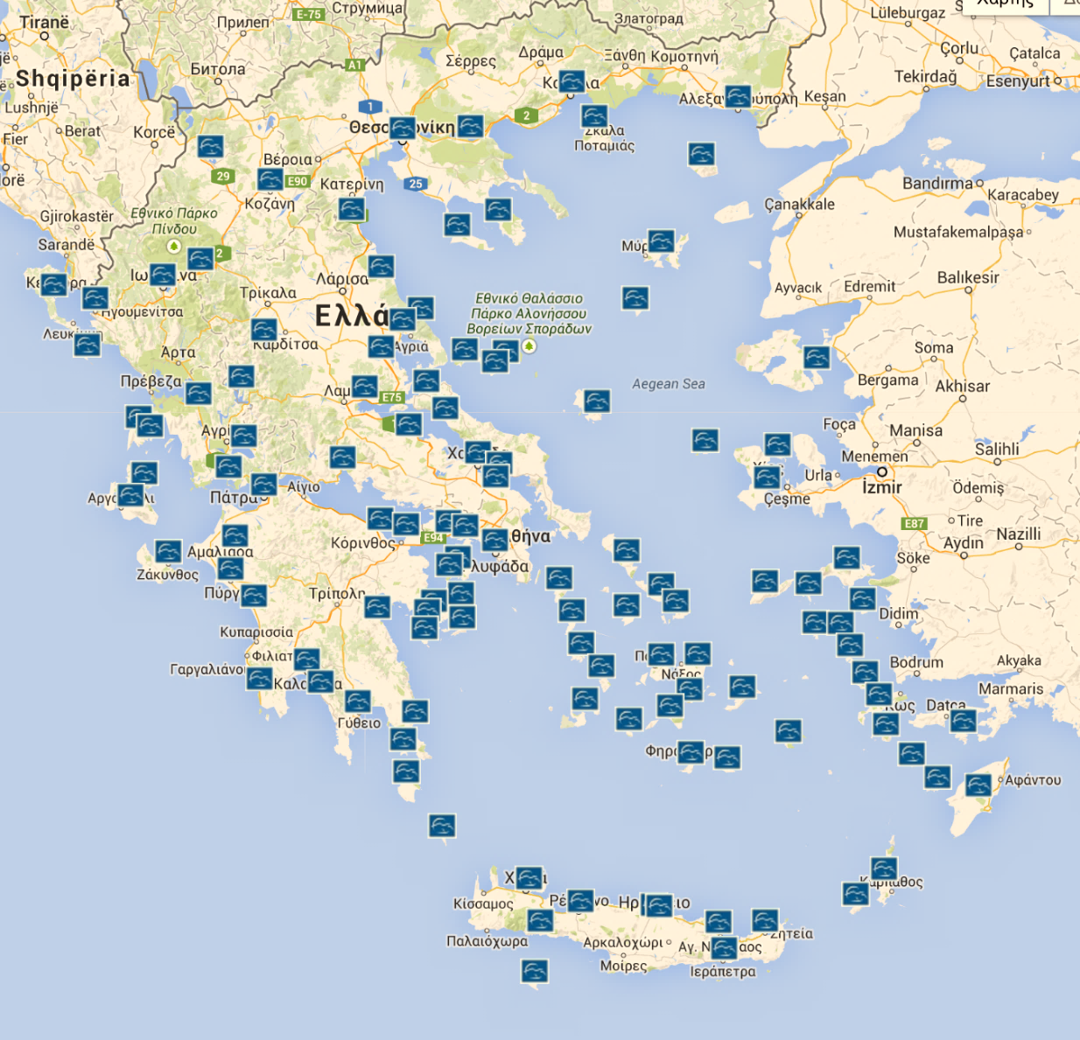
Figure iii: The waterdrome grid licenced or under consideration in the Hellenic region (ref).

The drawbacks of seaplanes
Despite the many advantages that the use of waterplanes present, there are several some disadvantages that could not be ignored, especially when a business plan is to be designed. First of all, the waterplane operation is expensive (ref). The increased maintenance and operation costs may limit the attractiveness of the investment. Indeed, small aircrafts are already expensive per passenger compared to cars or large aircrafts. On the other hand, waterplanes have additional operating costs: the floats themselves cost about 40% of the aircraft price and metal sheet damage is common. The latter is caused by things like sunken rocks, docks and waves from passing boats and accidents are mostly unavoidable due to the fact that waterplanes are meant to land in environments not easily controlled (ref).
Moreover, waterplanes suffer from severe saltwater erosion and fuel costs, due to greater traction. Also, waterplanes lack large passenger capacity. A waterplane has a few hundred pounds less payload than the aircraft version of the same type, due to the weight of the floats that have to be removed from the maximum total weight. It has to be noted that since any airplane trip involves time to travel to and from the airport, any waterplane less than 100-200 miles (160-320 km) takes more than a car ride (ref).
In addition, a major problem is the highly corrosive marine environment, affecting metal surfaces and requiring extensive maintenance processes on both the boat structure and the engine. For this reason, despite the special anti-corrosion protection that is applied at a regular basis, corrosion problems reduce the time limit of life and operation of the various individual systems. Another important disadvantage of waterplanes is the inability of landing on a water surface after sunset (under the current regulations) (ref).

The use (statistics) of questionnaires (capacity, type, time, cost)
Waterplanes have been operating for 100 years outside Greece. This indicates that in some countries there is not only the knowledge of the management and operation of waterplanes, but also a high level of technical expertise.
The literature review found a list of more than 350 operators and companies that focus in the field of waterplane trips. As seen in Figure i, the largest number of waterplane operators globally is located in the USA, with 80% located in North America overall. This highlights that Europe hasn’t exploited its full potential in this field, regardless of its extensive coastline and islandic regions.

Figure i: Waterplane operators’ global distribution (adapted from Mohr, 2010).
Another informative survey in the field was conducted by Denz (2007) and involved 1,200 waterplane pilots (professional and non-professional) from countries where this industry operates. Participants were primarily asked about the service background they usually offer (Figure ii). It was evident that the majority of waterplane flights were commercial and charter flights.

Figure ii: Type of waterplane services offered by the pilots (adapted from Mohr, 2010).
The survey participants were also asked about the occupancy rate of the participating flights (Figure iii), as well as the number of flights they operated per year (Figure iv). The average flight occupancy with any aircraft is 75%, while on the waterplane based on the above data seems to be 79%. However, conclusions from the number of flights cannot be withdrawn, as some non-professional pilots make 40 flights a year, while some professionals make 1200 flights a year.

Figure iii: Occupancy rate of waterplanes (adapted from Mohr, 2010).

Figure iv: Average number of waterplane flights per year (adapted from Mohr, 2010).
In addition, the average flight time and distance were also included in the survey. The longest flight distances are performed by clubs and training flights, while the average distance for commercial flights is between 30 and 70 nautical miles (Figure v). Similar observations apply to flight times, i.e. short times are performed by commercial flights, while long times, over 1 hour, are performed by aeroclubs (Figure vi).

Figure v: Average waterplane flight time (adapted from Mohr, 2010).

Figure vi: Average waterplane flight range (adapted from Mohr, 2010).
Finally, the respondents were asked about the type of connection between the three types of waterplane flights, ie from water to water, from land to water, and from land to land. In this case, 81% of the flights are performed from water to water.

Chapter 3. Methodology
Since this thesis aims to be a comprehensive plan of the waterplane business in the Hellenic region, both qualitative and quantitative methods where implemented (Saunders, Lewis and Thornhill, 2006). For the writing of the literature review, business plan, and financial assessment research papers, case studies, scientific articles, books from the international/national literature, and results of previous questionnaires were used. Furthermore, for the research gaps that arose it was decided to collect raw data from a variety of people through a designed questionnaire and specialized focus groups. The data obtained from the questionnaires and interviews, assisted in simplifying the assumptions and the unknown but necessary parameters of the waterplane topic. To the authors knowledge the findings of this research are unknown and the feasibility of such a project is yet to be found.
Questionnaire
The questionnaire, the results/graphs of which are presented in chapter 6, aims to capture as much as possible the trend and highlight the choices from a total of ?? people who were asked about waterplane issues. The aim was to obtain information on whether the respondents would choose the waterplane as a means of transport, what are their preferences for the destinations, the flight reasons, the money they would spend for such a transport, etc.
The plan was to distribute the questionnaire, via Google forms to a statistically homogenous sample of ? male and female adults, between 18 to 108 years old people from a variety of cultural backgrounds, to have the best possible sample and more representative conclusions.
The type of questions to be posed are primarily demographic, list and category questions (Davies and Hughes, 2007). The data collections will result in an informative database that will be further analysed with the statistical software package of SPSS (Field, 2013). The data analysis will hopefully give us important insight on the target groups that maybe interested and will support such a business. It will also provide valuable information on the business aspects that may deter customers, and therefore to design the business investment in a proactive way.
The actual questionnaire can be found in Appendix A and filled online in the following link: https://docs.google.com/forms/d/e/1FAIpQLSe4qiaEQWXqiKdDNCvU4ZLubVAUjTBLWiqmvklQRGIDgOZfUw/viewform?usp=sf_link
Focus Groups
the data collection went even further with the organising of think tank sessions with people that have experience in the aviation and tourism sector, which functioned as catalysts for the holistic approach of recommendations.
The interviews conducted provided information that could not be found in literature, since the respondents answered based on their personal experience and depending on their specialty.
The first interview was conducted with Ms. Pappas, former director of EOT, who explained the visitor statistics, but also the need of a multiple analysis in the selection of the best waterport location per zone of influence.
The second interview was with Mr. Giannis Bras, CEO of Five Senses Consulting, who discusses the restrictions that have prevented the operation of waterways to date and the changes that need to be made in the legal framework.
Finally, the third interview was given by Mr. Govas, director of the company ‘Hellenic Seaways’, who gave all the business, financial, technical information about the waterports and analysed the strategy of his company.
Ethical Approach
The answers that will be given, through the questionnaire and interviews, for the analysis of the data will be used only for the needs of the elaboration of this specific work. The data will remain strictly confidential and private. There will be absolute confidentiality regarding any sensitive information or data that will come to my knowledge in the context of people participation in the above process. Participants will have the opportunity to withdraw their questionnaire/ sessions at any time. I will finally make sure not to disclose the gathered information to third parties without the subject’s prior written permission. For ethical purposes, minors will be excluded from this procedure.

Chapter 4. Business Plan

Chapter 5. Financial Analysis
The main income of any commercial airline and subsequently for one that operates in the field of waterplanes, is the ticket fare. Therefore, a financial assessment needs to be conducted in order to investigate the potential profitability and viability of the venture. The initial steps towards this assessment is to define the variables; the factors by which ticket fares will be determined. These are:
i. the cost of fuel,
ii. the fuel consumption of the aircraft,
iii. the cost of salaries,
iv. the cost of the waterport fees,
v. the cost of maintenance,
vi. the cost of tax,
vii. the aircraft seat capacity,
viii. the cost of repaying the loan for the acquisition of the waterplane or the cost of leasing,
ix. season of activity,
Based on the above variables, the equation of the flight cost is as follows:
Cost = Fare Tax × [$\frac{t}{60}$ × (Fuel + Payroll + Leasing) + Waterport Cost] (4.1)
The cost of the fare tax is the tax imposed by the government on the fares of each flight. It is equal to the tax fare of the waterport per flight and will be symbolized with "T", where: T = (100 + VAT)% (4.2)
The cost of fuel is considered the cost of fuel consumption per hour of the selected seaplane, which depends on the type and weight. This will be symbolized with P.
The cost of payroll is essentially the cost of the wages offered to the two pilots of the waterplane symbolized with S.
The cost of leasing is the overall cost per flight hour and is divided into cost per flight hour and mechanical maintenance costs per flight hour. A company could opt to repay a mortgage by buying a waterplane, but it seems more advantageous to start by renting it from first. This overall cost will be denoted by R, whereas R1 and R2 will be the flight and maintenance costs, respectively. So, in more detail : R = R1 + R2 (4.3)
Leasing companies choose to provide mechanical maintenance services themselves for two reasons; Primarily to increase their income and secondly to supervise the proper maintenance of the aircraft.
The cost of the waterport is the amount paid by airlines for landing, mooring, and using the waterway’s facilities. This cost will be denoted by Kw. The cost of landing depends on the MTOW, ie the maximum offshore weight of the waterplane. This is defined by each seaplane manufacturer based on the following (Minas K. Pagonakis, 2016):
• MTOW ≤ 5.7 tons € 5.00 to € 10.00 per landing.
• MTOW> 5.7 tons € 10.00 to € 15.00 per landing.
The cost of mooring is calculated in a similar way:
• MTOW ≤ 5.7 tons € 0.20 to € 0.40 per mooring.
• MTOW> 5.7 tons € 0.40 to € 0.60 per mooring.
The cost for using the rest of the waterport facilities depends on the provision of basic flight services, i.e. waterplane guidance, anchoring, means of boarding and disembarkation, luggage loading/ unloading, ticket control, etc.
However, the cost of the flight, as mentioned before, also depends on the fullness or not of the seats. By sufficient occupancy we mean the number of positions where we achieve:
Revenue - Expenses = 0 (4.4).
Έστω m ο μέγιστος αριθμός των επιβατών ενός υδροπλάνου και B₀ ο αριθμός που απαιτείται για να επιτευχθεί το σημείο ισορροπίας. Ποσοστιαία λοιπόν θα έχουμε ότι η πληρότητα που απαιτείται θα είναι:
Namely, the number of positions by which an equilibrium point (0) will be reached. If m is the maximum waterplane passenger capacity and B₀ the number required to reach the equilibrium point, then the required occupancy will be:
B = $\frac{B_{0}}{m}$ B₀ = B × m (4.5)
Time is defined as the flight distance in relation with its speed:
t = $s/u$ (4.6), where s (km) is the distance and u (km / h) is the velocity.
So, by referring to the overall cost as K, equation 4.1 becomes:
4.1 K = T • [$\frac{t}{60}$ • (P + S + R₁ + R₂) + K_{w}] (4.7) or
K = (100 + VAT) % • [$\frac{t}{60}$ • (P + S + R₁ + R₂) + K_{w}] (4.8)
Διαιρώντας την εξίσωση 4.8 με το B₀, το οποίο είναι οι θέσεις του κρίσιμου σημείου θα έχουμε την συνάρτηση του κόστους του εισιτηρίου. Το κόστος του εισιτηρίου θα το συμβολίζουμε με K_{F}. Επομένως θα έχουμε:
When dividing equation 4.8 by B₀, which is the critical point occupancy, then we will come up with the minimum ticket cost. The cost of the ticket will be denoted with K_{F}. Therefore, we will have:
K_{F =} $K/{B_{0}}$ (4.9)
Once we have defined our equations and before proceeding into the actual calculation of the flight cost and fare, several assumptions need to be considered;
Some other parameters that may affect the actual cost such as seasonality, unforeseen costs (breakdown, company operating costs, etc) and other types of funding were not taken into account. Therefore, the results are indicative of how much is the minimum of the fare cost so that this venture is viable. But in addition to the cost of the flight and the ticket, the company has to think about other costs and challenges that will have to face like weather conditions, delays, cancelling of the flights, etc. It should be considered how these conditions can affect its activity both in time and cost.
To date, there are multiple types of waterplanes that present different characteristics. For the purposes of this thesis, Dornier Seastar CD2 was selected, due to its variable technological superiority and matching with the needs of Hellenic geography (ref) REF. It is characterised as the most advanced amphibious aircraft and its maximum velocity of Dornier Seastar CD2 is u = 333 km/h (ref company).
The financing method that was selected was through leasing instead of a mortgage or private capital. Therefore, the overall cost includes the leasing expenses. For a waterplane of this type the operating costs are approximately $300 and the maintenance costs are $90 per flight/hour (Wings, 2010; Vikings Air Ltd, 2021). The sum is $390 = £282 per flight hour. For comparison, a conventional aircraft of the same type and occupancy, Cessna 208 Caravan, presents a cost of £422.40 per hour.
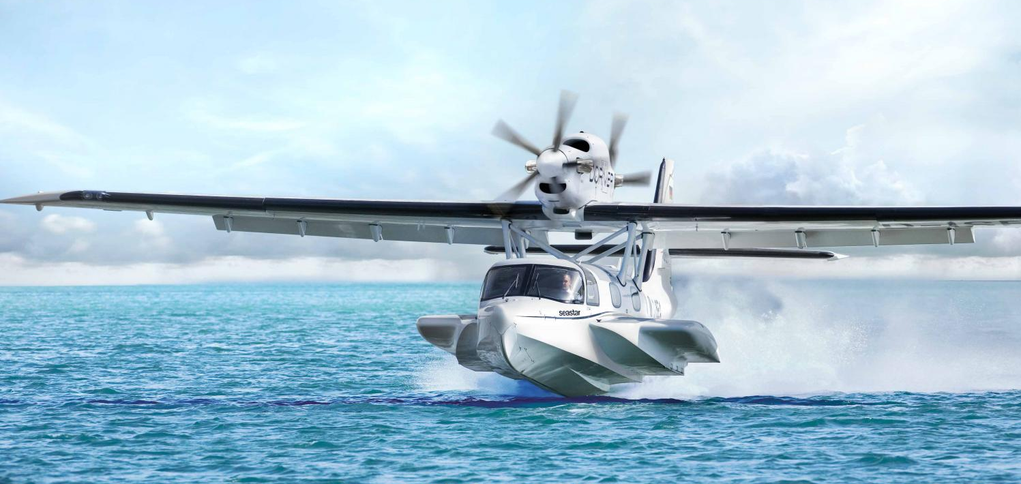
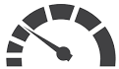 | 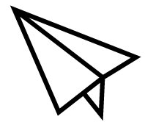 |  |  |  | 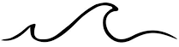
Max Cruise Speed | Max Range | Max Passengers | Max Take-off Weight | T&L distance | Wave Height
333 km/ h | 900 NM | 12 PAX | 5100 kg | 684 m | 0.6 m

From the company’s specification of the waterplane, the Seastar fuel consumption is 380 litre per hour (Avron, 2010). The fuel used in this type of aircraft is kerosene, which as of July 2021 costs $0.80 per litre (£0.58 /L). Therefore, the total fuel cost per flight hour 380 • 0.58 = £220.4.
Every aviation trip is equipped with two trained pilots (captain and first officer) of this specific type of waterplane. It is assumed that the average pilot’s salary will be £2.100 per month. If they work a shift of 8 hours per day, their flight hours are approximately 5. If we add to the assumption that they work 20 days a month then
S = $\left(\frac{2100}{20 × 5}\right)×2$ S = £42 per flight hour for both pilots.
According to article 18 of Greek law (4663/2020), the waterport operator shall determine the tariffs for the services provided for aircraft and passenger services. In addition, article 19 of the above states that ‘For each passenger departing from the waterport, the aircraft company operating the flights shall pay a fee in favor of the Greek State equal to five percent (5%) of the net fare corresponding to a specific itinerary (Greek Parliament, 2020).
If we assume that the average price of the waterport fees is €100 then we will have that K_{w} = £80.00.
After the VAT is applied (5%) we will have T = 105 %. Now if we substitute all the above calculated numbers equation 4.7 becomes:
Fee VAT | T | 105%
Fuel consumption | P | £220.4
Pilot salary | S | £42
Operation cost | R₁ | £217
Maintenance cost | R₂ | £65
Waterport expenses | K_{w} | £80

Therefore
K = T • [$\frac{t}{60}$ • (P + S + R₁ + R₂) + K_{w}]
K = 105% • [$\frac{t}{60}$ • (220.4 + 42 + 217 + 65) + 80]
- K = 1.05 • [$\frac{t}{60}$ • (544.4) + 80]
- K = 1.05 • (9.07 • t + 80) K = 9.53 t + 84 (equation 4.10)
The above equation represents the cost equation of the flight of a waterplane as a function of time. Dividing the above equation by the perspective passengers of a flight we have:
K_{F =} $K/{B_{0}}$ K_{F =} ${9.53 t + 84}/{B_{0}}$ (equation 4.11)
Scenario No. 1
In the ideal scenario, the waterplane flies in full capacity, meaning that all 12 seats are occupied. So, with the following calculations from equations 4.5, 4.6, 4.11 we will determine the breakeven point for the ticket fare. In this point the expenses are equal with the revenue. From that point onwards the company will start to record gains according to the final ticket fare. The aircraft flies at a cruise speed of 333km/h and a stall speed of 120km/h, therefore we calculated and use the average of the two as a reference (226 km/h). The range of the aircraft is 150 NM (277.8 km) thus the flight distance ranges from 20–260 km.
S | u | t | B₀ | K_{F}
[km] | [km/h] | [min] | [seats] | [£]
20 | 226 | 5.3 | 12 | 11.2
40 | 226 | 10.6 | 12 | 15.4
60 | 226 | 15.9 | 12 | 19.7
80 | 226 | 21.2 | 12 | 23.9
100 | 226 | 26.5 | 12 | 28.1
120 | 226 | 31.9 | 12 | 32.3
140 | 226 | 37.2 | 12 | 36.5
160 | 226 | 42.5 | 12 | 40.7
180 | 226 | 47.8 | 12 | 45.0
200 | 226 | 53.1 | 12 | 49.2
220 | 226 | 58.4 | 12 | 53.4
240 | 226 | 63.7 | 12 | 57.6
260 | 226 | 69.0 | 12 | 61.8
From the table it can be observed that the selected waterplane has a variety of travel times from 5 to 70 minutes according to the distance. Whereas the ticket fare has a minimum of £11 to £62. From figure v the majority waterplane flights are between 15-30 minutes. In the specific waterplane such a trip will cost £20-30.
Scenario No. 2
However, the reality is far away from the ideal scenario, so that leads to another case. As mentioned in the literature review (ref- figure iii Mohr) the majority of the waterplane flights (43%) run with an occupancy of 75–80%. For this reason, the initial assessment will be done according to this hypothesis, to investigate the cost of ticket to breakeven (equation 4.4).
S | u | t | B₀ | K_{F}
[km] | [km/h] | [min] | [seats] | [£]
20 | 226 | 5.3 | 9 | 15.0
40 | 226 | 10.6 | 9 | 20.6
60 | 226 | 15.9 | 9 | 26.2
80 | 226 | 21.2 | 9 | 31.8
100 | 226 | 26.5 | 9 | 37.4
120 | 226 | 31.9 | 9 | 43.1
140 | 226 | 37.2 | 9 | 48.7
160 | 226 | 42.5 | 9 | 54.3
180 | 226 | 47.8 | 9 | 59.9
200 | 226 | 53.1 | 9 | 65.6
220 | 226 | 58.4 | 9 | 71.2
240 | 226 | 63.7 | 9 | 76.8
260 | 226 | 69.0 | 9 | 82.4

From the table it can be mentioned that with the occupancy of 9 seats the minimum cost of the ticket is increased significantly. Namely, for the same distances the ticket fare has a minimum of £15 to a maximum of £83. From 100% occupancy to 75% in a flight, the ticket fare increases by 25%. A trip between 15-30 minutes will now cost £26-37.

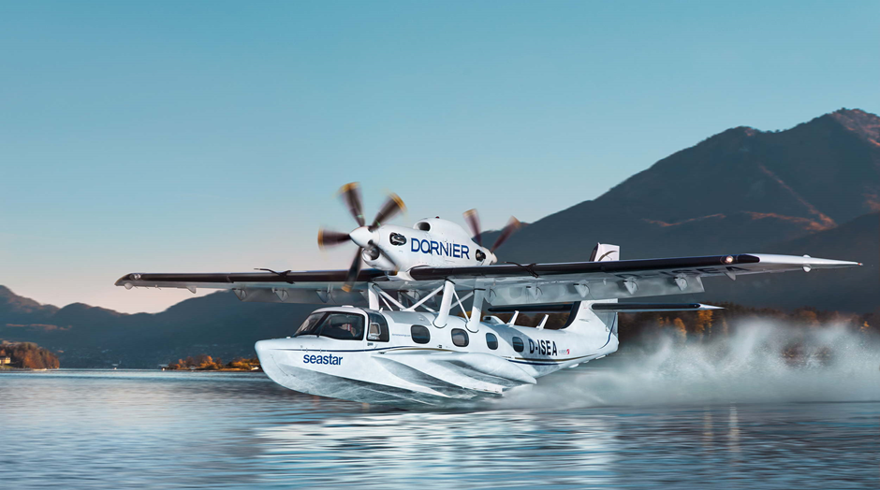
Taking as an example companies already operating in other countries Harbor Air in Canada for a 120 km flight charges £90 ($125.00), Air Malta in Malta for half day excursions charges approximately £100, while in Alaska ‘Alaskan seaplanes’ for a route of 35 km, they charge approximately £40. All these business are running successfully for a long time and report profits (AirMalta, 2021; Alaskan Seaplane, 2021; Harbour Air Seaplanes, 2021).

5.1 Waterplane versus airplane/ ferry/ bus/ car

To examine whether the waterplane will be a potentially sustainable investment both financially and as an alternative to the existing transportation means, an example will be utilised of a passenger travelling to Skiathos. Skiathos is an island of the Sporades archipelago, which in a straight line is located 135 km from Athens (VA, 2021). If we suppose that a resident of Athens wants to go to the island of Skiathos can do so by several options.
Option 1 (with own car)
If we assume that they have a car, the first option is to drive from Athens to Agios Konstantinos, Fthiotida, with a distance of 190 kilometres and a duration of 2 hours and ten minutes (VA, 2021). From there they will take the ferry to the port of Skiathos with a cruising duration of about 4 hours. The cost for this option is:
• Fuel cost = £19.3 (with an average price of petrol of £1.36 per litre and fuel consumption of about 14.2 liters).
• Toll cost = £12.
• Cost of ferry ticket (Agios Konstantinos to Skiathos) = £26.
The total cost of the trip is £57.3, and the total travel time is 6h and 10min.
Option 2 (by bus)
If the passenger does not have their own car. Then the second option is to get the coach from Athens to Agios Konstantinos, Fthiotida, a distance of 190 km and duration 3 hours and then embark on the ferry to Skiathos with duration 4 hours (Direct Ferries, 2021; KTEL, 2021). The cost in this case will be:
• KTEL ticket cost = £12.
• Ship ticket cost = £26.
• Other transportation costs to the coach station = £2-10.
The total cost will be £ 40-48 and last almost 7 hours. Much cheaper than the first option, but more time consuming.
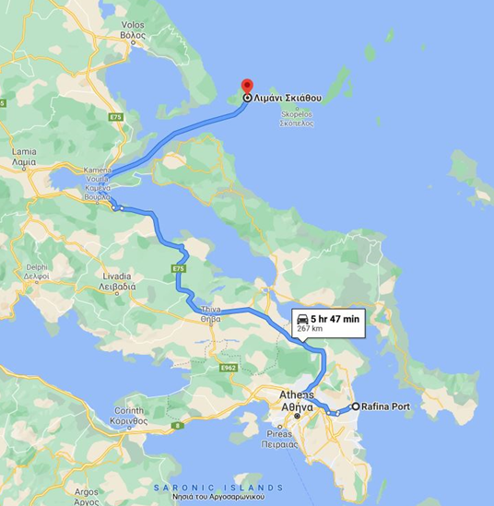
Fig*: Route by land & sea Athens-Skiathos
Option 3 (by airplane)
The third option is to fly to Skiathos Airport from Athens International Airport with Aegean Airlines with an average ticket fare of around £70 and a flight duration of 40 minutes (Aegean Airlines, 2021). We should also include the cost of transportation to Athens airport, which is £10 by tube and £30 by taxi, and take 40 minutes from the city center (Booking, 2021). The total cost of the trip is a minimum of £90 and does not exceed two hours.
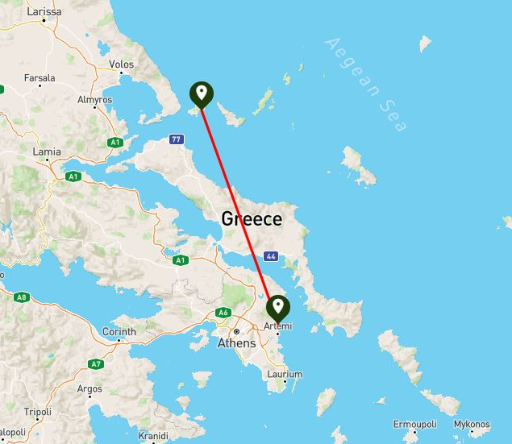
Fig*: Route by air Athens-Skiathos
Option 4 ( by waterplane)
The fourth option could potentially be the transportation to Skiathos via the waterplane. As a starting point the projected waterport has been selected in the port of Piraeus, which will be formed as an extension of the Athenian Riviera. The trip from the center of Athens to the port of Piraeus will be done either by public transport (local bus, subway) or by taxi.The cost will be between £2-10 with an average trip time of 30 minutes.
Below we will evaluate the ticket prices for this option and the duration of the trip based on the two scenarios analyzed above in relation to occupancy, scenario No1 and No2. In both scenarios the waterplane trip duration will be 40 minutes and another 30 minutes to reach the waterport, in total 70 minutes.
Occupancy 100%: The ticket price for a 135 km route corresponds to a base rate of £36.5 (table100%). Meaning that this should be the minimum ticket price for the company to break even.
Occupancy 75%: The ticket price for a 135 km route corresponds to a base price of £ 48.7 (table75%). If the company wishes to have some profit, then the ticket fare should be higher than the above price.
By the evaluation of all the options, the summarized costs and trip duration of the each trip can be found below:
Table* 1: Cost and duration of all means of transportation from Athens to Skiathos.
135 km | Duration [min] | Means of Transportation [£] |  |  |  |  |  | Total Cost [£]
135 km | Duration [min] | Car | Bus | Airplane | Ferry | Other | Waterplane | Total Cost [£]
Option 1 | 370 | 31.3 | - | - | 26 | - | - | 57.3
Option 2 | 420 | - | 12 | - | 26 | 2-10 | - | 40-48
Option 3 | 80 | - | - | 70 | - | 10-30 | - | 80-100
Option 4 | 70 | - | - | - | - | 2-10 | 36.5 (100%)  48.7 (75%) | > 38.5-46.5 (100%)  > 50.7-58.7 (75%)

From our example of a passenger travelling from Athens to Skiathos, it is observed that the most economical option is the coach (2), with a total cost of £40-48 and the most time consuming trip with a total travel time of 7 hours. The shortest trip is by seaplane and plane, where the whole trip will take 1 hour and 20 minutes. The net flight time of both the airplane and the waterplane is 40 minutes. Of these two, the plane is the most expensive, about twice as expensive as the bus/ car and ship. The price of the waterplane is not far from the price of the car and takes five times less time.
In other words, it is proved that the waterplane is a potentially beneficial solution for consumers and a significant competitor for existing means of transport.

Chapter 6. Questionnaire Discussion
The thesis questionnaire (Appendix A) was sent to 100 people from which no?? replied with their answers. From this amount of people 50% were male and the other 50% were female respondents. The age range was from 18 to 65 plus, with the largest part of respondents representing the ages of 36-50 years old (..%) followed by 26-35 years old (..%). It has to be noted that only one respondent belonged in the age group 18-25, hence this sample cannot be regarded as representative. ...% of the respondents have completed university degrees, ...% have graduated from high school, and there is also a small percentage that have obtained a doctorate (..%). The most common type of traveler from an array of 5 options was the family one (..%), followed by couples (..%) and solo travelers (..%). In this case, the answers given cover all the traveler type options, thus the picture is complete.
Να βάλουμε τα demographic figures
From the questionnaire analysis it was observed that the majority of participants are usually travelling during the summer (..%), and to a leaser extend in autumn (..%), spring (..%) and winter (..%). There is also a large percentage of those that said that they are travelling all year around.
The waterplane is not a widespread means of transport neither in Europe nor in Greece, and therefore this is noticed with the fact that only 3 participants have actually travelled with the waterplane. From them one has responded that they want to do it again and the other two answered maybe. On the other hand there is great enthusiasm from those that they had never tried a waterplane: (..%) are looking forward to travel by a waterplane, whereas (..%) are skeptical. Only one was negative and explained that the main reason behind this is that he feels that waterplanes will increase noise pollution and destroy remote areas. The idea of travelling with waterplanes seems exciting for more than half of the responded and a minor percentage (..%) would only use it if it was necessary.
There are no significant variations between the numbers that preferred waterplane trips with duration of 15-30 minutes, 30-60 min, and >60 min. In fact, it was surprising that almost 1/3 of the people feel comfortable with the trips over an hour in so small aircrafts. In any case the majority (..%) would opt for waterplane trips 30-60 min.
From figure ..? it can be seen that overall the participants do not wish to spend more than €100 for a waterplane trip of 40 min with the majority willing to pay something between €50-100 (..%). In more detail there is another percentage that will not pay more than €50 (..%). From the statistical analysis (ρ=0.024), the older the respondent the more money are willing to spend in a waterplane fare. This is probably associated with the fact that people from older generations travel on a higher budget.
It was expected that the primary reason that the participant would take a waterplane is for vacation or other transfer by ..%. Another interesting percentage is that of people using the waterplane for tours at ..%. To a lesser extent people will use it for goods transfer (..%), emergencies (..%) or any other (..%).
In the question of preference between waterplane and ship given that the waterplane is 2 times more expensive but faster 4 times than the ship less than half of respondents would clearly prefer the waterplane (..%). The alternative of the ship is a strong competitor against the waterplane since ..% prefers or ..% is likely to prefer this option. Another interesting statistical finding is from the comparison between the answers given and gender, where from those that would not exchange the ship with the waterplane 80% are women.
On the other hand, when the bus become the alternative, the trend is much more conclusive. Only ..% would clearly preferred the bus instead of the waterplane given that the last is 3 times more expensive and 5 times faster. The percentage is significantly high with those that they would opt for waterplane (..%). This is a clear tendency that the travel duration is an important factor when choosing a means of transportation.
It is not worthy that the majority of the responded combine feel either safe (..%) or extremely safe (..%). However it has to be noted that ..% feel somewhat safe or not safe at all (..%). This indicates that the element of safety of waterplanes should not be disregarded and it should be further supported with campaigns that waterplane is a safe means of transfer.
In the last question of the survey there are a variety of possibly answers with regards to the deterring factors for not using a waterplane. The majority of respondents are worried about the cost of the ticket (..%) followed by those that equally (..%) share the same concerns over safety and convenience. Other main reasons include luck of availability (..%), weather (..%) and time (..%).
From the statistical analysis its seems that the elements of safety and the cost of tickets are the main factors to deter waterplane users of the age groups 26-35 and 35-50. Since these groups are the dominant age base of consumers then it is highlighted that the company policies should focus on these two variables.
All the questions posed compared against the demographics to extract even more information and tendencies. However, in the majority of the comparisons the Pearson factor (ρ) was greater than 0.05, and therefore the statistical hypothesis was not valid (Appendix C). Namely, the gender, age education, and type of traveler were in very few cases the determining factors.
Questions | Pearson Correlation - ρ
Questions | Gender | Age | Education | Type of traveler
Q₁ | 0.552 | 0.507 | 0.640 | 0.300
Q₂ | 0.629 | 0.734 | 0.300 | 0.021
Q₃ | 0.357 | 0.115 | 0.200 | 0.234
Q₄ | 0.861 | 0.193 | 0.145 | 0.787
Q₅ | 0.383 | 0.337 | 0.350 | 0.221
Q₆ | 0.469 | 0.024 | 0.209 | 0.559
Q₇ | 0.466 | 0.622 | 0.133 | 0.327
Q₈ | 0.037 | 0.267 | 0.519 | 0.247
Q₉ | 0.768 | 0.561 | 0.706 | 0.521
Q₁₀ | 0.887 | 0.812 | 0.247 | 0.375
Q₁₁ | 0.190 | 0.018 | 0.093 | 0.591

Chapter 7. Conclusion

ΣΚΕΨΕΙΣ
Για να γίνει βιώσιμο και υλοποιήσιμο το εγχείρημα της δημιουργίας επιχειρήσεων που θα δραστηριοποιούνται στο τομέα του υδροπλάνου θα πρέπει να δημιουργηθούν πλείστα υδατοδρόμια, έτσι ώστε να υπάρχει πληθώρα επιλογών δραστηριοποιήσεις των εταιριών και μετακίνησής των ενδιαφερομένων πελατών.
Η διαδικασία για τη δημιουργία υδατοδρομίων έχει 3 στάδια: Πρώτον την άδεια ίδρυσης, δεύτερον την άδεια λειτουργίας και τελευταίο το πτητικό κομμάτι.
Seaplane transport saves time and implies a better level of quality of transport services and safety.

References

Appendix

