

The Design of a Photoplethysmography (PPG) Monitor and Emergency Services Communication System

by
Joshua J Port

Supervisor: Steve Mosey

Project submitted as part of the requirements for the award of
BSc (Hons) Computing (stream)
BEng (Hons) Electrical and Electronics Engineering

October 2024

Student Name: |  | Joshua J Port |  | Student Number: |  | 2114468

Module: |  | Independent Project |  | Module Code: |  | ACCA6020

Project Title: |  | Photoplethysmography (PPG) Monitor and Emergency Services Communication System.

Project Tutor: |  | Steve Mosey
Word Count |  | 1520

Photoplethysmography (PPG) Monitor and Emergency Services Communication System

Contents
Photoplethysmography (PPG) Monitor and Emergency Services Communication System 2
Aims 3
Objectives 3
Background to the Project/Literature Review 4
Device comparison 5
Project Design 5
Resources 8
References 12
Appendix 13

Figure 1 – Sensor Module Example [7] 6
Figure 2 – Bluetooth Module Example [8] 6
Figure 3 – Diagram on How the Sensor Module and Design Will Work [9] 7
Figure 4 - Visual Representation of the Sensor Working 7
Figure 5 - Photoplethysmography Participant Questionnaire 9
Figure 6 - Photoplethysmography Participant Information Leaflet 10
Figure 7 - Project Timeline Gantt Chart 11
Figure 8 - Table for the Gantt Chart 13

Table 1 - Objectives List 4
Table 2 - Comparison Table Between Two Common HR Monitors and The Project Monitor [5] [6] 5

Aims
The aim of this project is to design a specific, wrist worn, watch which can help to monitor the user’s heart rate and send out an alert to the emergency services, should that rate drop below a predetermined critical level. This design will be made due to the current gap in the market for heart rate alert and detection systems. The main problem with the current devices is that the monitor can only send a message to the user’s next of kin. This poses a problem to a large number of potential users due to their next of kin being hundreds, if not thousands, of miles away from their location. By enabling the watch to communicate with the emergency services, a higher level protection and life preservation can be put into place. The device will be simplistic in both the use and design aspects allowing an ease of use for all age groups.

Objectives
Objective | How will it be achieved? | What could cause complications?
Decide on a design which has a specific gap within the current market industry. | Extensive background research regarding PPG monitors will be undertaken in order to establish which areas need to be covered to bridge the current gaps in industry. | Areas within this domain are already widely covered, so finding a gap could be quite difficult.
Understand how the Photoplethysmography sensor operates and the calculations to determine the heart rate / blood flow. | A plethora of background information will be obtained from prior research within this domain and books associated with the design. This will be shown in the project’s literature review. | Finding niche papers tailored to the areas surrounding this design could pose a challenge. Some website or books could also show fictional information.
Design a functioning software simulation of the design model using a known simulation software. | This will be achieved by choosing a specific programmable integrated chip which can be used with the design, as well as, using a known software. | Choosing the wrong chip could be catastrophic for this model. Also getting the input and output voltages wrong could have a cascading effect to the hardware design.
Design a functioning hardware design model from the simulated design. | This will be achieved by ensuring the simulation software is functioning normally as well as, ordering the materials well ahead of time. | The design could have faulty components.  Short circuiting of the devices being used.
Table 1 - Objectives List
Overall, the deliverables for this project will be:
- A software schematic
- A software design
- A hardware schematic
- A hardware design mode. This will look within the realms of a wrist worn smart / sensor watch.
- Two Power Point viva’s, to show the development of the project.
- A poster to showcase the overall design and its functionality.

Background to the Project/Literature Review
Photoplethysmography was first explained in the 1930’s as the study / measurement of light absorption in a localised area of tissue over a selective period of time [1]. This was done by shinning a controlled level of light (lux) through the patient’s skin and recording the absorption by checking how much light had been reflected off the blood cells to the sensor. This first design for this technology included a large light and reflector photocell device placed above the back of the hand. Since then, the sensor technology has significantly advanced as well as, shrunk in size to be both wrist worn or finger worn. The advancements of this allow the user to constantly track their health throughout the day without big external equipment. This is widely used by customers who use the gym or want to collect data relating to their specific workout or lifestyle [2].
The current market for these devices consists of brands such as Garmin, Fitbit, Whoop and Polar [3]. These devices are all consistent with the aspect of them being worn on the wrist and being low profile in size. This implies that the project should take more of a step towards device being wrist worn rather than the other options such as, a band across the heart or round the finger. Another factor to be considered is the specified sensor technology used in these designs. The specific technology used is identical to that of a pulse oximeter to which a green light is projected into the skin and the reflected light level (in lux) is measured by an optical sensor [4]. The level of the lux is then taken and placed into a heart rate monitor equation where the finalised level of the users’ heart rate can be displayed on a Liquid Crystal Display (LCD) style terminal. The finalised design will consist of some of these previous technologies or modules however, it will have new developmental areas such as a communication link directly to the emergency services through the users’ phone.

Device comparison
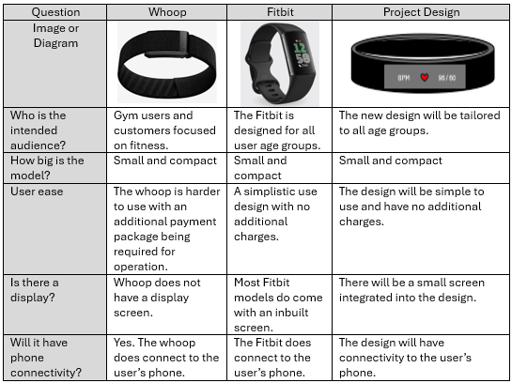
Table 2 - Comparison Table Between Two Common HR Monitors and The Project Monitor [5] [6]

Project Design
The first stage of the project will be the simulation design which will incorporate the use of the proteus simulation software and its already inserted components. This simulation will be the first design element to establish the exact value and amount of the specified component which will be required to create a fully functioning hardware design. Proteus will be used due to the familiarity with this software as well as containing all of the required resources for the project.
The product in question will have the capability to monitor the users heart rate using the reflection of light off of the blood vessels back to a photo detector using the equations associated with photoplethysmography. The value of the reflected light will then be placed into the heart rate calculated equation and output the final result onto a small display such as an LCD. The device will have to be small enough for the user to wear it around the wrist and made from comfy materials to avoid any irritation.
The model will be designed using some selective predesigned modules such as the sensor unit and an LCD but in addition to this, the model will also be designed with new concept elements. Shown below is an image of a predesigned sensor model. This sensor unit is the same style unit which will be incorporated into the final design alongside a product specific, predesigned or newly designed, printed circuit board (PCB) with a main programmable integrated chip (PIC) and a Bluetooth module. The Bluetooth module will be responsible for connecting to the users’ phone to allow a call to be made to the emergency services.
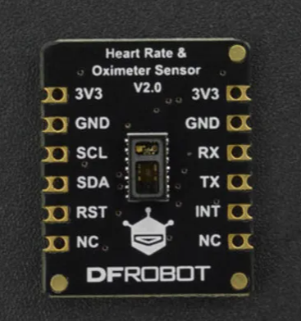
Figure 1 – Sensor Module Example [7]
Shown below here is the type of module which can control the Bluetooth connectivity to the users’ phone to ultimately place a call to the respective emergency service required. This is one of the most fundamental aspects of the design due to the nature of what it does.
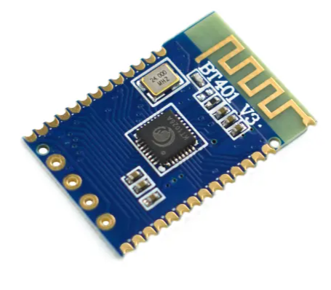
Figure 2 – Bluetooth Module Example [8]

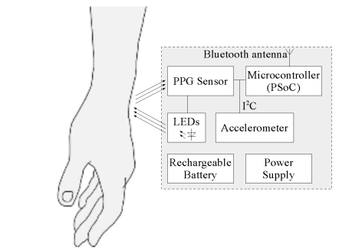
Figure 3 – Diagram on How the Sensor Module and Design Will Work [9]
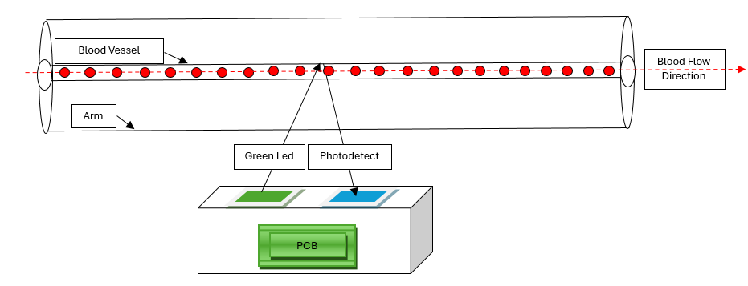
Figure 4 - Visual Representation of the Sensor Working
Figure 3 shows a model of how the project design will be made within the casing of the heart rate monitor. The LED will emit a green light into the skin which will allow the light to be reflected off of the flowing blood cells within the users’ blood vessels (Figure 4). This reflected light level will be picked up by a PPG photo detective sensor and the information transferred to the microcontroller via a communications link such as I²C. The device will be battery operated however, the battery will be rechargeable to be firstly; easy to use and secondly, more environmentally friendly. In order to charge the device, A power cable will be run from the socket / USB plug to the device.

Resources
Data about current devices and what users want to see in this project will be determined with a questionnaire. This questionnaire (figure 5) will not ask for any names and will be kept in accordance with the Data Protection Act 2018 and GDPR standards. Before the start of the study, the participants will be asked to read through the information leaflet (figure 6) to ensure they would like to take part in the study and asked for a written signature for consent before starting the questionnaire. This will ensure that all participants are willing to take part in the study and are able to take part.

Shown below in figure 7 is the timeline which has been set out for each element of this project. This is broken down into 5 categories (as shown in the appendix). The first element up until the 28th of October will be preparing the background information and proposal to submit to get approval to continue with the project. Once this has been approved the next 3 months will be designing a software model which will be the baseline for the function of the design. This will require a laptop and the Proteus simulation software. Next will be the hardware design, based off of the simulation, as well as the report. The hardware will be designed at least a month prior to the end of the project to allow corrections if required. The project will close on the 29th of April and the presentation of findings will be set for the 6th of May.
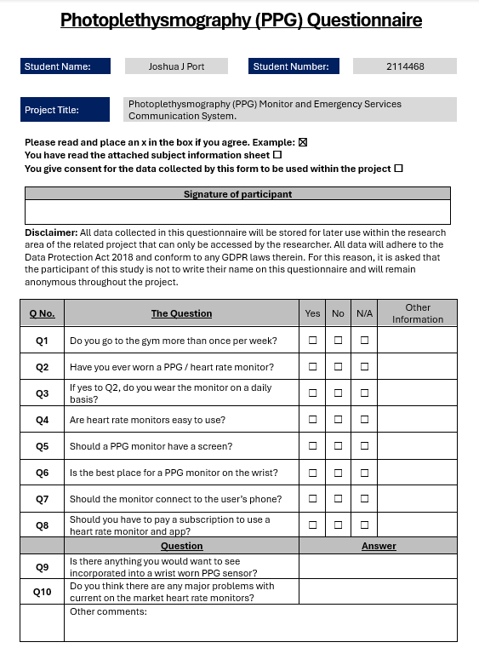
Figure 5 - Photoplethysmography Participant Questionnaire


Figure 6 - Photoplethysmography Participant Information Leaflet

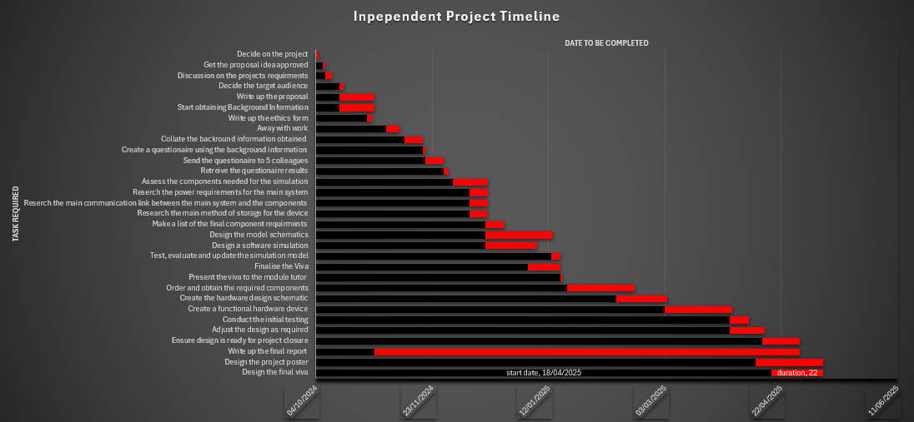
Figure 7 - Project Timeline Gantt Chart

References

[1] | K. H. S. Aymen A. Alian, “Photoplethysmography,” in Best Practice and Research Clinical Anaesthesiolgy , New Haven, Elsevier, 2014, pp. 395 - 406.
[2] | F. Sartor, G. Papini, L. G. E. Cox and J. Cleland, “Methodological Shortcomings of Wrist-Worn Heart Rate Monitors Validations.,” in Methodological Shortcomings of Wrist-Worn Heart Rate Monitors Validations., Canada, Academic Search Premier, 2018, pp. p.e10108-e10108.
[3] | E. C. Traci Pedersen, “8 Best Heart Rate Monitors in 2024,” Healthline, 05 Feburary 2024. [Online]. Available: https://www.healthline.com/health/fitness/heart-rate-monitor. [Accessed 17 October 2024].
[4] | C. V. H. a. N. V. H. Neide Simões-Capela, “Heart Rate Estimation From Wrist-Worn Photoplethysmography: A Review,” Heart Rate Estimation From Wrist-Worn Photoplethysmography: A Review, vol. XIX, no. 16, pp. 1-2, 2019.
[5] | Whoop, “Whoop Bands,” Whoop, 2024. [Online]. Available: https://shop.whoop.com/en-uk/collections/band?order_by=featured. [Accessed 21 October 2024].
[6] | Google, “Fitbit Charge 6 Tracker,” Google, 2024. [Online]. Available: https://store.google.com/product/fitbit_charge_6?hl=en-GB. [Accessed 21 October 2024].
[7] | DFRobot, “DFRobot Heart Rate And Oximeter Sensor Breakout Board Heart Rate Sensor Breakout Board,” RS, 2024. [Online]. Available: https://uk.rs-online.com/web/p/sensor-development-tools/2473241?cm_mmc=UK-PLA-DS3A-_-google-_-CSS_UK_EN_ePMax_Prio2-_--_-2473241&matchtype=&&gad_source=1&gclid=Cj0KCQjwmt24BhDPARIsAJFYKk30oowNIN1e8O9IfiiM2D9pVorbGs8cll-2MdUhi-sy0I79pf5DAW8aAgKNEALw_wcB&gc. [Accessed 22 October 2024].
[8] | RS, “DFRobot DFR0781 Bluetooth Module Bluetooth 5.0,” RS Components, 2024. [Online]. Available: https://uk.rs-online.com/web/p/bluetooth-modules/2473227?gb=s. [Accessed 24 October 2024].
[9] | M. W. a. B. Pankiewicz, “Photoplethysmographic Time-Domain Heart Rate Measurement Algorithm for Resource-Constrained Wearable Devices and its Implementation,” MDPI, Gdańsk, Poland , 2020.

Appendix
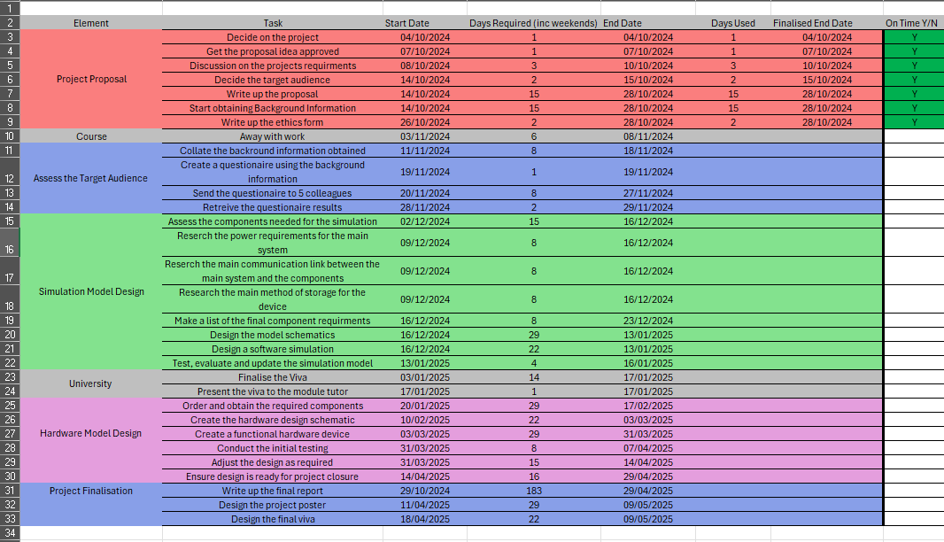
Figure 8 - Table for the Gantt Chart

