

Student Name: Kevin Thakarshibhai Maniya

Student ID: 2437416

Module Name: Marketing Management
Module Code: LCMB7024

Lecturer’s Name: Dr Laila Maazouz

Work Count: 2474

Term 1

Table of Contents
1. Introduction 3
2. Task 1: Critical Analysis of the Macro Marketing Environment 3
2.1 Overview of the Macro Marketing Environment 3
2.2 Selection of Two External Macro Marketing Actors 5
2.3 Critical Analysis of Each Actor 6
3. Task 2: Strategic Responses of Pioneering and Follower Organisations 7
3.1 Pioneering Organisations’ Strategic Responses 7
3.3 Follower Organisations’ Strategic Responses 9
4. Conclusion 11
Reference list 12

1. Introduction
This report is aimed at examining critically the ways strategic marketing management can enable organisations to react appropriately to the dynamic external environment forces in the macro marketing environment. Strategic marketing management chooses to align long term goals of an organisation according to the market opportunity it faces through pinpointing of information in relation to decision making, allocation of resources and positioning of the organisation. With growth and innovation in the industry being characterized by the world of digital transformation, environmental factors and evolving consumer demands, external factors have become a central concept to maintain growth and innovation in various industries, including technology, retail, and automotive industries.
Macro marketing environment analysis is important in identifying external opportunities and threats that determine the performance of the market. Understandings like the PESTEL ones enable companies to assess the political, economic, social, technological, environmental, and legal trends that directly influence the formulation of the strategies. The process facilitates proactive as opposed to reactive decision-making so as to enable pioneering as well as follower firms adjust well to market instability and consumer transition.
This report has two important tasks in its scope. The former critically examines the macro marketing environment, which entails the selected external factors and their impact on strategic decision-making. The second looks at how the pioneering and the follower organisations react strategically to these macro forces in terms of already existing models like the Growth Matrix by Ansoff and the Generic Strategies as proposed by Porter.

2. Task 1: Critical Analysis of the Macro Marketing Environment

2.1 Overview of the Macro Marketing Environment
The macro marketing environment is a wide set of external forces that influences the market conditions and strategic decisions-generally broken down into Political, Economic, Social, Technological, Environmental and Legal (PESTEL) (Raimoranta, 2025). These forces are beyond the control of the firm but directly affect customer behaviour, cost structure, distribution channels and regulatory risk hence regular scanning of the macro environment is central to strategic marketing management. PESTEL offers an organized way of turning heterogeneous signals (evolving regulation, disruptive technologies, shifting consumer values) into inputs that can be acted upon to position, segment and allocate resources.
For example, innovation can quickly alter the product lifespan: today, international sales in the field of electric cars amount to approximately 17 million units, which is more than 20% of all new car sales, proving the implementation of technology as an instrument making it possible to redefine entire markets (IEA, 2024; Rho Motion, 2025). Environmental policies also modify the cost models and market access: the recycled-content requirements towards PET bottles (e.g. 25% by 2025; 30% by 2030) as well as single-use plastics regulations imposed by the EU are already imposing on packaging redesign and supply-chain reform in food and beverage and retail (European Parliament, 2018; Vargas, 2025). These are enhanced by social and consumer trends: per surveys, consumers will be willing to pay a sustainable premium (average 9.7%) to greener products, increasing the revenue argument of sustainable repositioning (PWC, 2024).
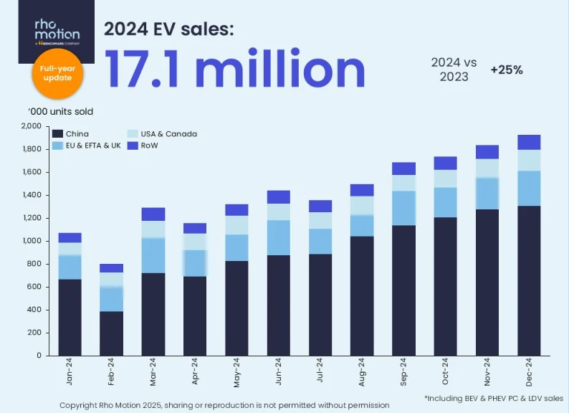
Figure 1: Electric Vehicles sales in 2024
(Source: Rho Motion, 2025)
Effective environmental scanning enables firms to move from reactive contingency planning to proactive capability building; anticipating threats (e.g., compliance costs, supply shortages) and seizing opportunities (e.g., first-mover advantage in new segments). PESTEL diagnosis is related to marketing strategy (brand, product range, pricing, distribution and communications), which enhances strength of strategic decisions in unstable markets and enables pioneers and followers to align investments with plausible futures (Grand View Research, 2024; NIQ, 2024).

2.2 Selection of Two External Macro Marketing Actors
Two macro actors are chosen to be analysed in detail Technological change (electrification and digitalisation), and Environmental regulation with consumer sustainability preferences (Weckowska et al., 2024; Brenner and Hartl, 2021). The reason behind these selections was that (1) technological change is swiftly altering product and cost structure in capital-intensive industries (automotive and IT in particular) and (2) environmental regulation and emerging sustainability demand are also restructuring packaging, sourcing and brand legitimacy in consumer markets (food and beverage in particular). Both drivers also have short-term commercial impacts and long-term strategic impacts.
Technological relevance can be demonstrated by the registered expansion of the EV market: reputable research indicates approx. 17.0-17.1 million EVs in global sales in 2024, and the worldwide EV stock goes to around 58 million vehicles at the end of 2024 values that have a direct impact on the OEM product planning, sourcing and dealer/channel plans (IEA, 2024; Virta, 2025). BYD’s 2024 performance (annual sales rising into the multi-million range; December 2024 monthly volumes >500,000 units) shows how scale advantages are emerging among new-era pioneers (Rogers, 2025; Bekker, 2025).
Environmental relevance is shown by policy and market signals: the EU’s single-use plastics and recycled-content policies (e.g., 25% recycled PET by 2025, 30% by 2030) create binding inputs-side changes for beverage and packaged-food companies, while market sizing for sustainable packaging (global sustainable packaging market $273 billion in 2023, projected to grow strongly) demonstrates large commercial opportunity (Grand View Research, 2024). Sustainability willingness report by PwC’s Voice of the Consumer (2024) showing a mean sustainability premium willingness 9.7%, a critical demand-side indicator of pricing/positioning (PWC, 2024).
External Actors Selection summary table
Actor | Rationale | Key 2024-25 evidence
Technological (Electrification / Digitalisation) | Alters product architecture, channel economics & entry | Global EV sales approx. 17 million (2024); global EV fleet about 58 million; BYD 2024 volumes > 4.2 million (IEA, 2024; Rho Motion, 2025).
Environmental (Regulation & Sustainability Demand) | Forces packaging/inputs change; shifts consumer preferences | EU recycled-content targets 25% by 2025 / 30% by 2030; sustainable packaging market approx. USD 273 billion (2023); consumers willing to pay about 9.7% premium (Grand View Research, 2024).

2.3 Critical Analysis of Each Actor
Technological (Automotive Industry Example): The rapid electrification has asymmetrical effects. Pioneers (e.g., Tesla, BYD) have scale effects, brand halo, and software/energy-service revenue chances; e.g., BYD reported multi-million-car sales annually in 2024 (approx. 4.27m vehicles) meaning cost and distribution scale effects of vertically integrated pioneers (Rogers, 2025; Bekker, 2025). However, pioneers require high exposure to research and Development (R&D) and capex and increased competition: Tesla has signalled a slight decrease in deliveries in 2024 (approx. 1.79m units) and a decline in margins when faced with tighter competition in the pricing (Montgomery, 2025; Hawkins, 2025). Among pioneers, there are monetizable software services and regulatory credit revenues, and commoditisation of core hardware and concentration of battery suppliers. Strategic implication: innovators need to expand modular platform investments, getting long-term battery supply, and post-sale software ecosystems monetisation (Tesla, 2025; Westerheide, 2025).
Followers (traditional OEMs) have switching costs of legacy ICE platforms and dealer networks, but can adopt those fast-follower schemes, including alliances, platform sharing and product niches, to constrain capex and speed market entry. The possible strategic actions would be joint EV platforms venture and outsourcing battery development to experts to save time-to-market and maintain margins (IEA, 2024).
Environmental (Food & Beverage Industry Example): Both compliance costs and market openings are brought about by regulatory requirements and consumer demand. Leading F&B companies to redesign packaging (refill schemes, more PCR) can earn loyalty and premium pricing but justified by market sports that package sustainably and a consumer willing to pay more premiums, but require conversion and supply-chain expenses (PWC, 2024). Existing green innovations can be replicated by followers, as there is a reduced investment in R&D but authenticity can be questioned; it has been shown that countries like France have already exceeded a target of 25% recycled PET before 2025, proving feasible on the supply side when investing early (Vargas, 2025). Strategic implication: pioneers should vertically secure recycled content and quantify lifecycle benefits; and followers are advised to use approved glass-labels and cost-efficient packaging alternatives with the avoidance of greenwashing (NIQ, 2024).

3. Task 2: Strategic Responses of Pioneering and Follower Organisations

3.1 Pioneering Organisations’ Strategic Responses
Innovative firms react to macro shocks by taking proactive, capability-enhancing strategies that integrate the market-creating and scale-defensive activities ambit of activity that would be conveniently situated in Growth Matrix of Ansoff (product development, market development, differentiation, and diversification) as well as in the Generic Strategies of Porter (differentiation, defensive scale) (Anand et al., 2025). In the journal of automotive, the first-mover-moves have been partly precipitated by the global electrification demand (electric car sales was around 17 million in 2024): high-pressure on product development (new EV models, battery tech), to meet the demand, plus high-pressure on market development (exports and new markets): first-movers in the automotive industry are BYD and Tesla (AP News, 2025). First-mover advantages (brand halo, proprietary software ecosystems) are captured by pioneers, and scale allows them to lower cost per unit; for example, in the case of BYD, it sells approx. 4.2-million-unit vehicles annually, implying scale can serve as an inexpensive tool to vertically integrate and provide customized pricing (AP News, 2025; Spirlet, 2025).
In food and beverage, the first-mover consumer product companies are using differentiation (environmentally-friendly packaging e.g. eco-packaging, plant-based product lines) and product development to attract sustainability premiums. The investments in recycled materials and refill schemes are premised by the sustainable-packaging industry (market approx. USD 273 billion in 2023/24), which helps the trailblazers to price-up and lock-in sustainability-intent hippies (Grand View Research, 2024).
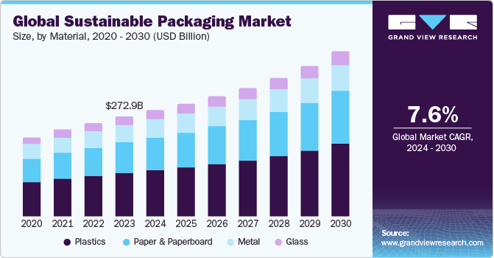
Figure 2: Sustainable Packaging Industry Growth
(Source: Grand View Research, 2024)
In technology/cloud, the technology/cloud leaders (AWS, Google Cloud, Microsoft Azure) adopt market-development/diversification by adding new managed services, region expansion, enterprise vertical products supported by growing public cloud-spend forecasts (approx. USD 723 billion end-user public cloud spend forecast by 2025). These types of pioneers use differentiation (scope of activities, trust), as well as economies of scale to maintain margins when expanding into supplemental services (AI platforms, security), which is similar to diversification/product development steps made by Ansoff (Gartner, 2024).
Strategically, pioneers should:
- Early investment on proprietary capabilities (software, and supply contracts) purchase recycling feedstock.
- Selective vertical integration (battery supply, packaging feedstocks) is used in order to gain a margin.
- Withdraw finances (software subscriptions, loyalty/refill programmes) to increase the income base.
These actions correlate the aggressive expansion option of Ansoff with the differentiation option of Porter (and where scale can be affected, with leadership in costs), allowing pioneers to transform macro trends into defensible competitive advantage (Grand View Research, 2024). These strategies collectively illustrate how pioneering organisations convert external challenges such as regulatory shifts and technological disruption into opportunities for innovation, differentiation, and long-term market leadership.

3.3 Follower Organisations’ Strategic Responses
Follower organisations generally emphasise risk-reduced imitation and selective adaptation over disruptive bets all moves by Ansoff Matrix’s market-penetration and product-development are applied selectively, with reliance on one or the other of the cost-focus or focused differentiation offered by capability as preferred by Porter (Ferreira and Marques, 2024). Automotive establishments have partnered with legacy OEMs (e.g., Ford, Volkswagen) sharing platform work to launch products in targeted, stage-based releases and capex carefully to maintain dealer networks. Notably, large established companies are extendedly equipping in existing plants and making massive announcements to manufacture competitive EVs (Ford investing several billion in retooling and creating a universal EV architecture), gaining market share in current customer markets and taking the form of partnership and modularity of platforms, as a strategy to reduce risk (Schreiner, 2025; ESG News, 2025).
The food & beverage followers copy proven green innovations (recycled PET, refill kiosks) instead of coming up with them, a strategy that is less risky to implement in the market, product development/ market penetration approach. Volunteering increased recycled content targets by large players in the F&B sector (e.g. reported rPET gains in 2024) demonstrates the ability of followers to scale tested solutions and comply with regulation without necessarily being the first to invent the technology; but they need to address the issue of authenticity to prevent greenwashing allegations (Coca-Cola HBC, 2025; Horton, 2024).
Market penetration and service-line optimization have been deployed by many chains to act as a recovery tool during post-pandemic demand (Marriott, Hilton) to prioritize revenue management, selective promotional tactics and sustainability credentials to draw higher-yield segments and avoid risky diversification of products. STR/industry reporting demonstrates to the followers the patterns of recovery of the “Revenue Per Available Room” (RevPAR) in 2024-25 and suggests that the focus should be placed on the utilisation and the recovery of the margins, as opposed to radical strategic shifts (Marriott International, 2025; (The American Hotel & Lodging Association (AHLA), 2025).
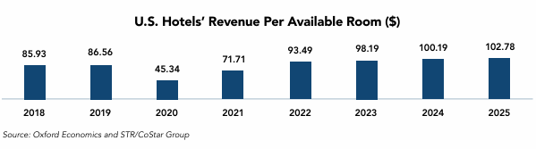
Figure 3: Increase Rate in Revenue Recovery in Per Available Rooms in the USA
(Source: The American Hotel & Lodging Association (AHLA), 2025)
Recommended follower tactics:
- Fast-follower product development: Develop established technology (EV platforms, rPET packaging) through licensing or joint venture to reduce the requirements of R and D, and hi-tech, accelerate the possibilities of time-to-market (Schreiner, 2025).
- Focused Porter strategies: Be cost focused or niche differentiated in certain segments (affordable EVs, value-tier lodging) or use the local sustainability credentials.
- Operational pragmatism: Making supply chains more efficient, finding contract manufacture and leveraging strategic alliances to disaggregate capex.
By aligning the lower-risk growth options suggested by Ansoff with the focus options proposed by Porter, followers will be able to remain competitive without the excess of capital expenditure, transforming macro pressures into stepwise, capital-wise, financially sound steps instead of life-threatening gambits (ESG News, 2025). Such responses reveal how follower organisations turn external pressures into organised strategies of adapting to the external pressures, balancing innovation with safety to stay afloat and competitive in a fast-changing marketplace, dictated by technological, environmental, and economic change.

4. Conclusion
In conclusion, as it has been analysed, under the macro marketing environment and strategic organisational responses, on-going environmental scanning forms the core of maintaining competitiveness in the constantly changing global markets. In task 1, it was established that macro forces like technological change and environmental regulation are changing industries in a pace that has never been witnessed. The analysis has shown that technological changes, including electric vehicle innovation and digital transformation, are redefining production systems and consumer demands, and environmental pressures and sustainability demands are putting firms under pressure to redesign their packaging and sourcing and communication strategies. All these external changes present great opportunities and strategic risks that demand informed and data-based marketing decisions.
Task 2 also demonstrated how innovative, differentiated, and diversified organisations also use the turbulence in the environment proactively to transform the environment into opportunities of growth. Conversely, adaptive strategies that follower organisations apply to stand a chance of survival include fast-follower product development, partnering, and positioning with cost considerations. These two strategic approaches show the key role of marketing management in matching the organisational capabilities with the external realities. Finally, the results highlight that continuous scanning of the environmental audit, in combination with responsive strategies, can help organisations to expect change, drive stronger positions in the market, and continue to create value over time in any industry. Strategic marketing management is, consequently, not only responsive but also a vital catalyst of strength and creative forces in a shaky business world.

Reference list
Anand, P., Nithya, N.Dr.D., Sripriya, N.Dr.V., Vaishnavi, N.Dr.M. and Sinduja, N.Dr.R. (2025). Strategic Minds: Navigating The Landscape Of Modern Management. Doi: https://doi.org/10.25215/1997811014.
AP News (2025). BYD reports 2024 revenue over $100B, topping Tesla’s sales. [online] AP News. Available at: https://apnews.com/article/ed166ad35a8a9d6425b85512da8e12c9.
Bekker, H. (2025). 2024 (Full Year) Global: BYD Worldwide Car Sales and Productions - Car Sales Statistics. [online] Best-selling-cars.com. Available at: https://www.best-selling-cars.com/brands/2024-full-year-global-byd-worldwide-car-sales-and-productions/.
Brenner, B. and Hartl, B. (2021). The perceived relationship between digitalization and ecological, economic, and social sustainability. Journal of Cleaner Production, 315, p.128128. Doi: https://doi.org/10.1016/j.jclepro.2021.128128.
Coca-Cola HBC (2025). Making our Packaging Circular. [online] CCH Group Website. Available at: https://www.coca-colahellenic.com/en/a-more-sustainable-future/mission-2025/making-our-packaging-circular.
ESG News (2025). Ford to Invest $5B in New Electric Vehicle Platform. [online] ESG News. Available at: https://esgnews.com/ford-to-invest-5b-in-new-electric-vehicle-platform/.
European Parliament (2018). Plastic waste and recycling in the EU: facts and figures. [online] Topics | European Parliament. Available at: https://www.europarl.europa.eu/topics/en/article/20181212STO21610/plastic-waste-and-recycling-in-the-eu-facts-and-figures.
Ferreira, A. and Marques, M.B. (2024). The Importance of the Ansoff Matrix for the Study of the Information Services Market. [online] Canadian Journal of Information and Library Science. Available at: https://www.researchgate.net/publication/382141729_The_Importance_of_the_Ansoff_Matrix_for_the_Study_of_the_Information_Services_Market.
Gartner (2024). Gartner Forecasts Worldwide Public Cloud End-User Spending to Total $723 Billion in 2025. [online] Gartner. Available at: https://www.gartner.com/en/newsroom/press-releases/2024-11-19-gartner-forecasts-worldwide-public-cloud-end-user-spending-to-total-723-billion-dollars-in-2025.
Grand View Research (2024). Sustainable Packaging Market Size And Share Report, 2030. [online] www.grandviewresearch.com. Available at: https://www.grandviewresearch.com/industry-analysis/sustainable-packaging-market-report.
Hawkins, A.J. (2025). Tesla’s sales fell year-over-year for the first time. [online] The Verge. Available at: https://www.theverge.com/2025/1/2/24334102/tesla-q4-2024-production-delivery-drop-first.
Horton, H. (2024). Coca-Cola accused of quietly dropping its 25% reusable packaging target. [online] the Guardian. Available at: https://www.theguardian.com/environment/2024/dec/03/coca-cola-accused-dropping-reusable-packaging-target.
IEA (2024). Trends in Electric Cars. [online] IEA. Available at: https://www.iea.org/reports/global-ev-outlook-2024/trends-in-electric-cars.
Marriott International (2025). 2024 Annual Report. [online] Available at: https://marriott.gcs-web.com/static-files/a7664c0f-5bd1-4066-9fc9-b05eb6c93772.
Montgomery, B. (2025). Tesla shares fall as company reports first decline in annual deliveries. [online] the Guardian. Available at: https://www.theguardian.com/technology/2025/jan/02/tesla-stock-falls.
NIQ (2024). The State of Wellness and Better ForTM Products. [online] NIQ. Available at: https://nielseniq.com/global/en/insights/analysis/2024/state-of-better-for/.
PWC (2024). Consumers willing to pay 9.7% sustainability premium, even as cost-of-living and inflationary concerns weigh: PwC 2024 voice of the consumer survey. [online] PwC. Available at: https://www.pwc.com/gx/en/news-room/press-releases/2024/pwc-2024-voice-of-consumer-survey.html.
Raimoranta, R. (2025). Case Study of the Impact of Risk Management Practices on Supply Chain Efficiency. [online] Uwasa.fi. Available at: https://osuva.uwasa.fi/handle/10024/19771.
Rho Motion (2025). Over 17 million EVs sold in 2024 - Record Year. [online] Rho Motion. Available at: https://rhomotion.com/news/over-17-million-evs-sold-in-2024-record-year/.
Rogers, J. (2025). Chinese EV makers BYD, Nio, Li and XPeng end 2024 on a sales high. [online] MarketWatch. Available at: https://www.marketwatch.com/story/chinese-ev-makers-byd-nio-li-and-xpeng-end-2024-on-a-sales-high-0299997a.
Schreiner, B. (2025). Ford overhauls plant to produce electric vehicles despite Trump funding pullback. [online] AP News. Available at: https://apnews.com/article/bde8fee4209176be186e6b4f91252dd2.
Spirlet, T. (2025). More trouble for Tesla as China’s BYD crosses $100 billion barrier. [online] Business Insider. Available at: https://www.businessinsider.com/byd-china-crosses-100-billion-barrier-trouble-tesla-elon-musk-2025-3.
Tesla (2025). Tesla Fourth Quarter 2024 Production, Deliveries & Deployments | Tesla Investor Relations. [online] Tesla.com. Available at: https://ir.tesla.com/press-release/tesla-fourth-quarter-2024-production-deliveries-and-deployments.
The American Hotel & Lodging Association (AHLA) (2025). 2025 STATE OF THE INDUSTRY REPORT. [online] Available at: https://www.ahla.com/sites/default/files/25_SOTI.pdf.
Vargas, M. (2025). Key 2025 Targets of the EU Single-Use Plastics Directive. [online] Plastics Engineering. Available at: https://www.plasticsengineering.org/2025/02/key-2025-targets-of-the-eu-single-use-plastics-directive-007926/.
Virta (2025). The Global Electric Vehicle Market In 2024. [online] Virta Global. Available at: https://www.virta.global/global-electric-vehicle-market.
Weckowska, D., Weiss, D., Schwäbe, C. and Dreher, C. (2024). Technological innovation system analyses and sustainability Transitions: A literature review. Environmental Innovation and Societal Transitions, 54, pp.100935–100935. Doi: https://doi.org/10.1016/j.eist.2024.100935.
Westerheide, C. (2025). Tesla releases 2024 financial results: Revenue is up, but profits are down - electrive.com. [online] electrive.com. Available at: https://www.electrive.com/2025/01/30/tesla-releases-2024-financial-results-revenue-is-up-but-profits-are-down/.

