Independent project
Process documentation portfolio
P146448
Throughout this portfolio I will attempt to discover, analyse and critically assess the key moments and findings whilst completing my independent project. I have attempted to investigate discrimination within the LGBT community through the use of surveys, interviews and independent research of literature. The final outcome of this project being a piece of verbatim theatre surrounding individual’s stories that I have obtained, regarding experiences from members of the community around discrimination or times where they have discriminated against others in the community.
I have outlined both the aims and objectives that I believe will aid me in completing this project.
Aims-
- Highlight something that I believe is a big problem in the LGBTQ+ community.
- Give a voice to a community that isn’t a prominent in society as others.
- Allow individuals to explore an issue that isn’t as talked about as it should be.
Objectives –
- Undertake independent research to see the areas of discrimination that are big within the community.
- Undertake independent research regarding the literature surrounding this topic.
- Work closely with members of the LGBT community to obtain stories for a piece of verbatim theatre.
- Use the power of social media for members of the LGBT community to complete surveys about discrimination to aid me in completing my interviews.
- Tell individual of the community stories authentically.
- Remain a duty of care to all individuals taking part.

I began the research process by creating an online survey for members of the LGBT community to complete. The survey accompanied my research by analysing areas of discrimination that are prominent within the community and aided me in seeing the number of people who believe discrimination within the community is something that needs to be looked at. [Appendix 1]
The results concluded by stating that 100% of individuals who took part believe that discrimination within the community is something that needs to be addressed, essentially giving the need for a project like mine.
The survey revealed that 82% of individuals have experienced some area of discrimination from members of the LGBT community at some point, 53.66% of that result being discriminated because of their size. In an article that discusses body image and satisfaction amongst gay men using survey results, it states that gay men may feel less confident with their bodies as opposed to heterosexual men, suggesting this is due to the fact of how important appearance is deemed to be in the gay community (Allensworth. D et al. 2008). The figures taken from both my survey and the article reinforces the idea of how individuals in the community feel the pressure to conform to certain standards as a gay male and emphasizes how individuals appearance can strengthen the idea of how discriminatory the community can be.
I chose the technique of verbatim theatre because I believe it is best suited for a project like mine as opposed to other applied drama techniques. I wanted to portray members of the LGBT community stories of discrimination and let individuals know how prominent this is in society. One of my aims for the project was to allow a community who is sometimes silenced in society to have a voice and express themselves without the fear of judgement. Robin Soans expresses that verbatim theatre for him isn’t just the case of asking interesting questions, it is also about widening the variety of people you speak to and how important it is to include individuals who traditionally haven’t been seen or heard in theatre. (Soans, 2008, p.18). I agree with Soans point and believe that by interviewing all aspects of the LGBT community I was able to not only get a balanced argument from a community perspective but also assisted my research by getting a variety of different experiences and points of view. By turning their stories into a piece of verbatim theatre it is also introducing the topic of LGBT discrimination within the community, something that I believe isn’t talked about enough in society today, especially not in theatre. Verbatim theatre has allowed the participants of this project to tell their stories and highlight key areas of discrimination within the community, which is the essential aim of this project, therefore proving to be a more effective technique compared to the work of other applied drama approaches such as Boal’s forum theatre as I am not trying to work with the audience to explore how we can invite a positive change to the situation. Verbatim theatre is also widely talked about as being honest, accurate or truthful (Norton-Taylor, 2008, p.131). Creating a piece of theatre that follows these guidelines I also believe aids myself in reaching the aims and objectives of the project.
I interviewed members of the community who all identify differently to ensure I obtained a balanced argument when looking at discrimination within the community. I asked individuals to express a time where they have discriminated against others in the LGBT community or a time where they have experienced discrimination in the community and how the experience was for them. For the safety of the individual all interviews and the stories used have been kept anonymous. All individuals interviewed were given consent forms prior to the interview that explained the intentions of the project and allowed them to ask any questions that needed clarifying. This is one of the fundamental areas of verbatim theatre that the national theatre discovery express, allowing individuals before the interview what your intentions are with their stories (National theatre gallery, 2014). [Appendix 2] [Appendix 3]

There are many ethical implications that verbatim theatre holds, the performer must ensure they are telling individual’s stories authentically and representing them or their stories to a standard that they are pleased with, similar to how Preston talks about the individual involved having a level of responsibility towards ensuring that the representations that are made are produced through a climate or sensitivity, dialogue, respect and willingness for reciprocity (Preston, 2009, p. 66). Preston also believes that the individuals, when working with applied theatre, may ask themselves the following critical questions when looking at the ethical implications of representation:
- How appropriate is our preferred aesthetic for engaging with the politics of speaking with, for or about communities?
- How do we deal with moral and/or political tensions at the heart of the stories and texts that are created?
- How can we work sensitively, and create a genuine climate of dialogue and reciprocity?
- How are issues of voice, authority and ownership reconciled in the process of constructing narratives and representations that result?
- How will representations that have been created impact in diverse, unpredictable and political contexts?
(Preston, 2008, p. 68).
Taking in Preston’s critical questions I found that as the researcher of this project I have to ensure that I allow individuals to tell their stories without the fear of judgement, understanding that any tension I may feel to individuals’ opinions should not impact the way I tell them as opposed to other opinions I may agree with more. In my opinion it is also important to work sensitively with participants’ stories in order to create a larger story, ensuring that I am not changing what participants have anonymously expressed to me. Due to the topic that I am looking I believe keeping the anonymity of the participants allows them to express freely their beliefs and opinions allowing me to obtain real life experiences for verbatim purposes. The anonymity of participants’ stories stops the audience from perceiving them in a certain way.
Because of the nature of this project it is also important to hold a duty of care to not only the participants but the audience members too. The end of the performance will allow individuals to receive information on anything that may have affected them in anyway, offering support lines and organisations that can offer help around the topics of LGBT and discrimination. As the facilitator of this project it is also vital to have a risk assessment of the possible risks that may happen during the performance, reinforcing that duty of care to all involved. Before the performance took place the audience were given a disclaimer to provide them with some information about the piece, giving them the opportunity to leave the performance at any given time. [Appendix 4] [Appendix 5] [Appendix 6]

My initial idea for the practical element of the independent project was to use both live performance and video projection to authentically portray individual’s sorties to engage the audience. After rehearsing with the projection and voice overs I found that it wasn’t as powerful as I originally thought it would be. I found that the projection wasn’t able to capture participants’ stories in an engaging manner and found the production and the way it was filmed to be uninteresting. The rehearsal process allowed me to identify the areas that were strong in the piece and the areas that required improvement. The whole point of this project was to tell individuals stories of discrimination authentically, this consumed a lot of my focus and stopped me from looking at it from a theatre perspective as I was so involved with what they were saying as opposed to how I would be delivering it. Although telling individuals stories is the main point I am trying to portray I began to experiment with the dialogue and movement to see how I could develop the piece to be delivered in an engaging manner. I started to develop the dialogue in sections, creating different personalities for each characters by using both voice and body, the end result being five different personas that I could embody during the performance, making it more memorable and giving the opportunity for the audience to relate to the piece and engage on a higher level.

Delivering participants stories without any emotion. Keeping the performance neutral with limited movement and levels within the space.

By developing characters I believe it will make the performance more relatable and believable to the audience, essentially creating a more engaging piece of theatre. Allowing a stronger invitation for audience reflection.

Didn’t allow the characters to become relatable or believable. Performance without the emotion or any dramatic conventions made the delivery of the stories limited

With the performance being limited without any emotional aspects it made the piece lifeless. This could stop the audience from engaging to the piece and may stop individuals from critically reflecting on the piece and what it meant to them.

By using Kolb’s’ experiential learning cycle, I believe I was able to successfully identify the weak areas of the performance by: creating the experience, reflecting on what needed to be improved, make assumptions of how the audience would feel and then devising a plan in order to establish the performance to a higher standard. (Kolb, 1974)
I found how individuals label in the community to be a prominent point when undergoing the interview process and wanted to incorporate that in some way. I began to play around with the idea of labels in the LGBT community, taking key words, phrases and facts from my independent research and using them throughout the performance. The original idea of attaching the labels to myself throughout the performance proved underwhelming, the labelling showed no real value at this point and became unclear to audience members during the rehearsal process. I found that it would be more effective for audience members to think about the labelling and what the term means for them, allowing audience members to feel more included in the piece, also allowing time for critical reflection for the audience. [Appendix 7]
I chose the space of the studio specifically as I wanted to create an intimate setting. The facts and statistics on both the LGBT community and verbatim theatre around the studio that audience members were invited to look around allowed them to feel a better sense of involvement and to give audience members who either don’t identify within the community or come from a theatrical background an insight into the LGBT community and verbatim theatre. I chose for the audience to be in a non-traditional setting and separate from one another to reinforce the idea of discrimination within the LGBT community, showing that even though all audience members are together they are still somewhat divided.
The production of the performance was very stripped back. I decided to take a Grotowski approach and create a minimalistic piece of theatre regarding props, costumes etc. only using body and craft as a way to captivate the audience (Grotowski, 2002, p. 21). The reason for the Grotowski approach being that I didn’t want to devise a performance where the main focus wouldn’t be the stories, although this still could have been done with the use of props, I believe it would have taken away the true essence of participants stories and could have distracted the audience from what was being delivered to them.
I believe the overall performance went well. I felt that my performance allowed individuals to engage with the piece and the stories being told, inviting the audience, at times, to reflect and question. I felt as a performer that I created different characters that the audience could identify throughout, using different levels and my body to differentiate each story. However, at some points I found myself going into a neutral position when telling stories. The characters I embodied could have been portrayed on a larger scale, this could have reinforce the audience’s engagement even further. Although I believe the performance went well, I think there were some areas that needed to be improved. The audience participation, in my opinion, needed more clarity. I feel that my shift from performer to facilitator needed to be more obvious and sharper. A more concise explanation would have aided the audience to think deeper and allow them to question on a larger scale what labels mean to them. If I was to do this project again I believe a higher level of performance skills and clear explanation would be extremely beneficial. It would allow the audience to engage and question on a stronger level, inviting a possibility of a change in thought process for individuals. This project was very time consuming, gathering survey results, interviews etc. For future projects this has taught me to work on time management skills and allow enough room for both the research and the practicality of the project. I believe more time spend in rehearsals would have allowed me to develop the characters and their personas even further, inviting the audience to be captivated on a deeper level.
After the performance I conducted an interview with one of the participants who I had previously interviewed to obtain their story. The participant was shocked by their story after hearing it the performance and expressed how they didn’t think they discriminated until hearing it back. They stressed how their thought process has now changed upon reflecting on the piece, questioning the way they thought and why they thought it at the time. The participant also mention how the performance itself was a good starting point and a platform for a topic they believe is being brushed under the carpet, they believed it was a successful way of bringing a topic that isn’t talked about as much as it should be to light. After interviewing the participant about their experience of the project I found it fit with my original aims of giving a voice to a community who are less heard in society and bringing light to a topic that isn’t talked about as much as it should be. The interview after with the participant allowed me to identify the key moments and strong points that this project has to offer if I was to take it out to a wider community. Upon reflection I think that it would have been extremely beneficial to have all participants I interviewed at the performance to see if their thought process has changed in anyway, creating a better-rounded conclusion for this project.

To conclude, by using verbatim theatre I was able to identify the areas of discrimination within the community and obtain hard hitting stories to engage the audience in a positive and reflective manner. Using verbatim theatre has allowed myself to bring light to a topic that, in my opinion is non-existent in society today. I believe strongly that I gave the LGBT community a voice in a authentic and approachable manner, successfully meeting the aims that I had originally set for this project.

References
Allensworth, D. et al. (2008) ‘Body Image, Body Satisfaction, and Unsafe Anal Intercourse among Men Who Have Sex with Men. Pp. 49-56
Soans, R. et al. (2011) Verbatim Verbatim contemporary documentation theatre. London: Oberon Books Ltd.
Prentki, T and Preston, S. (2009) The Applied Theatre Reader. Oxon: Routledge
Grotowski, J. (2002) Towards a Poor Theatre. New York: Routledge
National theatre discovery. (2014) The ethics of verbatim theatre [video]. Available at: https://www.youtube.com/watch?v=39JSv-n_W5U (accessed: 29th April 2018).

Appendix 1

Discrimination in the LGBTQ+ community

1. Age?
 |  |  | Response Percent | Response Total
1 | 16-20 |  | 18.00% | 9
2 | 21-25 |  | 42.00% | 21
3 | 25-30 |  | 24.00% | 12
4 | 30+ |  | 16.00% | 8
 |  |  | answered | 50
  Analysis | Mean: | 2.38 | Std. Deviation: | 0.96 | Satisfaction Rate: | 46
  Analysis | Variance: | 0.92 | Std. Error: | 0.14
 |  |  | skipped | 0

2. How do you identify within the community?
 |  |  | Response Percent | Response Total
1 | Gay |  | 24.00% | 12
2 | Lesbian |  | 16.00% | 8
3 | Bisexual |  | 20.00% | 10
4 | Transgender male |  | 24.00% | 12
5 | Transgender female |  | 14.00% | 7
6 | Other (please specify): |  | 4.00% | 2
 |  |  | answered | 50
  Analysis | Mean: | 3.06 | Std. Deviation: | 1.51 | Satisfaction Rate: | 40.8
  Analysis | Variance: | 2.28 | Std. Error: | 0.21
 |  |  | skipped | 0
Other (please specify): (2)
1 | 16/04/18 8:58PM  ID: 79913334 | Heterosexual
2 | 16/04/18 8:58PM  ID: 79913224 | Polyamarous

3. Have you ever been discriminated against by another member of the LGBTQ+ community?
 |  |  | Response Percent | Response Total
1 | Yes |  | 82.00% | 41
2 | No |  | 18.00% | 9
 |  |  | answered | 50
  Analysis | Mean: | 1.18 | Std. Deviation: | 0.38 | Satisfaction Rate: | 18
  Analysis | Variance: | 0.15 | Std. Error: | 0.05
 |  |  | skipped | 0

4. If yes can you please select the reason(s) for the discrimination?
 |  |  | Response Percent | Response Total
1 | Colour of skin |  | 29.27% | 12
2 | Nationality |  | 12.20% | 5
3 | Religious belief |  | 9.76% | 4
4 | Size |  | 53.66% | 22
5 | Other (please specify): |  | 17.07% | 7
 |  |  | answered | 41
  Analysis | Mean: | 3.83 | Std. Deviation: | 1.75 | Satisfaction Rate: | 65.24
  Analysis | Variance: | 3.07 | Std. Error: | 0.27
 |  |  | skipped | 9
Other (please specify): (7)
1 | 16/04/18 12:31PM  ID: 79854101 | 'not bisexual just haven't fully come out yet'
2 | 16/04/18 5:22PM  ID: 79890920 | not what a 'typical' boy should look like
3 | 16/04/18 5:23PM  ID: 79891024 | dating apps
4 | 16/04/18 5:27PM  ID: 79891471 | dating apps
5 | 16/04/18 8:52PM  ID: 79912783 | dating applications
6 | 27/04/18 11:37AM  ID: 80944708 | Through Grindr
7 | 27/04/18 11:40AM  ID: 80945017 | Too masculine

5. Have you ever discriminated against members of the LGBTQ+ community?
 |  |  | Response Percent | Response Total
1 | Yes |  | 58.00% | 29
2 | No |  | 42.00% | 21
 |  |  | answered | 50
  Analysis | Mean: | 1.42 | Std. Deviation: | 0.49 | Satisfaction Rate: | 42
  Analysis | Variance: | 0.24 | Std. Error: | 0.07
 |  |  | skipped | 0

6. Has anyone in the community ever commented negatively regarding you being too masculine or too feminine?
 |  |  | Response Percent | Response Total
1 | Yes |  | 62.00% | 31
2 | No |  | 38.00% | 19
 |  |  | answered | 50
  Analysis | Mean: | 1.38 | Std. Deviation: | 0.49 | Satisfaction Rate: | 38
  Analysis | Variance: | 0.24 | Std. Error: | 0.07
 |  |  | skipped | 0

7. Do you think discrimination within the community is something that needs to be addressed?
 |  |  | Response Percent | Response Total
1 | Yes |  | 100.00% | 50
2 | No |  | 0.00% | 0
 |  |  | answered | 50
  Analysis | Mean: | 1 | Std. Deviation: | 0 | Satisfaction Rate: | 0
  Analysis | Variance: | 0 | Std. Error: | 0
 |  |  | skipped | 0

Appendix 2


Consent form

This is for a university dissertation final project in the subject of applied drama. The project is focusing on discrimination within the LGBTQ+ community and how we treat each other as a community. The content taken from this interview will then be used for a piece of verbatim theatre. Verbatim theatre is a type of theatre that uses individual’s stories in its strictest from word for word. If I find the content of this interview relevant to what I am trying to achieve the participant’s stories will then be told through theatre anonymously. This interview will be recorded for research purposes only in order for the interview to be transcribed and remembered at a later date.

1. | I have read and understood the information about this specific project and what the purpose of the interviews are for
2. | I have been given the opportunity to ask questions about the project and my participation.
3. | I agree to participate in the project and for my story to be used.
4. | I understand I can withdraw at any time without giving reasons.
5. | The procedures regarding confidentiality have been clearly explained.
6. | I agree that this interview is allowed to be recorded for research purposes.

Participant signature date

___________________ ____________________ ________________

Researcher signature date

___________________ ____________________ ________________

Appendix 3

How do you identify within the community?
Are you okay with this interview being recorded for research purposes?

What is your age?

Interview Questions

Do you think discrimination in the community is something that needs to be talked about more? Can you explain your reasons for your answer?

Have you ever been discriminated against by another member of the community? If yes can you tell me about this experience? How did it make you feel?

Have you ever discriminated against another member of the community? If yes what were your reasons for doing so?

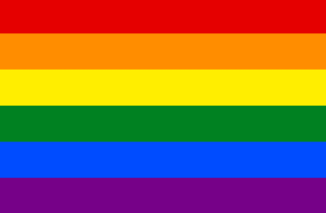
APPENDIX 4

HELPLINES

AND

ORGANISATIONS

SWITCHBOARD
LGBT CYMRU

0300 330 0630
0800 840 2069 http://www.lgbtcymruhelpline.org.uk
chris@switchboard.lgbt
https://switchboard.lgbt/
Switchboard provides a one-stop listening service for LGBT+ people on the phone, by email and through Instant Messaging.
Provide general information, advice and confidential support in many areas of life and around various issues that LGBT people, their family and friends might experience.

LGBT FOUNDATION

0345 330 3030
helpline@lgbt.foundation

LGBT Foundation's Helpline Service provides thousands of hours of advice and support to thousands of people every year.

APPENDIX 5

Risk assessment
Name of facilitator/performer - Joseph Pratlett.
Date- 17/05/18
Location-Town hill studio.

Hazard. | Who is affected? | Scale of risk (/10). | Control measures.
Falling equipment. | Everyone | 3 | Take appropriate action depending on the individual injury and keep a record of any injury that has taken place. If no injury ensure to remove the falling equipment from the space that is being worked in.
Well being | Everyone | 5 | Ensure that appropriate safe guarding is in place for both facilitator, performers and individuals. Give appropriate sign posting when required.
Electrical equipment | Everyone | 1 | If any electrical equipment does ignite be sure that all fire exits are clear and the room is evacuated as quickly as possible and everyone knows the correct fire assembly point.
Fire and similar emergencies.
Identify the nearest fire extinguishers in the room | Door near electric cupboard
Identify the nearest fire exits in the room | Large side double doors
Identify the correct fire assembly point for your group | Outside annex building
Who is the person responsible for checking that everyone involved has gone to the assembly point | Myself
How will you communicate this information to everyone involved? | Calmly telling individuals to leave the premise as soon as possible
Address of nearest walk in medical centre | Singleton hospital
Telephone number of nearest walk in medical centre | 01792 205666

Singed by facilitator J.PRATLETT

Dated 17/05/18

Appendix 6

DISCLAIMER
The performance you are about to see contains stories of discrimination within the LGBT community. The stories are taken directly from interviews and do not express the opinions of the performer. You are invited to look around the space and take everything around in the room. When you feel comfortable please place yourself in a seat or space that isn’t reserved. Please leave the space as you see it unless stated otherwise. You are allowed to leave the space at any time without questioning, if this does happen can you please remove yourself from the space using the nearest door in an orderly manner so that it doesn’t distract the performer or audience.

Appendix 7
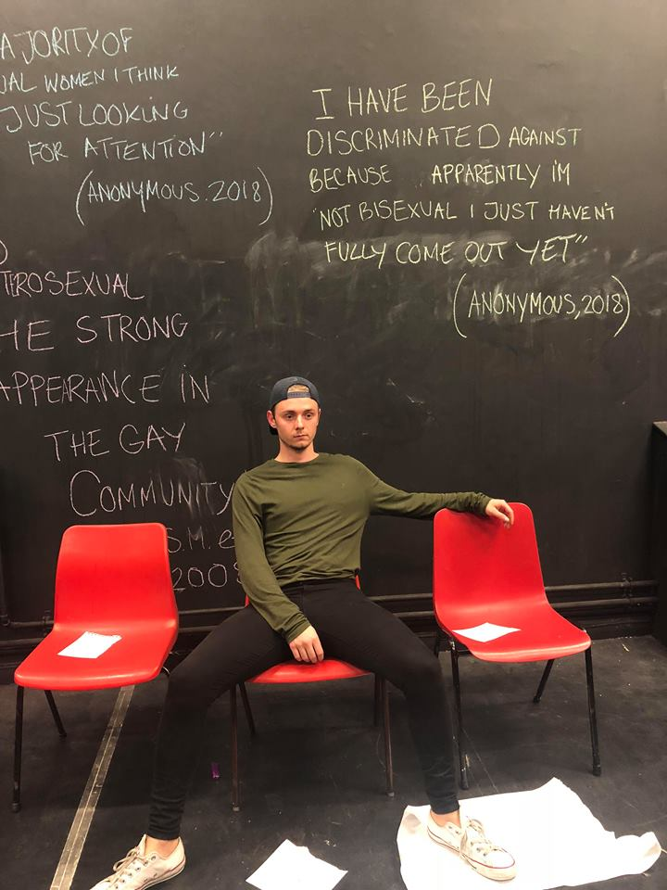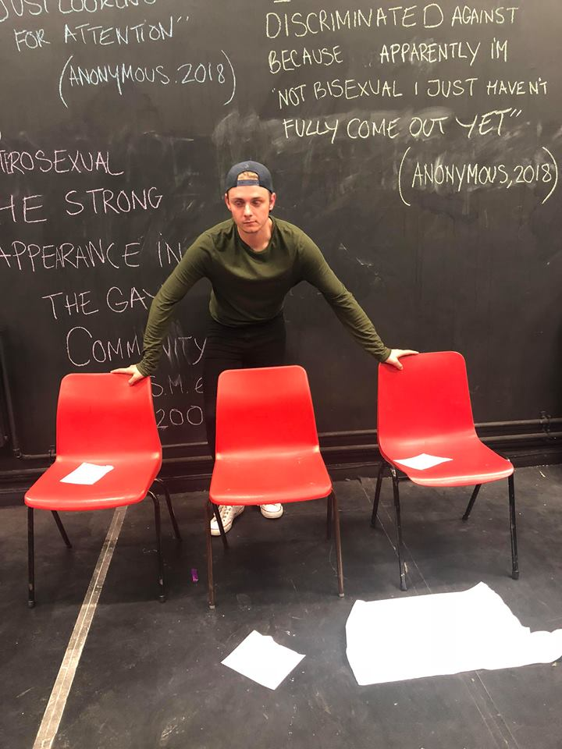
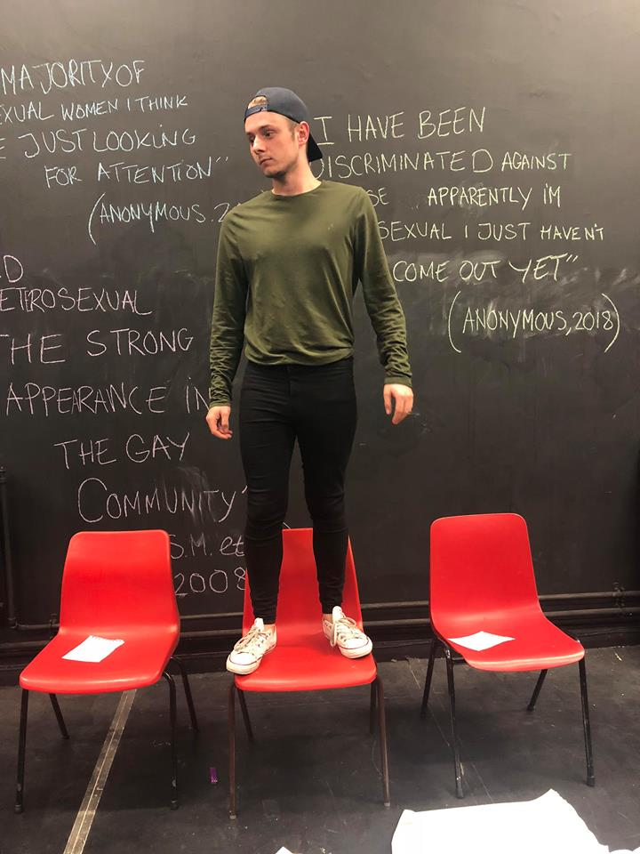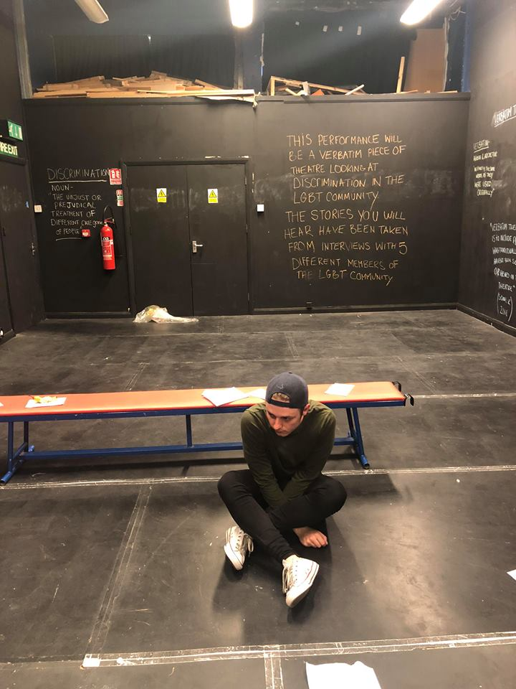

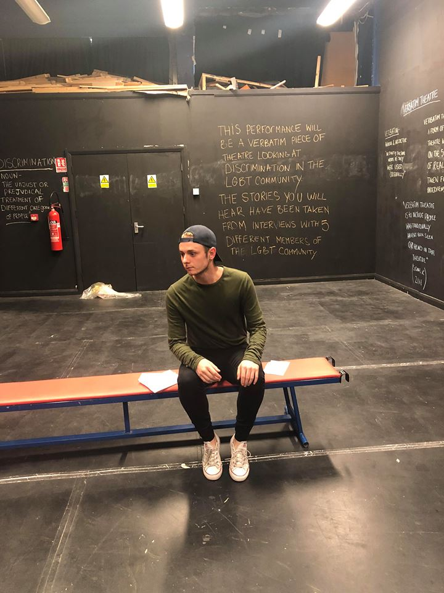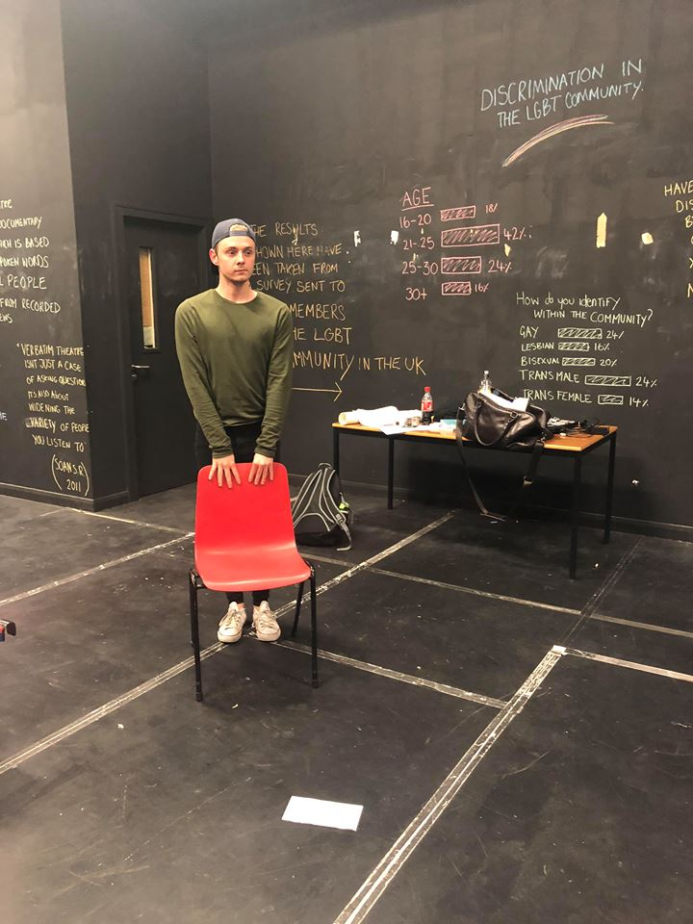

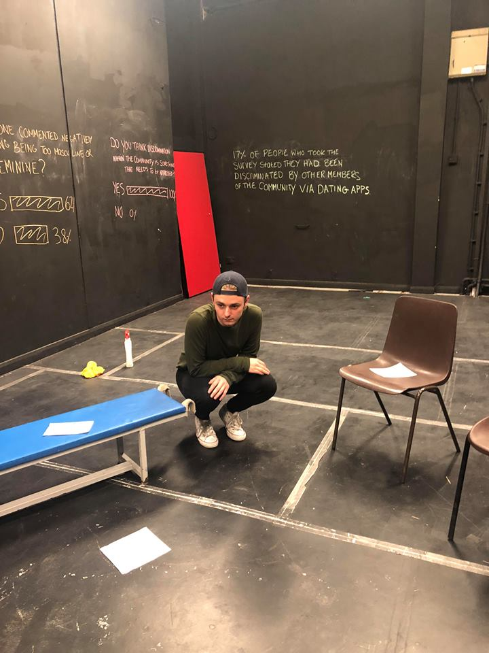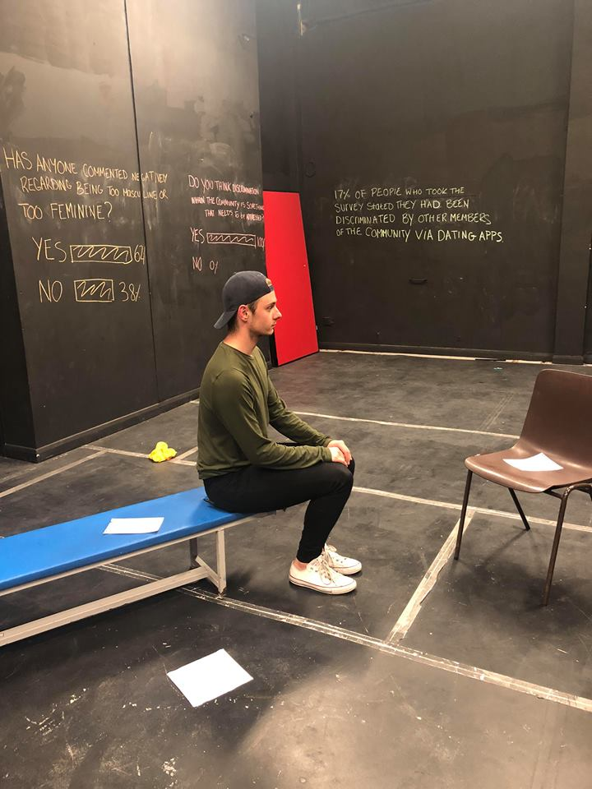

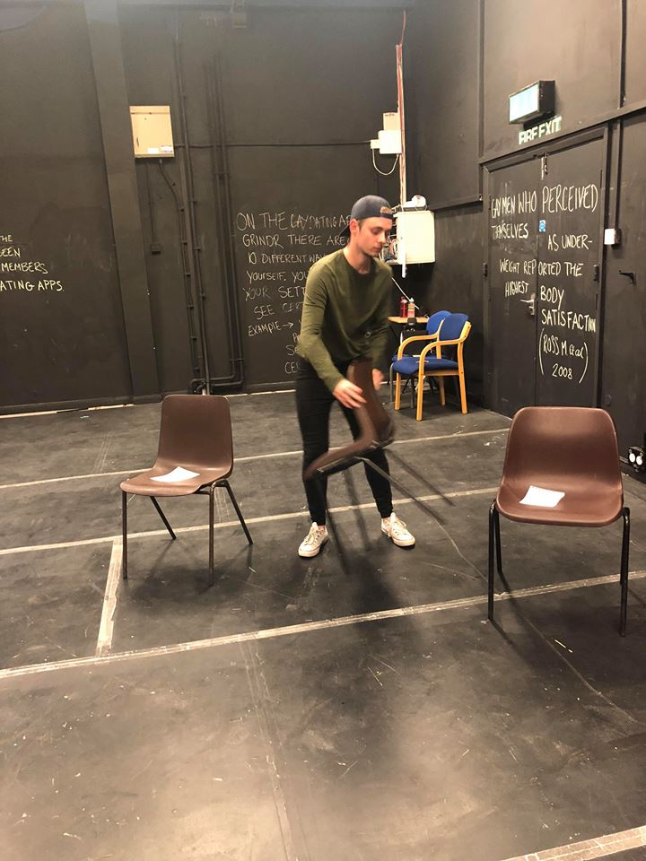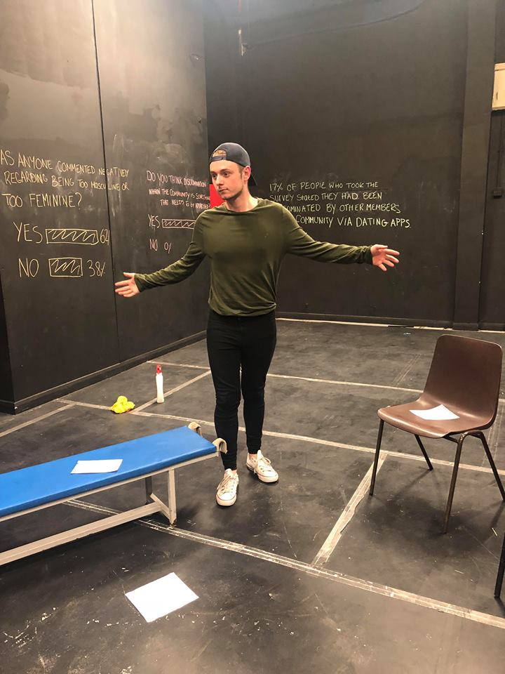

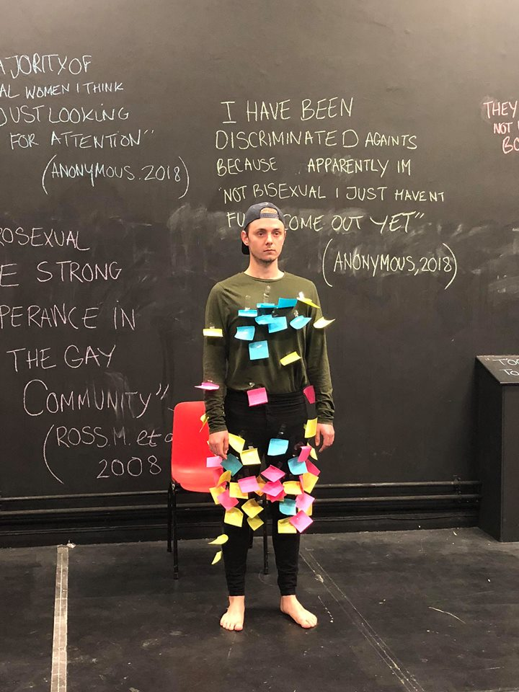

Appendix 8
APPLICATION FOR ETHICAL APPROVAL

In order for research to result in benefit and minimise risk of harm, it must be conducted ethically. A researcher may not be covered by the University’s insurance if ethical approval has not been obtained prior to commencement.

The University follows the OECD Frascati manual definition of research activity: “creative work undertaken on a systematic basis in order to increase the stock of knowledge, including knowledge of man, culture and society, and the use of this stock of knowledge to devise new applications”. As such this covers activities undertaken by members of staff, postgraduate research students, and both taught postgraduate and undergraduate students working on dissertations/projects.

The individual undertaking the research activity is known as the “principal researcher”.

Ethical approval is not required for routine audits, performance reviews, quality assurance studies, testing within normal educational requirements, and literary or artistic criticism.

Please read the notes for guidance before completing ALL sections of the form.

This form must be completed and approved prior to undertaking any research activity. Please see Checklist for details of process for different categories of application.

SECTION A: About You (Principal Researcher)

Full Name: |  |  | Joseph Pratlett
Tick all boxes which apply:
Member of staff: | ☐ | Student: |  | ☒ | Honorary research fellow: | ☐

Faculty/School/Centre: | University of Wales trinity saint David’s
Campus: | Townhill
E-mail address: | josephpratlett@outlook.com
Contact Telephone Number: | 07885569826
For students:
Student Number: | P146448 | Undergraduate | ☒
Programme of Study: | Applied drama | Taught Postgraduate | ☐
Director of Studies/Supervisor: |  | Research | ☐

SECTION B: Approval for Research Activity

Has the research activity received approval in principle?  (please check the Guidance Notes as to the appropriate approval process for different levels of research by different categories of individual) |  | YES | ☒ | NO | ☐
 |  |  |  | Date
If Yes, please indicate source of approval (and date where known): | Research Degrees Committee |  | ☐
 | Faculty Research Committee |  | ☐
 | Other (write in) |  | ☐
Approval in principle must be obtained from the relevant source prior to seeking ethical approval.

SECTION C: External Ethical Guidance Materials

Please list the core ethical guidance documents that have been referred to during the completion of this form (including any discipline-specific codes of research ethics, and also any specific ethical guidance relating to the proposed methodology). Please tick to confirm that your research proposal adheres to these codes and guidelines.
☐
☐
☐

SECTION D: External Collaborative Research Activity

Does the research activity involve collaborators outside of the University? |  | YES | ☐ | NO | ☒
If Yes, please provide the name of the external organisation and name and contact details for the main contact person:
Institution
Contact person name
Contact person e-mail address

Where research activity is carried out in collaboration with an external organisation
Does this organisation have its own ethics approval system? | YES | ☐ | NO | ☒
If Yes, please attach a copy of any final approval (or interim approval) from the organisation

SECTION E: Details of Research Activity

Indicative title: | Discrimination within the LGBTQ+ community
Proposed start date: | March 2018 | Proposed end date: | 18th May 2018
Purpose of research activity (including aims and objectives)
Outline the purpose, aims and objectives of the research activity, including key research questions. Show briefly how existing research has informed the proposed activity and explain what the research activity will add and how it addresses an area of importance. (Maximum 300 words)
My independent project is looking at discrimination within the LGBTQ+ and how members of the community treat one another. The final outcome of this project will be a verbatim theatre piece based on individual’s stories that I have obtained regarding discrimination, followed by a check in interview with the members stories I have used and how the process was for them seeing their stories told through theatre in front of an audience.
Aims-
- Highlight something that I believe is a big problem in the LGBTQ+ community
- Give a voice to a community that isn’t a prominent in society as others.
- Allow individuals to explore an issue that isn’t as talked about as it should be.
Objectives –
- Undertaking independent research to see the areas of discrimination that are big within the community
- Work closely with members of the LGBT community to obtain stories for a verbatim theatre piece
- Use the power of social media for members of the LGBT community to complete surveys about discrimination to aid me in completing my interviews
- Tell individual of the community stories authentically
- Remain a duty of care to all individuals taking part

(this box should expand as you type)
Proposed methods
Provide a brief summary of all the methods that may be used in the research activity, making it clear what specific techniques may be used. If methods other than those listed in this section are deemed appropriate later, additional ethical approval for those methods will be needed. (Maximum 600 words)
The project will include research purpose interviews and surveys.

(this box should expand as you type)

Location of research activity
Identify all locations where research activity will take place.
Townhill campus

(this box should expand as you type)
Research activity outside of the UK
If research activity will take place overseas, you are responsible for ensuring that local ethical considerations are complied with and that the relevant permissions are sought. Specify any local guidelines (e.g. from local professional associations/learned societies/universities) that exist and whether these involve any ethical stipulations beyond those usual in the UK (provide details of any licenses or permissions required). Also specify whether there are any specific ethical issues raised by the local context in which the research activity is taking place, for example, particular cultural sensitivities or vulnerabilities of participants.
(this box should expand as you type)

SECTION F: Scope of Research Activity

Will the research activity include: | YES | NO
Use of a questionnaire or similar research instrument? | ☒ | ☐
Use of interviews? | ☒ | ☐
Use of diaries? | ☐ | ☒
Participant observation with their knowledge? | ☐ | ☒
Participant observation without their knowledge? | ☐ | ☒
Use of video or audio recording? | ☒ | ☐
Access to personal or confidential information without the participants’ specific consent? | ☐ | ☒
Administration of any questions, test stimuli, presentation that may be experienced as physically, mentally or emotionally harmful / offensive? | ☒ | ☐
Performance of any acts which may cause embarrassment or affect self-esteem? | ☐ | ☒
Investigation of participants involved in illegal activities? | ☐ | ☒
Use of procedures that involve deception? | ☐ | ☒
Administration of any substance, agent or placebo? | ☐ | ☒
Working with live vertebrate animals? | ☐ | ☒
Other primary data collection methods, please explain in this box | ☐ | ☒

If NO to every question, then the research activity is (ethically) low risk and may be exempt from some of the following sections (please refer to Guidance Notes).

If YES to any question, then no research activity should be undertaken until full ethical approval has been obtained.

SECTION G: Intended Participants

Who are the intended participants: | YES | NO
Students or staff at the University? | ☒ | ☐
Adults (over the age of 18 and competent to give consent)? | ☒ | ☐
Vulnerable adults? | ☐ | ☒
Children under 18? | ☐ | ☒
Prisoners? | ☐ | ☒
Young offenders? | ☐ | ☒
Those who could be considered to have a particularly dependent relationship with the investigator or a gatekeeper? | ☐ | ☒
People engaged in illegal activities? | ☐ | ☒
Others (please identify): | ☐ | ☐

Participant numbers and source
Provide an estimate of the expected number of participants. How will you identify participants and how will they be recruited?
Between 5-10 participants. Identified and recruited through personal relationships.

this box should expand as you type)

Information for participants: | YES | NO | N/A
Will you describe the main research procedures to participants in advance, so that they are informed about what to expect? | ☒ | ☐ | ☐
Will you tell participants that their participation is voluntary? | ☒ | ☐ | ☐
Will you obtain written consent for participation? | ☒ | ☐ | ☐
Will you explain to participants that refusal to participate in the research will not affect their treatment or education (if relevant)? | ☒ | ☐ | ☐
If the research is observational, will you ask participants for their consent to being observed? | ☐ | ☐ | ☒
Will you tell participants that they may withdraw from the research at any time and for any reason? | ☒ | ☐ | ☐
With questionnaires, will you give participants the option of omitting questions they do not want to answer? | ☒ | ☐ | ☐
Will you tell participants that their data will be treated with full confidentiality and that, if published, it will not be identifiable as theirs? | ☒ | ☐ | ☐
Will you debrief participants at the end of their participation, in a way appropriate to the type of research undertaken? | ☒ | ☐ | ☐
If NO to any of above questions, please give an explanation
(this box should expand as you type)

Information for participants: | YES | NO | N/A
Will participants be paid? | ☐ | ☒ | ☐
Is specialist electrical or other equipment to be used with participants? | ☐ | ☒ | ☐
Are there any financial or other interests to the investigator or University arising from this study? | ☐ | ☒ | ☐
Will the research activity involve deliberately misleading participants in any way, or the partial or full concealment of the specific study aims? | ☐ | ☒ | ☐
If YES to any question, please provide full details
(this box should expand as you type)

SECTION H: Anticipated Risks

Outline any anticipated risks that may adversely affect any of the participants, the researchers and/or the University, and the steps that will be taken to address them.

If you have completed a full risk assessment (for example as required by a laboratory, or external research collaborator) you may append that to this form.

Full risk assessment completed and appended?

Yes ☒
No ☐

Risks to participants
For example: emotional distress, financial disclosure, physical harm, transfer of personal data, sensitive organisational information
Emotional distress for participants hearing negative stories of discrimination within the LGBT community.
Emotional distress for participants coming to terms with their sexuality.

(this box should expand as you type)
If research activity may include sensitive, embarrassing or upsetting topics (e.g. sexual activity, drug use) or issues likely to disclose information requiring further action (e.g. criminal activity), give details of the procedures to deal with these issues, including any support/advice (e.g. helpline numbers) to be offered to participants. Note that where applicable, consent procedures should make it clear that if something potentially or actually illegal is discovered in the course of a project, it may need to be disclosed to the proper authorities
Full disclosure will be placed on the door before participants enter the room expressing how this performance may be harmful for them in anyway. Stating they do not have to enter or can leave at any time if they don’t feel comfortable.

Sign posting will be giving to all participants if needed giving different contacts and organisations offering help and support
(this box should expand as you type)
Risks to investigator
For example: personal safety, physical harm, emotional distress, risk of accusation of harm/impropriety, conflict of interest
N/A
(this box should expand as you type)
University/institutional risks
For example: adverse publicity, financial loss, data protection
N/A

(this box should expand as you type)
Adverse outcomes
List measures put in place to limit any adverse effects or outcomes of research activity where appropriate. Include any emergency protocols.
N/A
(this box should expand as you type)

Disclosure and Barring Service
If the research activity involves children or vulnerable adults, a Disclosure and Barring Service (DBS) certificate must be obtained before any contact with such participants. | YES | NO | N/A
Has a DBS certificate been obtained? | ☐ | ☐ | ☒

SECTION I: Feedback, Consent and Confidentiality

Feedback
What feedback will be provided to participants, how will this be done and when?
Sign posting after performance
Check in with participants of how the experience was for them

(this box should expand as you type)
Informed consent
Describe the arrangements to inform potential participants, before providing consent, of what is involved in participating. Describe the arrangements for participants to provide full consent before data collection begins. If gaining consent in this way is inappropriate, explain how consent will be obtained and recorded.
All stated in consent form that participants will read before any consent is given
Check list below:

I have read and understood the information about this specific project and what the purpose of the interviews are for

I have been given the opportunity to ask questions about the project and my participation.

I agree to participate in the project and for my story to be used.

I understand I can withdraw at any time without giving reasons.

The procedures regarding confidentiality have been clearly explained.

I agree that this interview is allowed to be recorded for research purposes.

SECTION J: Data Protection and Storage

In completing this section refer to the University’s Research Data Management Policy and the extensive resources on the University’s Research Data Management web pages (http://uwtsd.ac.uk/library/research-data-management/).
 | YES | NO
Does the research activity involve personal data (as defined by the Data Protection Act)?  “personal data” means data which relate to a living individual who can be identified—  (a) from those data, or  (b) from those data and other information which is in the possession of, or is likely to come into the possession of, the data controller, and includes any expression of opinion about the individual and any indication of the intentions of the data controller or any other person in respect of the individual. | ☐ | ☒
If YES, provide a description of the data and explain why this data needs to be collected:
(this box should expand as you type)
Does it involve sensitive personal data (as defined by the Data Protection Act)?  “Sensitive personal data” means personal data consisting of information as to –  (a) the racial or ethnic origin of the data subject,  (b) his political opinions,  (c ) his religious beliefs or other beliefs of a similar nature,  (d) whether he is a member of a trade union (within the meaning of the Trade Union and Labour Relations (Consolidation) Act 1992),  (e) his physical or mental health or condition,  (f) his sexual life,  (g) the commission or alleged commission by him of any offence, or  (h) any proceedings for any offence committed or alleged to have been committed by him, the disposal of such proceedings or the sentence of any court in such proceedings. | ☒ | ☐
If YES, provide a description of the data and explain why this data needs to be collected:
Individuals personal stories of times they’ve been discriminated by members of the community or times they have discriminated
(this box should expand as you type)

Will the research activity involve storing personal data on one of the following: | YES | NO
Manual files (i.e. in paper form)? | ☒ | ☐
University computers? | ☐ | ☒
Private company computers? | ☐ | ☒
Home or other personal computers? | ☒ | ☐
Laptop computers/ CDs/ Portable disk-drives/ memory sticks? | ☐ | ☒
“Cloud” storage or websites? | ☐ | ☒
Other – specify: | ☐ | ☒
For all stored data, explain the measures in place to ensure data confidentiality, including details of password protection, encryption and anonymisation:
Individuals interview transcripts and recordings saved onto personal laptop. No names are included on these and laptop is locked with password.

(this box should expand as you type)

Will the research activity involve any of the following activities: | YES | NO
Electronic transfer of data in any form? | ☐ | ☒
Sharing of data with others at the University? | ☐ | ☒
Sharing of data with other organisations? | ☐ | ☒
Export of data outside the European Union or importing of data from outside the UK? | ☐ | ☒
Use of personal addresses, postcodes, faxes, emails or telephone numbers? | ☐ | ☒
Publication of data that might allow identification of individuals? | ☐ | ☒
Use of data management system? | ☐ | ☒
Data archiving? | ☐ | ☒
If YES to any question, please provide full details, explaining how this will be conducted in accordance with the Data Protection Act (and/or any international equivalent):
(this box should expand as you type)

List all who will have access to the data generated by the research activity:
Myself

(this box should expand as you type)
List who will have control of, and act as custodian(s) for, data generated by the research activity:
Myself

(this box should expand as you type)
Give details of data storage arrangements, including where data will be stored, how long for, and in what form. Will data be archived – if so how and if not why not.
Personal laptop. Will be kept to look at for any similar future projects.

(this box should expand as you type)

SECTION K: Declaration

The information which I have provided is correct and complete to the best of my knowledge. I have attempted to identify any risks and issues related to the research activity and acknowledge my obligations and the rights of the participants.

In submitting this application I hereby confirm that I undertake to ensure that the above named research activity will meet the University’s Research Ethics and Integrity Code of Practice
Signature of applicant: Joseph pratlett |  | Date: | 2/5/18

For students:
Director of Studies/Supervisor: | Ali Franks
Signature: | J.Pratlett
Date: | 2/5/18

For staff:
Head of School/Assistant Dean:
Signature:
Date:

Checklist: Please complete the checklist below to ensure that you have completed the form according to the guidelines and attached any required documentation:
☒ | I have read the guidance notes supplied before completing the form.
☒ | I have completed ALL RELEVANT sections of the form in full.
☒ | I confirm that the research activity has received approval in principle
☒ | I have attached a copy of final/interim approval from external organisation (where appropriate)
☒ | I have attached a full risk assessment (and have NOT completed Section H of this form) (where appropriate)
☒ | I understand that it is my responsibility to ensure that the above named research activity will meet the University’s Research Ethics and Integrity Code of Practice.
☒ | I understand that before commencing data collection all documents aimed at respondents (including information sheets, consent forms, questionnaires, interview schedules etc.) must be confirmed by the DoS/Supervisor, module tutor or Head of School.

RESEARCH STUDENTS AND STAFF ONLY
All communications relating to this application during its processing must be in writing and emailed to pgresearch@uwtsd.ac.uk , with the title ‘Ethical Approval’ followed by your name.
You will be informed of the outcome of your claim by email; therefore it is important that you check your University and personal email accounts regularly.

STUDENTS ON UNDERGRADUATE OR TAUGHT MASTERS PROGRAMMES should submit this form (and receive the outcome) via systems explained to you by the supervisor/module leader.

This form is available electronically from the Academic Office web pages: http://www.uwtsd.ac.uk/academic-office/

Application Process

All staff research projects and all research students must submit the Ethical Approval Form to the University Ethics Committee via the Academic Office (pgresearch@uwtsd.ac.uk). Staff research directly in relation to personal study for taught undergraduate or Masters programmes should be submitted via the Faculty procedures explained below.

Taught masters and taught undergraduate research Ethical Approval Forms are considered within Faculties. Faculties will provide details of the specific processes for this. Where the Ethical issues within any single ethical application are of particular concern the Faculty will refer these to the University Ethics Committee. Any student activity that involves the collection of primary data needs to undergo Ethical approval, this includes assignment work as well as dissertations.

Notes for guidance in completion of this form

Section A: About You
Please complete all relevant sections

Section B: Approval for research activity
Research proposals must be approved in principle before applying for Ethical Approval. The proposal approval only becomes final when the ethical approval is received.

The process for proposal approval varies according the individual and programme of study:
- Research students, by application on form PG1 to the Research Degrees Committee
- Taught students by review of research proposal within Faculties (Faculties provide specific details of these processes)
- Staff, by agreement by the Head of School/Assistant Dean

Section C: External Ethical Guidance materials
Many discipline areas are required to operate with the discipline specific codes of research ethics (for example health, psychology, education etc.), any such codes must be listed and you must tick to confirm that you have consulted with these.

Section D: External Collaborative Research Activity
Provide details of the external collaborative partners, where appropriate you might want to submit a copy of the external collaboration agreement with the Ethical Approval Form. If the partner requires the research to be subject to its own internal Ethical approval process then please provide details of that process and a copy of any final (or interim) approvals received from the organisation.

Section E: Details of Research Activity
Remember that the individuals reviewing this Ethical Approval Form may not have seen your research proposal, and also may not be experts in the specific area of your research. The information provided should therefore be jargon free and clearly stated.
Indicative Title: please use the same title as used on the research proposal.
Purpose: the Ethical approval process will want to ensure that the methods you propose are adequate and appropriate to address the research aims and objectives. Excessive additional data collection can be seen as unethical.
Proposed Methods: the Ethical approval process seeks to ensure that you understand the methods that are intended, and that the implementation of those methods will be appropriate and without unnecessary impact on respondents. Please be specific.
Location: this needs to mention geographical location and also local situation (for example, within Local Authority Offices in Cardiff, using a private room but close to other individuals). If you are collecting data within an organisational setting then you need to explain the permissions that you have obtained to do this.
Research Activity outside of the UK: please complete this section in detail, and note any guidance you have received. Also describe your own familiarity (or not) with the location that you will be utilising.

Section F: Scope of Research Activity
Please tick ALL of the research activities that might be undertaken. If any additional types of activity are intended then please add an extra box and describe these.
If you have answered no to all questions in F then sections G and J do not need to be completed. Section H should be considered, and may be completed. Signatures are still required in section K.

Section G: Intended Participants
Please tick all categories that might apply.
Numbers & Source: if you are using a series of different methods or research activities please list numbers for each stage/phase. Be clear about how you will find respondents. Will you use intermediaries, and if so how? How will you ensure compliance with your sampling strategy?
Information for participants: all participants should be appropriately informed about the research, what is expected of them and what will happen to the information that they provide. The Ethical review process does not ask to see this documentation, but requires this to be reviewed and approved by the Director of Studies in the case of research students, the supervisor/module tutor in relation to students on taught programmes and the Head of School/Assistant Dean in relation to staff research.

Section H: Anticipate Risks
All research carries some level of risk. The answers you provide to questions in this section will be reviewed to ensure that you have an appropriate understanding of the type of risks involved and how you can mitigate against these risks. If you have completed a full risk assessment, as required for example for laboratory work, field work, clinical tests, diving operations, or by a collaborative partner, you may append that to this form. In that case, please tick the box indicating this has been provided. You will not then be required to complete Section H.
Risk to participants Think very carefully about how your actions/questions/discussions might affect the people you are involving as participants. You might identify the risk as small but it would still be a risk. Many types of question have the potential to make respondents less content with their life / job; you need to recognise and try to ameliorate any such effects
If these are business owners, time with you may reduce profit.
In some locations physical risk is very real to both participants and yourself, please consider this.
Risk to you, the researcher Think about where you will meet people, if there are any dangers involved in the location. If you are meeting people as individuals think about using a public place. In general do not visit people in their own homes or remote locations. If you are talking to individuals about certain issues think about how their responses might affect you emotionally. What about the risk of collecting insufficient data?
Risk to the University When undertaking your research, you are acting as a member of the University (student or staff). Professionalism is important, so it is important to be well organised and well prepared. Punctuality, clarity etc. are all part of this. What will you do to ensure this? You must ensure you do not harm the good name of the University in any way and do nothing to undermine the reputation of the research it conducts and sponsors. Upholding high standards of conduct and integrity are vital in this regard. You must also conduct the research in such a way to minimise the potential for claims of negligence made against the University, its researchers and any collaborating individual or organisation. In this respect you should always comply with ethical, legal and professional frameworks, obligations and standards as required by statutory and regulatory authorities, as well as the university’s Research Integrity and Ethics Code of Practice. Research misconduct in this respect can take many forms, including:
- fabrication: making up results or other outputs (eg, artefacts) and presenting them as if they were real
- falsification: manipulating research processes or changing or omitting data without good cause
- plagiarism: using other people’s material without giving proper credit
- failure to meet ethical, legal and professional obligations: for example failure to declare competing interests; misrepresentation of involvement or authorship; misrepresentation of interests; breach of confidentiality; lack of informed consent; misuse of personal data; and abuse of research subjects or material
- improper dealing with allegations of misconduct: failing to address possible infringements such as attempts to cover up misconduct and reprisals against whistle-blowers

Adverse Outcomes. Think carefully about the possibilities, and cover here

Section I: Feedback, Consent and Confidentiality
Feedback to participants: outline your approach. Will interview transcripts be shared with respondents to check accuracy? Will summaries of questionnaire analysis be made available to respondents in some way? Will an overview report be provided? How and when?
Informed consent: Draft letter / e-mail / or heading (or footer) section of questionnaire must be approved by DoS/supervisor (if research student), supervisor/module tutor if taught student, or Head of School / Assistant Dean if a member of staff.
Confidentiality/Anonymity. Explain clearly how you will ensure confidentiality and anonymity.

Section J: Data Protection and Storage
Before completing this section it is necessary to read the University’s Research Data Management information. The questions that follow are designed to ensure compliance with the Data Protection Act as well as established research protocols.

Many research activities will involve electronic transfer of data and use of data management systems in the summarisation and analysis of data. You will need to explain these in relation to compliance with the Data Protection Act.
Think carefully about who will have access to your data, this will include supervisors and examiners. Also that a thesis will be made available via the University library and the British Library system. If you are seeking an access bar for a period of time after completion then mention it here. If you will provide a copy of your findings, or intend to give a presentation, to a facilitating/ supporting/accessing organisation then explain that in this section. But also think about the general principle of data sharing, as explained in the Research Data Management information.
In terms of storage of data please ensure security, and also mitigate against loss of data.

Section K: Declaration
Ensure the appropriate countersignatures have been provided
Look carefully at the checklist and ensure that you comply with and tick all that are relevant to your research.

