

INFORMATION BOOKLET
Long-Term Condition Management

Asthma: Understanding, Managing and Living Well
A Comprehensive Resource for Health and Care Professionals in the UK

Module: Community Care and Management of Longer-Term Conditions
Module Code: LCHS7003
Programme: MSc Public Health and Social Care in Practice
Lecturer: Muhammad Khan
Student name: Himani Vasantkumar Prajapati - 2529437
Assignment: Component 1 — Information Booklet of Long-Term Condition Management
Submission Deadline: 17th July 2026

University of Wales Trinity Saint David

Executive Summary
Asthma is a permanent swell of the airways that is identified to affect an estimated 262 million people around the globe as well as 5.4 out of the 60 million people in United Kingdom which is a severe burden to the community, and involves considerable physical, psychological and social consequences to an individual. This educational booklet critically examines the meaning, frequency and pathogenesis of asthma and how it manifests its multidimensional impact on the person, the family and society at large. NHS interventions, both pharmacological and non-pharmacological, are evidenced-based and a critical evaluation made of two theoretic models, one based in the UK is the House of care model and the other model is a global Chronic Care Model, which propose proactive, person-centerd management of a long-term condition. The national policy drivers such as NICE NG80 and NHS Long Term Plan, and the National Review of Asthma Deaths are critically analysed. Recommendations on how self-management support, mental health integration and advance care planning can be improved in the contemporary pathways to asthma care are made.

Table of Contents
1. Introduction and Context 5
1.1 Overview 5
1.2 Burden and Prevalence 5
1.3 Risk Factors and Aetiology 6
2. Impact of Asthma: Physical, Psychological, Social and Family Dimensions 7
2.1 Physical Impact 7
2.2 Psychological Impact 7
2.3 Social Impact 8
2.4 Impact on Families and Carers 8
2.5 Evidence-Based NHS Treatments 8
3. Theoretical Models and Frameworks for Asthma Management 9
3.1 UK Model: The NHS Long Term Conditions Model (House of Care Framework) 9
3.2 International Model: The Chronic Care Model (Wagner, USA) 10
4. Policy Agendas: National and Local Health and Social Care Initiatives 10
4.1 National Policy Framework 10
4.2 Asthma Self-Management Interventions: Estimated Reduction in Adverse Outcomes (%) 11
4.3 Local Policy and Integrated Care Systems 12
5. Recommendations for Person-Centered Care, Self-Management and End of Life Planning 12
5.1 Person-Centered Care Approaches 12
5.2 Self-Management Support 13
5.3 End of Life Care Considerations in Severe Asthma 13
Conclusion 13
Reference List 15

1. Introduction and Context

1.1 Overview
Asthma is a long-term airway inflammatory disease characterised by reversible airflow obstruction, bronchial hyperirritability and airway swellings. Global Initiative for Asthma (GINA) defines it as a heterogeneous disease, generally being characterised by airway inflammation which is chronic and history of respiratory symptoms including wheeze, shortness of breath, chest tightness and cough which can change over time and intensity in nature coupled with the changeable expiratory airflow limitation (Talic et al., 2021). The bronchi of the asthmatic are hyper-receptive to the numerous triggers; environmental, occupational and physiological, that result in the periods of bronchoconstriction that inhibit the transfer of air that brings about the common signs and symptoms manifested by the asthmatic patients around the world.

1.2 Burden and Prevalence
Asthma is a non-communicable disease with the prevalence estimates at 262 million people throughout the world as of the year 2019 by the World Health Organization (WHO) and is one of the most widespread diseases in the world. It causes the deaths of about 455,000 people every year, most of which are in the low- and middle-income countries where the limited access to preventive treatment is acutely low (Hanna et al., 2022). Also, the economic effect is enormous: direct health care spending, emergency room hospitalization and work force loss would amount to hundreds of billions of pounds annually on a global scale and on this basis, it is within the high-priority category of the public health and economics focus of asthma (Gasparrini, 2022).
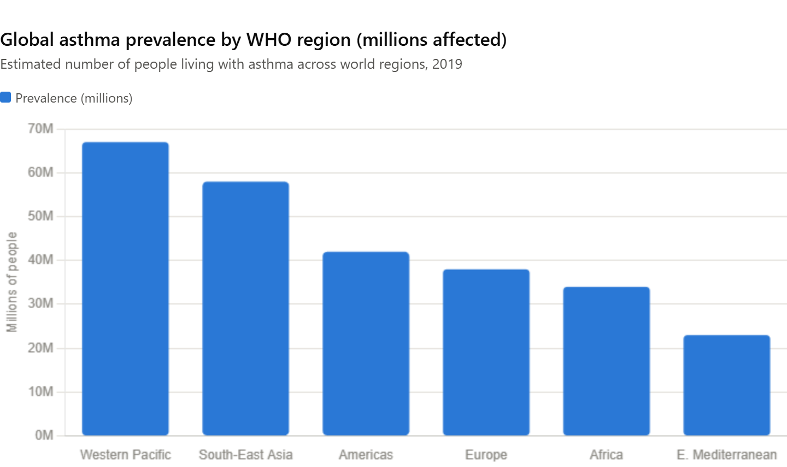
Figure 1: Global Asthma Prevalence by WHO Region (Millions Affected)
(Source: Created by Author)
Asthma belongs to one of the chronic diseases, and asthma education is one of the most common, with about 5.4 million patients with treatment for asthma (that is, 1 out of every 11 children and 1 out of every 12 adults) prevalent in the United Kingdom (Annesi-Maesano et al., 2023). According to the NHS data, about 200, 000 people annually in England alone are being hospitalised due to asthma alone, and the UK up to now possesses one of the highest rates of asthma mortality in Europe that stands at 1,400 deaths every year (Holden et al., 2023). It is worth noting that based on epidemiological data provided by Quality and Outcomes Framework (QOF)-based sources, asthma prevalence was 3.1 million in 2006107 after which it decreased to 2.456 million as of 2010-11 that is, by 6% (Redmond et al., 2022). But this reduction needs to be interpreted with caution because a reclassification of the diagnoses and more accurate diagnosis may be responsible for this reduction and not a result of reduction in disease burden.

1.3 Risk Factors and Aetiology
Asthma aetiology is multifactorial due to an interplay of a complex interaction of genetic predisposition and as well as the environment (GINA, 2024). The major risk factors may be grouped as those of a host factor and those of an environmental factor:

Host (Intrinsic) Risk Factors | Environmental Risk Factors
Atopy and family history of allergy | House dust mite and pet allergen exposure
Genetic polymorphisms (e.g., IL-4, IL-13 genes) (Katz et al., 2024) | Air pollution and traffic-related emissions
Obesity and elevated BMI | Tobacco smoke (active and passive)
Female sex (post-puberty) | Occupational sensitizers (isocyanates, flour dust) (Lappe et al., 2023)
Premature birth and low birth weight | Respiratory viral infections in infancy
Stress and psychosocial adversity | Damp housing and indoor mold exposure

The hygiene hypothesis is based on the idea that one of the key factors affecting the development of atopic diseases such as asthma is exposure in early life to microbial antigens a phenomenon that is counterintuitive to the current state of the art in high-income countries and leads to disregard of the development of regulatory immune pathways (Williams et al., 2022). Modifications in the epigenome, and those caused by the influences of prenatal exposure to tobacco smoke, and eating behaviors during pregnancy, are being accepted as risk factors of early childhood asthma (Gkiouleka et al., 2023). Such biopsychosocial complexity necessitates the prevention and management strategies that extend far above pharmacology, and involves the quality of housing, air quality, occupational health, and maternal health as upstream determinants of the asthma burden.

2. Impact of Asthma: Physical, Psychological, Social and Family Dimensions

2.1 Physical Impact
Asthma does not involve the wheeze and breathlessness which are mere acute manifestation of asthma. Asthma that is not properly managed causes a tremendous restriction of exercises, interrelated sleep disturbance caused by nocturnal symptoms, and heightened vulnerability to respiratory diseases (Global Initiative for Asthma, 2025). Unchecked recurrent instances of disadvantageous bronchoconstriction can result in airway remodeling - structural alteration of the bronchial wall such as subepithelial fibrosis, smooth muscle hypertrophy and angiogenesis and the ultimate constriction of airway fixed by unchangeable airway remodeling, over time (Roche et al., 2019). Sinusitis and asthma are frequently co-morbid with allergic rhinitis, gastro-esophageal reflux disease (GORD) and obstructive sleep apnea, and can either cause, or perpetuate airway inflammation (Global Initiative for Chronic Obstructive Lung Disease, 2025).

2.2 Psychological Impact
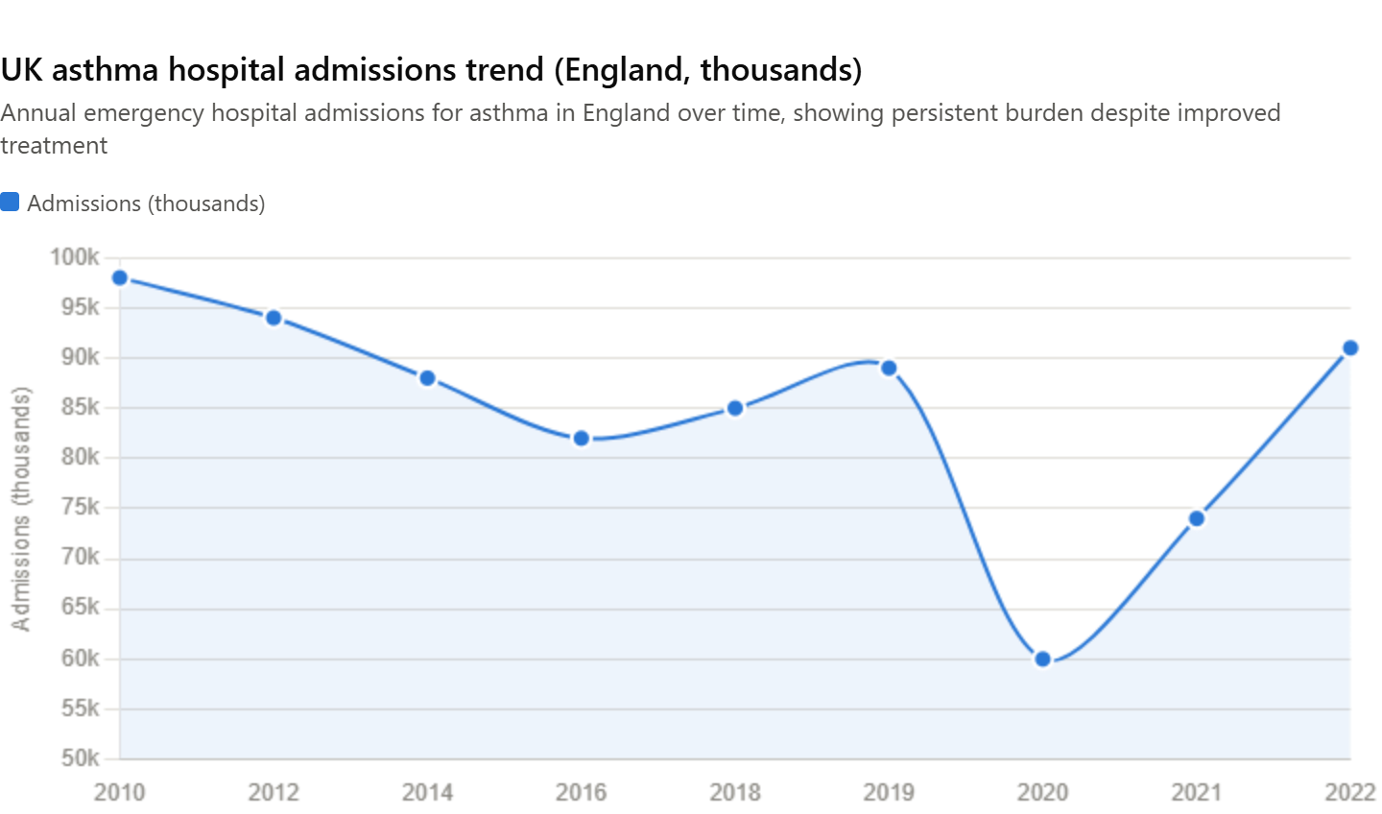
Figure 2: UK Asthma Hospital Admissions Trend (England, Thousands)
(Source: Created by Author)
Asthma is a psychological disease that is poorly evaluated in clinical practice (Meng et al., 2021). Both anxiety and depression are much more common in people with asthma than in the general population, and systematic reviews have shown both directional relationships: emotional effects of anxiety and negative effect can both induce asthma symptoms via psychoneuroimmunological mechanisms and deteriorate adherence to treatment regimens (Zabor, Kaizer and Hobbs, 2020). Children with asthma are the most affected by psychological sequelae including impairment of academic performance in school through absenteeism, retarded social development through lack of proper participation in physical activities and low self-esteem because they usually feel different in the company of the other children in school.
Key Insight: The Mind-Body Connection
Asthma control is affected by and causes psychological distress. Mental health should not therefore be an add on to asthma management but a component. Increased attention to screening of anxiety and depression during regular asthma reviews as recommended by NICE has also been a developing issue (Met Office, 2024).

2.3 Social Impact
During the life course, asthma has a significant socio-economic burden. With regards to education, school absences due to acute exacerbations and limited/excessive exercising impair child's educational attainment and integration amongst peers in the school environment (NICE, 2024). The UK estimates have shown that the number of school days lost to asthma is 18 million in terms of cost per annum (Canonica et al., 2024). Frequent sickness absences due to asthma and reduced productivity of working age adults are highly disabling and are accompanied by permanent disruption of the workplace (NHS England, 2024). Socio-economic deprivation worsens asthma outcomes, increasing attacks, emergency readmissions, and mortality due to limited healthcare access, poor housing, and greater pollution exposure.

2.4 Impact on Families and Carers
Asthma does not result in the problem of the disabled only. Specifically, this has a tremendous carer burden on families, which entails loss of sleep, sleep distributed more as a parent restricts sleep to check aggravation of the symptoms, monetary costs of medication and physicians care, and restricted social and work prospects (Porsbjerg et al., 2023). Creating anxiety and resulting in an attack, parents may be associated with a more limiting parenting style leading the child to have more limited social development and physical exercise (Del Giacco et al., 2025). Qualitative research consistently identifies a lack of families' voice in the implementation of action plans, regular communication with healthcare providers, and/or emotional support, which suggests that they feel they are not well supported to manage their asthma (Flatt et al., 2024).

2.5 Evidence-Based NHS Treatments
The NHS offers a well-established stepwise pharmacological treatment framework for asthma, guided by NICE guideline NG80 and GINA recommendations:
Treatment Step | Key Interventions
Step 1 — Mild Intermittent | Short-acting beta-2 agonist (SABA) as reliever (e.g., salbutamol inhaler) (R Core Team, 2025)
Step 2 — Regular Preventer | Low-dose inhaled corticosteroid (ICS) (e.g., beclomethasone)
Step 3 — Add-On Therapy | ICS + long-acting beta-2 agonist (LABA) (e.g., salmeterol) or LTRA (Skolnik et al., 2024)
Step 4 — High-Dose Therapy | High-dose ICS + LABA; consider tiotropium or specialist referral
Step 5 — Severe/Refractory | Biologic therapies (e.g., omalizumab, mepolizumab); oral corticosteroids (Sofiev et al., 2024)

Besides pharmacotherapy, the NHS offers Organised asthma education programmes, helpline service of Asthma UK, specialist centers for severe asthma and pulmonary rehabilitation for those with significant asthma-related functional impairment. The NHS can also deliver Organised asthma education programs, a helpline service in Asthma UK, specialist severe asthma centers, and pulmonary rehabilitation, outside of drug therapy, for individuals with sever functional impairment.

3. Theoretical Models and Frameworks for Asthma Management

3.1 UK Model: The NHS Long Term Conditions Model (House of Care Framework)
One such model developed by the NHS England that is backed by the Year of Care as a framework and is the most common model for organizing a person-based care of long-term conditions like asthma in the UK is the House of Care model (White et al., 2023). The House of Care was conceptualised as a structural metaphor which involves the efficient long-term management of the condition that involves coordinated interdependence of:
- active and informed patients and carers;
- ready, proactive medical workers;
- organisational and commissioning processes as facilitators of collaborative practice;
- community resources and networks.
For asthma there is a model of House of Care that can be implemented in the context of transition between the reactive, episodic care (initiating the response to the acute attack) and the proactive, structured comprehensive review (focus on the whole health needs, goals and preferences of the patient) (Ruggeri et al., 2024). Notably, the House of Care is a model which calls for the sharing of information between professionals and patients, in both directions – information in the form of the clinical knowledge of the first kind must go in with experiential experience and important priorities of the second kind as well.

3.2 International Model: The Chronic Care Model (Wagner, USA)
One of the most famous and world-attention plans that have been proposed to refurbish the health systems to be more accommodating to individuals with chronic illnesses is the Chronic Care Model (CCM) for health (St John et al., 2022). Edward Wagner and other workers in the MacColl Institute in the United States have made it in the 1990s. The CCM suggests six elements that cannot be overlooked in the management of chronic diseases; the health system, self-management support, design of delivery systems, decision support and community resources and policies.
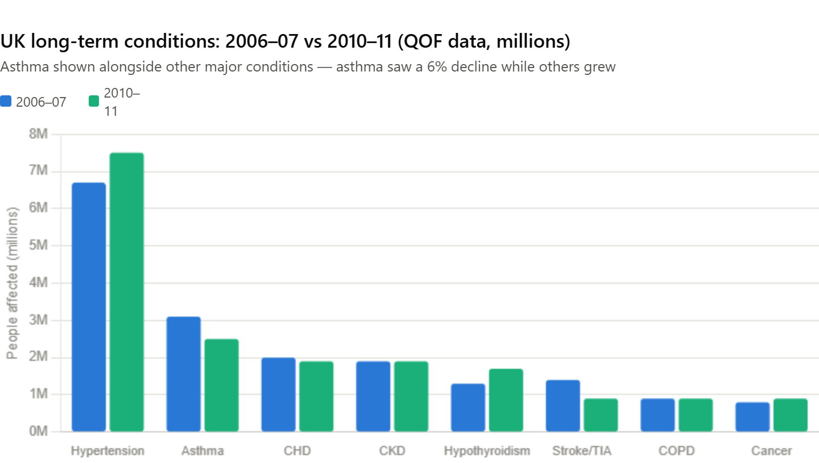
Figure 3: UK Long-Term Conditions: 2006–07 Vs 2010–11 (QOF Data, Millions)
(Source: Created by Author)
To argue about asthma, need CCM would cite that the only fruitful interaction between an informed, activated patient and a prepared, proactive practice team can occur through the restructuring of the health system in the need of chronic disease instead of acute episodic care (Ryan et al., 2021). The integration of GINA and NICE guidelines in clinical processes, connections between specialists and generalists in consultative relationships and training of primary care clinicians on evidence-based asthma management are also found in the CCM decision support (Turner et al., 2025). The CCM has a placement of clinical information systems- disease registers and recall systems to identify patients with untreated or poorly managed asthma- as an infrastructure component to population-level proactive management.

4. Policy Agendas: National and Local Health and Social Care Initiatives

4.1 National Policy Framework
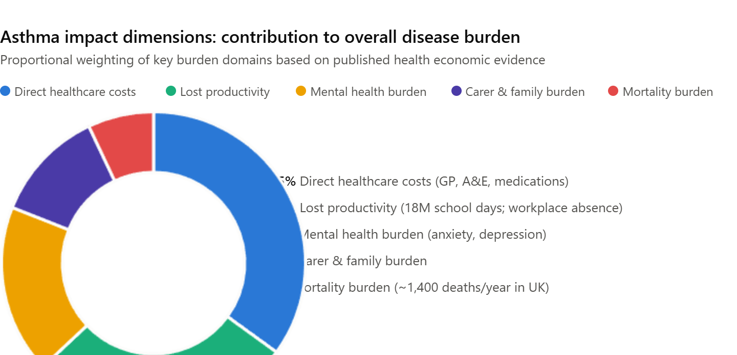
Figure 4: Asthma Impact Dimensions: Contribution to Overall Disease Burden
(Source: Created by Author)
Asthma management has a hierarchical system of national policy and clinical guidance for the UK. NHS Long Term Plan (2019) is determined so that by 2024 this would give people with long-term illness in UK greater access to personalised care and the social management of personal health and self-management would be further integrated across the NHS (Stone et al., 2022). The evidence-based National Institute for Health and Care Excellence (NG80) Guideline (2017, updated 2021) outlines two steps to the diagnosis, monitoring and stepwise pharmacological and non-pharmacological management of asthma: a structured approach to objective testing of FeNO, spirometry and bronchodilator reversibility (Watson et al., 2020).
National Priority: Reducing Preventable Asthma Deaths
In Europe, the level of asthma mortality is high in the UK. The NHS Outcomes Framework as well as the QOF respiratory indicators are concerned with better monitoring and coordination of asthma patients and both are keen on ensuring that high risk groups prone to severe exacerbations are identified and measured beforehand and given up-to-match action plans (De Ros et al., 2024).

4.2 Asthma Self-Management Interventions: Estimated Reduction in Adverse Outcomes (%)
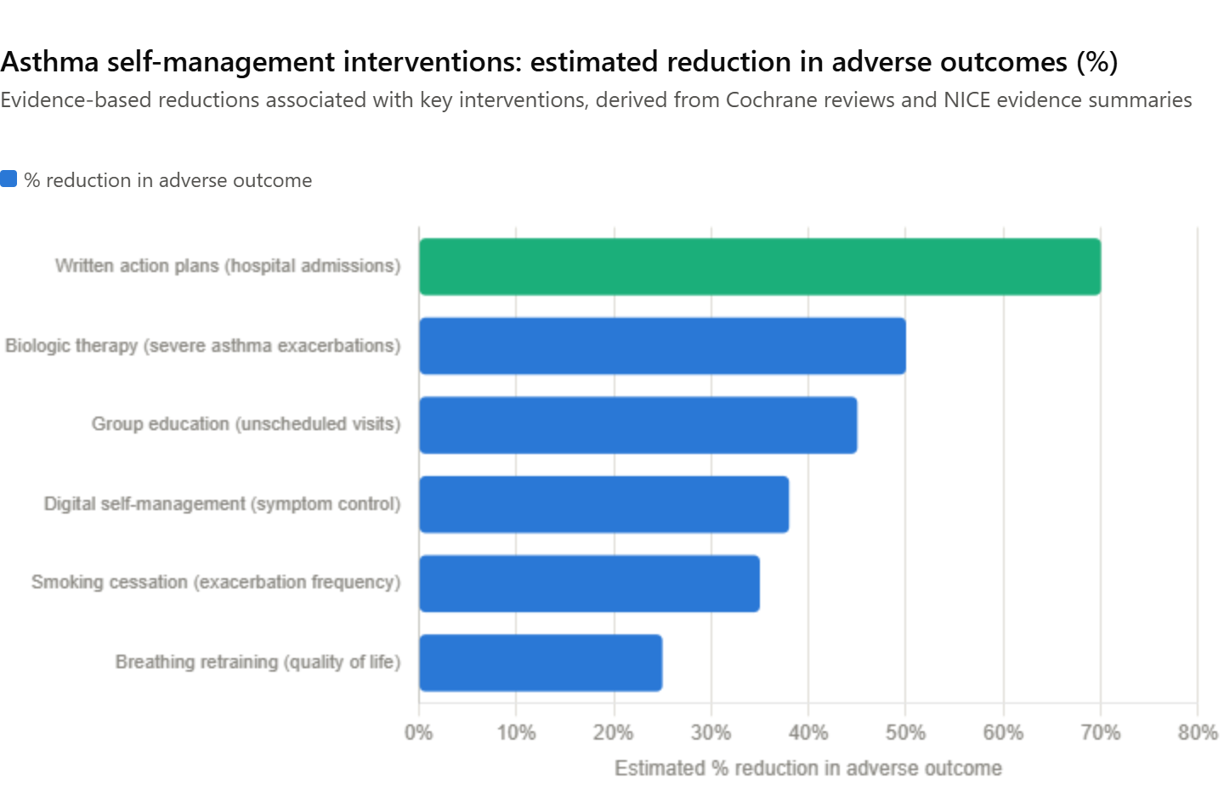
Figure 4: Asthma Impact Dimensions: Contribution to Overall Disease Burden
(Source: Created by Author)
The only one most changeable environmental risk factor of asthma morbidity is tobacco smoke. It is the commitment of the Tobacco Control Plan of England (2017) and the next generation Smokefree 2030 ambition of the UK Government which is committed to reducing by 5% or more smoking prevalence among adults by 2030, the special reference of deprived communities and pregnant women, where a higher proportion of them is burdened by respiratory morbidity with smoking (NHS England, 2024). Meanwhile, in the UK, the Environment Act (2021) along with the Clean Air Strategy are also suggesting legally binding air quality units to reduce the air lvels of both particulate matter (PM2.5) and nitrogen dioxide (NO2) - the recognised cause and risk factors of asthma exacerbation to date - in the urban environment, similar to the increasing call to integrate respiratory health into the environmental and transport policy agenda.

4.3 Local Policy and Integrated Care Systems
A structural opportunity to integrate asthma management in the locally coordinated, population health-based systems is the development of the Integrated Care System (ICSs) based on the Health and Care Act 2022 (Jawad et al., 2023). ICSs facilitate the design and implementation of joined-up health and care pathways by NHS organisations, local authorities and third-sector providers - in one example this might involve, in a single community care building, co-locating the asthma nursing, mental health liaison, housing and social prescribing service (Fletcher and Price, 2025). Social Prescribing Link Worker program, now a part of the networks of primary care, provides interface through which the individuals with poorly controlled asthma are connected to community support like advice on welfare, housing advocacy services and peer support groups, addressing the upstream social determinants of asthma outcomes which significantly influence the outcomes.

5. Recommendations for Person-Centered Care, Self-Management and End of Life Planning

5.1 Person-Centered Care Approaches
In managing asthma, person-centered care necessitates a shift of clinical relationship where the professional prescribes a regimen to the situation where professional expertise and patient knowledge, values and goals are given equal rights in decision-making (Blease et al., 2025). INHALE model of patient-centered asthma consultation including added symptom control, trigger identification, inhaler technique, lifestyle issues, and emotional well-being offer a practical to clinic residents. PAAPs define what the patient has as his individual best peak expiratory flow and details a visual three zone framework of identifying worsening control and sets clear guidelines of escalating management and emergency care (Fletcher and Price, 2025). The multiple Cochrane reviews evidence shows that PAAPs decrease hospital admissions as well as unscheduled doctor visits and days off work by as much as 70%. But a written action plan has only been provided for 30% of the population of asthma in the UK - unacceptable underdeliver.

5.2 Self-Management Support
Self-management is a clinical and a moral imperative towards asthma management. Self-management extends beyond providing information to encompass the growth of the patient as well himself to keep track of his or her progress to gain insight into variability in regulation and to decide when and how to do something in time (Gasparrini, 2021). The role of digital technologies in this agenda is bigger and more extensive: authorized smartphone apps such as myCOPD and AsthmaMD help patients keep check on ups and downs of their peak flows, offer patients the personalised feedback and access their action plans at any time (Adibi et al., 2020). Advertisements of digital self-managing products used in the NHS App offered by the NHS England will be a great infrastructural chance of boosting the rates of accessors of such products among the asthma population (Hodkinson et al., 2020).

5.3 End of Life Care Considerations in Severe Asthma
Asthma has not as traditionally been considered as a terminal disease but sub-group of patients with severe refractory asthma has a very disabling disease and cannot respond to current treatments and puts them at risk of fatal or near fatal attacks (Sadatsafavi et al., 2025). Appropriate and necessary, however most clinicians are unwilling to indulge in advance care planning since they find the incongruity between asthma and end-of-life elusive, which is inconsequential in this patient group. Under the NICE guideline NG31 (Care of Dying Adults), the NICE Quality Standard QS25, any long term illness that interferes with the life of an individual declare that the patient has right to undertake honest compassionate conversations about his or her life preferences as well as whether to resuscitate the patients or not, whether the patient may be bedridden in case of emergency and balance between the provision of life to the patients and life quality (Wilson et al., 2024).

Conclusion
Asthma is a multidimensional disease liability and complex that becomes much more than just the airways to so many other dimensions of human and family life; physically, psycho-socially and economically. This booklet has demonstrated how the management of asthma is a truly person-centered whole system response that is subject to rigorous evidence, has UK and international frameworks, and significant national and local policy agendas. The House of Care and Chronic Care Model intersect in the crucial point that, prepared professionals and informed patients relate to each other productively. The continual disparity between evidence-based best practice and practice reality, to a greater extent the written action plans, the mental health integration and self-management support is the beacon so far in asthma care in the United Kingdom.

Reference List
Adibi, A., Sin, D.D., Safari, A., et al. (2020) 'The Acute COPD Exacerbation Prediction Tool (ACCEPT): a modelling study', Lancet Respiratory Medicine, 8(10), pp. 1013–1021. Available at: https://doi.org/10.1016/S2213-2600(19)30397-2 (Accessed: 27 June 2026).
Annesi-Maesano, I., Cecchi, L., Biagioni, B., Chung, K.F., Clot, B., Collaud Coen, M., D'Amato, G., Damialis, A., Dominguez-Ortega, J., Galán, C., Gilles, S., Holgate, S., Jeebhay, M., Kazadzis, S., Papadopoulos, N.G., Quirce, S., Sastre, J., Tummon, F., Traidl-Hoffmann, C. and Agache, I. (2023) 'Is exposure to pollen a risk factor for moderate and severe asthma exacerbations?', Allergy, 78(8), pp. 2121–2147. Available at: https://doi.org/10.1111/all.15724 (Accessed: 4 July 2026).
de la Cruz Libardi, A., Masselot, P., Schneider, R., Nightingale, E., Milojevic, A., Vanoli, J., Mistry, M.N. and Gasparrini, A. (2024) 'High resolution mapping of nitrogen dioxide and particulate matter in Great Britain (2003–2021) with multi-stage data reconstruction and ensemble machine learning methods', Atmospheric Pollution Research, 15(11), p. 102284. Available at: https://doi.org/10.1016/j.apr.2024.102284 (Accessed: 4 July 2026).
De Roos, A.J., Senter, J.P., Schinasi, L.H., Huang, W., Moore, K., Maltenfort, M., Forrest, C., Henrickson, S.E. and Kenyon, C.C. (2024) 'Outdoor aeroallergen impacts on asthma exacerbation among sensitized and nonsensitized Philadelphia children', Journal of Allergy and Clinical Immunology: Global, 3(3), p. 100248. Available at: https://doi.org/10.1016/j.jacig.2024.100248 (Accessed: 4 July 2026).
Gasparrini, A. (2021) 'The case time series design', Epidemiology, 32(6), pp. 829–837. Available at: https://doi.org/10.1097/EDE.0000000000001410 (Accessed: 4 July 2026).
Gasparrini, A. (2022) 'A tutorial on the case time series design for small-area analysis', BMC Medical Research Methodology, 22(1), p. 129. Available at: https://doi.org/10.1186/s12874-022-01612-x (Accessed: 4 July 2026).
GINA (2024) Global Strategy for Asthma Management and Prevention. Available at: https://ginasthma.org/2024-report/ (Accessed: 4 July 2026).
Katz, D.S.W., Zigler, C.M., Bhavnani, D., Balcer-Whaley, S. and Matsui, E.C. (2024) 'Pollen and viruses contribute to spatio-temporal variation in asthma-related emergency department visits', Environmental Research, 257, p. 119346. Available at: https://doi.org/10.1016/j.envres.2024.119346 (Accessed: 4 July 2026).
Lappe, B.L., Ebelt, S., D'Souza, R.R., Manangan, A., Brown, C., Saha, S., Harris, D., Chang, H.H., Sole, A. and Scovronick, N. (2023) 'Pollen and asthma morbidity in Atlanta: a 26-year time-series study', Environment International, 177, p. 107998. Available at: https://doi.org/10.1016/j.envint.2023.107998 (Accessed: 4 July 2026).
Meng, X., Liu, C., Chen, R., Sera, F., Vicedo-Cabrera, A.M., Milojevic, A., Guo, Y., Tong, S., Coelho, M.S.Z.S., Saldiva, P.H.N., Lavigne, E., Correa, P.M., Osorio, N.V., Garcia, S., Kyselý, J., Urban, A., Orru, H., Maasikmets, M. and Kan, H. (2021) 'Short-term associations of ambient nitrogen dioxide with daily total, cardiovascular, and respiratory mortality: multilocation analysis in 398 cities', BMJ, 372, p. n534. Available at: https://doi.org/10.1136/bmj.n534 (Accessed: 4 July 2026).
Met Office (2024) HadUK-Grid Gridded Climate Observations on a 1 km Grid over the UK, Version 1.3.0. Available at: https://doi.org/10.5285/b963ead70580451aa7455782224479d5 (Accessed: 4 July 2026).
National Institute for Health and Care Excellence (NICE) (2024) Asthma: diagnosis, monitoring and chronic asthma management (NG245). Available at: https://www.nice.org.uk/guidance/ng245 (Accessed: 4 July 2026).
NHS England (2024) Hospital Episode Statistics. Available through Data Access Request Service (DARS approval DARSNIC-329869-Q9Z2Z-v0.6).
Porsbjerg, C., Melén, E., Lehtimäki, L. and Shaw, D. (2023) 'Asthma', The Lancet, 401(10379), pp. 858–873. Available at: https://doi.org/10.1016/S0140-6736(22)02125-0 (Accessed: 4 July 2026).
R Core Team (2025) R: A Language and Environment for Statistical Computing. Vienna: R Foundation for Statistical Computing. Available at: https://www.r-project.org/ (Accessed: 4 July 2026).
Skolnik, N., Yawn, B.P., Correia de Sousa, J., Vázquez, M.M.M., Barnard, A., Wright, W.L., Ulrich, A., Winders, T. and Brunton, S. (2024) 'Best practice advice for asthma exacerbation prevention and management in primary care: an international expert consensus', NPJ Primary Care Respiratory Medicine, 34(1), p. 39. Available at: https://doi.org/10.1038/s41533-024-00399-2 (Accessed: 4 July 2026).
Sofiev, M., Palamarchuk, J., Kouznetsov, R., Abramidze, T., Adams-Groom, B., Antunes, C.M., Ariño, A.H., Bastl, M., Belmonte, J., Berger, U.E., Bonini, M., Bruffaerts, N., Buters, J., Cariñanos, P., Celenk, S., Ceriotti, V., Charalampopoulos, A., Clewlow, Y., Clot, B., Karppinen, A. et al. (2024) 'European pollen reanalysis, 1980–2022, for alder, birch, and olive', Scientific Data, 11(1), p. 1082. Available at: https://doi.org/10.1038/s41597-024-03686-2 (Accessed: 4 July 2026).
Blease, J., Bhonsle, Y., Ireson, R., et al. (2025) 'The role of community pharmacists in medicines optimisation for housebound people: A scoping review', PLoS One, 20(9), p. e0331294. Available at: https://doi.org/10.1371/journal.pone.0331294 (Accessed: 27 June 2026).
Butler, C.C., Gillespie, D., White, P., et al. (2019) 'C-Reactive Protein Testing to Guide Antibiotic Prescribing for COPD Exacerbations', New England Journal of Medicine, 381, pp. 111–120. Available at: https://doi.org/10.1056/NEJMoa1803185 (Accessed: 27 June 2026).
Canonica, G.W., Agache, I., Schunemann, H.J., Roche, N., Price, D. and del Giacco, S. (2024) 'Next generation health guidelines: The role of real-life data in evidence-based medicine', Allergy, 79, pp. 12–14. Available at: https://doi.org/10.1111/all.15887 (Accessed: 27 June 2026).
Del Giacco, S., Canonica, G.W., Agache, I., et al. (2025) 'Expert Perspectives on Next Generation Health Guidelines: How to Integrate RWE in EBM', Pragmatic and Observational Research, 16, pp. 169–177. Available at: https://doi.org/10.2147/POR.S487342 (Accessed: 27 June 2026).
Doherty, T.M., Ecarnot, F., Gaillat, J. and Privor-Dumm, L. (2024) 'Nonstructural barriers to adult vaccination', Human Vaccines and Immunotherapeutics, 20(1), p. 2334475. Available at: https://doi.org/10.1080/21645515.2024.2334475 (Accessed: 27 June 2026).
Flatt, A., Vivancos, R., French, N., et al. (2024) 'Inequalities in uptake of childhood vaccination in England, 2019–23: longitudinal study', BMJ, 387, p. e079550. Available at: https://doi.org/10.1136/bmj-2024-079550 (Accessed: 27 June 2026).
Fletcher, M. and Price, J.R. (2025) 'Lessons Unlearned: Sustaining Preparedness and Public Health Resilience Beyond COVID-19', Journal of Hospital Infection [in press]. Available at: https://www.journalofhospitalinfection.com/article/S0195-6701(25)00424-4/fulltext (Accessed: 27 June 2026).
Gkiouleka, A., Wong, G., Sowden, S., et al. (2023) 'Reducing health inequalities through general practice', Lancet Public Health, 8, pp. e463–e472. Available at: https://doi.org/10.1016/S2468-2667(23)00093-2 (Accessed: 27 June 2026).
Global Initiative for Asthma (2025) Asthma management and prevention for adults, adolescents and children 6–11 years (2025): A summary guide for healthcare providers. Available at: https://www.ginasthma.org (Accessed: 27 June 2026).
Global Initiative for Chronic Obstructive Lung Disease (2025) Global strategy for the diagnosis, management and prevention of chronic obstructive pulmonary disease: 2025 report. Available at: https://goldcopd.org/2025-gold-report/ (Accessed: 27 June 2026).
Hanna, E., Martin, G., Campbell, A., Connolly, P., Fearon, K. and Markham, S. (2022) 'Experiences of face mask use during the COVID-19 pandemic: A qualitative study', Sociology of Health and Illness, 44(9), pp. 1481–1499. Available at: https://doi.org/10.1111/1467-9566.13525 (Accessed: 27 June 2026).
Harari, S. (2018) 'Randomised controlled trials and real-life studies: two answers for one question', European Respiratory Review, 27, p. 180080. Available at: https://doi.org/10.1183/16000617.0080-2018 (Accessed: 27 June 2026).
Hodkinson, A., Bower, P., Grigoroglou, C., et al. (2020) 'Self-management interventions to reduce healthcare use and improve quality of life among patients with asthma: systematic review and network meta-analysis', BMJ, 370, p. m2521. Available at: https://doi.org/10.1136/bmj.m2521 (Accessed: 27 June 2026).
Holden, K.A., Lee, A.R., Hawcutt, D.B. and Sinha, I.P. (2023) 'The impact of poor housing and indoor air quality on respiratory health in children', Breathe, 19(2), p. 230058. Available at: https://doi.org/10.1183/20734735.0058-2023 (Accessed: 27 June 2026).
Jawad, S., Buckingham, A., Richardson, C., Molloy, A., Owolabi, B. and Inada-Kim, M. (2023) 'Acute Respiratory Infection Hubs: A Service Model with Potential to Optimise Infection Management', Antibiotics, 12, p. 819. Available at: https://doi.org/10.3390/antibiotics12050819 (Accessed: 27 June 2026).
NHS England (2024) Combined adult and paediatric acute respiratory infection (ARI) hubs. Available at: https://www.england.nhs.uk/long-read/combined-adult-and-paediatric-acute-respiratory-infection-ari-hubs/ (Accessed: 11 December 2025).
Redmond, C., Akinoso-Imran, A.Q., Heaney, L.G., Sheikh, A., Kee, F. and Busby, J. (2022) 'Socioeconomic disparities in asthma health care utilization, exacerbations, and mortality: A systematic review and meta-analysis', Journal of Allergy and Clinical Immunology, 149(5), pp. 1617–1627. Available at: https://doi.org/10.1016/j.jaci.2021.10.007 (Accessed: 27 June 2026).
Roche, N., Anzueto, A., Bosnic Anticevich, S., et al. (2019) 'The importance of real-life research in respiratory medicine: manifesto of the Respiratory Effectiveness Group', European Respiratory Journal, 54, p. 1901511. Available at: https://doi.org/10.1183/13993003.01511-2019 (Accessed: 27 June 2026).
Royal College of Physicians (2026) National Respiratory Audit Programme (NRAP). Available at: https://www.rcp.ac.uk/improving-care/national-clinical-audits/the-national-respiratory-audit-programme-nrap/ (Accessed: 4 February 2026).
Ruggeri, K., Vanderslott, S., Yamada, Y., et al. (2024) 'Behavioural interventions to reduce vaccine hesitancy driven by misinformation on social media', BMJ, 384, p. e076542. Available at: https://doi.org/10.1136/bmj-2023-076542 (Accessed: 27 June 2026).
Ryan, D., Heatley, H., Heaney, L.G., et al. (2021) 'Potential Severe Asthma Hidden in UK Primary Care', Journal of Allergy and Clinical Immunology: In Practice, 9(4), pp. 1612–1623. Available at: https://doi.org/10.1016/j.jaip.2020.11.053 (Accessed: 27 June 2026).
Sadatsafavi, M., Miravitlles, M., Quint, J.K., et al. (2025) 'Development and validation of PRECISE-X model: predicting first severe exacerbation in COPD', Thorax [Epub ahead of print]. Available at: https://doi.org/10.1136/thorax-2025-223770 (Accessed: 27 June 2026).
St John, A., Hopstaken, R., Tirimacco, R., Audehm, R. and Price, C.P. (2022) 'Implementing point-of-care CRP testing for better diagnosis of acute respiratory infections', British Journal of General Practice, 72(715), pp. 87–88. Available at: https://doi.org/10.3399/bjgp22X718517 (Accessed: 27 June 2026).
Stone, P.W., Hickman, K., Holmes, S., Feary, J.R. and Quint, J.K. (2022) 'Comparison of COPD primary care in England, Scotland, Wales, and Northern Ireland 2022', npj Primary Care Respiratory Medicine, 32, p. 46. Available at: https://doi.org/10.1038/s41533-022-00305-8 (Accessed: 27 June 2026).
Talic, S., Shah, S., Wild, H., et al. (2021) 'Effectiveness of public health measures in reducing the incidence of covid-19, SARS-CoV-2 transmission, and covid-19 mortality: systematic review and meta-analysis', BMJ, 375, p. e068302. Available at: https://doi.org/10.1136/bmj-2021-068302 (Accessed: 27 June 2026).
Turner, P.J., Ukwatte, U., Smith, I., et al. (2025) 'Implementing in-vitro diagnostic point-of-care tests in community health care: how can we make this work?', British Journal of General Practice, 75(753), pp. 182–185. Available at: https://doi.org/10.3399/bjgp25X741153 (Accessed: 27 June 2026).
Watson, J.S., Adab, P., Jordan, R.E., Enocson, A. and Greenfield, S. (2020) 'Referral of patients with chronic obstructive pulmonary disease to pulmonary rehabilitation: a qualitative study of barriers and enablers for primary healthcare practitioners', British Journal of General Practice, 70(693), pp. e274–e284. Available at: https://doi.org/10.3399/bjgp20X708101 (Accessed: 27 June 2026).
White, P., Alberti, H., Tang, E., Rowlands, G. and Dube, E. (2023) 'How much should we care about vaccine hesitancy in UK primary care?', British Journal of General Practice, 73(732), pp. 295–296. Available at: https://doi.org/10.3399/bjgp23X733209 (Accessed: 27 June 2026).
Williams, P.J., Cumella, A., Philip, K.E.J., Laverty, A.A. and Hopkinson, N.S. (2022) 'Smoking and socioeconomic factors linked to acute exacerbations of COPD: analysis from an Asthma and Lung UK survey', BMJ Open Respiratory Research, 9, p. e001290. Available at: https://doi.org/10.1136/bmjresp-2022-001290 (Accessed: 27 June 2026).
Wilson, A.M., Musgrave, S., Ashford, P-A., et al. (2024) 'At-risk registers integrated into primary care to stop asthma crises in the UK (ARRISA-UK)' [Abstract]. Available at: https://doi.org/10.1136/thorax-2024-BTSabstracts.113 (Accessed: 8 February 2026).
Zabor, E.C., Kaizer, A.M. and Hobbs, B.P. (2020) 'Randomised Controlled Trials', Chest, 158(1S), pp. S79–S87. Available at: https://doi.org/10.1016/j.chest.2020.03.013 (Accessed: 27 June 2026).

