Cover page
E Portfolio

Table of Contents
Cover page 1
Task 1: Written summary 2
Task 2: Infographic 4
Task 3: Essay plan 6
References 8

Task 1: Written summary

How to succeed in your degree, with psychology…

You may have got into university, however that doesn't mean your study habits surrounding studying are too standard. Using low standard approaches to studying may compromise how successful you are in your degree.

Your efforts to learn are associated with the accuracy of how skilfully you can observe and assess your levels of knowledge and understanding. Base your studying on evidence of progress to avoid lowering the standard of your studying.

To avoid procrastination, focus on the word ‘if’ and following it up with the word ‘then’ this ensures you are more reluctant to follow a schedule.

When taking notes don't reproduce someone Elses, read and take notes with the perspective of gaining knowledge for your own understanding, actively engage in the topic to help get the most of out of your note taking and reading.

To achieve successful paraphrasing focus on the way you are making use of sources, you can start by generating questions related to your source material that require an explanation from you to follow, this ensures you are setting the idea to what you want to write.

Individuals think to complicate their writing however these backfires. Strip your writing from unnecessary complexities and terminology, write with the aim of being understood by a non-expert audience.

Peer evaluation is crucial to ensure group members take accountability for their contributions, this guarantees that all team members participate. This involves team members rating each other's contributions withing the project.

When giving presentations ensure that each slide has relevance and avoid unnecessary detail. To avoid going of topic stick to most relevant material, ensure each title has clear assertion.

When revising does not rely on short term performance such as cramming, this may seem easier when revising but makes exams harder, focus on spreading out revision, this is more effective.

References:
Penn, P. (2019b). The psychology of effective studying : how to succeed in your degree. Routledge Uuuu-Uuuu.

Task 2: Infographic

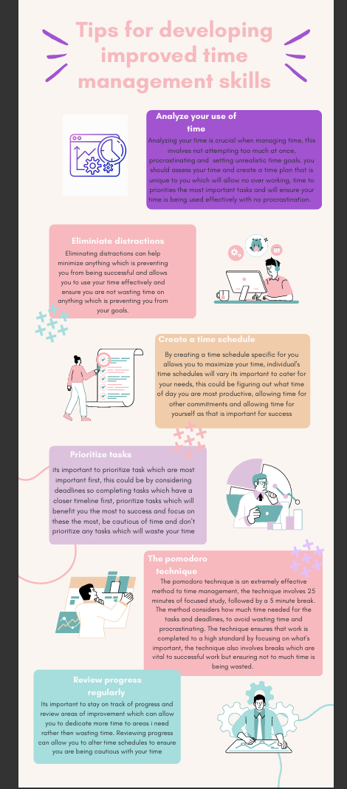
Reference list:

Time image: bsd_studio. (2021). Time analysis gradient linear. In vecteezy. https://www.vecteezy.com/vector-art/2997211-time-analysis-gradient-linear-vector-icon

Ferner, J. D. (1995). Successful time management : a self-teaching guide. New York Wiley.

Springer, C. (2020). Learning and Collaboration Technologies. Human and Technology Ecosystems : 7th International Conference, LCT 2020, Held as Part of the 22nd HCI International Conference, HCII 2020, Copenhagen, Denmark, July 19-24, 2020, Proceedings, Part II. Springer International Publishing, Imprint Springer.

Task 3: Essay plan

Describe and discuss the psychological, social and physical benefits of engaging in a sporting activity.

Introduction | General  introductory  comments | Engaging in sports can have various benefits for individuals, sports can benefit people psychologically by participating in physical activity can reduce depressive and anxiety symptoms as exercise causes the release of neurotransmitters in brain which boost mood. Sports has a myriad of benefits on physical health from promoting general health to preventing illness and disease. The engagement in sports can also allow individuals to expand social circles and benefit by developing social skills.
Paragraph 1 | Topic sentence | Psychological benefits - Engaging in sports can decrease stress and anxiety due to endorphins
Paragraph 1 | Support | 1. Physical activity can decrease stress hormones, such as cortisol in the bloodstream, relieving anxiety and stress symptoms. Furthermore, engaging in sports stimulates the production of endorphins which can act as mood elevators and reduce stress. (Eime et al., 2013) 2. Exercise produces an immense rush of endorphins which aid the reduction discomfort and act as natural pain relievers which can ease an individual's anxiety and stress. (Becheva et al., 2023)
Paragraph 2 | Topic sentence | Physical benefits – Engaging in sports can improve your physical health and reduce risk of illness
Paragraph 2 | Support | 3. Engaging in sports can have a variety of benefits on physical health such as muscle strengthening sports can reduce muscle atrophy, obesity and osteoporosis. Participating in sport can reduce the risk of cancer and diabetes, it reduces joint pain and enhances bone density. (Davies et al., 2019)
Paragraph 3 | Topic sentence | Social benefits – participating in sports allows you develop social skills
Paragraph 3 | Support | 3. Participating in sport can allow you to gain new social skills, create social norms, gives you the chance to be part of a community and develop new social circles. Sport can provide individuals with a sense of belonging and identity. (Davies et al., 2019) 5.  Participation in sport initiates important social value and creates social support, people can often rely on engaging in sports for social benefits such as creating new social circles, ensuring sport is valuable activity for individuals across various demographics. (Wagner & Moustakas, 2024)
Paragraph 4 | Topic sentence | Psychological benefits - The engagement in sports can reduce depressive symptoms
Paragraph 4 | Support | 4. There have been links found between the relationship of physical activity and levels of depression; physical activity can prevent depressive symptoms. Serotonin is associated with mood changes. Serotonin is increased after physical activity, which can act as an antidepressant, therefore showing physical activity and engaging in sports reduces depression and improves mental health. (Garcia-Falgueras, 2015)
Conclusion | Summary of main ideas | Overall engaging in sports is highly beneficial on physical and psychological health as well as promoting social skills. Sports can prevent both psychological and physical illnesses

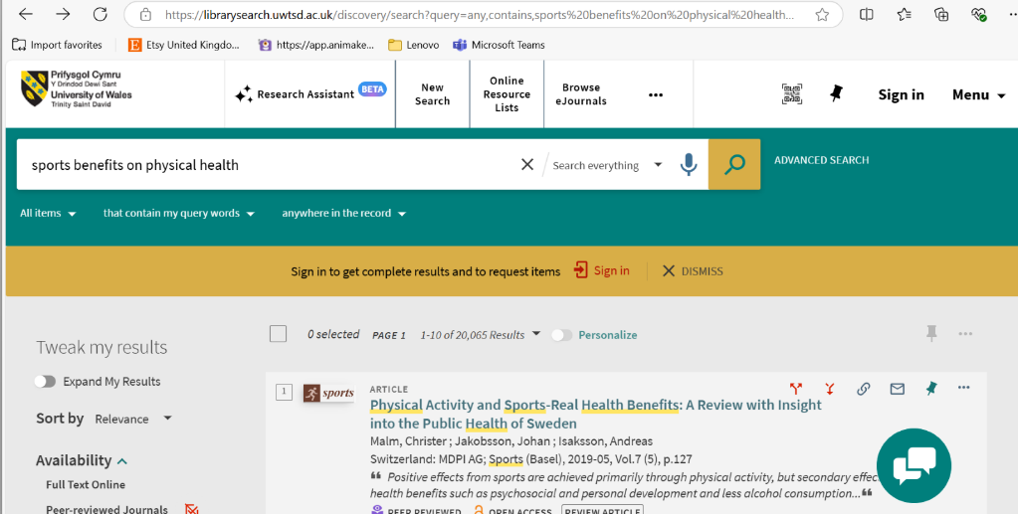

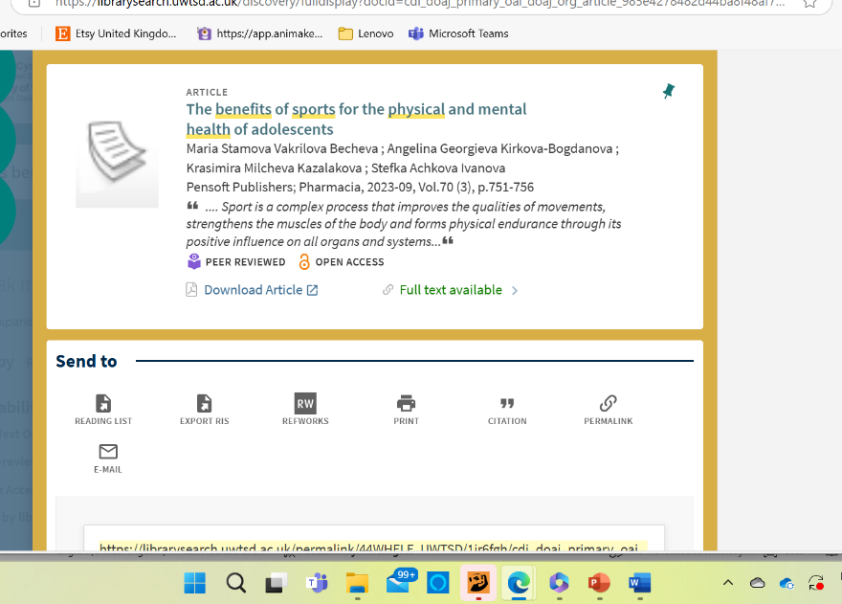
I used a library search using the university’s library system to gather information, I used two sources from the library system, the first one I discovered using the search term ‘sports benefits on physical health’, this source I found was an article, the article was dated 2019 so this could potentially be outdated, therefore lacks credibility so is not the most appropriate to use. The second source I found through the library was another article based on the benefits sports has on the physical and mental health of adolescents, this article was produced in 2023 so would be up to date and reliable, however the article was based upon adolescents, so is not inclusive and minimizes my research gathered from the source , as I was researching all ages not just adolescents. However this source was reliable and appropriate to use, it just lacked inclusivity.

How to acknowledge your use of AI

I confirm that I have not used any AI tools in the research and creation of this assignment. I confirm that I have not presented any AI generated materials as my own work. I confirm I have copies of my drafts, notes and other resources I used, which I may be asked to provide in evidence.

References (in full)

- (Eime et al., 2013)
Eime, R. M., Young, J. A., Harvey, J. T., Charity, M. J., & Payne, W. R. (2013). A Systematic Review of the Psychological and Social Benefits of Participation in Sport for Children and adolescents: Informing Development of a Conceptual Model of Health through Sport. International Journal of Behavioral Nutrition and Physical Activity, 10(1), 98. https://doi.org/10.1186/1479-5868-10-98#

- (Becheva et al., 2023)
Becheva, M. S. V., Kirkova-Bogdanova, A. G., Kazalakova, K. M., & Ivanova, S. A. (2023). The benefits of sports for the physical and mental health of adolescents. Pharmacia, 70(3), 751–756. https://doi.org/10.3897/pharmacia.70.e111888

- (Davies et al., 2019)
Davies, L. E., Taylor, P., Ramchandani, G., & Christy, E. (2019). Social return on investment (SROI) in sport: a model for measuring the value of participation in England. International Journal of Sport Policy and Politics, 11(4), 585–605. https://doi.org/10.1080/19406940.2019.1596967

- (Garcia-Falgueras, 2015)
Garcia-Falgueras, A. (2015). Psychological benefits of sports and physical activities. ResearchGate. https://www.researchgate.net/publication/285523632_Psychological_Benefits_of_Sports_and_Physical_Activities

- (Wagner & Moustakas, 2024)
Wagner, J., & Moustakas, L. (2024). Redirecting. Proquest.com. https://www.proquest.com/scholarly-journals/conceptualisation-measurement-social-cohesion/docview/2904909704/se-2?accountid=130472

