Aspect | Interpretivism | Social Constructionism
Core Focus | How individuals interpret and make sense of experiences | How groups collectively create meanings through social interaction
Level of Analysis | Individual level | Group/society level
View of Truth | Multiple individual truths exist | Created through social consensus
Knowledge Creation | Comes from personal interpretation of events | Built through shared experiences and agreements
Research Focus | How individuals interpret experiences | How knowledge is collectively created
Typical Example | Individual managers having different views of what "good leadership" means | How a team develops a shared understanding of "customer-first" through meetings and practice
Power Consideration | Focus on individual interpretations based on personal position/role | Examines how power structures influence collective meaning-making
Analysis Approach | Documents individual experiences and looks for patterns | Examines HOW shared practices and understanding develop
Business Value | Understanding individual responses, motivations, and decision-making | Understanding organizational culture, collective practices, and shared meanings
Key Challenge | Making sense of multiple individual perspectives without oversimplifying | Managing diverse views while tracking how shared unders

These metaphors highlight key differences:

Social Constructionism: Emphasis on collective creation and interaction
Interpretivism: Focus on individual perspective and personal meaning-making

Each set of metaphors captures their respective philosophical essence:

Social Constructionism: How meaning emerges through collective interaction
Interpretivism: How individuals make personal sense of shared reality

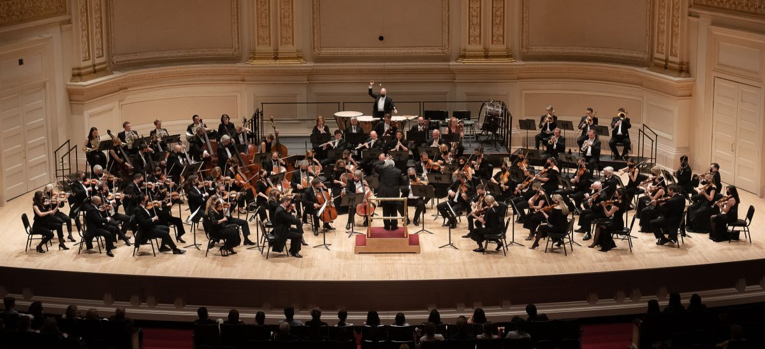

The orchestra
Many individual musicians
Each playing their own part
Through practice and interaction they create collective harmony
The conductor (power) influences but doesn't play
The final music emerges from collective effort

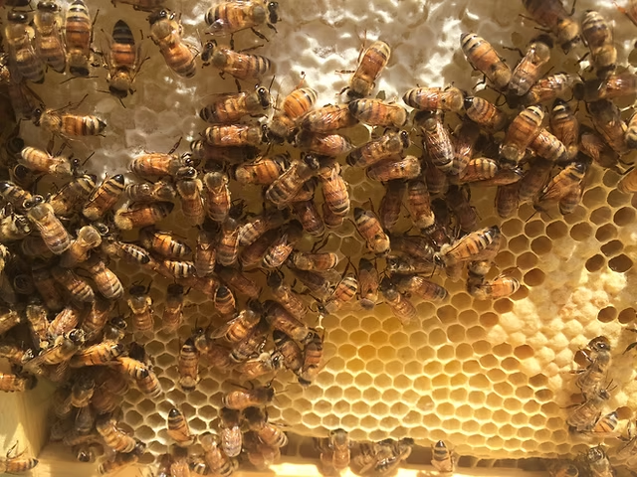

The Beehive
Multiple bees working together
Creating shared structures
Developing collective patterns
Communication through dance and pheromones
Producing something bigger than individual efforts

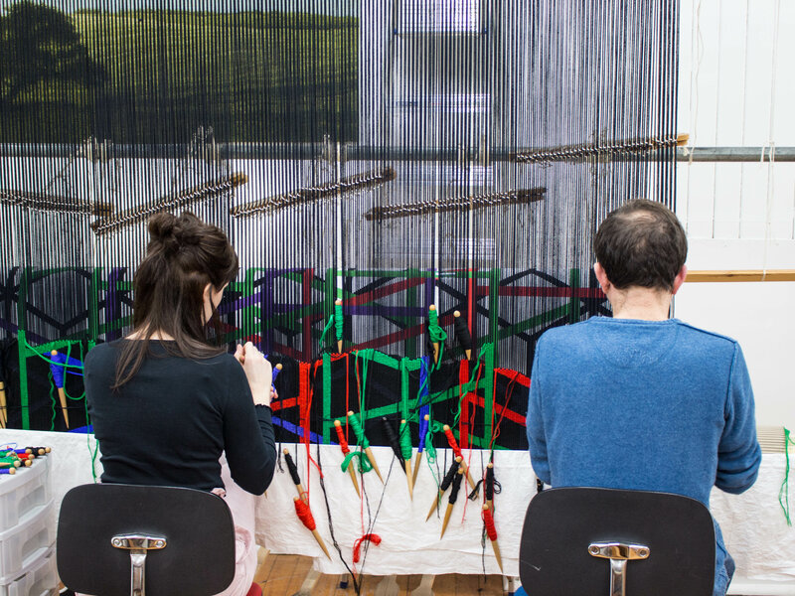

Tapestry Weavers
Different colored threads (individual views)
Multiple hands weaving together
Pattern emerges through collective work
Final image only visible when threads combine
Each thread contributes to larger picture

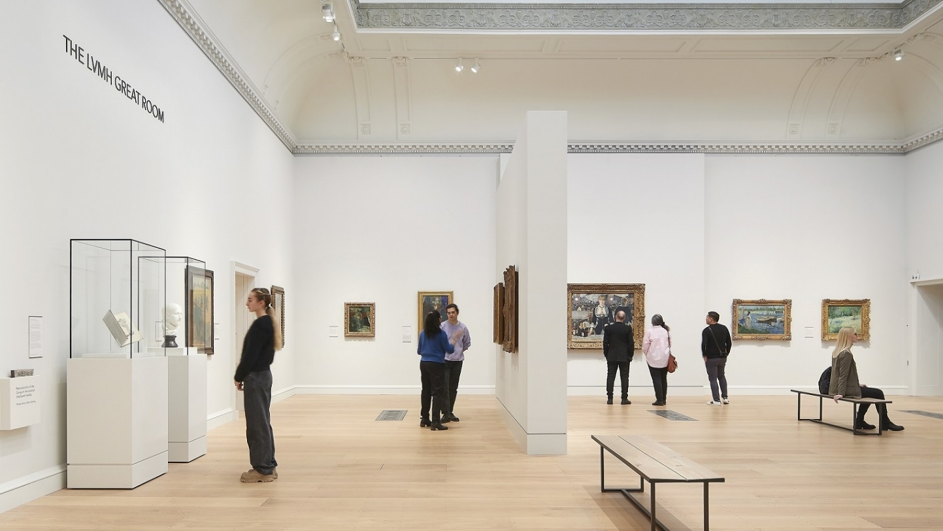

Art Gallery Visitors

Same painting, different interpretations
Each viewer sees something unique
Personal experience shapes meaning
Individual emotional responses
No 'correct' interpretation exists



Kaleidoscope

Same pieces create different patterns
Each turn shows new perspective
Individual viewpoint determines pattern
Multiple valid views exist
Personal position affects what's seen



Library Readers

Same book, different readings
Personal interpretation of text
Individual meaning-making
Unique understanding from same source
Personal context shapes understanding

