

Does a recession impact the UK construction industry in a negative way?
Liam Evans
2023

Table of Contents
Chapter 1 2
1.1 Does a recession impact the UK construction industry in a negative way? 2
1.2 Abstract 2
1.3 Introduction and background 2
1.4 Aims and objectives. 3
Chapter 2 3
2.1 Introduction 3
2.2 Recession 3
2.3 2008 Recession 4
2.4 UK construction industry through the 2008 recession 5
2.5 Why the construction industry is affected by a recession 5
2.6 Similarities between previous recessions and current times 6
2.7 Summary 7
Chapter 3 8
Methodology 8
3.1 Research Methods 8
Chapter 4 8
4.1 Results 8
Discussion 9
5.1 Introduction 9
5.2 Conclude whether a recession will negatively impact the construction industry and to what extent. This will be done by researching previous times of recession and understand what actions were taken. 10
5.3 Look for patterns within previous recessions and look for similar patterns within the construction industry. Finding a trend within both occurrences will give an insight to how a future recession is likely to impact the industry. 10
5.4 Identify how different parts of the construction supply chain react to a recession in the UK, this includes suppliers, contractors and smaller sub- contractors. I will do this by researching current actions taken by these parties and look back to the last recession and what actions were taken then. 11
5.5 Current knowledge on the subject. 11
5.6 Significance of research. 12
6.0 References 13

Chapter 1

Does a recession impact the UK construction industry in a negative way?

1.2 Abstract

The research carried out will gain further understanding on how a UK recession affects the construction industry, the aim is to focus on how the construction industry reacts to a recession. This is a very relevant topic to current times and one that will benefit the construction industry. The intent of this research was to better equip construction companies for the forthcoming years during a recession and future recessions. Historically recessions do not occur very frequently, they are pretty far and few between. Though, any occurrence in the future that a recession does happen, the information gathered will better equip builders and construction companies to handle the situation. Times of uncertainty within the industry can cause a lot of companies to struggle financially or even worse go through. The main goal of this research is to give an insight on what to expect in the future.

1.3 Introduction and background

According to Yael Selfin ‘The UK is estimated to have entered a recession in the third quarter of 2022’ (KPMG, 2022). A recession in its simplest terms is when the economy is slowed down in order to slow down growth in the economy. One of the methods used to do this is by increasing interest rates, making it harder to borrow money. By doing this it stops people and business from being able to borrow money with low borrowing fees. This has a big effect on industry in general, but the intention of this project is to find out whether it has an impact on UK construction.
With the industry employing ‘2.2 million’ people in the United Kingdom (Statista 2022). The construction industry is a big part in the UK economy. Even the smallest number of job cuts due to less work can have a big knock on effect on the country as a whole. This project will inspect whether the UK industry will feel the pressure of this recession or will it continue to develop and thrive in the conditions.

1.4 Aims and objectives.

- Conclude whether a recession will negatively impact the construction industry and to what extent. This will be done by researching previous times of recession and understand what actions were taken.

- Look for patterns within previous recessions and look for similar patterns within the construction industry. Finding a trend within both occurrences will give an insight to how a future recession is likely to impact the industry.

- Identify how different parts of the construction supply chain react to a recession in the UK, this includes suppliers, contractors and smaller sub- contractors. I will do this by researching current actions taken by these parties and look back to the last recession and what actions were taken then.

Chapter 2

Defining a recession and its effects on the general population.

2.1 Introduction

The focus of the research is on construction and the link that it has with a recession. Secondary knowledge gained from sources will give adequate information to answer the project’s aims and objectives. Having this knowledge alongside the information provided by the primary sources will mean that any information not gathered from a secondary source can be picked up from a primary source. On the converse hand, both sources may conflict which will then indicate that there is no correlation between a recession and a negative impact on construction in the UK, thus indicating null hypothesis.

2.2 Recession

Throughout history, the UK has gone through 8 recessions. With the first falling between ‘1430 – 1430’ (history, 2022). This being years and years ago, the underlying concept remained the same. With this driven by ‘shortages of sliver which led to deteriorating coinage’ (history, 2022). A recession is defined as ‘two quarters in a row when gross domestic product (GDP) falls’ (RTE, 2023). When economies tend to shrink and for all businesses and the public it usually has a negative impact. There is never a guarantee as to how long it will last or how bad the circumstances can be. Throughout the last recession in 2008, unemployment reached ‘2.7 million people’ (ons.gov, 2018). With an unemployment rate this high it then makes it harder for the economy to grow and results in a longer period of recession and low economic growth. Low employment does have a knock on effect to other industries across the country. With higher unemployment comes lower incomes, with lower incomes resulting in lower spending. This sequence of events can circle as with less money being spent resulting in businesses performing worse, which can then result in more unemployment. This cycle can be very hard to break, and it is possible to go round and round for years on end.

2.3 2008 Recession

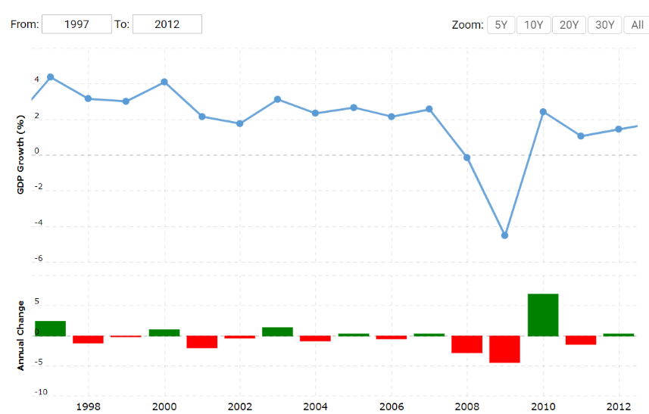
2008 was the last recession that the UK went through. According to the office of national statistics, the UK economy ‘took 5 years to recover’ (ons.gov, 2018). Recession is measured by how the country’s GDP performs over a period of time. Judging these figures does not give a true reading to how people or industries were affected by it. To get a true idea of the effect felt by industry metrics such as unemployment, redundancies and economic growth will all need to be factored in. As seen in Fig.1, the UK GDP was running at around level between the years of 1997 to 2007. The GDP of a country ‘measures the size of a country’s economy’ (bankofenglad, 2019). Seeing a stable graph for this metric indicates that growth in the economy is constant and stable. Stable growth in an economy is seen to be ‘between 2% and 3%’ (thebalance, 2023). This aligns with how the UK performed between the highlighted years leading up to the recession. Next is to identify what were the root causes to this recession and whether it has any similarities to what the UK is experiencing in the present day. As said by Paul Kosakowski, the financial crises of 2008 was caused by ‘the growth of predatory mortgage lending, unregulated markets, a massive amount consumer debt, the creation of "toxic" assets, the collapse of home prices, and more contributed to the financial crisis of 2008.’ (Investopedia, 2023).
Fig.1 Graph Showing UK GDP between 1997 to 2012. Taken from Macrotrends (2023).

2.4 UK construction industry through the 2008 recession

Through the 2008 recession the construction industry did suffer, an article in the guardian stated that ‘the number of new houses being built in Britain has plummeted by nearly 60% from a year ago’ (Guardian, 2008). This occurred on 20th June 2008. Contrary to this, less than 24 months ago in August 2006 ‘George Wimpey boasts of its record land bank as its profits jump 25%’ (Guardian 2008). With these two completely opposite statements falling just 2 years apart, it is clear how fast the tide can turn. With the recession seeming to be the driving force to these events. George Wimpey is the name of notional contractor Taylor Wimpey, prior to their name change. By looking at Taylor Wimpey’s 2008 earnings sheet, there is a clear difference from that year and the year prior. In 2007 their turnover was ‘4.142 billion’ (annualreports, 2008) pounds. The following year they saw an annual turnover of ‘3.467 billion’(annualreports, 2008) pounds. Though turnover is not the driving force in whether a business is successful, this is more often the profit for the year. In 2007 they made a pre tax profit of ‘346.1 million’ (annualreports, 2008) pounds. Whereas the following year they made pre tax loss of ’74.7 million’ (annualreports, 2008) pounds.
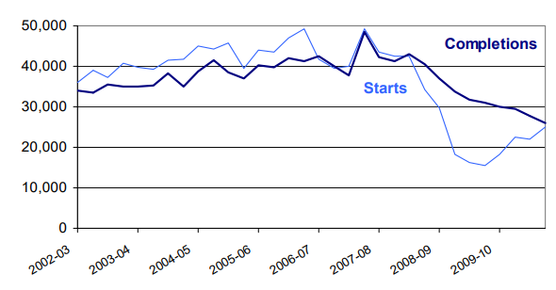
Fig.2 demonstrates that it is not only the financial element of the industry that suffered but the volume of properties being built massively decreased. Through 2002 to the start of 2008 the distance between starts and completions was similar. Indicating that there is a constant turnover of properties being developed to then being completed in a relatively short time period. As seen in the graph, once in the year 2008 the number of new domestic projects being started decreases to almost half the previous years. A lot of domestic property construction is funded by clients purchasing early on in the build. This way, the client can have a large input, and also the contractor is able to fund the build using this money. Due to banks not offering loans to people, be that for mortgages or general loans, this process is slowed down massively. With a decrease in the volume of houses being built, in turn will result in a lower turnover.
Fig.2 Graph Showing number of domestic houses starts and completions between 2002 – 2010. Taken from gov.uk (2010).

2.5 Why the construction industry is affected by a recession

Construction is a huge part of the UK economy. With the industry having ‘44,166 businesses operating across the UK’s residential construction industry’ (propertyreporter, 2022). The industry generates a revenue of ‘£78.9 billion’ (propertyreporter, 2022). The industry provides great value to the country, both financially and by supplying jobs to people. Main contractors turning over millions are just as affected by a recession as a small contractor turning over £500,000 a year. What tends to happen during a recession is that contractors will aim to reduce their costs across the company. This can be via redundancies or reducing overheads such as making staff work from home where possible to reduce the need of offices. With unprecedented times looming for contractors, they do this in order to survive. Anirban Basu offers a good perspective into what effects a recession will have by stating that ‘the challenge for contractors has been that demand for their services has often exceeded their capacity to supply them’ (constructionexec, 2022) this is very often the case where contractors end up having to turn down work or give long lead times on completion of new projects. Basu then went on to say ‘Contractors would find themselves having to compete more aggressively for work’ (constructionexec, 2022). This scenario drives the price down for works. A recession can cause a vicious circle with regards to tender price. Tender price is ‘the amount indicated by a Bidder as the lowest amount for which that Bidder is prepared to perform the Contract’ (lawinsider, 2023). This can be both for a multi-million pound project right the way down to a £5,000 patio job. With lenders being less willing to offer money to both private owners as well as larger clients looking to start new projects. With clients having less capital to spend on their desired projects, there is obviously going to be less work available to win. With contractors having costs hanging over their heads this can often lead to them underpricing works in order to win the work. Once one contractor begins to underprice work, others soon follow. This is a trend that happens in the industry and is essential for the survival of contractors. Underpricing works can often lead to poor workmanship and a generally lower standard of work being produced. A devastating example of this was the Grenfell tower fire. With budgets being set so low at the beginning of a project, along with projects running over budget, contractors then cut corners to cover their costs. This is in effort of the contractors doing the job for less cost to them. There are many contractors big and small that end up going into administration during this process as the continual pressure of winning work to stay afloat eventually becomes their downfall. ‘Lowest cost tendering is cited as one of main factors that lead to Carrilion’s collapse, and that their strategy of undercutting to win the tenders, in the end was their undoing (ellisfox, 2022). With Carrilion being a flagship to this method of tendering not working, there will be hundreds of stories of smaller contractors suffering from the same consequences as they did.

2.6 Similarities between previous recessions and current times
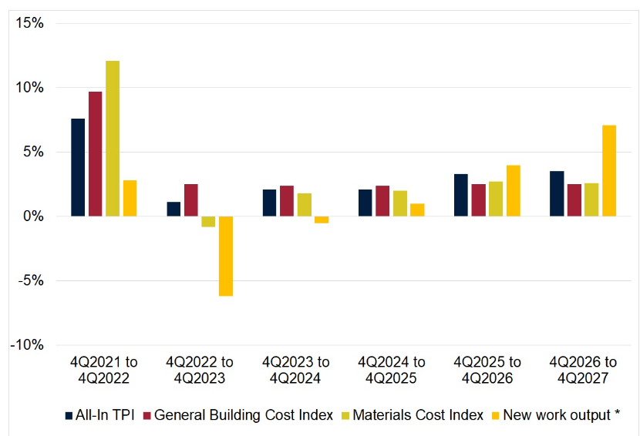
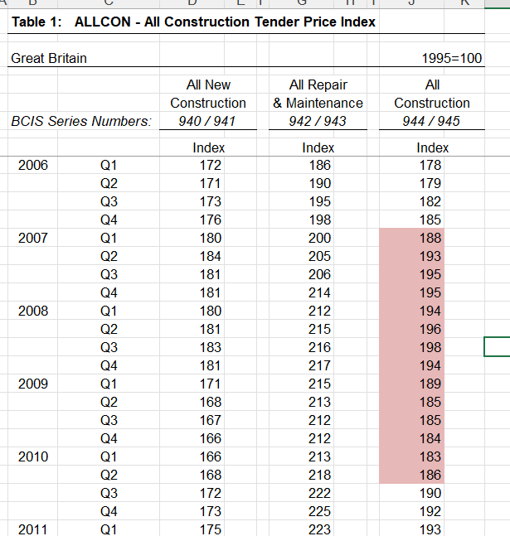
Within the construction industry there are a few metrics to gauge how all areas aspects are handling the financial climate. Right across the supply chain there are changes to how the businesses react. One of these metrics ais the tender price index. BCIS, who are a reliable RICS accredited source offer an index that follows this tender price. ‘The BCIS Tender Price Index Panel is intended to measure the trend of contractors’ pricing levels in accepted tenders at commit to construct’ (BCIS, 2022). Fig 3 shows how the industry went through a massive hike in tender cost, material cost and general building cost through 2021. With the cost of living spiraling in the UK it is no surprise that construction was soon to follow suit. Opposing these statistics is the large drop off in numbers in the following year. Material cost was a large area of concern to all in the industry last year and this cost was a driving force in the other indices increasing. With the material cost index rising 13%, these costs will have either been absorbed by the contractor, if they were tied into a contract or pushed on to the client in new tender costs. With cost to both client and contractor this did end in a lower output of new work. With the possibility of work drying up the pricing of contractors will inevitably have to come down in order to accommodate the lower demand. This lowering of pricing is shown in the 4 bars adjacent to the 2021 bars. BCIS forecast a stabilization phase for construction and low growth in both output of new work and costings in the coming years. ‘Construction demand is forecast to shrink, and with fewer opportunities in the market as well as the overall economic uncertainty there will be greater keenness to secure work’ (BCIS, 2022). This statement supports previous statements that recessions result in less available work.
Fig 4. Table showing the TPI of general construction years highlighted 2007 – 2010. Taken from gov.uk (2012)
Fig 3. Graph showing information regarding pricing/ costs in construction. Taken from BCIS (2022).
Fig 4 offers a table outlining how the tender price index has changed over time throughout the years of 2006 and 2011. Highlighted in red is the TPI between the years of 2007 and 2010, when the UK was in a recession. Within this timeframe the index acts differently to the previous and following years. The index declines from the third quarter of 2008. These figures go against the grain of how the index usually performs quarter to quarter. With the TPI in fig 3 coming to an almost stand still in 2022 the similarities between both timeframes are there.

2.7 Summary

There has been plenty of research carried out on recession as a topic and fortunately this was the same with construction during a recession. Finding statistics from national contractors during the timeframe of around 2008 will help in answering the aims and objectives set out. Though Taylor Whimpey’s statistics do not apply to all contractors this will be a good guide to go off. Running these alongside information gathered from a managing director of an SME will give a middle ground between both. An average of both conclusions will be taken to cover a large pool of building contractors throughout the 2008 recession.
Government and BCIS websites gave figures against the tender price index across a range of years. The tender price index gives a reading as to where contractors are pricing works. This can be seen as a supply and demand measurement, whereas demand decreases so does the TPI in order to promote people spending money. This is seen in 2007 through to 2009 in Fig.4 and will be something to consider when analysing the results.

Chapter 3

Methodology

3.1 Research Methods

The research will begin by investigating online to get a better understanding in what a recession is. By gathering this information, it will offer what information will be relevant towards a UK construction. UWTSD library is a good way to access factual information, and this will be utilized throughout the project. Another form of gaining the information required is carrying out interviews to experienced people in the construction industry. There are many experienced people throughout the construction industry that hold a wealth of knowledge. Personnel which have been in the industry since at least 2008 will offer an insight into the topic of the project. One interviewee will be the managing director of an established domestic construction company. They have been in the industry for 40 years and therefore will have experience on differing financial circumstances in industry. This interview will be semi structured with a couple of opening questions then look to allow them to freely speak about the raised topics. All information will be taken on board and matched against the already researched knowledge to possibly form a relationship between the data. This data should bring a conclusion to the project and reach the aims and objectives set out.

Chapter 4

4.1 Results

After collecting the data that the interviewee provided, it was very much in keeping with the information gathered through secondary research. The first question asked was ‘how would you describe your periods of trading within a recession to not in a recession?’ The answer given was very much supportive of the fact that the period of a recession did make it more difficult. ‘During 2007 I had bought a plot of land with the intention of developing 13 properties, these were not self- funded and needed financing through bank loans.’ As previously stated, loaning money from the bank becomes increasingly difficult once in a recession. ‘I quickly realised that the purchase of the land did fall at the wrong time. The site was put on hold for 3 years until the situation stabilised and banks were more forthcoming in lending money.’ Figures shown during chapter 2 are very supportive of these statements.
The interviewee had done a lot of work on new build projects, but in order to fill in the gaps of loaning money had to go looking for work privately. I asked, ‘Did you have to lay any staff off due to being on stop or were you able to find other work?’ He replied ‘For me to keep the boys in work I had to think pragmatically, with more and more people in the same boat, and less work coming in I was being priced out by other companies. This did end with me needing to lower my prices to clients in order to cover the boys’ wages, which was not ideal, but it needed to be done.’ The previous statement of the need to lower costs in order to keep staff in employment seems a running theme during these times. With the TPI showing a downward trend through the years of 2007 and the forthcoming years, this is an example as to why the reduced costs.

Chapter 5

Discussion

5.1 Introduction

As previously discussed through this project the aim was to conclude whether a recession negatively impacted the construction industry. After research through secondary research as well as primary research, a conclusion has been able to be made. Initially, through collecting data from online sources the finger was always pointing towards the side of recessions negatively impacting the industry. A lot of the research gathered consisted of contractors on a larger scale, with some of these being Taylor Whimpey and Carillion. Though this information was helpful towards answering the topic, more information was needed to cover SMEs in the industry. This led to an interview held with the managing director of a local contractor. Having been running for 40 years they had experience with current conditions and also conditions through the 2008 recession as a direct comparison.
Throughout the project the end goal was always to answer the title of the alongside working towards the aims and objectives. These aims and objectives were set out to give the best reflection on the question in the title. These aims and objectives were outlined in section 1.4.

5.2 Conclude whether a recession will negatively impact the construction industry and to what extent. This will be done by researching previous times of recession and understand what actions were taken.

Through research into previous recessions a conclusion is able to be made as to whether construction is negatively impacted by a recession. 2008 gave a lot of information on this subject as it was the last recession the UK went through. The conclusion made is that the industry is negatively affected, and this was made clear by looking at the financial information of companies such as Taylor Whimpey along with TPI’s taken from reliable sources such as BCIS and gov.uk.
The second part of this question was to what extent is it affected. Research into Taylor Whimpey between the years 2007 and 2008 gave an insight to this. The difference between their profit was 1.5 billion pounds. Figures like these make it very hard for any sort of business and it does put them under a lot of pressure. Threats of making losses like these can not only affect the financials, but also the quality aspect of work. Corner cutting can creep into a lot of work and in turn causes a problem further down the line. Fig.2 in section also showed data supporting the fact that a recession has an effect on the industry, along with showing the drop off in completions of projects during these times. Starts of new projects and completion of existing projects decreased through the years of 2007 right through to 2010. This decrease affects financials of the majority of companies negatively due to being able to turn over less projects.
A conclusion to this question was made, considering the evidence and statistics displayed that a recession does negatively impact the industry and can have a large impact.

5.3 Look for patterns within previous recessions and look for similar patterns within the construction industry. Finding a trend within both occurrences will give an insight to how a future recession is likely to impact the industry.

The main event focused on with regards to previous recessions was the period of 2007 – 2009. This was chosen due to it not being long ago, which allows for more accurate readings and more similarities to modern methods of construction. It became clear that the recession during 2008 was a tough period for all, but the aim set out required data to be run alongside each other to find a correlation. With the effects of the recession imposing itself throughout the year 2007, this was felt by the construction industry almost instantly. With the tender price index indicating that the reading dropped within Q1 of 2007 (Fig 4, gov.uk, 2012). This decline indicates a change in mentality for contractors. Through busier times, the TPI tends to increase due to contractor turning away work, this shift indicates that contractors are beginning to lower bidding prices in order to secure work through uncertain times.
This correlation between the years of the recession and the tender price index fitted in with the thoughts of the managing director of company A. Through regular conditions the tender price index tends to increase gradually following inflation, meaning year on year prices incrementally increase. The interviewee had to reduce their prices to keep up with competitors, which can snowball and have a large effect on the industry.
Judging by the reactions made to the recession in 2008, it is likely that any future recession would follow a similar course. With contractors under cutting in order to secure work and in turn secure employment for their staff. Negative impacts of this can be lower quality of work and lower quality of materials being used. Similarities between current times and 2008 were made in Fig 3 outlining the increases in building cots alongside decreases in building output. Margins can shrink through a recession and with material costs increasing it can be tempting to contractors to cut costs by using lower quality materials. Lower output of work there is less to go round which results in desperation and in turn lower tendering prices.
To conclude, a pattern was made between the years of the recession and the years the construction industry felt an effect. Almost instantaneously as the recession hit the industry reacted to it.

5.4 Identify how different parts of the construction supply chain react to a recession in the UK, this includes suppliers, contractors and smaller sub- contractors. I will do this by researching current actions taken by these parties and look back to the last recession and what actions were taken then.

Each part of the industry in the end reacts in a similar way. As one of them increases their prices, they all must follow suit. This applies to SMEs and national contractors as they are all in the same boat. If work is drying up for national contractors, then they require to look for work and end up lowering costs in order to secure it. The same applies to the smaller scale contractors. Examples given in the project were the likes of Carillion and Taylor Whimpey. Both national scale contractors, and both suffer during recession times. The same applied to the managing director of company A, once work seems to get quieter, in order to secure work the margins must decrease and lower prices to secure work. Alongside this, Fig 3 in section 2.6 showcased how much materials increased during current times which has similarities to 2008. Often these increases in costs are not able to be passed on to the client and are absorbed in the contractor’s margin.
A recession proved to be a difficult time for the vast majority involved in the construction industry. National contractors and smaller contractors all feel the effects. The project covered this objective and showcased how both sides of the industry react in a similar manor.

5.5 Current knowledge on the subject.

My current knowledge on recession is quite limited. I have got a brief understanding on what a recession is, but not on how the UK construction industry is affected. The main information I know is that interest rates are increased which in turn makes borrowing money more costly. The aim of this is to slow down growth in wealth generally which slows down inflation. The last recession of note in the UK was around 2008 which had a huge impact on the British economy. The economic climate we are currently experiencing is very similar to the beginning of the 2008 recession. With the bank of England base interest rate at 2.25%, it seems as though it is heading in a similar direction. This has spiked from the 0.1% we had just 12 months ago.

5.6 Significance of research.

The research carried out is very important and relevant to events that are happening now. 14 years have elapsed since the UK economy has been in its current state. Circumstances have changed a lot since the last recession, but I intend on finding similarities with regards to time frames and differing correlations between recessions and construction in the UK. Throughout my research I hope to see consistent results from different times in UK history. Reliability of my research is key for me to be able to be able to make a judgement on whether my hypothesis is correct, incorrect or null. What I currently understand of a recession is that there is a lot of uncertainty across all industries. Very little industries thrive through a recession as previously stated it becomes harder and more costly to borrow money. The knock-on effect that this gives my chosen industry will give me a good understanding on how it is affected. As a trainee quantity surveyor pricing work is something I am heavily involved in. The outcome of this research will prepare me for the upcoming period and maybe differ how I price things. This may be by looking for long term contracts which will secure work through unprecedented times, or look for shorter term work due to supplier prices being uncertain. These are answers I hope to get throughout this project.

5.7 Reflection

Throughout this project I think that I covered the aims and objectives set out well. The data gathered did enable me to make conclusions on each question and in allowed me to draw a conclusion that a recession does negatively impact the construction industry.
To be critical I could have had a larger sample size of interviewees and possibly created a questionnaire to get more responses and therefor get a more accurate reading tp how others felt through those times.

6.0 References

Bank of England (2019). What is GDP? [online] www.bankofengland.co.uk. Available at: https://www.bankofengland.co.uk/explainers/what-is-gdp [Accessed 1 Jan. 2023].

Barnett, J. (2023). Recession spreads to British construction as experts brace for a jump in unemployment and the cost of living. [online] CityAM. Available at: https://www.cityam.com/recession-spreads-to-british-construction-as-experts-brace-for-a-jump-in-unemployment-and-the-cost-of-living [Accessed 27 Jan. 2023].

BCIS. (2023). BCIS five-year forecast (building) - December 2022. [online] Available at: https://bcis.co.uk/news/bcis-five-year-forecast-building-december-2022/#:~:text=A%20recession%20combined%20with%20high [Accessed 6 Mar. 2023].

Business Review. (2023). Available at: https://www.annualreports.com/HostedData/AnnualReportArchive/t/LSE_TW_2008.pdf [Accessed 4 Mar. 2023].

constructionexec.com. (2023). What a Recession Would Look Like for Construction Contractors. [online] Available at: https://constructionexec.com/article/what-a-recession-would-look-like-for-construction-contractors [Accessed 5 Mar. 2023].

for, D. (2012). BIS prices and cost indices. [online] GOV.UK. Available at: https://www.gov.uk/government/statistics/bis-prices-and-cost-indices [Accessed 5 Mar. 2023].

Graeme Wearden and Kollewe, J. (2008). Housebuilders in crisis: timeline. [online] the Guardian. Available at: https://www.theguardian.com/business/2008/jun/13/construction.housingmarket [Accessed 4 Mar. 2023].

Investopedia. (2023). The Fall of the Market in the Fall of 2008. [online] Available at: https://www.investopedia.com/articles/economics/09/subprime-market-2008.asp#:~:text=FAQs- [Accessed 5 Feb. 2023].

KPMG. (2022). Living standards take a hit as the UK enters protracted recession - KPMG United Kingdom. [online] Available at: https://kpmg.com/uk/en/home/media/press-releases/2022/12/living-standards-take-a-hit-as-the-uk-enters-protracted-recession.html#:~:text=The%20UK%20is%20estimated%20to [Accessed 22 Jan. 2023].

Law Insider. (2023). Tender Price Definition: 556 Samples. [online] Available at: https://www.lawinsider.com/dictionary/tender-price#:~:text=Tender%20Price%20means%20the%20amount%20indicated%20by%20a%20Bidder%20as [Accessed 5 Mar. 2023].

Macrotrends (2022). U.K. GDP Growth Rate 1961-2020. [online] www.macrotrends.net. Available at: https://www.macrotrends.net/countries/GBR/united-kingdom/gdp-growth-rate [Accessed 1 Feb. 2023].

Sky HISTORY TV channel. (2023). Worst recessions in British history - What is a recession and are we currently in one? [online] Available at: https://www.history.co.uk/articles/worst-recessions-in-british-history [Accessed 28 Jan. 2023].

Statista. (2023). Construction industry: employees 2010-2016. [online] Available at: https://www.statista.com/statistics/432509/number-employees-construction-industry-united-kingdom/ [Accessed 25 Jan. 2023].

What is a recession? (2023). www.rte.ie. [online] Available at: https://www.rte.ie/news/business/2023/0210/1355841-what-is-a-recession/#:~:text=In%20the%20UK%2C%20the%20most [Accessed 1 Feb. 2023].

