Appendices

Session 1

Appendix 1.1- Nursery Low Attaining Pupil
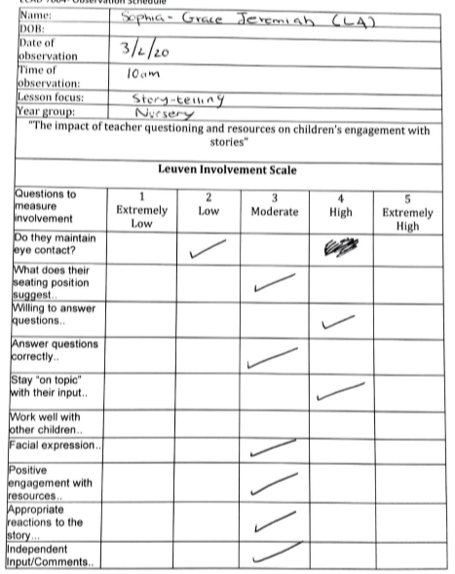

Session 1

Appendix 1.2- Nursery Middle Attaining Pupil
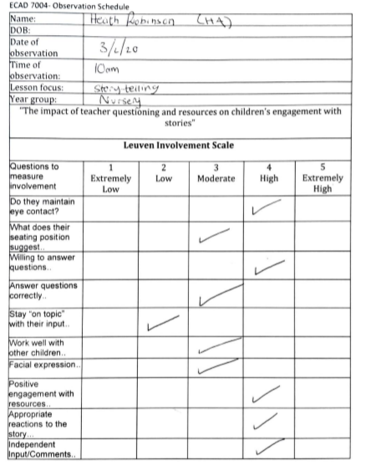

Session 1

Appendix 1.3- Nursery High Attaining Pupil

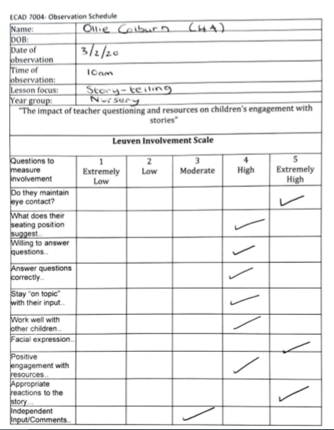

Session 1

Appendix 2.1- Reception Low Attaining Pupil

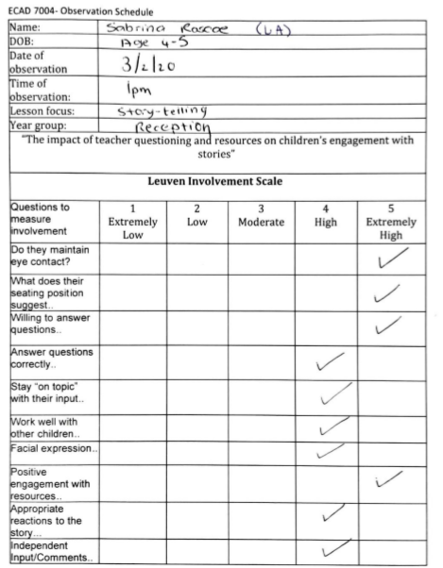

Session 1

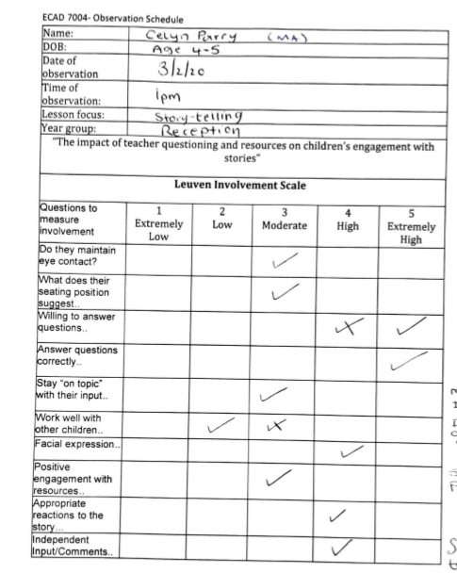
Appendix 2.2- Reception Middle Attaining Pupil

Session 1

Appendix 2.3- Reception High Attaining Pupil
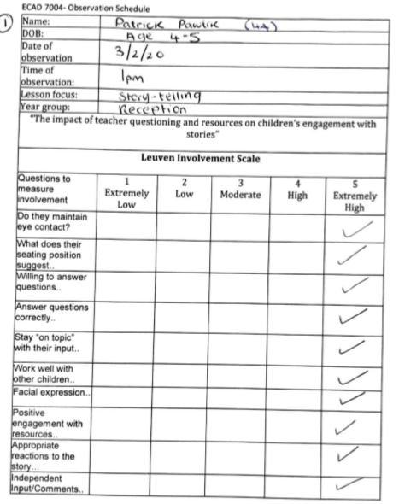

Session 2

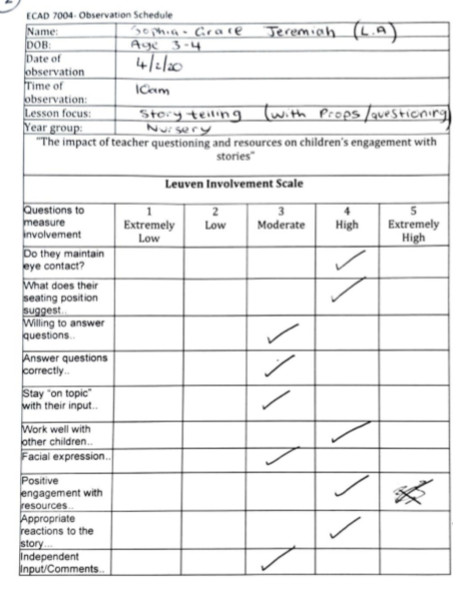
Appendix 3.1- Nursery Low Attaining Pupil

Session 2

Appendix 3.2- Nursery Middle Attaining Pupil
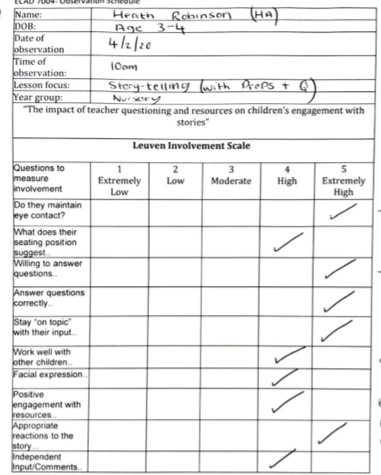

Session 2

Appendix 3.3- Nursery High Attaining Pupil
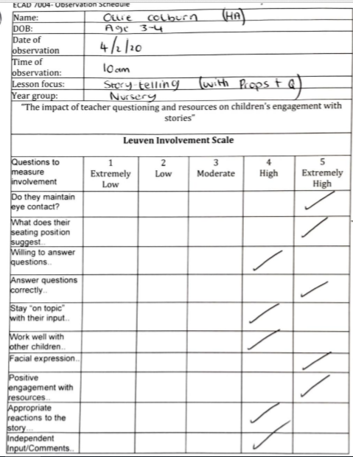

Session 2

Appendix 4.1- Reception Low Attaining Pupil

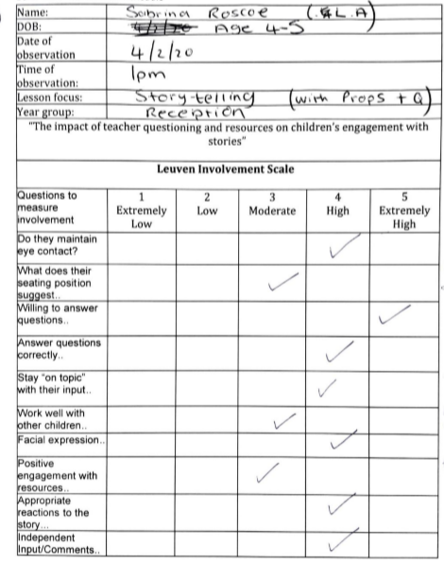

Session 2

Appendix 4.2- Reception Middle Attaining Pupil

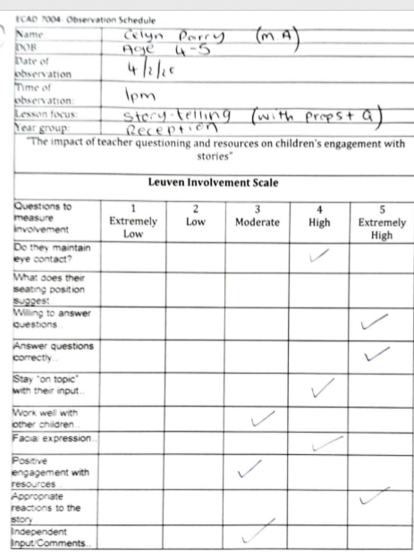

Session 2

Appendix 4.3- Reception High Attaining Pupil
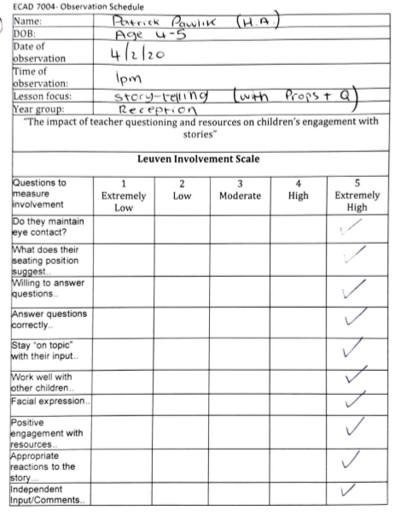

Appendix 5- Interview Schedule
ECAD 7004- Interview Schedule
Black Text- Questions after the story with group of 3 pupils
Blue Text- Questions that can be used within the telling of the story
Green Text- Used within the story and afterwards in focus group
Interview questions

Response to the story:

Did you like the story?
Why did you like/not like the story?
What was good/bad?

Characters
Who is your favourite person? (Use lollipop pictures or tick-sheet)
Why or what do you like about them?
What’s the coolest thing about your favourite character?
Did Penguin Blue have any friends? -Jeff, Flo, Clive, Wilbur
Who were his friends?
Who was penguin blue (e.g. naming a friend who had that mask)?

Understanding of events
On the boat:

What is Penguin Blue and his friends searching for? - Treasure

What do they use to help them find treasure?

Can you remember how many seas they sailed across? - Seven

Something bad happens to their boat- what do you think it could be?

Sinking:

What’s happened to Penguin Blues boat?
What would you do if you were on the boat?
In the water:
What do they find at the bottom of the ocean?
Make reference to the book Penguin Blue Reads

At the shore:

Who do they meet?
Make reference to the captain of the ship?
What’s that in the water? -The whale
Pirate ship rising:
What helps the pirate ship float?
How do you think they get home?
Ending:
What have they done to the pirate ship?
Who’s found the treasure here?
Do you think Penguin Blue had fun?
Where would you go if you were a pirate on a pirate ship?

Appendix 6- Nursery Interview Transcripts

Nursey Observations
S – lower attainment
H – higher attainment/ ALN
O – higher attainment

Nursery study A

Observation - NA1
Think-Pair-Share
Ruth – but then suddenly, oh no, a rip. What do you think is going to happen? We are all going to think (puts finger to head), then we are going to talk to our friends and then we are going to share with everybody else. So everybody think, what will happen if it rips?
Children - (whisper ‘sink’ to each other)

Observation – NA2
Thumbs up
Ruth – Did you like the story?
Ruth - Thumbs up for yes, thumbs sideways for I’m not sure and thumbs down for no. (Ruth illustrates by showing how to hold thumbs).
Children – (O and H hold thumbs up) (Sofia doesn’t do anything)
Ruth – S, did you like the story?
S - (nods)
Ruth – put your thumbs up (Ruth holds thumbs up to show S)
S - (holds thumbs up)

Observation – NA3
Ruth – What was your favourite part?
O – The boat, when they all jumped in.

Observation - NA4
Ruth – Can anybody remember the name of this character? (Ruth holds picture of Penguin Blue)
H – I don’t know, what is he called?
Ruth – What do you think H?
H – Captain Blue?
Ruth – Well done H, it’s Penguin Blue.

Observation - NA5
Ruth – Now this is a harder one. Does anyone know who this is? (Holds up a picture of Cutlass Jeff)
H – I don’t know.
Ruth – do you remember you said, ‘I like his sword’ and then I said, ‘Some people call it a cu, cu’ (waits for children).
H – captain?
Ruth – It's a cutlass. He is Cutlass J...’
O – Cutlass Jeff.
Ruth – Good boy O, well done.
Ruth – And the last one was First Mate Fl...’ (waits for children).
O – Flo?
Ruth – Well done O.
Ruth – So out of these characters, who was your favourite? Was it Cutlass Jeff with his big cutlass sword?
H – I liked Cutlass Jeff!
Ruth – Why did you like him? Was it is sword? Was it his big yellow eyelashes?
H – No, this one. (Points to sword).
Ruth – Or, did you like First Mate Flo?
S – Yeah! (nods head)
Ruth – and who liked this one? (holds up a picture of penguin blue).
O – (puts his hand up).

Observation - NA6
Ruth – Did you like the characters in the story?
S – Yeah!
Ruth – Can you remember what type of animals they were?
S – Penguins.

Observation - NA7
Ruth – And can you remember what they were searching for?
O – Treasure.

Nursery Study B

Observation - NB1
Children showing an awareness of the story by predicting what comes next.
Ruth – what do you think they are looking for?
H – Treasure
S – Treasure
O – Gold

Observation - NB2
Using resources to aid understanding and make the learning experience more authentic
Ruth – (shows the children the map) this is a treasure map and they need this to find the gold.
O – Oh
Ruth - So H, where do you think the gold is? What do you think marks the spot? Can you show me on the map?
O – There (points to the x)
Ruth – H, where do you think the treasure is?
H - (Follows lines to the x)
Ruth – What do you think S?
S - (Points to x)

Observation - NB3
Think-Pair-Share
Ruth – but then suddenly, oh no, a rip. What do you think is going to happen? We are all going to think (puts finger to head), then we are going to talk to our friends and then we are going to share. So everybody think, what will happen if it rips?
Children - (whisper ‘sink’ to each other)
Ruth – but why will it rip, what will get inside the boat? (Ruth points to fake ocean) What is this?
H – the ocean.
Ruth – So will the ocean get inside the boat?
H – nods
Ruth – And then it will be so heavy it will sink?
H - nods

Observation - NB4
Thumbs up
Ruth – the murky depths as black as night. But wait, a flag, a mast, a deck. What do you think they have found at the bottom of the ocean?
O – A pirate ship.
Ruth – What do you think H and S, do you think O is right? Thumbs up for yes, thumbs sideways for I’m not sure and thumbs down for no.
H - (H puts his thumbs up right away)
Ruth – S, do you think O is right?
S - (nods)
Ruth – put you’re thumbs up for yes (Ruth puts her thumbs up)
S - (puts her thumbs up)

Observation - NB5
Independent input
Ruth – Well blow me down, a sunken wreck, for penguin blue a closer look...
O – How they going to lift it up?
Ruth – How are they going to lift it up? I don’t know, but should we find out (Ruth reads on).

Observation - NB6
Children showing an awareness of the story by predicting what comes next.
Ruth – Alas there’s no time to explore. Tired penguins need to get ashore. A desert island, small and sandy. Phew! That’s extremely handy!
Ruth – Look, says Flo, there’s someone waving. My name is Captain Walker Plank. Been stuck here since my galleon sank.
Ruth – Can you say Captain Walker Plank?
Children - (Children repeat Captain Walker Plank)
Ruth - (Points to picture of shipwreck) who do you think this ship belongs to?
H - (Points to the picture of Captain Walker Plank) Him!
Ruth – Captain Walker Plank. O, do you think it is his ship?
O – Yeah
Ruth – S, do you think it is his ship?
S - Yeah

Observation - NB7
Engagement with story (O said this was his favourite part later on)
Ruth – Shipwrecked pirates never fear because blue has a good idea.
Ruth – What's his idea?
Ruth – Hey says ‘these puffer fish’, they are deflated (Ruth sucks in her cheeks) and then they inflate (Ruth puffs out her cheeks) and then they deflate (Ruth sucks in her cheeks).
Children - (Follow sucking their cheeks in and out)
Ruth – they take in all the air.
Ruth - ‘these puffer fish and some kelp, we’ll raise this ship and home we’ll sail. These fish inflate and up she goes toward the surface’.
Ruth – so what happens boys and girls is the fish inflate and because they have air inside them, they make the ship go up to the top.
Ruth – so the ship goes straight to the surface. Thar she blows! Look, it just popped to the top because the puffer fish were puffed and the whale helped too because he went (Ruth makes sound of water shooting out and pushes her fist into the air).
O - (Copies the sound and also pushes his fist into the air).

Observation - NB8
Thumbs up and showing understanding of the story
Ruth – okay everybody, did you like the story? Thumbs up for yes, thumbs sideways for I’m not sure and thumbs down for no.
Children - (H and O put their thumbs up, but S does not)
Ruth – S, did you like the story?
S - (Nods head)
Ruth – What was your favourite part?
H – Um, I think... the whale floating up
Ruth – What did the whale do for the boat?
O – It blasted (pumps his fist in the air)
H - (Also pumps his fist upward)
Ruth – O, what was your favourite part?
O – It was the boat.
Ruth – you liked the boat too? How about you S?
S - Boat

Appendix 7- Reception Interview Transcripts

S- Lower Attainment
P- Higher Attainment
C- Middle Attainment

Reception Study A

Observation-RA1
Remembering characters
Liam- What are his friends names, can you remember?
P- Cutlass Jess
P- That’s Penguin Blue (pointing at picture)

Observation- RA2
Predicting what happens next..
Liam- Its time to hit the treasure trail, oh where are they going?
S- Treasure
S- To find Treasure

Observation- RA3
Remembering characters
Liam- Who’s in the boat? Can you see?
C- (Hand up) Penguin Blue!
S- I need the toilet
P- Alba Seal

Observation- RA4
Predicting what happens next
Think-pair-share
Liam- Then suddenly, oh no, a rip! Patrick I want you to chat to Mason, Martha can you chat to Archie and Celyn, and I want you to have a think , what happens next? Have a chat to each other
Patrick chatted to Mason
Martha attempted to chat to Archie and Celyn, but no discussion.
C- The fish poked the boat, and they’re falling, so they’re gonna fall out the boat, and they’re gonna swim.
Liam- Patrick what do you think?
P- I think, they gonna fall and they gonna swim.

Observation-RA5
Predicting what happens next
Liam- Oh look, there’s somebody waving, who do we think could be waving?
P- I don’t know
S- A seal
Liam- You think it could be a seal?
S- Yes look!
P- Or a bird!
C- I think it’s a donkey.

Observation- RA6
Giving their own opinion on the situation
Liam- Hands up, what would you do if you were stuck on a desert island?
C you’ve got your hand up nicely!
C- Umm I would, I would shout for help
Liam- You would shout for help? Very good!
Liam- Sabrina what would you do?
S- I would just lie down and just wait for somebody to help me
Liam- That’s a really good idea I think I would do the same

Observation- RA7
Remembering of characters
Liam- Who’s getting on the ship now?
All together- The pirates
Liam- Yes all the pirates, who else?
S- The polar bear
Liam- Yes very good Sabrina

Observation- RA8
Predicting what happens next
Liam- Where are they going now do you think?
P- I don’t know
Liam- Celyn where are they going now do you think?
C- I think they’re going to umm, I think they’re gonna go, I think they’re going home
Liam- I think they are too, I think you’re right.

Observation- RA9
Drawing activity
Liam- What was your favourite part Patrick? Or who was your favourite person?
P- Penguin Blue!
S- I liked Penguin Blue
Liam- Who have you drawn their Celyn?
C- Penguin Blue
Liam- Can anyone remember any other friends
Silence…..
S- I found treasure
P- Wilbur
Liam- What are you drawing Sabrina?
S- Penguin Blue

Reception Study B
Observation- RB1
Remembering of characters
Liam- Look who I’ve got in here, I have got….
P- Penguin Blue!
C- Penguin Blue!
Liam- Who else have we got? Cutlas..
C- Jeff!
P- Cutlas Jeff, Cutlas Jeff!
Liam- Well done Patrick, and who’s my other person?
All together- First Mate Flo!

Observation-RB2
What happens next
Liam- What happens next?
C- It’s sinking!
P- All of them get in
Liam- Yes all of them get in the boat! So lets start with Penguin Blue, into the boat
In goes.. what was his name?
P- Cutlass Jeff
Liam- Excellent well-done Patrick
P- And First Mate Flo
Liam- Sabrina do you remember what the Polar Bear was called?
Silence…

Observation- RB3
Understanding of the story
Liam- Can anybody tell me what a sail does? Why do we need one on our boat?
C- Because, it needs to go! And it blows in the wind
Liam- Excellent Celyn!

Observation- RB4
Understanding of the story
Liam- What do they need to help them find the treasure?
Celyn- I know, a map!
Patrick- A map!
Celyn- I can see the map over there!

Observation- RB5
What happens next
Liam- Then suddenly, oh no a rip! Hands up who can remember what happens in this part?
Celyn…
C- The fish ripped the boat, and then the boat was sinking.
Liam- Well done Excellent!

Observation- RB6
What happens next
Liam- But wait a flag a mast a deck, hands up who remembers what this is at the bottom of the sea?
S- Hello, hello (takes pirate hat off)
Liam- Put it back on your head, pirates always keep their hats on their head.
P- A pirate boat!

Observation- RB7
Understanding of the story
Liam- Who’s he? Where did he come from?
S- The boat!
Liam- Yes the boat, he came off the boat and now he’s stuck on a desert island. What’s his name?
C- Grrrrr (noise)
S- RRRR (noise)
Liam- Captain…
P- Captain Walker Plank!

Observation- RB8
Own opinion on the story
Liam- Sabrina, how would you feel if you were stuck on a desert island?
S- Id sleep there forever and wait for somebody to save me
Liam- what about you Celyn?
S- and if there was a zombie on there
Liam- A zombie?
S- and bite me, I would just be dead.
Liam- Oh that’s sad, Celyn what about you?
S- and until somebody gives me a true love kiss
C- I’d ring my phone for help
Liam- That’s a smart idea I think, Patrick what would you do if you were stuck on a desert island?
p- I would climb on all the trees, then I would jump in the water
Liam- Why would you do that?
P- because I wanted to swim
Liam- You would swim to safety would you? (P nods) That would be a good idea!

Observation-RB9
Own opinion on the story through drawing
Liam- What’s that your drawing Sabrina?
S- Penguin Blue! That’s his nose, then his smile. And he’s holding some treasure, two treasures. Yes he found it for the pirates.
Liam- Did he have anything to help him find the treasure?
S- Nope, ummmm chocolate coins, he just digged
Liam- Is that Penguin Blue Celyn?
C- Cutlass Jeff
S- and the wind was blowing…
Liam- What was he holding in his hands?
C- Treasure!

Appendix 8- Reflection Model
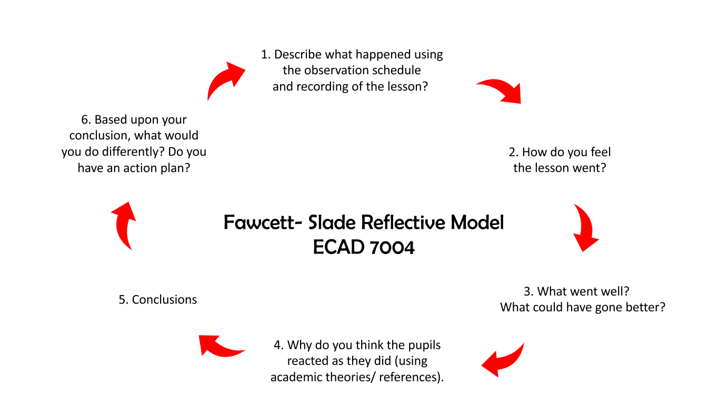

Appendix 9- Nursery Reflection Session 1
- Describe what happened using the observation schedule and recording the lesson? | We invited the children into the small room, where there was a pirate flag on the floor. The children sat on the pirate flag and told them they would hear a pirate story. The flag and children were in view of the camera, situated behind Ruth (the reader). Liam (the observer) sat to the side of the group and completed 3 observation sheets whilst Ruth read the story. She incorporated questioning and two other AFL strategies as the story went on including: thumbs up and think-pair-share.  Liam filled in the Leuven involvement scale, rating the 3 children from 1 to 5 on a variety of different factors.  After the story, the children drew a picture relating to the book whilst Ruth asked a number of different questions.
- How do you feel the lesson went? | The children were very engaged to begin with. As the story progressed, the engagement of certain children decreased, however by using questioning Ruth was often able to reengage their focus. One of the children brought in a toy which distracted his focus as well as the child next to him, until we removed it. The children answered questions very well which proved they were listening and understood the story.  We asked all questions that we had planned for, as well as some additional questions, and the environment was managed safely.  We made the story applicable to the children and made sure our techniques were tailored to the age group. Children were able to pose their ideas surrounding what happened next..
- What went well? What could have gone better? | What Went Well:  - Children were able to answer on topic  - They were able to name some characters showing they had remembered the story  - They showed appropriate actions and reactions to the story  - The children showed awareness of the overarching story line, realising the real-life context  - Teacher questioning contributed to higher engagement levels and understanding  - Manged the learning environment well  What could have gone better:  - A child not bringing in a toy that distracted him  - Children not coming to the door and distracting other children  - Gaining more of an output in the drawing activity
- Why do you think the pupils reacted as they did? (References) | Assessment for learning techniques: improved understanding and engagement. Engagement was limited at the start of think-pair-share as they probably aren’t used to doing it.  Higher attaining pupil and lower attaining pupil benefiting from collaborative environment. Repeating what other children did, more contact time for the MKO’s  Some children weren’t able to sit still and engage for the full period of time- Age, transition, possible ALN, other peers’ influences, toys.  Drawing activity, some children didn’t want to do a drawing; possibly getting restless and distracted by his peers playing outside. Another child wanted to leave because he had seen his friend leave.  Engagement was generally good throughout from the way the story was told, tone of voice and actions creating involvement. Sitting on the pirate flag.  Brining prior knowledge, 1 child showed understanding of pirates and animals beforehand, others were able to give limited input and ideas.
- Conclusions | Overall, the story telling activity went really well. We were happy with the data we collected. At times engagement decreased as a result of distractions and low concentration levels, however, teacher questioning reengaged the children and brought them back on task with the story.  The use of think-pair-share and thumbs up engaged the entire class at one time. Children who were reluctant to engage benefited from this.  The pictures resource enabled the children to pick their favourite and prompted them to say why they liked them. It also helped them to remember elements of the story/characters  The pirate flag gave them an initial spark of excitement, because the activity wasn’t necessarily a normal teaching time. We also think it kept them sat and engaged throughout.
- Based upon your conclusion, what would you do differently? Do you have an action plan? | Model think-pair-share, prompt them for more explanations. Further open-ended questioning.  Add more physical resources to help make the children remember scenes and characters from the book

Appendix 10- Nursery Reflection Session 2
- Describe what happened using the observation schedule and recording the lesson? | Again, the children were invited to come into the room for a story. We attracted them by explaining we are going on a pirate adventure, and that we have pirate hats for them. Started the lesson by giving out hats, Ruth used a number of toys to replicate scenes in the story while the children sat on the pirate flag and watched. Liam again recorded and completed an observation sheet. Liam completed the Leuven involvement scale rating a number of factors from 1 to 5. Ruth used questioning, think-pair-share and thumbs up as AFL strategies during the story. The children weren’t interested in completing a drawing afterwards as they became restless, but they stayed to answer questions. One of the resources encouraged the children to stay for the last 5 minutes when they perhaps were ready to leave.
- How do you feel the lesson went? | We think that the engagement, focus, and answering of questions was much higher than the previous lesson. Their general concentration levels were higher, and this showed that they appreciated the context of the book and showed more understanding.  The addition of more resources aided their understanding through visual learning, and we were able to refer to these more to add to their understanding and recreated scenes from the book e.g. who was your favourite character?  (Sail explanation).  The resources added an excitement factor to the book, they wanted to touch and see the resources such as the map. The map especially added to cross curricular responsibilities, as they were verbally counting the seven seas out loud. This was also done independently without any prompting.
- What went well? What could have gone better? | What went well?  - Children were able to answer on topic whilst referring to resources to answer questions  - They were able to name most characters showing they had remembered the story  - They showed appropriate actions and reactions to the story with excitement  - The higher ability children showed awareness of the overarching story line, realising the real-life context and reacting to this with emotions  - Teacher questioning contributed to higher engagement levels and understanding  - Manged the learning environment well  - Resources and props added to the excitement  - The props stopped them from wanting to leave  - Their understanding was evident when referring to the props  - Putting a picture to the name  - Adding an overarching theme of friends (ethics)  - We didn’t create too much excitement with the props as this could have distracted children further affecting their concentration and understanding  What could have gone better?  - One child’s hat kept coming off and this was a distraction  - The props caused children to stop sitting as nicely because of their excitement  - The story could have been shorter as they weren’t able to complete the drawing task at the end as they were restless  - Hard to manage the resources, the book and other props at the same time as managing the children.
- Why do you think the pupils reacted as they did? (References) | - Visual learning aspect to the story added to engagement and therefore understanding  - Sense of empathy, being more a part of the story  - The length of the story along with the extra time to introduce props caused children to become restless- couldn’t complete drawing  - Active learning element they enjoyed- blended learning experience (puffing cheeks)  - Lower ability learning from her peers  - Lower ability’s engagement was higher but not necessarily her understanding  - More able engaged more and understanding was higher as a result  - Differentiation maybe not evident
- Conclusions | We think that resources added to their understanding, as well as engagement levels being increased. We think that there was a lot of attention cues in the environment which may have added to confusion. We think the more able benefited more from this story. The level of detail when we told this story may have been too much for this age group, especially the lower ability child who has just joined nursery.
- Based upon your conclusion, what would you do differently? Do you have an action plan? | - Try to add differentiation strategies to cater for the lower ability child  - Use a book which is more apparent to the L.A child  - Place more emphasis on key points in the book and tell it in a way that becomes apparent to the children  - Reduce the time scale of the story so that they don’t become restless and are able to complete the task at the end  - Complete the story/research in the regular time slot that is part of their discrete lesson routine. Wanted to play instead

Appendix 11- Reception Reflection Session 1
- Describe what happened using the observation schedule and recording the lesson? | We invited children into a small room, who were excited to read a story about a pirate adventure. They were excited by the pirate flag on the floor and listened to the instructions of sitting on the pirate boat.  There were 6 children, in which Liam sat in front to tell the story, and Ruth recorded the session whilst completing 3 observation sheets. Liam incorporated questioning and two other AFL strategies as the story went on including: thumbs up and think-pair-share.  Ruth filled in the Leuven involvement scale, rating the 3 children from 1 to 5 on a variety of different factors.  After the story, the children drew a picture relating to the book whilst Liam and Ruth asked a number of different questions. We recorded their feedback and took pictures of their drawing.
- How do you feel the lesson went? | The lesson went well, and we covered everything we had planned for. The majority of children listened and engaged well, despite one child distracting some of her peers and fussed with the resources. 1 child had to leave to go to the toilet but didn’t cause any problems.  The environment was managed safely, and the children showed good understanding of the book. The children drew pictures which were relevant to the story and could explain what they had drawn.
- What went well? What could have gone better? | What went well…  - 3 out of 6 children engaged with the think-pair-share strategy and this isn’t something they’re used to doing  - Every child could answer questions at different levels of complexity. Mostly on topic.  - Every child drew a picture about the story and could explain what they had drawn  - Every child sat and listened well, engaged with most scenes in the book  What could have gone better?  - Having 6 children in a small environment was a squeeze, and this caused a lot of fidgeting and distractions by peers.  - Not all 6 children engaged in the think-pair-share, and this may have been down to pairings.  - 1 or 2 children kept shouting out when we were opting for a hands-up strategy  - 1 of our focus children left the room to go to the toilet for 2 minutes
- Why do you think the pupils reacted as they did? (References) | Our Assessment for learning strategies assisted understanding and engagement.  Think-pair-share strategy perhaps didn’t benefit the lower ability as much  They were interested in pirates and showed excitement from the start, liked the pictures, and flag.  The story rhymed (Alliteration) which helped the children to remember words and phrases  Mixed ability group, influence of the more able working with lower ability
- Conclusions | The lesson went as planned, and we collected lots of valuable data. We think that more physical resources will help children to remember the characters and scenes in the story. The AFL strategies worked well with the higher ability but may not have been as effective with the lower ability.
- Based upon your conclusion, what would you do differently? Do you have an action plan? | Seating arrangements- Higher ability with lower ability  Model how to do think-pair-share  Speed up the pace of the book to maintain engagement  Add more physical resources to help make the children remember scenes and characters from the book  Open ended questioning with prompts

Appendix 12- Reception Reflection Session 2
- Describe what happened using the observation schedule and recording the lesson? | We invited children into a different environment than the previous day as the classroom wasn’t available. Most children were extremely excited to take part despite one child who didn’t want to do it as he had done it the day before.  Liam told the story using a number of resources and using AFL strategies of open-ended questioning. Ruth completed 3 observation sheets on our target children and rated them on a number of factors using the Leuven involvement scale. The children also completed a drawing about their film.
- How do you feel the lesson went? | The lesson did excite the children, but maybe the lower ability seemed more excited than the higher ability. They had a good understanding of the book and were able to answer questions surrounding what happened next.. and why did this happen… etc  If slightly, engagement was lower than the day before as the children were distracted by the resources and props. This didn’t affect their understanding as such, but concentration definitely dipped.  We don’t feel the props had as much of an effect as it did with the nursery children in the morning, but they seemed less impressed with this aspect. They were all willing to answer questions. We covered all areas of our planning, despite the use of think-pair-share strategy.
- What went well? What could have gone better? | What went well?  - We structured the room to avoid distractions and kept resources and props at a distant to not fully distract their attention.  - We changed the seating arrangements so that lower ability was sat next to higher ability, and this stopped the fuss and distraction of the day before  - They were able to answer questions well and have their own independent input.  - They were able to remember the story from the previous day  - They were much better with the characters and we covered these many times- this was evident in the drawing activity  - Element of science included with the sail and the wind  - Copied the actions of the puffer fish  - Cross curricular links- counting  What could have gone better?  - Lower ability were extra distracted by their hats  - Towards the end they started to reach for the toys  - Didn’t include think-pair-share, forgot the pair part  - People coming in and out of the room- distraction in different environment as the previous room wasn’t available  - Thought the excitement level would have been as high as the nursery children in the morning- maybe seen these methods used before. Excitement didn’t really fluctuate from day before.
- Why do you think the pupils reacted as they did? (References) | - Higher ability seemed to show less excitement, but more understanding  - Lower ability more excitement, general understanding  - Resources providing a distraction rather than facilitation  - Other people in the environment causing distractions  - Recalling story from the day before- their age had an influence  - Able to sit for longer and complete a drawing  - Questioning to remember characters  - Drawing activity of new characters, they couldn’t remember the day before
- Conclusions | We think that with this reception age the resources did facilitate the children’s understanding and contributed to what they could remember. However, they did create distractions in the environment, and the excitement wasn’t elevated for the majority.
- Based upon your conclusion, what would you do differently? Do you have an action plan? | - Keep resources to limited contact so that they can concentrate throughout without added distractions  - As their a bit older, utilise some more in depth AFL techniques to encourage more thinking time and imagination. E.g Sabrina’s imagination with the island.

Appendix 13- Research Lesson Plan 1

Student-teacher | Ruth Slade and Liam Fawcett | Class: | Nursery/Reception
AoLE or Subject | Languages, Literacy and Communication | Date: | 3rd February 2020
Lesson Focus: | Story telling
Meaningful links to Curriculum | What Matters:  Learners who listen and read effectively are prepared to learn throughout their lives.  Progression Step 1:  - I can listen to what is read and respond to what I hear, view or read.  - I can ask and answer questions about what I hear, view or read.
Learning Objectives (focus on Learning- use accessible vocabulary):
The pupils will learn to:

- Listen to the story ‘Sunk’ and respond to what they hear and see.
- Engage and answer questions posed by the teacher in order to display understanding.
- Remember key events from the story.

Success Criteria (clearly linked to each Learning Objective and related to the process and/or product of learning) | Assessment of Pupils’ Learning  Evidence  (What have the learners to say/write/do/produce – to demonstrate learning)
- I can listen to the story of “Sunk”  - I can remember the main parts of the story  - I can answer questions about the story  - I can relate to the story and have my own viewpoint. | - Sit and listen to the story  - Show understanding through appropriate response to questions  - Show that they remember key events and characters in the story through drawing and response.  - Verbally express their own opinions and ideas about the book.

Time | Activities/Methodology/Key Concepts  (Teacher’s Role – including key teaching points, differentiation strategies and key questions) | Pupil Tasks  (Pupils’ role –including differentiation, engagement in formative assessment and homework) | Resources  (Including Health and Safety requirement)
Opening phase (with links to prior learning) | Set up story telling environment.  Camera, book, Pirate Flag  Invite children into the room to take a seat in a circle in front of teacher. | Move into classroom, sit down on the pirate flag in front of teacher’s chair. | Camera  “Sunk Story Book”  Observation sheet  Interview Questions  Pirate Flag
Teaching & Core Learning | - Begin to read the story ‘Sunk’  - As I read the story, I will ask questions from the interview schedule and prompt the children to guess the next part of the story at appropriate points. | Sit and listen to the story “SUNK”  Raise hands to answer questions posed by the teacher.  Try to guess next events in the story | Interview Questions  Camera Recording  Sunk Story Book  Pirate Flag set up
Plenary | Ask the questions from interview schedule whilst our target children are drawing us a picture of a character or event from the story.  Verbally record questions we ask whilst they are drawing. | Draw a picture of their favourite event or character from the film.  Answer questions posed by the teacher while they continue to draw. | Interview Questions  Camera Recording

Appendix 14- Research Lesson Plan 2

Student-teacher | Ruth Slade and Liam Fawcett | Class: | Nursery
AoLE or Subject | Languages, Literacy and Communication | Date: | 4 February 2020
Lesson Focus: | Story telling
Meaningful links to Curriculum | What Matters:  Learners who listen and read effectively are prepared to learn throughout their lives.  Progression Step 1:  - I can listen to what is read and respond to what I hear, view or read.  - I can ask and answer questions about what I hear, view or read.
Learning Objectives (focus on Learning- use accessible vocabulary):
The pupils will learn to:

- Listen to the story ‘Sunk’ and respond to what they hear and see.
- Engage and answer questions posed by the teacher in order to display understanding.
- Remember key events from the story.
Success Criteria (clearly linked to each Learning Objective and related to the process and/or product of learning) | Assessment of Pupils’ Learning  Evidence  (What have the learners to say/write/do/produce – to demonstrate learning)
- I can listen to the story of “Sunk”  - I can remember the main parts of the story  - I can answer questions about the story  - I can relate to the story and have my own viewpoint. | - Sit and listen to the story  - Show understanding through appropriate response to questions  - Show that they remember key events and characters in the story through drawing and response.  - Verbally express their own opinions and ideas about the book.

Time | Activities/Methodology/Key Concepts  (Teacher’s Role – including key teaching points, differentiation strategies and key questions) | Pupil Tasks  (Pupils’ role –including differentiation, engagement in formative assessment and homework) | Resources  (Including Health and Safety requirement)
Opening phase (with links to prior learning) | Set up story telling environment.  Camera, book, Pirate Flag  Invite children into the room to take a seat in a circle in front of teacher. | Move into classroom, sit down on the pirate flag in front of teacher’s chair. | Camera  “Sunk Story Book”  Observation sheet  Interview Questions  Pirate Flag  Pirate hats  Pirate treasure coins  Penguin teddies  Polar bear teddy
Teaching & Core Learning | - Begin to read the story ‘Sunk’  - As I read the story, I will ask questions from the interview schedule and prompt the children to guess the next part of the story at appropriate points.  - I will invite the children to put on the pirate hats.  - As I read the book 'Sunk’, I will use the props listed to enhance the story. | Sit and listen to the story “SUNK”  Raise hands to answer questions posed by the teacher.  Try to guess next events in the story  Put on a pirate hat. | Interview Questions  Camera Recording  Sunk Story Book  Pirate Flag set up  Pirate hats  Pirate treasure coins  Penguin teddies  Polar bear teddy
Plenary | Ask the questions from interview schedule whilst our target children are drawing us a picture of a character or event from the story.  Verbally record questions we ask whilst they are drawing. | Draw a picture of their favourite event or character from the film.  Answer questions posed by the teacher while they continue to draw. | Interview Questions  Camera Recording

Appendix 15- Information Sheet
INFORMATION SHEET
PROJECT TITLE: An exploration into the impact of teacher questioning, and the use of resources on children’s engagement with stories.

6 January 2020

Dear Parent / Guardian,

Our names are Ruth Slade and Liam Fawcett and we are studying for a PGCE qualification at Yr Athrofa, University of Wales Trinity Saint David. We are currently student teachers within Cadoxton Primary School and are teaching your child’s class.

I would like to invite your child to participate in our research project. The title of the project is ‘An exploration into the impact of teacher questioning, and the use of resources on children’s engagement with stories’. Through your child’s participation, I hope to identify methods of improving engagement and understanding in young learners through the use of storytelling.

Our study will be undertaken in two phases. In phase one we will take a lesson in Cadoxton Nursery. During the lesson we will read the book ‘Sunk’ by Rob Biddulph. We plan to use resources and questioning throughout the story in order to enhance the children’s learning and engagement with the story. Following the lesson we plan to ask your child a few questions about the story, such as ‘Did you like the story?’ and ‘Who was your favourite person in the story?’. We would also like to record the lesson and interview so that we can study the children’s responses in more depth later on. In phase two of our study we will undertake the same process (with any necessary improvements) in Cadoxton’s Reception class.

All names will be kept strictly confidential and will only be known by my research partner and myself. Your child’s participation in this study is completely voluntary so you or your child can withdraw from the study at any stage. Your child will also be asked to give their assent before the beginning of the study.

After careful and precise analysis of the data obtained from the lesson observation and group interview, I would be happy to provide you with a copy of the findings at your request. The results of the research will be discussed in a university assignment that will contribute to my PGCE course. The results of this study will be stored on my research partner’s personal computers and mine and online storage systems and all raw data will be destroyed once the assessment has been marked.

I thank you in advance for your time. If any questions do arise, feel free to contact me at your convenience.

Yours sincerely,

Ruth Slade
Liam Fawcett

Appendix 16- Consent Form

PARENTAL CONSENT FORM
PROJECT TITLE: An exploration into the impact of teacher questioning, and the use of resources on children’s engagement with stories.

Name of Researchers: Ruth Slade and Liam Fawcett

Please initial box

1.I confirm that I have read and understand the information sheet dated 6 January 2020 for the above study.

2. I confirm that I am happy for my child to be recorded during this study.
3. I understand that my child’s participation is voluntary and that I am free to

withdraw my child from the study at any time, without giving any reason.

4. I understand that my child can choose to withdraw at any time, without giving a reason.

5. I understand that the information given by my child will be used in a university assignment.

6. I understand that my child’s name will not appear at any time.

7.I agree for my child to take part in the above study.

_____________________ _____________________________ __________
Child’s name Parent signature Date

When completed, please return by the 13th of January 2020

Thank you.

Appendix 17- Ethics Form
APPLICATION FOR ETHICAL APPROVAL

In order for research to result in benefit and minimise risk of harm, it must be conducted ethically. A researcher may not be covered by the University’s insurance if ethical approval has not been obtained prior to commencement.

The University follows the OECD Frascati manual definition of research activity: “creative work undertaken on a systematic basis in order to increase the stock of knowledge, including knowledge of man, culture and society, and the use of this stock of knowledge to devise new applications”. As such this covers activities undertaken by members of staff, postgraduate research students, and both taught postgraduate and undergraduate students working on dissertations/projects.

The individual undertaking the research activity is known as the “principal researcher”.

Ethical approval is not required for routine audits, performance reviews, quality assurance studies, testing within normal educational requirements, and literary or artistic criticism.

Please read the notes for guidance before completing ALL sections of the form.

This form must be completed and approved prior to undertaking any research activity. Please see Checklist for details of process for different categories of application.

Delete the Guidance Notes at the end of the form BEFORE submitting your application

SECTION A: About You (Principal Researcher)
Full Name: |  | Liam Fawcett
Tick all boxes which apply: |  | Member of staff: | ☐ | Honorary research fellow: | ☐
Undergraduate Student | ☐ | Taught Postgraduate Student | ☒ | Postgraduate Research Student | ☐

Faculty/School/Centre: | UWTSD
Campus: | Swansea
E-mail address: | 1903149@student.uwtsd.ac.uk
Contact Telephone Number: | 07580960673
For students:
Student Number: | 1903149
Programme of Study: | PGCE Primary
Director of Studies/Supervisor: | Catherine Morgan

SECTION B: Approval for Research Activity
Has the research activity received approval in principle?  (please check the Guidance Notes as to the appropriate approval process for different levels of research by different categories of individual) |  | YES | ☒ | NO | ☐
 |  |  |  | Date
If Yes, please indicate source of approval (and date where known): Approval in principle must be obtained from the relevant source prior to seeking ethical approval | Research Degrees Committee |  | ☐
 | Faculty Research Committee |  | ☐
 | Other (write in)  Catherine Morgan |  | ☒ | 17/12/19

SECTION C: Internal and External Ethical Guidance Materials
Please list the core ethical guidance documents that have been referred to during the completion of this form (including any discipline-specific codes of research ethics, and also any specific ethical guidance relating to the proposed methodology). Please tick to confirm that your research proposal adheres to these codes and guidelines.
UWTSD Research Ethics & Integrity Code of Practice | ☒
UWTSD Research Data Management Policy | ☒
 | ☐

SECTION D: External Collaborative Research Activity
Does the research activity involve collaborators outside of the University? |  | YES | ☐ | NO | ☒
If Yes, please provide the name of the external organisation and name and contact details for the main contact person and confirmation this person has consented to their personal data being shared.as part of this collaboration.
Institution
Contact person name
Contact person e-mail address

Has this individual consented to sharing their details on this form? |  | YES | ☐ | NO |  |  | ☐
Are you in receipt of a KESS scholarship? |  | YES | ☐ | NO |  |  | ☐
Is your research externally funded |  | YES | ☐ | NO |  |  | ☐
Are you specifically employed to undertake this research in either a paid or voluntary capacity? | Voluntary | YES | ☐ | NO |  | ☐
 | Employed | YES | ☐ | NO |  | ☐
Is the research being undertaken within an existing UWTSD Athrofa Professional Learning Partnership (APLP) | If YES then the permission question below does not need to be answered. | YES | ☐ | NO |  |  | ☐
Permission to undertake the research has been provided by the partner organisation | (If YES attach copy)  If NO the application cannot continue | YES | ☐ | NO |  |  | ☐

Where research activity is carried out in collaboration with an external organisation
Does this organisation have its own ethics approval system? | YES | ☐ | NO | ☐
If Yes, please attach a copy of any final approval (or interim approval) from the organisation

SECTION E: Details of Research Activity
Indicative title: | The impact of teacher questioning, and the use of resources on children’s engagement with stories.
Proposed start date: | 27/01/20 | Propose end date: | 21/02/20
Introduction to the Research (maximum 300 words)
Ensure that you write for a Non-Specialist Audience when outlining your response to the three points below:
- Purpose of Research Activity
- Proposed Research Question
- Aims of Research Activity
- Objectives of Research Activity
Demonstrate, briefly, how Existing Research has informed the proposed activity and explain
- What the research activity will add to the body of knowledge
- How it addresses an area of importance.
Purpose of Research Activity

The purpose of my study is to explore the effects of two strategies on children’s engagement with stories:
These strategies will include:
- Using resources to aid story-telling
- Using appropriate teacher questioning strategies to further learners understanding

I would like to understand the effect of planning, implementing and reflecting upon the use of these strategies in my practice to improve the learning experience. My hypotheses are that engagement will be higher with the use of resources that excite and interest the children. I also believe teacher questioning will involve the learner which will ultimately improve their understanding. Reflecting upon the initial use of these strategies in phase 1, will ultimately help to improve our teaching and engage the learners further in phase 2.

Some existing research that I have looked into is as follows:

A good story for children includes enough information to make sense of characters, and the events the characters are involved in. These elements need to be expressed in a way in which the desired effects are attained by the learners (Peterson and McCabe 1997). In this case, questioning will form an important part in the way the book is expressed.

A valuable way of helping children attain these outcomes is to use ‘expressive devices’ which make a story worth attending and enjoyable (Gelmini-Hornsby, Ainsworth and O’Malley, 2011). The resources we use will directly relate to the book and attempt to stimulate engagement and interest.

I am addressing the effects on engagement of using both of these strategies together in which I have designed both with a personal touch.

References
Gelmini-Hornsby, G., Ainsworth, S. and O’Malley, C., 2011. Guided reciprocal questioning to support children’s collaborative storytelling. International Journal of Computer-Supported Collaborative Learning, 6(4), pp.577-600.

Peterson, C., & McCabe, A. (1997). Extending Labov and Waletsky. Journal of Narrative and Life History, 7 (251), 258.

(this box should expand as you type)
Research Question

An exploration into how teacher questioning, and the use of resources and props can impact upon young learners’ engagement with stories.

(this box should expand as you type)
Aims of Research Activity

- The aim of the research study is to identify methods of improving the engagement of young learners and consequently improving their understanding
- Through the use of resources I plan to make the story telling lesson a more enjoyable experience.

(this box should expand as you type)
Objectives of Research Activity

- To use a variety of story related resources with the aim of improving engagement and understanding
- To use appropriate teacher questioning strategies with the aim of improving engagement and understanding
- To reflect upon our findings from lesson 1, for the purpose of improvement to be actioned in lesson 2
- To record our findings from both lessons, and reflect upon them academically with the aim of improving our personal pedagogy
Proposed methods (maximum 600 words)
Provide a brief summary of all the methods that may be used in the research activity, making it clear what specific techniques may be used. If methods other than those listed in this section are deemed appropriate later, additional ethical approval for those methods will be needed.
Lesson Study

In phase 1 of our lesson study, we will conduct our planned lesson in a Nursery class. 1 person will teach the lesson on story-telling, and the other person will observe.
Following the lesson, we will reflect upon how the lesson went, and make any necessary improvements.
In phase 2 of our research, we will conduct the improved lesson plan in a reception class.
The 2 researchers will swap roles in phase 2.
Our research will focus upon 3 students in each phase, ranging in ability level.

The following methods will be used in both Phase 1 and 2 to record important findings based upon engagement:

Observations

In order for the researcher to observe the lesson we have developed an observation schedule using the Leuven Scale. We have developed a number of questions or components to measure engagement levels involving eye contact, body language, input and engagement with peers.
The observer will complete the observation schedule throughout the lesson as a non-participant observer.

Recordings

Forming part of the interview schedule, as researchers we would like to record the story telling lesson and interviews to avoid missing any important evidence. We plan to ask a staff member to record the lesson using a phone or iPad device. Due to the age of the participants, a section of our interview questions will be used within the lesson itself.

Interviews

Due to age of the participants we plan to ask questions during and after the story to avoid making the interview process too arduous. We have developed a number of questions in an interview schedule such as: Did you like the story? Who was your favourite character?
The interview will adopt a semi-structured approach in order to maintain flexibility with the age group that we are using, and also expand on any useful information.
After each lesson, the interview will adopt a focus group approach and conducted in groups of 3.

(this box should expand as you type)

Location of research activity
Identify all locations where research activity will take place.
Primary School C is an English Medium school which joined with a nearby nursery school in 2016. There are over 450 pupils aged 3-11, ranging from part-time children in nursery up to Key Stage 2 at year 6. The most recent inspection by Estyn was carried out in November 2017 in which they impressively described the school as ‘delivering exciting learning experiences that engage pupils successfully and enrich their lives’ (Estyn, 2017, p.4). Primary School C is a pioneer school. This involves working closely with the Welsh Government to adopt developments proposed by Donaldson, (2015) relating to the Welsh National curriculum. It also involves working with other schools within a network to focus on professional learning. Some important information on the school includes 36% of children are on free school meals, and 31% of pupils have additional learning needs (ALN), both above the national average (Estyn, 2017).
As part of the lesson study, the first lesson will take place within a Nursery Class of the school and the second lesson will take place within a Reception Class.

References

Donaldson, G. (2015). Successful Futures. [online] Available at: https://gweddill.gov.wales/docs/dcells/publications/150225-successful-futures-en.pdf [Accessed 4 Oct. 2019].

Estyn, (2017). A report on Primary School C. [online] Available at: https://www.estyn.gov.wales/sites/www.estyn.gov.wales/files/documents/C%20Community%20Primary.pdf [Accessed 4 Oct. 2019].

(this box should expand as you type)
Research activity outside of the UK
If research activity will take place overseas, you are responsible for ensuring that local ethical considerations are complied with and that the relevant permissions are sought. Specify any local guidelines (e.g. from local professional associations/learned societies/universities) that exist and whether these involve any ethical stipulations beyond those usual in the UK (provide details of any licenses or permissions required). Also specify whether there are any specific ethical issues raised by the local context in which the research activity is taking place, for example, particular cultural and/or legal sensitivities or vulnerabilities of participants.
(this box should expand as you type)
Use of documentation not in the public domain: Are any documents NOT publicly available? | NO | ☒
 | YES | ☐
If Yes, please provide details here of how you will gain access to specific documentation that is not in the public domain and that this is in accordance with prevailing data protection law of the country in question and England and Wales.

(

SECTION F: Scope of Research Activity
Will the research activity include: | YES | NO
Use of a questionnaire or similar research instrument? | ☒ | ☐
Use of interviews? | ☒ | ☐
Use of diaries? | ☐ | ☒
Participant observation with their knowledge? | ☒ | ☐
Participant observation without their knowledge? | ☐ | ☒
Use of video or audio recording? | ☒ | ☐
Access to personal or confidential information without the participants’ specific consent? | ☐ | ☒
Administration of any questions, test stimuli, presentation that may be experienced as physically, mentally or emotionally harmful / offensive? | ☐ | ☒
Performance of any acts which may cause embarrassment or affect self-esteem? | ☐ | ☒
Investigation of participants involved in illegal activities? | ☐ | ☒
Use of procedures that involve deception? | ☐ | ☒
Administration of any substance, agent or placebo? | ☐ | ☒
Working with live vertebrate animals? | ☐ | ☒
Other primary data collection methods, please explain in this box  For example, ‘focus groups’. Please indicate the type of data collection method(s) in this box and tick the accompany box. | ☐ | ☒
Details of any other primary data collection method:  (this box should expand as you type) | ☐ | ☒
If NO to every question, then the research activity is (ethically) low risk and may be exempt from some of the following sections (please refer to Guidance Notes).

If YES to any question, then no research activity should be undertaken until full ethical approval has been obtained.

SECTION G: Intended Participants
Who are the intended participants: | YES | NO
Students or staff at the University? | ☐ | ☒
Adults (over the age of 18 and competent to give consent)? | ☐ | ☒
Vulnerable adults? | ☐ | ☒
Children and Young People under the age of 18? (Consent from Parent, Carer or Guardian will be required) | ☒ | ☐
Prisoners? | ☐ | ☒
Young offenders? | ☐ | ☒
Those who could be considered to have a particularly dependent relationship with the investigator or a gatekeeper? | ☐ | ☒
People engaged in illegal activities? | ☐ | ☒
Others (please identify specifically any group who may be unable to give consent) please indicate here and tick the appropriate box. | ☐ | ☒
Other – please indicate here: | ☐ | ☒

Participant numbers and source
Provide an estimate of the expected number of participants. How will you identify participants and how will they be recruited?
How many participants are expected? | Around 10 pupils will take part in each lesson, as Nursery and Reception classes are normally kept to groups of 8-10. We will specifically observe and interview 3 pupils from each class to use in our lesson study.
Who will the participants be? | The participants will be 3 students from Nursery and 3 from Reception. These will be decided with the advice of our mentor. These will be age 3-5
How will you identify the participants? | We will identify the students based on attainment level. We plan to select a low, average and high attaining pupil. We will discuss our selections with each class teacher in order to ensure that they are appropriate.

Information for participants: | YES | NO | N/A
Will you describe the main research procedures to participants in advance, so that they are informed about what to expect? | ☒ | ☐ | ☐
Will you tell participants that their participation is voluntary? | ☒ | ☐ | ☐
Will you obtain written consent for participation? | ☒ | ☐ | ☐
Will you explain to participants that refusal to participate in the research will not affect their treatment or education (if relevant)? | ☒ | ☐ | ☐
If the research is observational, will you ask participants for their consent to being observed? | ☒ | ☐ | ☐
Will you tell participants that they may withdraw from the research at any time and for any reason? | ☒ | ☐ | ☐
With questionnaires, will you give participants the option of omitting questions they do not want to answer? | ☒ | ☐ | ☐
Will you tell participants that their data will be treated with full confidentiality and that, if published, it will not be identifiable as theirs? | ☒ | ☐ | ☐
Will you debrief participants at the end of their participation, in a way appropriate to the type of research undertaken? | ☒ | ☐ | ☐
If NO to any of above questions, please give an explanation

Information for participants: | YES | NO | N/A
Will participants be paid? | ☐ | ☒ | ☐
Is specialist electrical or other equipment to be used with participants? | ☐ | ☒ | ☐
Are there any financial or other interests to the investigator or University arising from this study? | ☐ | ☒ | ☐
Will the research activity involve deliberately misleading participants in any way, or the partial or full concealment of the specific study aims? | ☐ | ☒ | ☐
If YES to any question, please provide full details

SECTION H: Anticipated Risks

Outline any anticipated risks that may adversely affect any of the participants, the researchers and/or the University, and the steps that will be taken to address them.

If you have completed a full risk assessment (for example as required by a laboratory, or external research collaborator) you may append that to this form.
Full risk assessment completed and appended? |  | Yes | ☒
 |  | No | ☐
Risks to participants
For example: emotional distress, financial disclosure, physical harm, transfer of personal data, sensitive organisational information
Risk to Participant:  Affecting pupils’ self-esteem as we are only choosing 3 pupils out of a group of 10  We will be asking a lot of questions and so they may feel under pressure to answer the question correctly  We may need to record pupils’ full name which needs to be kept anonymous | How will you mitigate the Risk to Participants  Explaining to the participants and mentor their rights to participating and withdrawing  Acting in accordance with guidelines set out in BERA  Saving raw data on password protected laptops  Taking the appropriate steps to remove raw data
If research activity may include sensitive, embarrassing or upsetting topics (e.g. sexual activity, drug use) or issues likely to disclose information requiring further action (e.g. criminal activity), give details of the procedures to deal with these issues, including any support/advice (e.g. helpline numbers) to be offered to participants. Note that where applicable, consent procedures should make it clear that if something potentially or actually illegal is discovered in the course of a project, it may need to be disclosed to the proper authorities
Risks to investigator
For example: personal safety, physical harm, emotional distress, risk of accusation of harm/impropriety, conflict of interest
Risk to Investigator:  Allegations from pupils whilst completing the research  Being accused of favouritism  Possible bias in the recording of data due to the teacher’s relationship with pupils  Accusation of falsification or fabrication of evidence | How will you mitigate the Risk to Investigator:  Always have more than one adult present in the room  All children will be involved in the main lesson and we won’t make it clear that we are specifically focused on 3. The interview after will be informal and not attract a lot of attention.  Acting in accordance with guidelines set out in UWTSD research ethics and integrity code of practice
University/institutional risks
For example: adverse publicity, financial loss, data protection
Risk to University:  The need to uphold the good name of the University  Not falsifying any data that could impact the representation and standards if the University  Not behaving in a way that could impact the relationship between school and University | How will you mitigate the Risk to University:  Acting in a professional manner and  Following UWTSD research ethics and integrity code of practice

Disclosure and Barring Service
If the research activity involves children or vulnerable adults, a Disclosure and Barring Service (DBS) certificate must be obtained before any contact with such participants. | YES | NO | N/A
Does your research require you to hold a current DBS Certificate? | ☒ | ☐ | ☐

SECTION I: Feedback, Consent and Confidentiality
Feedback
What de-briefing and feedback will be provided to participants, how will this be done and when?
Verbal feedback will be provided to pupils at the end of the story.

Informed consent
Describe the arrangements to inform potential participants, before providing consent, of what is involved in participating. Describe the arrangements for participants to provide full consent before data collection begins. If gaining consent in this way is inappropriate, explain how consent will be obtained and recorded in accordance with prevailing data protection legislation.
Consent forms will be provided to all children and their parents. The class teacher will discuss what will they will be doing over the two lessons in a way that is appropriate for the age group. Along with the class teacher/mentor we will distribute these information sheets prior to any research taking place.

Confidentiality / Anonymity
Set out how anonymity of participants and confidentiality will be ensured in any outputs. If anonymity is not being offered, explain why this is the case.
Anonymity will be preserved by keeping the names of the pupils and the name of their school strictly private in our final lesson study proposal.

Furthermore, all research activity will be carried out in accordance with BERA Guidelines and the guidance of UWTSD.

SECTION J: Data Protection and Storage
In completing this section refer to the University’s Research Data Management Policy and the extensive resources on the University’s Research Data Management web pages (http://uwtsd.ac.uk/library/research-data-management/).
Does the research activity involve personal data (as defined by the General Data Protection Regulation 2016 “GDPR” and the Data Protection Act 2018 “DPA”)? | YES | NO
“Personal data” means any information relating to an identified or identifiable natural person (‘data subject’). An identifiable natural person is one who can be identified, directly or indirectly, in particular by reference to an identifier such as a name, an identification number, location data, an online identifier or to one or more factors specific to the physical, physiological, genetic, mental, economic, cultural or social identity of that natural person. | x
If YES, provide a description of the data and explain why this data needs to be collected:
Consent forms completed by the parents of participants will include names. The information collated will be secured adhering to data protection policies and will be destroyed once the research is complete. Any data collection and storage will adhere to the University’s Research Data Management Policy.
Does it involve special category data (as defined by the GDPR)? | YES | NO
“Special category data” means sensitive personal data consisting of information as to the data subjects’ –  (a) racial or ethnic origin,  (b) political opinions,  (c ) religious beliefs or other beliefs of a similar nature,  (d) membership of a trade union (within the meaning of the Trade Union and Labour Relations (Consolidation) Act 1992),  (e) physical or mental health or condition,  (f) sexual life,  (g) genetics,  (h) biometric data (as used for ID purposes), |  | x
If YES, provide a description of the special category data and explain why this data needs to be collected:
Will the research activity involve storing personal data and/or special category data on one of the following: | YES | NO
Manual files (i.e. in paper form)? | ☒ | ☐
University computers? | ☒ | ☐
Private company computers? | ☒ | ☐
Home or other personal computers? | ☒ | ☐
Laptop computers/ CDs/ Portable disk-drives/ memory sticks? | ☒ | ☐
“Cloud” storage or websites? | ☒ | ☐
Other – specify: | ☒ | ☐
For all stored data, explain the measures in place to ensure the security of the data collected, data confidentiality, including details of password protection, encryption, anonymisation and pseudonymisation:
We plan to record the lesson and so it will be stored on a personal phone or I-pad device. Consent forms completed will be kept within a locked cupboard and accessed only by researchers. All information will be destroyed following submission of the research on the 21st February.

All Data Storage
Will the research activity involve any of the following activities: | YES | NO
Electronic transfer of data in any form? | ☒ | ☐
Sharing of data with others at the University? | ☒ | ☐
Sharing of data with other organisations? | ☒ | ☐
Export of data outside the European Union or importing of data from outside the UK? | ☐ | ☒
Use of personal addresses, postcodes, faxes, emails or telephone numbers? | ☐ | ☒
Publication of data that might allow identification of individuals? | ☐ | ☒
Use of data management system? | ☐ | ☒
Data archiving? | ☐ | ☒
If YES to any question, please provide full details, explaining how this will be conducted in accordance with the GDPR and DPA (and/or any international equivalent):
Electronic transfer of data- email and sharing files and folders between the partnership
Sharing data with others at the University- between the partnership and university mentors
Other Organisations- With members of the school in which the research takes place e.g. class mentor

We will obtain GDPR consent to share these files on our consent form

List all who will have access to the data generated by the research activity:
Liam Fawcett
Ruth Slade

List who will have control of, and act as custodian(s) for, data generated by the research activity:
Liam Fawcett

Give details of data storage arrangements, including security measures in place to protect the data, where data will be stored, how long for, and in what form. Will data be archived – if so how and if not why not.
We will delete any sensitive information within 1 year, or after we have finished with its use

Please indicate if your data will be stored in the UWTSD Research Data Repository (see https://researchdata.uwtsd.ac.uk/ ). If so please explain. (Most relevant to academic staff)
Confirm that you have read the UWTSD guidance on data management (see https://www.uwtsd.ac.uk/library/research-data-management/) | YES | ☐
 | NO | ☒
Confirm that you are aware that you need to keep all data until after your research has completed or the end of your funding | YES | ☒
 | NO | ☐

SECTION K: Declaration
The information which I have provided is correct and complete to the best of my knowledge. I have attempted to identify any risks and issues related to the research activity and acknowledge my obligations and the rights of the participants.

In submitting this application I hereby confirm that I undertake to ensure that the above named research activity will meet the University’s Research Ethics and Integrity Code of Practice
Signature of applicant: | L.Fawcett | Date:  17/12/19

For STUDENT Submissions:
Director of Studies/Supervisor: | Shan Samuel-Thomas | Date:  17/12/19
Signature: | S. Samuel-Thomas | Date:  17/12/19

For STAFF Submissions:
Head of School/Assistant Dean: |  | Date:
Signature: |  | Date:

Checklist: Please complete the checklist below to ensure that you have completed the form according to the guidelines and attached any required documentation:
☒ | I have read the guidance notes supplied before completing the form.
☒ | I have completed ALL RELEVANT sections of the form in full.
☒ | I confirm that the research activity has received approval in principle
☒ | I have attached a copy of final/interim approval from external organisation (where appropriate)
☐ | I have attached a full risk assessment (and have NOT completed Section H of this form) (where appropriate) ONLY TICK IF YOU HAVE ATTACHED A FULL RISK ASSESSMENT
☒ | I understand that it is my responsibility to ensure that the above named research activity will meet the University’s Research Ethics and Integrity Code of Practice.
☒ | I understand that before commencing data collection all documents aimed at respondents (including information sheets, consent forms, questionnaires, interview schedules etc.) must be confirmed by the DoS/Supervisor, module tutor or Head of School.
☒ | I have deleted the guidance notes before submitting the PG2 for consideration

RESEARCH STUDENTS AND STAFF ONLY
All communications relating to this application during its processing must be in writing and emailed to pgresearch@uwtsd.ac.uk , with the title ‘Ethical Approval’ followed by your name.
You will be informed of the outcome of your claim by email; therefore it is important that you check your University and personal email accounts regularly.

STUDENTS ON UNDERGRADUATE OR TAUGHT MASTERS PROGRAMMES should submit this form (and receive the outcome) via systems explained to you by the supervisor/module leader.

This form is available electronically from the Academic Office web pages: http://www.uwtsd.ac.uk/academic-office/

Application Process

All staff research projects and all research students must submit the Ethical Approval Form to the University Ethics Committee via the Academic Office (pgresearch@uwtsd.ac.uk). Staff research directly in relation to personal study for taught undergraduate or Masters programmes should be submitted via the Faculty procedures explained below.

Taught masters and taught undergraduate research Ethical Approval Forms are considered within Faculties. Faculties will provide details of the specific processes for this. Where the Ethical issues within any single ethical application are of particular concern the Faculty will refer these to the University Ethics Committee. Any student activity that involves the collection of primary data needs to undergo Ethical approval, this includes assignment work as well as dissertations.

Appendix 18- Props/Resources Image Lesson 1

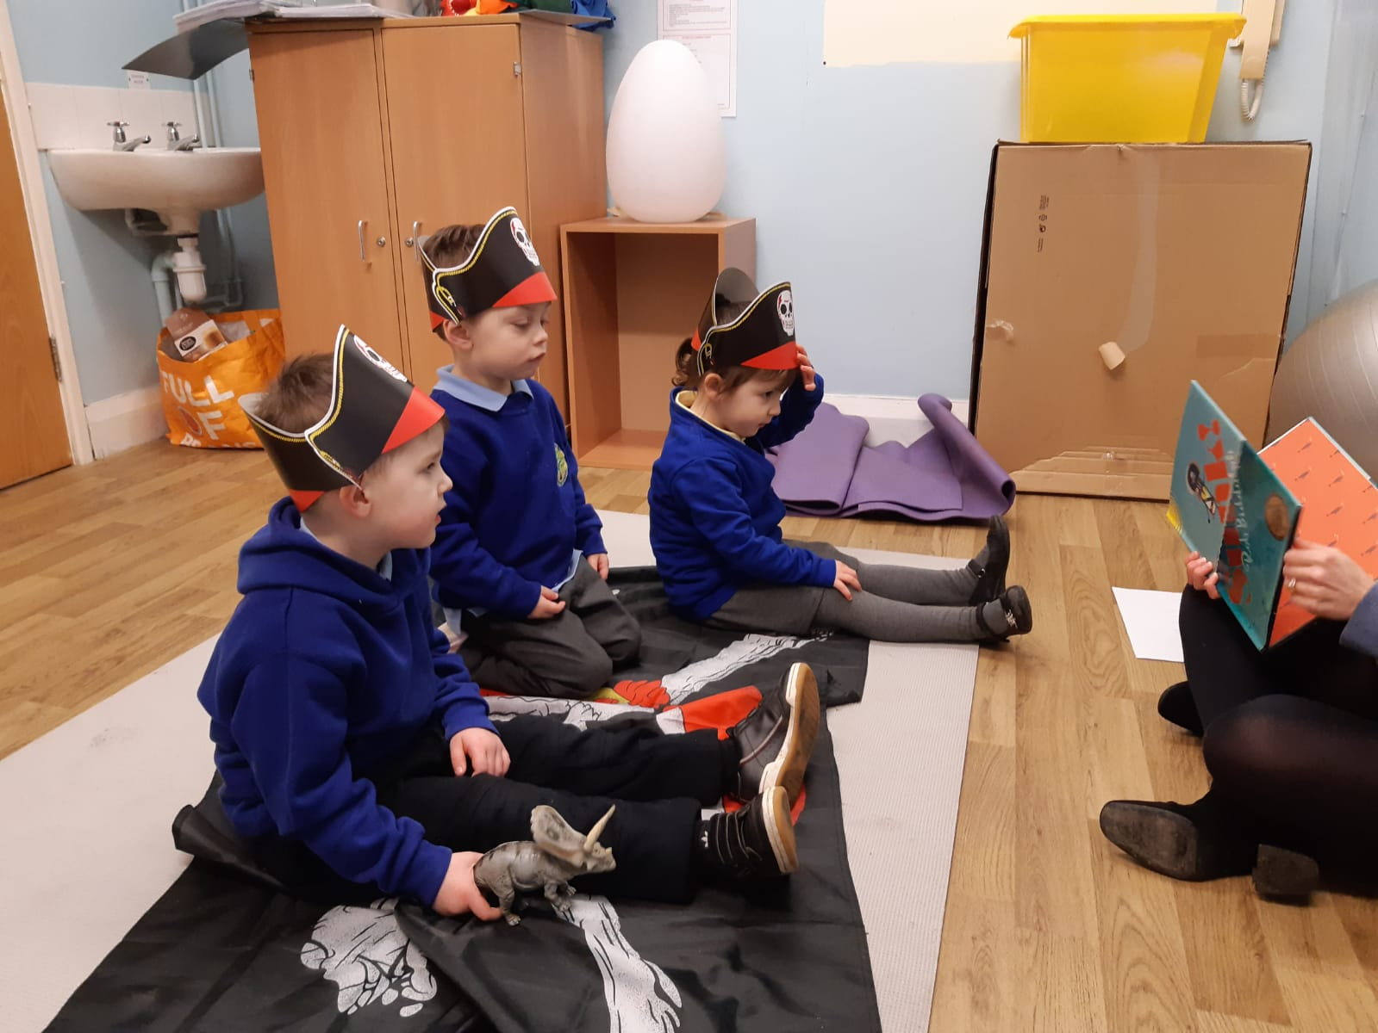

Appendix 19- Props/Resources Image Lesson 2

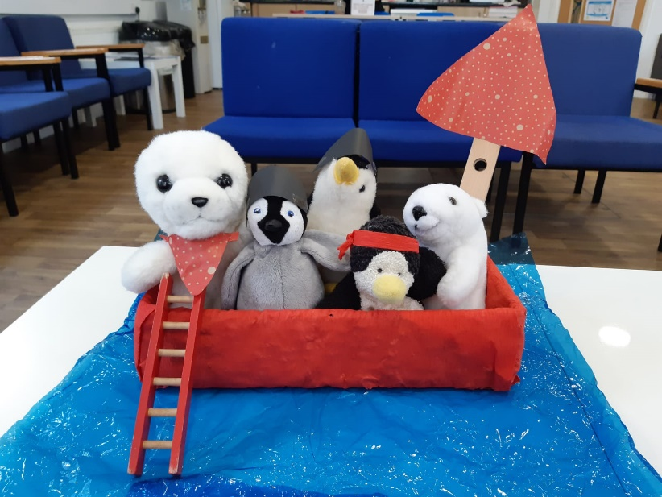

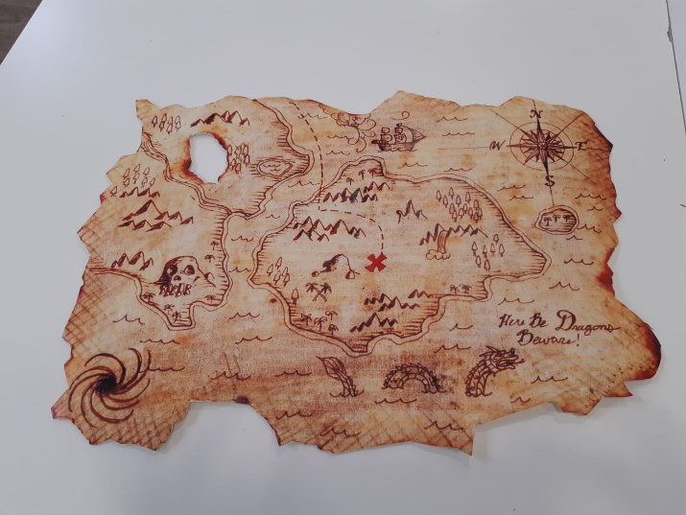
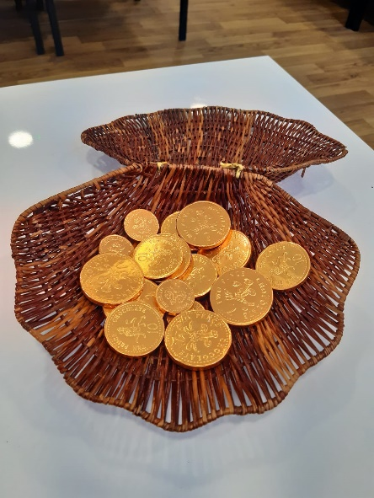

Appendix 20- Drawing Activity


