Managing Projects in Organisations BMSW5009

Promoting Romanian Desserts and Charity Donation

Student ID – 2310673
Student Name – Silvia Mita

Blog 1 - Planning the Event Using a Work Breakdown Structure (WBS)
Romanian Desserts and Donation project taught me the power of proper planning (Borcoman and Sorea, 2023). To plan the project in line with our model, we assisted ourselves with the Work Breakdown Structure (WBS) that aided us in the division of the project into small activities and the allocation. This assisted us in knowing what was required to be done before the event.
There was a role of each team member. This project was organised by Ionut, desserts were purchased by Andreea Porumbel, Mariana designed the posters and banners, and Andreea Lilea assisted in the setup of the event and collection of donations, and I distributed the flyers all over the university.
I found the WBS helpful because it helped me to be more organised and coordinated. It lessened the confusion, enhanced the intensity, and assisted us in tracking progress.
Another advantage of the WBS was that it also helped the teams from collapsing on themselves as each one had specific duties to perform, without distractions. This reduced duplication, miscommunication and timelines for the planning process.
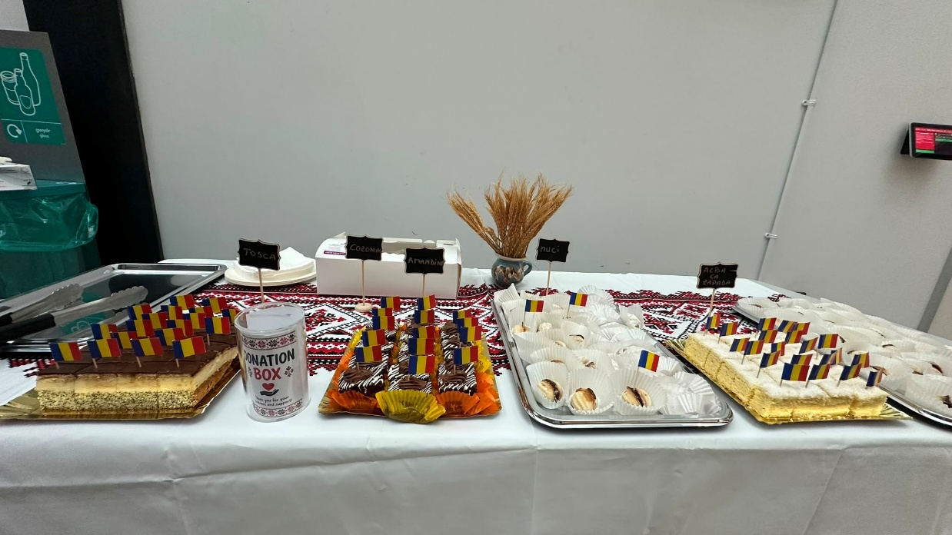
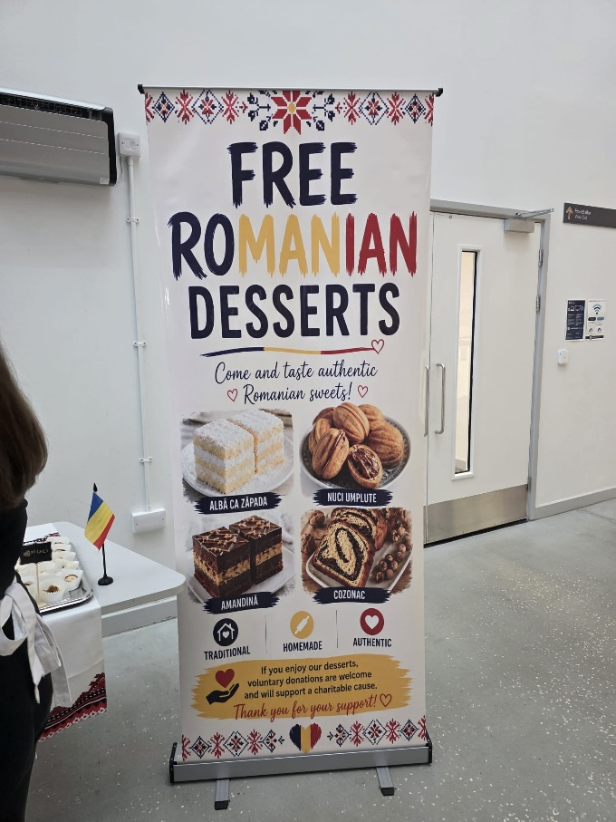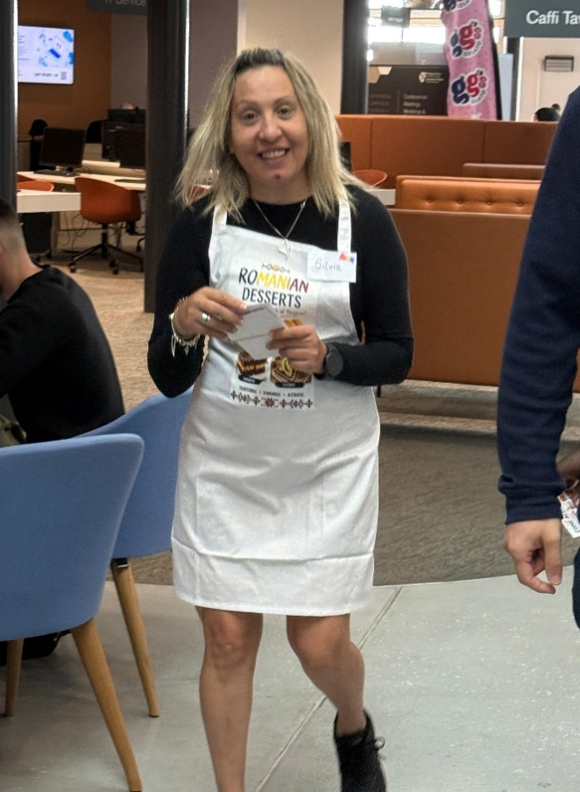
Blog 2 - Using a Gantt Chart to Coordinate the Event Schedule
In this project, I have learned the importance of a timeline in successful project management. We have not installed any type of specific software, but our crew operated according to a designed plan since it is in a Gantt chart. This helped us in organising our activities in the right order and to get activities completed before the actual date.
The project was started by ordering Romanian desserts and designing posters and banners (Lequeux-Dincă, Preda and Vijulie, 2024). The activity that I was allocated to carry out was to distribute invitations and flyers a week before the event. As the event was nearing its commencement, the team set up the display table, set up the equipment, and set up the system of donation.
A loosely structured time enabled us to be time savvy with a timetable. It was proved to be a key resource as Gantt Charts help improve coordination, monitor the progress, and deliver the project effectively.
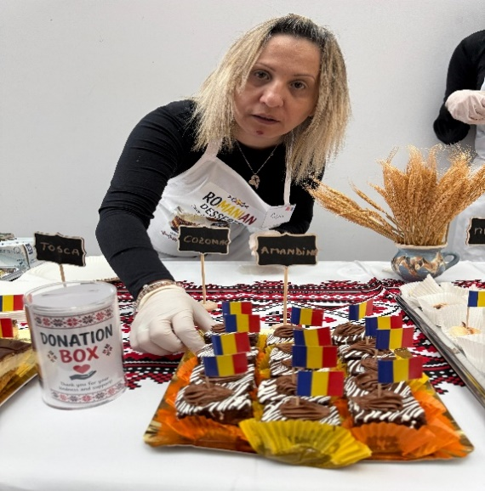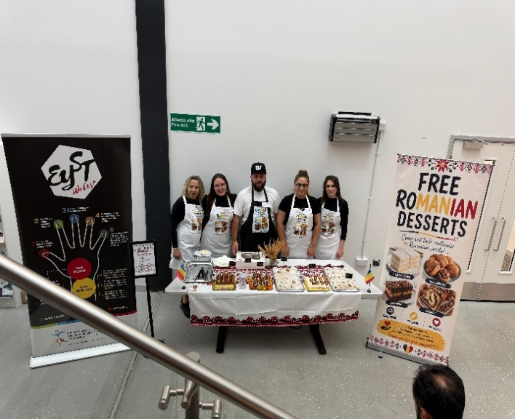
Blog 3 - Stakeholder Management
A lesson that I got from this project was the importance of stakeholder management. The Romanian Desserts and Donation event was successful due to the efforts of several stakeholders.
The event and the University of Wales Trinity Saint David approved the event, and EYST Swansea Charity was the recipient of the gifts. Homemade Cakes Laboratory helped in serving the desserts; the students and those who attended the event had to taste the products and contribute to the fundraising event (Proquest.com, 2025). Other stakeholders that played vital roles were the project team, as we were a team that was to put the event together, as well as carry out the event.
I also learned that communication matters when communicating with various groups of stakeholders. Being able to keep the stakeholders informed was also beneficial in creating trust and making sure that expectations were also met. This experience made me realise better that stakeholder management assists in the success of projects, and improves work relations.
I also learned the significance of prioritisation of stakeholders. University Operations had high power, with their reasoning being that they needed to approve in order to go ahead with the event, thus having a high interest.
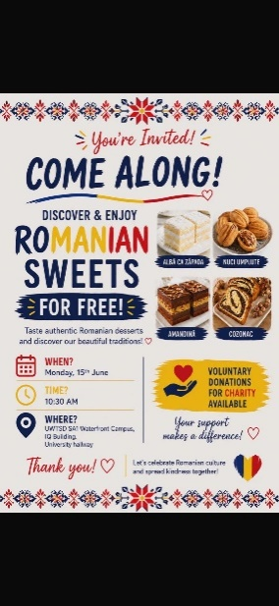
Blog 4 - Risk Management
Having to know that risk identification is a significant project management aspect, I got to learn the same during the planning. Our team took into account several risks that might influence the event and came up with measures in order to minimise their impact.
Management of food allergies was done by posting allergen labelling of each dessert. To maintain food hygiene, we would wear gloves anytime visiting visitors (Oliveira et al., 2024). Another issue was the low attendance, and as such, I sent flyers and invitations before the occasion. Supply risks were also minimised since the order of the desserts had been determined beforehand, and the challenges that were related to the donations were addressed with the help of a ready system of POS payments.
These measures performed quite well, as during the execution of the event, there was no problem and no critical concerns. This experience made me understand that risk management can be used to ensure that project teams are ready in case of trouble and be able to make the project more likely to succeed.
The high risk due to food allergy concerns was washing hands and sanitising between foods; therefore, there was no allergen information on the desserts. Food hygiene was also deemed to be a high risk, and gloves were worn during food service. Lower and medium level attendance was deemed as a medium risk, and flyers/invites were given out before the event. The sourcing delay was considered to be a medium-risk event, which was mitigated by the use of advance purchase of desserts.
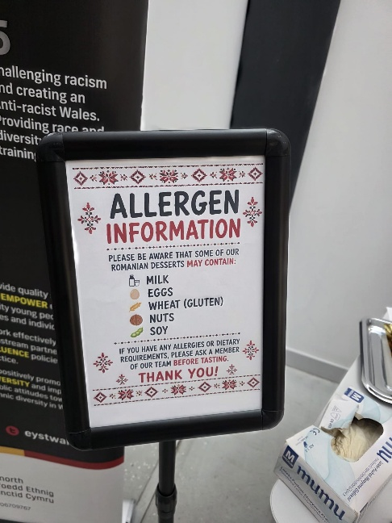

Blog 5 - Personal Reflection and Self-Development Plan
Considering the project on Romanian Desserts and Donation, it seems that it is a learning process. My activity was giving flyers and advertising the event, which enabled me to enhance and practice my skills in communication and organisation (García-Santiago, 2022).
The process of collaborating with my staff members helped me to learn new skills in the value of collaboration, accountability, and effective communication. I loved the idea of being able to take the Romanian culture and engage with visitors attending the event. One of those was to remind them to come, although sending the invitations early in advance was quite helpful in enticing people.
Although I am happy with the input I have made, I understand well how I can further improve. As a way of enhancing my leadership, once I can communicate with stakeholders and understand the software of the project scheduling, I would develop strategies for the projects I would wish to achieve or be involved with in future. The overall impact of this project will be that I am now more confident and I have gained experience in project management, which I can apply in future, be it in academics or a career.
The main challenge was to make a people's festival happen, which attracted their participation in the donation drive. The most challenging part of this was to get a people's festival going, to which they donated, and to get them to attend. I would do the same thing again, but would get started by increasing awareness of the project via social media and giving out flyers.
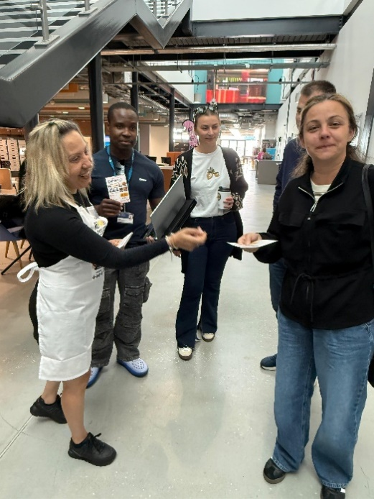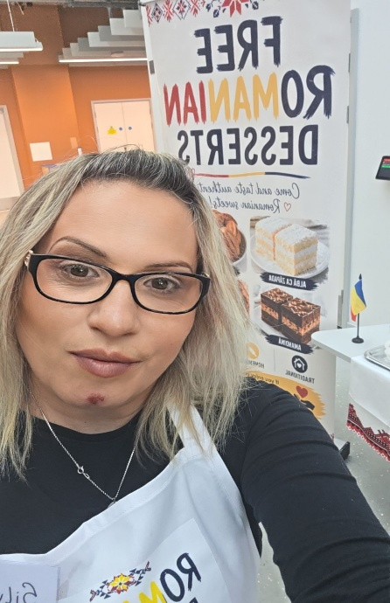

References
Borcoman, M. and Sorea, D. (2023). ‘Ethnic Soups from Rupea Area (Romania) as Resources for Sustainable Local Development’. Sustainability, [online] 15(2), p.943. doi:10.3390/su15020943.
García-Santiago, M.-D. (2022). ‘Communicating the Resilience and Corporate Social Responsibility of SMEs during Lockdown in Spain: A Visual and Exploratory Study of Communication Mechanisms and Strategies’. Sustainability, [online] 14(13), p.7944. doi:10.3390/su14137944.
Lequeux-Dincă, A.-I., Preda, M. and Vijulie, I. (2024). ‘Authentic Romanian Gastronomy—A Landmark of Bucharest’s City Center’. Tourism and Hospitality, [online] 5(2), pp.251–275. doi:10.3390/tourhosp5020017.
Oliveira, I., Almeida, M., Gomes, J.J.F. and Henriques, A.R. (2024). ‘Specific Personal Hygiene Procedures and Practices in Food Handlers—A Cross-Sectional Study in Butcher and Fishmonger Shops in Almada’. Hygiene, [online] 4(2), pp.207–220. doi:10.3390/hygiene4020017.
Proquest.com. (2025). Educating the New Generation of Food Scientists Through Innovative Learning Experiences - ProQuest. [online] Available at: https://www.proquest.com/openview/1689741549c9dba37983c0ad342f970e/1?pq-origsite=gscholar&cbl=18750&diss=y [Accessed 19 June 2026].

