LCBB4004
University of Wales Trinity Saint David
Marketing Fundamentals
Assignment 2

Lecturer: Tushara Balendran
Student: Georgi Dimitrov, 1917423

Table of Contents
Introduction 3
Task 1 4
1.1 Processes and stages of marketing including the role of the marketing mix 4
Task 2 10
2.1 Stakeholder engagement and their impact on the marketing activities of an organization 10
Recommendation 14
Conclusion 15
References 16

Introduction
Marketing is an action which accumulates information about the market and passes to other department so that the departments can conduct well. The roles of marketing make different changes on the business operations. In this case, marketing mix helps to evaluate the plan and also creates a structure so that the plan is well implemented. The promotion of the brand is accomplished using marketing mix. However, the brand recognition of company will also assist in the process of developing products simultaneously. This report will be made on Amazon’s marketing activities and roles. It is essential to derive a better performance from the selective resources using marketing activities and roles.

Task 1

1.1 Processes and stages of marketing including the role of the marketing mix
Marketing functions
Marketing refers to an action that is undertaken to promote buying and selling of a product, conduct market research, concurring promotional activities. Marketing places the product in front of the customers so that it can the customers can purchase it and it will increase sales. These marketing activities have different impact on the business (Baines, 2017). The roles of marketing make different changes on the business operations. Marketing plan is considered as a marketing strategy to attain business goals. In this case, marketing mix helps to evaluate the plan and also creates a structure so that the plan is well implemented. The process and stages are stated in the following section in the context of Amazon.
Process of marketing
Mission
Amazon has a mission of reaching customers as much as it can so that the organization can expand the business. A perfect mission of the business helps to integrate business and creates a structure that the organization can follow (Blakeman, 2014). However, the business structure is needed to be managed because all of the business activities are depended on the business structure. Mission helps to create a good and flexible marketing plan of the business. In this case, a flexible marketing plan helps to drag the attention of the customers even better.
Situation analysis
To accomplish the situation analysis, PESTLE and SWOT analysis play a very vital role. It is used to clarify the external and internal condition of the organization in various manner. Here, the PESTLE and SWOT analysis are given on the following:
PEST Analysis
Political-legal: Amazon is being dangerously by the operations of the Brexit. Because of the Brexit, the expansion beyond natural operational area is becoming hard. As the result, Amazon UK is being negatively influenced by the political factors. However, the political stability in the UK has been very much evident. So, it has been making positive impact on the operations of Amazon UK on regular manner.
Economic: In the economic condition, Amazon UK is getting positive side as the inflation rate and interest rate are stable. As the result, Amazon UK is getting effective sort of investment from the investors. Thus, it is bringing effective and positive impact on the processes of Amazon UK. On the other side, because of the operations of Amazon UK, a lots of jobs are being created. Thus, it is also making positive impact by creating employment (Baines, 2017).
Social-environment: During the pandemic, Amazon UK has been focusing on the social issues and applications. All of these social issues and applications have been in favour of Amazon UK. The organization has effectively focused on the customer demands and it is a positive thing. On the contrary, the customers are also accepting the products of Amazon UK effectively. Thus, all of these issues are making positive impact on the Amazon UK too.
Technology: Technology is changing on regular manner and Amazon UK is required to focus on new technology to keep their operations smooth (Dreskin, 2015). All of these technologies are becoming used to provide Amazon UK with the competitive advantage. In this way, technology related operations are getting effective. As the result, an organization like Amazon UK has been able to achieve effectiveness from the technology operations.
SWOT Analysis
Strengths: In Amazon UK, customer service is one of the leading advantage. They have the best possibility of supporting the customers based on their demands. So, it is being a strength for an organization like Amazon UK. On the other side, they also have expanded operational area which can be used in the future days (Blakeman, 2014). They also have skilled workforce to support customers.
Weaknesses: On the other side, there are also various weaknesses related to the ground too. Amazon UK do not have any strong physical location as they have a lot of storehouses. Their supply chain techniques are also not effective enough. Because of poor operations, their operational costs are getting increased on regular manner.
Opportunities: In the same way, Amazon UK can also achieve various sort of opportunities too. Here, Amazon UK can create even more effective strategies that can lead toward better sides. In the similar side, Amazon UK can also train their employees so that the customer service can get better (Antonetti, 2017). Their operational areas can also be expanded in significant manner in future.
Threats: There are various threats associated on the processes as well. Amazon UK might get poorly influenced by the changing demand and customer needs. On the other side, because of the higher range of competition, Amazon UK can also face a lot of threats as well. In this way, the threats are being controlled for an organization like Amazon UK.
Marketing strategy
To work on the marketing strategies, STP strategies will have to be analysed significantly.
Segments: There are various segments which are available on the Amazon UK. There are segments based on the behaviour which is used to make the behavioural analysis.
Target market: As the form of targeted segment, only those will be chosen who are comfortable to order anything online. Because of choosing this specific segment, the target market of Amazon UK is being satisfied (Antonetti, 2017).
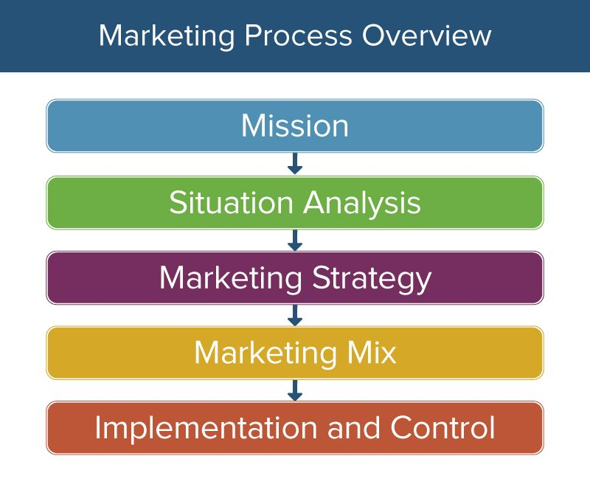
Figure: Overview of market process (Dreskin, 2015)
Positioning: For the purpose of successful positioning, the products are placed as lower in cost but higher in quality. When the products have lower price, it can be successful at meeting the customers of all background. In this way, Amazon UK has been working on the positioning strategies on significant manner.
Marketing mix
Marketing mix is a technique which is used by the organization to promote its products and services in the market. The promotion of the brand is accomplished using marketing mix. It is a set of marketing tools that an organization utilizes to pursue its marketing objectives in the target market (Freeman, 2010). However, Amazon uses marketing mix for the promotion for its products and brands. In the section below the marketing mix of Amazon is given.
Product: Amazon produces different products and retails those to the customers. In this case, Amazon assures that the quality of the product is protected and the design is done in a way so that it drags the attention of the customers. It assures the high usability of the products so that it can assure a better output. However, the brand recognition of company will also assist in the process of developing products simultaneously. Due to the high quality of the product, the durability is quite strong that helps to attain the mission of gaining as much as customers. Amazon needs to assure these factors while producing products (Antonetti, 2017).
Place: Amazon will try to expand its market into different areas including South Asia and so on. In this case, Amazon needs to have a good recognition in the market and people will have to prefer the brand. That is why the quality needs to be assured and the products will be placed on the websites. While considering market segments and strategies it is essential to conduct market research which is done using situation analysis (Goi, 2019). Due to the Covid-19 outbreak, people are maintaining social distancing and that is why it is essential to place the products on the websites of Amazon. Thus it will be delivered to the people as soon as it can be.
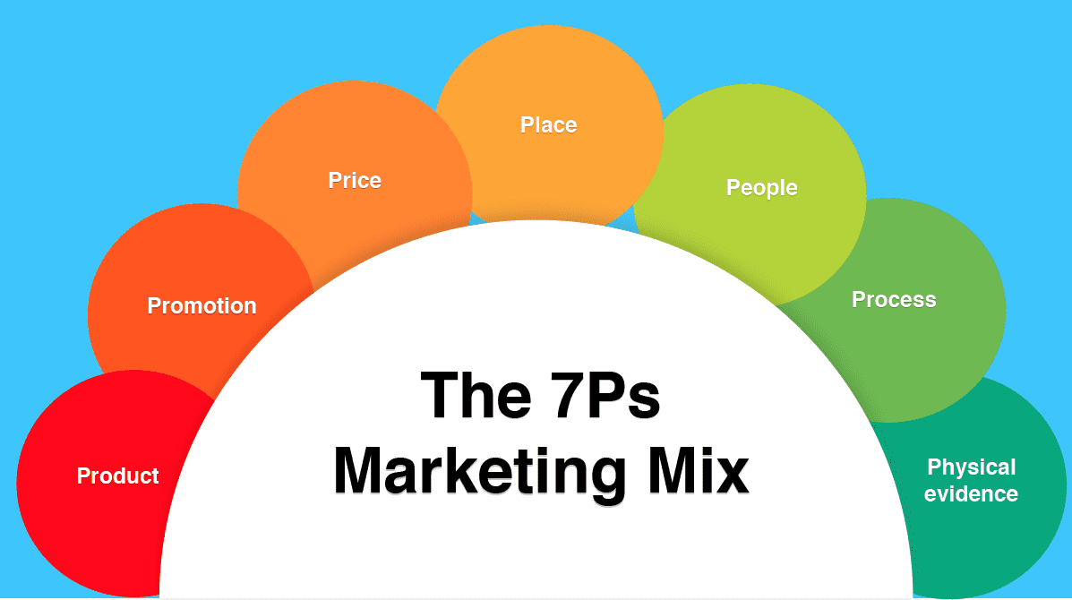
Figure: Marketing Mix (Graham, 2018)
Price: In terms of considering the pricing, Amazon will be analysing the market so that it can have idea about the other brands and their rates of products. In this case, the price will be based on the penetration strategy, loss leader, value-based strategy and cost-plus strategy. In this case, Amazon follows the competitive strategy so that it can set the price according to the competition charges. In order to find the perfect pricing strategy it is essential to determine pricing position, segments, ability and competition (Holtzschue, 2017). The market is full of competition and it will be making so many alterations in the business. However, a proper strategy of pricing will be a lot more changes in the conduction process of business.
Promotion: Branding and letting people know about the brand, products and other things are done using the promotional activities. The promotional activities are done using offline and online promotion by Amazon. The online promotion undertakes the action of boosting posts on social media platforms. On the other hand, Amazon uses mailing system to let people know about the upcoming offers and deals. Offline promotion is availing sponsorship and so on. Through these offline and online promotion, Amazon can take place in the market.
People: In the case of business organization like Amazon, the marketing executives need to have wide knowledge and idea about the marketing strategies and plan. To pursue the plan, the marketing executives need to have proper skill and ability to accumulate marketing activities. In different aspects, the skill gap of employees are seen which can be eradicated using training process to the employees. Good marketing skill can assure competitive advantage for Amazon and Amazon brings different skill development programs for the business (Noriega, 2017). The organization should increase their investment into online services and thus the employees need to be skilled enough to process it.
Process: The operational and functional process of the business is accelerated with the help of marketing activities. Process is an action that is taken in delivering the product to the customers. In the marketing activities, there are different stages which are needed to be accomplished. In the conversion procedure, more staff related to sales is needed to be involved so that the entire process feels good. The assessment of facts that Amazon equips like payment system, product distribution, developing customer relation, sales funnel and so on.
Physical Evidence: An organization is needed to acknowledge physical evidence because it helps to bring out positive output (Jobber, 2012). Physical evidence undertakes the proof of a transaction happened and it is the way of being assured about the existence of the brand. The existence of the brand is acknowledged by people through emblem and logo. It has a unique packaging process that can also be recognizable. Validation denotes to visual quantifiable aspects of the brand like its website, logo, social media presence and business cards and so on.
Implementation and control
Implementation of the plan will be successfully implied in this case and the proper control over the marketing process is needed to be assured. The achievement of the plan will take 6 months or even 1 year. With the proper implementation of the plan will be administrated with the help of proper control (Ellis, 2012). Hence the guideline of the marketing executives is needed to be followed accordingly. Otherwise it can create a lot of problems in the operational process.
Hence these are the marketing process of Amazon that is assisting to create a place in the market.

Task 2

2.1 Stakeholder engagement and their impact on the marketing activities of an organization
Stakeholder Engagement
Amazon takes different operation, functional, situational and so on decision for the welfare for the business organization. The business organization will be influencing the related parties of the business. In this case the related parties are stakeholders. The engagement of stakeholders is essential to be managed because the stakeholders are the integral part of the organization. Stakeholder’s engagement is a procedure through which the related parties can get influenced by the decisions taken by Amazon. Stakeholders’ engagement can also influence the decisions of the business (Withey, 2016). In this case, the decisions of business need to be taken properly otherwise it will be making different impact on the performance. The marketing activities assure the proper engagement of stakeholder but it also ensures that it bring positive impact on the business. Thus it works in the increment of sales as well as profit.
Stakeholders of Amazon
The stakeholders of Amazon are the integral part of the business because it cannot run without it. Stakeholder gets influenced due to the decision making of the business as well as business gets influenced due to the engagement of them. There are stakeholder parties related both internally and externally to the organization. Managers and directors are the stakeholders of the business who are managing the business properly. Managers are liable to report to the directors because they have the high power of taking decisions. According to the decisions of stakeholders the organization takes actions (Malhotra, 2018). Managers are recruited to follow the instructions given by the stakeholders. Again, strategic partner is another stakeholder who forms an agreement to share resources with mutual affiliation and success. It is expected that both parties who have participated in the agreement will get equal benefits and growth. NGOs and employee’s union also influenced impact because these are other stakeholders of Amazon. That is why Amazon needs to focus on accomplishing corporate social responsibilities properly.
Figure: Stakeholder of Amazon (Mittal, 2019).
Employees are the integral part and one of the most important stakeholders available in the business. Employees are significant to run an entire business with proper management. Employees are liable to get the attention of another stakeholder which is customer. Customer and communities are the stakeholders who are essential for the improvement and development. In this case, business has to invest in different projects so that Amazon can meet the demand of the customers. The parties who invest in the company are known as investors who are another stakeholder of Amazon (Jones, 2018). With high investment, Amazon will enter into the market which is full of competition. This competition is created by the competitors who are the stakeholders of Amazon. Amazon needs to beat the stakeholder properly otherwise it will never be able to take place in the market. On the contrary, Amazon needs to accept and follow the laws which are enforced by the government and other law enforcing parties. Thus Amazon will be able to follow a guideline given by the government and law enforcing parties.
Stakeholders’ impact on marketing activities
Marketing activities upholds activities that help to take place in the market and gain customer satisfaction. Marketing refers to an action that is undertaken to promote buying and selling of a product, conduct market research, concurring promotional activities. Marketing plan is considered as a marketing strategy to attain business goals (Scott, 2015). Marketing activity is required for the development of the business because thus the marketing activities will assist to gain competitive advantage. The marketing activity is conducting proper research in the business so that it can gain idea about the macro environment and also about internal condition.
Using marketing activity, Amazon basically thinks of expanding the business and that is why it equips the method of STP strategy. STP strategy is a tool of segmenting market, target particular market and positioning the products. Marketers select a particular segment and target to expand or penetrate the market. In this case, the Amazon selects particular products that will be used for the development within the business (Siro, 2018). On the other hand, it will be make different impact on the business. Another section, marketing activities also includes building customer experiences, set product distribution channels and promotional activities. It is essential to set required product distribution channel so that products can be supplied properly. Thus it will assure good activities of promoting products and services to get acknowledged in the market.
Stakeholders’ impose huge impact on the marketing activities of the organization. Stakeholders’ are influencing the marketing activities. The employees are influencing marketing activities through keeping themselves motivated so that positive outcome can be assured. If the employees get demotivated then inefficiency and ineffectiveness will be seen. Customers are needed to be kept satisfied because the increment of sales depends on them (Lugasi, 2018). On the other hand, the managers and directors are needed to be kept informed about the process. The research that the organization will conduct and the result of it will be informed to the directors and managers. This helps to analyse the information and take decisions. NGOs and employee union has an impact on market penetration and getting the attention of customers. In this case, the company need to follow the corporate social responsibility.
Government and law enforcing parties will be imposing different laws on the business which will be influencing the business. In this case, Amazon needs to follow the laws like employment act and so on. Regarding the law, market will be influencing the business and the market is full of competitors. The competitors will be influencing the business in different ways and sometimes organization will be benchmarking them. Thus it will be influencing the business procedure and marketing activities (Smith, 2015). The promotional activities need to be done properly otherwise customers have a lot of other options to choose. Strategic partners will be influencing the marketing activities of product distribution channels. Investors will be influencing market research as well as selecting the segment in the market.

Stakeholders’ engagement will be making different impact on the marketing activities and it brings both positive and negative impact on the business. The positive impact is highly seen in the context of Amazon. Communicating with the stakeholders’ will assist to gain different knowledge about business and the organization can equip new strategies in this case (Visser, 2019). While conducting research, the stakeholders’ engagement can provide with proper information about the market and thus it will result into effective decision making. For instance, employees can communicate with the customer’s to acknowledge their needs and demand with the customers within the business. It will also assist in building customer experience in the business.
However it has some negative sides too in the business process. The stakeholders’ engagement is making different negative changes and influencing negatively on the marketing roles. Mission and vision of the organization is connected with the marketing roles. For instance, stakeholders’ sometimes pressurizes the organization to produce products that are reasonable as well as lucrative (Withey, 2013). In this case, the products will not be able to meet quality regarding this thing. Thus it may increase sales but due to the low quality the customer may get negative. Hence it will bring negative impact on the business and it will lose the strong base of customers.
Hence it can be said that, stakeholders’ have both positive and negative impact on the business which can bring positive impact. On the contrary, conflict among stakeholders’ can also bring negative impact on the marketing roles of Amazon.

Recommendation
It is seen that stakeholders’ bring both positive and negative impact on the marketing activities of the business. The organization will be making different impact on the business and thus it will be sharing different changes (Berry, 2019). Hence, stakeholder’s engagement can be improved through following some recommendations which are given in the following section.
- The communication among the stakeholders’ needs to be increased so that proper flow of information can be derived from it. Thus it is highly essential to assure communication to derive effectiveness,
- Amazon needs to communicate scopes, aims and desired results of engagement with the stakeholders’ to improve their motive. Thus it will encourage them to work within the system and bring positive impact on the marketing roles,
- Proper training is needed in this case and project professional needs to be introduced so that proper understand of different perspectives can be addressed. This is how, an effective stakeholders’ engagement can be managed within the system.
These are the recommendations that can bring effective stakeholders’ engagement and positive impact on the marketing roles of Amazon.

Conclusion
A perfect mission of the business helps to integrate business and creates a structure that the organization can follow. With the proper implementation of the plan will be administrated with the help of proper control. The stages of marketing consist of sectors that help to prevail better understanding through integrating marketing plan. Stakeholder’s engagement is a procedure through which the related parties can get influenced by the decisions taken by Amazon. Stakeholder gets influenced due to the decision making of the business as well as business gets influenced due to the engagement of them.

References
Baines, P., Fill, C., Rosengren, S., & Antonetti, P. (2017). Fundamentals of marketing. Oxford University Press.
Blakeman, R., (2014). Integrated marketing communication: creative strategy from idea to implementation. Rowman & Littlefield.
Coe, J. M. (2014). The fundamentals of business to business sales and marketing. New York, NY: McGraw-Hill.
Data, A.P., (2014). For each type of product indicated. Include construction details, material descriptions, dimensions of individual components and profiles, and finishes for aluminum-framed systems.
Dreskin, J. (2015). Marketing Fundamentals. In A Practical Guide to Indie Game Marketing (pp. 13-28). Routledge
Freeman, R.E., (2010). Strategic management: A stakeholder approach. Cambridge university press.
Goi, C.L., (2019). A review of the marketing mix: 4Ps or more?. International journal of marketing studies, 1(1), p.2.
Graham, H., (2018). Marketing strategy and competitive positioning. Pearson Education India.
Holtzschue, L., & Noriega, E. (2017). Design fundamentals for the digital age. Van Nostrand Reinhold. introduction. Pearson Education.
Jobber, D., & Ellis-Chadwick, F. (2012). Principles and practice of marketing (No. 7th). McGraw-Hill Higher Education.
Keller, K.L., (2010). Building and managing corporate brand equity. The expressive organization: Linking identity, reputation, and the corporate brand, pp.115-137.
Kotler, P. and Armstrong, G., (2010). Principles of marketing. Pearson education.
Kumar, P. (2020). A Review of Relationship Marketing Fundamentals. Journal of Talent Development and Excellence, 12(2s), 3915-3921.
Lancaster, G., & Withey, F. (2016). Marketing fundamentals. Routledge.
Malhotra, N.K., (2018). Marketing research: An applied orientation, 5/e. Pearson Education India.
Mittal, S.K., (2019). Sales promotion & marketing communications. Global Vision Pub House.
Pride, W.M. and Ferrell, O.C., (2016). Foundations of marketing. Cengage Learning.
Reid, D. A., Plank, R. E., & Lichtenthal, J. D. (2014). Fundamentals of business marketing research. Psychology Press.
Richards, K.A. and Jones, E., (2018). Customer relationship management: Finding value drivers. Industrial marketing management, 37(2), pp.120-130.
Scott, D.M., (2015). The new rules of marketing and PR: How to use social media, online video, mobile applications, blogs, news releases, and viral marketing to reach buyers directly. John Wiley & Sons.
Siro, I., Kápolna, E., Kápolna, B. and Lugasi, A., (2018). Functional food. Product development, marketing, and consumer acceptance—A review. Appetite, 51(3), pp.456-467.
Smith, S. M., & Albaum, G. S. (2015). Fundamentals of marketing research. Sage.
Visser, M., Sikkenga, B., & Berry, M. (2019). Digital Marketing Fundamentals: From Strategy to ROI. Routledge.
Withey, F., & Lancaster, G. (2013). CIM coursebook marketing fundamentals 07/08. Routledge.

