University of Wales Trinity Saint David

School of Engineering

Series Hybrid Vehicle CW2



Wesley Patrick – 1701708

MSc Automotive Engineering

Hybrid Powertrain & Control – ACEA7007

Table of Contents
1.0. Introduction 3
2.0. Specification 4
3.0. Methodology 9
3.1. Additional weight 9
3.2. Final drive 9
3.3. Efficiency 10
4.0. Analysis 12
4.1. Costing 12
4.2. Fuel usage and emissions 12
5.0. Conclusion 14
6.0. References 15

Equation 1 - Wheel Speed 10
Equation 2 - Final Drive Ratio 10
Equation 3 - Efficiency Equation 11
Equation 4 - Final Drive Efficiency 11
Equation 5 - Motor Efficiency Equation 11
Equation 6 - Battery Efficiency Equation 11
Equation 7 - Generator Efficiency Equation 11

Figure 1 – HPEVS AC-12 Metric Peak Graph (HPEVS, 2022) 5
Figure 2 - HPEVS AC-12 Metric Continuous Graph (HPEVS, 2022) 6
Figure 3 - GBS 100Ah Configurable Li-Ion Battery Pack w/ EMUS G1 BMS & Charger (Motorsport, 2022) 7
Figure 4 - HPEVS AC-20 Metric Continuous Graph (HPEVS, 2022) 8

Table 1 - HPEVS AC Electric-Motor Drive Systems (AC-12) characteristics 4
Table 2 - HPEVS AC-20 Motor Characteristics 8
Table 3 - Weight of series hybrid components 9
Table 4 - Component Efficiencies Table 11
Table 5 - Costing Table 12
Table 6 - Fuel Usage & Emissions 12

Introduction
In recent history companies and organisations have had to be more mindful of their “green image” and taking steps to mitigate negative effects to the environment. For a company who manage and operate corporate off-road buggy experiences, “green image” has become a large issue as their sole principle relies on recreational vehicles that cause harm to the environment. To continue providing exhilarating experiences in a safe environment for recreational and corporate use the company must develop a new strategy that will positively affect their carbon footprint.
One such method of improving the company’s carbon footprint is developing a series hybrid system that can be fitted to the off-road buggy. A series hybrid utilises an internal combustion engine that does not propel the vehicle but instead runs a generator that charges the vehicles battery pack (Randall, 2021). This solution provides a viable option as it allows the ICE unit to be operated at the most efficient point therefore reducing the fuel usage and harmful gaseous emissions.
The focus of this report will be to research and specify series hybrid components that are compatible with each other and the off-road buggy that will be used, which will be the same Renegade DX10-C Corporate 300cc as was used for the duty cycle analysis for the same company. The duty cycle will be identical to the previous duty cycle analysis of an ICE powered off-road buggy for an accurate analysis of propulsion systems. This duty cycle will provide comparative results which will allow for analysis of fuel usage, emissions, performance, and energy usage.

2.0. Specification
The process of converting an ICE propelled vehicle to a series hybrid vehicle is a lengthy project consisting of an array of components. Components must be specified based on compatibility and suitability to ensure the off-road buggy can operate in a similar window to the ICE variant. The series hybrid conversion is comprised of an electric motor and controller, battery and controller, generator, and an ICE unit, these components all come with their own fittings and fixings meaning that certain components cannot be used in conjunction with each other. There are also compatibility measures when evaluating the performance of the components as a range of voltage, and current are used which may not be suitable or optimal for use with each other. The suitability of the specified components is based upon the requirements of the duty cycle that has been developed for this comparative study, the components need enough performance to comfortably undertake the duty cycle without being considered “overkill” at which point the added weight will not deliver any additional benefit to the companies model of delivering exhilarating corporate experiences.
The motor that has been specified for this conversion is the HPEVS AC Electric-Motor Drive Systems (AC-12), HPEVS state that this motor is ideal for use in smaller applications such as golf cars, utility vehicles, and motorcycles (HPEVS, 2022). The specifications for this motor are displayed in the table below.
Table 1 - HPEVS AC Electric-Motor Drive Systems (AC-12) characteristics
Voltage | 48 | V
Current | 350 | A
Torque | 72.4 | Nm
Peak Power | 13.28 | kW
Peak Efficiency | 4000 | rpm
Weight | 22.7 | KG

The figures in the table above have been interpolated from the figures below showing the traces for torque, power output, battery voltage, and DC current. The specification motor is required to have a peak power output that is higher than the peak power observed during the ICE duty cycle. This criteria is satisfied because the peak power observed during the ICE was 10.7kW, allowing for additional weigh and efficiency losses this motor comfortably covers the required peak power. Looking at the lower figure showing the continuous graph, these figures are for an uncooled motor whilst it is ideal to show the characteristics of the motor with no cooling applied it could be said that the chassis design of the off-road buggy would inherently allow airflow to cool the motor which may improve certain characteristics of the motor.
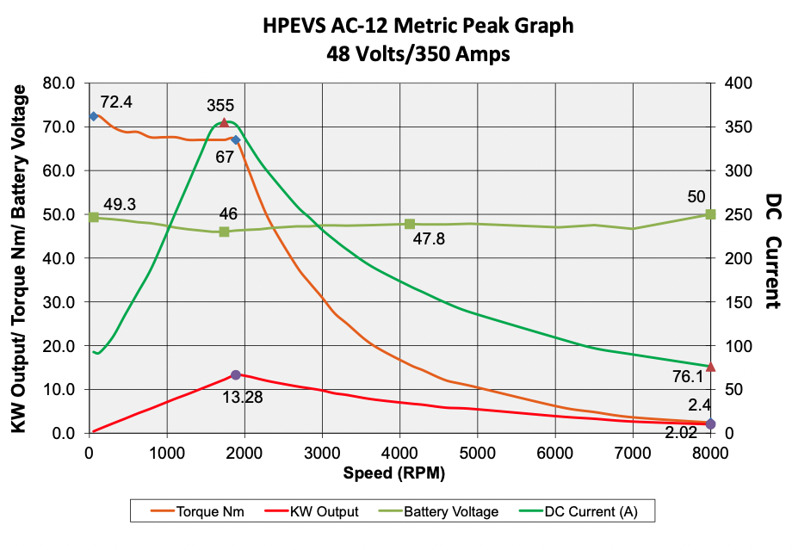
Figure 1 – HPEVS AC-12 Metric Peak Graph (HPEVS, 2022)
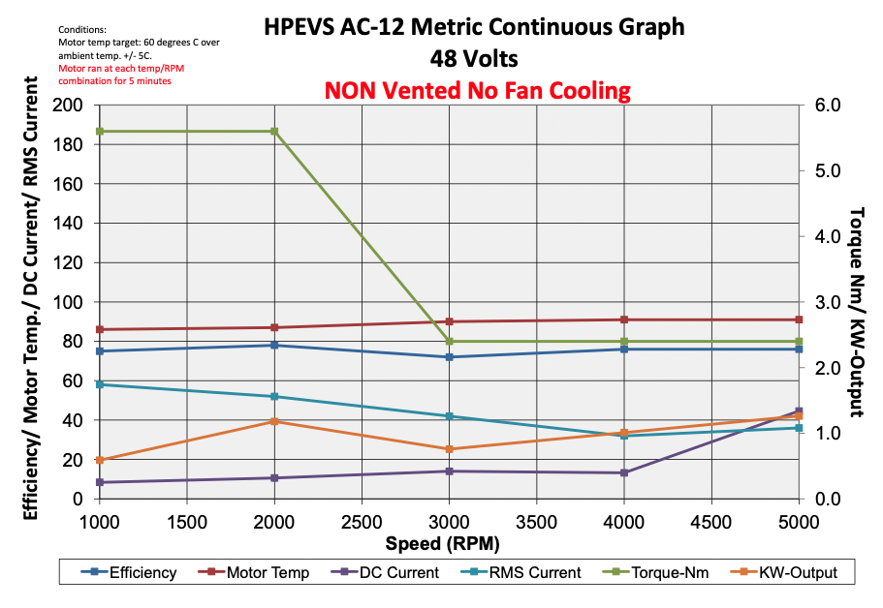
Figure 2 - HPEVS AC-12 Metric Continuous Graph (HPEVS, 2022)
To aid in the compatibility of the system components HPEVS supply their motors in a package with a compatible motor controller, for this system the Curtis 1236SE-6521, which has a voltage range of 48-80V at 450A. this method of procuring components is ideal as it means compatibility is ensured while keeping costs lower than buying individual components. The responsibility of the motor controller is to provide advanced control of the motor ensuring traction is maintained and power is delivered appropriately (Electrics, 2022).
The battery in a series hybrid vehicle is responsible for the energy storage of the system. Energy storage is a crucial element of the series hybrid system as the ICE power unit does not supply direct energy to the wheels, the power instead is drawn from the battery to power the wheels. The battery that has been specified for this project is the GBS 100Ah Li-Ion battery pack, the requirement of the motor is 48V with a maximum current of 350A. an amp hour (Ah) is the rating of a battery or cell that informs the user of how much amperage it can provide for exactly one hour (Powered, 2022). The configuration of this battery pack is comprised of 16 cells at 12.8 nominal voltage per four cells giving the system over 48V available whilst adding 25kg to the buggies weight (Motorsport, 2022).
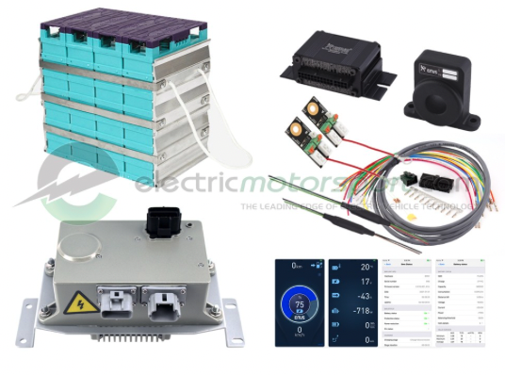
Figure 3 - GBS 100Ah Configurable Li-Ion Battery Pack w/ EMUS G1 BMS & Charger (Motorsport, 2022)
Similarly to the motor, the battery pack and battery management system are supplied in a package deal to ensure compatibility across the system. The battery management system that has been specified by electric motorsport for this package is the EMUS G1, the package also ships with a charger, wiring loom, and all components that are required for fitting as shown in the figure above. The battery management system is, as stated, responsible for the management of the battery controlling the rate of power delivery to the motor to drive the wheels. The EMUS G1 BMS is capable of supporting single battery cells between 2-5V and can support up to 225 cells per battery pack which far exceed the requirements of the specified system (Motorsport, 2022).
The generator in the series hybrid system is driven by the ICE unit converting kinetic energy into electrical energy that can be stored in the battery system. The power that is required by the system is an average of 4.77Kw, meaning that the generator is required to produce this amount plus the efficiency losses of the system at the ICE’s peak efficiency point of 5500rpm. The HPEVS AC-20 can comfortably provide for the required power demand at the specified rpm allowing the OEM ICE unit to remain a part of the system. The specification of the motor generator and its performance graphs are displayed in the figures below (HPEVS, 2022).
Table 2 - HPEVS AC-20 Motor Characteristics
Voltage | 48 | V
Current | 350 | A
Torque | 18Nm@5000rpm
Peak Efficiency | 8kW@4000rpm
Weight | 24.5 | KG

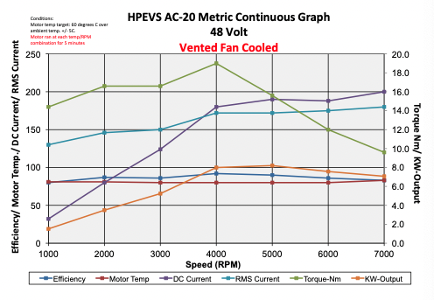
Figure 4 - HPEVS AC-20 Metric Continuous Graph (HPEVS, 2022)
The ICE unit that has been specified for this project, as stated previously, will be the OEM ICE power unit that comes fitted to the vehicle. Using the OEM ICE allows for a lower cost and less labour intensive conversion from internal combustion propulsion to a series hybrid vehicle. The ICE is a 278cc four stroke single cylinder engine producing a maximum of 13.4kW at 5500rpm, which comfortable encapsulates the average and maximum power requirement from the duty cycle. By using the OEM ICE unit also allows for the power unit to remain in its standard location, thus reducing labour costs (Blitzworld, 2021).

3.0. Methodology
In order to accurately specify the series hybrid components they must be implemented into the drive cycle prior to fitment so that any benefits and potential issues can be highlighted and mitigated if required. The required steps below implement the additional weight of the components as well as the efficiencies of the system. These factors are calculated through the equations listed in each section below.

3.1. Additional weight
The conversion from ICE to series hybrid comes with potentially extensive weight gains through additional components. Due to the motor, motor controller, battery, battery management system, and generator being new components these come with their own additional weight which must be implemented into the system. the weights of the components are listed in the table below, a miscellaneous row has been added to the table to account for additional wiring looms and components that are not explicitly advertised as having an accurate weight (HPEVS, 2022) (HPEVS, 2022) (Motorsport, 2022) (Electrics, 2022).
Table 3 - Weight of series hybrid components
Component | Weight
Motor | 22.7KG
Motor controller | 2KG
Battery | 31.4KG
Generator | 24.5KG
Miscellaneous | 5KG
Total | 85.6KG

With the additional weight of the components the buggy weight has been increased from 365KG to 450.6KG, this is the curb weight of the buggy. With the additional weights in the buggy such as driver, passenger, their kit and fuel the new total weight of the buggy has increased to a total of 652.93KG although, this does include 22.33KG of fuel which can be reduced in the series hybrid variant as the ICE will be operating within its peak efficiency zone.

3.2. Final drive
The ICE buggy uses a traditional chain drive system to deliver power to the wheels from the gearbox, the series hybrid will retain this chain drive system between the motor and rear axle. Chain driven systems have been used extensively throughout industry, particularly for smaller vehicles such as motorcycles and utility vehicles. A chain driven final drive solution provides an ease of serviceability, whilst also offering smooth shock absorption from sudden shock loading such as harsh acceleration. The negatives to using a chain drive solution, specifically in the case of an off-road utility vehicle is that the system will be exposed to a wide array of dirt and particulates that will coat the chain and sprocket potentially leading to the chain becoming dislodged or prone to quicker wear (Glimmerveen, 2018). Due to the new series hybrid variant of the off-road buggy having a chain and sprocket final drive solution, this means that equations can be used similarly to those in the motorcycle or utility sector to find the final drive ratio, the equations below detail the derivations required to find this ratio.
From the ICE duty cycle the rolling circumference and average velocity have already been calculated, using these values the wheel speed can be calculated:
Equation 1 - Wheel Speed
$$\left(\frac{V_{Average}}{RC}\right)∙60=Wheel RPM \\ ∴\left(\frac{9.91}{1.82}\right)∙60=324.92 RPM$$
(Markings, 2018)
Using the wheel speed and the most efficient point of the motor, which has been established as 4000rpm the equation below can be used to calculate the final drive ratio:
Equation 2 - Final Drive Ratio
$$\frac{V_{Motor}}{V_{Wheel}}=Final Drive Ratio \\ ∴\frac{4000}{324.92}=12.31:1$$

3.3. Efficiency
Each component within the series hybrid system has its own efficiency of power conversion which need to be considered, failure to meet the required power demand will result in the ICE power unit not being able to the generator, thus resulting in battery discharge.
Working backwards from the ICE buggy average power requirement of 4771W per second, the efficiencies of each component in the table below, can be implemented into the equations listed below with the power required from the previous equation being substituted into the following one as the system is calculated back to the ICE power unit.
Table 4 - Component Efficiencies Table
Component | Efficiency | Source
Final Drive | 97% | (Power Transmission Engineering, 2017)
Motor | 89% | (Boloor, et al., 2019)
Battery | 87% | (Voelcker, 2021)
Generator | 89% | (Boloor, et al., 2019)

Equation 3 - Efficiency Equation
$$Power required+Efficiency loss=Power supply requirement$$
Equation 4 - Final Drive Efficiency
$$4771+\left(4771∙0.03\right)=4914.13W$$
Equation 5 - Motor Efficiency Equation
$$4914.13+\left(4914.13∙0.11\right)=5454.68W$$
Equation 6 - Battery Efficiency Equation
$$5454.68+\left(5454.68∙0.13\right)=6163.79W$$
Equation 7 - Generator Efficiency Equation
$$6163.79+\left(6163.79∙0.11\right)=6841.81W$$
From this, conclusions can be made that in order for the average power requirement of 4771W at the wheel to be observed, the ICE power unit is expected to drive the generator so that it can produce 6841.81W. From earlier statements the ICE units peak efficiency point at 4500rpm produces 8948.4W, which comfortably covers the required power by the generator whilst still providing enough power for the battery to recharge.

4.0. Analysis

4.1. Costing
Each component that has been specified for the conversion from ICE propulsion to a series hybrid off-road buggy has a purchase cost. The costing outline in the table below is a fundamental element of this project as it informs the customer of the rough outline cost to purchase the necessary components. This costing outline excludes many miscellaneous costs such as additional wiring harnesses, fixings and fittings, or labour cost as this is only a project specification, if this specification were to progress through the purchase process, then a full costing outline could be produced with guidance on labour costs.
Table 5 - Costing Table
Component | Cost | Source
Motor and Controller | £1855 | (HPEVS, 2022)
Battery and BMS | £3589.28 | (Motorsport, 2022)
Generator | £1128 | (HPEVS, 2022)
ICE power unit | N/A
Total | £6572.28

4.2. Fuel usage and emissions
The duty cycle that has been adapted for use with the series hybrid variant of the off-road buggy to show the fuel usage and carbon dioxide emissions. In order for an accurate comparison the figures in the table below indicate the buggy completing 25 laps of the duty cycle, which is the maximum number of laps that can be completed within an hour.
Table 6 - Fuel Usage & Emissions
 | ICE | Series Hybrid
1 lap fuel consumption | 0.1109L | 0.0212L
25 lap fuel consumption | 2.773L | 0.53L
MPG | 34.23 | 179
1 lap CO2 production | 252814.93g | 48282.21g
25 lap CO2 production | 6320.37kg | 1207.06kg

From the figures above it is clear that the series hybrid variant off-road buggy uses considerably less fuel than its ICE powered counterpart, at 0.0897 litres per lap. This saving in fuel could lead to vast savings within the company as they operate corporate events throughout their calendar. With the current climate meaning petrol prices are at an average of 166.8p per litre in the UK at the time of writing, this means that the series hybrid buggy would need to complete an estimated 43,900 laps in order to offset the cost of the series hybrid conversion (Confused.com, 2022). This amount of laps equates to around 1750 hours of running or 293 days of 6 hour blocks. From a greener image perspective however the series hybrid variant produces almost 5000kg less than the ICE variant over a one hour session, which vastly increases the companies “green image”.

5.0. Conclusion
The duty cycle that has been developed to compare the operational use of an internal combustion powered off-road buggy and a series hybrid variant to justify the conversion to the series hybrid off-road buggy. This report details the specification of the series hybrid components required in order to undertake the project, although the cost of the conversion is costly the benefits of the conversion offer considerable savings in the longer term with any financial impact expected to be mitigated within 18-24 months from the cost offset data. The extensive savings in fuel and reduction of gaseous emissions observed greatly improve the “green image” of the company potentially increasing their customer base due to the ever-present drive to support companies that are less harmful to the environment.

6.0. References
Blitzworld, 2021. Renegade DX10-C (Auto) Corporate 300cc. [Online]
Available at: https://www.blitzworld.co.uk/Adult-Buggies/Renegade-DX10-CORPORATE-300cc-Auto
[Accessed 25 11 2021].
Boloor, M., Valderrama, P., Statler, A. & Garcia, S., 2019. Electric Vehicles 101, s.l.: NRDC.
Confused.com, 2022. Petrol Prices. [Online]
Available at: https://www.confused.com/petrol-prices
[Accessed 24 3 2022].
Electrics, E., 2022. Curtis 1236SE. [Online]
Available at: https://evolveelectrics.com/collections/controllers-1/products/1236-se
[Accessed 18 3 2022].
Glimmerveen, J., 2018. Motorcycle: Shaft Vs Chain Drive. [Online]
Available at: https://www.liveabout.com/shaft-drive-motorcycle-or-chain-drive-743302
[Accessed 22 3 2022].
HPEVS, 2022. AC-20. [Online]
Available at: https://www.hpevs.com/Site/power_graphs/metric/continuous/pdf/ac-20/48-volt/650-amp/ac-20%2048%20volt%20metric%20continuous%20FC.pdf
[Accessed 19 3 2022].
HPEVS, 2022. HPEVS AC Electric-Motor Drive Systems (AC-12). [Online]
Available at: https://www.hpevs.com/hpevs-ac-electric-motors-ac12-for-golf-car-mining-utility-ground-support-vehicles.htm
[Accessed 18 3 2022].
HPEVS, 2022. HPEVS AC-12 Metric Continuous Graph. [Online]
Available at: https://www.hpevs.com/Site/power_graphs/metric/continuous/pdf/ac-12/48-volt/650-amp/ac-12%2048%20volt%20metric%20continuous%20graph%20TE%20NF.pdf
[Accessed 18 3 2022].
HPEVS, 2022. HPEVS AC-12 Metric Peak Graph. [Online]
Available at: https://www.hpevs.com/Site/power_graphs/metric/peak/pdf/ac-12/48-volt/350-amp/ac-12%2048%20volt%20350%20amp%20metric%20peak%20graph.pdf
[Accessed 18 3 2022].
HPEVS, 2022. HPEVS AC-20 Metric Continuous Graph. [Online]
Available at: https://www.hpevs.com/Site/power_graphs/metric/continuous/pdf/ac-20/48-volt/650-amp/ac-20%2048%20volt%20metric%20continuous%20FC.pdf
[Accessed 19 3 2022].
Markings, S., 2018. How to Calculate Wheel Speed. [Online]
Available at: https://sciencing.com/calculate-wheel-speed-7448165.html
[Accessed 22 3 2022].
Motorsport, E., 2022. GBS 100Ah Configurable Li-Ion Battery Pack w/ EMUS G1 BMS & Charger. [Online]
Available at: https://www.electricmotorsport.com/batteries/battery-packages/gbs-60ah-configurable-li-ion-battery-pack-w-bms-charger-1036.html
[Accessed 19 3 2022].
Power Transmission Engineering, 2017. A Look at Belt, Chain and Gear Drive Technology. [Online]
Available at: https://www.powertransmission.com/blogs/4-editors-choice/post/105
[Accessed 22 3 2022].
Powered, M., 2022. Understanding Battery Amp Hours. [Online]
Available at: https://www.mkbattery.com/blog/understanding-battery-amp-hours
[Accessed 19 3 2022].
Randall, C. J., 2021. What Are the Advantages and Disadvantages of Series Hybrid Designs?. [Online]
Available at: https://homeguides.sfgate.com/advantages-disadvantages-series-hybrid-designs-78758.html
[Accessed 17 3 2022].
Voelcker, J., 2021. EVs Explained: Charging Losses. [Online]
Available at: https://www.caranddriver.com/features/a36062942/evs-explained-charging-losses/
[Accessed 22 3 2022].

