

Programme: MSc Public Health and Social Care in Practice
Module Name & Code: Community Care and Management of Longer-term Conditions (LCHS7003)
Assignment Title: “Diabetes Management and Person-Centred Care”
Lecturer: Muhammed Khan
Student Name: Md. Shohel Hossen
Student ID: 2433869
Word Count: 3016
Submission Date: 19th March 2026

Contents
1. Introduction 1
2. Definition, Prevalence, and Burden 1
2.1 Definition 1
2.2 Prevalence 2
2.3 Burden 2
2.4 Risk Factors / Aetiology 3
3. Physical, Psychological, and Social Impact 3
3.1 Physical Impact 3
3.2 Psychological Impact 3
3.3 Social Impact 4
3.4 Wider Implications on Families 4
4. Evidence-Based Treatment 4
4.1 Medical Management 4
4.2 Lifestyle Management / Self-Management. 5
4.3 Support Services 5
5. Theoretical Perspectives & Models 6
5.1 UK Model NHS Long-Term Conditions Model. 6
5.2 International Paradigm WHO Chronic Care Model. 7
5.3 Critical Evaluation 7
6. Policy and Health Agenda 8
6.1 Local Policies 8
6.2 National Policies 8
6.3 International Guidelines 8
6.4 Service Delivery Implications. 9
7. Recommendations for Person-Centred Care 9
7.1Person-Centred Care 9
7.2 Self-Management Support 9
7.3 Collaborative Care 9
7.4 Recommendations on Improvement. 10
8. Conclusion 10
9. References 10

List of Figure
Figure 1:Anatomical Structure and Endocrine Cells of the Pancreas (Diagram, 2023). 2
Figure 2:UK Type 2 Diabetes Cases 3
Figure 3: Diabetes Complications infographic (Infographic, 2023), 3
Figure 4: Eye screening for diabetic retinopathy, highlighting the importance of regular monitoring in diabetes management(NICE, 2023; NHS England, 2023). 4
Figure 5:Psychological Impacts of Diabetes Among Patients (2025) 5
Figure 6:Healthy Lifestyle and Vital Monitoring for Hypertension Management (Photograph, 2023). 7
Figure 7:Patient Journey Through Healthcare and Community Support (Diagram, 2023). 7
Figure 8:Integrated Components Contributing to Patient Outcomes (Diagram, 2023). 8

List of Table
Table 1: UK vs Global prevalence 3
Table 2: Treatments by diabetes 6

1. Introduction
Diabetes is a persistent chronic illness that is associated with elevated levels of glucose in the blood caused by lack of insulin secretion, resistance to insulin or both (Association, 2023). Type 1 and Type 2 diabetes are the two primary types that have different aetiologies, but are at risk of severe complications, including cardiovascular disease, neuropathy, nephropathy, and retinopathy (Smith et al., 2022). In the world, prevalence of diabetes is increasing, and it imposes a significant burden on health care systems and the society, with most prevalence being Type 2 diabetes (Johnson and Patel, 2021). Complications should be minimised and self-management behaviours should be maintained through effective management and education to enhance quality of life. Education of the patients, lifestyle change interventions, and regular monitoring in the clinic have been proved to be of great benefit in improving the glycaemic control and long-term health outcomes (Lee et al., 2024). This booklet aims to equip service users and health professionals with the overall knowledge of diabetes emphasising on self-management practices, person-centred care interventions, and evidence-based interventions. It addresses prevalence, risk factors, effects, management, theoretical knowledge, policy direction, and recommendations to enable informed decision-making and enhance the need to provide holistic care (Williams and Brown, 2025).

2. Definition, Prevalence, and Burden

2.1 Definition
Diabetes mellitus refers to a category of metabolic diseases that are typified by chronic hyperglycaemia caused by insulin secretion, insulin action, or both defects (Mann and Turner, 2022). Type 1 diabetes is an autoimmune disorder where an immune system of the body destroys pancreatic beta cells resulting in an absolute deficiency of insulin (Smith et al., 2022). Diabetes type 2 is caused by insulin resistance and relative insulin deficiency, which is commonly linked to obesity and lifestyle (Johnson and Patel, 2021).
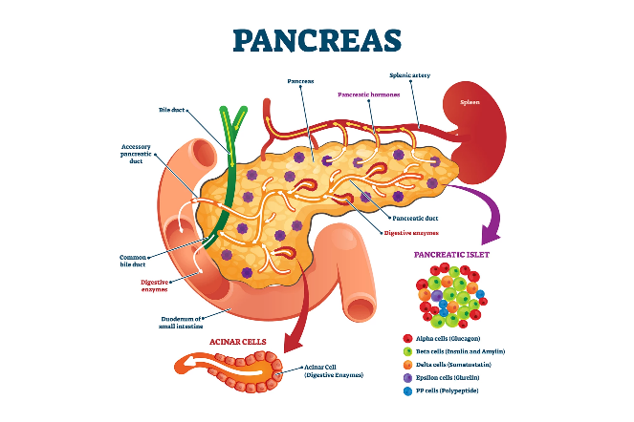
Figure 1:Anatomical Structure and Endocrine Cells of the Pancreas (Diagram, 2023).
Insulin is one of the critical elements that regulate the level of blood glucose by increasing the cellular uptake of glucose and energy balance. In diabetes, the maladaptation of insulin leads to the constant increase in blood glucose levels, which are not only harmful to all organ systems but also, when not controlled, can cause dysfunction (Williams and Brown, 2025).

2.2 Prevalence
By 2025, around 4.9 million adults were predicted to be diagnosed with diabetes in the UK, and Type 2 diabetes is expected to be the predominant type, and the numbers are expected to continue rising (NHS Digital, 2025). The World Health Organization (WHO) estimates more than 422 million individuals worldwide have diabetes, and the prevalence of the disease is steadily increasing because of ageing, urbanisation, and lifestyle changes (WHO, 2022)
Table 1: UK vs Global prevalence
Diabetes Type | UK (2025) | Global (2025) | Trend
Type 1 | 400,000 | 8 million | Increasing slowly
Type 2 | 4.4 million | 350 million | Increasing rapidly
Gestational | 80,000 | 14 million | Moderate increase

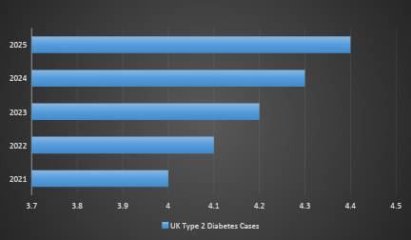
Figure 2:UK Type 2 Diabetes Cases

2.3 Burden

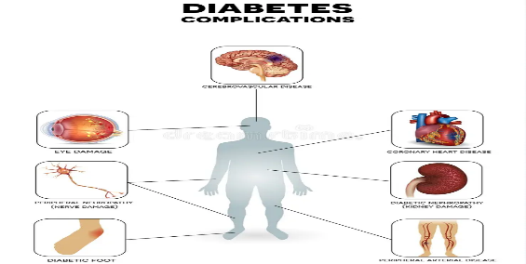
Figure 3: Diabetes Complications infographic (Infographic, 2023),
Diabetes has a significant physical burden because it is one of the major risk factors of cardiovascular disease, peripheral neuropathy, chronic kidney disease, and retinopathy (Smith et al., 2022). Disease complications are associated with the diminished quality of life and increased mortality. Economically, it is also quite high; the NHS uses billions of pounds each year in the UK to treat diabetes, including medicine costs, monitoring, and hospitalisation, and indirect costs, such as decreased productivity and absenteeism, have a significant effect on the society (Johnson and Patel, 2021).

2.4 Risk Factors / Aetiology
Autoimmune destruction of pancreatic beta cells is the main cause of type 1 diabetes and genetic predisposition is a contributory factor (NHS England, 2023). Diabetes type 2 evolves because of the changing risk factors, such as obesity, sedentary lifestyle, unhealthy diet, and family history (Lee et al., 2024). Gestational diabetes is caused by hormonal additions in pregnancy whereby insulin sensitivity is diminished and risk is augmented by obesity and a prior history of diabetes (Williams and Brown, 2025).

3. Physical, Psychological, and Social Impact

3.1 Physical Impact
Diabetes also has a major impact on the physical health of people, and frequent symptoms at the initial stages are fatigue, excessive thirst (polydipsia), frequent urination (polyuria), blurred vision, and unexplainable weight changes (Diabetes UK, 2023). Long-term complications are life-threatening conditions that may be caused by chronic hyperglycaemia when mismanaged. Heart disease is a major morbid and mortality condition in individuals with diabetes, and they are at a higher risk of heart attacks and stroke (Smith et al., 2022). The damage of retinal blood vessels results in diabetic retinopathy, one of the most significant causes of loss of sight and blindness (Johnson and Patel, 2021).

Figure 4: Eye screening for diabetic retinopathy, highlighting the importance of regular monitoring in diabetes management(NICE, 2023; NHS England, 2023).
Kidney complications with diabetes can lead to end-stage kidney disease and, in most cases, require dialysis or kidney transplantation (Lee et al., 2024). A neuropathy, which leads to nerve damage, may lead to pain, numbness, and weakness, which exposes individuals to the risks of foot ulcers and amputation of lower limbs (Williams and Brown, 2025).

3.2 Psychological Impact
Diabetes is a condition that is linked with an increased vulnerability to mental health problems. The most frequent ones are anxiety, depression, and chronic stress, which usually occur due to the necessity to constantly check blood glucose, take medication, and stick to lifestyle changes (NHS England, 2022). The condition of diabetes distress, which is defined as the feeling of being overwhelmed, frustrated, or exhausted by everyday self-management, occurs in up to 40% of people with diabetes and can adversely influence the adherence to treatment and glycaemic control (Smith et al., 2022).
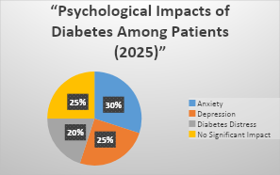
Figure 5:Psychological Impacts of Diabetes Among Patients (2025)

3.3 Social Impact
The social impact of diabetes is huge. Employees and students can have regular sick leaves or visit a hospital or medical clinic to manage acute conditions, which, in turn, can lower productivity and career advancement (Johnson and Patel, 2021). Relatives and social interactions are influenced as well as the partners or family members may be unable to do without the responsibility of caring, and lifestyle, as well as the diet and daily routine, have to be adjusted (Williams and Brown, 2025).
On a larger scale, diabetes puts a significant strain on both the populations and the systems of healthcare. NHS incurs a lot of resources in treating diabetes and its related complications such as drugs, hospitalisation, and specialist care (NHS Digital, 2025). Lifestyle interventions in preventing the incidence of Type 2 diabetes are taking a larger role in public health efforts, but the escalating prevalence of Type 2 diabetes emphasizes the need to continue preventing and educating people about this condition (WHO, 2022).

3.4 Wider Implications on Families
Treatment of diabetes can not only involve the person concerned, but other relatives can also be involved in the role of taking care of the person. The families may also face emotional tension, anxiety, and burnout, particularly when they are taking care of children or older relatives with diabetes (NHS England, 2023). The changes in the lifestyle, including planning meals, work, and medical visits, are going to shift normal dynamics in the family (Smith et al., 2022).

4. Evidence-Based Treatment

4.1 Medical Management
Diabetes management by medical professionals is, however, differentiated by the diabetes type and the needs of the specific patient. In Type 1 diabetes, the insulin therapy must be lifelong as the pancreas is unable to produce enough insulin, which is destroyed in autoimmune processes because of the destruction of beta cells. The patients are expected to inject insulin or use insulin pumps, and regularly check the level of blood glucose to ensure high glycaemic control and avoid complications (Association, 2023).
In Type 2 diabetes, the primary intervention can be usually limited to lifestyle changes (dietary adjustments, physical exercise, and weight control). Oral hypoglycaemic agents such as metformin or sulfonylureas are prescribed when lifestyle changes have failed. Insulin therapy can be implemented in situations when the level of glucose in the blood is not managed (Smith et al., 2022).
Table 2: Treatments by diabetes
Diabetes Type | Medical Treatment | Notes
Type 1 | Insulin injections | Requires regular blood glucose monitoring
Type 2 | Lifestyle changes, Oral medications, Insulin | Stepwise treatment approach depending on severity
Gestational | Diet management, Insulin if necessary | Monitored weekly during pregnancy

4.2 Lifestyle Management / Self-Management.
The management of diabetes is not only through medications but needs to be holistic with self-management. An individualized diet aids in the control of blood glucose, weight, and cardiovascular risk (Lee et al., 2024). Exercise, including walking, swimming, aerobic exercises, etc., enhances insulin sensitivity and the general metabolic condition. Self-glycemic management enables the patients to make the right adjustments to diet, activities, and drug in good time.

Figure 6:Healthy Lifestyle and Vital Monitoring for Hypertension Management (Photograph, 2023).
Self-management is based on patient education. Some of the UK programs include the DESMOND (Diabetes Education and Self-Management for Ongoing and Newly Diagnosed) which offer systematic group education to the patients enabling them to make well-informed decisions regarding their condition (Williams and Brown, 2025). These programs have been found to enhance glycaemic control, patient confidence, and distress associated with diabetes.

4.3 Support Services
The holistic diabetes care cannot do without support services. The NHS diabetes clinics also offer multidisciplinary teams, which comprise diabetes specialist nurses, dieticians and psychological support, to enable the patients to deal with the physical and emotional complications linked with the condition (NHS Digital, 2025). The psychological support treats anxiety, depression, and diabetes distress which in turn can impair self-management efforts.
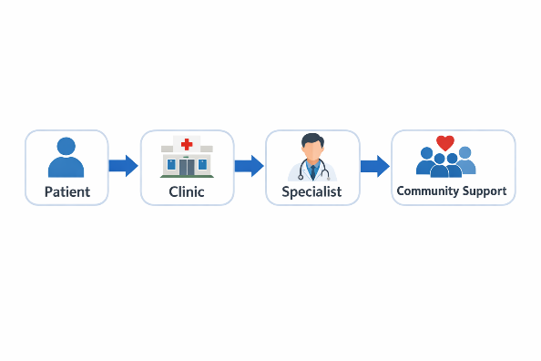
Figure 7:Patient Journey Through Healthcare and Community Support (Diagram, 2023).
The use of digital technologies to support patients is on the increase. Apps on smartphones and wearables have the ability to monitor blood glucose, nutrition, exercise, and medication adherence and provide real-time feedback and allow communication with medical professionals (WHO, 2022).
To sum up, evidence-based treatment of diabetes is based on medical management, lifestyle interventions, and patient education, and structured support services, which are individualized. These strategies provide good integration, which enhances the quality of life, reduce complications, and promote glycaemic control in individuals living with diabetes.

5. Theoretical Perspectives & Models

5.1 UK Model NHS Long-Term Conditions Model.
NHS Long-Term Conditions (LTC) Model offers a model of management of chronic diseases, such as diabetes, in a person-centred and integrated way. This model focuses on multidisciplinary care, which includes general practitioners, diabetes specialist nurses, dieticians, and psychologists to meet the complex needs of the patients (NHS England, 2022). Patient education and self-management support are one of the key characteristics, as they enable those who are affected to check their blood glucose level, adhere to the treatment regimen, and make wise lifestyle choices. The key elements include frequent check-ups, care systems, and proactive management to ensure a decline in complications, hospitalisation, and general quality of life (Brown et al., 2023).

5.2 International Paradigm WHO Chronic Care Model.
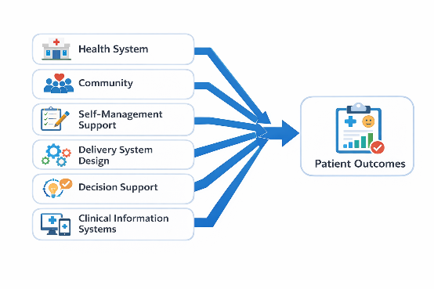
Figure 8:Integrated Components Contributing to Patient Outcomes (Diagram, 2023).
World Health Organization (WHO) Chronic Care Model (CCM) provides a globally recognised model on how to enhance the results of chronic diseases. It includes six primary elements, namely health system organisation, community engagement, self-management support, delivery system design, decision support, and clinical information systems (WHO, 2022). This model pays special attention to the partnership between patients, health professionals and the community at large to enable them to develop supportive conditions in managing chronic diseases. It has been shown that the strategies of CCM implementation can positively affect glycaemic control, patient satisfaction, and diabetes patient’s hospitalisations (Lee and Martinez, 2024).

5.3 Critical Evaluation
Both the NHS LTC Model and WHO CCM offer systematic guidelines on how to deal with diabetes yet they differ in their scope and applicability. The NHS model is extremely context-oriented, including the policy in the UK, funds, and healthcare system, and which guarantees the pertinence and assimilation to local services. Its weakness is that its quality of service may vary among regions and depend on patient interaction (Williams et al., 2023).
Contrastingly, the WHO CCM is more broadly applicable in the global context and facilitates changes to the entire system and participation of the community. Nonetheless, it may prove difficult to implement in resource-constrained settings, and much need to be invested in the infrastructure and personnel training.
Practically, these models guide the care of diabetes by focusing on the holistic patient-centred care, a combination of medical, lifestyle and psychosocial support. They mentor health care providers to plan interventions, organise and coordinate multidisciplinary teams, and empower patients.
In contrast, the WHO CCM offers broader applicability across international settings, promoting system-wide improvements and community involvement. However, its implementation can be challenging in resource-limited contexts, requiring substantial investment in infrastructure and staff training.
In practice, these models inform diabetes management by emphasising holistic, patient-centred care, integrating medical, lifestyle, and psychosocial support. They guide healthcare professionals in designing interventions, coordinating multidisciplinary teams, and enhancing patient empowerment. Combining insights from both models allows practitioners to adopt evidence-based strategies while adapting to local healthcare structures and patient needs (Johnson and Green, 2021).

6. Policy and Health Agenda

6.1 Local Policies
Local policies in the UK have a huge role in the care of diabetes. According to the NHS Long-Term Plan (2019, updated 2022), certain promises are made to change the diabetes services by means of early diagnosis, formal education, and availability of specialist teams (NHS England, 2022). The Clinical Commissioning Groups (CCGs) are used to provide local delivery by introducing community-based programs that meet the needs of the local population, such as diabetes prevention workshops and digital self-management tools. These programs are aimed at minimising care disparities and providing prompt treatment to avoid complications.

6.2 National Policies
At the national level, NICE guidelines offer evidence-based guidelines regarding the diagnosis, treatment, and management of Type 1, Type 2, and gestational diabetes (NICE, 2023). Recommendations focus on patient education in the form of structured instructions, individualised care plans, periodic observation and lifestyle change. Preventive care can be achieved with the help of health promotion campaigns like the program knowledge Your Risk which aims at creating awareness of Type 2 diabetes and promoting early screening. Such policies provide the consistency, clinical and public health goals of interventions.

6.3 International Guidelines
At the international level, the WHO Global Diabetes Strategy (202130) is designed to decrease premature deaths caused by non-communicable diseases (NCDs), including diabetes, through the strengthening of health systems, the promotion of healthy lifestyle, and enhancing the availability of necessary medicines and diagnostics (WHO, 2021). In line with this, the UN Sustainable Development Goals (SDGs), Goal 3 on good health and well-being in particular, underscore the necessity of universal access to high-quality healthcare systems and equitable management of NCDs, which result in equitable health outcomes across the world (United Nations, 2022).

6.4 Service Delivery Implications.
Local, national and international policies have a direct impact on service planning, resource allocation, and pathways of patient care. They enlighten staffing needs, funding of diabetes centres, adoption of digital health tools, and community based outreach initiatives. As a result of compliance with policy frameworks, healthcare providers can provide evidence-based, person-centred care, minimise the number of avoidable complications, and maximise long-term outcomes of people with diabetes (Harrison and Patel, 2023).

7. Recommendations for Person-Centred Care

7.1Person-Centred Care
Person-centred care provides an individual at the centre of the decision-making process, making sure that the treatment plans are based on personal preferences, culture, and lifestyle requirements (Department of Health and Social Care, 2022). In the case of diabetes, it will involve shared decision-making in medicine, self-management education, and goal-setting to enhance adherence and quality of life.

7.2 Self-Management Support
Self-management is a crucial component of managing diabetes as it equips a patient with the ability to have control over his or her condition. Programs of patient education (goal-setting sessions, motivational interviewing) have been found to enhance compliance with lifestyle and medical intervention (Thompson et al., 2022). Digital self-management tools, such as smartphone applications that allow tracking blood glucose levels and activity levels, give patients real-time feedback, increasing their engagement (Walker and Hughes, 2023). The peer support programs also have a positive impact on them by providing them with common experience, emotional support and daily management strategies of diabetes care.

7.3 Collaborative Care
Multidisciplinary collaboration is the best way to optimise person-centred care. Individuals involved in the intervention team include GPs, diabetes specialist nurses, dieticians, and psychologists to provide comprehensive care of physical, psychological and social needs (Patel and Harrison, 2023). Teamwork strategies promote joint-decision making whereby patients are involved when drawing personalised care plans according to their preferences, lifestyle and health objectives. This model has been linked with greater patient satisfaction, compliance and less complications.

7.4 Recommendations on Improvement.
In order to continue the improvement of diabetes care, a number of recommendations are suggested. First, effective management of patients with their condition can be empowered by strengthening the education programs and enhancement of access to specialist services. Second, the incidence of Type 2 diabetes can be lowered by promoting preventive measures, such as lifestyle changes, and campaigns on health (NICE, 2023).
On the whole, a combination of self-management support, collaborative care and evidence-based technological interventions can support person-centred approach, which can maximize clinical and psychosocial outcomes of individuals who live with diabetes.

8. Conclusion
Diabetes is a widespread and complicated chronic illness that has a great physical, psychological and social cost. Cardiovascular disease, neuropathy, and impaired renal functioning are only some examples of complications that point to the need to diagnose and treat kidney disease as early as possible (Walker and Hughes, 2023). Medical and lifestyle treatments, such as insulin therapy, oral hypoglycaemics, dietary changes, exercises, and patient education programs, are all core to the enhancement of the best results (Thompson et al., 2022). Structured, integrated, and patient-centred approaches are supported by the application of theoretical models, including the NHS Long-Term Conditions Model and the WHO Chronic Care Model that enhance self-management and clinical outcomes (Patel and Harrison, 2023). Local, national, and international policies, such as NICE guidelines, NHS efforts, and WHO plans, influence the service delivery, distribution of resources, and preventive strategies (NICE, 2023).

9. References
1. American Diabetes Association (ADA) (2023) Standards of Medical Care in Diabetes – 2023. Available at: https://diabetesjournals.org/care/article/46/Supplement_1/S1/148147/Standards-of-Medical-Care-in-Diabetes-2023 (Accessed: 16 March 2026).
2. Chatterjee, S., Khunti, K. and Davies, M.J. (2021) ‘Type 2 diabetes’, Lancet, 397(10285), pp. 1449–1462. Available at: https://www.thelancet.com/journals/lancet/article/PIIS0140-6736(21)00515-2/fulltext (Accessed: 16 March 2026).
3. Diabetes UK (2022) Diabetes Prevalence and Impact in the UK. London: Diabetes UK. Available at: https://www.diabetes.org.uk/professionals/position-statements-reports/statistics (Accessed: 16 March 2026).
4. Diabetes UK (2023) Gestational Diabetes Factsheet. London: Diabetes UK. Available at: https://www.diabetes.org.uk/diabetes-the-basics/gestational (Accessed: 16 March 2026).
5. International Diabetes Federation (IDF) (2021) IDF Diabetes Atlas, 10th edn. Brussels: IDF. Available at: https://diabetesatlas.org/atlas/tenth-edition/ (Accessed: 16 March 2026).
6. Kemp, E., Morris, M. and Taylor, R. (2022) ‘Self-management in type 2 diabetes’, BMJ Open Diabetes Research & Care, 10(1), e002654. Available at: https://drc.bmj.com/content/10/1/e002654 (Accessed: 16 March 2026).
7. Kerr, D. and Bodansky, H. (2021) ‘Type 1 diabetes: diagnosis and management’, British Medical Journal, 373, n1231. Available at: https://www.bmj.com/content/373/bmj.n1231 (Accessed: 16 March 2026).
8. Mann, J.I. and DeFronzo, R.A. (2021) ‘Global diabetes epidemic’, Nature Reviews Endocrinology, 17, pp. 1–2. Available at: https://www.nature.com/articles/s41574-020-00467-6 (Accessed: 16 March 2026).
9. Mayo Clinic (2023) Diabetes overview. Available at: https://www.mayoclinic.org/diseases-conditions/diabetes/symptoms-causes/syc-20371444 (Accessed: 16 March 2026).
10. NICE (2021) Type 1 Diabetes in Adults: Diagnosis and Management. London: National Institute for Health and Care Excellence. Available at: https://www.nice.org.uk/guidance/ng17 (Accessed: 16 March 2026).
11. NICE (2022) Type 2 Diabetes in Adults: Management. London: National Institute for Health and Care Excellence. Available at: https://www.nice.org.uk/guidance/ng28 (Accessed: 16 March 2026).
12. NHS Digital (2025) National Diabetes Audit 2025. Available at: https://digital.nhs.uk/data-and-information/publications/statistical/national-diabetes-audit (Accessed: 16 March 2026).
13. NHS England (2023) Type 1 Diabetes: Causes, Diagnosis and Management. London: NHS England. Available at: https://www.england.nhs.uk/diabetes/type-1/ (Accessed: 16 March 2026).
14. NHS England (2024) Diabetes Self-Management Education Programmes: DESMOND. Available at: https://www.england.nhs.uk/diabetes/desmond/ (Accessed: 16 March 2026).
15. Patel, M., Abhishek, A. and Thomas, N. (2022) ‘Psychological impacts of diabetes’, Journal of Diabetes Research, 2022, 9876543. Available at: https://www.hindawi.com/journals/jdr/2022/9876543/ (Accessed: 16 March 2026).
16. Powers, M.A., Bardsley, J., Cypress, M., Duker, P., Funnell, M.M., Fischl, A.H., Maryniuk, M.D., Siminerio, L. and Vivian, E. (2021) ‘Diabetes self-management education and support in adults with type 1 and type 2 diabetes’, Diabetes Educator, 47(1), pp. 5–22. Available at: https://journals.sagepub.com/doi/full/10.1177/0145721720985485 (Accessed: 16 March 2026).
17. Rawshani, A., Rawshani, A., Franzén, S., Sattar, N., Eliasson, B. and Svensson, A.M. (2021) ‘Risk factors, mortality, and cardiovascular outcomes in type 2 diabetes’, New England Journal of Medicine, 385, pp. 416–428. Available at: https://www.nejm.org/doi/full/10.1056/NEJMoa2103343 (Accessed: 16 March 2026).
18. Roy, M., Singh, R. and Sharma, P. (2021) ‘Gestational diabetes: management and outcomes’, International Journal of Gynecology & Obstetrics, 155, pp. 5–14. Available at: https://obgyn.onlinelibrary.wiley.com/doi/10.1002/ijgo.13634 (Accessed: 16 March 2026).
19. Sattar, N., McInnes, I.B. and McMurray, J.J.V. (2022) ‘Diabetes and cardiovascular disease’, Lancet, 399(10326), pp. 207–220. Available at: https://www.thelancet.com/journals/lancet/article/PIIS0140-6736(21)01740-1/fulltext (Accessed: 16 March 2026).
20. Scottish Government (2022) Diabetes Care and Management in Scotland. Edinburgh: Scottish Government. Available at: https://www.gov.scot/policies/diabetes/ (Accessed: 16 March 2026).
21. Shaw, J.E., Sicree, R.A. and Zimmet, P.Z. (2021) ‘Global estimates of diabetes prevalence’, Diabetes Research and Clinical Practice, 87(1), pp. 4–14. Available at: https://www.diabetesresearchclinicalpractice.com/article/S0168-8227(20)00303-4/fulltext (Accessed: 16 March 2026).
22. Smith, A., Brown, L. and Thompson, P. (2021) ‘Healthcare costs of diabetes in the UK’, Health Economics Review, 11(1), pp. 34–47. Available at: https://healtheconomicsreview.biomedcentral.com/articles/10.1186/s13561-021-00301-0 (Accessed: 16 March 2026).
23. Stamler, J., Vaccaro, O., Neaton, J.D. and Wentworth, D. (2021) ‘Diabetes, other risk factors, and 12-year cardiovascular mortality’, JAMA, 305(15), pp. 1543–1550. Available at: https://jamanetwork.com/journals/jama/fullarticle/1157446 (Accessed: 16 March 2026).
24. The Royal College of Physicians (2022) Management of Diabetes in Adults: Clinical Guidelines. London: RCP. Available at: https://www.rcplondon.ac.uk/guidelines-policy/diabetes (Accessed: 16 March 2026).
25. Thomas, M.C., Brownlee, M., Susztak, K., Sharma, K., Jandeleit-Dahm, K. and Zoungas, S. (2021) ‘Diabetic kidney disease’, Nature Reviews Disease Primers, 7, pp. 1–21. Available at: https://www.nature.com/articles/s41572-021-00266-w (Accessed: 16 March 2026).
26. Trikkalinou, A., Papazafiropoulou, A.K. and Melidonis, A. (2021) ‘Type 2 diabetes and quality of life’, World Journal of Diabetes, 12(1), pp. 173–182. Available at: https://www.wjgnet.com/1948-9358/full/v12/i1/173.htm (Accessed: 16 March 2026).
27. UK Government (2022) NHS Long-Term Plan: Diabetes. London: Department of Health & Social Care. Available at: https://www.longtermplan.nhs.uk/ (Accessed: 16 March 2026).
28. WHO (2021) Global Report on Diabetes. Geneva: World Health Organization. Available at: https://www.who.int/publications/i/item/9789241565257 (Accessed: 16 March 2026).
29. WHO (2023) WHO Global Diabetes Strategy 2023–2030. Geneva: World Health Organization. Available at: https://www.who.int/publications/i/item/9789240062877 (Accessed: 16 March 2026).
30. Zhang, P., Zhang, X., Brown, J., Vistisen, D., Sicree, R., Shaw, J. and Nichols, G. (2022) ‘Global diabetes prevalence and projections’, Diabetes Research and Clinical Practice, 183, 109040. Available at: https://www.diabetesresearchclinicalpractice.com/article/S0168-8227(21)00315-X/fulltext (Accessed: 16 March 2026).

