University of Wales Trinity St David -Swansea
Liam Thomas
p143797
Site Investigation of Water and Sewage Treatment Plants
Water Treatment Technology

Abstract
The first part of this report will discuss and analyze the treatment process for Felindre water treatment works. Each of the treatment processes are explained, specifically to how they are run at that site. Each of the processes are then explained individually, explaining how they work and what their role is within water treatment. Felindre isn’t a ‘perfect site’, but it treats water using modern techniques such as CoCoDAFF and does so very efficiently.
The design of a pre-sedimentation tank was made based on a provided specification and further improvements to the site are suggested within this piece of writing, such as electrocoagulation.
The second part of this report will discuss and analyse the treatment process for Llanelli waste water treatment works. The whole treatment process is explained, from the sewers at the entrance to the UV treatment at the end. Each of the individual processes that are used within the plant are then explained. These include; screening, grit removal, primary settlement, biological treatment and final settlement, and UV disinfection. Electrocoagulation is a suggested improvement to the plant as well as an advanced oxidation process.
The pressure difference across a reverse osmosis membrane was also calculated based on the provided specification.

Contents
Abstract 1
Felindre Water Treatment Works 3
Introduction 3
Principles of Treatment Site 4
Treatment Processes 5
Coagulation and Flocculation 5
Counter-Current Dissolved Air Flotation & Filtration 5
Manganese Removal & Disinfection 6
Granular Activated Carbon 6
De-chlorination 6
Considerations for Improvement 7
Conclusion 8
Design of Pre-Sedimentation Tank 9
Llanelli Waste Water Treatment Works 11
Introduction 11
Principles of Treatment Site 12
Treatment Processes 14
Screenings 14
Primary and Final Settlement 15
Biological Treatment 15
UV Disinfection 16
Improvements 17
Osmotic Membrane 18
Conclusion 19
References 20

Table of Figures
Figure 1 - Schematic Diagram of Felindre 5
Figure 2 - Coagulation and Flocculation [3] 6
Figure 3 - Llanelli process flow chart 13
Figure 4 - Settlement Tank 13
Figure 5 - Bar Screens[9] 15
Figure 6 - Aerated Grit removal[8] 15
Figure 7 - Advantages & Disadvantages of AOP[15] 18

Felindre Water Treatment Works

Introduction
Felindre water treatment works is located in Felindre, Swansea. It is the largest water treatment works in Wales, treating of 100ML of water per day. Their raw water is obtained from the River Towy and is pumped through several reservoirs before reaching the plant. At the plant the water goes through the following processes:
- Coagulation
- Flocculation
- Counter current dissolved air flotation and filtration
- Manganese removal through chlorination
- Granular activated carbon for taste and odour removal
- De-chlorination with sulphur dioxide

Principles of Treatment Site

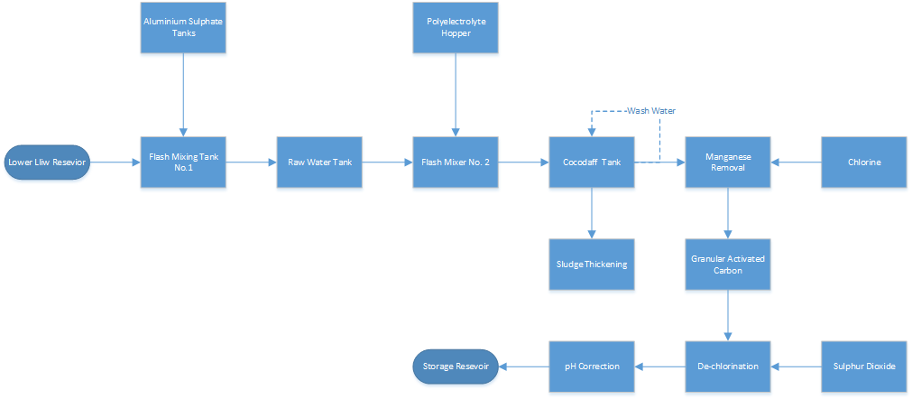
Figure 1 - Schematic Diagram of Felindre
Felindre obtains its raw water from the River Towy, high lift pumping stations transport the water to the upper Lliw reservoir and then low lift pumping stations transfer the water to the lower Lliw reservoir. The flow of water from the lower Lliw reservoir to the plant is controlled by a dam.
The first process the water undergoes after it has entered the plant is coagulation. Aluminium sulphate is dosed into the water to form flocs; this is done in the first of two flash mixing tanks to aid with the formation of flocs. The water then enters the second of two flash mixing tanks to undergo flocculation. Polyelectrolytes are added to aid the formation of larger floccules. Both of the flash mixing tanks are 8m deep.
After coagulation and flocculation, the water enters one of eight counter-current dissolved air flotation and filtration (CoCoDAFF) tanks. Each filter has two cells and a central channel, air gets pumped into the cells from large tanks in the adjacent room where the air is stored at 6bar. The air creates bubbles within the water roughly 2-3mm in size, the same size as the floc particles. The clean water then gets filtered through a sand and anthracite bed at the bottom of the cells. When a sufficient cake has formed on the top of the water, troughs open on the outside of the cells and the central channel is flooded with filtered water. A spray system on the outside walls then turns on to remove the sludge. The central channel overflows pushing the sludge towards the troughs, the sludge then gets taken to the sludge thickening section of the plant.
After the water has been filtered it undergoes manganese removal, this is achieved by dosing the water with chlorine to increase the pH from 6.5 to 7.6. The chlorine is stored in liquid form, up to 23.5 tonnes of chlorine. Once the pH has reached 7.6 and the chlorine is above 1.3PPM, the manganese can be washed out.
The water then enters a granular activated carbon to remove any unusual taste and odour, then de-chlorination with sulphur dioxide and final pH correction are both carried out before the water is deposited in the final surface reservoir.

Treatment Processes
This section will discuss the various treatment processes used in the Felindre water treatment works.

Coagulation and Flocculation
Coagulation and flocculation are the addition of coagulants and polymers to a water source to clump small destabilised particles together.[1] Coagulants come in two metal groups; aluminium and iron. The aluminium group usually consists of aluminium sulphate, aluminium chloride and sodium aluminate and the iron group consists of ferric sulphate, ferrous sulphate, ferric chloride and ferric chloride sulphate.[2] The purpose of the coagulant is to produce positive charges on the negatively charged particles allowing them to become attracted to each other. This process is combined with rapid mixing to quickly coat all of the particles.
Flocculation involves the addition of a polymer and slow mixing to aid in the formation of larger flocs. Slow mixing is required as rapid mixing would break the flocs that are being formed.
A great disadvantage of coagulation is the use of chemicals as a coagulant, which have large transport costs. An effective alternative would be the use of electrocoagulation, by running an electric current through a pair of electrodes (typically aluminium or iron) in the water, the same results can be achieved without the use of chemicals.
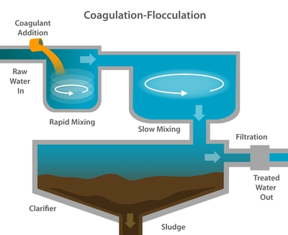
Figure 2 - Coagulation and Flocculation [3]

Counter-Current Dissolved Air Flotation & Filtration
Counter-current dissolved air flotation & filtration is the combination of dissolved air flotation and rapid gravity filtration.
Water enters the tank at a high level and aerated water enters the tank via nozzles which are usually situated just above the filter media. The nozzles create a blanket of bubbles uniformly across the tank. These bubbles rise up the tank and attach to the flocs, bringing them to the surface. The sludge is then scraped off the top of the water. The rest of the water goes down through the filter. The filter could be mono-media, dual media or multi media. In the case of Felindre the filter is a dual media filter, consisting of sand and anthracite. This process filters out any particles that are too small to be attached to the bubbles. A portion of the water that passes through the filter is then aerated and used to produce the bubbles.
The benefits of CoCoDAFF compared with regular DAFF is that it has a significantly smaller footprint.[4]

Manganese Removal & Disinfection
Chlorine is added to the water at this stage to oxidise the water and remove manganese. To remove the manganese there must be a sufficient PPM of chlorine and a pH above 7. When the chlorine is introduced into the system it oxidises with the manganese producing manganese dioxide. At this point the manganese can either be washed or filtered out.[5]

Granular Activated Carbon
Granular activated carbon are filters that consist of small pieces of carbon. Their use is to reduce bad tastes and odour within the water. This achieved by the chemicals that produce the bad tastes and odour sticking to the carbon filter.
This process has the ability to remove 81 chemicals very effectively, these include all 32 organic containments including trihalomethanes. It does not, however, remove any of the following: minerals, salts or metals; inorganic contaminants such as lead, arsenic and asbestos; or microbiological contaminants. [6]

De-chlorination
De-chlorination is the use of sulphur dioxide to remove chlorine from the water. The main purpose for this is to further reduce the level of the four trihalomethanes: chloroform, bromodichloromethane, dibromochloromethane, and bromoform.[7] It is important for there to be as little present as possible of these in the water, as they have proven to increase the risk of cancer, with the maximum average level for public water systems being 80PPB.

Considerations for Improvement
Felindre is already a very sophisticated water treatment works, with efficient removal of turbidity via their coagulation/flocculation and CoCoDAFF tanks. Granular activated carbon then further improves water quality by removing taste and odour. The only obvious improvement would be to remove the use of chemicals in the coagulation/flocculation process, by introducing electrocoagulation.
Electrocoagulation uses two electrodes; an anode and cathode. When and electric current is run through them, the anode breaks down and replicates the process of adding aluminium sulphate. Using something such as Al3+, as the anode in this process would be a suitable sacrificial anode. However, the following things would need to be considered:
- Electrode surface area – Impacts the rate of the reaction
- Current – also effects the rate of reaction but also the rate at which the anode will degrade
- Life span of the anode
- Power consumption
- Cost of replacing the anode
Once those factors have been worked out, the electrocoagulation should be more efficient and save having to doa lot of chemical transportation and storage.

Conclusion
To conclude, as previously mentioned, Felindre already has a sophisticated water treatment process. Coagulation and flocculation to bond colloidal particles, CoCoDAFF to remove those particles and filter remove any remaining solids. Followed by chlorination to remove manganese, granular activated filter to remove taste and odour and ending with de-chlorination, before being deposited in the final surface reservoir.
The only potential improvement would be to replace coagulation with electrocoagulation, which would remove chemical storage and transport costs.

Design of Pre-Sedimentation Tank
As part of the suggestions for improvements to the site, a new pre-sedimentation tank is being designed for the follow characteristics.
$$Maximum flow=\frac{60000m^{3}}{day}$$
$$Particle diameter \left(d_{s}\right)=200×{10}^{-6}$$
$$Cohesion constant \left(k\right)=0.05$$
$$Daracy-Weisbach friction factor \left(f\right)=0.025$$
$$Particle density \left(ρs\right)=1.25×{10}^{3} kg/m^{3}$$
$$Viscosity of Water \left(μ\right)=1.003×{10}^{-3}kg/ms$$
$$Acceleration due to gravity \left(g\right)=9.81ms^{-2}$$

Using these values, the scour velocity can be calculated with the following equation:
$$Vh= \sqrt{\frac{8k}{f}×\frac{\left(ρs-ρl\right)}{ρl}gd_{s}}$$
$$Vh= \sqrt{\frac{8×0.05}{0.025}×\frac{\left(1.25×{10}^{3}-1×{10}^{3}\right)}{1×{10}^{3}}×9.81×200×{10}^{-6}}$$
$$V_{h}=0.08859m∕s$$
Assuming that the horizontal velocity is 1/3 of the scour velocity.
$$Actual horizontal velocity= \frac{v_{h}}{3}= 0.02953 m/s$$
The settling velocity can then be calculated with the following equation:
$$v_{t}=\frac{g\left(ρ_{s}-ρ_{c}\right)ⅆ_{s}^{2}}{18μ}$$
$$v_{t}=\frac{9.81\left(1⋅25×{10}^{3}-1×{10}^{3}\right){\left(200×{10}^{-6}\right)}^{2}}{18×1.003×{10}^{-3}}$$
$$v_{t}=5⋅43×{{10}^{-3}m}/s$$
Assuming the overflow rate is 4 times to settling velocity
$$Overflow rate=4 ×vt=21.73×{10}^{-3} m/s$$
Using the overflow rate and flow rate, the area of the settlement tank can be calculated.
$$Settlement surface area=\frac{flow rate}{overflow rate}$$
$$L×W=\frac{flow rate}{overflow rate}= \frac{60,000÷86,400}{21.73×{10}^{-3}}=31.957m^{2}$$
$$H×W=\frac{flow rate}{horizontal velocity}= \frac{60,000 ÷86,400}{0.02953}=23.52m^{2}$$
Assuming the length to width ratio is 6:1.
$$W ×6W=31.957$$
$$W×W=\frac{31.903}{6}=5.326$$
$$W= \sqrt{5.326}=2.308m$$
$$L=6×2.308=13.85m$$
$$H=\frac{23.52}{2.308}=10.19m$$
The length and settling velocity can then be used to calculate the detention time, using the following equation.
$$t=\frac{L}{Vh}$$
$$t=\frac{13.85}{0.02953}=469.01 seconds=7.82 Minutes$$
With the given specification and the following assumptions:
- Horizontal velocity was 1/3 of the scour velocity
- Length to width ratio was 6:1
- Overflow rate was 6 times the settling velocity
The required tank dimensions would be 2.308m wide, 13.85m long and 10.19m high and would have a detention time of 7.21 minutes.

Llanelli Waste Water Treatment Works

Introduction
Llanelli waste water treatment is located in Llanelli, Wales. The goal of the treatment plant is to improve the quality of the water enough so that it can be discharged back into the river. The waste water comes from toilets, showers, sinks, storm drains, dishwashers, washing machines etc. The water then arrives at the waste water plant and undergoes five stages of treatment:
- Preliminary treatment – Bars and screens to remove large solids
- Grit removal
- Primary settlement
- Bio-treatment
- Final settlement
- UV disinfection
After undergoing these treatment processes, the water is returned to the river.

Principles of Treatment Site
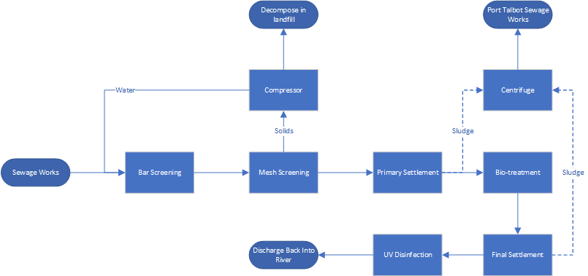
Figure 3 - Llanelli process flow chart
The water enters from the sewage works and the first stage in the treatment process is screening. The first screen is a bar screen, this screens large solids such as logs, paper, plastics, metals etc. After the first bar screen are three mesh screens, with a hole diameter of 6mm. These are used to screen out sanitary products, wet wipes and other smaller solids that can’t be screened by the bars. All the solids collected by the mesh screens are then compressed to remove any excess water before being collected in a skip. Any water extracted from the solid is put back into the system. A current issue with the screening process is a large amount of tampon applicators are entering the system.
After the removal of large solids, the water enters a grit settlement tank. This process removes the particles that were too fine to be screened by the 6mm mesh filter but are heavy enough to settle. These include sand, gravel, coffee granules, seeds etc.
The next stage is primary settlement, this consists of four large tanks, two primary tanks and two storm tanks.
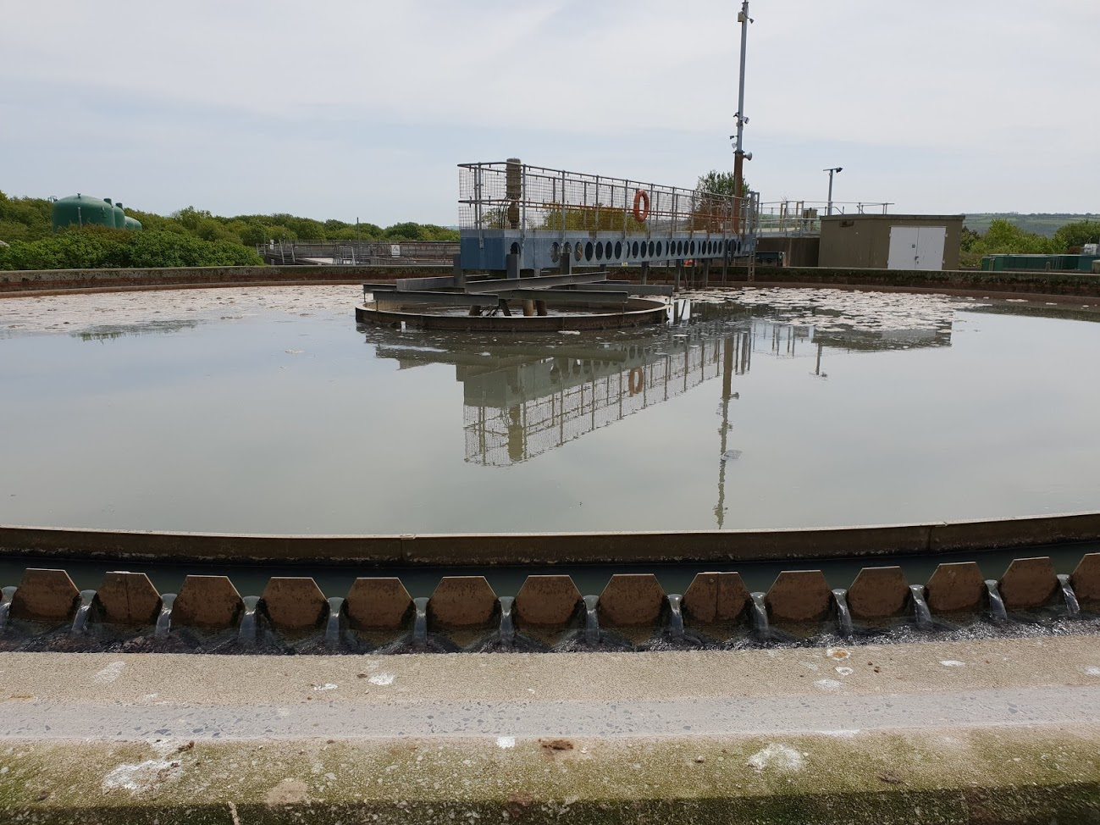
Figure 4 - Settlement Tank
Due to the slow and low turbulent flow of the water in the tanks, the sludge settles on the surface. Large scrapers prevent sludge from clinging to the walls and simultaneously draws the sludge to the centre.
The water then goes into 6-meter-deep biological treatment tanks, the first section is aerated using 3 blowers at 0.6bar. The water is oxidised up to 2mg/L, this is to keep the bugs that consume the waste alive. The second part of the tanks is for ammonia reduction, the bugs that feed in this section survive with oxygen therefore, oxygen levels are reduced.
The water then goes into one of the three final settlement tanks that work the same as the first, large round tanks with the settled sludge being drawn towards the centre by the slow-moving scrapers. These tanks have an issue with algae growth, which must be cleaned off manually during dry periods.
The sludge from both settlement tanks goes into a centrifuge, at this point the sludge is 3-4% dry solids. The centrifuge dries the sludge with the help of hydrogen sulphate. The process dries the sludge to 20-30% dry solids. The sludge then gets taken to Port Talbot sewage works where the sludge is use in a biogas plant to produce electricity.
The final stage of the treatment is UV disinfection. There are 8 UV lamps on a screen and there are 17 screens. UV disinfects the water by sterilising the bacteria, it doesn’t kill them and the sterilisation rate is around 80%. There are 2 sets of screens but only one is use at a time, the other is used when the first is being replaced which costs £32,000 and must be done every 14,000 hours.

Treatment Processes

Screenings
In almost all waste water treatment works the first stage of treatment is screening. This is usually in 3 parts; bar screening, mesh screening and grit settlement. The first section, bar screening, consists of metal bars several centimetres apart. This screens out larger solids such as logs, timber, rags, debris, stones, rubbish etc.[8]
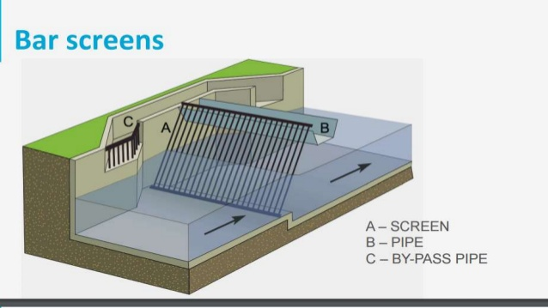
Figure 5 - Bar Screens[9]
The second stage is a mesh screen, the opening sizes can vary from 1.5mm to 6mm. These are primarily used for solids that are small enough to fit through the bar screens and these usually include sanitary products, wet wipes, smaller bits of wood, smaller bits of debris and for the finer screens even some suspended solids.[8]
The last stage is grit removal. This involves removing the heavier solids that remain, typically this includes sand, gravel, eggshells, bone chips etc. The most common type of grit removal is an aerated chamber; air is introduced into the water flow causing the water to spiral, this causes the heavy particles to be accelerated and drop to the bottom of the tank while lighter ones become suspended.[8]
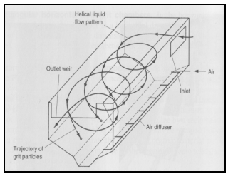
Figure 6 - Aerated Grit removal[8]
The advantage of screening is that it requires very little equipment maintenance but requires frequent cleaning to prevent loss of flow in the system.

Primary and Final Settlement
Both primary and final settlement tanks will be covered in this section since they function in a similar manner. Both are large round tanks that reduce the velocity of the water to allow sludge to settle. There are scrapers in the tank which pull the sludge towards the centre so that it can be removed. Water jets direct any sludge that floats to the surface towards the centre. The sludge is then taken to the sludge treatment process where it is thickened.
At the primary settlement stage 60% of suspended solids are removed and 35% of BOD removed.[10]
Final settlement tanks focus more on the recovery of the organisms that are used for treatment in between these two processes, so that they can be reused. The issue with the final settlement tanks is they can have a problem with algae growth, which can eventually hinder the process.[11]

Biological Treatment
The biological treatment process uses bacteria to digest the remaining solids within the water. Biological treatment comes in both aerobic and anaerobic forms. Aerobic bacteria require the water to be aerated so that they can survive
Table 1 - Aerobic and Anaerobic Biological Treatment[12]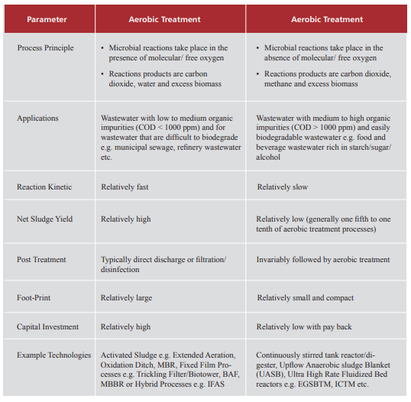
Anaerobic Treatment
As shown in the table above both aerobic and anaerobic treatment have their use cases.

UV Disinfection
UV disinfection is an alternative to chemical disinfection. It consists of ultra violet lights that sterilise bacteria, viruses and protozoa, preventing them from reproducing. This is achieved by damaging the nucleic acids within the microorganisms.
One big advantage of UV disinfection is its ability to sterilise Cryptosporidium and Giardia, which are two protozoa that are a threat to public health. It also has other advantages such as reducing costs of storage and transport of chlorine while also reducing by-product formation.

Improvements
As part of this report, improvements to the existing waste water treatment will be suggested. The suggested improvements should allow for the waste water to be used in industrial and domestic applications, reducing the strain on mains water.
The first suggestion would be to use electrocoagulation at the end of the treatment process to further reduce the turbidity of the water. The type of anode used would depend on the suspended solids in the water, but it would likely aid in the reduction of turbidity to the extent where the water could be used in industrial applications.
Another suggestion for improvement could be the addition of an advanced oxidation process. There are multiple methods, but the main purpose is the creation of hydroxyl radicals which then remove organic matter and organic contaminants.
Hydroxyl radicals can be produced using various methods, these are:
- Oxidizing agents (H₂O₂ and O₃)
- Irradiation (Ultraviolet or ultrasound)
- Catalysts (Fe²⁺)
The most interesting method being the latter, this is because Fe²⁺ can be used as a sacrificial anode within electrocoagulation. Meaning there is the potential to combine electrocoagulation with an advanced oxidation process.[13]
In Mexico a test was conducted on electrocoagulation in conjunction with both Fenton and ozone AOP’s, the test was investigating if the combination of the two processes were an effective technique to remove pollutants from ice cream waste water. Electrocoagulation alone produced 40% COD removal, while with the addition of the Fenton process the COD removal increased by a further 25%.[14]
The specific method of AOP would likely vary site to site, but it has been proven to be an effective method of water treatment due to its ability to remove organic materials without polluting future processes. Its advantages and disadvantages are shown in the figure below.
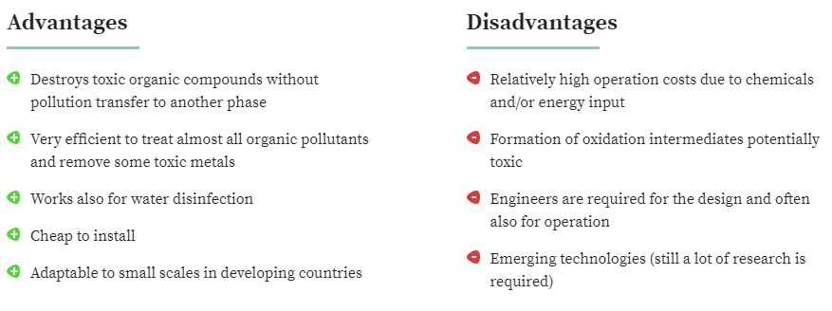
Figure 7 - Advantages & Disadvantages of AOP[15]
AOP could be introduced either before of after the secondary process (biological treatment) but it would depend on the individual treatment works.

Osmotic Membrane
The pressure difference in an osmotic semi permeable membrane must be calculated. On the one side of the membrane is brackish water and on the other side is mineral free water. The temperature of the water is assumed to be 25°C. The molar concentrations are as follows.
${Na}^{+},$0.02; ${Mg}^{2+},$ 0.015; ${Ca}^{2+},$ 0.01; $K^{+},$ 0.001; ${Cl}^{-},$ 0.025; ${HCO}_{3},$ 0.001; ${NO}_{3}^{ -},$ 0.002; and ${SO}_{4}^{ 2-},$ 0.012.
The osmotic pressure can be approximated using the following equation.
$$π=cRT$$
$$Where: \\ C=summation of the molar concentration of the dissolved ions$$
$$R=universal gas constant 0.08206\frac{Latm}{Kmol} \\ T=Temperature in °K$$
$$c=0.02+0.015+0.01+0.001+0.025+0.001+0.002+0.012 \\ c=0.086M$$
$$π=0.086×0.08206×\left(273+25\right)=2.103atm$$

Conclusion
Llanelli waste water treatment works has more potential improvements that could be made in comparison to Felindre. It has an issue with algae on the final settlement tanks which require manual cleaning to remove. However, there is a large potential for improvement with the introduction of electrocoagulation and AOP’s. By introducing these two processes as a combined process, they could further improve the quality of the water to a standard that is acceptable for domestic and industrial use, thus reducing strain on the mains water system.
The exact configuration of the each of the process and their position in Llanelli’s treatment works would have to be considered before implementation, as there are various methods and implementations of both AOP’s and electrocoagulation, but tests in Mexico have proved the combination of the processes to be successful in treating their dairy waste water.

References
[1] Wikipedia, “Coagulation.” [Online]. Available: vandersar=mendeley. [Accessed: 29-May-2018].
[2] I. Publishing, “Coagulation and Flocculation in Water and Wastewater Treatment.” [Online]. Available: https://www.iwapublishing.com/news/coagulation-and-flocculation-water-and-wastewater-treatment. [Accessed: 29-May-2018].
[3] K. Science, “Coagulation-Flocculation.” [Online]. Available: https://www.koshland-science-museum.org/water/html/en/Treatment/Coagulation-Flocculation.html. [Accessed: 29-May-2018].
[4] “CONTROL CURRENT DISSOLVED AIR FLOTATION AND FILTRATION.” [Online]. Available: https://pciafrica.com/datasheet-cocodaff.html. [Accessed: 29-May-2018].
[5] “Iron and Manganese.” [Online]. Available: https://www.mrwa.com/WaterWorksMnl/Chapter 14 Iron and Manganese.pdf. [Accessed: 29-May-2018].
[6] “Granular Activated Carbon.” [Online]. Available: https://tappwater.co/en/what-activated-carbon-remove/. [Accessed: 29-May-2018].
[7] Wellowner, “Trihalomethanes.” [Online]. Available: http://wellowner.org/water-quality/trihalomethanes/.
[8] U. S. E. P. Agency, “Wastewater Technology Fact Sheet.” [Online]. Available: https://www3.epa.gov/npdes/pubs/final_sgrit_removal.pdf. [Accessed: 30-May-2018].
[9] “Waste Water Treatment.” [Online]. Available: https://www.slideshare.net/vasukisilva/waste-water-treatment-70415075. [Accessed: 30-May-2018].
[10] Partech, “Primary Settlement Tanks.” [Online]. Available: https://www.partech.co.uk/application/primary-settlement-tanks/. [Accessed: 30-May-2018].
[11] Partech, “Final Settlement Tanks.” [Online]. Available: https://www.partech.co.uk/application/final-settlement-industry/. [Accessed: 30-May-2018].
[12] A. Tech, “Biological Wastewater Treatment.” [Online]. Available: http://www.watertoday.org/Article Archieve/Aquatech 12.pdf. [Accessed: 30-May-2018].
[13] Y. Deng, “Advanced Oxidation Processes (AOPs) in Wastewater Treatment.” [Online]. Available: https://link.springer.com/article/10.1007/s40726-015-0015-z. [Accessed: 30-May-2018].
[14] A. L. Torres-Sa´nchez, S. J. Lo´pez-Cervera, C. de la Rosa, M. Maldonado-Vega, M. Maldonado-Santoyo, and J. M. Peralta-Herna´ndez, “Electrocoagulation process coupled with advance oxidation techniques to treatment of dairy industry wastewater,” Int. J. Electrochem. Sci., vol. 9, no. 11, pp. 6103–6112, 2014.
[15] F. Mazille, “Advanced Oxidation Processes.” [Online]. Available: https://www.sswm.info/sswm-university-course/module-6-disaster-situations-planning-and-preparedness/further-resources-0/advanced-oxidation-processes. [Accessed: 30-May-2018].

