Assignment one – A written report including a full analysis of Coca Cola’s Strategy

By Carly Edwards

1811705

Content
1.0 Introduction
1.1 Company background
1.2 Objectives of report
1.3 Business strategy
1.4 Competitive strategy / Business level strategy
2.0 Main Findings
2.1 Overview of coca colas strategy
2.2 Porters strategy analysis
2.3 Bowmans strategic clock analysis
2.4 Evaluation of Porters strategy and Bowmans strategic clock
2.5 SWOT and PEST analysis
2.6 Evaluation of SWOT and PEST analysis
2.7 Stakeholder analysis
2.8 Evaluation of stakeholder analysis
3.0 Conclusion
4.0 References
Executive summary -
This report will provide an in depth analysis and evaluation of Coca Cola’s internal and external environment. This will go on to show the organisations aspects of sustainability and resilience. The methods of analysis that has been used in this report include Michael Porter’s Five Forces alongside Bowmans Strategic Clock. A PEST and SWOT analysis has been conducted in order to gain a wider knowledge regarding the organisation and their internal and external environment. To also gain wider knowledge on Coca Cola’s stakeholders and how important they are to them a Power Interest Matrix was completed. It has been stated that resilience within an organisation means that individuals can adapt to major changes within the company and can keep good focus when faced with any major challenges. This is done by keeping the organisations end goal in their mind and working to full potential to make this a success. This is important to Coca Cola due to them being able to see that their employees can stay motivated, work well with other employees under difficult circumstances if any changes or challenges have arisen in the business. By the organisation having a resilient workforce it leads them to a success compared to companies that may struggle to work in challenging circumstances. It has been seen by Johnson and Scholes that ‘strategy determines the direction and scope of an organisation over the long term’, and they also go on to say that it should determine how resources are configured to ensure all needs of stakeholders and markets are being met. Strategy is also important within a business as it is the main drive for them in meeting objectives and having successful strategies being launches and not falling through. This is due to strategies being able to help organisations see what their strengths and weaknesses are and if there are any improvements that need to be made. This is crucial in ensuring that the organisation has a sustainable and profitable future (Ovans 2015).
Below is a table of theorist’s definitions on strategy and strategic management.
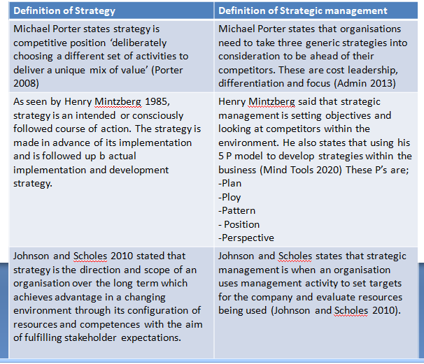
Introduction
1.1 Company background
Dr John Stith Pemberton, born in Atlanta, Georgia in 1886, was a local pharmacist who created the syrup for Coca Cola. He trialled it at Jacobs Pharmacy, where it was pronounced ‘excellent’, and placed on sale for five cents a glass as a soda fountain drink. Soda water was teamed with the new syrup to supply a drink that was directly ‘delicious and refreshing’, a topic that continues to echo today wherever Coca Cola is enjoyed (Coca Cola Company 2020). The brand has since become a household drink in over 200 countries across the world. The worldwide organisation has over 3000 refreshment drinks and a portfolio of 500 brands, ranging from Coca Cola and variations, to the organisation's enterprise carbonates like Fanta, Lilt, Sprite and PowerAde. Furthermore, within the UK, the organisation also pairs with Schweppes (Yafai 2016). In 1888 Pemberton sold portions of his company to different parties with a majority of the business being sold to an Atlanta businessman called Asa G. Candler. Candler also promoted the drink by making a gift of free drink vouchers and outfitting pharmacies and soda fountains with items bearing Coca Cola branding (IBID). In 1919 the Coca Cola company was sold to a gaggle of investors which was led by a person named Ernest Woodruff.
Advertising has always been an important element of the Coca Cola Company. Throughout the years, the jingles and famous slogans cultivated an image of Coca Cola as being a fun and refreshing beverage. This was showcased in Coca Cola’s famous ‘I'd like to buy the world a coke’ commercial that was released in 1971. In 1981, Robert c. Goizueta became chairman of the board of directors and CEO of the Coca Cola company. Goizueta organised various U.S. Coca cola bottling operations into a new public company, Coca Cola enterprises inc. Goizueta was committed to innovation and under his new leadership he introduced diet coke, which was the first extension of the Coca Cola trademark. This went on to be very popular and within a few years it became the most popular low-calorie soft drink within the world (IBID).
Due to the main challenges of the planet wide pandemic people throughout the world are affected. Within the coca cola organisation they are doing all they can to minimise the spread of corona virus, they are also supporting all requirements of their employees, customers, consumers and communities. It's been stated by James Quincey the chairman and CEO that ‘we are prioritizing safety –whether for our system associates or for our customers and consumers’. The security of coca colas system employees is their highest priority. Within some locations, their delivery drivers don't leave their truck which is reducing person to person interactions. a number of their manufacturing plants are implemented split shifts to avoid shift to shift contact (the Coca Cola company, 2020). It's been seen that the Coca Cola foundation is providing additional funding and grants to communities and organisations in response to corona virus. To date, over $55m has been provided to support local organisations and vulnerable communities during these times (IBID)
1.2 Report objectives -
1)
2)
3)
1.3 Business strategy
Coca Cola uses the differentiation strategy to form themselves as unique and break away from other companies. By using the differentiation strategy, coke creates a product that's unique and valued. Coke differentiates themselves by using unique marketing and advertising campaigns to entice their customers to remain loyal to their brand (Neil 2020).
Another differentiation strategy coke has used, is the Coca Cola freestyle machine. This machine allows customers to combine and match their classic Coca Cola beverages with many various flavours. They will continue to use this as a differentiation strategy to separate themselves from competitors and maintain customer loyalty (Naama et al 2019).
A further differentiated strategy Coca Cola could use could be the alcohol drinking culture to take advantage of the alcohol market. For instance, many drinks are ordered as a ‘rum and coke’ or ‘whiskey and coke’. A recommendation to the Coca Cola organisation could be that they could collaborate with a whiskey company like Captain Morgan and sell the liquor with a bottle of coke (BenLud 2013).
Dr Henry Mintzberg created 5 versions of strategy for organisations that they can adhere to, known as the 5p’s of strategy. By an organisation understanding each P they can develop a robust business strategy that takes full advantage of the organisation's strengths and capabilities (MindTools, 2020).
Coca Cola 5 P’s strategy -
Plan – it is evident that within the Coca Cola organisation they have strict plans. This is shown through their organisations SWOT and PEST analysis that they have in place, which is showing that the tools required for a successful planning phase are being used.
Ploy – Coca Cola doesn’t appear to specialise in being the most cost-effective option, they rely heavily on the success of their name. Coca Cola is legendary for their national Christmas trucks campaign, gifting free drinks to customers.
This has been seen to be a very clever marketing ploy by the organisation as the success of the campaign, which has run for the past 22 years, attracts thousands of individuals nationally. It also is an effective marketing tool as when consumers are getting something for free it makes them feel as if they are gaining something back (Bean ND). The
The campaigns success and positive customer experience simply cannot be replicated by competitors as the original idea that the organisation brought out was so unique. The idea of the Coca Cola Christmas truck has proven to be extremely popular throughout the world with individuals quoting ‘doesn't it feel like Christmas now the Coca Cola advert is on the TV’ and ‘it wouldn’t be Christmas without a visit to the coca cola truck’ (BusinessBalls, 2020).
Pattern – strategies can emerge from past organisation behaviour or simply from accidentally discovering which actions work.
Position – this is an organisations placement within their competitive market. It has been seen that Coca Cola are ranked the highest company within their market by repeatedly bringing out new strategies to draw in their consumers. This is giving consumers the sense that something new is continuously emerging, which they haven’t tried before, giving them the need and wants to try it. The Coca Cola organisation has kept the central part of their organisation which is Coke but they continuously adapt to their consumer's needs. The organisation uses strategic positioning so they can keep the same image all around the world. This has been seen to be a part of individuals daily lives (Vendredi 2012).
1.4 Competitive Strategy -
Michael Porter came up with generic competitive strategies. This is an organisations position within their current market and if their ‘profitability is above or below the industry average’ (Porter 1985). Having an above average profitability in an organisation means that they have competitive advantage. Porter stated that there are two types of competitive advantage which are low cost or differentiation. He also states within his strategy that with these two combined sections of competitive advantage leads to ‘generic strategies for achieving above average performance in the industry’. These are cost leadership, differentiation and focus.
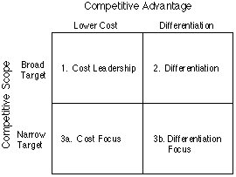
From analysing research into Coca Cola’s competitive advantage, it has been seen that, due to the company having a secret recipe for the formula to make the refreshing beverage it gains better taste over its competitors. It has been seen that their rivals Pepsi have made similar flavours as Coca Cola however, the taste will simply never be the same and beat the word wide brand. This ties in with customer loyalty which gives the company a competitive advantage as Coca Cola’s techniques are effectively developed resulting in them being able to keep costs low for consumers which has resulted in high customer loyalty (Karpinske 2017). Therefore, this is showing that the most generic strategy that’s employed by Coca Cola is cost leadership. This strategy is extremely effective that helps brands quickly increase their market share and gain popularity. This has led to both higher sales and recognition for the large company. Furthermore, this has proved to be a source of sustainable competitive advantage for Coca Cola (Pratap 2018).
2.0 MAIN FINDINGS;
2.1 Overview of Coca Cola’s strategies
1 – Market segmentation
Coca Cola uses the system of market segmentation. The first focus was on increasing an equivalent volume instead of profits so it increased its customer domains and make a robust foundation for future business. This was made possible by selling beverages at economical rates in order that higher number of masses can enjoy it. In developing markets, a balance was made between volume sold and pricing, whereas, in developed countries the main target was more on profit making by offering more small packages and premium packages like glass and aluminium bottles. In 2015, globally, price and blend rose 2 percent as of volume, helping increase organic revenue by 4 percent. Coca Cola also gained worldwide value share in their industry (Mayureshnikam et al 2018). This was due to market segmentation based on income and geography.
2- Brand establishment and customer relationship
Brand establishment becomes vital while expanding an organisations portfolio. Customers tend to trust a branded product and sometimes spend an additional penny upon it instead of choosing an unheard product. Name is additionally viewed as a standing quo in developed markets. Coca Cola made a right decision to take a position in developing the brand value by improving and modernising the advertisements, investing $250 million. These ads focused on creating an impression upon people and altered the attitude of Coca Cola from an occasional drink to an integral part of people’s lives. A breakthrough happened in 2015 when Coca Cola developed its first global marketing campaign. The first objective was to determine the ‘one-brand’ strategy to bring all its sub products under one name ‘Coca Cola’. The slogan ‘taste the feeling’ launched in early 2016 emphasizes the refreshment, taste, uplift and private connections that are all a part of enjoying an ice-cold Coca Cola. For the fitness-orientated consumers, it sent a broader message they will enjoy Coca Cola by choosing an appropriate sort of drink with varying numbers of calories in caffeine (IBID).
3 – Increasing financial efficiency
Coca Cola made efforts to realise financial flexibility by implementing an answer referred to as ‘zero-based work’, where an annual budget is revisedfrom zero and must be justified annually at the top instead of simply carrying over at levels established within the previous year. Also, savings were made by choosing to advertise carefully and hamper expenses in non-media marketing, like in-store promotion. Overall, $600 million were realised by productivity investment in 2015 which were further utilized in brand making, business improvement and providing decent dividends to shareowners (IBID).
4 – Increasing process efficiency
An organisation is often termed to be fully efficient when its process time is minimised without affecting the standard. Coca Cola took steps to reshape their business processes and investigated redundant areas. It removed a layer of functional management and connected their regional business units on to headquarters. Further investigation led to removal of process roadblocks and barriers which finally made it faster, smarter and more efficient. Focus was placed on employee interaction making work a fun-filled, exciting and career fulfilling environment. Employees were motivated to nourish curiosity, learning, innovation and growth (IBID).
5 – Focusing core competencies and models
Coca Cola’s primary core competency has been the power to manage an enormous system of independent bottling partners and also acquiring variety of bottles under its own. The first aim has been to enhance performance by increasing productivity, optimising manufacturing and distribution systems.
All this effort finally creates value for the retail and restaurant customers. In 2015, the organisation took major steps in North America to form company-owned bottling territories independent. The plan was to refranchise the North America bottling system by 2017. A replacement unified bottling partner was planned to line up in Western Europe and accordingly, a transaction was accounted. Furthermore, improvement and refranchising has been planned for bottling system in Southern Africa, East Africa, Indonesia and China. Coca Cola plans to scale back company-owned bottles to 3% from 18% of the worldwide volume (IBID).
2.2 Coca Cola’s analysis of Porter’s strategy -
Harvard graduate school professor Michael Porter invented ‘Porter’s five forces’ in 1979 to be ready to fully analyse an industry's attractiveness and certain profitability. This strategy has become one among the foremost popular business strategy tools employed by organisations. Porter noted that each organisation keeps a close eye on their competitors but he also encouraged them to seem beyond what their competitors do and appearance into other factors that would be impacting the business environment (Porter 2008). It’s been seen that Coca Cola need a customer orientated strategy which involves travelling above and beyond for the changing needs of their consumers and adapting to evolving changes within the environment (All Answers LTD 2018).
Bargaining power of suppliers – the bargaining power of suppliers of Coca Cola is weak. This is often due to the amount of suppliers being high and therefore the switching costs for Coca Cola are low. While the organisation can easily switch from one supplier to another, it is not possible for any supplier to modify faraway from Coca Cola as easily. This might cause losses for any of the suppliers (Pratap 2018).
Bargaining power of buyers / customers – the bargaining power of individual customers in Coca Cola’s case is low. Individual customers generally buy small amounts of coke and they aren't concentrated in specific markets either.
Therefore, overall the purchasers bargaining power is weak (IBID)
Threat of latest entrants – within the beverage industry there are several factors that discourage new brands from entering the market. Growing a brand overnight is impossible and there are significant investments that are required. Coca Cola do not have these concerns as they are already established (Butler 2020).
Threat of substitutes – main substitutes of Coca Cola products are the beverages made by their rival Pepsi, fruit juices and other hot and cold beverages. The amount of substitutes of Coca Cola products is high. There are several juices and other forms of hot and cold beverages within the market. The switching costs are low for the purchasers (Kasi, 2017).
Competitive rivalry between the prevailing players – there are two major players within the soda industry, Coca Cola and Pepsi. There's an intense rivalry between the two. There are a couple of smaller players but they do not pose major competitive threat to Coca Cola.
The two main players within this market are nearly an equivalent size and they have similar products and methods. The extent of differentiation between the 2 brands is additionally therefore low and the price war is intense between them. People have already heard of the ‘Coca Cola wars’, therefore the level of competitive rivalry between the two is strong (Pratap, 2018).
2.3 Bowmans strategic clock analysis
Bowmans clock –
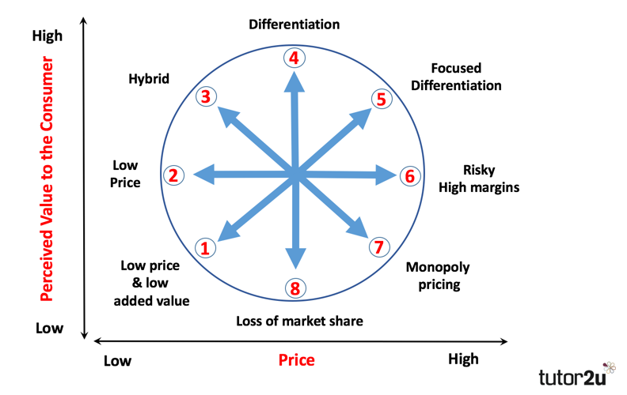
The Bowmans strategic clock was developed by Cliff Bowman and David Faulkner. It's purely a marketing model that helps the organisation analyse their position within the market (Bhasin, 2019). Coca Cola has taken the strategy option of hybrid, during which case it maintains its price and within Great Britain there are only 22 products available to consumers meaning, there is high differentiation there. Coca Cola has increased its annual marketing budget substantially, launched many new products, and developed a model to assist its retail customers maximise their sales while it continues to plan for the longer term.
Alternatively, it often tackled through economies of scale where the corporate produces in large quantities to hide cost and tries to penetrate different geographies. This choice has proved to be beneficial to Coca Cola albeit its market share has not grown tremendously. However, it definitely features a much higher market share than their competitor Pepsi (UK Essays, 2018).
2.4 Evaluation of Porters strategy and Bowmans strategic clock -
Porter’s five forces model is effective for Coca Cola because it enables them to ascertain whether a technique has the potential to bring profit to the company's competitive environment. Coca Cola is the leading brand within the beverages sector and features a global presence. Pepsi is their only major competitor within their market. When analysing Porter’s strategy, it's been seen that Coca Cola’s bargaining power of suppliers is weak. It's also been seen that threat of latest entrants to Coca Cola isn't a serious factor for them to consider as growing an enormous brand overnight is impossible and requires huge investments. Furthermore, it seems that Coca Cola doesn't need to worry about new entrants to their market but, consider their rivalry, Pepsi. This supports the threat of substitutes to Coca Cola as, the amount of substitutes of Coca Cola is high and their rivals are always beginning with new, similar flavours, maintaining with the changing environment (Pratap, 2018).
Bowmans strategic clock analysis shows that Coca Cola is trying to make their products more differentiated therefore, they are not ready to lose their share within the market. To conclude, it shows that they have always maintained their price leaving it as highly valued to their consumers.
2.5 Coca Cola SWOT and PEST analysis
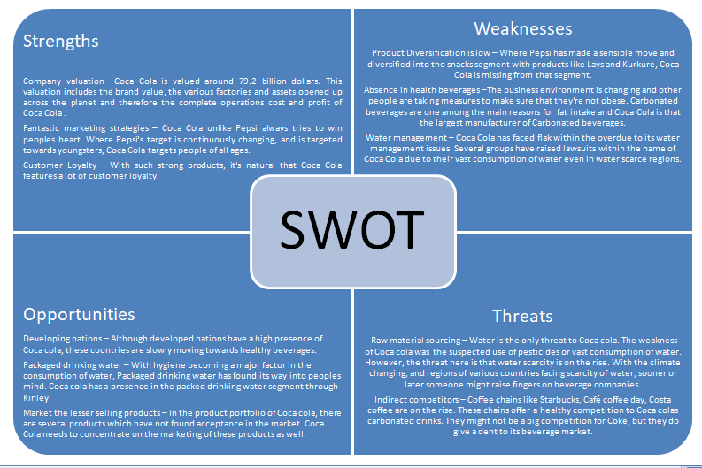
Please refer to appendix one for a full analysis on Coca Cola’s PEST.
2.6 Evaluation of SWOT and PEST analysis
Concluding on the SWOT analysis of Coca Cola it has been seen that they have a definitive market position within the soda industry. However, it is recommended to bring more innovative changes. Some of these changes could be, that Coca Cola need to step into the food market so, introduce new products like snacks. One more recommendation is that the company need to improve their water management system and be able to deal with all criticisms from environmental health.
The PEST analysis on coca cola shows that certain political, economic, social and technological factors are of particular important for the soda giants' business. While the technological factors might be under control within the business, the social, political and economic factors would require them to change its marketing strategies as per the changing conditions. Water scarcity is particularly a big problem that is affecting coca cola. Water scarcity would continue to trouble it in the long term in most of the countries where coca cola’s production plants are based. This will also be the most challenging area for them to manage. While they have made their way to adopting healthier products by increasing the number of low-calorie beverages and the world economy is also geared towards growth, a stronger dollar may still continue to bite (Pratap, 2018).
2.7 Stakeholder analysis – Mendelows 1981 power/interest matrix
Mendelows power interest matrix theory 1981, suggests that organisations analyse their stakeholder groups based on power, which is the ability to influence the organisations strategy or project resources, and also how interested they are within the organisation or project succeeding (Oxford College 2020). Regarding Coca Colas stakeholders, all of which have some level of power in their decisions to an extent, each different stakeholder has a different level of interest and power regarding the organisations.
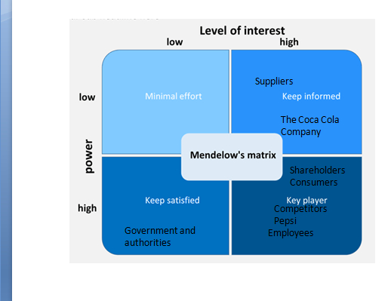
The power matrix model allows organisations to identify which stakeholders are majorly important with high power and high interest, and which they would need to manage closely, investing a lot of time and resources on. Once the organisation has identified these, keeping them on side and keeping them up to date on a daily basis is priority. Furthermore, those stakeholders with low power and low interest should be monitored and minimum effort expended in terms of time and money.
Stakeholders -
The following image by Coca Cola HBC 2020 shows Coca Cola’s stakeholders and how they engage with them.
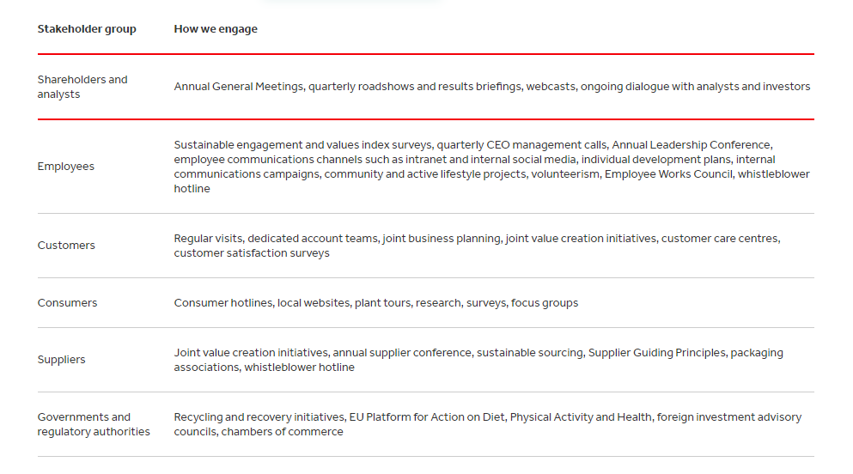
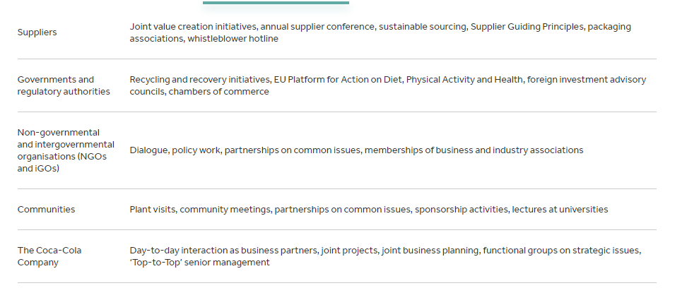
2.7 Evaluation of what was discovered in the stakeholder analysis -
The stakeholder analysis shows that Coca Cola have many stakeholders, each having a different level of power and interest to the organisation. With Coca Cola taking into consideration their stakeholders within their company decisions, this will increase their chances of succeeding through accommodating their needs and interest of the company (Oxford College 2020). The analysis shows how important the role of Coca Cola’s stakeholders is to them and their success. It also reveals how important it is for them to manage and identify which stakeholders are highly relevant for their projects to gain greater success for the organisation as a whole.
Conclusion - this report has provided a fair analysis of Coca Cola’s business and competitive strategy through utilising strategic management tools. Coca cola has a strong business strategy which is in line with the aims of the business.
Appendices –
Appendix one;
Coca cola PEST analysis
P – Political – As Coca Cola is classed ‘within the food category’ UK Essays, 2019), it has to ensure it abides by the regulations provided by the Food and Drug Administration (FDA) in order to protect public health. They are also impacted by any Government regulations introduced in regards to manufacturing or tax laws. Failure to adhere to these restrictions can result in fines. Another factor which influences Coca Cola is the Occupational Safety and Health Act. Failure to strictly follow this act may result in fines, penalties and potential shut down of the business if death was to occur.
E – Economical – coca cola is subject to many economical factors. Firstly, the growth or recession of the economy can have a huge impact and is a factor which is out of their control. A second factor is currency exchange. As coca cola is a global brand if the currency of a country devalues so will their profit margin, which again is largely out of their control. Coca cola have been very successful in optimising the way they utilised loan schemes, as demonstrated in the recession of 2001. They ‘took out low-cost loans’ whilst rates were low to grow the business before the rates increased in 2002. Finally, coca cola have been extremely skilled in increasing their income by adapting their flavours to appeal to countries outside of the U.S which is ‘roughly 70%’ of their income now.
S – Social – one of the largest influences on Coca Cola is media perception. If the media is portraying Coca Cola in a positive light then this usually results in positive outcomes for the business. Also, Coca Cola have adapted the flavours of their products to meet the demands of their customers in different societies and cultures. However, this focus does not appear to be continued in America which has seen a move towards healthier lifestyle choices such as bottled waters. Coca Cola has not created a product that is solely a healthy option to meet this new customer need.
T – Technological – Coca Cola have taken full advantage of the developments within technology. They have purchased the latest machinery which has enabled them to manufacture larger quantities and ensure faster delivery times of their products. However, purchasing the newest and most efficient machinery incurs a large cost.
In addition to purchasing the newest machinery, Coca Cola have maximised their opportunity to advertise and promote their products through the use of social media as seen via their naming campaign. This allowed them to cheaply and effectively promote whilst staying on trend a

References

https://www.citethisforme.com/cite/website
Bean, A., n.d. The Coca-Cola Truck- A Genius Marketing Ploy - Events/PR/Marketing. [online] Events/PR/Marketing. Available at: <http://harosa.com/coca-cola-truck-genius-marketing-ploy/> [Accessed 16 October 2020].
Bhasin, H., 2019. Bowman’S Strategy Clock - What Is Bowman’S Strategy Clock?. [online] Marketing91. Available at: <https://www.marketing91.com/what-is-bowmans-strategy-clock/> [Accessed 29 September 2020].
Businessballs.com. 2020. Mintzberg's 5Ps Of Strategy – Businessballs.Com. [online] Available at: <https://www.businessballs.com/strategy-innovation/5ps-of-strategy/> [Accessed 9 October 2020].
Butler, R., 2020. How Coca-Cola Stacks Up Against Its Competition. [online] Investopedia. Available at: <https://www.investopedia.com/articles/markets/120915/analyzing-porters-5-forces-cocacola.asp> [Accessed 3 October 2020].
Coca Cola HBC. n.d. Stakeholder Engagement. [online] Available at: <https://rs.coca-colahellenic.com/en/a-more-sustainable-future/sustainability-approach-and-impact/stakeholder-engagement> [Accessed 31 September 2020].
Ltd, A., 2018. Competitive Analysis Of Coca-Cola: PEST And Porter's Five. [online] UKDiss.com. Available at: <https://ukdiss.com/examples/competitive-analysis-of-coca-cola.php#citethis> [Accessed 4 October 2020].
Mindtools.com. 2020. Mintzberg's 5Ps Of Strategy: Improving The Robustness Of Your Strategy. [online] Available at: <https://www.mindtools.com/pages/article/mintzberg-5ps.htm> [Accessed 2 October 2020].
Oxford College of Marketing. 2020. What Is Mendelow's Matrix And How Is It Useful?. [online] Available at: <https://blog.oxfordcollegeofmarketing.com/2018/04/23/what-is-medelows-matrix-and-how-is-it-useful/> [Accessed 13 October 2020].
Patil, V., 2018. Marketing Strategy Of Coca COLA. [online] Iosrjournals.org. Available at: <http://www.iosrjournals.org/iosr-jbm/papers/Conf.ADMIFMS1808-2018/Volume-1/12.%2077-85.pdf> [Accessed 11 October 2020].
Porter, M., 2020. The Five Competitive Forces That Shape Strategy. [online] Harvard Business Review. Available at: <https://hbr.org/2008/01/the-five-competitive-forces-that-shape-strategy.> [Accessed 12 October 2020].
Pratap, A., 2018. Sources Of Coca Cola's Competitive Advantage. [online] notesmatic. Available at: <https://notesmatic.com/2019/01/coca-cola-sources-of-competitive-advantage/> [Accessed 30 September 2020].
BenLud. 2013. Business Level Strategy. [online] Mycokespot.blogspot.com. Available at: <https://mycokespot.blogspot.com/2013/03/business-level-strategy.html> [Accessed 6 October 2020].
Softdrinkcolawar.blogspot.com. 2012. Coca Cola Targeting And Positioning. [online] Available at: <https://softdrinkcolawar.blogspot.com/2012/12/coca-cola-targeting-and-positioning.html?m=1> [Accessed 7 October 2020].
UKEssays.com. 2020. Company Background And Overview Of Coca Cola. [online] Available at: <https://www.ukessays.com/essays/marketing/company-background-and-overview-of-coca-cola-marketing-essay.php> [Accessed 12 October 2020].
Yafai, N., 2016. History Of Coca-Cola. [online] InterExchange. Available at: <https://www.interexchange.org/articles/career-training-usa/2016/03/08/history-coca-cola/> [Accessed 1 October 2020].

