Info Skills Unit Evidence

Info Skills: Finding Information: Unit 1 Types of Information
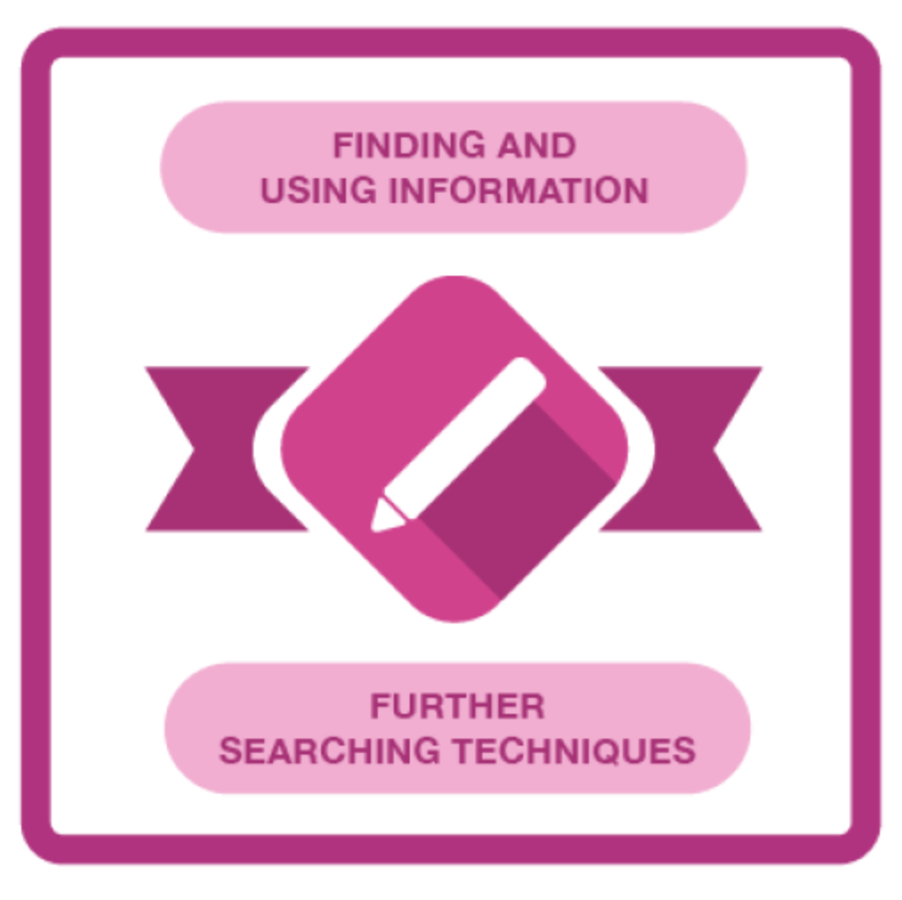

Info Skills: Finding Information: Unit 4, Section 1 (Critical Awareness)
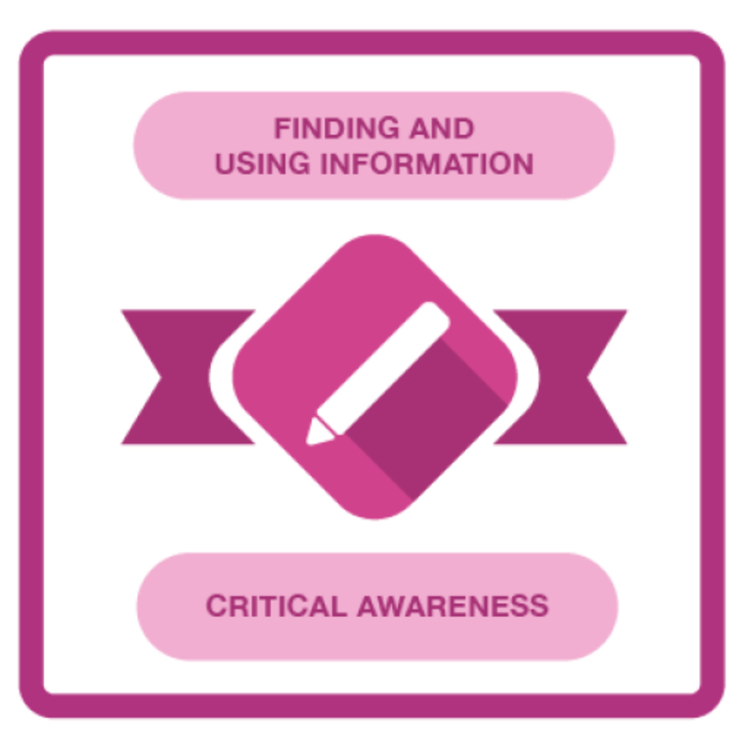

Info Skills: Referencing Basics
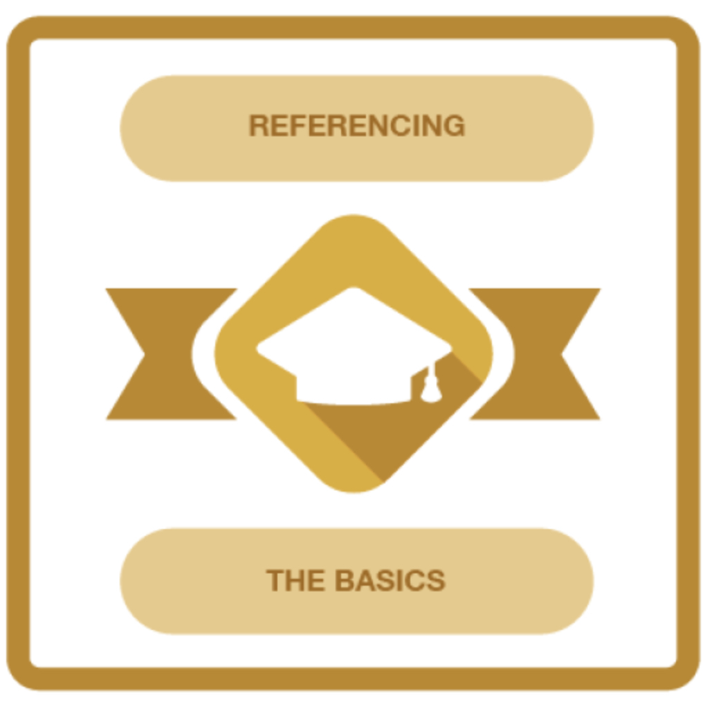

Info Skills: Academic Integrity
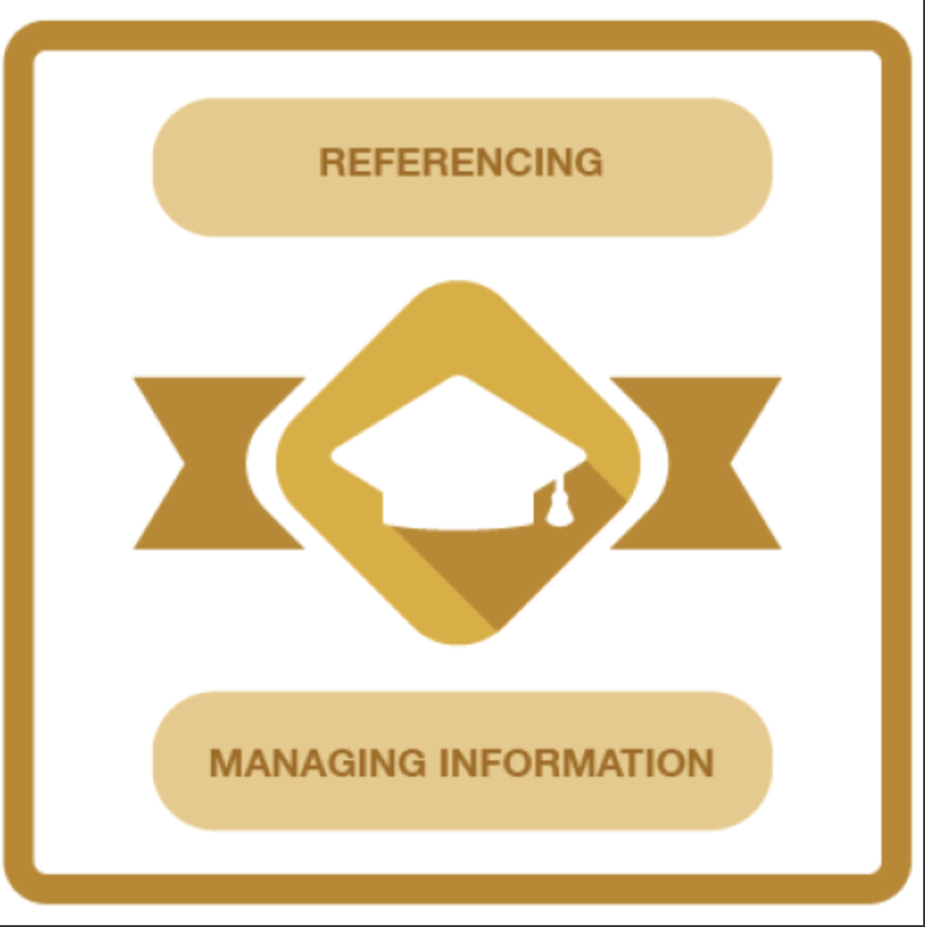

Info Skills: Evaluating Information:Critical thinking

