Name:__Edward Lloyd_______________________________

Student Number: __2511559______________________
__________________________________________________________

WORKSHEET 2 – TESTING (Tiles)

1. Original Code

[Copy and paste your original code from Moodle into this box. Do not change it.]

import math

tileWidth = 20
tileHeight = 20

print("Welcome to the Tile Calculator!\n"
"(Enter below the dimensions of the wall to be tiled.)\n")

wallWidth = 0
while wallWidth <= 0:
flag = 0
while flag == 0:
try:
wallWidth = int(input("Enter the width of the wall: "))
except ValueError:
print("Not a number, try again.")
else:
flag = 1

wallHeight = 0
while wallHeight <= 0:
flag = 0
while flag == 0:
try:
wallHeight = int(input("Enter the height of the wall: "))
except ValueError:
print("Not a number, try again.")
else:
flag = 1

tilesRequiredWidth = math.ceil(wallWidth / tileWidth)
tilesRequiredHeight = math.ceil(wallHeight / tileHeight)
tilesRequiredTotal = tilesRequiredWidth * tilesRequiredHeight

print(f"\nYou will require {tilesRequiredTotal} tile(s).\n")

tileStock = 25000

if tilesRequiredTotal >= tileStock:
print("Sorry, we don't stock that many tiles in stock!\n"
"Start again and select smaller dimensions for the wall.")
else:
print(f"We have enough tiles in stock! Happy tiling :D")

2. Code Testing

For each test below (i – vii), run your code and enter the values provided. Present a screenshot of the of what happened when the programme ran. Did the programme behave correctly or did it do something unexpected, and if so, why?

Input:

- Enter dimensions of wall: Width 40 Length 45
- Enter dimensions of wall: Width 100000 Length 200000
- Enter dimensions of wall: Width -16 Length -20

Logic:
- Enter dimensions of wall: Width 80 Length 80. The result should be 16 tiles
- Enter dimension of wall: Width 40 Length 45. The result should be 6 tiles
- Enter dimensions of wall: Width 85 Length 90. The result should be 25 tiles.
- Enter dimensions of wall: Width 15 Length 15. The result should be 1 tile.

Note: If you decided to include logic within your program to allow a tile to be cut such that 2 pieces can be used from the same tile where possible (therefore reducing the total number of tiles required), your results may differ from the above. In this case, explain your logic as part of your answer. If you did not, consider adding this logic to your final code.

Fill in a box for each test above. You should present 7 separate boxes, 1 for each test. (Note: the first box is provided as a template)

Input

Test i

Test i:
Input – Enter dimensions: Width 40 Length 45

Screenshot(s) of output:
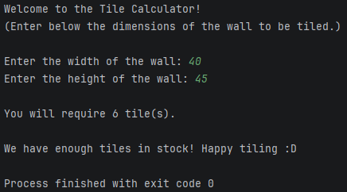
Result: Did the programme behave as expected i.e. syntactically and logically correct?
YES, the input was accepted and the programme returned the quantity of tiles required.

Test ii

Test ii:
Input – Enter dimensions of wall: Width 100000 Length 200000

Screenshot(s) of output:
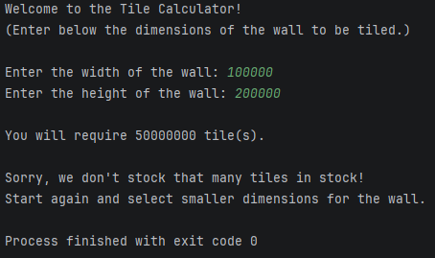
Result: Did the programme behave as expected i.e. syntactically and logically correct?
YES, the input was accepted, the programme returned the quantity of tiles required, and confirmed that the amount exceeded the stock levels and prompted the user to start again; consideration could have been made to use a while loop to return the user to the beginning of the programme.

Test iii
Test iii:
Input – Enter dimensions of wall: Width -16 Length -20
Screenshot(s) of output:
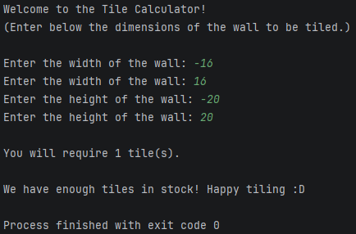
Result: Did the programme behave as expected i.e. syntactically and logically correct?
YES, the negative input was not accepted and only proceeded once the positive input was entered; however consideration could have been made to include a message warning the user of the invalid entry.

Logic

Test iv
Test iv:
Logic – Enter dimensions of wall: Width 80 Length 80. The result should be 16 tiles
Screenshot(s) of output:
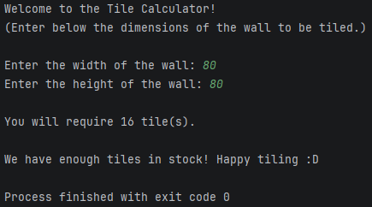
Result: Did the programme behave as expected i.e. syntactically and logically correct?
YES, the result was 16 tiles.

Test v

Test v:
Logic – Enter dimension of wall: Width 40 Length 45. The result should be 6 tiles
Screenshot(s) of output:
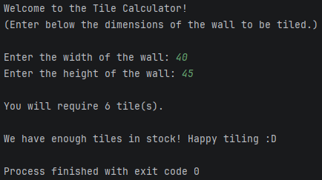
Result: Did the programme behave as expected i.e. syntactically and logically correct?
YES, the result was 6 tiles.

Test vi

Test vi:
Logic – Enter dimensions of wall: Width 85 Length 90. The result should be 25 tiles.
Screenshot(s) of output:
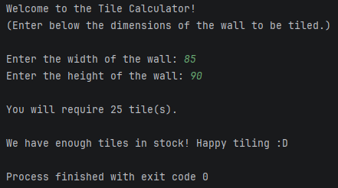
Result: Did the programme behave as expected i.e. syntactically and logically correct?
YES, the result was 25 tiles.

Test vii

Test vii:
Logic – Enter dimensions of wall: Width 15 Length 15. The result should be 1 tile.
Screenshot(s) of output:
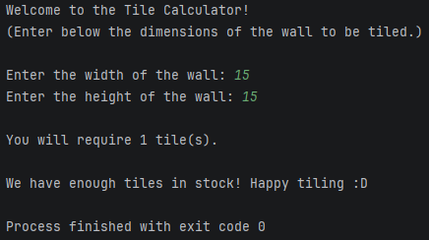
Result: Did the programme behave as expected i.e. syntactically and logically correct?
YES, the result was 1 tile.

3. Revised Code

Consider the results of the above tests and revisit your code in order to solve any problems discovered at the testing phase. (Note: you may not be able to solve all of them, but solve as many as you can.)

- Messages now return if the user tries to input values equal to or less than zero rather than just prompting them to input another value.
- Additional calculations were added based on the Note in the Code Testing section of this document, allowing the user to choose whether they want to cut tiles into 2 pieces (therefore reducing the total number of tiles required). The choice to calculate the tiles in cut and uncut was built in to provide the option for whole tiles if, for example, the tiles were asymmetrically patterned such that a cut tile could not be reused despite the waste.
- The logic behind the new calculation is that the number of uncut tiles is first calculated by using floor division when dividing the wall width and height by tile width and height [wallWidth // tileWidth] [wallHeight // tileHeight] so a wall that is 85 x 90 would produce a width and height of 4 tiles which results in a total of 16 whole tiles. This can be deducted from the original value calculated in the first iteration of the code (which calculated in whole tiles) [tilesRequiredTotal] so that 25 - 16 = 9 tiles which when divided by 2 (i.e. tiles cut in half) results in 4.5 tiles which, added back to the total uncut tiles (16) is 20.5 but as tiles are not sold in halves, math ceiling is applied at the end to generate the value of 21 tiles (of which 16 will not be cut and 5 will be cut).
- The number of tiles in stock was included in the failure message at the end of the programme to indicate to the user how much their request exceeded the stock.
- Formatting was added to return numbers with comma breaks for improved readability [1].
- The tile calculator is now in a while loop so while the tiles required is greater than the stock level, the user is prompted to start again until they enter wall dimensions which return a number of tiles within the stock level. The original code indicated the user should “start again” but the programme just exited at that point.

Paste your revised code here:

[Copy and paste your revised code here – note, do not use a screenshot]

import math
tileWidth = 20
tileHeight = 20
#Tile stock and variables to start while loop until user enters wall dimensions that generate a tile total less than or equal to stock of tiles and choice of whole or cut tiles.
tileStock = 25000
tilesRequiredTotal = tileStock + 1
tilesUncutCutTotal = tileStock + 1
userChoice = ""
while userChoice == "" or userChoice == "y" and tilesUncutCutTotal > tileStock or userChoice == "n" and tilesRequiredTotal > tileStock:
print("~ ~ Welcome to the Tile Calculator! ~ ~\n\n"
"Enter the dimensions of your wall below to check if we have enough tiles in stock.\n"
"(Please Note: our tiles are 20cm x 20cm.)\n")
#User input for wall width and height with validation to prevent noninteger input.
wallWidth = 0
while wallWidth <= 0: #Validation to prevent user input of value less than or equal to 0
flag = 0
while flag == 0:
try:
wallWidth = int(input("Enter the width of the wall (cm): "))
except ValueError:
print("Not a whole number, try again.")
else:
flag = 1
if wallWidth <= 0:
print("Wall width must be greater than zero, try again.")
wallHeight = 0
while wallHeight <= 0: #Validation to prevent user input of value less than or equal to 0
flag = 0
while flag == 0:
try:
wallHeight = int(input("Enter the height of the wall (cm): "))
except ValueError:
print("Not a whole number, try again.")
else:
flag = 1
if wallHeight <= 0:
print("Wall height must be greater than zero, try again.")
#Original calculation for tiles required (whole tiles only)
tilesRequiredWidth = math.ceil(wallWidth / tileWidth)
tilesRequiredHeight = math.ceil(wallHeight / tileHeight)
tilesRequiredTotal = tilesRequiredWidth * tilesRequiredHeight
#Additional calculation for uncut (whole) and cut (divided by 2) tiles
tilesUncutWidth = wallWidth // tileWidth
tilesUncutHeight = wallHeight // tileHeight
tilesUncutTotal = tilesUncutWidth * tilesUncutHeight
maximumTileCuts = 2
tilesCutTotal = (tilesRequiredTotal - tilesUncutTotal) / maximumTileCuts
tilesUncutCutTotal = math.ceil(tilesCutTotal + tilesUncutTotal)
#Choice is offered to calculate only in whole tiles (original) or to allow for cut tiles in calculation
print(f"\nThe tile calculator can allow a tile to be cut such that {maximumTileCuts} pieces can be used from the same tile.")
userChoice = ""
while userChoice != "y" and userChoice != "n":
userChoice = input("Do you want to cut and reuse tiles? (y/n) ").lower()
if userChoice != "y" and userChoice != "n":
print("Invalid input, try again (y/n).")
#Output of tiles required depending on user's choice of cut or whole tiles
if userChoice == "y":
print(f"\nYou will require {tilesUncutCutTotal:,} tile(s).\n")
else:
print(f"\nYou will require {tilesRequiredTotal:,} tile(s).\n")
#Outcome if enough tiles are or are not in stock for user request
if userChoice == "y" and tilesUncutCutTotal > tileStock or userChoice == "n" and tilesRequiredTotal > tileStock:
print(f"Sorry, we only have {tileStock:,} tiles in stock!\n"
"Start again and enter smaller dimensions for your wall.\n\n"
"* * * * * * * * * * * * * * * * * * * * * * * * * * * *\n")
else:
print(f"We have enough tiles in stock! Happy tiling :D")

References

[1] | S. Marnach, “Add commas into number string,” Stack Overflow, 3 March 2011. [Online]. Available: https://stackoverflow.com/questions/5180365/add-commas-into-number-string. [Accessed 24 March 2025].

