DS 1 Template

My Screenshots/Photos
- Please add 4–6 screenshots or photos of your digital life.
- You can use your phone or laptop.
- For each screenshot, write one or two sentences explaining what it shows.

Screenshot/Photo 1
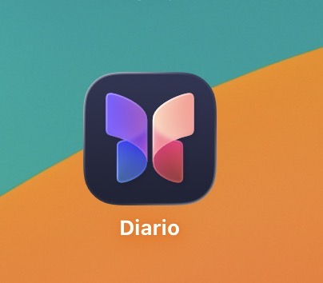
Diary App

I use this app to remember my sad and happy moods.

Screenshot/Photo 2
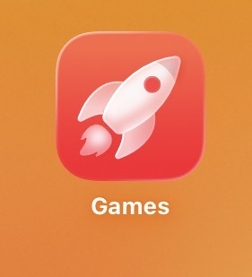
Games App

I use this app to find new Games , view my trophies and allows to resume games exactly where you left off.

Screenshot/Photo 3
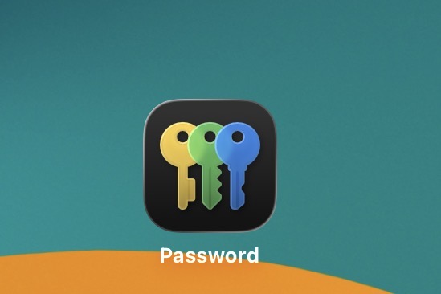
Password keys
This app is important to me because I have a lot of password to remember for the activity in my daily life.

Screenshot/Photo 4
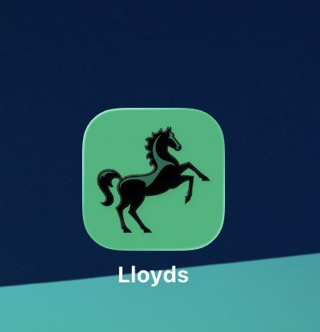
Bank App
I use this app for my transaction

Screenshot/Photo 5
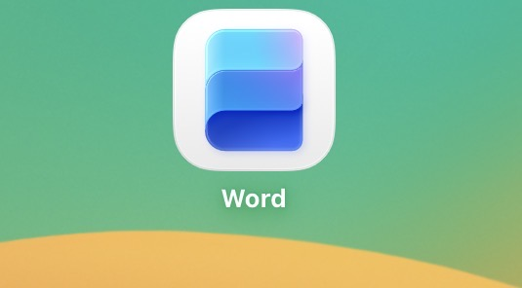
Microsoft Word

I use this App to create ,edit and format my document.

Screenshot/Photo 6

Facebook App

I use this app to socialise with my friends and my family all over the globe.

My Short Reflection
- Write 5–8 simple sentences about your digital life.
- You can use the sentence starters below if helpful.
I use digital tools for most of my daily activities (work, socialising, payments, free time etc.)
I feel confident when I use Facebook, Instagram, whatsapp because I like to stay in contact with people so I don’t feel alone in this country.
I want to improve to use my computer skills for my course work
I would like to learn more skills such as word, Excel and power point
I feel excited and comfortable to use the tools I am learning in class.

Sentence starters
- I use digital tools to …
- I feel confident when I …
- I want to improve …
- I often use these tools: …
- I sometimes feel nervous about …
- I hope this module will help me …
- Digital skills are important for me because …
You can write more if you want.

Submission Checklist
Before you submit, please check:
​​​ ☐ I added 4–6 screenshots
☐ I wrote short sentences for each screenshot
☐ I wrote my short reflection
☐ My work is my own
☐ My file opens correctly
​​☐ My file opens correctly

