University of Wales Trinity Saint David
Wales Institute of Science and Art



Engineering problem
Engineering Design
ACHA4001

Isaac Jones
2403961
04/04/2025

Table of contents
Table of contents 2
Chapter 1: Introduction 3
Chapter 2: Legislations 4
Chapter 3: Specification 5
Chapter 4: Time plan 6
Chapter 5: Designs 7
Sketches 7
CAD designs 13
Technical drawing 17
Chapter 6: Relevant research 22
Chapter 7: Materials and manufacturing processes 23
Chapter 8: Justification 24
Chapter 9: Conclusion 25
References 26

Chapter 1: Introduction
This report will cover the process of designing and developing a solution to an engineering problem. It will assess the transition from interpreting the client brief to generating initial sketches and ultimately finalizing a CAD design. The task set by an automotive original equipment manufacturer (OEM), in which the lid of the anodization tanks are too heavy and unsafe for a single person to lift. Therefore, a solution is required that allows one person to safely operate the tanks without the risk of injury.

Chapter 2: Legislations

It is important that before designing anything, legislations are considered which may impact the designs and application. This helps to protect the employers, employees, the environment as well as yourself. In this situation there are 2 main legislations that can impact the design process; these include the control of substances hazardous to health regulations 2002 (COSHH) (legislation.gov, 2002). Aswell as the manual handling operations regulations 1992 (Legislation.gov, 1992).
Considering COSHH is crucial for this task due to the anodizing fluid, which contains 30% sulfuric acid. If the acid is spilled, it can cause severe skin burns and damage the respiratory system, making breathing difficult. In extreme cases, it can even lead to blindness (Agency for Toxic Substances and Disease Registry, 2014). Therefore, it's essential that the design minimizes the risk of fluid spillage or splashing out of the tank.
Additionally, the Manual Handling Operations Regulations play a key role in this task, as the original issue was that lifting the lid required two people and raised several health and safety concerns. As a result, my designs must take these regulations into account and aim to minimize the risk of injury when handling the lid.

Chapter 3: Specification

Specification point: | How does this point affect my design? | On a scale of 1 to 5, how important is this point?
Aesthetics | There are no specific aesthetic requirements; the design should maintain a simple, bare stainless-steel theme. | 1
Cost | The design must remain cost-effective, as hundreds will be produced. | 4
Costumer | The design must be approved by both the line manager and the health and safety officer. | 4
Size and weight | The design must be light enough for one person to lift. | 5
Function | The design must completely cover the tank while remaining removable between operations. | 5
Materials and components | The cover is currently made from stainless steel, so it’s important to maintain this material choice to stay consistent with the overall design. Additionally, the design must be resistant to sulfuric acid and able to withstand temperatures up to 25 degrees Celsius. | 4
Manufacture | The designs must be simple and quick to manufacture, as several hundred units will need to be produced. | 3
Maintenance | The design must be easy to maintain, given the large number of tanks. | 3
Figure 1: Specification
This specification uses a point-based system to prioritize key requirements, with more points indicating more importance. This enables me to compare my initial designs against the specification and determine which idea best meets the task's needs.

Chapter 4: Time plan
I created a Gantt chart to monitor my progress throughout the design process, giving me a clear overview of both completed tasks and those still to be finished. The chart extended up to the due date, helping me visualize how much time remained before the assignment needed to be completed. This allowed me to efficiently allocate my time to the remaining tasks, ensuring that everything was completed before the due date.
 | 3/29/2025 | 3/30/2025 | 3/31/2025 | 4/1/2025 | 4/2/2025 | 4/3/2025 | 4/4/2025
Read the client brief
Create a specification based on client brief
Research possible solutions
Choose the 3 best designs and create sketches
Pick best idea and create CAD model
Create detailed technical drawings of the CAD model
Research manufacturing processes
Key
Started
Finished
Figure 2: Gantt chart

Chapter 5: Designs

Sketches
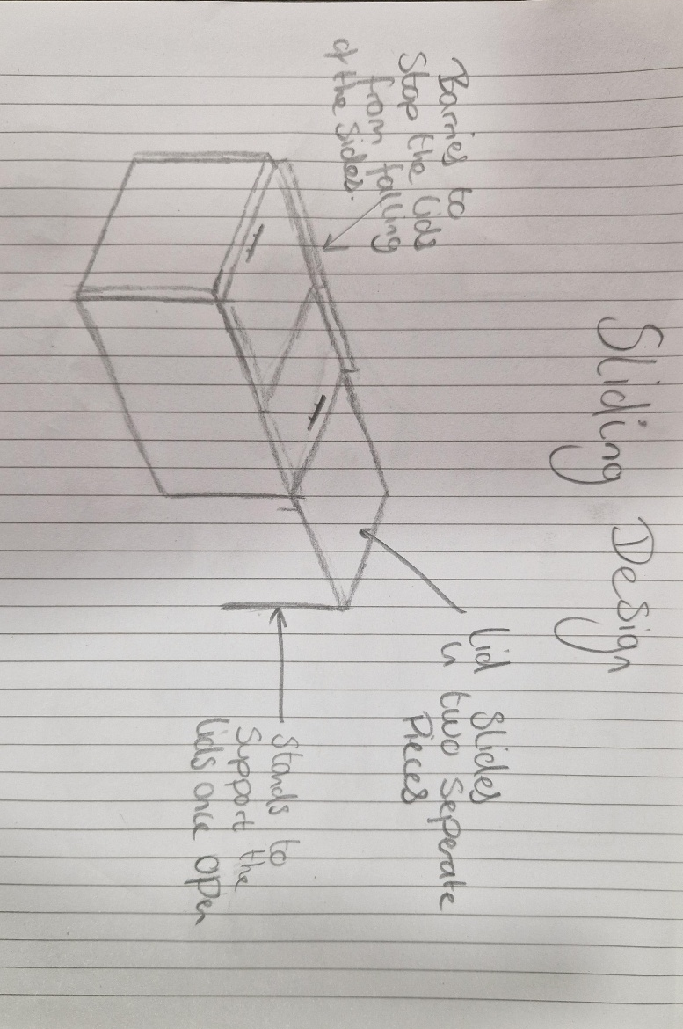
Figure 3: Sliding design
The sliding design offers a simple solution to the problem. It uses barriers to prevent the lid from shifting sideways when pushed or pulled, with these barriers attached to the tank rather than the lid. The lid itself is the original, but cut in half, and the handles are repositioned on top to make it easier to push and pull. To keep the lid supported when open, stands are attached to the lid, holding it in place.
The benefits of this design are that it can be easily pushed and pulled into place, allowing for effortless operation by a single person. Additionally, the design is relatively simple and inexpensive to produce. However, since the lids aren’t bolted or connected in place apart from barriers, they can easily become loose or shift, which may compromise the seal.
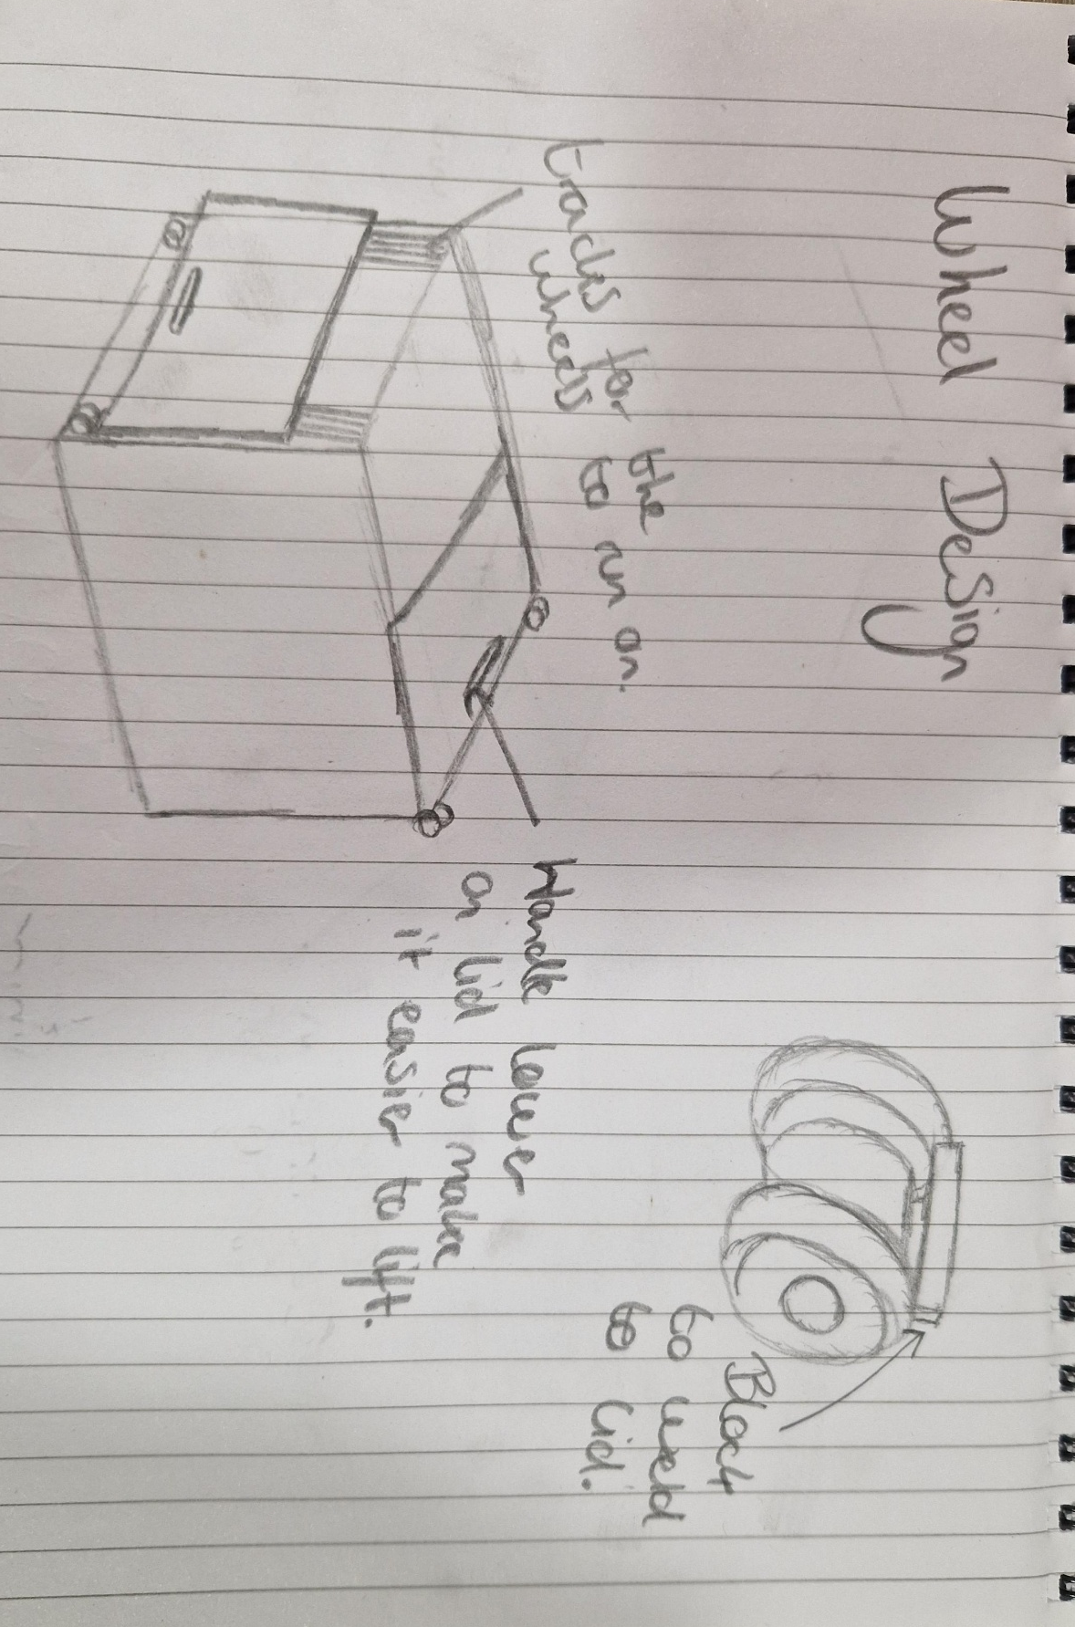
Figure 4: Wheel design

The wheel design is more complex, featuring two wheels welded to the bottom of each lid. These wheels travel vertically along a pair of tracks, and when they reach the top of the tank, the lid can rotate and close smoothly. To prevent the wheels from coming off the tracks, a cover runs vertically along the outside of each track, ensuring there is enough space for the lid to slide into. Additionally, a handle is positioned on the bottom of each lid to make lifting easier.
The benefits of this design are its compactness, as the lids slide down the side of the tank, taking up very little space. Additionally, the design remains stable laterally because the wheels are secured in the tracks, minimizing the lid’s lateral movement. However, this design is relatively complex and will be costly to fully design and manufacture. Moreover, lifting the lids will be more difficult since they need to be pulled rather than pushed, and research shows that people can push more weight than they can pull (The University of Newcastle Australia, 2009).
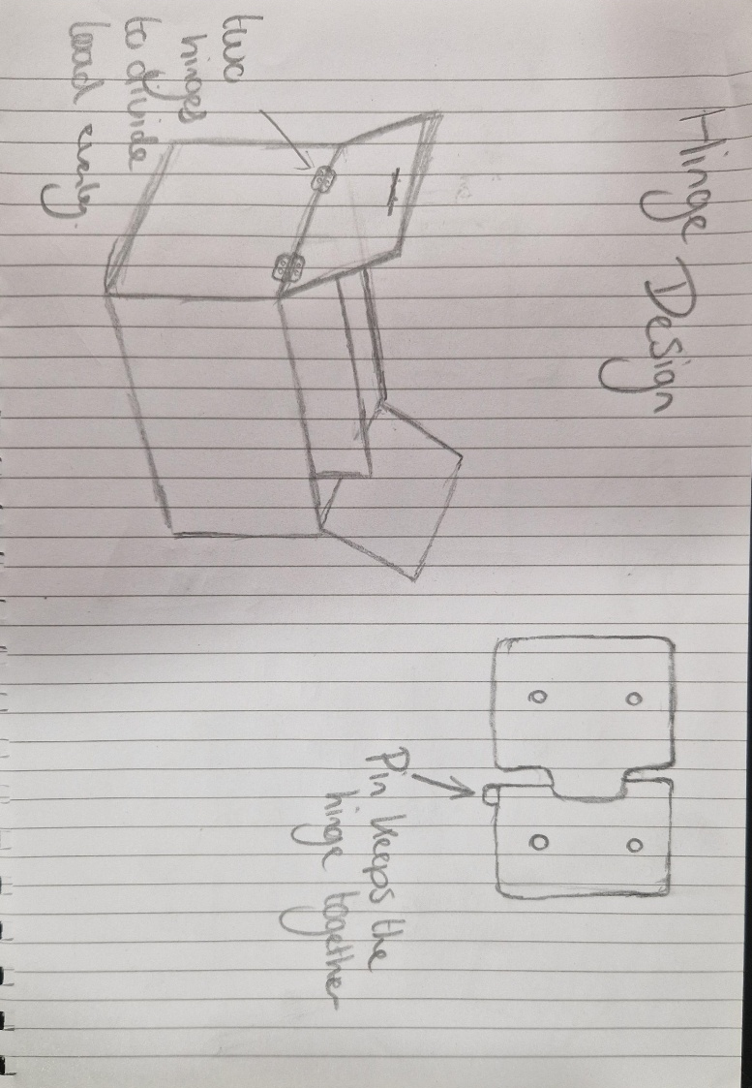
Figure 5: Hinge design

The hinge design utilizes standard hinges, which are attached to the top of the tank and the bottom of the lid using M6 bolts. Two hinges are placed on each side of the tank to evenly distribute the weight. Crucially, the hinges prevent the lid from shifting laterally, ensuring a consistent, tight seal on the tank. The handles are positioned at the top of the lids, so when opened, they are located at the bottom, making it easier to close the lid.
The advantages of this design lie in its low cost, as it uses the original lid, simply cut in half, with the handles relocated. The only additional materials required are the hinges, which are very inexpensive. Furthermore, this design eliminates lateral movement, ensuring the lid seals the tank tightly and consistently. While this design is easier to lift than the wheel design, since the lid can be pushed instead of pulled, it will still be fairly challenging to lift, as it requires lifting from a low position.

CAD designs
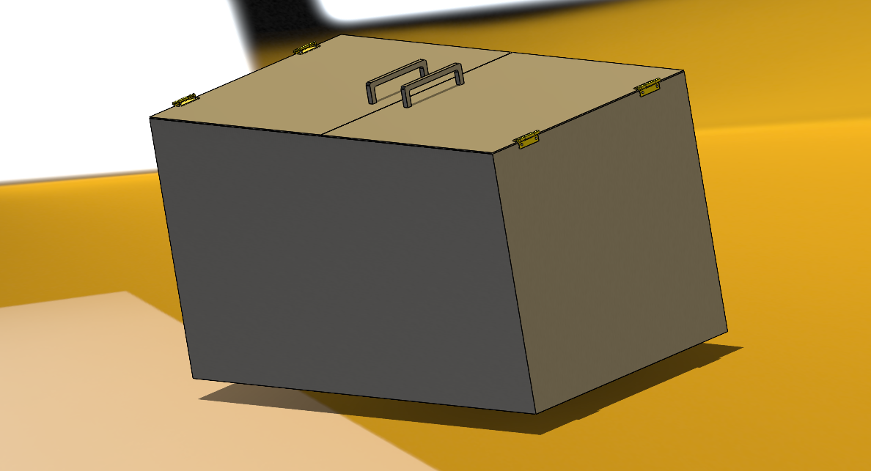
Figure 6: Closed CAD design

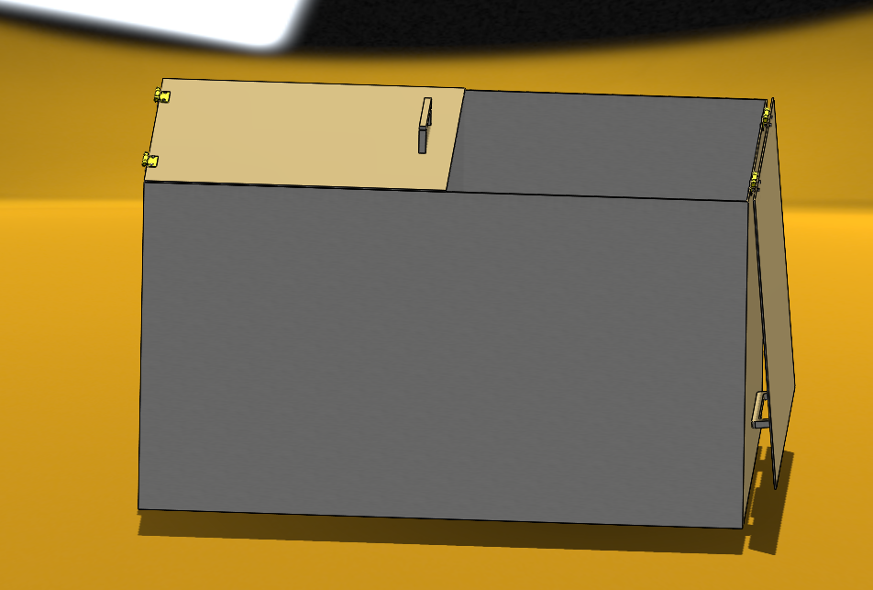
Figure 7: Open CAD design
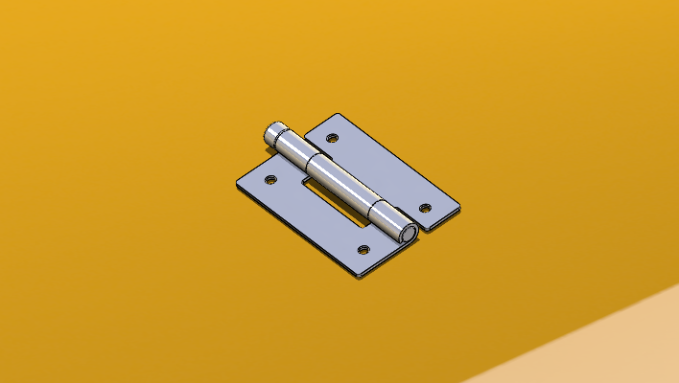
Figure 8: Hinge CAD design
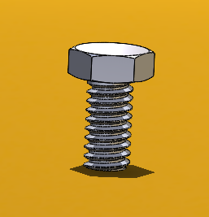
Figure 9: Bolt CAD design
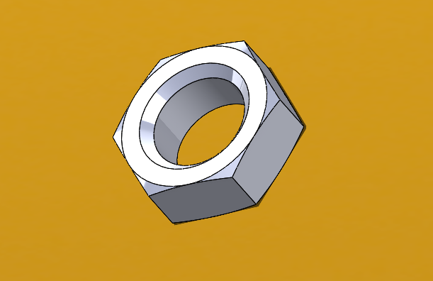
Figure 10: Nut CAD design
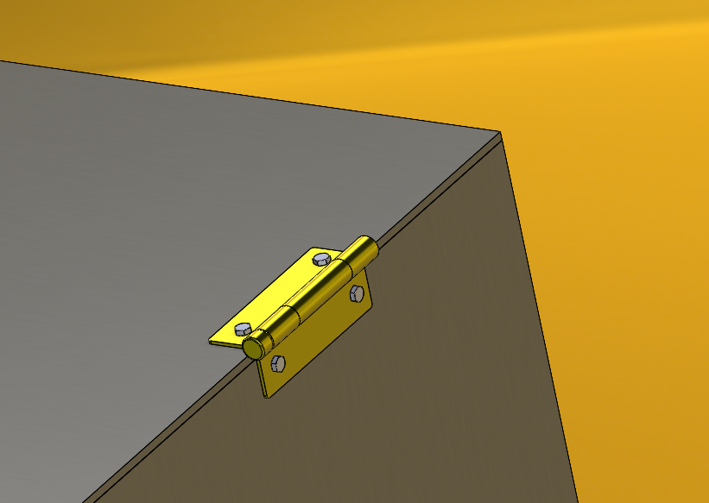
Figure 11: Hinge attached CAD
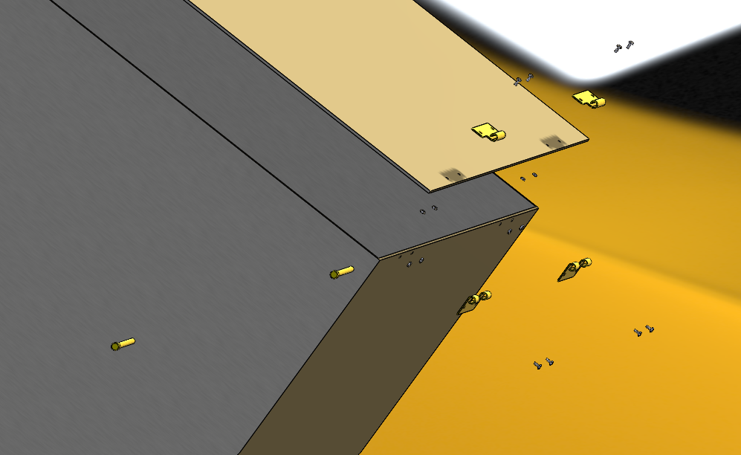
Figure 12: Final design assembly exploded view
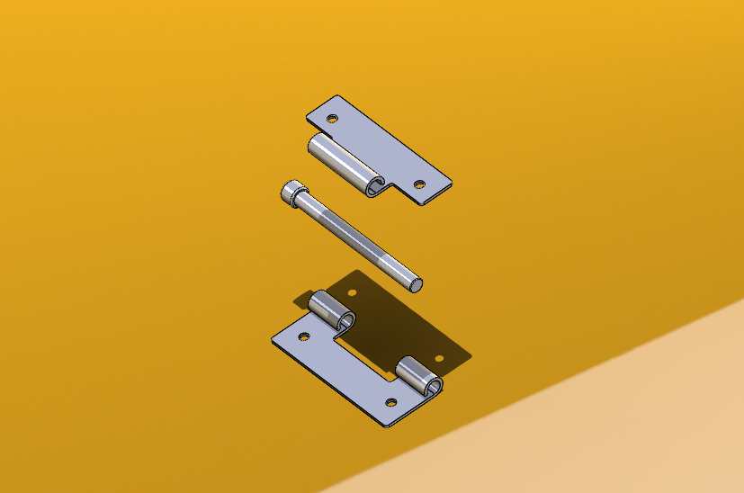
Figure 13: Hinge assembly exploded view
These are the CAD drawings for the design. As shown in Figures 6-13, I ultimately chose the hinge design. Figures 12 and 13 are particularly important, as they are exploded views that show how the final product can be assembled.

Technical drawing
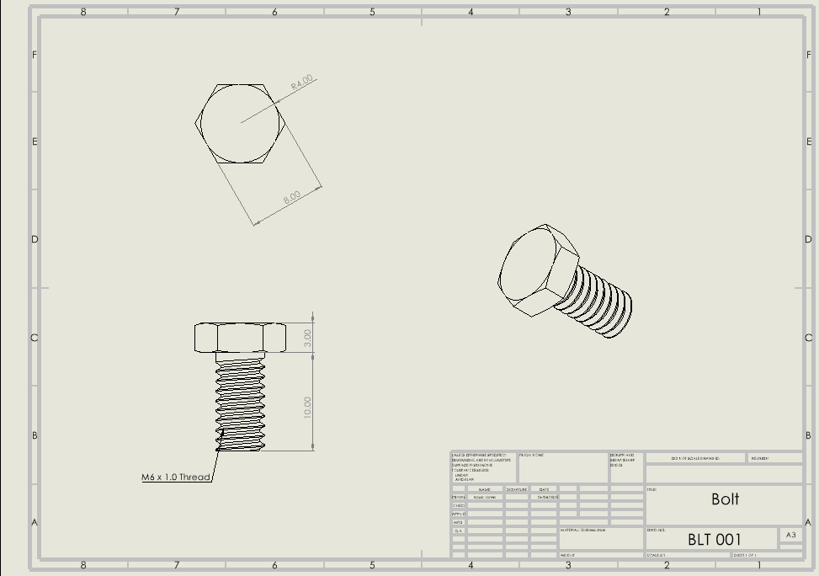
Figure 14: Bolt technical drawing
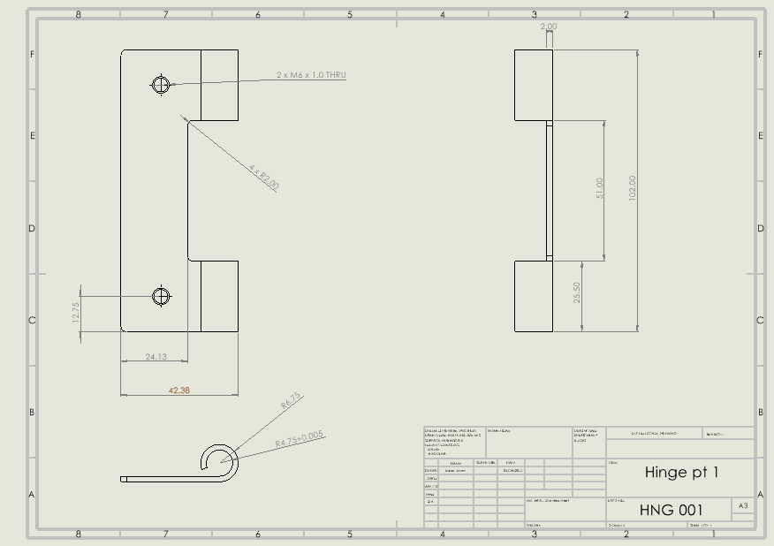
Figure 15: Hinge pt 1 technical drawing
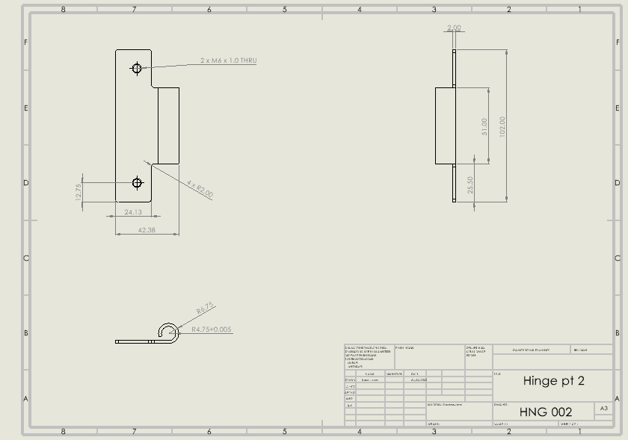
Figure 16: Hinge pt 2 technical drawing
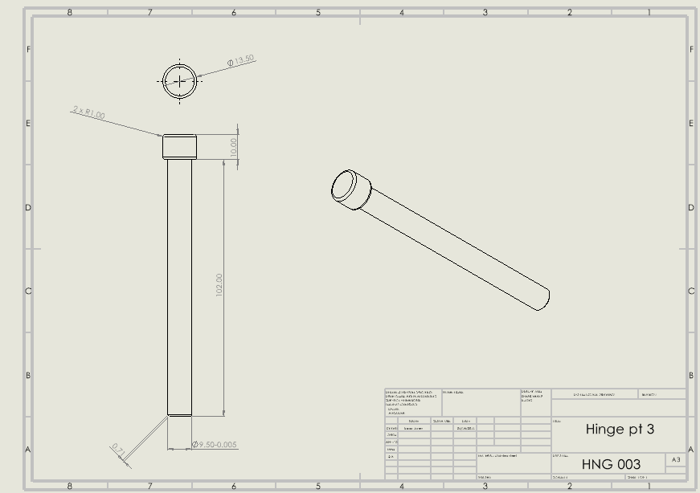
Figure 17: Hinge pt 3 technical drawing
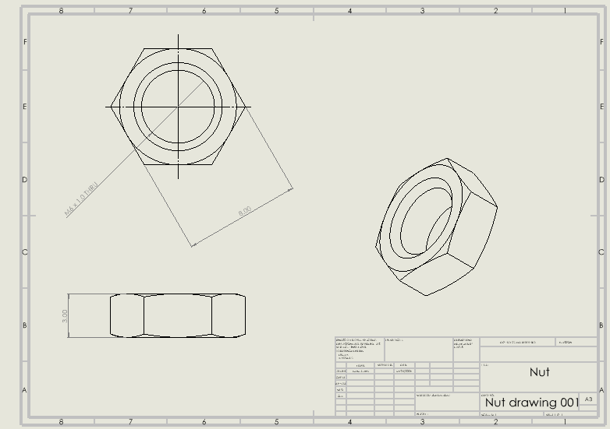
Figure 18: Nut technical drawing
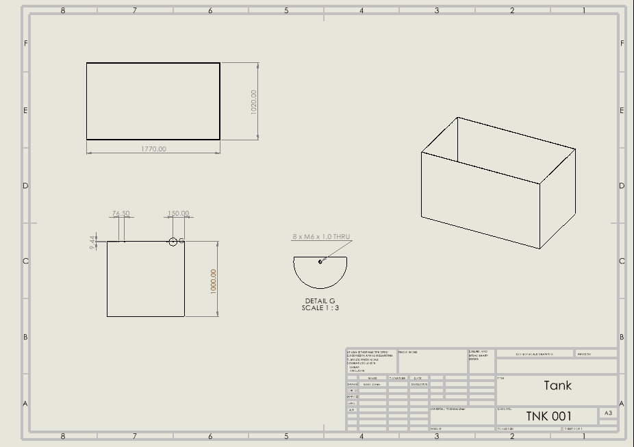
Figure 19: Tank technical drawing
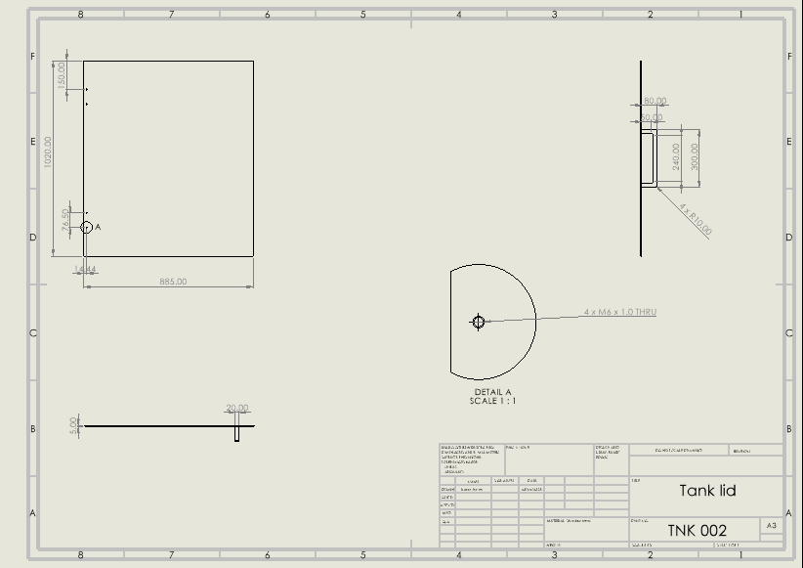
Figure 20: Tank lid technical drawing
These are the technical drawings for each component, allowing them to be easily manufactured.

Chapter 6: Relevant research
For one of my designs, I incorporated hinges, so it was crucial to verify their weight capacity. To do this, I first calculated the required hinge size based on the weight of the lid. The lid was made from a stainless-steel sheet measuring 1770mm in length, 1020mm in width, and 5mm in thickness. I began by calculating the volume of the steel sheet and then multiplied it by the density of steel, which typically ranges from 7500kg/m^3 to 8000kg/m^3 (John, 2024)To ensure the hinges would be sufficient, I used the higher density value. This resulted in a steel sheet weight of 72.16kg. Since the sheet would be split into two pieces, I halved this weight, meaning the hinges needed to support just 36.1kg. Based on the guidelines from (Cooke brothers, 2024)this indicated that grade 10 hinges would be required.

Chapter 7: Materials and manufacturing processes
The design will be constructed entirely from stainless steel, with the lid welded along the edges internally to ensure a smooth exterior, protecting the operator’s hands from cuts. The hinges will be made by casting stainless steel into moulds, a cost-effective method compared to processes like extrusion, which is particularly important since the design will be applied to several hundred tanks (RMG hardware, 2020). Casting is also ideal for producing strong hinges capable of supporting the weight of the lid. The bolts used in this design will be M6 bolts, chosen for their wide availability and versatility, making them suitable for most applications (Screwfix, 2025). These bolts will also be stainless steel, stainless steel was selected for its excellent corrosion resistance, as most other metals would rust in the presence of sulphuric acid (Ouarga et al., 2023).

Chapter 8: Justification
After comparing the 3 different designs with my specification, I decided that the hinge design meets the crucial points in my specification the best. For example, the design needed to be cheap enough so that several hundred could be produced. The hinge design would cost little to no money as (sealco-scotland, no date) are selling 2 similar hinges for £5.75, meaning that the design would cost no more than £11.50 per tank in extra materials. Additionally, the specification stated that the design needed to be light enough for 1 person to operate it alone. The hinge design allows one side of the lid to be lifted at a time and is kept stable by 2 hinges so it won’t slide from underneath the operator, furthermore, there is a handle which makes it even easier to lift. The hinges will be bolted on to the lid and tank with 4 bolts to each hinge, dividing the stress onto multiple points. In addition to this, the design had to be functional and fully seal the tank. Since the hinge design restricts lateral movement, the lid will consistently seal the tank perfectly.

Chapter 9: Conclusion
In conclusion, I created a hinge design which successfully met the criteria outlined in both the specification and the client brief, offering a safer method for operating the tanks while ensuring a tight seal to prevent leaks and spills. To further improve the design in the future, I would consider adding an extra hinge on each side to distribute the load more evenly, which would help extend the design's lifespan.

References
Agency for Toxic Substances and Disease Registry (2014) Sulfur Trioxide & Sulfuric Acid | Public Health Statement | ATSDR, Agency for Toxic Substances and Disease Registry. Available at: https://wwwn.cdc.gov/TSP/PHS/PHS.aspx?phsid=254&toxid=47 (Accessed: 1 April 2025).
Cooke brothers (2024) Hinge Load Capacity: Everything To Know | Cooke Brothers, Cooke brothers.co.uk. Available at: https://www.cookebrothers.co.uk/latest-news/2024/01/24/understanding-hinge-load-capacity-guide/?srsltid=AfmBOoqfi9BBbZ35Es1gEJhLi2SSLkp0uBW2tgwoayx3v5qfmgW2GDqN (Accessed: 29 March 2025).
John (2024) Density of Stainless Steel - thyssenkrupp Materials (UK), Steelprogroup.com. Available at: https://www.thyssenkrupp-materials.co.uk/density-of-stainless-steel (Accessed: 29 March 2025).
Legislation.gov (1992) The Manual Handling Operations Regulations 1992, Legislation.gov. Available at: https://www.legislation.gov.uk/uksi/1992/2793/contents/made (Accessed: 1 April 2025).
legislation.gov (2002) The Control of Substances Hazardous to Health Regulations 2002, legislation.gov. Available at: https://www.legislation.gov.uk/uksi/2002/2677/contents (Accessed: 1 April 2025).
Ouarga, A. et al. (2023) ‘Corrosion of iron and nickel based alloys in sulphuric acid: Challenges and prevention strategies’, Journal of Materials Research and Technology, 26, pp. 5105–5125. doi: 10.1016/J.JMRT.2023.08.198.
RMG hardware (2020) How to Make Hinges? Hinge Manufacturing Process - RMGhardware, rmghardware.com. Available at: https://www.rmghardware.com/hinge-manufacturing/ (Accessed: 3 April 2025).
Screwfix (2025) M6 Bolts | Nuts, Bolts & Washers | Screwfix, Screwfix. Available at: https://www.screwfix.com/c/screws-nails-fixings/bolts/cat840086?boltsize=m6 (Accessed: 3 April 2025).
sealco-scotland (no date) Carlisle Brass HIW14252/10BSS Eurospec 4 X 2 5/8 X 2mm Washered Hinge - Grade 10 60kg 102 X 68 X 2 - Pair - Sealco Scotland, sealco-scotland. Available at: https://www.sealco-scotland.co.uk/product/carlisle-brass-hiw14252-10bss-eurospec-4-x-2-5-8-x-2mm-washered-hinge-grade-10-60kg-102-x-68-x-2-pair/?srsltid=AfmBOoqQDIpi3CgatTa95u5iBczATJYsr-tiu7smr49qP9Sn9ZQIWeXcBlc&gQT=1 (Accessed: 31 March 2025).
The University of Newcastle Australia (2009) ‘MANUAL HANDLING’, p. 5. Available at: https://www.newcastle.edu.au/__data/assets/pdf_file/0015/82014/manual-handling-information.pdf (Accessed: 3 April 2025).

