Literature Review of Recent Advances in Motorcycle Dynamics

Maya Myerª*

ªMotorcycle Engineering, University of Wales Trinity Saint David, Swansea, UK

29 The Promenade, Swansea, SA1 6EN; 1801800@student.uwtsd.ac.uk
Literature Review of Recent Advances in Motorcycle Dynamics

A literature review of recent works in motorcycle dynamics was carried out. Surveyed works could be classified into three specific categories, with some overlap. It was found that most papers involved analytical models of part or all of a motorcycle, and quite a few of them regarded the simplification and accessibility of models for use without expensive equipment or extensive setup. It was concluded that further work in combining developed models to increase their reflection of reality might complement nicely with the general trend in increased access.

Keywords: review; dynamics; model; simulation

1: Introduction

A brief literature review was carried out to assess the state of the field of motorcycle dynamics. While the field itself doubtless contains many works of quality, the scope of this particular review was limited to recent years, from 2019 onward, in an attempt to gauge the current avenues of research being undertaken. Of the literature reviewed, it was discovered that three distinct classifications could be made: research seeking to increase model fidelity and availability, research seeking to better define contact patch interactions, and research concerning crash reconstruction and safety. While there exists some overlap between the categories, each of the works examined in this review will be classified and grouped according to its overarching theme.

2: Model Fidelity and Availability

Within this category, two subdivisions can be seen: models concerning all wheel drive (AWD) motorcycles, and models concerning rider interaction.

2.1: AWD Models

Bonci et al set out to create an AWD motorcycle model using symbolic equations of motion (EOM) derived from Lagrangian formulation [1]. Their model, seen in figure 1, carried some notable limitations and assumptions, mainly for the purposes of simplification. The two-body model they created ignored vertical dynamics—the effects of suspension—and treated the rider as a rigid element fused to the rear body, the motorcycle frame.

Figure 1 [1] Bonci et al's two-body rigid model--steering column (green) and frame plus rider (red)
It was validated against a multibody model in the MSC Adams software environment, and notably, the validation model did account for suspension behavior. Nevertheless, Bonci’s model performed relatively well, with the magnitude of error remaining below 2% [1,p.112877].
This model was then run through several test simulations regarding corner entry and exit to determine the effect of AWD application in cornering. What Bonci et al found was that front wheel torque entering a corner could increase roll and yaw rates, while the same on corner exit had adverse effects instead. According to Bonci: ‘this phenomenon resembles the behavior experienced by the few AWD riders. As they described, it's harder to regain the vertical trim while exiting a curve by operating the front torque’ [1,p.112877]. While the model developed appears to be successful in showing the potential advantages of an AWD system, Bonci et al mention that further work will be necessary to determine the proper application of such a driveline so as not to interfere with the rider’s demands on the vehicle.
Lot et al, in their work ‘A Sensorless Traction Strategy for All-Wheel Drive Electric Motorcycles,’ developed a model with much more practical application in mind [2]. While Bonci et al were more focused on academically proving a model to show the potential of AWD, Lot’s group made a model with the intention of actual deployment in traction control systems. The Lot model sought to optimise bike performance in terms of lateral and longitudinal accelerations by increasing the envelope area of a g-g diagram [2,p.3670]. They did this by deriving an expression for optimal torque bias which used only lateral and longitudinal accelerations as inputs, negating the need for sensor input detecting slip [2,p.3677]. However, as this expression still required acceleration data as input, Lot et al further refined it to a suboptimal bias expression, which required no sensor input but the rider torque demand—e.g. throttle position [2,p.3681]. Comparison between the optimal (β_{opt}), suboptimal (β∗), and a rear wheel drive (RWD) control can be seen in figure 2, where the truly sensorless suboptimal model still outperforms the control, though it does not perform quite as well as the optimal model.
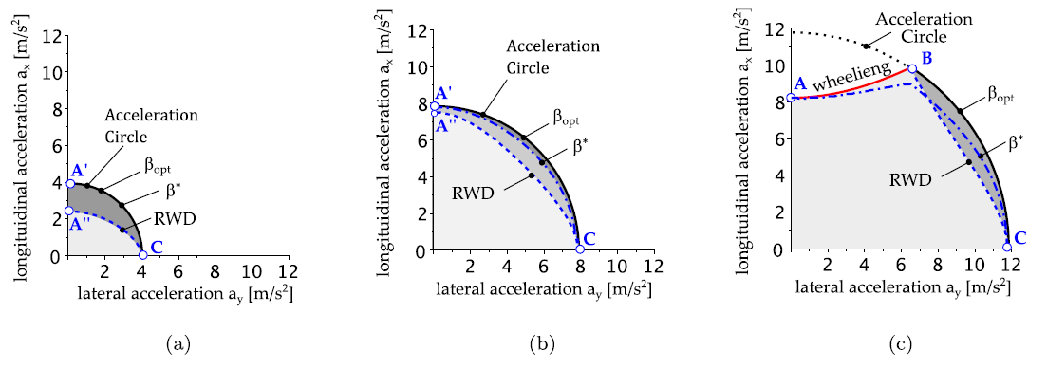
Figure 2 [2] Optimal and suboptimal torque bias models compared to RWD reference
Lot et al note that while the model did not improve straight line acceleration, it did indicate potential improvement in corners, and unlike slip-based traction control solutions, did not require sensor input [2,p.3686] making it a less expensive method in terms of components and setup.
Of particular note is that both models discussed in this section largely ignore both suspension and rider effects. In the Bonci model, the rider is modeled as a rigid body; the Lot model treats the entire motorcycle/rider system as a point-mass [2,p.3670]. While the models seem to perform well in their respective purposes, the effects of more realistic rider and suspension behavior on the models, beneficial or adverse, remain unknown.

2.2 Rider Interaction Models

Carputo et al focused on the very problem of dynamic rider behavior. Their work centered on the use of a machine learning (ML) algorithm to determine rider center of mass using image processing—specifically the gyroscopic cameras typically mounted behind the rider on racing motorcycles such as those in Moto GP; the main problem with this method being the limited field of view which does not capture the rider’s legs [3,p.379]. To address this, Carputo et al developed a ML algorithm to estimate the rider’s lower body position using upper body reference points gathered via OpenPose image processing software, trained using MotoGP19 game simulator video as the image source for consistency [3,p378]. Once the position of the lower body had been estimated, it would then be possible to combine it with the upper body reference points to determine a rider center of mass location continuously over the entire length of the data gathering period, allowing greater insight into performance optimisation.
The standard deviations for the rider center of mass X (horizontal) and Z (vertical) coordinates were 5cm and 9.1cm, respectively [3,p.385], with the sway areas shown in figure 3 below. Y (longitudinal) coordinates were not included in the scope of the work due to their relative constancy [3,p.381].
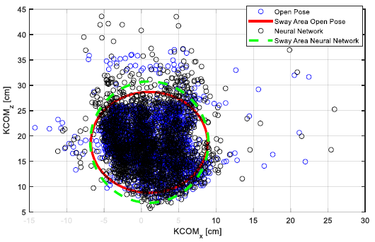
Figure 3 [3] Rider center of mass X and Z coordinate estimates from OpenPose software and Neural Network
The fairly large variance in the output data seems to have been the result of the OpenPose image processor being occasionally unable to determine proper upper body reference points, as illustrated in figure 4 [3,p.383]. Carputo et al assert that with better image processing, their developed neural network can be capable of quality output which may greatly enhance understanding of moment-to-moment motorcycle performance at relatively low cost and without the necessity of rider-mounted sensors [3,p.388].
Figure 4 [3] Errors in the OpenPose generated skeleton can be seen in some video frames (hips, spine, left arm)

On a more academic tack, Michel et al discuss the methodology concerning simulator development in their work ‘Rider in the Loop Dynamic Motorcycle Simulator: An Instrumentation Strategy Focused on Human Acceptability’ [4]. As the title suggests, the focus of their work is more on determining best practices for the development of motorcycle simulators which conform well to riders’ expectations of reality: ‘the congruence between the reactions of the system and the human driver’s expectations guarantees the acceptability of the system from the driver’s point of view’ [4,p.3]. Of great focus is the simulator’s handlebar assembly, as according to Michel et al, motorcycle handlebars act not only as an input device but as an important haptic feedback mechanism as well [4,p.10]. It was determined that an adequate handlebar assembly must be able to measure input torque with relatively little or no change in angular displacement and to return feedback torques under the same constraint. With that in mind, the prototype simulator handlebars included strain gauge, positional encoder, torque sensor, and high precision linear actuator as laid out in figure 5.
Figure 5 [4] The prototype simulator steering head connection setup pictured (a) and CAD model (b)
It was similarly determined that latency reduction was of equal import to the success of a simulator. To that end, Michel et al used physically segregated microcontrollers for the prototype simulator body and steering head in order to force parallelisation of the input computations [4,p.7]. The resultant prototype simulator was then tested via simple manoeuvres and found to have a latency of about 5ms for the steering head and 27ms for the body, which Michel et al mention is a bit higher than their goal of 10ms latency, but claim that it is still acceptable [4,p.17]. Of note is that large scale performance tests had yet to be undertaken on the prototype at the time of paper submission.

3. Contact Patch Interactions

Quite a few new additions to the literature featured studies on motorcycle interactions with the road surface, either via tyre model development or via normal force determination. Bartolozzi, Savino, and Pierini’s tyre model in particular has high overlap with the model accessibility category, as the stated aim of their work is ‘to define and validate a new high-fidelity motorcycle tyre model, for use in dynamic simulations, which can be characterised in real driving conditions by simple manoeuvres using reduced instrumentation, with limited knowledge of motorcycle parameters being required’ [5,p.4292]. Their model sought to replace the magic formula model typically used in dynamics calculation, which requires expensive equipment and many inputs to characterise a tyre. Bartolozzi et al adapted a simplified model intended for cars into one that could apply to motorcycles, and used a system of five equations to determine longitudinal force, lateral force, overturning moment, and yaw moment of a given tyre [5,p.4294]. The tyre could then be characterized by a series of simple tests with data gathered by onboard sensors typical to many bikes outfitted for racing. The new tyre model was verified in software against a magic formula tyre model, and was found to have good correlation with the reference data, as exemplified in the data from a second gear acceleration test displayed in figure 6. The authors note in their conclusions that while their simplified tyre model performs well in steady state manouevres, further work might find value in testing it against transient ones as well [5,p.4315].
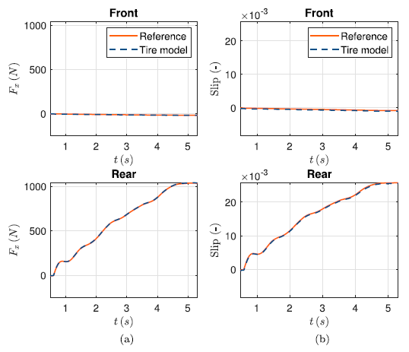
Figure 6 [5] Longitudinal force (a) and slip ratio (b) comparison of a second gear acceleration test

In ‘Tyre forces estimation for off-road motorcycles,’ Vasquez et al seek to fill in a hole in the literature regarding data for suspension setup. They observe that while there are quality studies involving tyre force determination for road vehicles, such work is suspiciously absent for their off-road counterparts [6,p.1]. Vasquez’ team attempted to determine tyre forces using inverse dynamics and, unlike other models seen in this review, treated the rider as a dynamic mass sprung to the motorcycle body rather than rigidly fastened. Their model was first validated against simulation data and later against real test data, and was found to be able to determine load transfer and braking events satisfactorily although front and rear braking distribution was ‘estimated inconsistently’, oscillating between front and rear before settling [6,p.6]. In the comparison with test data from a motocross track, the estimator model successfully varied its force predictions in accordance with features of the track, as well as determined periods of non-contact with the ground as well as braking effects from landing on surfaces with a negative slope (as in a jump or a ramp). Vasquez et al contended that their estimator was a viable tool for objectively determining bike performance characteristics without rider bias, and could even be useful in setting up onboard control systems [6.p.16].

4. Crashes and Safety

Several works dealt with motorcycle dynamics surrounding transient behaviors before and during a crash. Fatzinger, Landerville, Bonsall, and Simacek concerned themselves with data collection and analysis of motorcycle behavior during overbraking of the front wheel [7]. In tests both with and without a rider (replaced by a dummy for safety) using three different sport bikes, they instigated different overbraking events and measured time to fall as well as roll rate and deceleration during the event using GPS antennas and triaxial accelerometers and gyroscopes [7, p.593]. They determined a trend in that lean angle had an inversely proportional relationship to the average deceleration experience by the motorcycle during the fall event, and that rear brake application did not have a noticeable effect on deceleration during events when the front wheel was locked [7,p.957]. While their experimental data provided a good informational baseline for crash reconstruction, it did not include the effects of rider steering input or progressive braking, so its application to simulations of real world events may be somewhat limited.
Cattabriga et al similarly sought to add to the collective body of knowledge by characterising the onset of 'patter,' the cyclic instability during heavy braking that typically occurs just before wheel lock [8,p.33]. They defined a simplified model of a motorcycle head unit, the schematic of which can be seen in figure 7, which was able to rotate about the proximal position of the steering head in order to represent pitching of the motorcycle body during weight transfer.
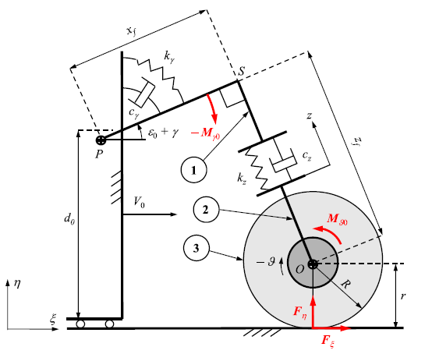
Figure 7 [8] The 3 degree of freedom simplified model schematic of a motorcycle steering head
This simplified model was compared to a more detailed multibody model and it was found that ‘all the relevant features and parameters controlling the onset and development of patter instability can be included in the minimal model, in spite of all the simplifying assumptions’ [8,p.44]. The model was run through several simulations of both stationary and transient braking events, and Battabriga’s team discovered two main inputs governing the onset of patter: applied downforce via damping, and forward velocity. The former was found to create a feedback loop with the pitching of the motorcycle body to effectively increase the energy in the system resulting in cyclic instability, and the latter was determined to have more destabilising effects as its value increased [8,p.53].

5. Conclusions

A brief literature review of recent advances in the field of motorcycle dynamics was conducted and it was discovered that many recent advances dealt with analytical models in some capacity, perhaps unsurprisingly. Within the literature surveyed, three categories could be determined as works concerning model improvements, works concerning road surface interaction, and works concerning crash reconstruction and safety. It should be noted that not every paper fell neatly into a single category: two could be classified in either the first or second category [5,6]. There existed a good mix of practically focused [2,3,5,6] and academically focused [1, 4,7,8] works, indicating healthy growth in both areas, and by extension, perhaps also indicating a certain lack of clear definition in the body of knowledge of the underlying mechanics determining the dynamic behaviors of motorcycles. Of particular interest is the tendency of motorcycle models to simplify or ignore either or both suspension and rider behavior [1,2,6,7]. Further research into dynamic model improvements might consider integrating works such as [3] and [5] into existing models like the ones defined in [1] and [2] to derive a more complete picture of the dynamic rider and motorcycle system. Clearly, though great bounds in terms of accessibility and ease of use are being made, there is more work to be done in order to give dynamic models a more complete reflection of the reality they simulate.

References

[1] Bonci A, Longhi S, Scala G A. Towards an All-Wheel Drive Motorcycle: Dynamic Modeling and Simulation. IEEE access. 2020; 8:112867–112882. doi: 10.1109/ACCESS.2020.3002685

[2] Lot R, Del Rosso V, Boria S, et al. A sensorless traction strategy for all-wheel drive electric motorcycles. Vehicle syst dyn. 2022; 60(11):3668–3693. doi: 10.1080/00423114.2021.1971266

[3] Carputo F, D’Andrea D, Risitano G, et al. A Neural-Network-Based Methodology for the Evaluation of the Center of Gravity of a Motorcycle Rider. Vehicles. 2021; 3(3):377–389. doi: 10.3390/vehicles3030023

[4] Michel P, Bouaziz S, Delgehier F, et al. Rider in the Loop Dynamic Motorcycle Simulator: An Instrumentation Strategy Focused on Human Acceptability. Electronics (Basel). 2022; 11(17):2690–. doi: 10.3390/electronics11172690

[5] Bartolozzi M, Savino G, Pierini M. Novel high-fidelity tyre model for motorcycles to be characterised by quasi-static manoeuvres - rationale and numerical validation. Vehicle syst dyn. 2022; 60(12):4290–4316. doi: 10.1080/00423114.2021.2013506

[6] Vasquez F, Lot R, Rustighi E, et al. Tyre forces estimation for off-road motorcycles. Mech syst and sig process. 2020; 150:107228–. doi: 10.1016/j.ymssp.2020.107228

[7] Fatzinger E, Landerville J, Bonsall J, et al. An Analysis of Sport Bike Motorcycle Dynamics during Front Wheel Over-Braking. SAE Int J of Adv and Curr Pract in Mobil. 2019; 1(3):951–966. doi: 10.4271/2019-01-0426

[8] Cattabriga S, De Felice A, Sorrentino S. Patter instability of racing motorcycles in straight braking manoeuvre. Vehicle syst dyn. 2021; 59(1):33–55. doi: 10.1080/00423114.2019.1663389

