NATESHA NATOYA LEWIS
2134545
Marketing Skills BMIH4005
Dale Clarke
A comparison of the marketing methods of two multinational hotel brands
Six Sense and Holiday Inn
Introduction
In this essay you will find comparing marketing methods between two hotel brands. Six Sense and Holiday Inn hotels are different in many ways, from customers, quality of service and different marketing strategies. They are both apart of the Intercontinental Hotel Group PLC, which makes them a branded hotel. This generates marketing skills in the form of a purpose that exists behind an action, fact or object. No two hotels are the same, but all hotels have an aim to have an excellent marketing skill that leads to more customer and more business. Marketing is a very important part of any business; this is where you advertise your business so that it is known to the public about the services you offer and the reason why your service is better than your latest competitor. Below it will explain all the marketing strategy for “Six Sense” and “Holiday Inn” along with the difference in the way they market themselves. Examples of the 5cs, swot analysis, bowman’s clock and 7ps of marketing mix. These will be explained in details of the comparisons of the two hotels and how these strategize their marketing skills. The pestle system will also be explained along with a few diagrams in the appendix.
Main Body
Holiday Inn is an American hotel that was founded in 1952 by Kemmons Wilson, since then it has been spread across six continents throughout the world. Holiday Inn also has resorts under its name along with club vacations. The services they offer are hotel rooms, food service and function room. In their function room they host weddings, parties, meetings and other events that would require the size and location they have on offer. Segmentation is where a brand targets a specific group of people as their consumers. For the holiday inn they target businessmen within their mid-thirties to forties. “Market segmentation helps a business to lower the risk by finding out which product will earn the most.” Evan Tarver (2023) Marketing organises course of action that is well built, will increase the flow of customers and spread the awareness of the brand. This comes in the form of, logos, adverts from Tv to billboards and promotions. “Holiday Inn promotes travel planning with mobile destination guide contest. He states that, holiday Inn the hotel brand group has teamed up with major franchises in order to get more consumers” A.Samuley (2017). They have various marketing strategies over the years in order to deal with their competitors, law change, cost of living and climate change. The result led to digital marketing. Six Sense hotel story began in 1995, their mission is to make the world a better place by creating an environment that is suitable for customers and the planet. During my research six sense hotel, had very little weakness that I could use to explain how they dealt with it using different marketing strategies. Their strength lies within their unique ways of creating an unforgettable environment for families to enjoy. Their aim is to be different from other hotel brands by inventing recyclable materials along with creating their own water to have that extra special feeling for their consumers. Unlike the holiday inn, six sense uses the 5cs, where climate is of importance for their resources, for example, their ski resorts that all depends on the weather conditions.
The 5cs of marketing are, company, customers, competitors, collaborators and climate, see appendix 3 for a diagram. These has a real effect on hotels with a brand name and how they approach the 5cs. “whenever a 5c analysis is carried out, it provides a comprehensive outline of the great significance factors that makes a difference to your business” J.Birt (2023) Holiday Inn collaborates with franchises such as booking.com, hotel.com, expedia and much more. These are a few of their supply chains to get more consumer to their business. These franchises mostly do Tv advert and to what we have learnt, visual always gets more attention, along with the discounts that comes with using these franchises. Six sense hotel is its own competitor, there is no other brand hotel like the six sense that I could find in my research. The company had change the CEO in recent years but since then, they have expanded greatly.
The six sense swot analysis states that they provide an extraordinary experience for their customers. They offer different activities that is suitable for families. These activities range from, learning about food in a class setting, outdoor cooking events that comes with a one-to-one hired help. Lawn meals are also available in various destination that has views no one has ever seen in any other hotel. Please see diagram below in appendix 5 for example. Six senses has been granted a high level award for their great effort in being a hotel with a brand name that provides healthy habits. The Holiday swot analysis has stated due to the hotel being so great with how it markets itself and the franchises it poses around the world, a upper hand has gain in this situation. Their weak point is, not being able to match their competitor’s strategy. They are face with some huge competitors such as “Six Sense hotel”. This is where each hotel has different ways of marketing. According to P.Landman (2022) “ There is an importance to carry out the steps of SWOT analysis to receive great results”.
The Bowmans Strategy clock explain the different levels located on the chart, where each company is position in the marketing world. See in the appendix 1 below the chart where Six Sense hotel was placed “5” this called focused differentiation. Holiday inn was placed at “3” this is called hybrid. “Bowmans clock is advantageous figure that enables you to understand how an enterprise compete in the market world.” M.Sridharan(2021) These levels based on their performance as a brand hotel. It was said that “growth hacking are hybrid of marketer and coder” A.Chen (2012) used by D.Chaffery (2019) this is where a brand ask questions, such as “what is the best way to get consumers to my establishment”. I use this example to demonstrate as to why I place Holiday Inn on the clock as a hybrid. In recent years they have develop a weakness in gaining more business for their establishment.
The Pestle Analysis is the politics, social, legal, economics, technological and environment aspect of marketing. According to T.Bush (2019) “every organisation acts in some kind of political environment”. See diagram in appendix 4 for example. The holiday inn is not an environmental based company because they are not a recyclable brand as the Six Sense, where they do recycle, and their aim is to make the world a better place. Holiday inn is a government-based company as they rely on their policies to carry out taxable information concerning their employees. They operate all over the world so that makes them sociable. The Six Sense Hotel has a different social background, even though they are environmentally friendly not everyone is for saving the planet, so holiday inn will be more social able. The six sense uses less technology as they use nature as a way of saving the planet, from recycle to sun light and reusing the coral reefs.
“The marketing mix refers to the tactics (or marketing activities) that we have to satisfy the customers needs.” A. Allen (2020) This known as the 7Ps of marketing, which consist of the product, price, promotion, place, people, packaging and process, see appendix 2 below for table example. The 7ps are an important part of marking. The product is the first P that is needed of the 7. Without a product, you have nothing to market. With the Six Sense Hotel their product is their wellness and sustainability for customer interested in saving the planet. Their prices also vary, and they have provided the opportunity for discount if booking is done early. They are widely spread across Europe and Asia. Their facilities can accommodate any weather as they have location around the globe even areas with severe weather condition. The people they accommodate are interested in saving our planet and recycling, although everyone is welcome, their main targets are families. The Holiday inn speaks differently, they have been around longer than Six Sense hotel and they have more location and is more well know to lot more consumer in the hotel industry. Holiday Inn product is their large conference rooms and events that they are known to have, that is their product, what they market. The people they target, are businesspeople who uses their rooms and conference room so it’s a double sale in the way they package each deal.
Conclusion
In conclusion, both hotel market their establishment for the same reason to make money. They do it differently as they have different customers and different ways of doing thing. We have learnt that Six Sense Hotel aims to save the planet, they obey the rules of the land, but their biodegradable plans do minimise the politics influence. The holiday is government based, where political influence is adhered due to their financial structure and how they deal with taxes. The comparison between each hotel is the different ways in which they have chosen to market their business. We have gone through each analysis in detail to analyse how each business dealt with their strengths and weakness of marketing strategy. To conclude the comparison between the two establishment, we can safely say that these two businesses has very little in common but like all businesses their aim to make a sale.

Appendix 1
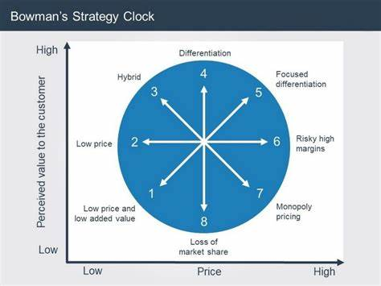
bowman's clock theory - Bing images

Appendix 2
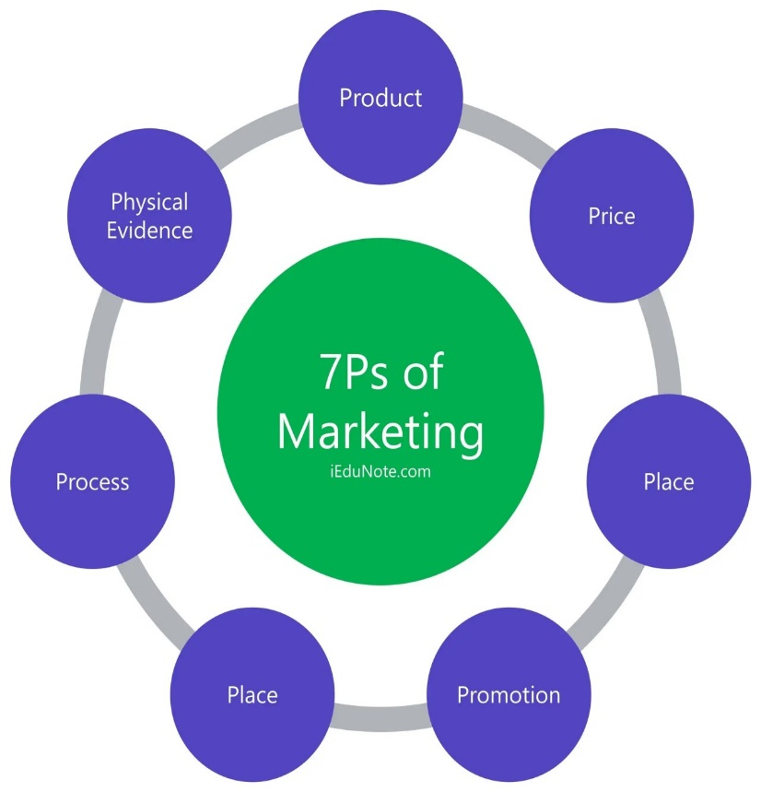
Marketing Mix: Definition, Elements, Examples, Diagram (iedunote.com)

Appendix 3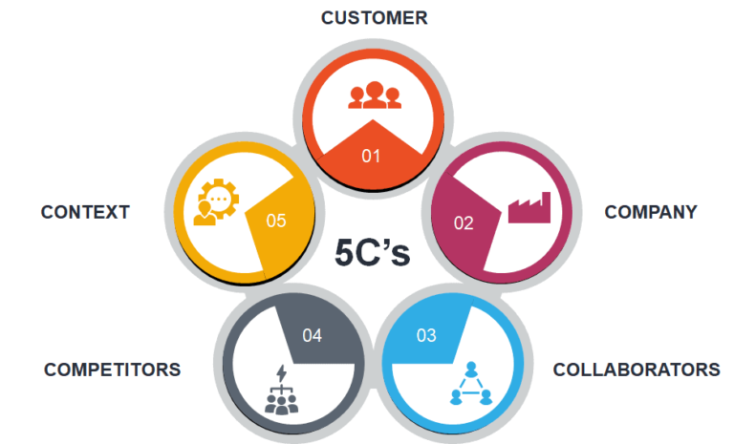

5 cs of marketing diagram - Bing images

Appendix 4

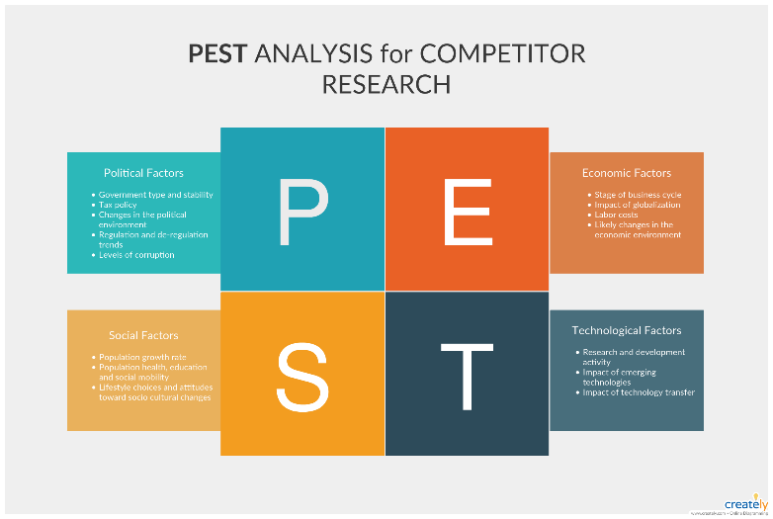
pestle analysis diagram - Bing images
Appendix 5
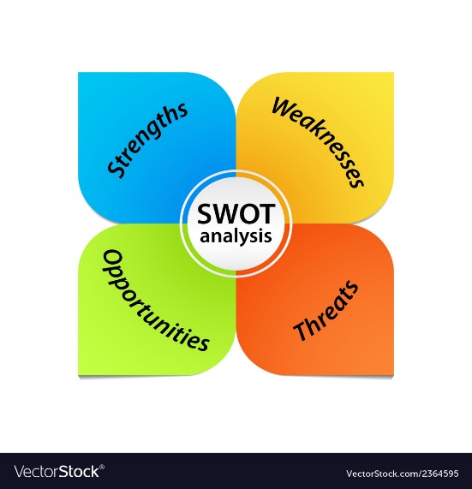
swot analysis diagram - Bing images

Reference
*A. Allen, Oxford College of Marketing
Understanding the 7ps of marketing
The 7Ps of The Marketing Mix | Oxford College Of Marketing (08/10/2020)

*Alex Samuely
Marketing Dive (2017)
Journal
Holiday Inn promotes travel planning with mobile destination guide contest | Marketing Dive

*Bowmans clock diagram
Appendix 1
bowman's clock theory - Bing images

*D. Chaffey
Page 328
Digital marketing ,pearson education (8-1-2019)

*Evan Tarver
Journal
Market Segmentation- Definition, Example, Types, Benefits (30.3.2023)
Market Segmentation: Definition, Example, Types, Benefits (investopedia.com)

*5cs of marketing diagram
Appendix 3
5 cs of marketing diagram - Bing images
*7ps of marketing diagram
Appendix 2
IeDunote
Marketing Mix: Definition, Elements, Examples, Diagram (iedunote.com)

*Jamie Birt
Journal
5cs of Marketing Analysis Definition, tips and example
5 C’s of Marketing Analysis: Definition, Tips and Example | Indeed.com (11.03.2023)

*Mithum Sridharan
Journal
Bowman’s stragetic clock : How to position your product
Bowman's Strategic Clock - How To Position Your Product? (thinkinsights.net) (27.4.2021)

*Patrick Landman
Hotel SWOT analysis
journal
Hotel SWOT Analysis | SWOT Analysis Examples for Hotels (xotels.com)(2022)
*Pestle Diagram
Appendix 4
pestle analysis diagram - Bing images

*Swot Anaysis Diagram
Appendix 5
swot analysis diagram - Bing images

*Thomas Bush
Pestle analysis explained (with examples)
Journal
PESTLE Analysis Explained (With Examples) (23.05.2019)

