

Student Name: -Samina Bibi
Student Number: - 2412887
Module: Introduction to independent Research skills
Module Code: - BMHP5019
Component 1: -Template
Lecturer: - Raheela Shaikh

CONTENTS

Introduction and Rationale 2
Research Aim and Objectives 2
Objectives: 2
Methodology 2
Scoping Review Framework 2
Research Question 3
Inclusion/Exclusion Criteria 3
Data Collection and Analysis 3
Ethical Considerations 4
References 5
Appendices 6

Digital Exclusion and Healthcare Access among Older Adults in England: A Qualitative Analysis of NHS and Government Policy Documents (2020–2025)

Introduction and Rationale
Digital technologies are playing an increasing role in delivering NHS services including online appointments, NHS registration systems, patient portals and health apps. These innovations could help enhance healthcare services, but they also could pose challenges for people who do not have access to digital resources or the ability to use them. Digital exclusion is especially prevalent among older people, potentially making it more difficult for them to access healthcare services. (Ge et al., 2025). It is therefore important to consider NHS and governmental policy documents to better grasp how these challenges are recognised and acted upon by policy makers (Yang et al., 2025).

Aim
This scoping review aims to examine the nature of policy statements found in NHS and UK Government documents in relation to digital exclusion and access to health services for older adults in England from 2020 to 2025.

Objectives:
- To find indicators of digital exclusion in policy documents.
- To explore older adults' experiences of access barriers to health care.
- To identify policy strategies that foster Digital Inclusion.
- To reveal the areas that need more studies and policy development.

Methodology

Scoping Review Framework
This review will follow the scoping review framework created by Arksey and O'Malley and will utilise the simplified thematic analysis created by Aveyard for the purposes of identifying the key themes.
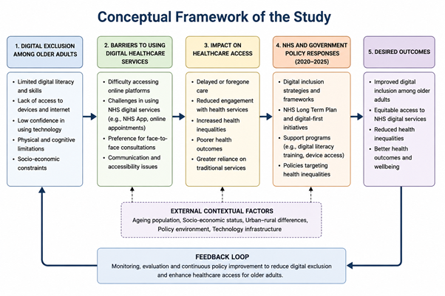
Figure 1 (Conceptual Framework of the Study

Research Question
What is the age of digital exclusion and healthcare access in the policy documents by the NHS and the UK Government from 2020-2025?

Inclusion/Exclusion Criteria
The inclusion criteria include English language and government policy documents relevant to digital health, healthcare access and ageing populations, or health inequalities, published from 2020-2025. Publications that are not in England, non-policy literature, and publications prior to 2020 will not be included.

Data Collection and Analysis
The key words used to search the NHS England and GOV.UK repositories to identify policy documents will include “digital exclusion”, “older adults”, “digital health” and “healthcare access” (Schofield, 2025). Existing evidence identifies that certain groups of people are more likely to experience digital exclusion in healthcare (Wilson et al., 2024). In addition, policy responses for telemedicine, the NHS's digital transformation, inequalities in NHS App use and older adults' acceptance of technology will be used to inform their analysis (Gobburi et al., 2025). Thematic analysis of documents will be done following Aveyard's approach (Laverty et al., 2026).

Ethical Considerations
There will be no human participants in the review as it relies on publicly available policy documents. The use of transparent methods, accurate reporting and appropriate referencing will be used to maintain ethical practice.

REFERENCES
Farre, A., Fang, M., Hannah, B., Makita, M., McFadden, A., Menezes, D., Rodriguez, A., Sixsmith, J. and M Gray, N., 2023. Exploring the use of digital technology to deliver healthcare services with explicit consideration of health inequalities in UK settings: A scoping review. Digital Health, 9, p.20552076231185442.
Ge, H., Li, J., Hu, H., Feng, T. and Wu, X., 2025. Digital exclusion in older adults: A scoping review. International Journal of Nursing Studies, 168, p.105082.
Gobburi, R.K., Olawade, D.B., Olatunji, G.D., Kokori, E., Aderinto, N. and David-Olawade, A.C., 2025. Telemedicine use in rural areas of the United Kingdom to improve access to healthcare facilities: A review of current evidence. Informatics and Health, 2(1), pp.41-48.
Laverty, A.A., Reidy, C., KC, S., Papoutsi, C., Gudgin, B., Majeed, A. and Powell, J., 2026. The NHS App should focus on inequalities to improve population health. Journal of the Royal Society of Medicine, 119(2), pp.37-41.
Schofield, M., 2025. Digital transformation in UK contemporary healthcare: Lessons from NHS England. In Perspectives on Digital Transformation in Contemporary Business (pp. 61-80). IGI Global Scientific Publishing.
Wilson, S., Tolley, C., McArdle, R., Slight, R. and Slight, S., 2024. Who is most at risk of digital exclusion within healthcare? International Journal of Pharmacy Practice, 32(Supplement_1), pp. i3-i4.
Yang, H.J., Lee, J.H. and Lee, W., 2025. Factors influencing health care technology acceptance in older adults based on the technology acceptance model and the unified theory of acceptance and use of technology: meta-analysis. Journal of Medical Internet Research, 27, p.e65269.

Appendices
Figure 1 Conceptual Framework of the Study

